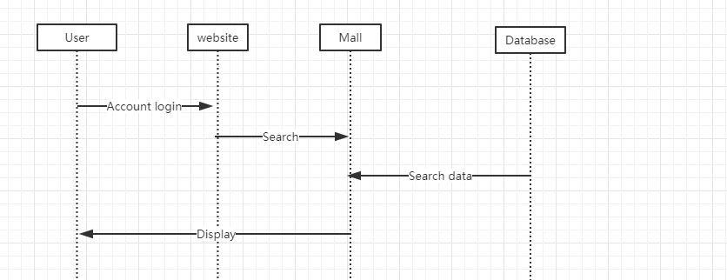

Users need to open the site and log in with their own account. Then go to the mall page to search for the goods you want, and the database will feed back to them the relevant goods that will be on the shelves.

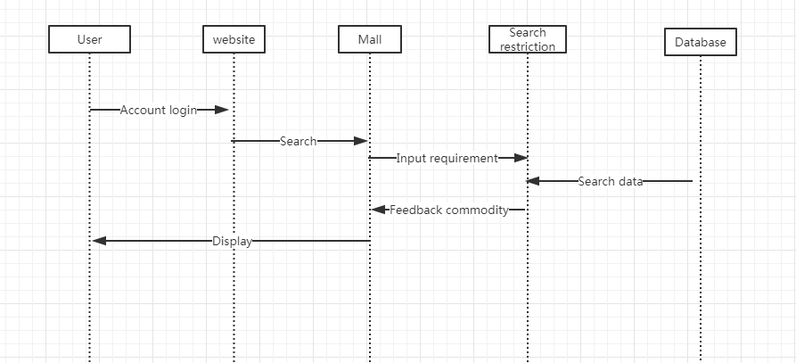

Users open the site to log in with their own account, enter the mall page, search for the goods they need, but also limit the search conditions, such as price and model. After the search in the database, the matching items will be fed back to the user.

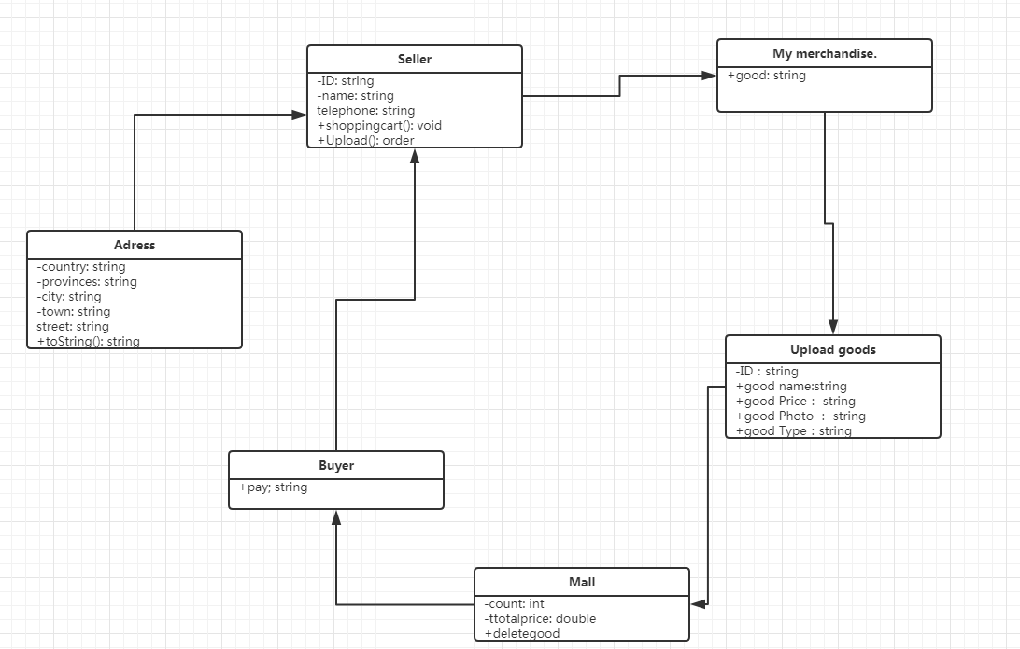

First, define three properties and two methods for the seller, and the user must register before logging in. I define four types of uploaded items that users use to upload their own products. And finally reached the mall's database. For the buyer to search, the buyer finally sends the order to the seller, determines the user's address information through the location class, and generates the order of the leased goods.