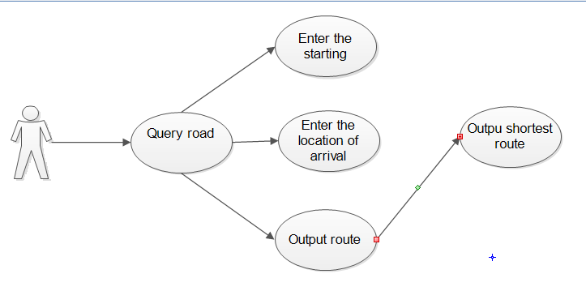

|  |  |  |  |
| --- | --- | --- | --- |
| Query line use case | Query route | Identifier | A004 |
| Use case description | Query the route from the departure point to the end point | | |
| Use case participant | User ontology | | |
| Prerequisites for this use case | 1. User successfully logs in to the navigation system  2. User network is smooth  3. The user entered the start and end points | | |
| Postconditions for this use case | The system can get a feasible line from the starting point and the ending point. | | |
| The basic operational flow of this use case | 1. The user enters the start and end points.  2. The system begins to query for feasible routes.  3. The query is completed.  4. The system shows the user the traffic conditions of the line. | | |
| Use cases related to the main line |  | | |
| Optional operating procedure | 1. The user queries the route.  2. The system starts to query.  3. The query failed, the starting point of the input is incorrect. | | |
| Postconditions for this use case | The system obtains the location information of the user | | |
| The basic operational flow of this use case | 1. The user must turn on the GPS.  2. The system uses GPS to start positioning.  3. Positioning is successful.  4. The system shows the location information to the user | | |
| Optional operating procedure | 1. The user starts to locate.  2. The system obtains user positioning.  3. The positioning failed, the user GPS is not turned on. | | |

