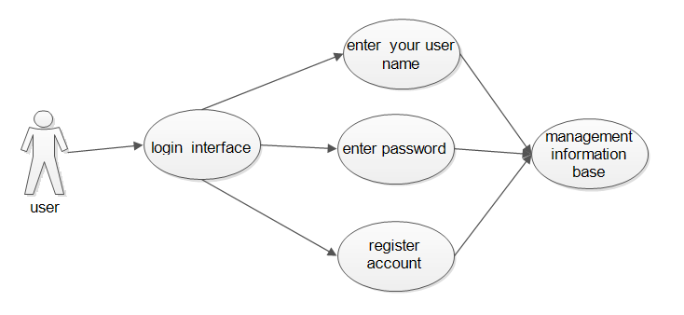

User positioning use case：

|  |  |  |  |
| --- | --- | --- | --- |
| Use case name | positioning service | Identifier | A002 |
| Use case description | The software locates the user's location | | |
| Use case participant | User ontology | | |
| Prerequisites for this use case | The user successfully logs in to the system and keeps his GPS on. | | |

Login system use case：

|  |  |  |  |
| --- | --- | --- | --- |
| Use case name | log in system | Identifier | A003 |
| Use case description | User login system | | |
| Use case participant | User ontology | | |
| Prerequisites for this use case | User has already registered an account | | |
| Postconditions for this use case | Users of this navigation software increase | | |
| The basic operational flow of this use case | 1. The user enters the relevant account name and password.  2. The system automatically detects and verifies the account number and password.  3. The system verifies the identity of the user.  4. The verification is completed and the user logs in successfully. | | |
| Optional operating procedure | 1. The user enters the corresponding information.  2. The system verifies the account number and password.  3. Login information error, re-login | | |