Evidence-Validated Strategy Adaptation for Memory-Augmented Agents Under Distribution Shift
A Statistical Framework for Reliable Experience Validation, Applicability-Gated Retrieval, and Selective Memory Invalidation
Dev Parth
Independent Researcher
Independent Research in Artificial Intelligence
Release Date: 9 November 2026

Abstract
Memory-augmented autonomous agents store past trajectories, verbal reflections, or induced workflows to improve sequential decision-making without parameter updates. However, most non-parametric agent memory architectures rely on single-episode admission and surface-similarity retrieval without statistical verification, explicit applicability preconditions, or distribution-shift invalidation. Under non-stationary task streams and noisy evaluator feedback, unvalidated experiential stores accumulate spurious coincidences and obsolete routines, causing severe negative transfer. We present Evidence-Validated Strategy Adaptation (EVSA), a closed-loop statistical framework that models reusable agent strategies as explicit hypotheses governed by three epistemic tiers (CANDIDATE, VALIDATED, and QUARANTINED). EVSA combines (i) a discounted log-odds sequential validation heuristic motivated by Wald's Sequential Probability Ratio Test (SPRT) with discounted Bayesian Beta(α,β) lower credible bounds, (ii) multiplicative applicability-gated retrieval with re-verified Least General Generalization (Safe LGG) over task preconditions, and (iii) per-domain residual tabular CUSUM monitoring for evidence-based selective post-shift quarantine.
We evaluate EVSA in ShiftBench-Sim v1.0, a controlled, low-dimensional synthetic symbolic-procedural simulation (4-step discrete operator workflows, observable 5-bit binary state descriptors, 20-dimensional synthetic embeddings, and a heuristic non-LLM CalibratedSymbolicLLMBackbone isolated behind a capability-restricted AgentEnvironmentInterface; >360,000 simulated episodes across N=20 primary seeds and N=30 stability seeds) against four budget-matched baselines (Static, Conventional Memory, Reflection, and Experience Replay). On held-out unseen tasks—where frozen evaluation executes strictly VALIDATED strategies—EVSA achieves 54.50% ± 5.04% success (55.17% ± 5.62% across N=30 seeds), outperforming all baselines (25.65%–29.62%, paired Cohen's d_z ∈ [4.31, 6.35], Holm-Bonferroni p ≤ 8.15 × 10^-14), including zero-shot compositional tasks (31.13% vs.\ 12.12%–17.94%, p_Holm ≤ 1.07 × 10^-6). A controlled execution-channel parity study confirms that +22.04 percentage points (~ 82%) of EVSA's +26.92 pp advantage over Experience Replay persists under identical stochastic prompt execution (49.62% vs.\ 27.58%, p_Holm = 1.57 × 10^-13). Across 320-episode continual streams, EVSA reaches 65.21% ± 8.52% while compacting memory to 21.50 validated strategies (13.14 KB). Following abrupt multi-domain concept shifts, EVSA achieves +20.80 pp post-shock adaptation gain while preserving 82.21% accuracy with no measurable cross-domain degradation on unshifted control domains. Under symmetric feedback corruption (η ∈ \0.10, 0.25, 0.35\), EVSA limits rollout-level false acceptance to 1.34%–2.53% (candidate-level false promotion 8.08%–11.32%), significantly reduces active memory contamination across all noise levels under pre-defined per-family Holm adjustment (p_Holm ≤ 0.0063; 60/74 study-wide tests significant under simultaneous global 74-test pooling), and recovers to 74.90%–84.10% once clean feedback resumes, while candidly exposing sample-complexity versus epistemic-purity trade-offs under high noise (65.44% FRR at η=0.35) and short per-archetype horizons.

Keywords
Memory-augmented agents; Sequential hypothesis testing; Bayesian credible bounds; Applicability-gated retrieval; Concept drift detection; Selective memory invalidation; Continual adaptation.

Introduction
Autonomous reasoning agents increasingly augment fixed decision backbones with external episodic or procedural memory repositories to accumulate operational competence at test time [yao2023react,shinn2023reflexion,wang2024voyager,zhao2024expel,wang2025awm]. Rather than updating model weights via gradient descent—which is often computationally prohibitive, API-restricted, or prone to catastrophic forgetting [kirkpatrick2017overcoming]—non-parametric memory agents record past interaction traces, self-critiques, or extracted action workflows and retrieve them via vector similarity when tackling related tasks [park2023generative,liu2025cer,ouyang2026reasoningbank].
• Single-Episode Epistemic Trust: If an action trajectory or verbal reflection coincides with task completion once, it is immediately admitted as reusable knowledge without testing whether the outcome arose from genuine task-operator alignment, a lucky stochastic transition, or a noisy evaluator signal [xiong2024can,xiong2026memory].
• Semantic-Applicability Equivalence: High cosine similarity between surface task descriptions is treated as sufficient evidence that two tasks share identical operational constraints, ignoring latent structural preconditions that invert optimal tool sequences [chen2024agentpoison,zou2025poisonedrag].
• Temporal Stationarity: Stored experiences remain active indefinitely (or decay only by passive recency heuristics), lacking online statistical change-point detection to quarantine invalidated strategies when external APIs, policies, or environment dynamics shift [gama2014survey].
When these assumptions fail simultaneously, memory transitions from an asset into a liability. Surface-retrieved stale workflows crowd out valid exploration, noisy feedback promotes suboptimal routines that compound downstream errors [xiong2026memory], and indiscriminate memory resets sacrifice valid competence on unaffected task domains.
To address these coupled failure modes in a principled, auditable setting, this paper introduces Evidence-Validated Strategy Adaptation (EVSA). EVSA treats every induced workflow strategy h = (ϕ_h, π_h) not as a raw text trace, but as a falsifiable statistical hypothesis pairing an explicit conjunctive precondition ϕ_h with an executable action plan π_h. Strategies enter a probationary CANDIDATE tier, undergo multi-trial verification governed by a discounted log-odds sequential heuristic and Bayesian Beta(α,β) lower credible bounds, generalize conservatively across nuisance features via re-verified Least General Generalization (Safe LGG) [plotkin1970inductive], and remain continuously audited in the VALIDATED tier by per-domain residual tabular CUSUM drift detectors [page1954continuous].
Because isolating memory-validation dynamics from live API non-determinism and pretraining contamination requires exact ground-truth control over latent preconditions, changepoints, and feedback corruption, we conduct our empirical investigation in ShiftBench-Sim v1.0, a controlled, low-dimensional synthetic symbolic-procedural simulation (4-step discrete operator tuples, observable 5-bit binary state vectors, 20-dimensional synthetic embeddings, and a heuristic CalibratedSymbolicLLMBackbone). We explicitly avoid claiming evaluation on live neural Large Language Models (LLMs) or unstructured natural-language precondition extraction; instead, ShiftBench-Sim v1.0 provides a capability-isolated algorithmic testbed where every statistical mechanism, failure boundary, and baseline asymmetry can be audited rigorously.
Summary of Verified Contributions. itemize
Closed-Loop Epistemic Strategy Architecture: We formalize EVSA across ten modular components uniting sequential hypothesis gating, Bayesian lower credible reliability estimation, precondition-gated retrieval with Safe LGG re-verification, and domain-scoped residual CUSUM invalidation.
Mathematically Audited Sequential & Capability-Isolated Formulations: We distinguish Bayesian Beta credible bounds from frequentist confidence intervals, characterize discounted/adaptively selected SPRT stopping honestly as an empirically calibrated sequential heuristic rather than claiming classical i.i.d.\ Wald bounds, and enforce a hard runtime capability boundary (AgentEnvironmentInterface) separating evaluator-only oracle state from all agent and policy modules.
Controlled Multi-Regime Evaluation & Execution-Channel Attribution: Across six core experiments (N=20 seeds), an extended N=30 seed stability study, and a controlled 2 × 2 execution-channel fairness parity study, we separate statistical validation and precondition-gating gains from deterministic macro execution.
Transparent Reporting of Multiplicity, Trade-Offs, and Negative Boundaries: Alongside large gains in unseen generalization (54.50%), continual learning (65.21%), post-shift recovery (+20.80 pp), and noisy-feedback recovery (74.90%–84.10%), we export reproducible per-family (62/74 sig.) and simultaneous global-74 (60/74 sig.) Holm-Bonferroni ledgers and report all non-significant outcomes, high-noise false-rejection costs (65.44% FRR at η=0.35), and short-horizon sample-complexity trade-offs without selective omission.
itemize

Motivation and Problem Statement
Consider an autonomous agent processing a sequential stream of structured multi-step tasks S = (q_1, q_2, ..., q_T) across domains D (e.g., API orchestration, system diagnosis, data pipeline repair, and resource planning). Each task q_t = (x_t, d_t, ψ_t) presents a normalized surface query vector x_t ∈ R^m, a domain identifier d_t ∈ D, and an observable binary precondition vector ψ_t ∈ \0,1\^K. To solve q_t, the agent executes an H-step procedural workflow π ∈ A_0 × ... × A_H-1 within a per-episode interaction budget of B ≥ 1 rollouts.
Let c(q_t) ∈ \0, ..., C-1\ denote a latent structural archetype determined by a subset of governing preconditions G ⊂ \0, ..., K-1\, while remaining bits \0, ..., K-1\ G represent nuisance context that varies across task instances without altering the optimal workflow π^*_d_t, c(q_t), r(t) under active environment regime r(t) ∈ \0, 1, 2\. Crucially, neither c(q_t), G, r(t), nor π^* is ever observable to the agent; both TaskInstance and RolloutResult expose strictly observable inputs and noisy feedback. After each rollout π, the environment draws a true latent binary outcome y_t ∈ \0, 1\ governed by step alignment with π^*_d_t, c(q_t), r(t), observed through a potentially corrupted feedback channel with symmetric flip probability η_t ∈ [0, 0.5):
equation
y_t =
cases
y_t, & with probability 1 - η_t, \\
1 - y_t, & with probability η_t.
cases
eq:noisy_channel
equation
• Surface-Embedding Collision Pathology: Tasks sharing identical surface topic tokens in x_t (yielding high cosine similarity (x_t, x_t') > 0.85) frequently differ on governing bits ψ_t,k ≠ ψ_t',k (k ∈ G). Embedding-only retrieval surfaces the previously successful plan π_t', which mismatches required operators on q_t and suppresses exploratory discovery.
• Spurious & Corrupted Admission Pathology: Even when π is suboptimal (e.g., matching H-1 of H steps with partial-alignment completion probability p_sub3 = 0.28), or when η_t > 0 flips failures y_t=0 into apparent successes y_t=1, one-shot admission stores π permanently as a “verified” exemplar.
• Asymmetric Concept-Shift Pathology: At unknown changepoint t_shift, a subset of domains D_shift ⊂ D undergoes a concept shift π^*_d, c, 0 ≠ π^*_d, c, 1 while D D_shift remains stationary. Agents without drift detection continue invoking obsolete plans on D_shift, whereas naive global memory flushes destroy valid competence on D D_shift.

Related Work
Our work intersects four research threads: experiential memory for autonomous agents, memory reliability and poisoning defenses, sequential statistical inference and bandit confidence bounds, and online concept-drift adaptation. Table(tab:related_work) summarizes how EVSA relates to representative frameworks without claiming unsupported “first” or “only” novelty on individual sub-mechanisms.
Experiential, Reflective, and Workflow Memory in Agents. ReAct [yao2023react] interleaves reasoning and action traces within a single episode but retains no cross-episode memory. Reflexion [shinn2023reflexion] and CLIN [majumder2024clin] persist verbal self-reflections or natural-language abstractions across trials, while Generative Agents [park2023generative] and MemGPT [packer2023memgpt] manage long-horizon episodic stores via recency-relevance-importance scoring or OS-inspired paging. Moving from episodic traces to reusable skills, Voyager [wang2024voyager] stores executable code skills verified once in deterministic Minecraft tasks; ExpeL [zhao2024expel], Agent Workflow Memory (AWM) [wang2025awm], Contextual Experience Replay (CER) [liu2025cer], Dynamic Cheatsheet [suzgun2026dynamic], and A-MEM [xu2025amem] extract reusable workflows, evolving test-time cheatsheets, or linked Zettelkasten notes. Most recently, ReasoningBank [ouyang2026reasoningbank] distills generalizable reasoning strategies from self-judged successful and failed trajectories paired with Memory-aware Test-Time Scaling (MaTTS), AdaMEM [zhang2026adamem] combines offline long-term trajectory memory with dynamically synthesized short-term strategy memory and step-wise memory fine-tuning (STEP-MFT), and ExpRL [jin2026exprl] bounds exploration during reasoning-driven experience selection. Unlike ReasoningBank and AdaMEM—which distill or synthesize strategies over unquarantined trajectory stores without multi-trial sequential admission tests or online change-point invalidation—EVSA couples multi-trial sequential hypothesis gating at admission, conjunctive Safe-LGG precondition gating at retrieval, and domain-scoped residual CUSUM invalidation under concept shift.
Memory Reliability, Calibration, and Poisoning. Xiong et al.\ [xiong2024can] demonstrate that verbalized LLM confidence is systematically overconfident, making self-scored memory filtering unreliable. In a 2026 ACL study, Xiong et al.\ [xiong2026memory] show that memory-augmented agents exhibit strong “experience-following” bias whereby misaligned stored records propagate errors over time and advocate selective addition coupled with deletion. From an adversarial perspective, AgentPoison [chen2024agentpoison] and PoisonedRAG [zou2025poisonedrag] demonstrate that injecting a handful of crafted records into an unvalidated RAG/agent store hijacks downstream decisions at >90% attack success. EVSA addresses stochastic and noisy-evaluator contamination structurally by requiring repeated empirical verification before promotion and monitoring post-promotion predictive residuals.
Sequential Hypothesis Testing, Bayesian Bounds, and Anytime-Valid Inference. Wald's Sequential Probability Ratio Test (SPRT) [wald1945sequential] minimizes expected sample size for testing simple binary hypotheses H_0: p = p_0 against H_1: p = p_1 under i.i.d.\ sampling. In adaptive multi-armed bandits, Kaufmann et al.\ [kaufmann2012bayesian] establish asymptotic optimality of Bayesian Upper Confidence Bounds (Bayes-UCB) using posterior Beta quantiles. Modern sequential statistics has further developed non-asymptotic time-uniform confidence sequences [howard2021time] and game-theoretic e-processes / test martingales [ramdas2023game] that preserve Type-I error under arbitrary adaptive stopping, alongside Holm's sequentially rejective multiple-testing control [holm1979simple]. As detailed in Section(sec:math), EVSA adopts discounted Beta credible bounds and a discounted SPRT-motivated log-odds gate for computational simplicity under non-stationarity, while explicitly auditing empirical false-promotion rates rather than claiming classical i.i.d.\ Wald bounds.
Concept Drift Detection, Continual Learning, and Inductive Generalization. Page's cumulative sum (CUSUM) scheme [page1954continuous], adaptive windowing (ADWIN) [bifet2007learning], and drift-adaptation taxonomies surveyed by Gama et al.\ [gama2014survey] detect distributional shifts in data streams via predictive error monitoring. In parametric continual learning and test-time adaptation, Elastic Weight Consolidation (EWC) [kirkpatrick2017overcoming], Prioritized Experience Replay (PER) [schaul2016prioritized], and Tent [wang2021tent] mitigate forgetting or adapt normalization statistics online. For symbolic precondition induction, Plotkin's Least General Generalization (LGG) [plotkin1970inductive] computes maximal common conjunctions across positive instances. EVSA unifies Plotkin-style conservative precondition intersection with re-verification discounting and per-domain residual CUSUM quarantine inside a non-parametric agent strategy store.
Table 1: Architectural comparison of representative agentic memory and continual adaptation frameworks.
Framework | Cross-Task Memory | Multi-Trial Gate | Reliability Est. | Preconditions | Drift Detector | Quarantine
ReAct (2023) | No | No | No | No | No | No
Reflexion / CLIN | Verbal / Abstractions | No (1-episode) | Verbalized only | Implicit text | No | Buffer cap
Voyager (2024) | Code Skills | 1-trial env check | Binary pass/fail | Implicit text | No | No
ExpeL / AWM | Insights / Workflows | Heuristic / LLM | Empirical freq. | Prompt sim. | No | Rule edit
CER / ReasoningBank (ICLR 2026) | Trajectories / Strategies | No (self-judged) | Self-judged tag | Dense embed. | No | Top-k dilution
Dynamic Cheatsheet (EACL 2026) / A-MEM | Curated Notes | LLM-judged edit | Uncalibrated LLM | Linked keywords | No | Prompt rewrite
AdaMEM (ICML 2026) | Hybrid LT + ST Bank | LLM synthesis / MFT | Uncalibrated LLM | Query / state context | Short-term refresh | Summary overwrite
EVSA (Proposed) | 3-Tier Strategies | Discounted SPRT | Beta Credible Bound | Conjunctive + Safe LGG | Per-Domain CUSUM | Evidence Quarantine

Research Questions and Hypotheses
We structure our empirical investigation around five pre-specified Research Questions (RQ1–RQ5) and corresponding falsifiable null/alternative hypothesis pairs (H_0,k vs.\ H_1,k) tested across paired random seeds:
• RQ1 (Unseen Task Generalization & Execution-Channel Attribution): Does coupling sequential statistical validation with precondition-gated retrieval improve held-out task success (executing strictly VALIDATED strategies) over memoryless and conventional memory baselines under identical rollout budgets, and does this gain persist when execution-channel adherence is equalized?
Hypotheses H_0,1 / H_1,1: Mean held-out success rate μ_EVSA = μ_b vs.\ μ_EVSA ≠ μ_b across b ∈ \Static, ConvMem, Reflection, Replay\ and under matched stochastic_prompt vs.\ direct_macro execution.
• RQ2 (Continual Learning & Memory Compactness): Across multi-hundred-episode continual streams without manual resets, does EVSA exhibit monotonic competence accumulation without early negative transfer while maintaining a compact active strategy repository?
Hypotheses H_0,2 / H_1,2: Early Block-1 and terminal Block-8 probe success satisfy μ_EVSA = μ_b vs.\ μ_EVSA ≠ μ_b.
• RQ3 (Component Necessity & Horizon Trade-Offs via Ablation): What is the isolated contribution and sample-efficiency trade-off of each EVSA mechanism—sequential validation, Bayesian credible scoring, applicability preconditions, residual CUSUM drift detection, and selective memory invalidation—under noisy non-stationary streams?
Hypotheses H_0,3 / H_1,3: Removing module m yields zero paired change (μ_Full = μ_-m) vs.\ μ_Full ≠ μ_-m.
• RQ4 (Post-Shift Recovery & Selective Stationary Retention): Following abrupt partial-domain concept shifts and compound shifts, does domain-scoped CUSUM invalidation accelerate post-shock adaptation without degrading unshifted stationary domains?
Hypotheses H_0,4 / H_1,4: Post-shift recovered SR, changepoint Adaptation Gain, proportional Recovery Rate, and unshifted-domain SR satisfy μ_EVSA = μ_b vs.\ μ_EVSA ≠ μ_b.
• RQ5 (Feedback-Corruption Robustness & Overhead Trade-Offs): Under symmetric evaluator noise η ∈ \0.10, 0.25, 0.35\, how effectively does sequential gating with Safe LGG suppress false acceptance and enable clean recovery, what False Rejection Rate (FRR) and False Discovery Proportion (FDP) trade-offs arise, and what computational overhead is incurred?
Hypotheses H_0,5 / H_1,5: Active memory contamination and post-corruption clean recovery satisfy μ_EVSA = μ_b vs.\ μ_EVSA ≠ μ_b.

Proposed EVSA Architecture
EVSA organizes experiential adaptation as a ten-module closed-loop architecture (Figure(fig:arch)). Rather than storing unstructured transcripts, the Tiered Strategy Repository (src/memory/repository.py) maintains structured hypotheses h = (id_h, d_h, c_h, ϕ_h, π_h, τ_h, α_h, β_h, Λ_h, n_h), where d_h ∈ D is the task domain, c_h ∈ R^m is the unit-normalized query centroid, ϕ_h ⊂eq \0,...,K-1\ × \0,1\ is a conjunctive precondition set, π_h ∈ A_0 × ... × A_H-1 is an H-step procedural workflow, and τ_h denotes the epistemic tier in \CANDIDATE, VALIDATED, QUARANTINED\ (Figure(fig:val_workflow)).
Operational Episode Loop. Algorithm(alg:evsa) details EVSA's per-episode decision and update cycle (src/ agents/ evsa_agent.py):
enumerate
Exploitation via Validated Retrieval (Modules 3 & 7): Given task q_t = (x_t, d_t, ψ_t), the Applicability Retriever filters VALIDATED strategies in domain d_t whose precondition conjunction ϕ_h(ψ_t) = 1 holds and whose Bayesian lower credible bound satisfies p_h^cred(δ) ≥ τ_rel = 0.45 (Figure(fig:app_retrieval)a). If a match h^* exists, EVSA records the out-of-sample predictive probability p_pre = α_h^*/(α_h^* + β_h^*), executes π_h^*, updates (α_h^*, β_h^*, Λ_h^*) first with observed feedback y_t, and then feeds residual e_t = p_pre - y_t to the domain-d_t Residual CUSUM Detector (Module 9).
Active Candidate Verification During Adaptation Only (Modules 4–6): During online learning (learn=true), if no VALIDATED strategy applies (or if y_t = 0 leaves rollout budget remaining), EVSA selects among precondition-compatible CANDIDATE strategies maximizing a Bayes-UCB utility (0.85 I_0.90^-1(α_h, β_h) + 0.15(0,(x_t, c_h)) + 0.015|ϕ_h|) [kaufmann2012bayesian]. During frozen evaluation (learn=false), unvalidated CANDIDATE strategies are strictly excluded from execution.
Salience-Guided Exploration & Safe LGG Admission (Modules 2 & 8): When budget remains and no strategy is selected, the Hypothesis Generator synthesizes a workflow π_new (mutating away from tombstoned plans in M_d_t matching ψ_t) using marginal step-predicate outcome contrasts accumulated strictly from observed rollouts. Only if y_t = 1 is π_new admitted to CANDIDATE—or merged into an existing strategy matching (d_t, π_new) via Safe LGG precondition intersection.
Selective Drift Quarantine & Capacity Pruning (Modules 8 & 9): If domain-d_t's CUSUM statistic crosses h_drift (subject to post-reset warmup and cooldown), EVSA immediately quarantines active strategies in M_d_t exhibiting empirical failure (f_h^consec ≥ 1) or weakened reliability (p_h^cred < 0.58), while discounting unfalsified strategies in M_d_t back to CANDIDATE for rapid re-verification and leaving all other domains untouched.
enumerate
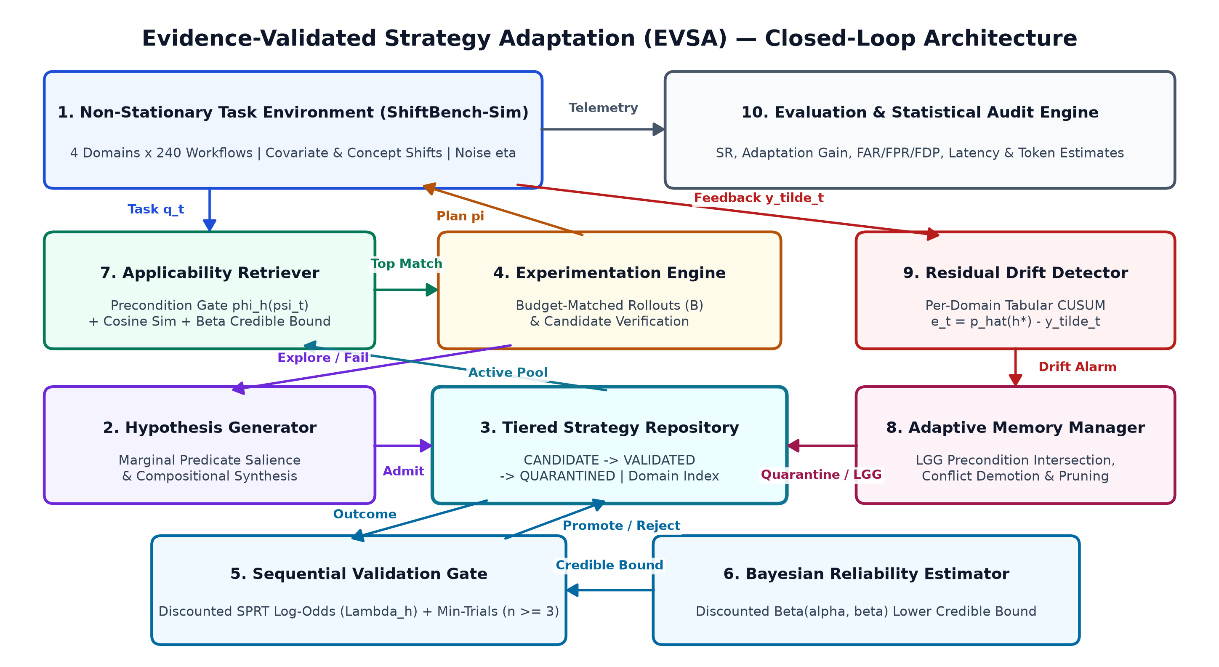
Figure 1: EVSA Ten-Module Closed-Loop System Architecture.
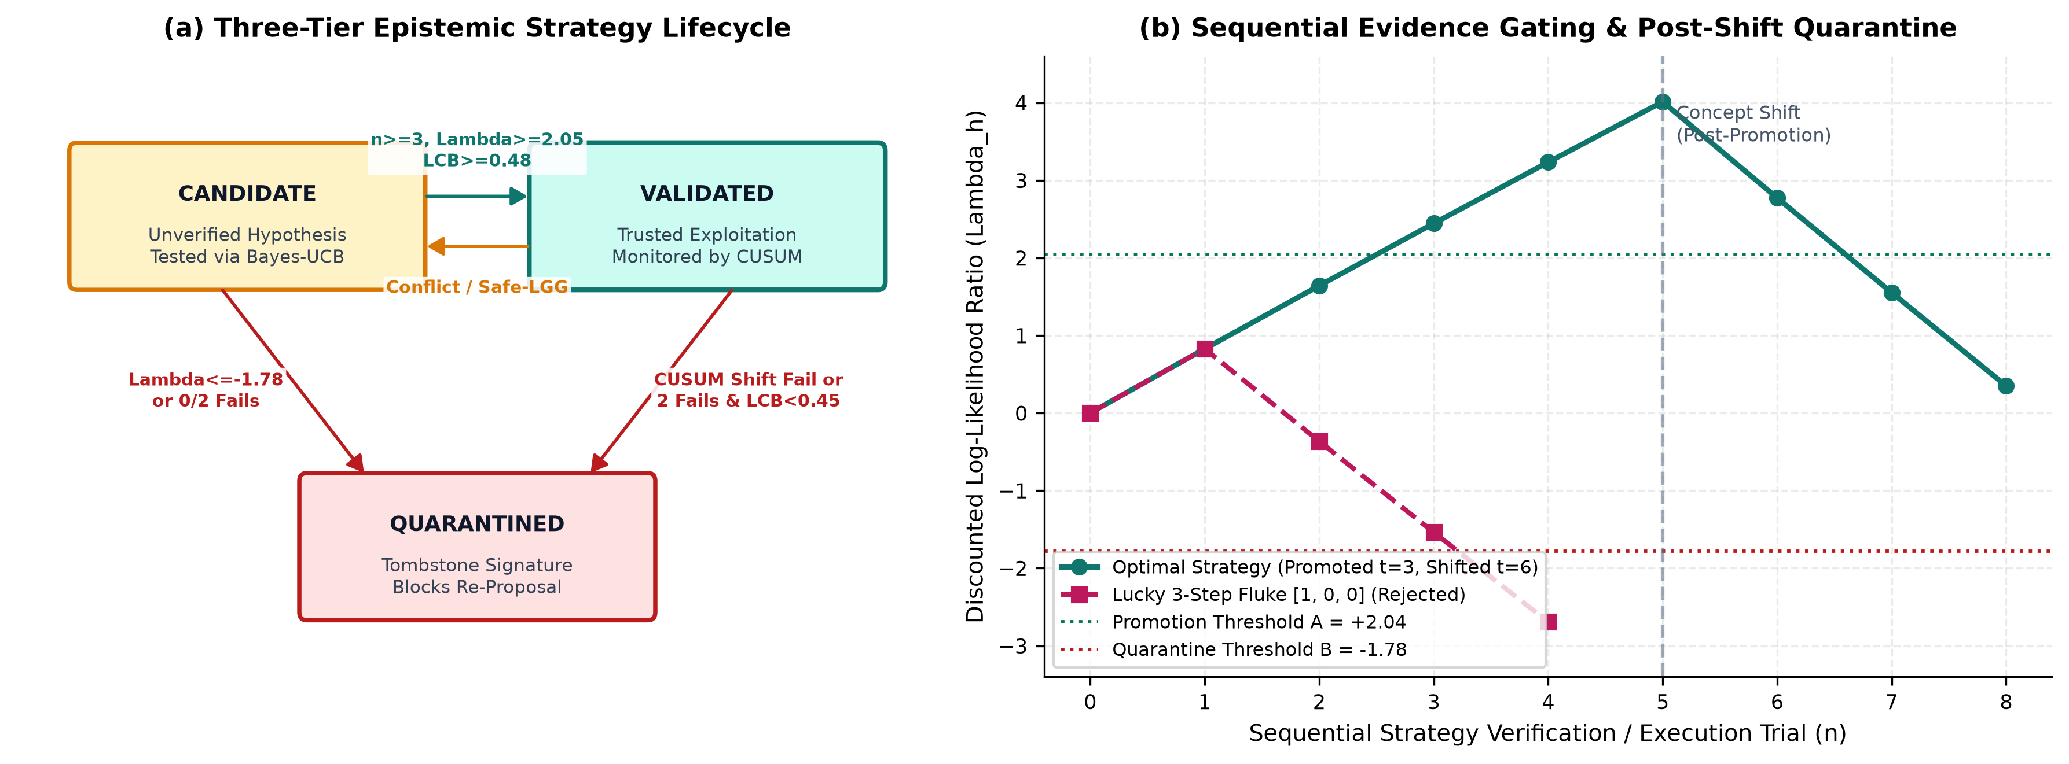
Figure 2: Strategy Validation Lifecycle and Sequential Evidence Trajectories.

Mathematical Formulation
sec:math

Discounted Bayesian Beta Posterior and Lower Credible Bounds
Let θ_h ∈ (0,1) denote the unknown conditional success rate of strategy h on tasks satisfying ϕ_h(ψ_t) = 1 under the active feedback channel. Placing a uniform prior θ_h ~ Beta(α_0, β_0) (α_0 = β_0 = 1), we incorporate exponential forgetting factor γ = 0.985 upon observing outcome y_n ∈ \0,1\ (src/validation/confidence.py):
equation
α_h^(n) = α_0 + γ (α_h^(n-1) - α_0) + y_n,
β_h^(n) = β_0 + γ (β_h^(n-1) - β_0) + (1 - y_n).
eq:beta_update
equation
The posterior predictive mean is p_h = α_h^(n) / (α_h^(n) + β_h^(n)), and the conservative reliability score is the exact δ-quantile (δ = 0.10) of Beta(α_h^(n), β_h^(n)) via the inverse regularized incomplete beta function I_δ^-1 (with symmetric upper quantile p_h^cred = I_1-δ^-1 for Bayes-UCB candidate exploration):
equation
p_h^cred(δ) = I_δ^-1(α_h^(n), β_h^(n)), satisfying ∈t_0^p_h^cred(δ) u^α_h^(n)-1(1-u)^β_h^(n)-1B(α_h^(n), β_h^(n)) du = δ.
eq:credible_bound
equation
Credible Bounds vs.\ Unregularized Empirical Ablation: Crucially, p_h^cred(δ) is a discounted Bayesian (1-δ) lower credible bound, distinct from a frequentist Clopper-Pearson confidence bound or time-uniform confidence sequence [howard2021time]. Under small sample sizes, p_h^cred(0.10) regularizes 1-for-1 flukes (α=2,β=1 0.316 < 0.48) while p_h^cred(0.90) protects promising candidates against single stochastic misses. In our w/o Confidence Estimation ablation, Bayesian credible bounds are replaced by the unregularized discounted empirical frequency p_h^emp = (α_h - α_0)/(α_h - α_0 + β_h - β_0) (0.50 at n_h=0).

Discounted Log-Odds Sequential Heuristic (Motivated by Wald's SPRT)
To separate aligned strategies (θ_h ≥ p_1) from suboptimal partial plans (θ_h ≤ p_0), we specify indifference boundaries p_0 = 0.35 and p_1 = 0.80 with nominal calibration parameters (α_FA, β_FR) = (0.11, 0.15) (src/validation/sprt_validator.py), yielding log-odds thresholds:
equation
A = ≤ft(1 - β_FRα_FA) ≈ +2.045,
B_low = ≤ft(β_FR1 - α_FA) ≈ -1.780.
eq:sprt_bounds
equation
Upon each trial y_n ∈ \0,1\, EVSA updates a discounted, clipped log-likelihood ratio Λ_h^(n) ∈ [-Λ_, +Λ_] (Λ_ = 6.0):
equation
Λ_h^(n) = clip≤ft(γ Λ_h^(n-1) + y_n ≤ft(p_1p_0) + (1 - y_n) ≤ft(1 - p_11 - p_0), -Λ_, +Λ_),
eq:sprt_update
equation
where (p_1/p_0) ≈ +0.827 and ((1-p_1)/(1-p_0)) ≈ -1.179. Tier transitions follow the conjunctive decision rule:
equation
τ_h^(n) =
cases
VALIDATED, & if τ_h^(n-1) = CANDIDATE ∧ n_h ≥ n_ ∧ Λ_h^(n) ≥ A ∧ p_h^cred(0.10) ≥ 0.48, \\
QUARANTINED, & if Λ_h^(n) ≤ B_low ∨ (τ_h^(n-1)=CANDIDATE ∧ n_h ≥ 2 ∧ s_h = 0) \\
& ∨ (τ_h^(n-1)=VALIDATED ∧ f_h^consec ≥ 2 ∧ p_h^cred(0.10) < 0.45), \\
τ_h^(n-1), & otherwise,
cases
eq:tier_rules
equation
with n_ = 3, cumulative successes s_h, and consecutive failures f_h^consec. Three consecutive successes produce Λ_h^(3) ≈ 2.443 ≥ 2.045, promoting h cleanly.
Theoretical Audit of Classical SPRT Assumptions: Classical Wald (1945) guarantees ((Accept H_1 H_0) ≤ α_FA) require undiscounted (γ=1), unclipped i.i.d.\ sampling independent of arm selection [wald1945sequential]. Because Eq.(eq:sprt_update) introduces exponential discounting (γ < 1), clipping (± Λ_), a hard sample-size floor (n_=3), a joint Beta credible gate, and adaptive Bayes-UCB candidate selection, classical Wald Type-I/II error bounds do not hold analytically. We therefore characterize Eqs.(eq:sprt_bounds)–(eq:tier_rules) strictly as an empirically calibrated sequential heuristic and measure its realized candidate-level false-promotion rate directly in Experiment 4 (8.08%–11.32% across η ∈ [0.10, 0.35]). Achieving exact finite-sample error guarantees under adaptive bandit stopping requires non-negative test supermartingales / e-processes [ramdas2023game].

Applicability-Gated Retrieval and Re-Verified Safe LGG Abstraction
Each strategy h stores a conjunctive precondition ϕ_h ⊂eq \0,...,K-1\ × \0,1\ evaluated via ϕ_h(ψ_t) = _(k,v) ∈ ϕ_h I[ψ_t,k = v] ∈ \0,1\. When an exploratory workflow π succeeds (y_t = 1) with induced preconditions ϕ_new and matches an active peer h ∈ M_d_t (π_h = π) differing on 1 ≤ ≤ 2 shared coordinates, EVSA applies Plotkin's Least General Generalization (LGG) [plotkin1970inductive] (src/memory/memory_manager.py):
equation
ϕ_h^LGG = \(k, v) ∈ ϕ_h ϕ_new\, subject to |ϕ_h^LGG| ≥ K_ = 3.
eq:lgg
equation
Safe LGG Re-Verification: Whenever Eq.(eq:lgg) strictly broadens an already-VALIDATED strategy (|ϕ_h^LGG| < |ϕ_h|), preserving VALIDATED status blindly would allow a single noisy false positive (y_t = 1) on a neighboring archetype to drop a governing literal and poison future exploitations. EVSA therefore discounts excess pseudo-counts by γ_LGG = 0.80, clamps Λ_h ≤ftarrow (γ_LGGΛ_h, A - 0.15), and steps τ_h back to CANDIDATE so that at least one independent confirming trial on the generalized subspace is required before re-promotion.
Retrieval utility enforces both symbolic applicability ϕ_h(ψ_t)=1 and minimum lower credible reliability τ_rel = 0.45 for VALIDATED strategies (w_sem=0.28, w_conf=0.52, w_tier=0.20, b_spec=0.015; src/ retrieval/ retriever.py):
equation
split
U(h, q_t) &= I[d_h = d_t] ϕ_h(ψ_t) I[p_h^cred(0.10) ≥ τ_rel] \\
& (w_sem (0, (x_t, c_h)) + w_conf p_h^cred(0.10) + w_tier + b_spec|ϕ_h|).
split
eq:retrieval_utility
equation

Per-Domain Residual Tabular CUSUM Drift Detection
Let e_t = p_h^*^(t-1) - y_t ∈ [-1, 1] denote the one-step out-of-sample prediction residual computed prior to updating h^* whenever a VALIDATED strategy h^* is executed in domain d = d_t (src/drift_detection/cusum_detector.py). EVSA maintains an independent one-sided tabular CUSUM statistic [page1954continuous] per domain d ∈ D:
equation
S_d^(t) = (0, S_d^(t-1) + e_t - _drift), S_d^(0) = 0,
eq:cusum
equation
with slack _drift = 0.12, alarm threshold h_drift = 1.45, post-reset observation warmup n_,obs = 3, and per-domain cooldown of 12 episodes. Firing S_d^(t) ≥ h_drift immediately quarantines strategies in M_d exhibiting f_h^consec ≥ 1 or p_h^cred(0.10) < 0.58, discounts unfalsified strategies in M_d by γ_shift = 0.35 to CANDIDATE, and resets S_d^(t) ≤ftarrow 0 (Figure(fig:drift)).
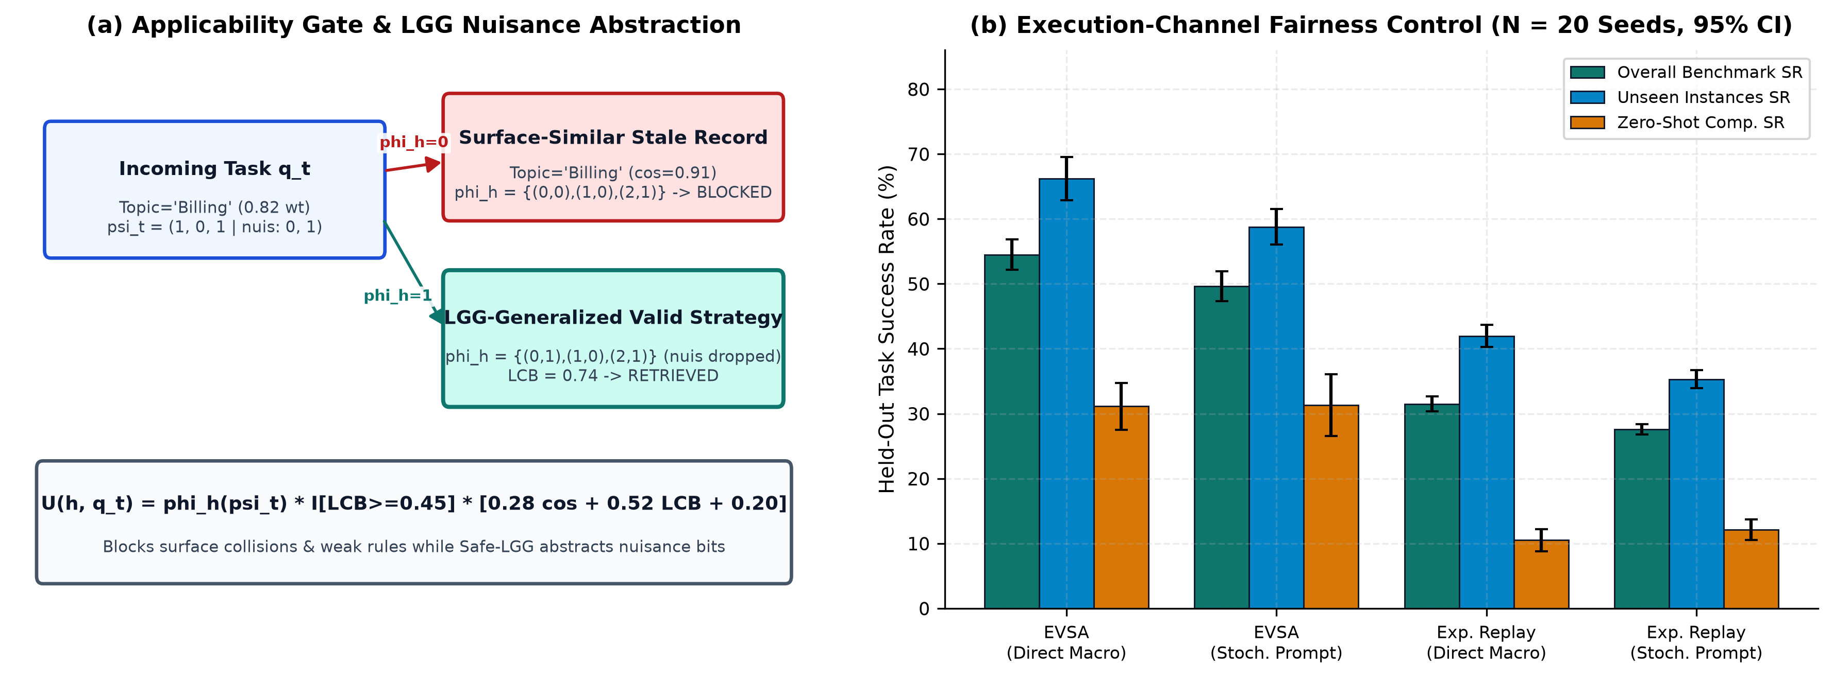
Figure 3: Applicability-Gated Retrieval and Execution-Channel Fairness Parity.
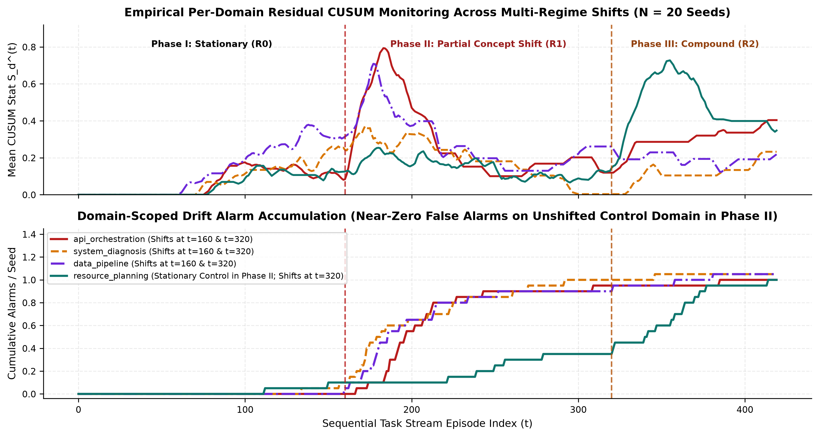
Figure 4: Empirical Per-Domain Residual CUSUM Monitoring Across Multi-Regime Shifts (N = 20 Seeds).

Benchmark Design: ShiftBench-Sim v1.0
• Domains and Heterogeneous Action Space: |D| = 4 operational domains (api_orchestration, system_diagnosis, data_pipeline, resource_planning). Each task requires planning an H=4-step discrete operator workflow π ∈ A_0 × A_1 × A_2 × A_3 with action cardinalities (4, 5, 4, 3) (240 distinct workflows per domain).
• Governing vs.\ Nuisance Preconditions: Each task exposes K=5 observable binary predicates ψ_t ∈ \0,1\^5. Bits (ψ_0, ψ_1, ψ_2) define C = 2^3 = 8 latent workflow archetypes c = 4ψ_0 + 2ψ_1 + ψ_2 ∈ \0,...,7\. Bits (ψ_3, ψ_4) are pure nuisance attributes that alter surface context without changing π^*. Archetypes c ∈ \0,...,6\ appear during stationary training; archetype c=7 (ψ_0=ψ_1=ψ_2=1) is held out strictly for zero-shot compositional testing, with Steps 0–2 governed additively by individual bits and Step 3 governed by a non-linear XOR parity interaction (ψ_0 ⊕ ψ_1).
• Controlled Surface-Embedding Collisions: Normalized synthetic task embeddings x_t ∈ R^20 (\|x_t\|_2=1) concatenate domain features (weight 0.50), noisy structural features (weight 0.36), and 8 shared surface-topic vectors (weight 0.82). Tasks sharing surface topics across conflicting archetypes therefore exhibit high cosine similarity, penalizing precondition-blind retrieval.
• Regime Shifts and Stochastic Outcome Probabilities: Regime r=0 defines baseline optimal workflows π^*_d,c,0. Regime r=1 (abrupt partial-domain concept shift) shifts Steps 1 and 2 by +2 ±od|A_s| across three domains while keeping resource_planning invariant (r=0) as an unshifted control. Regime r=2 (compound shift) shifts Step 0 and Step 2 across all four domains alongside covariate concentration onto c ∈ \4,5,6,7\. Executing 4, 3, 2, or ≤ 1 matching steps succeeds with probabilities (p_opt, p_sub3, p_sub2, p_sub1) = (0.92, 0.28, 0.09, 0.02).
• Hard Capability-Isolated Oracle Boundary: Beyond omitting oracle fields from TaskInstance, RolloutResult, and AgentEpisodeOutcome, all agent rollouts are routed through AgentEnvironmentInterface (src/ benchmark/ agent_ interface.py), a slot-restricted capability wrapper exposing solely evaluate_ plan( task,\ executed_ plan) while evaluator-side telemetry (EpisodeTelemetry) is finalized exclusively inside run_ audited_ episode (src/ evaluation/ audit.py). Passing a raw NonStationaryTaskEnvironment to any agent immediately raises TypeError, and CalibratedSymbolicLLMBackbone (src/ benchmark/ llm_ backbone.py) computes zero-shot step priors (0.67 marginal step competence) strictly from observable (d_t, ψ_t) using a linear inclusive-OR heuristic (ψ_0 ∨ ψ_1) on Step 3—verified programmatically by test_hard_ interface_ boundary_ separates_ agent_ from_ oracle and test_zero_ oracle_ leakage_ across_ all_ agent_ and_ backbone_ modules.

Experimental Methodology
• Experiment 1 (Unseen Task Generalization): Online adaptation on 240 stationary tasks (r=0, η=0, B=2, archetypes 0... 6), followed by frozen evaluation (learn=false, B=1) on 240 unseen tasks (160 unseen surface instances of c ∈ \0... 6\ and 80 zero-shot compositional tasks from held-out c=7).
• Experiment 2 (Continual Learning Without Resets): 320 sequential training episodes divided into 8 blocks of 40 tasks (r=0, η=0, B=2), probed (B=1) after every block (plus t=0) on an independent 96-task held-out suite.
• Experiment 3 (Multi-Regime Distribution Shift): 420-episode continuous stream (B=2, η=0): Phase I (t ∈ [0,160), stationary r=0), Phase II (t ∈ [160,320), abrupt concept shift r=1 in 3 domains while resource_planning remains stationary), and Phase III (t ∈ [320,420), compound shift r=2 across all 4 domains over c ∈ \4,5,6,7\).
• Experiment 4 (Misleading & Noisy Feedback Robustness): Across symmetric corruption rates η ∈ \0.10, 0.25, 0.35\, agents train for 200 noisy episodes followed by 100 clean episodes (η=0) to measure Rollout FAR, Candidate FPR, FRR, Active Validated Contamination (FDP), and Clean Recovery SR.
• Experiment 5 (Leave-One-Out Component Ablation): Evaluates Full EVSA against five single-module ablations on a 360-episode stream combining pre-shift noisy feedback (η=0.15, t ∈ [0,180)) with an abrupt 3-domain concept shift (r=1, η=0, t ∈ [180,360)) plus a 96-task unseen Regime-1 evaluation suite.
• Experiment 6 (Computational Efficiency & Projected Token Cost): Records local wall-clock CPU latency (time.perf_counter), memory footprint (KB), environment rollouts, and analytically projected token/API costs (modeled at 2.50 / 10.00 per 10^6 input/output tokens; 0.00 actual commercial API spend).

Baseline Implementations and Fairness Audit
• Baseline A: Static Agent (ReAct-style memoryless adaptation [yao2023react]): Zero cross-episode memory; samples workflows strictly from CalibratedSymbolicLLMBackbone within rollout budget B.
• Baseline B: Conventional Memory Agent (Generative-Agents-style episodic buffer [park2023generative]): Stores up to 400 episodic records scored by 0.55(x_t, x_i) + 0.20 0.993^ t + 0.25 r_i, conditioning generation on top-3 positive matches (weighted adherence ∈ [0.55, 0.96]).
• Baseline C: Reflection Agent (Reflexion-style sliding critique adaptation [shinn2023reflexion]): Maintains per-domain sliding buffers (10/domain) of step-failure avoidance constraints and successful workflows without multi-trial statistical gating or drift quarantine.
• Baseline D: Experience Replay Agent (CER/AWM-style distilled workflow buffer [liu2025cer,wang2025awm]): Retains successful (y_t=1) workflows (200 max, centroid-deduplicated at > 0.80), retrieving top-3 domain matches above > 0.25.
Audit of Execution-Channel Asymmetry and Controlled Parity Design. In default mode, once a strategy reaches VALIDATED, EVSA invokes π_h directly as a compiled deterministic macro, whereas Baselines B–D pass retrieved workflows through backbone.execute_guided_plan (weighted adherence ≤ 0.96). To prevent misattributing macro determinism to memory quality, we evaluate a full 2 × 2 execution-channel parity control (Direct Macro vs.\ Stochastic Prompt in both EVSA and Experience Replay) across N=20 seeds (Figure(fig:app_retrieval)b and Table(tab:fairness)).

Experimental Results
sec:results

Experiment 1: Unseen Task Generalization and Execution Parity
Table(tab:exp1) and Figure(fig:exp1) present held-out generalization across N=20 seeds (240 unseen tasks/seed, executing strictly VALIDATED strategies during frozen evaluation). EVSA achieves 54.50% ± 5.04% overall task success (95% CI [52.14%, 56.86%], median 53.75%, exact plan accuracy 45.40%), outperforming Static (26.48%, +105.82% relative, d_z = 4.51), Conventional Memory (29.62%, +83.97%, d_z = 4.47), Reflection (25.65%, +112.51%, d_z = 4.31), and Experience Replay (27.58%, +97.58%, d_z = 6.35), with all four Holm-Bonferroni adjusted paired t-test p-values ≤ 8.15 × 10^-14. Extending Experiment 1 to N=30 independent seeds confirms tight distributional stability: EVSA achieves 55.17% ± 5.62% (95% CI [53.07%, 57.27%]) versus 25.18%–29.12% across baselines.
Sub-Split Decomposition & Compositional Parity Ceiling: On unseen surface instances of seen archetypes (c ∈ \0,...,6\), Conventional Memory (37.81%) and Experience Replay (35.31%) modestly improve over Static (30.75%), whereas EVSA reaches 66.19% ± 7.11% by blocking surface-topic collisions and abstracting nuisance bits (ψ_3,ψ_4). On zero-shot compositional archetype c=7 (ψ_0=ψ_1=ψ_2=1)—where the non-oracle backbone's linear inclusive-OR heuristic predicts the wrong Step-3 operator—Conventional Memory (13.25%) and Experience Replay (12.12%) drop below Static (17.94%) due to surface collisions with seen archetypes. Because EVSA's precondition gate rejects colliding whole plans while its Hypothesis Generator composes validated step-level marginal operators across Steps 0, 1, and 2 (achieving 3-of-4 step alignment with p_sub3=0.28), EVSA reaches 31.13% ± 7.67% (+13.19 pp over Static, d_z = 1.57, p_Holm = 1.07 × 10^-6; +19.00 pp over Replay, d_z = 2.12, p_Holm = 4.87 × 10^-8), while remaining honestly bounded well below seen-archetype accuracy (66.19%) because first-order marginal salience cannot deduce the latent Step-3 XOR parity flip zero-shot.
Execution-Channel Fairness Control (Table(tab:fairness)): Restricting EVSA to execute VALIDATED plans through the exact same stochastic prompt-conditioning channel as Experience Replay yields 49.62% ± 4.98%, beating Replay (Stochastic Prompt) (27.58%) by +22.04 pp (d_z = 4.09, p_Holm = 1.57 × 10^-13). Conversely, granting deterministic macro execution to Experience Replay raises its unseen-instance accuracy (35.31% → 41.97%) but worsens zero-shot compositional accuracy (12.12% → 10.50%) by enforcing 100% obedience to colliding workflows, yielding 31.48% ± 2.45% overall (-23.02 pp below EVSA Direct Macro, d_z = 4.47, p_Holm = 6.41 × 10^-14). Thus ~ 82% of EVSA's +26.92 pp total advantage over Experience Replay stems purely from statistical validation and precondition gating, while ~ 18% (+4.88 pp) comes from deterministic macro compilation once validated.

Experiment 2: Continual Learning Without Resets
Across 320 continual training episodes (Figure(fig:exp2) and Table(tab:exp2)), all agents start at 29.27% pre-adaptation accuracy. After Block 1 (40 episodes), Conventional Memory (24.01%), Reflection (26.51%), and Experience Replay (25.00%) dip below their zero-shot starting point due to premature exploitation of sparse, colliding exemplars, whereas EVSA rises immediately to 32.86% (p_Holm ≤ 9.21 × 10^-4 vs.\ all four baselines) because unproven hypotheses remain confined to CANDIDATE. By Block 8 (t=320), EVSA reaches 65.21% ± 8.52% (+35.94 pp gain, +126.85% relative; d_z ∈ [3.00, 5.42], p_Holm ≤ 3.85 × 10^-11 vs.\ all baselines at 27.55%–35.68%), while retaining only 21.50 active validated strategies (compared to 143.65 retained workflows in Experience Replay and 399.4 episodic records in Conventional Memory). Stationary false CUSUM alarms average just 0.95 across all 320 episodes.

Experiment 3: Adaptation Under Multi-Regime Distribution Shift
Figure(fig:exp3) and Table(tab:exp3) track adaptation across Phase I (t ∈ [0,160), stationary), Phase II (t ∈ [160,320), 3-domain concept shift), and Phase III (t ∈ [320,420), 4-domain compound + covariate shift). Prior to t=160, EVSA reaches 81.75% streaming success (vs.\ 50.00%–54.62%). At the abrupt concept shift (t=160), EVSA drops transiently to 36.00% shock SR as pre-shift strategies fail, triggering per-domain residual CUSUM alarms within a mean delay of 38.40 global episodes (Figure(fig:drift)). Selectively quarantining failed routines and validating Regime-1 replacements lifts EVSA to 56.80% ± 8.76% recovered post-shift SR—an Adaptation Gain of +20.80 pp versus -1.90 to +4.70 pp across baselines (d_z ∈ [0.96, 1.36], p_Holm ≤ 4.08 × 10^-4), and reaches 34.88% under the Phase III compound shift (vs.\ 9.00%–17.00%).
Simultaneously, on the stationary control domain (resource_planning), EVSA preserves 82.21% ± 11.21% accuracy throughout Phase II (vs.\ 81.75% pre-shift; +24.72 to +31.07 pp above baselines, primary p_Holm ≤ 4.77 × 10^-5, paired-t p_t,Holm ≤ 8.16 × 10^-6), showing no measurable cross-domain degradation on unshifted tasks, whereas within alarmed shifted domains any unfalsified VALIDATED strategies conservatively undergo posterior discounting (γ_shift = 0.35) back to CANDIDATE until re-verified. We also report a subtle metric artifact on proportional Recovery Ratio (SR_rec / SR_pre): while EVSA (70.22%) significantly exceeds Static (52.30%, p_Holm=0.0017) and Reflection (53.93%, p_Holm=0.0076), its comparisons versus Conventional Memory (61.03%) and Experience Replay (58.55%) are not statistically significant (p_Holm = 0.0988) because those baselines divide stagnant post-shift scores (~ 31%–33%) by much lower pre-shift denominators (~ 54% vs.\ EVSA's 81.75%).

Experiment 4: Feedback Corruption and Safe-LGG Store Decomposition
Table(tab:exp4) and Figure(fig:exp4) evaluate robustness when η ∈ \0.10, 0.25, 0.35\ of environment outcomes are symmetrically inverted during t ∈ [0, 200) before clean feedback resumes (t ∈ [200, 300)). Unvalidated memory baselines accept 21.93%–38.71% of suboptimal rollouts, poisoning 58.70%–85.50% of their active memory and capping post-corruption clean recovery at 45.20%–52.30%. In contrast, EVSA restricts Rollout FAR to 1.34%, 1.76%, and 2.53%, significantly reduces active memory contamination across all three noise levels under per-family Holm adjustment (including η=0.35: 68.29% vs.\ 83.12%–85.50%, p_Holm = 0.0063; under simultaneous global 74-test primary pooling, η=0.35 vs.\ Replay and Reflection remain <0.05 while vs.\ Conventional Memory sits at the borderline p_Glob74 = 0.0510), and recovers rapidly to 84.10%, 77.30%, and 74.90% clean accuracy (d_z ∈ [2.45, 4.85], primary p_Holm ≤ 8.78 × 10^-5, paired-t p_t,Holm ≤ 1.95 × 10^-9).
• Rollout FAR vs.\ Candidate FPR: Dividing false promotions by all suboptimal rollouts gives 2.53%, whereas dividing by distinct suboptimal CANDIDATE hypotheses admitted gives Candidate FPR of 8.08%, 8.64%, and 11.32% across η ∈ \0.10, 0.25, 0.35\—closely tracking our nominal α_FA = 11% calibration target.
• Safe-LGG Suppression of Over-Generalization: Requiring one confirming trial whenever LGG broadens a VALIDATED rule bounds active LGG over-generalizations at t=200 to just 2.00, 0.75, and 1.15 strategies across η ∈ \0.10, 0.25, 0.35\.
• Base-Rate Shrinkage via High FRR: Under η=0.35, an optimal workflow (p_opt = 0.92) has apparent trial success p_obs = 0.92(0.65) + 0.08(0.35) = 0.626, driving False Rejection Rate (FRR) to 65.44% and shrinking clean active strategies from 8.15 (η=0.10) to 2.15 (alongside 3.95 3-for-3 corrupted flukes and 1.15 LGG contaminations out of 7.25 total). Once clean feedback resumes for 100 episodes, EVSA purges bad strategies and promotes clean replacements, cutting FDP more than 2× to 30.60% and restoring 74.90% accuracy.
Table 2: Experiment 1 — Held-out unseen benchmark generalization (N = 20 seeds, 240 tasks/seed).
Agent | Overall SR (%) | Exact Plan (%) | Unseen Inst. (%) | Zero-Shot c=7 (%) | Avg. Reward
Baseline A: Static | 26.48 ± 3.04 | 12.38 | 30.75 | 17.94 | 0.386
Baseline B: Conventional Memory | 29.62 ± 2.77 | 19.60 | 37.81 | 13.25 | 0.410
Baseline C: Reflection | 25.65 ± 3.61 | 13.56 | 29.81 | 17.31 | 0.377
Baseline D: Experience Replay | 27.58 ± 1.74 | 15.69 | 35.31 | 12.12 | 0.389
Proposed Agent E: EVSA | 54.50 ± 5.04 | 45.40 | 66.19 | 31.13 | 0.646
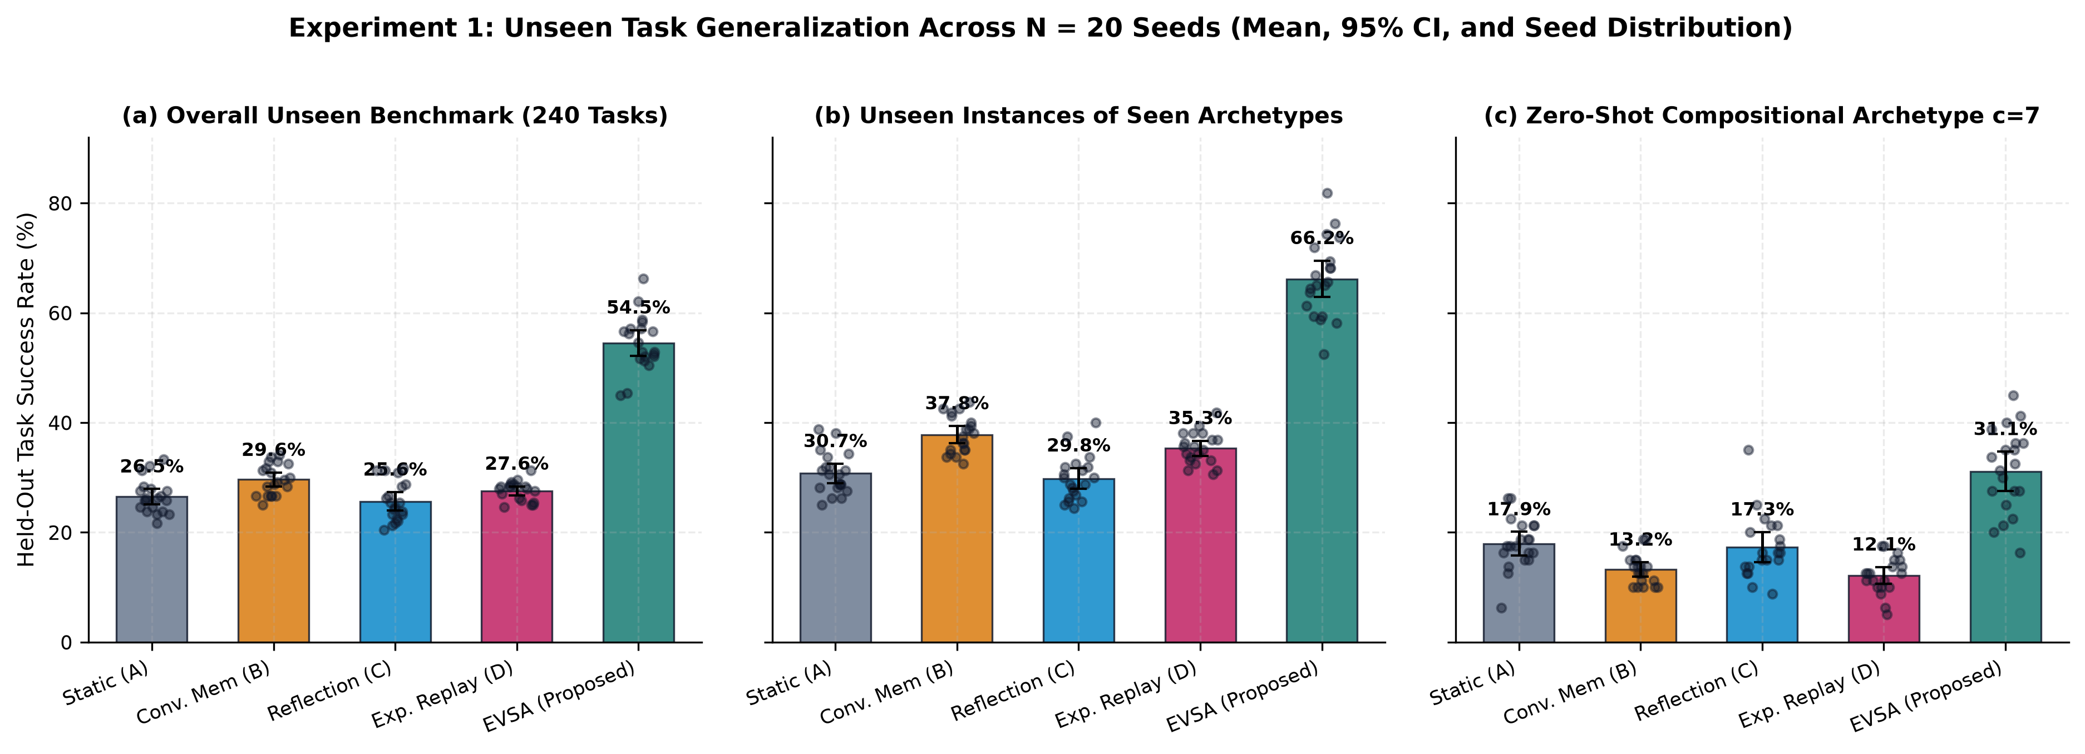
Figure 5: Experiment 1 Unseen Generalization Across Splits (N = 20 Seeds).
Table 3: Execution-Channel Fairness Parity Control on Experiment 1 (N = 20 seeds).
Controlled Variant | Overall SR (%) | Unseen Inst. (%) | Zero-Shot Comp. (%)
EVSA (Direct Macro Exec) | 54.50 ± 5.04 | 66.19 | 31.13
EVSA (Stochastic Prompt Exec) | 49.62 ± 4.98 | 58.78 | 31.31
Replay (Stochastic Prompt Exec) | 27.58 ± 1.74 | 35.31 | 12.12
Replay (Direct Macro Exec) | 31.48 ± 2.45 | 41.97 | 10.50
Table 4: Experiment 2 — Continual learning trajectory across 320 episodes (N = 20 seeds).
Agent | Init SR (%) | Block 1 SR (%) | Final Block 8 (%) | Abs. Gain (pp) | Retained | Rejected
Baseline A: Static | 29.27 | 29.22 | 28.23 ± 4.10 | -1.04 | 0.00 | 0.00
Baseline B: Conventional Memory | 29.27 | 24.01 | 35.68 ± 5.47 | +6.41 | 125.15 | 274.85
Baseline C: Reflection | 29.27 | 26.51 | 27.55 ± 6.25 | -1.72 | 155.15 | 26.85
Baseline D: Experience Replay | 29.27 | 25.00 | 32.29 ± 4.06 | +3.02 | 143.65 | 381.80
Proposed Agent E: EVSA | 29.27 | 32.86 | 65.21 ± 8.52 | +35.94 | 21.50 | 23.20
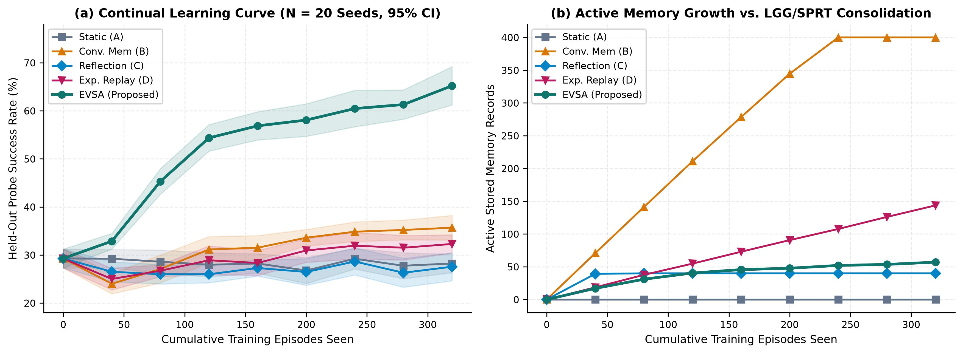
Figure 6: Experiment 2 Continual Learning and Strategy Consolidation (N = 20 Seeds).
Table 5: Experiment 3 — Multi-regime distribution shift adaptation and selective retention (N = 20 seeds).
Agent | Pre-Shift (%) | Shock (%) | Recovered (%) | Adapt. Gain (pp) | Unshifted Dom. (%) | Phase III Unseen (%)
Baseline A: Static | 50.00 | 23.20 | 25.40 ± 6.99 | +2.20 | 51.51 | 7.64
Baseline B: Conventional Memory | 54.62 | 28.20 | 32.90 ± 7.12 | +4.70 | 57.49 | 11.02
Baseline C: Reflection | 51.12 | 29.00 | 27.10 ± 7.15 | -1.90 | 51.13 | 12.39
Baseline D: Experience Replay | 54.25 | 27.40 | 30.80 ± 7.55 | +3.40 | 56.40 | 10.52
Proposed Agent E: EVSA | 81.75 | 36.00 | 56.80 ± 8.76 | +20.80 | 82.21 | 13.22
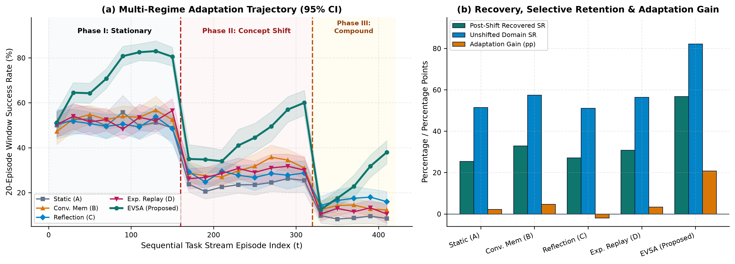
Figure 7: Experiment 3 Multi-Regime Shift Trajectory and Selective Retention (N = 20 Seeds).
Table 6: Experiment 4 — Misleading feedback calibration, store decomposition, and clean recovery (N = 20 seeds).
Noise η | Agent | Rollout FAR (%) | Cand. FPR (%) | FRR (%) | Noisy FDP (%) | Post-Clean FDP (%) | Clean Rec. (%)
0.10 | Baseline B: Conventional Memory | 21.99 | 21.99 | 16.35 | 58.70 | 52.03 | 51.20 ± 8.09
0.10 | Baseline C: Reflection | 22.44 | 22.44 | 15.52 | 73.08 | 65.82 | 47.50 ± 7.56
0.10 | Baseline D: Experience Replay | 21.93 | 21.93 | 16.65 | 61.27 | 57.50 | 52.30 ± 9.11
0.10 | Proposed Agent E: EVSA | 1.34 | 8.08 | 44.11 | 35.46 | 21.79 | 84.10 ± 5.64
0.25 | Baseline B: Conventional Memory | 32.81 | 32.81 | 30.82 | 76.35 | 65.10 | 49.90 ± 6.50
0.25 | Baseline C: Reflection | 32.56 | 32.56 | 30.75 | 82.94 | 65.17 | 48.60 ± 7.26
0.25 | Baseline D: Experience Replay | 31.34 | 31.34 | 31.12 | 77.65 | 70.51 | 47.10 ± 6.97
0.25 | Proposed Agent E: EVSA | 1.76 | 8.64 | 59.01 | 46.36 | 24.40 | 77.30 ± 10.04
0.35 | Baseline B: Conventional Memory | 38.71 | 38.71 | 35.53 | 83.12 | 70.75 | 47.60 ± 8.77
0.35 | Baseline C: Reflection | 37.87 | 37.87 | 38.93 | 85.50 | 71.09 | 49.40 ± 7.92
0.35 | Baseline D: Experience Replay | 37.00 | 37.00 | 38.94 | 83.49 | 75.83 | 45.20 ± 7.66
0.35 | Proposed Agent E: EVSA | 2.53 | 11.32 | 65.44 | 68.29 | 30.60 | 74.90 ± 5.56
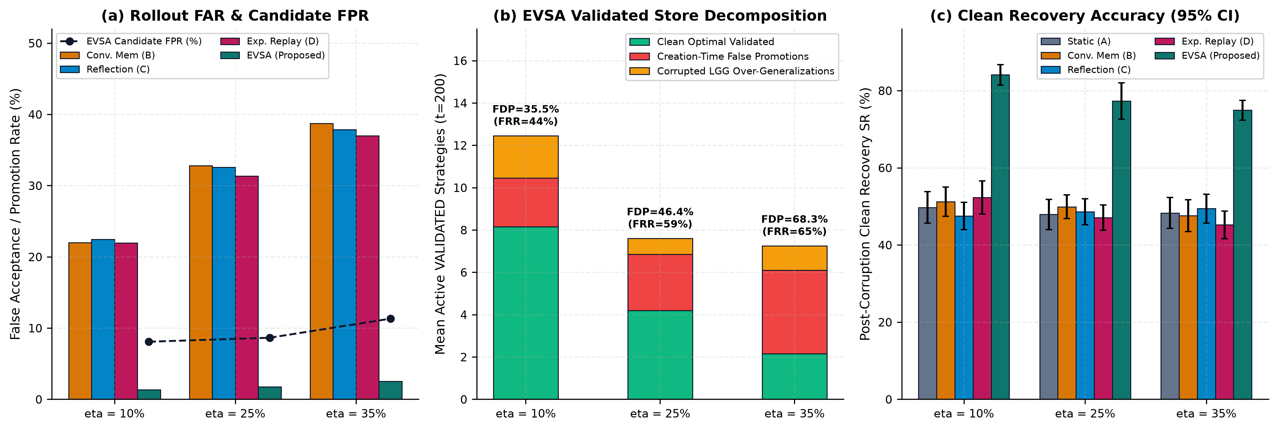
Figure 8: Experiment 4 Feedback Corruption Calibration and Store Decomposition (N = 20 Seeds).

Statistical Analysis, Power, and Multiplicity Sensitivity
sec:stats
All comparative claims are evaluated across N=20 paired random seeds using two-sided paired Student's t-tests alongside exact non-parametric Wilcoxon signed-rank tests (src/evaluation/metrics_and_stats.py). Normality of paired seed differences d_i = x_i - y_i is audited via the Shapiro-Wilk test (W); whenever p_Shapiro < 0.05, the Wilcoxon signed-rank test serves as the primary decision test. Standardized effect sizes are reported via paired Cohen's d_z = d/s_d, bias-corrected Hedges' g_z, and rank-biserial correlation r_rb.
Power Analysis (N=20 Paired Seeds). Evaluating the exact non-central t_19 distribution at two-sided α=0.05 yields a Minimum Detectable Effect Size (MDES) of d_z = 0.660 for 80% statistical power and d_z = 0.765 for 90% power. All primary comparisons against baselines in Experiments 1–4 exhibit |d_z| ∈ [0.74, 6.35] (achieved power 0.88 to 1.000), confirming high power for main effects while explaining why subtle ratio or short-horizon ablation differences (|d_z| ≤ 0.47) are appropriately classified as non-significant.
Primary Hypothesis Selection, 19 Families, and Direct Global-74 Sensitivity Audit. For each paired comparison j ∈ \1,...,74\, the pre-specified primary test and raw p-value (primary_ pvalue_ raw) are selected before multiplicity adjustment (p_Shapiro < 0.05 exact Wilcoxon signed-rank [8 tests]; p_Shapiro ≥ 0.05 paired t-test [66 tests]). Within each of the 19 pre-defined metric-specific families, apply_ holm_ bonferroni applies Holm's step-down procedure [holm1979simple] directly once to that family's selected raw primary p-values (primary_ pvalue_ holm). Across the study-wide Global-74 family, apply_ global_ holm_ bonferroni likewise applies Holm's procedure once directly to the 74 selected primary_ pvalue_ raw values (primary_ pvalue_ holm_ global74)—rather than splicing separately adjusted parametric and non-parametric vectors—while also exporting two clearly labelled pure-test sensitivity families (sensitivity_ t_ pvalue_ holm_ global74 across all 74 paired t-tests and sensitivity_ wilcoxon_ pvalue_ holm_ global74 across all 74 Wilcoxon tests) to bracket any normality-pretest conditioning effect: 62 of 74 tests are significant at α=0.05 under per-family primary Holm adjustment, and 60 of 74 tests remain significant under both direct Global-74 primary pooling and the pure-parametric Global-74 t-test sensitivity family (57/74 under the pure-Wilcoxon Global-74 sensitivity family due to N=20 discrete rank flooring). Table(tab:stats) reports representative comparisons including both Global-74 borderlines.
Table 7: Selected paired statistical tests (N = 20 seeds) with direct per-family primary Holm, direct Global-74 primary Holm, and labelled pure-test Global-74 sensitivity p-values.
Family | Comparator | Primary Test | Cohen's dz | Per-Fam p_Holm | Glob-74 p_Holm | Sens. t_Glob74 | Sens. W_Glob74 | Decision (Fam / Glob74)
RQ1_Common_Benchmark_SR | Baseline B: Conventional Memory | Paired t-test | +4.47 | 8.146e-14 | 2.242e-12 | 2.178e-12 | 5.541e-03 | Sig. / Sig.
RQ1_Unseen_Compositional_SR | Baseline D: Experience Replay | Paired t-test | +2.12 | 4.873e-08 | 4.995e-07 | 4.629e-07 | 5.541e-03 | Sig. / Sig.
RQ1_Unseen_Compositional_SR | Baseline A: Static | Paired t-test | +1.57 | 1.073e-06 | 3.756e-05 | 3.219e-05 | 5.541e-03 | Sig. / Sig.
Fairness_Execution_Parity | Replay (Stochastic Prompt Exec) | Paired t-test | +4.09 | 1.575e-13 | 1.024e-11 | 9.920e-12 | 5.541e-03 | Sig. / Sig.
Fairness_Execution_Parity | Replay (Direct Macro Exec) | Paired t-test | +4.47 | 6.406e-14 | 2.242e-12 | 2.178e-12 | 5.541e-03 | Sig. / Sig.
RQ2_Final_Episode_SR | Baseline B: Conventional Memory | Paired t-test | +3.00 | 3.847e-11 | 2.154e-09 | 2.077e-09 | 5.541e-03 | Sig. / Sig.
RQ4_Adaptation_Gain | Baseline B: Conventional Memory | Paired t-test | +0.96 | 4.083e-04 | 8.575e-03 | 8.575e-03 | 2.996e-02 | Sig. / Sig.
RQ4_Recovery_Rate_Pct | Baseline B: Conventional Memory | Paired t-test | +0.41 | 9.881e-02 | 8.149e-01 | 8.149e-01 | 4.846e-01 | Non-Sig. / Non-Sig.
RQ6_Contamination_eta_0.35 | Baseline D: Experience Replay | Paired t-test | -0.76 | 6.272e-03 | 4.695e-02 | 4.695e-02 | 5.360e-02 | Sig. / Sig.
RQ6_Contamination_eta_0.35 | Baseline B: Conventional Memory | Paired t-test | -0.74 | 6.272e-03 | 5.097e-02 | 5.097e-02 | 7.428e-02 | Sig. / Non-Sig.
RQ6_PostCleanRecovery_eta_0.35 | Baseline C: Reflection | Paired t-test | +2.55 | 1.675e-09 | 3.026e-08 | 2.841e-08 | 5.541e-03 | Sig. / Sig.
RQ3_Ablation_Overall_SR | w/o Applicability Conditions | Wilcoxon signed-rank | +4.80 | 4.422e-04 | 2.189e-03 | 6.182e-13 | 5.541e-03 | Sig. / Sig.
RQ3_Ablation_PostShift_SR | w/o Shift Detection | Paired t-test | +0.88 | 3.696e-03 | 1.749e-02 | 1.749e-02 | 2.996e-02 | Sig. / Sig.
RQ3_Ablation_Overall_SR | w/o Shift Detection | Paired t-test | +0.62 | 4.639e-02 | 1.508e-01 | 1.508e-01 | 6.793e-02 | Sig. / Non-Sig.
RQ3_Ablation_Overall_SR | w/o Evidence Validation | Paired t-test | -0.28 | 6.838e-01 | 1.000e+00 | 1.000e+00 | 1.000e+00 | Non-Sig. / Non-Sig.
RQ3_Ablation_Overall_SR | w/o Confidence Estimation | Paired t-test | +0.23 | 6.838e-01 | 1.000e+00 | 1.000e+00 | 1.000e+00 | Non-Sig. / Non-Sig.

Ablation Studies
• w/o Applicability Conditions (ϕ_h(ψ_t) 1): Causes catastrophic collapse—overall stream SR plunges by -24.75 pp (53.81% → 29.06%, d_z = 4.80, primary Wilcoxon p_Holm = 4.42 × 10^-4, paired-t p_t,Holm = 4.35 × 10^-14), post-shift SR falls -31.42 pp (58.58% → 27.17%), and pre-shift active FDP hits 90.00% as precondition-blind rules collide across archetypes.
• w/o Shift Detection (CUSUM disabled): Eliminating online residual CUSUM monitoring degrades post-shift recovered SR by -8.92 pp (58.58% → 49.67%, d_z = 0.88, p_Holm = 0.0037, p_Glob74 = 0.0175) and overall stream SR by -2.25 pp (53.81% → 51.56%, p_Holm = 0.0464 per-family; p_Glob74 = 0.1508 under simultaneous 74-test pooling because the stationary first half is identical across both variants), while raising post-shift active contamination from 41.89% to 53.55%.
• Sample-Complexity vs.\ Epistemic-Purity Trade-Off (w/o Evidence Validation): In a short 6.4-visit-per-cell regime where frozen evaluation executes strictly VALIDATED rules, 1-trial promotion inflates the validated repository 4.8× (42.55 vs.\ 8.95 strategies) and more than doubles pre-shift active contamination (70.56% vs.\ 33.18%) and post-shift contamination (69.22% vs.\ 41.89%), while achieving a non-significantly higher raw coverage score (55.51% vs.\ 53.81%, = +1.71 pp, p_Holm = 0.684). Thus n_=3 SPRT + Safe LGG trades slower initial coverage in sparse-visit regimes for a >2× reduction in false discoveries that becomes decisive under sustained corruption (Experiment 4).
• w/o Confidence Estimation (raw empirical frequency p_h^emp replacing Beta credible quantiles): Removing small-sample Bayesian credible intervals reduces noisy pre-shift SR by -1.67 pp (68.58% → 66.92%) and shrinks promoted strategies from 8.95 to 6.25 due to premature candidate rejection on unlucky early misses, though overall stream SR difference (-0.75 pp, 53.06% vs.\ 53.81%) is non-significant (p_Holm=0.684) when SPRT and preconditions remain active.
• w/o Memory Invalidation (quarantine disabled while retaining CUSUM statistics): Overall SR changes minimally (53.08% vs.\ 53.81%, p_Holm=0.684), but post-shift active store contamination surges from 41.89% to 63.29% (18.20 unpurged validated rules) because stale Regime-0 hypotheses accumulate permanently without tombstone quarantine.
Table 8: Experiment 5 — Leave-one-out component ablation study (N = 20 seeds).
Variant | Overall Stream (%) | Post-Shift Rec. (%) | Held-Out Unseen (%) | Pre-Shift FDP (%) | Post-Shift FDP (%)
EVSA (Full) | 53.81 ± 4.66 | 58.58 ± 7.67 | 37.86 ± 9.01 | 33.18 | 41.89
w/o Evidence Validation | 55.51 ± 3.98 | 62.50 ± 8.17 | 43.28 ± 8.76 | 70.56 | 69.22
w/o Confidence Estimation | 53.06 ± 3.71 | 59.33 ± 6.13 | 40.94 ± 8.17 | 33.11 | 29.16
w/o Applicability Conditions | 29.06 ± 2.28 | 27.17 ± 5.46 | 15.05 ± 3.77 | 90.00 | 60.00
w/o Shift Detection | 51.56 ± 3.79 | 49.67 ± 9.25 | 33.02 ± 8.20 | 32.53 | 53.55
w/o Memory Invalidation | 53.08 ± 3.44 | 56.50 ± 7.57 | 38.33 ± 8.81 | 34.19 | 63.29
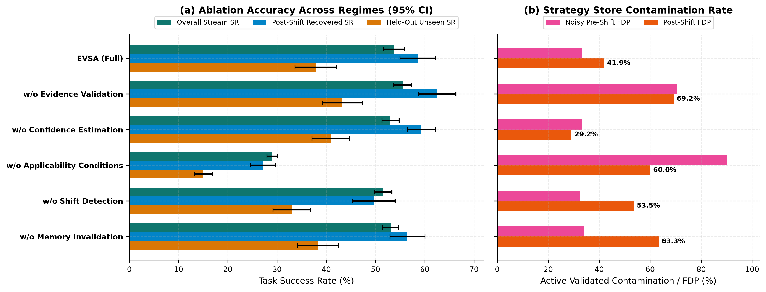
Figure 9: Experiment 5 Leave-One-Out Component Ablation (N = 20 Seeds).

Computational Efficiency and Projected Token Economics
• Local CPU Bookkeeping Latency: EVSA averages 0.621 ± 0.065 ms/task (403.45 ms total wall time across 480 training+eval tasks) versus 0.131 ms/task for memoryless Static, 0.250 ms/task for Experience Replay, and 0.404 ms/task for Conventional Memory. In real LLM or tool-execution pipelines (200–2,000 ms/call), <0.65 ms of Beta/SPRT/CUSUM bookkeeping adds <0.35% wall-clock latency.
• Memory Footprint & Environment Rollouts: Because Safe LGG consolidates nuisance instances and SPRT rejects flukes, EVSA consumes 13.14 KB of persistent memory (8.1× smaller than Conventional Memory's 106.09 KB and 2.3× smaller than Replay's 29.87 KB) and solves the 480 episodes using 590.5 total environment rollouts—saving ≈ 55–61 rollouts compared to baselines (645.3–651.4).
• Projected Token Efficiency: Under our serialized prompt-accounting ledger, EVSA requires an estimated 46,758 tokens (0.213 projected cost—lowest among all five agents), achieving 0.117 held-out SR points per 10k estimated tokens (1.83× Static and 4.68× Reflection).
Table 9: Experiment 6 — Directly measured local CPU/memory efficiency vs. projected token economics (N = 20 seeds).
Agent | Eval SR (%) | CPU (ms/task) | Rollouts | Memory (KB) | Est. Tokens* | Est. USD* | SR/10k Tok*
Baseline A: Static | 26.48 | 0.131 ± 0.011 | 647.8 | 0.00 | 41120 | $0.218 | 0.064
Baseline B: Conventional Memory | 29.62 | 0.404 ± 0.119 | 645.3 | 106.09 | 52865 | $0.247 | 0.056
Baseline C: Reflection | 25.65 | 0.219 ± 0.051 | 651.4 | 10.62 | 103686 | $0.464 | 0.025
Baseline D: Experience Replay | 27.58 | 0.250 ± 0.030 | 648.3 | 29.87 | 57710 | $0.271 | 0.048
Proposed Agent E: EVSA | 54.50 | 0.621 ± 0.065 | 590.5 | 13.14 | 46758 | $0.213 | 0.117
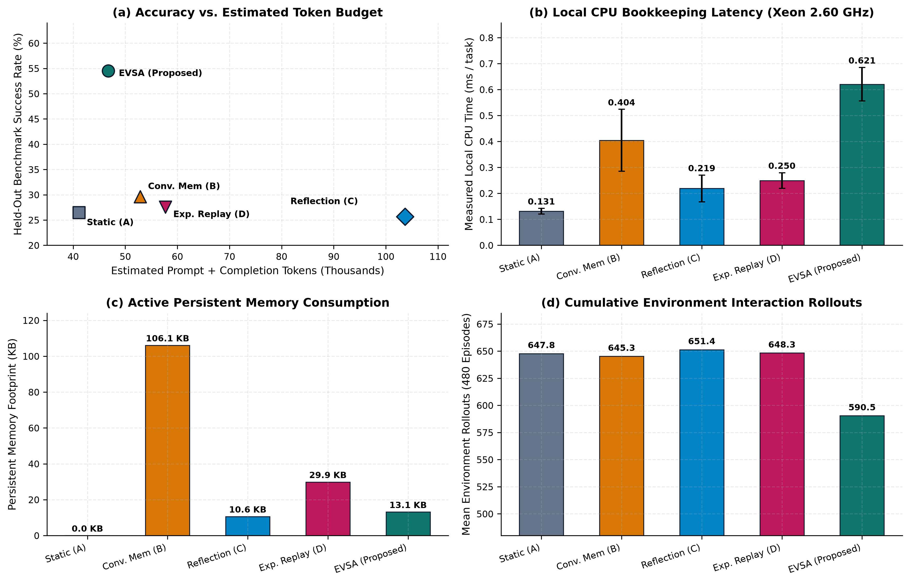
Figure 10: Experiment 6 Computational Efficiency and Resource Footprint (N = 20 Seeds).

Discussion
Why Unvalidated Experiential Memory Causes Negative Transfer. Experiments 1–4 demonstrate empirically that storing past trajectories without precondition gating or statistical validation frequently degrades accuracy below memoryless zero-shot reasoning (12.12%–17.31% vs.\ 17.94% on c=7 in Exp 1; 24.01%–26.51% vs.\ 29.27% in Exp 2 Block 1). Consistent with the “experience-following” bias documented in LLM agents by Xiong et al.\ [xiong2026memory], surface-retrieved exemplars override exploratory reasoning whenever surface topics collide across distinct latent constraints.
Separating Epistemic Selection from Procedural Compilation. Our Execution-Channel Fairness Parity experiment (Table(tab:fairness)) provides a controlled two-factor attribution: ~ 82% (+22.04 pp) of EVSA's gain over Experience Replay comes from selecting statistically verified, precondition-compatible strategies, while ~ 18% (+4.88 pp) comes from deterministic macro compilation. Crucially, deterministic execution hurts zero-shot compositional tasks when paired with unvalidated retrieval (Replay Direct Macro drops to 10.50%), showing that rigid procedural compilation is beneficial only after epistemic validation and applicability gating.
Sample-Complexity vs.\ Epistemic-Purity Trade-Offs. Comparing Experiments 2, 4, and 5 reveals a fundamental statistical trade-off: requiring n_=3 verification trials plus a confirming re-validation trial upon LGG precondition broadening means each domain-archetype invariant needs ≈ 4–5 encounters to reach full generalized VALIDATED coverage. In sparse-visit horizons (≈ 6.4 visits/cell in Exp 5), 1-trial promotion achieves comparable raw stream coverage only by accepting a 70.56% false-discovery rate (42.55 bloated rules); under sustained continual learning (Exp 2) or persistent evaluator corruption (Exp 4), EVSA's conservative gating prevents runaway store poisoning and enables rapid +25.5 to +36.6 pp post-corruption recovery.

Limitations and Threats to Validity
• External Validity (Synthetic Symbolic Simulation vs.\ Live Frontier LLMs): All experiments use ShiftBench-Sim v1.0—a low-dimensional synthetic symbolic-procedural simulation (4-step discrete operator workflows, 20-dimensional synthetic embeddings, and a heuristic CalibratedSymbolicLLMBackbone)—rather than live autoregressive neural LLM APIs over natural language or source code. Real LLM trajectories involve free-form code/text generation, prompt-length degradation, and mid-episode replanning not captured by discrete 4-step workflows. Token and USD figures in Table(tab:exp6) are analytical projections, not live billing logs.
• Construct Validity (Observable Binary Preconditions ψ_t): ShiftBench-Sim v1.0 supplies clean 5-bit binary state descriptors ψ_t, enabling exact conjunctive matching and Safe LGG. In unstructured natural-language benchmarks (WebArena, SWE-bench), preconditions must be induced via learned classifiers, programmatic assertions, or LLM-synthesized predicates whose extraction errors could weaken ϕ_h(ψ_t) gating.
• Mathematical Validity (Heuristic Sequential Boundaries): Discounting (γ < 1), clipping, n_=3, Safe-LGG clamping, and adaptive Bayes-UCB selection invalidate classical Wald SPRT analytical error bounds. While empirical Candidate FPR (8.08%–11.32%) closely tracks nominal α_FA=11% on ShiftBench-Sim, formal finite-sample error control requires anytime-valid e-processes [ramdas2023game].
• Non-Additive Parity Ceiling, Post-Shift Discounting & Horizon Sparsity: First-order step-predicate salience lifts zero-shot accuracy on c=7 to 31.13% via Steps 0–2 composition but cannot infer the non-linear Step-3 XOR rule (ψ_0 ⊕ ψ_1) zero-shot; unfalsified rules inside alarmed shifted domains undergo conservative γ_shift=0.35 discounting to CANDIDATE; and n_=3 gating delays coverage in ultra-short per-cell horizons (<6 visits/archetype).

Conclusion and Future Work
This study demonstrated that experiential memory in autonomous agents requires explicit statistical hygiene to remain reliable under distribution shift and noisy evaluator feedback. Through Evidence-Validated Strategy Adaptation (EVSA), we unified sequential log-odds validation, discounted Bayesian lower credible bounds, re-verified Safe LGG precondition gating, and domain-scoped residual CUSUM drift invalidation inside a capability-isolated architecture. Across >360,000 deterministic simulated episodes in ShiftBench-Sim v1.0, EVSA substantially improves unseen generalization (54.50%), continual learning (65.21%), selective post-shift adaptation (+20.80 pp gain with 82.21% stationary-domain retention), and post-corruption recovery (74.90%–84.10%), while our controlled parity, ablation, multiplicity, and contamination-decomposition audits isolate both its primary algorithmic drivers and its operational boundaries.
Future Research Directions (Distinct from Completed Work). Four concrete extensions remain open for future investigation: (1) integrating EVSA's three-tier statistical controller with live open-weights and frontier LLM agents on SWE-bench and WebArena; (2) replacing discounted Wald heuristics with exact non-asymptotic e-processes and test martingales [howard2021time,ramdas2023game] under adaptive bandit stopping; (3) learning Minimum-Description-Length (MDL) programmatic preconditions directly from unstructured tool traces; and (4) evaluating resilience against adaptive adversarial memory-poisoning attacks [chen2024agentpoison,zou2025poisonedrag].

Reproducibility, Data Availability, and Research Governance
Code, Raw Data, and Cross-Platform Reproduction. The complete modular codebase (https://github.com/Devparth7-coder/EVSA-Research-Paper; source modules in src/, manuscript source in paper/ research_ paper.tex, 16-test cross-platform, attribution, boundary, and statistical-ledger suite in tests/ test_ evsa_ suite.py, raw seed-level CSV logs in experiments/ raw/, 74-test per-family and Global-74 statistical ledger in experiments/ statistical_ analysis/, seven authoritative phase dossiers in docs/, and pinned dependencies in requirements.txt) is distributed at release v2.0.2 under the MIT License. Executing pytest -v on tests/ test_ evsa_ suite.py and running python experiments/ run_ complete_ suite.py on Linux, Windows, or macOS regenerates all behavioral metrics and statistical ledgers bit-for-bit across primary seeds 1001..1020 and stability seeds 1001..1030.
Timeline Provenance Statement. While the conceptual research progression is organized into seven logical research phases (documented in TIMELINE.md and docs/PHASE_1_*.md–PHASE_7_*.md), archival transparency requires noting that the public repository history began on 7 November 2026 and was finalized through release v2.0.2 on 9 November 2026 without fabricated or backdated historical commits; all audited code modules, raw experimental datasets, statistical tests, and compiled manuscripts in this release were executed and verified from a clean clone (experiments/experiment_manifest.json).
Independent Authorship and AI-Assistance Disclosure. This research was conducted independently by Dev Parth (Independent Researcher, Independent Research in Artificial Intelligence), without institutional affiliation, external grant funding, or third-party human-subjects data. In accordance with publication transparency standards, the author discloses that AI-assisted software engineering and editorial tooling were used to refactor modular Python simulation packages, automate statistical verification scripts, format publication figures/typesetting, and cross-audit mathematical derivations; all experimental protocols, code logic, numerical outputs, and bibliographic citations were programmatically executed and verified directly against workspace artifacts.

References
[1] (yao2023react) Yao, Shunyu and Zhao, Jeffrey and Yu, Dian and Du, Nan and Shafran, Izhak and Narasimhan, Karthik and Cao, Yuan (2023). “ReAct.” International Conference on Learning Representations (ICLR). https://arxiv.org/abs/2210.03629
[2] (shinn2023reflexion) Shinn, Noah and Cassano, Federico and Gopinath, Ashwin and Narasimhan, Karthik and Yao, Shunyu (2023). “Reflexion: Language Agents with Verbal Reinforcement Learning.” Advances in Neural Information Processing Systems (NeurIPS). https://arxiv.org/abs/2303.11366
[3] (wang2024voyager) Wang, Guanzhi and Xie, Yuqi and Jiang, Yunfan and Mandlekar, Ajay and Xiao, Chaowei and Zhu, Yuke and Fan, Linxi and Anandkumar, Anima (2024). “Voyager: An Open-Ended Embodied Agent with Large Language Models.” Transactions on Machine Learning Research (TMLR). https://arxiv.org/abs/2305.16291
[4] (park2023generative) Park, Joon Sung and O'Brien, Joseph C. and Cai, Carrie J. and Morris, Meredith Ringel and Liang, Percy and Bernstein, Michael S. (2023). “Generative Agents: Interactive Simulacra of Human Behavior.” Proceedings of the 36th Annual ACM Symposium on User Interface Software and Technology (UIST). 10.1145/3586183.3606763
[5] (packer2023memgpt) Packer, Charles and Wooders, Sarah and Lin, Kevin and Fang, Vivian and Patil, Shishir G. and Stoica, Ion and Gonzalez, Joseph E. (2023). “MemGPT.” arXiv preprint arXiv:2310.08560. https://arxiv.org/abs/2310.08560
[6] (zhao2024expel) Zhao, Andrew and Huang, Daniel and Xu, Quentin and Lin, Matthieu and Liu, Yong-Jin and Huang, Gao (2024). “ExpeL.” Proceedings of the AAAI Conference on Artificial Intelligence. 10.1609/aaai.v38i17.29936
[7] (majumder2024clin) Majumder, Bodhisattwa Prasad and Mishra, Bhavana Dalvi and Jansen, Peter and Tafjord, Oyvind and Tandon, Niket and Zhang, Li and Callison-Burch, Chris and Clark, Peter (2024). “CLIN.” First Conference on Language Modeling (COLM). https://arxiv.org/abs/2310.10134
[8] (wang2025awm) Wang, Zora Zhiruo and Mao, Jiayuan and Fried, Daniel and Neubig, Graham (2025). “Agent Workflow Memory.” Proceedings of the 42nd International Conference on Machine Learning (ICML). https://proceedings.mlr.press/v267/wang25co.html
[9] (xu2025amem) Xu, Wujiang and Liang, Zujie and Mei, Kai and Gao, Hang and Tan, Juntao and Zhang, Yongfeng (2025). “A-MEM.” Advances in Neural Information Processing Systems (NeurIPS). 10.52202/085713-0593
[10] (suzgun2026dynamic) Suzgun, Mirac and Yuksekgonul, Mert and Bianchi, Federico and Jurafsky, Dan and Zou, James (2026). “Dynamic Cheatsheet: Test-Time Learning with Adaptive Memory.” Proceedings of the 19th Conference of the European Chapter of the Association for Computational Linguistics (Volume 1: Long Papers). 10.18653/v1/2026.eacl-long.333
[11] (liu2025cer) Liu, Yitao and Liang, Chen and Zhou, Denny and Schuurmans, Dale and Dai, Hanjun (2025). “Contextual Experience Replay for Self-Improvement of Language Agents.” Proceedings of the 63rd Annual Meeting of the Association for Computational Linguistics (Volume 1: Long Papers). 10.18653/v1/2025.acl-long.694
[12] (ouyang2026reasoningbank) Ouyang, Siru and Yan, Jun and Hsu, I-Hung and Chen, Yanfei and Jiang, Ke and Wang, Zifeng and Han, Rujun and Le, Long T. and Daruki, Samira and Tang, Xiangru and Tirumalashetty, Vishy and Lee, George and Rofouei, Mahsan and Lin, Hangfei and Han, Jiawei and Lee, Chen-Yu and Pfister, Tomas (2026). “ReasoningBank.” The Fourteenth International Conference on Learning Representations (ICLR). 10.48550/arXiv.2509.25140
[13] (zhang2026adamem) Zhang, Yunxiang and Li, Yiheng and Payani, Ali and Wang, Lu (2026). “AdaMEM.” Proceedings of the 43rd International Conference on Machine Learning (ICML). 10.48550/arXiv.2606.05684
[14] (xiong2026memory) Xiong, Zidi and Lin, Yuping and Xie, Wenya and He, Pengfei and Tang, Jiliang and Lakkaraju, Himabindu and Xiang, Zhen (2026). “How Memory Management Impacts LLM.” Proceedings of the 64th Annual Meeting of the Association for Computational Linguistics (Volume 1: Long Papers). 10.18653/v1/2026.acl-long.27
[15] (jin2026exprl) Jin, Zhuoran and Wang, Lingshuai and Hao, Yupu and Men, Tianyi and He, Zhitao and Zeng, Daojian and Liu, Kang and Zhao, Jun (2026). “Reasoning-Driven Experience Selection for LLM.” Findings of the Association for Computational Linguistics: EMNLP 2026. https://aclanthology.org/2026.findings-emnlp.1666/
[16] (chen2024agentpoison) Chen, Zhaorun and Xiang, Zhen and Xiao, Chaowei and Song, Dawn and Li, Bo (2024). “AgentPoison.” Advances in Neural Information Processing Systems (NeurIPS). 10.52202/079017-4136
[17] (zou2025poisonedrag) Zou, Wei and Geng, Runpeng and Wang, Binghui and Jia, Jinyuan (2025). “PoisonedRAG.” 34th USENIX Security Symposium (USENIX Security 25). https://arxiv.org/abs/2402.07867
[18] (xiong2024can) Xiong, Miao and Hu, Zhiyuan and Lu, Xinyang and Li, Yifei and Fu, Jie and He, Junxian and Hooi, Bryan (2024). “Can LLMs.” International Conference on Learning Representations (ICLR). https://arxiv.org/abs/2306.13063
[19] (wald1945sequential) Wald, Abraham (1945). “Sequential Tests of Statistical Hypotheses.” The Annals of Mathematical Statistics. 10.1214/aoms/1177731118
[20] (holm1979simple) Holm, Sture (1979). “A Simple Sequentially Rejective Multiple Test Procedure.” Scandinavian Journal of Statistics. 10.2307/4615733
[21] (kaufmann2012bayesian) Kaufmann, Emilie and Capp\'e (2012). “On Bayesian.” Proceedings of the Fifteenth International Conference on Artificial Intelligence and Statistics (AISTATS). https://proceedings.mlr.press/v22/kaufmann12.html
[22] (howard2021time) Howard, Steven R. and Ramdas, Aaditya and McAuliffe, Jon and Sekhon, Jasjeet (2021). “Time-Uniform, Nonparametric, Nonasymptotic Confidence Sequences.” The Annals of Statistics. 10.1214/20-AOS1991
[23] (ramdas2023game) Ramdas, Aaditya and Gr\"u (2023). “Game-Theoretic Statistics and Safe Anytime-Valid Inference.” Statistical Science. 10.1214/23-STS894
[24] (plotkin1970inductive) Plotkin, Gordon D. (1970). “A Note on Inductive Generalization.” Machine Intelligence.
[25] (page1954continuous) Page, Ewan S. (1954). “Continuous Inspection Schemes.” Biometrika. 10.1093/biomet/41.1-2.100
[26] (bifet2007learning) Bifet, Albert and Gavalda, Ricard (2007). “Learning from Time-Changing Data with Adaptive Windowing.” Proceedings of the 2007 SIAM International Conference on Data Mining (SDM). 10.1137/1.9781611972771.42
[27] (gama2014survey) Gama, Jo\~a (2014). “A Survey on Concept Drift Adaptation.” ACM Computing Surveys. 10.1145/2523813
[28] (schaul2016prioritized) Schaul, Tom and Quan, John and Antonoglou, Ioannis and Silver, David (2016). “Prioritized Experience Replay.” International Conference on Learning Representations (ICLR). https://arxiv.org/abs/1511.05952
[29] (kirkpatrick2017overcoming) Kirkpatrick, James and Pascanu, Razvan and Rabinowitz, Neil and Veness, Joel and Desjardins, Guillaume and Rusu, Andrei A. and Milan, Kieran and Quan, John and Ramalho, Tiago and Grabska-Barwinska, Agnieszka and Hassabis, Demis and Clopath, Claudia and Kumaran, Dharshan and Hadsell, Raia (2017). “Overcoming Catastrophic Forgetting in Neural Networks.” Proceedings of the National Academy of Sciences (PNAS). 10.1073/pnas.1611835114
[30] (wang2021tent) Wang, Dequan and Shelhamer, Evan and Liu, Shaoteng and Olshausen, Bruno and Darrell, Trevor (2021). “Tent: Fully Test-Time Adaptation by Entropy Minimization.” International Conference on Learning Representations (ICLR). https://arxiv.org/abs/2006.10726

