
TRAINING OF DATABASE
Problem Statement: Postgres Exercises
March 30 2020
BISAG

Problem Statement
Create a Database which contains our Defense 5th floor Employees data, following are the requirements of Employees Data.
1)Collect all employees data who is serving to 5th floor like Bisag, Ethos, Security, Casual Labors, Canteen etc.
2)Employees data should contains these many fields in employees details.
Emp id
Emp name
Emp dob
Emp location
Emp designation
*Emp qualification
Emp current project
Emp lab no
Emp gender
Emp city
Emp salary
Joining date

3)Maintain Number of projects with respect to employees.

SQL Exercise
1. List of the employees who are working on BRO Recruitment project.
Solution:
select e.emp_name, pd.project_name from tb_emp_project_map_dtl as pm
inner join tb_employee_dtl as e on e.emp_id = pm.emp_id
inner join tb_project_dtl as pd on pm.project_id = pd.project_id
WHERE pd.project_name ='BRO'
2. List of the employees who are not working on EME Project.
SELECT emp_name,project_name FROM tb_employee_dtl as e
INNER JOIN tb_emp_project_map_dtl as m ON e.emp_id=m.emp_id
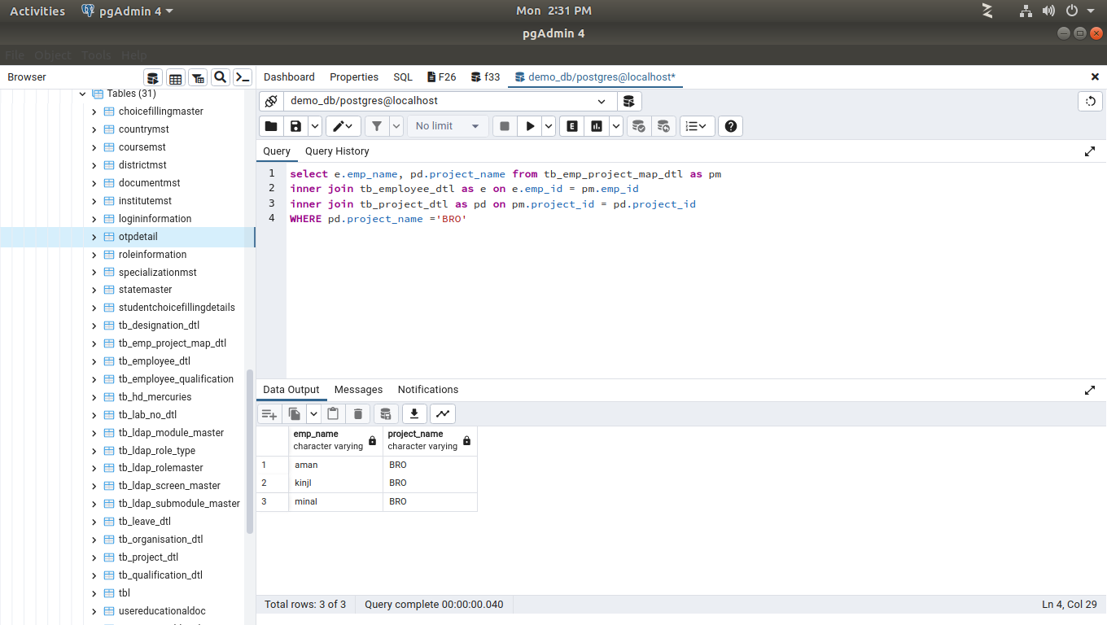
INNER JOIN tb_project_dtl as p ON m.project_id =p.project_id
WHERE NOT project_name = 'EME';
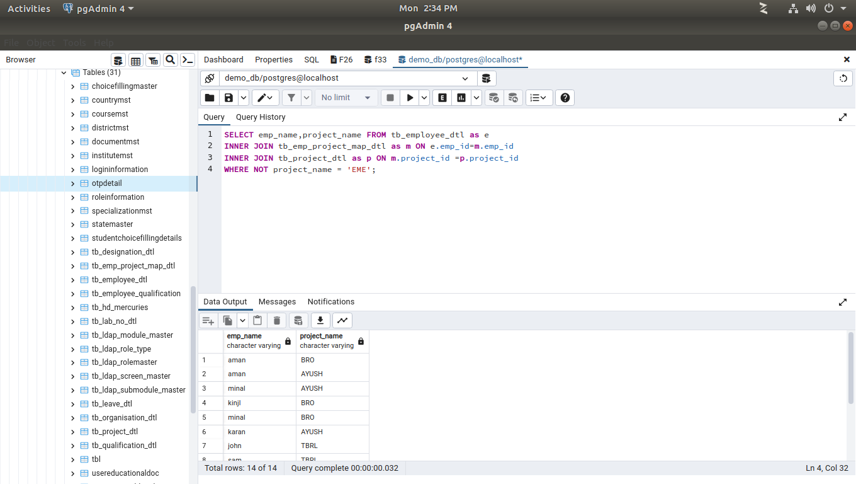
3. List of the employees whose experience is more or equal to 2 years in descending order.
SELECT emp_name, age(hire_date) from tb_employee_dtl
WHERE EXTRACT(YEAR
FROM age(CURRENT_DATE, hire_date)) >= 2
ORDER BY age(hire_date) DESC;
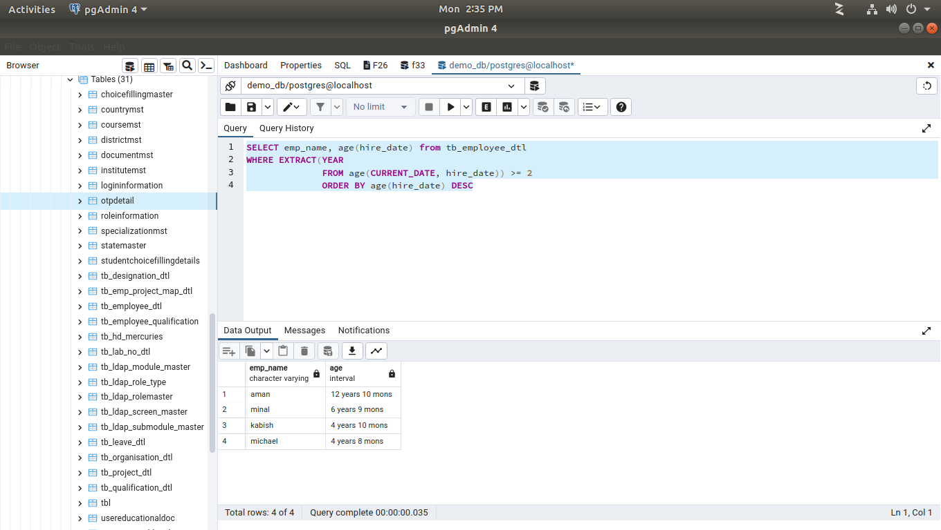
4. List of the employees whose salary is less than 20,000 Rs.
SELECT emp_name,emp_salary from tb_employee_dtl
WHERE emp_salary<20000;
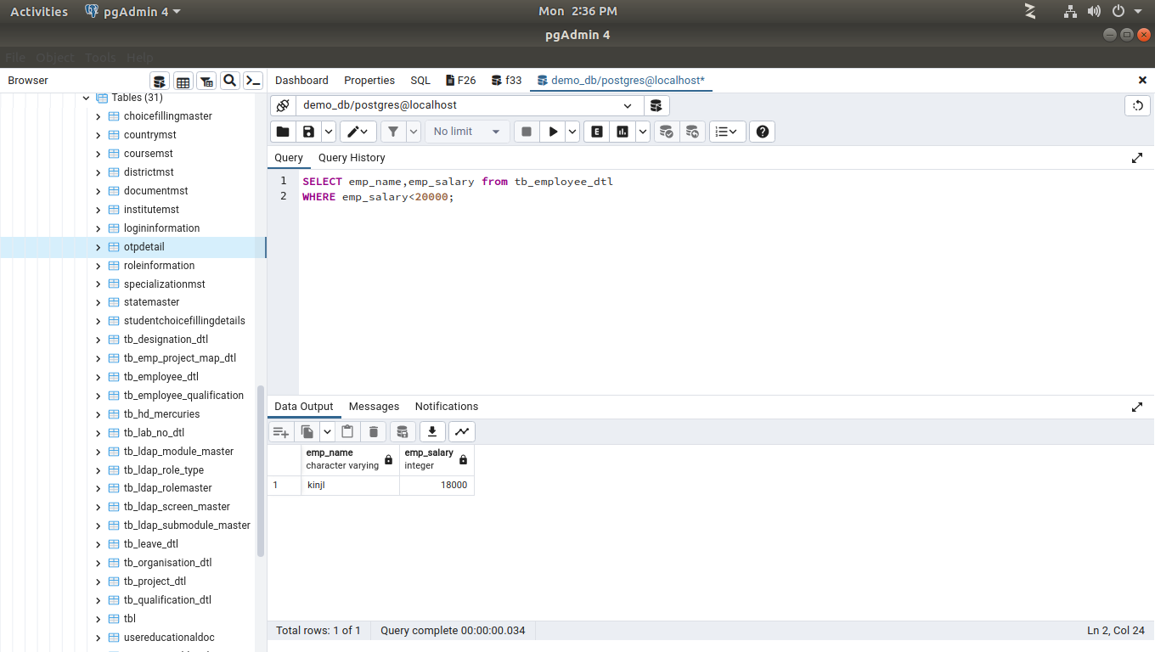
5. List of the employees whose salary is more than 20,000 Rs.
SELECT emp_name,emp_salary from tb_employee_dtl
WHERE emp_salary>20000;
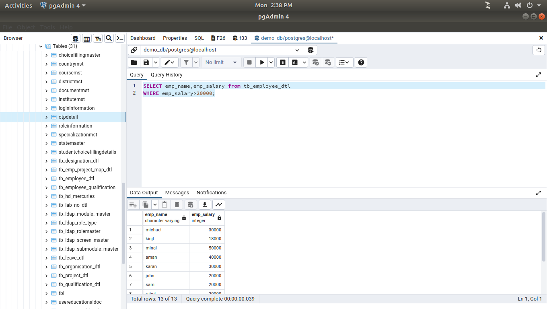
6. List of the employees whose salary in between of 10,000 to 50,000 Rs.
SELECT emp_name,emp_salary from tb_employee_dtl
WHERE emp_salary BETWEEN 10000 AND 50000;
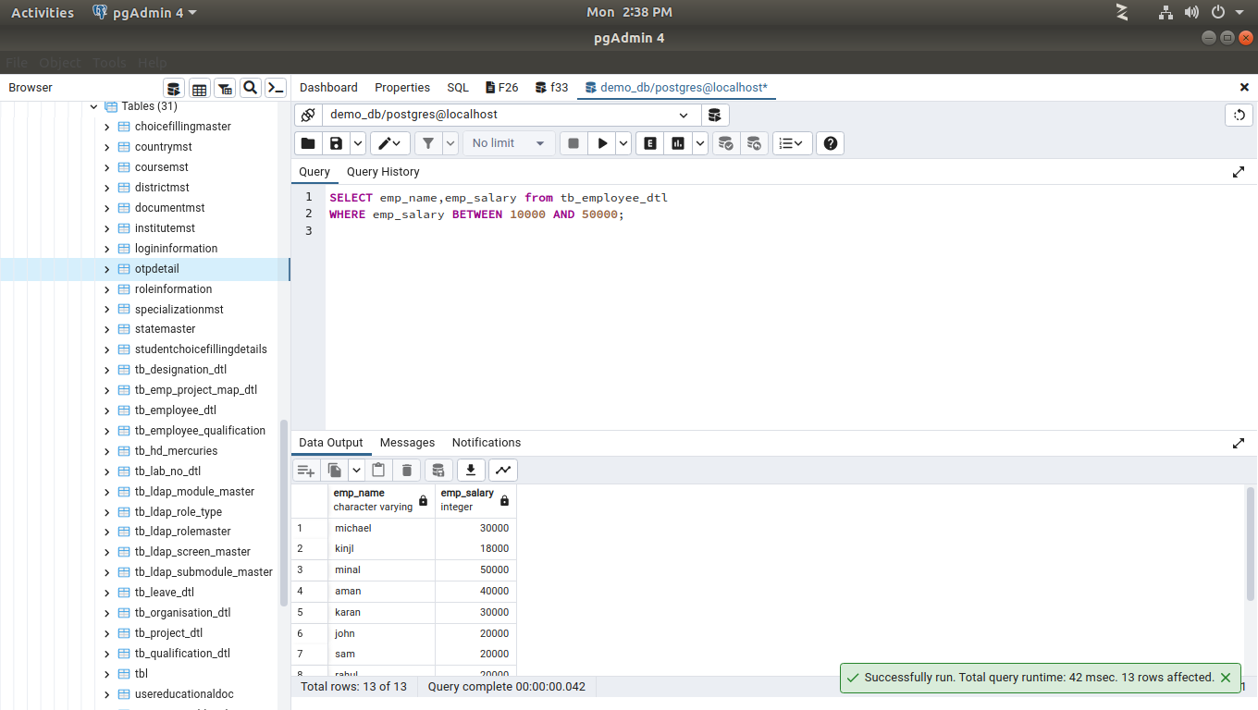
7. List the employee who has minimum salary.
SELECT emp_name,emp_salary FROM tb_employee_dtl
where emp_salary=(select MIN(emp_salary) from tb_employee_dtl);

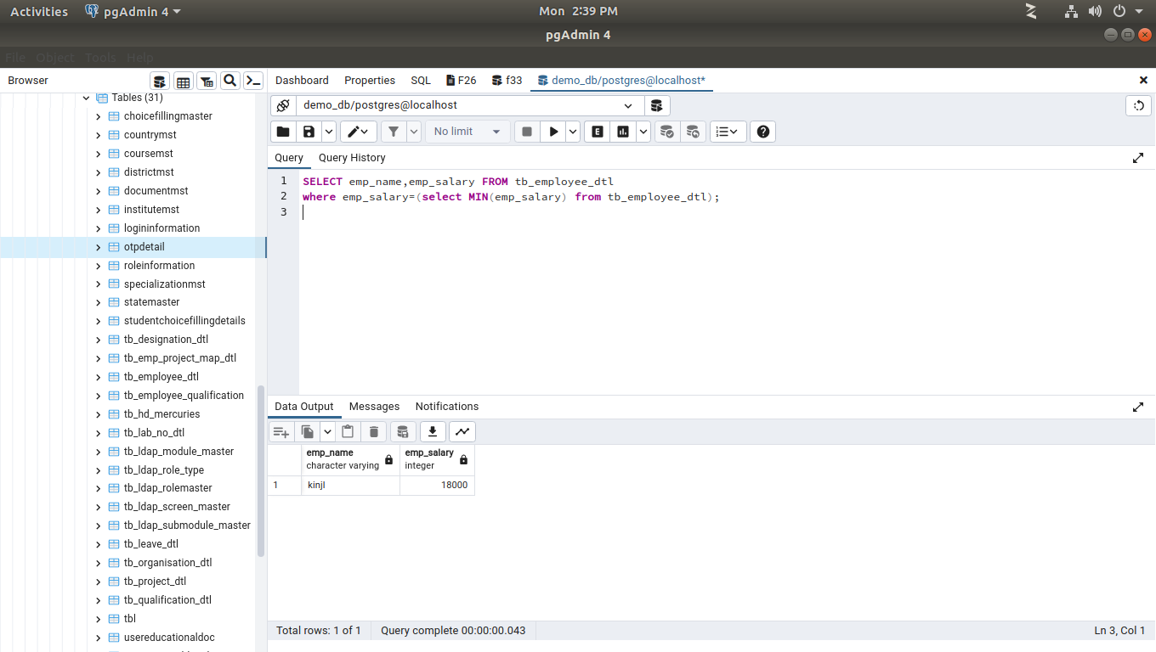
8. List the employee who has maximum salary.
SELECT emp_name,emp_salary FROM tb_employee_dtl
where emp_salary=(select MAX(emp_salary) from tb_employee_dtl)

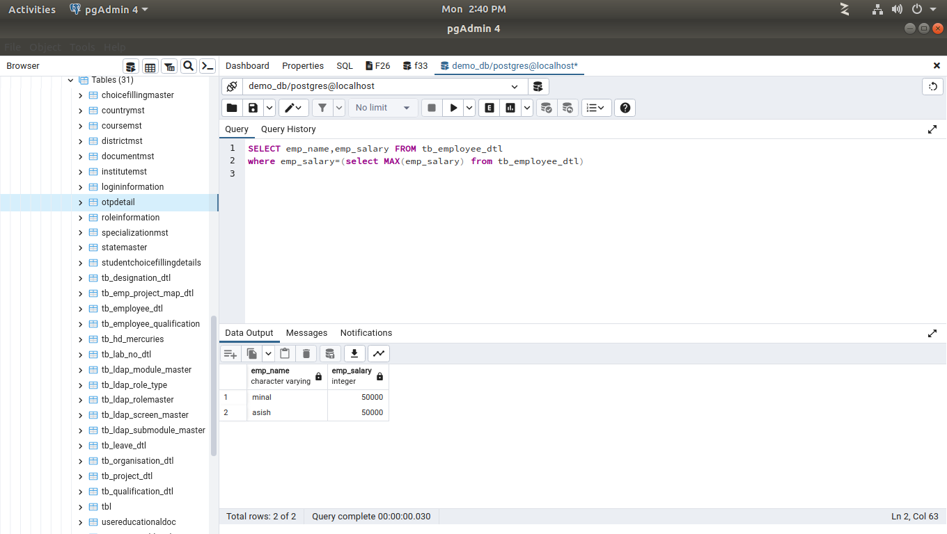
9. Total salary of all employees and average salary of each employee.
SELECT emp_name, SUM(emp_salary), AVG(emp_salary) FROM tb_employee_dtl
GROUP BY emp_name

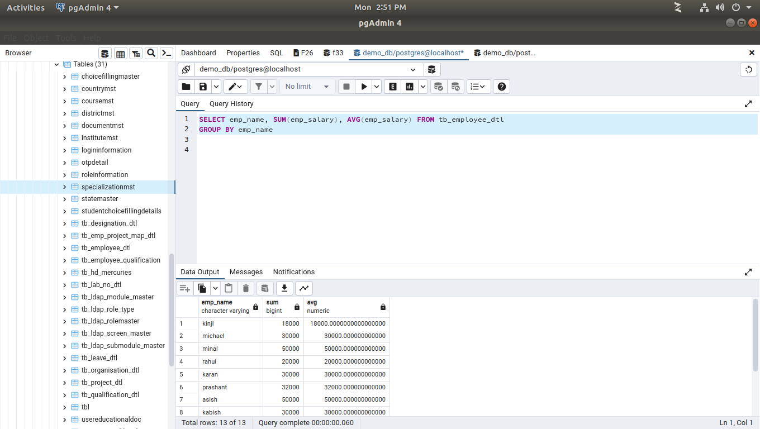
10. List of the employees who are working on diff. project to be mention project name in ascending order and employees name in descending order.
SELECT emp_name,project_name FROM tb_employee_dtl as e
INNER JOIN tb_emp_project_map_dtl as m ON e.emp_id=m.emp_id
INNER JOIN tb_project_dtl as p ON m.project_id =p.project_id
ORDER BY emp_name desc,
project_name asc;
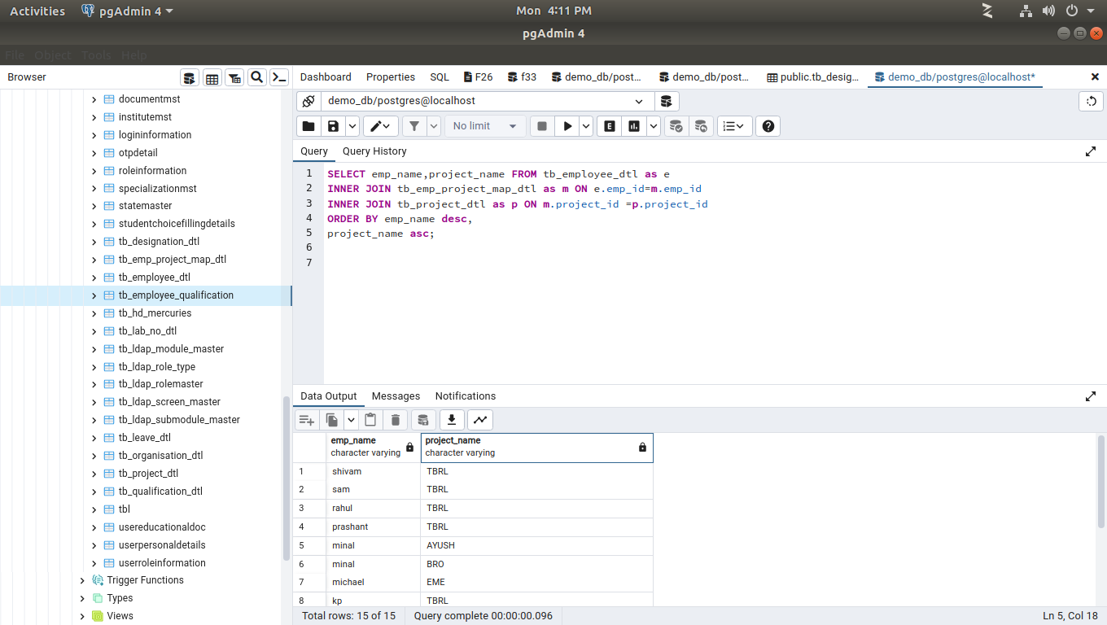
11. List of the employees who joined in the month of July.
SELECT *
FROM tb_employee_dtl
WHERE to_char(hire_date, 'mon')='jul';
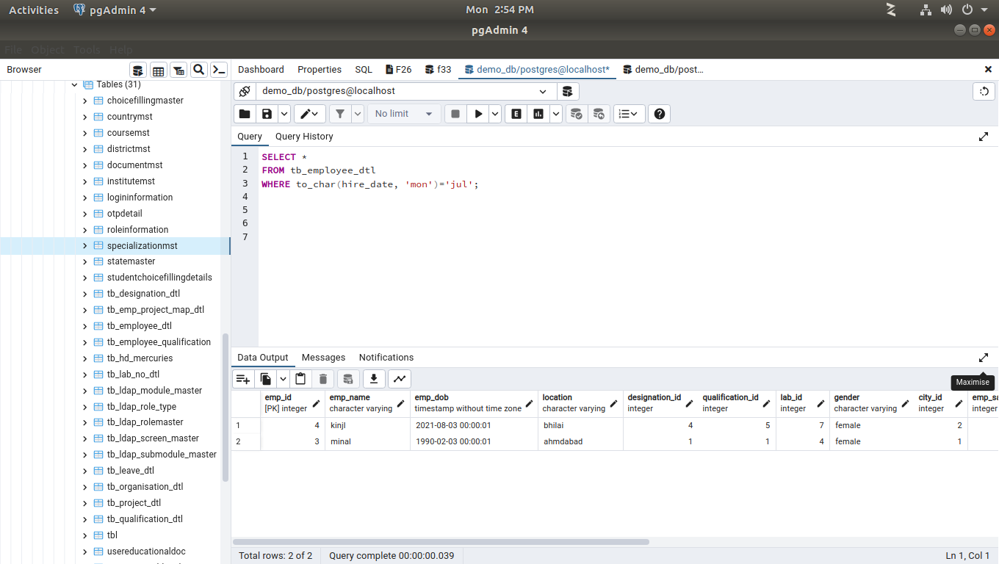
12. List of the employees who joined in the year of 2018.
SELECT
emp_name AS "Name of Employee",
char_length(emp_name) AS "Length of Name"
FROM tb_employee_dtl
WHERE char_length(emp_name)>=6
LIMIT 5
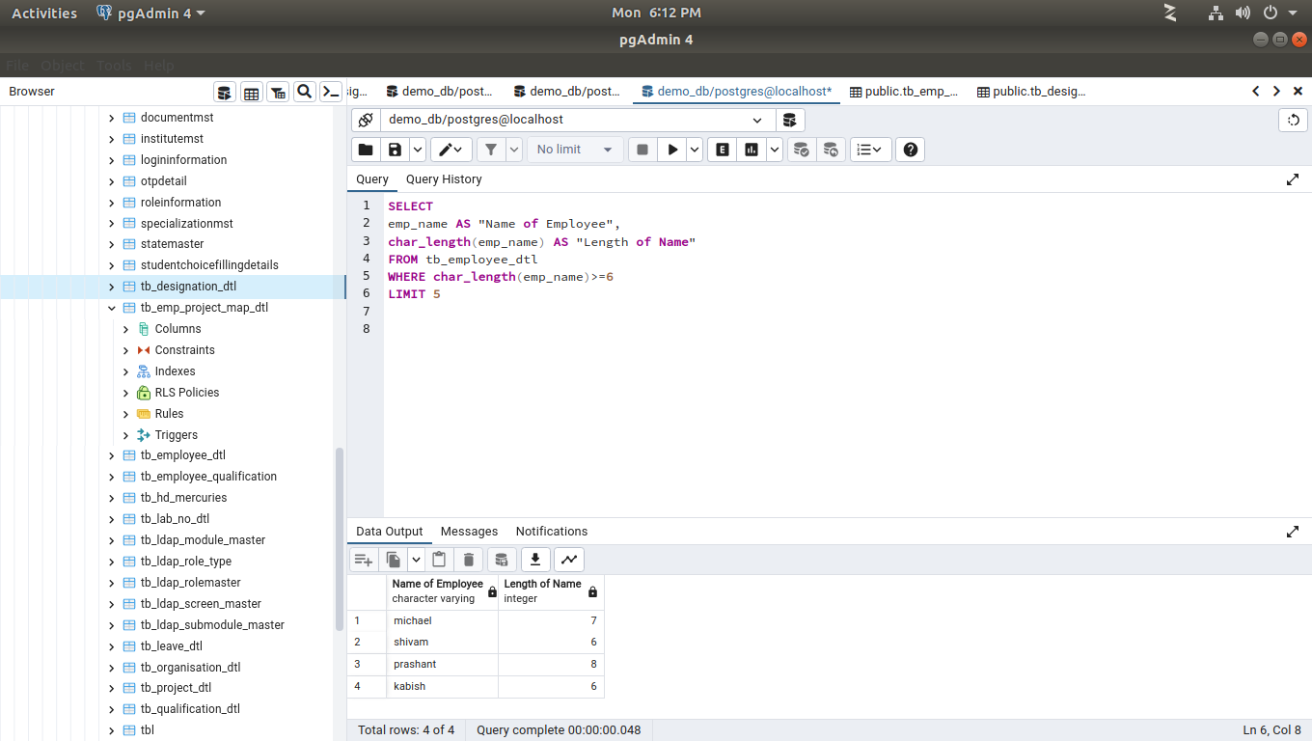

13. List of the employees who are resident of Gandhinagar.
SELECT emp_name,districtname FROM tb_employee_dtl e
INNER JOIN districtmst AS d ON d.did=e.city_id
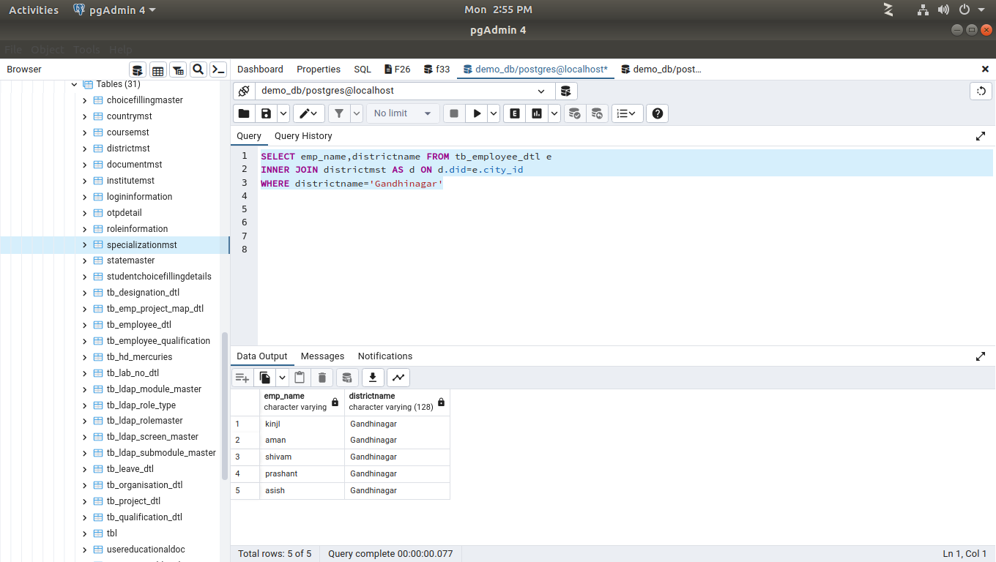
WHERE districtname='Gandhinagar'
14. List of the employees who up down from different cities to Gandhinagar.(mention cities name)
SELECT emp_name,location FROM tb_employee_dtl e
INNER JOIN districtmst AS d ON d.did=e.city_id
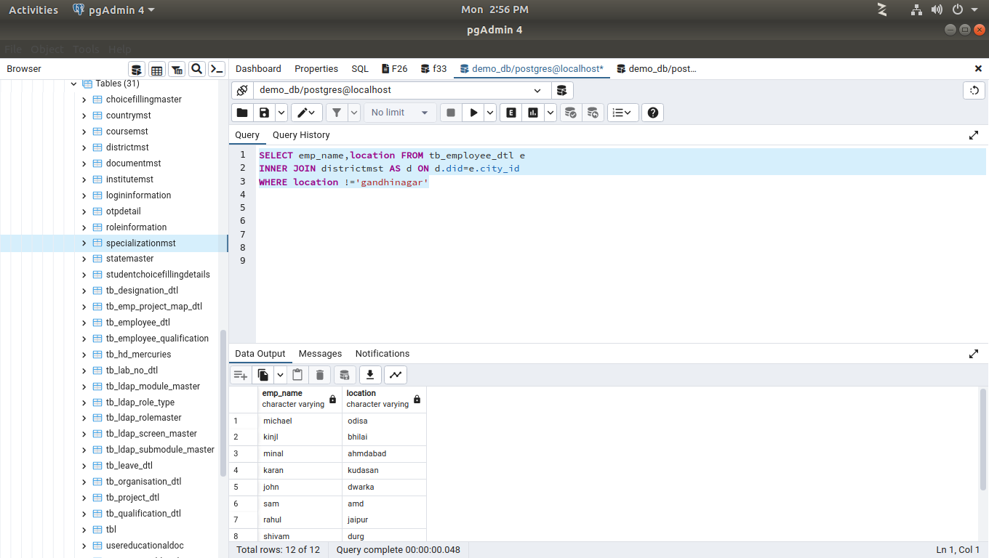
WHERE location !='gandhinagar'
15. No. of Employees based on their technical Qualification(Graduate/Post Graduate)
SELECT COUNT(emp_name) as numemp ,qualification_name FROM tb_employee_dtl e
INNER JOIN tb_qualification_dtl AS q ON q.id=e.qualification_id
GROUP BY qualification_name
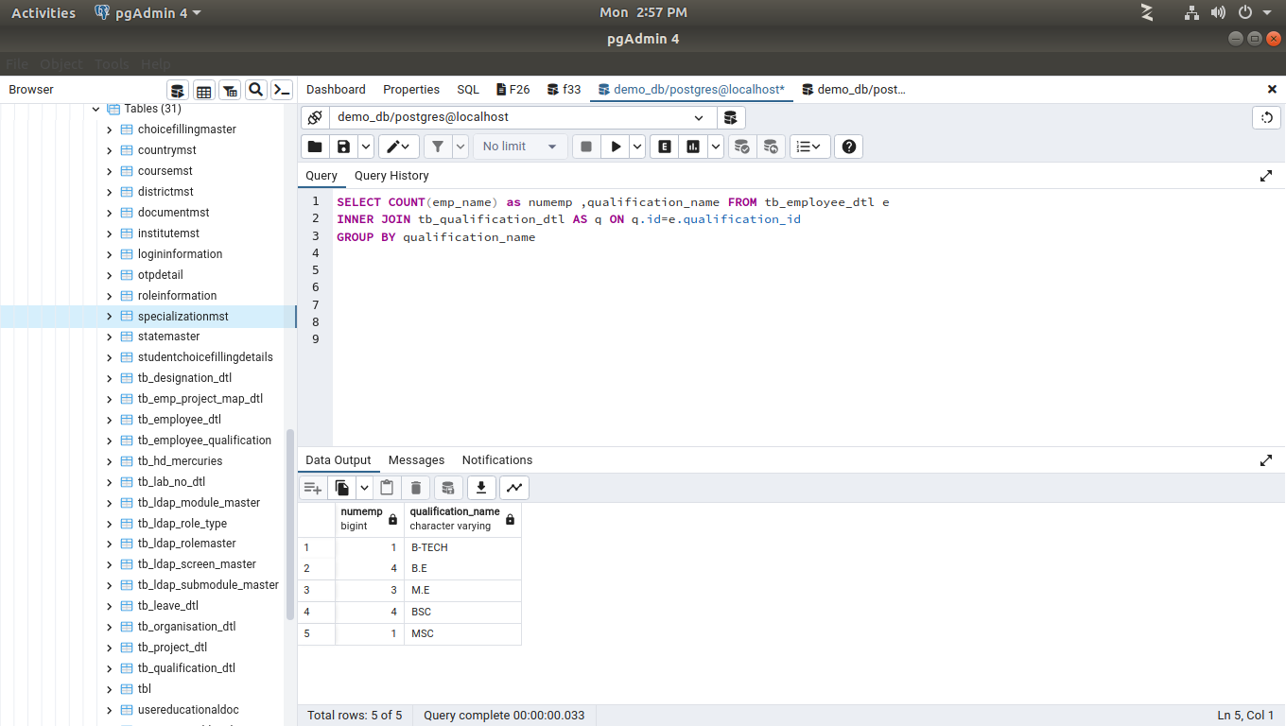

16. The Number of employees in each project where less than 5 number of employees.
SELECT COUNT(emp_name) as numofemp , project_name FROM tb_employee_dtl e
INNER JOIN tb_emp_project_map_dtl AS m ON m.emp_id=e.emp_id
INNER JOIN tb_project_dtl AS p ON p.project_id=e.emp_id
GROUP BY project_name
HAVING COUNT(emp_name)<5
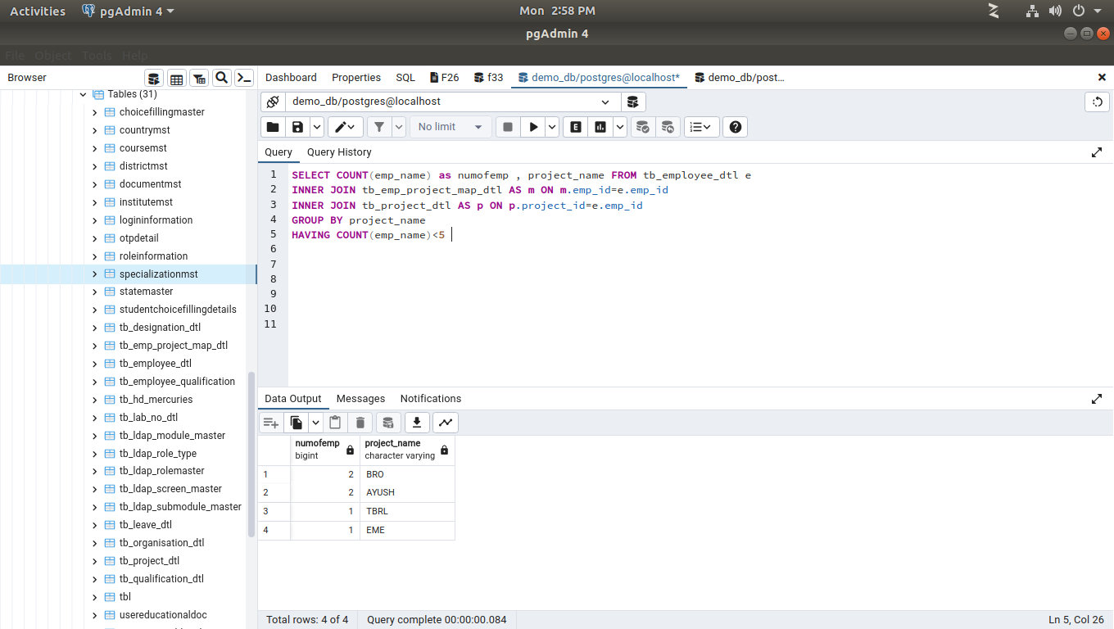

17. List the Team Leader name, Project Name and numbers of employees working for those team leaders in ascending order on team leader ID.
select e.emp_name, a.emp_count,pd.project_name
from tb_emp_project_map_dtl pm
inner join tb_project_dtl pd on pm.project_id= pd.PROJECT_id
inner join tb_employee_dtl e on pm.emp_id = e.emp_id
inner join tb_designation_dtl d on e.designation_id = d.id and d.designation_name = 'TEAM LEAD'
inner join (select count(emp_id) as emp_count,project_id from tb_emp_project_map_dtl group by project_id) a on pd.PROJECT_id = a.project_id
group by e.emp_name, a.emp_count, pd.project_name
order by e.emp_name asc
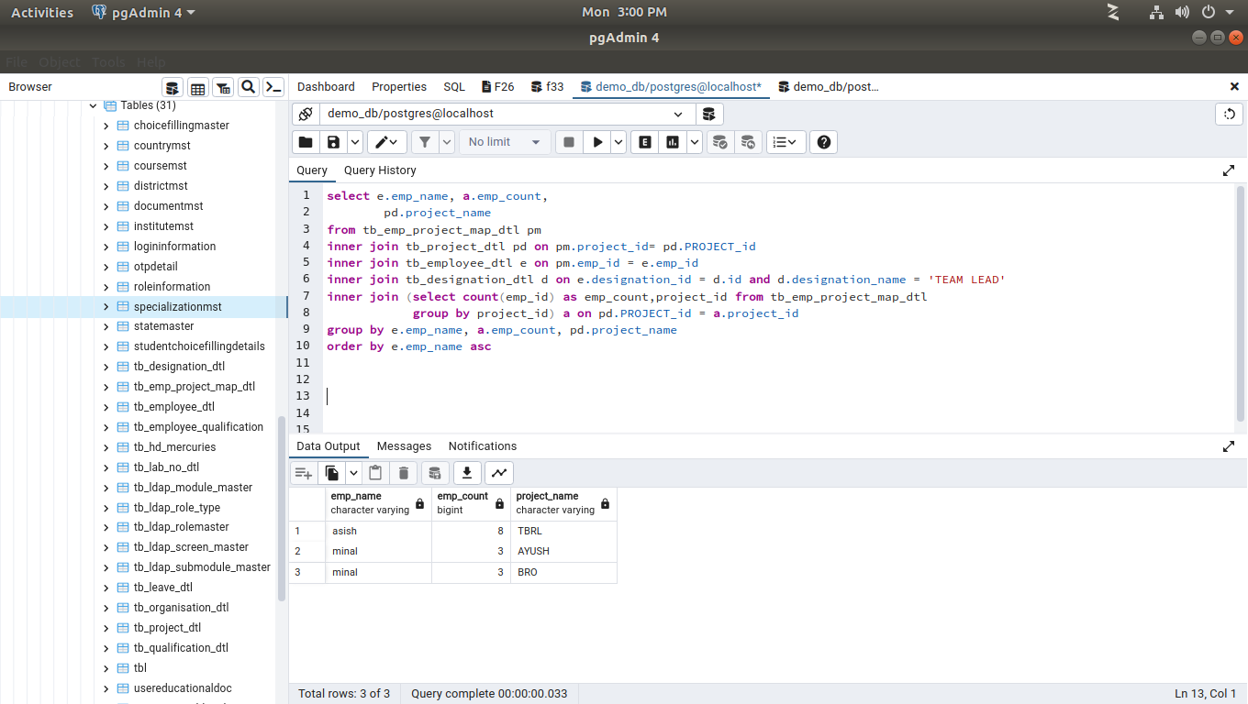

18. List of the employees whose name having more or equal to six characters limit to 5 employees.
SELECT
emp_name AS "Name of Employee",
char_length(emp_name) AS "Length of Name"
FROM tb_employee_dtl
WHERE char_length(emp_name)>=6
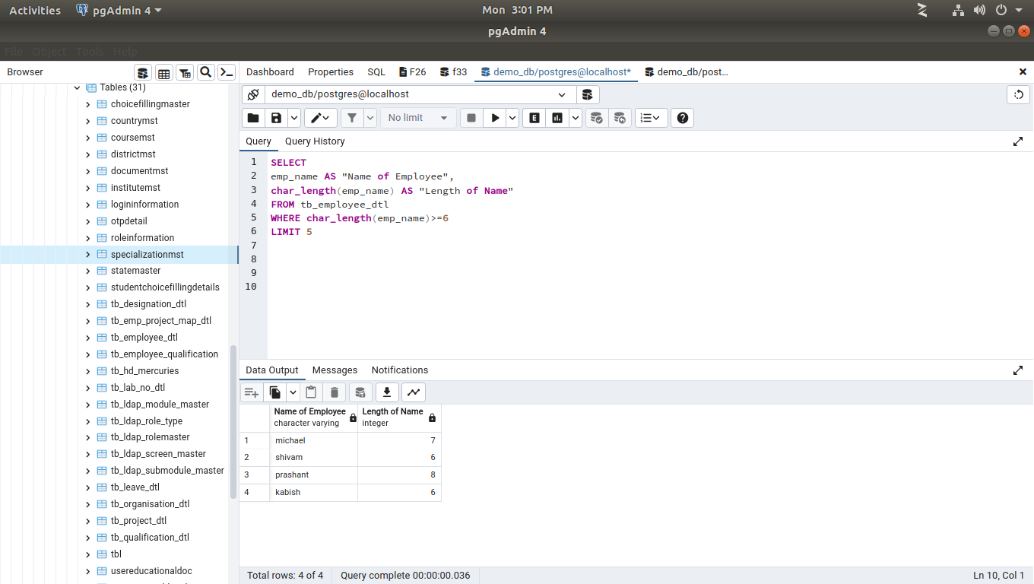
LIMIT 5
19. List of the employees whose name start with ‘M’ and with 5 Characters in their name.
SELECT emp_name AS "Name of Employee",
char_length(emp_name) AS "Length of Name"
FROM tb_employee_dtl
WHERE emp_name LIKE 'm%' AND char_length(emp_name)=5
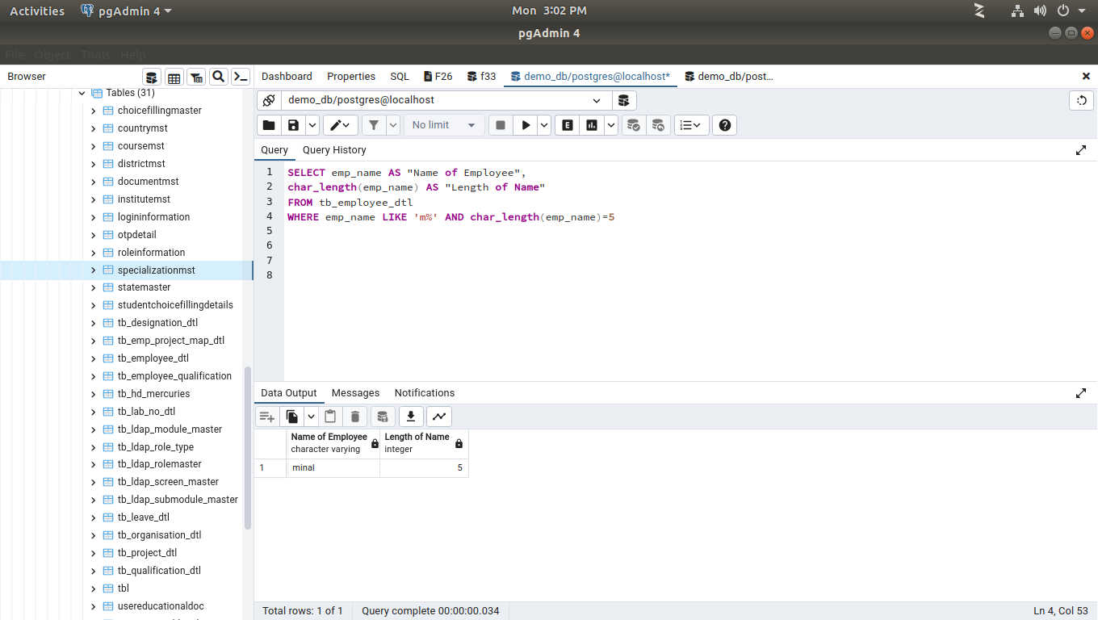
20. List of the employees whose name having 5 Characters in name, 2nd Character must be ‘I’ and end character to be ‘L’.
SELECT emp_name AS "Name of Employee",
char_length(emp_name) AS "Length of Name"
FROM tb_employee_dtl
WHERE char_length(emp_name)=5 AND LOWER(SUBSTR(emp_name,2,1)) ='i' AND emp_name LIKE'%l'
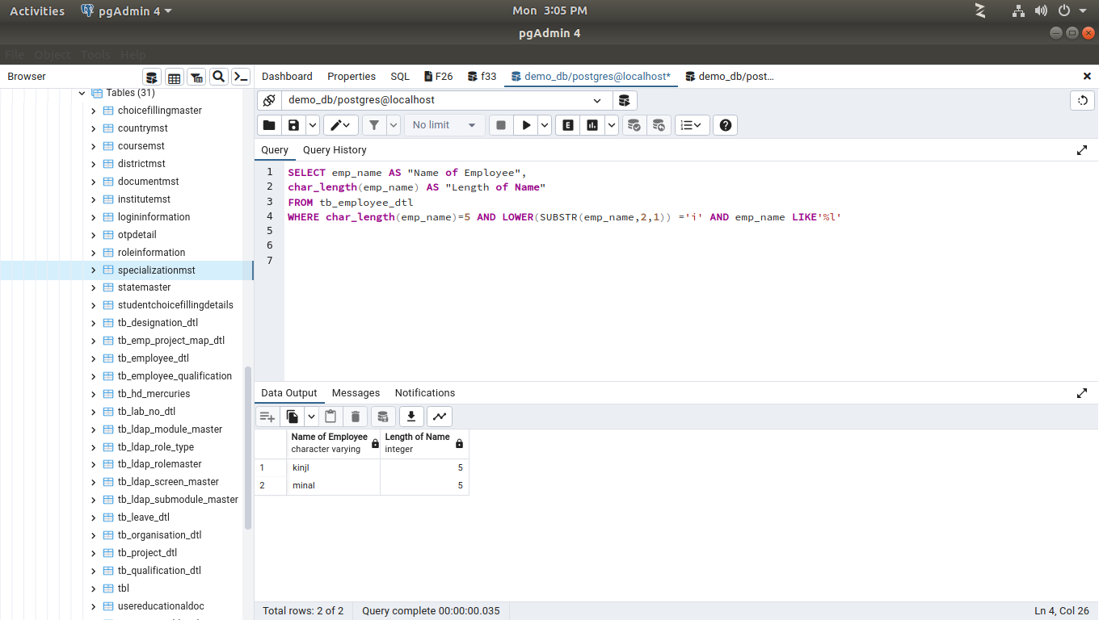

21. List all the employees with thier Designation as a team lead/Senior developer in Ascending Order.
SELECT emp_name,designation_name FROM tb_employee_dtl e
INNER JOIN tb_designation_dtl AS d ON d.id=e.designation_id
WHERE designation_name='TEAM LEAD' OR designation_name='Technical head'
ORDER BY designation_name ASC
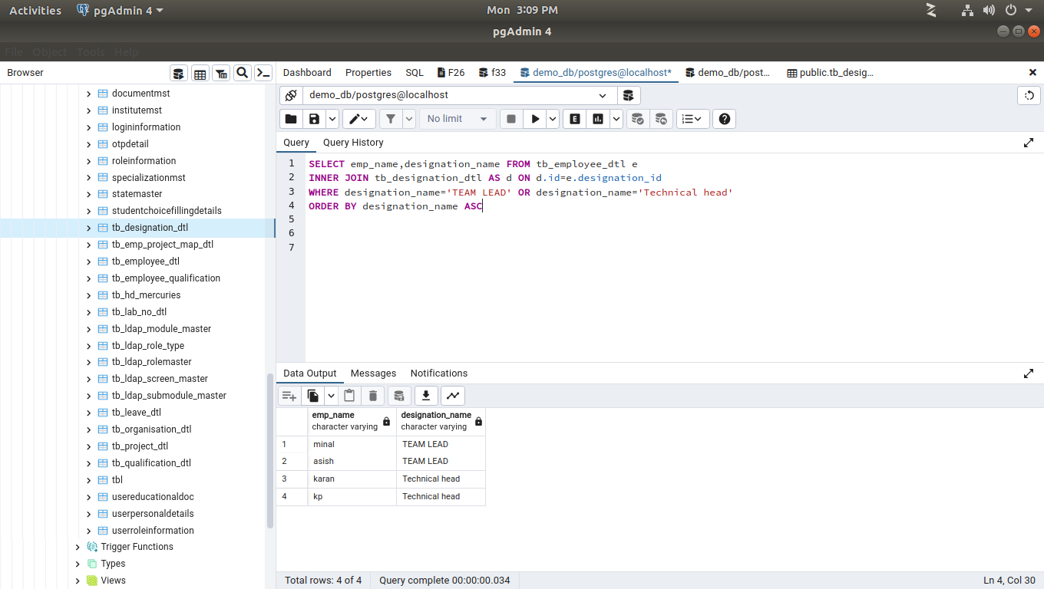

22. List all the Detail of employees like Age, Salary, Experience who is from Ethos and Ncog and having experience more than one year.
SELECT emp_name,age(emp_dob) AS birthdate,emp_salary,age(hire_date) AS workexp,organisation FROM tb_employee_dtl e
INNER JOIN tb_organisation_dtl AS o ON o.id=e.organisation_id
WHERE EXTRACT (YEAR FROM age(CURRENT_DATE,hire_date))>1
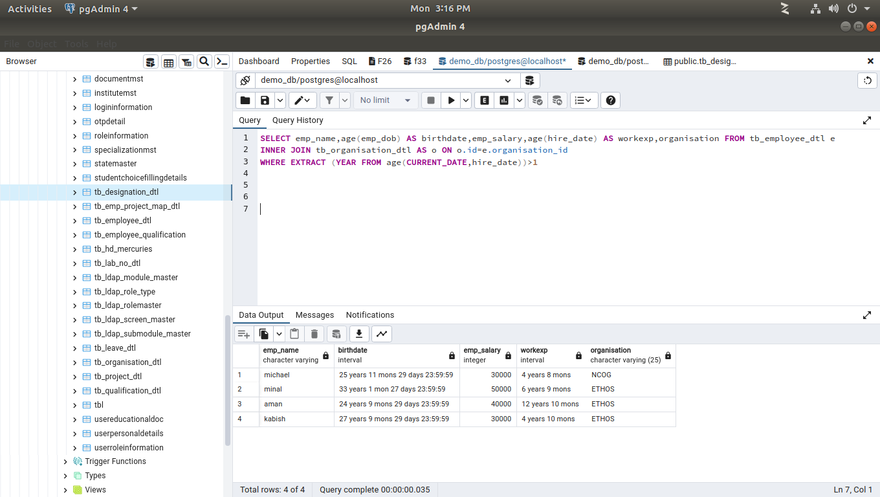

23. List all the Employees whose Name Start with (A,M,K,P) and end with (N,L,H) in Descending Order.
SELECT emp_name FROM tb_employee_dtl
WHERE (emp_name LIKE 'a%'
OR emp_name LIKE 'm%'
OR emp_name LIKE 'k%'
OR emp_name LIKE 'p%')
AND
(emp_name LIKE '%n'
OR emp_name LIKE '%l'
OR emp_name LIKE '%h')
ORDER BY emp_name DESC
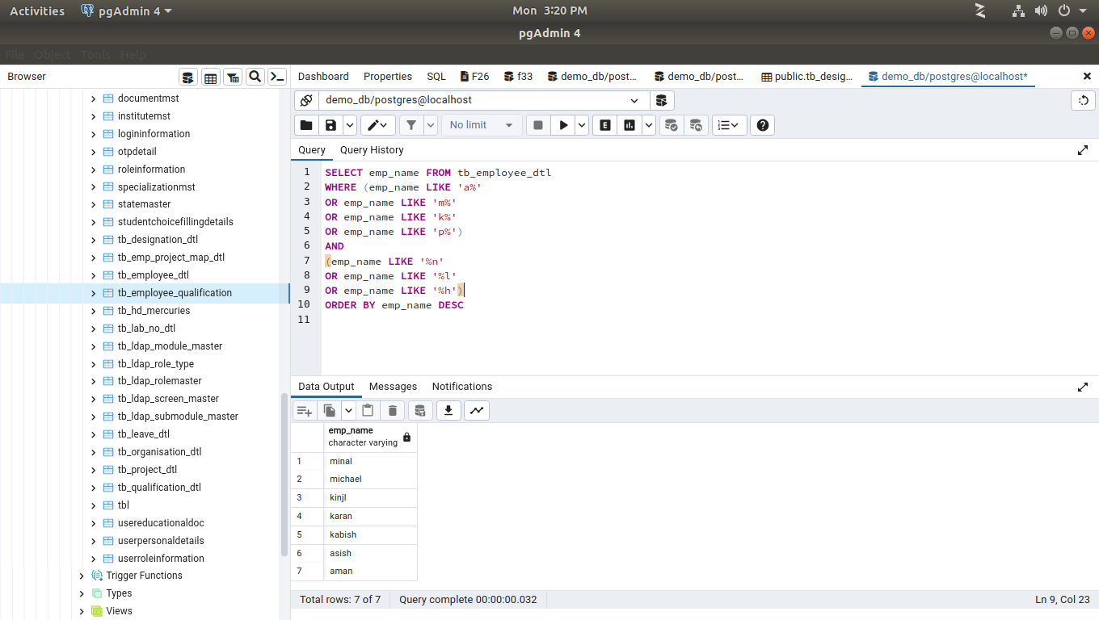
24. Find the number of counts of Employees in all Projects(Project wise count of employees).
select COUNT(emp_name) AS numberofemplyee,project_name from tb_emp_project_map_dtl as pm
inner join tb_employee_dtl as e on e.emp_id = pm.emp_id
inner join tb_project_dtl as pd on pm.project_id = pd.project_id
GROUP BY project_name
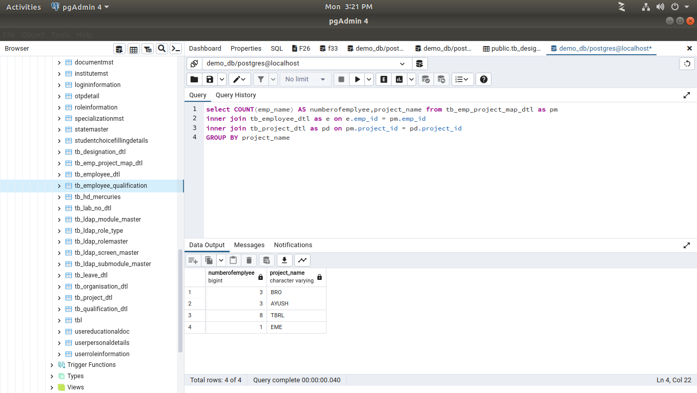
25. Write a SQL query to fetch Details Project Name,Employee name whose Designation is Team Leaders and counts of Employee under them.
select distinct p.project_name,e.emp_name as team_leader, a.emp_count as team_size
from tb_emp_project_map_dtl ep
inner join tb_project_dtl p on ep.project_id = p.project_id
inner join tb_employee_dtl e on ep.emp_id = e.emp_id
inner join tb_designation_dtl d on e.designation_id = d.id and d.id = 6
inner join (select count(emp_id) as emp_count,project_id from tb_emp_project_map_dtl group by project_id )a on p.project_id = a.project_id
group by e.emp_name, a.emp_count, p.project_name
order by e.emp_name

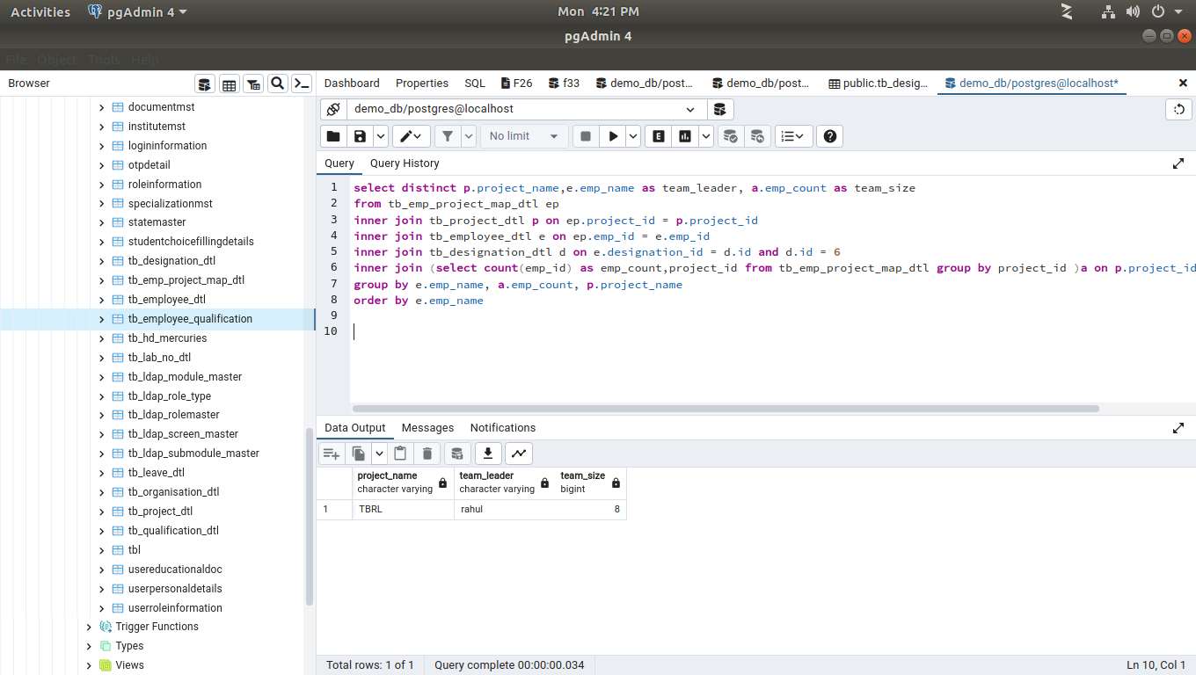
26. Find the details of the Team Leaders like his/her Name ,Age, organization, designation, salary, Experience and also they have more than one project.
select emp_name,age(emp_dob) as dob,organisation, designation_name,emp_salary,age(hire_date) as experience from tb_employee_dtl e
inner join tb_designation_dtl as d ON d.id=e.designation_id and d.id = 1
inner join tb_organisation_dtl as o ON o.id=e.organisation_id
inner join (select count(project_id)as emp_count,emp_id from tb_emp_project_map_dtl group by emp_id having count (distinct project_id) > 1) pc on e.emp_id = pc.emp_id
order by e.emp_name

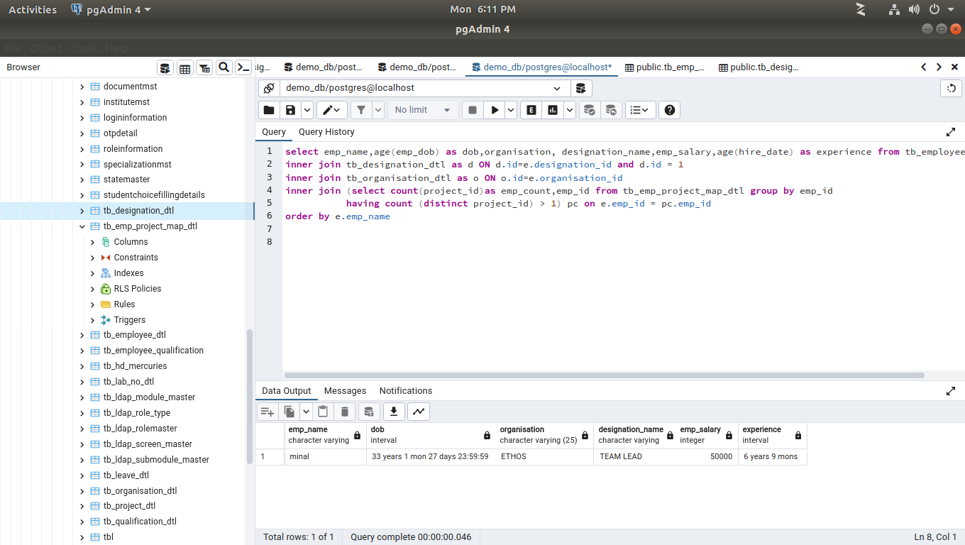

27. Write a query to fetch details of all employees excluding the employees who have less than one year of Experience.
select emp_name,age(emp_dob),organisation, designation_name,emp_salary,age(hire_date),project_name from tb_emp_project_map_dtl as pm
inner join tb_employee_dtl as e on e.emp_id = pm.emp_id
inner join tb_project_dtl as pd on pm.project_id = pd.project_id
inner join tb_designation_dtl as d ON d.id=e.designation_id
inner join tb_organisation_dtl as o ON o.id=e.organisation_id
WHERE EXTRACT (YEAR FROM age(CURRENT_DATE,hire_date))>1
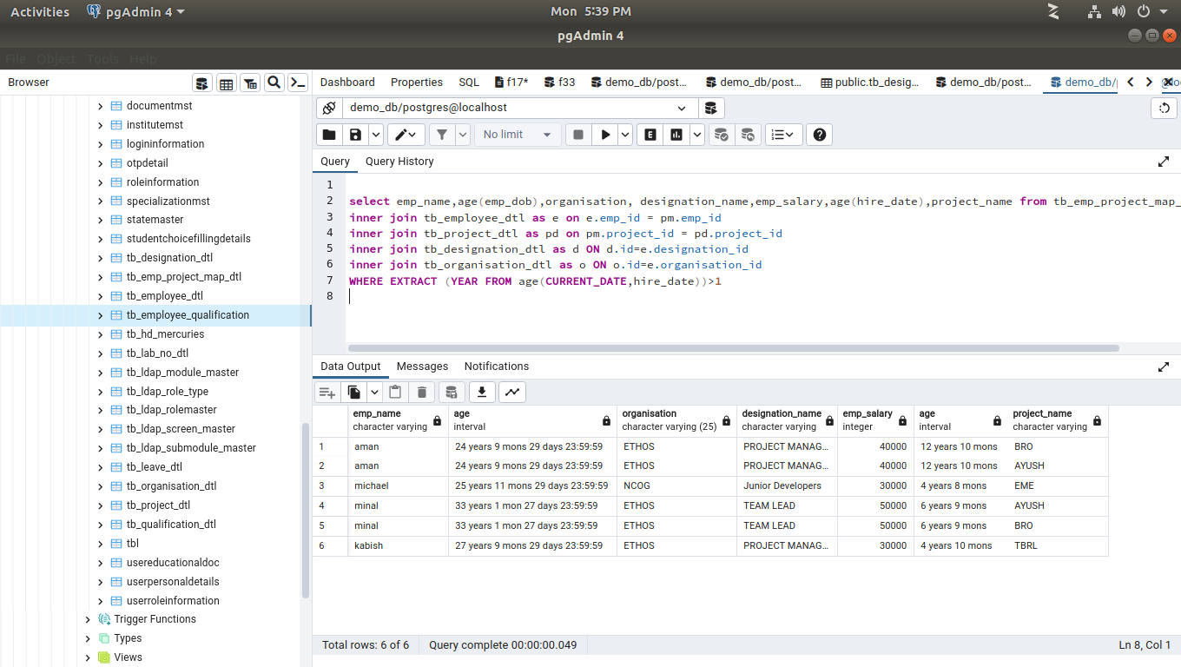

28. Write a query to fetch details of 5 Highest Experience having qualification in M.Tech/MCA and age should be greater than 25.
select emp_name,age(emp_dob),organisation,qualification_name designation_name,emp_salary,age(hire_date),project_name from tb_emp_project_map_dtl as pm
inner join tb_employee_dtl as e on e.emp_id = pm.emp_id
inner join tb_project_dtl as pd on pm.project_id = pd.project_id
inner join tb_designation_dtl as d ON d.id=e.designation_id
inner join tb_organisation_dtl as o ON o.id=e.organisation_id
INNER JOIN tb_qualification_dtl as q ON q.id=e.qualification_id
WHERE EXTRACT (YEAR FROM age(CURRENT_DATE,hire_date))>5 AND (qualification_name='M.E' OR qualification_name='MSC')
AND EXTRACT(YEAR FROM age(CURRENT_DATE,emp_dob))> 25
GROUP BY e.emp_name,age(emp_dob),organisation,qualification_name,designation_name,emp_salary,age(hire_date),project_name
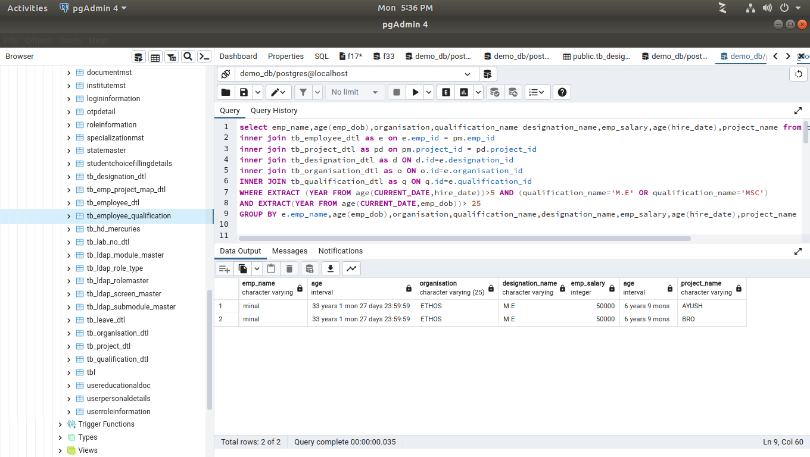
29. List of all the Employees with their name and Organization having total leaves of current Year is greater than 15 days and display result in ascending order of total leaves count.
SELECT emp_name,organisation,no_of_leave FROM tb_employee_dtl e
INNER JOIN tb_organisation_dtl AS o ON o.id=e.emp_id
INNER JOIN tb_leave_dtl AS l ON l.id =e.emp_id
WHERE no_of_leave>15
ORDER BY no_of_leave AS
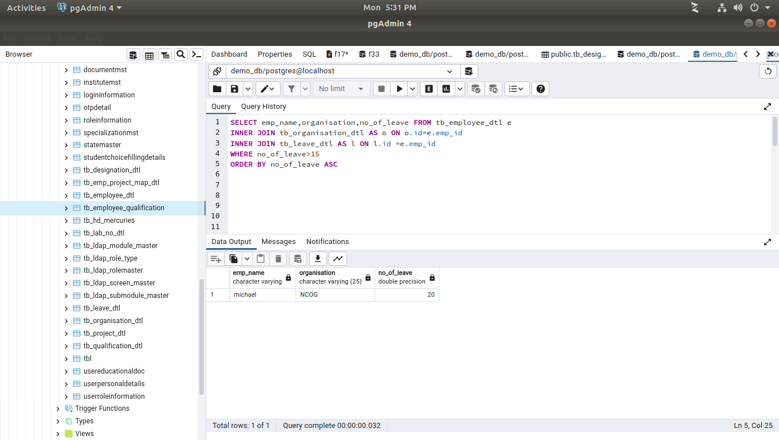
30. Write a query to fetch details that capture number of the leaves of all the employees of last month and it should be organization wise.
SELECT emp_name,organisation, AGE(leave_to, leave_from) AS employment_leave_interval FROM tb_employee_dtl e
INNER JOIN tb_organisation_dtl AS o ON o.id=e.emp_id
INNER JOIN tb_leave_dtl AS l ON l.id =e.emp_id
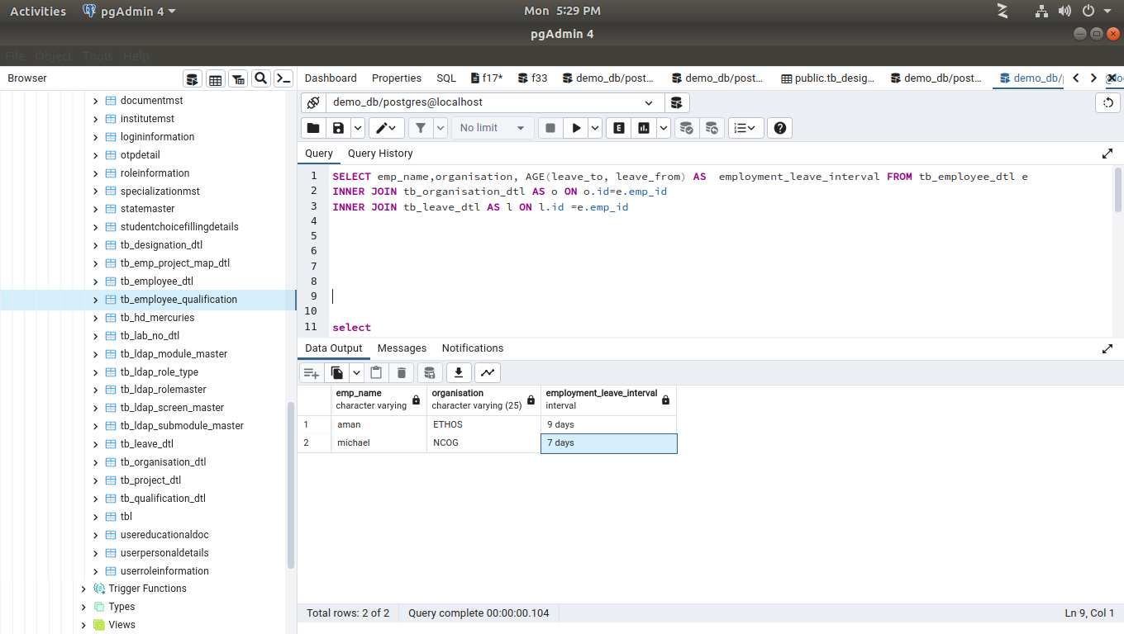
31. Write a query to fetch details Project wise like this for all Projects w.r.t the Number of Employees with their Highest Qualification and also include Security and Casual labors as a Other in Project Name.
select distinct p.project_name,
(select count(ep.project_id) from tb_employee_dtl e
inner join tb_emp_project_map_dtl ep on e.emp_id = ep.emp_id
and ep.project_id = p.project_id
where e.qualification_id = '1') as m_tech,
(select count(ep.project_id) from tb_employee_dtl e
inner join tb_emp_project_map_dtl ep on e.emp_id = ep.emp_id
and ep.project_id = p.project_id
where e.qualification_id = '2') as be_it,
(select count(ep.project_id) from tb_employee_dtl e
inner join tb_emp_project_map_dtl ep on e.emp_id = ep.emp_id
and ep.project_id = p.project_id
where e.qualification_id = '3') as mca,
(select count(ep.project_id) from tb_employee_dtl e
inner join tb_emp_project_map_dtl ep on e.emp_id = ep.emp_id
and ep.project_id = p.project_id
where e.qualification_id = '5') as bsc
from tb_project_dtl p
inner join tb_emp_project_map_dtl ep on p.project_id = ep.project_id
inner join tb_employee_dtl e on ep.emp_id = e.emp_id
order by p.project_name

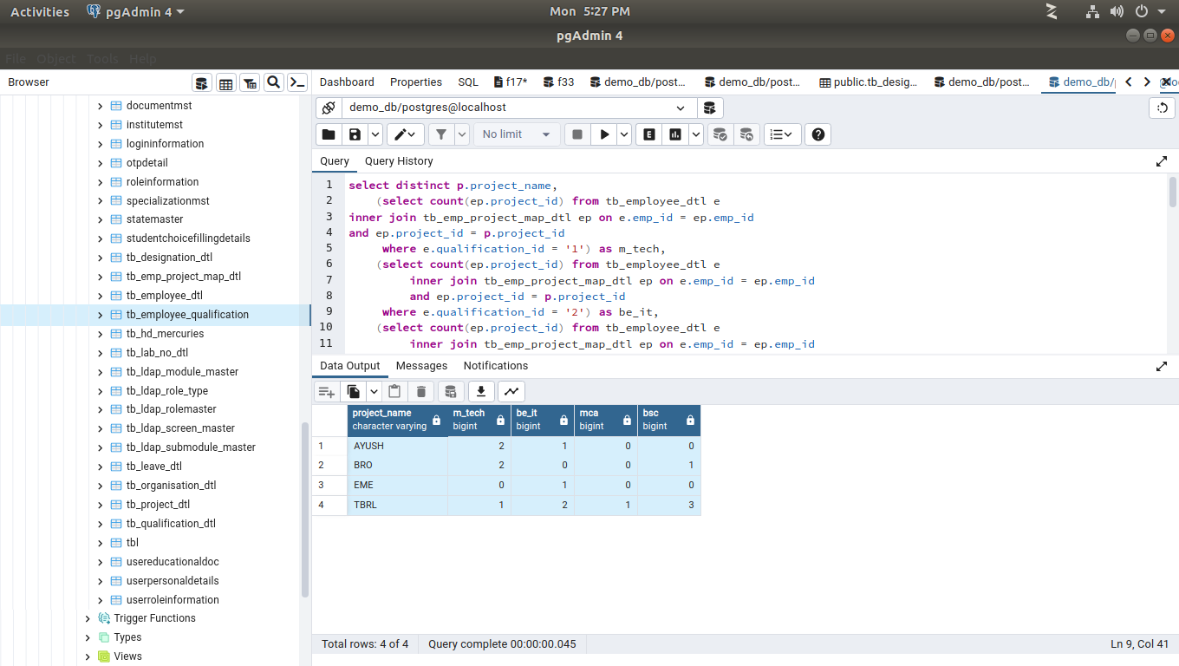

32. Name of Employee with Designation who is in multiple Projects(Exclude the Employee who is in single project) with Project Name. Conditions Applied Duplication of Employee Name but Not Project Name:
select emp_name, designation_name, project_name
from tb_emp_project_map_dtl as pm
inner join tb_employee_dtl as e on e.emp_id = pm.emp_id
inner join tb_project_dtl as pd on pm.project_id = pd.project_id
inner join tb_designation_dtl as d ON d.id=e.designation_id
inner join tb_organisation_dtl as o ON o.id=e.organisation_id
inner join tb_qualification_dtl as q ON q.id=e.qualification_id
WHERE pm.project_id in (select project_id from tb_emp_project_map_dtl group by project_id
HAVING COUNT(DISTINCT emp_id)>1)
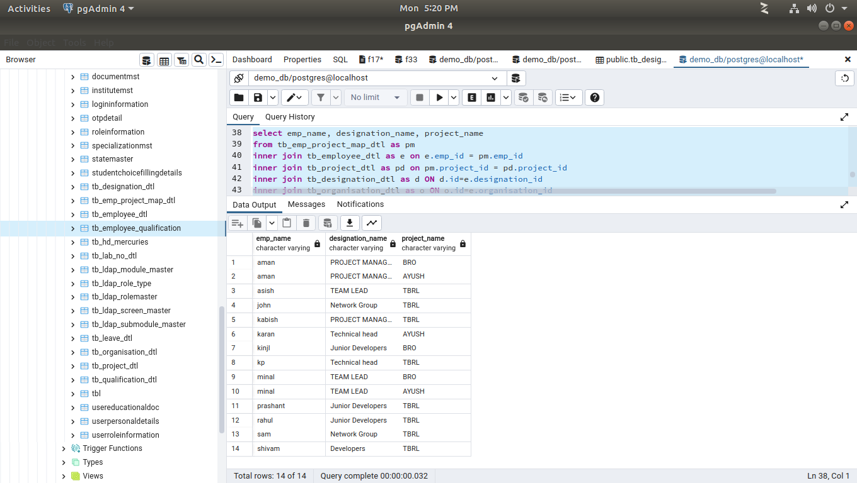
ORDER BY e.emp_name,pm.project_id
33. Create a Query which Display Name of Employee with Experience and their Designation will be based on this cases:
Case 1 :Employee whose
Experience > 8 and Qualification B.tech/M.tech is Project Manager

Case 2 :Employee whose
Experience > 6 and Qualification M.tech/MCA is Project Technical head.

Case 3 :Employee whoseExperience >= 2 and Experience <= 6 and Qualification M.tech/MCA/B.Tech is Team Leaders.
Case 4 :Employee whose
Experience >= 1 and Experience <= 2 and Qualification B.Tech is Developers.

Case 5 :Employee whose
Experience < 1 Qualification B.Tech/BCA is Junior Developers.

Case 6 :Employee whose
Experience > 3 Qualification Diploma is Network Group.

Case 7 :
Remaining are falls into “Others”
SELECT emp_name,qualification_id,age(hire_date),
CASE
WHEN EXTRACT(YEAR
FROM age(CURRENT_DATE, hire_date))> 8 AND qualification_id=1 OR qualification_id=2 THEN 'PROJECT MANAGER'
WHEN EXTRACT(YEAR
FROM age(CURRENT_DATE, hire_date)) > 6 AND qualification_id=1 OR qualification_id=2 THEN 'Technical head'
WHEN EXTRACT(YEAR
FROM age(CURRENT_DATE, hire_date))>= 2 AND EXTRACT(YEAR
FROM age(CURRENT_DATE, hire_date))<= 6
AND qualification_id=1 OR qualification_id=3 OR qualification_id=4 THEN 'Team Leader'

WHEN EXTRACT(YEAR
FROM age(CURRENT_DATE, hire_date)) >= 1AND EXTRACT(YEAR
FROM age(CURRENT_DATE, hire_date))<= 2
AND qualification_id=1 OR qualification_id=3 OR qualification_id=3 THEN 'Developer'
WHEN EXTRACT(YEAR
FROM age(CURRENT_DATE, hire_date)) <1 AND qualification_id=3 OR qualification_id=5 THEN 'Junior Developers'
WHEN EXTRACT(YEAR
FROM age(CURRENT_DATE, hire_date)) >3 AND qualification_id=6 THEN 'Network Group'

ELSE 'OTHER'
END designation_name

from tb_emp_project_map_dtl as pm
inner join tb_employee_dtl as e on e.emp_id = pm.emp_id
inner join tb_project_dtl as pd on pm.project_id = pd.project_id
inner join tb_designation_dtl as d ON d.id=e.designation_id
inner join tb_organisation_dtl as o ON o.id=e.organisation_id
inner join tb_qualification_dtl as q ON q.id=e.qualification_id


