**Acknowledgement**

I would like to express my deepest appreciation to all those who provided me the possibility to complete this report.  A special gratitude I give to my final year project coordinator **Prof. Himani**, whose contribution in stimulating suggestions and encouragement helped me to coordinate my project especially in writing this report.

Furthermore I would also like to acknowledge with much appreciation the crucial role of our Principal, who gave the permission to use all required equipment and the necessary materials to complete the task “Project Management System”. Special thanks go to my project manager **Prof. Himani**, who help me to assemble the parts and gave suggestion about my Project. I have to appreciate the guidance given by other supervisor as well as the panels especially in my project presentation that has improved my presentation skills thanks to their comment and advices.

**Yours Thankfully**

**Prajapati Dev**

**Prajapati Rahul**

**SELF CERTIFICATE**

This is to certify that project entitled Project Management System is done by me is an authentic work carried out for the partial fulfillment of the requirements for the award of the degree of **Master of Computer Application** under the guidance of **“Prof. Himani**”. The matter embodied in this project work has not been submitted earlier for award of any degree or diploma to the best of my knowledge and belief.

Signature of the Student

**TABLE OF CONTENTS**

**1 Introduction**

|  |  |  |  |
| --- | --- | --- | --- |
|  | 1.1 | Existing System | 1 |
|  | 1.2 | Need for the New System | 1 |
|  | 1.3 | Objective of the New System | 2 |
|  | 1.4 | Problem Definition | 2 |
|  | 1.5 | Core Components | 2 |
|  | 1.6 | Project Profile | 3 |
|  | 1.7 | Assumptions and Constraints | 4 |
|  | 1.8 | Advantages and Limitations of the Proposed System | 5 |
| **2** | **Requirement Determination & Analysis** | |  |
|  | 2.1 | Requirement Determination | 6 |
|  | 2.2 | Targeted Users | 7 |
| **3** | **System Design** | |  |
|  | 3.1 | Use Case Diagram | 8 |
|  | 3.2 | Class Diagram | 12 |
|  | 3.3 | Activity Diagram | 13 |
|  | 3.4 | Data Dictionary | 14 |
| **4** | **Development** | |  |
|  | 4.1 | Coding Standards | 36 |
| **5** | **Agile Documentation** | |  |
|  | 5.1 | Agile Project Charter | 37 |
|  | 5.2 | Agile Project Plan | 37 |
|  | 5.3 | Agile User Story ( Minimum 3 Tasks) | 38 |
|  | 5.4 | Agile Release Plan | 39 |
| **6** | **Proposed Enhancements** | | **40** |
| **7** | **Conclusion** | | **41** |
| **8** | **Bibliography** | | **42** |

**1. Introduction**

**1.1 Existing System**

* Currently all the information about projects and issues are manage manually.
* Project manager does not keep track of how many issues are still not resolved or pending.
* Currently issue life cycle is not managed so project manager does not knowledge about issue status report

**1.2 Need for the New System**

* The main intention behind the project management system is that to track issue and store the issue information in the database for future reference.
* The admin and project manager can fully understand what the status of each issue and whether it is fixed , assigned or wontfix.

**1.3 Objective of the New System**

* The main objective of the Project Management System is to manage the details of projects module, which Developer,Project manager and Tester are alocate to project.
* It manages all the information about Project.

**1.4 Core Components**

* Admin
* Project Manager
* Developer
* Tester
* Query

|  |  |
| --- | --- |
| 1.6 Project Profile | |
| Project Title | Project Management System |
| Project Objective | An Project Management System (PMS) is an online web application that allows a complete life-cycle management of Project in an organization. Using this web application admin manage the different level of user that involved in a any project development. |
| Internal Guide | **Prof. Himani** |
| Team member | **Prajapati Dev**  **Prajapati Rahul** |
| Team size | 2 |
| Front end | Python with Django |
| Back end | MY SQL |
| Duration | 12 Months |
| Supporting Tools | * **Server**: XAMPP Server * **Browser**: Chrome / Firefox * **Editor Tools :** Visual Studio Code |

**2. Requirement Determination and Analysis**

**2.1 Requirement Determination**

1.**Admin*:***Admin is responsible to manage the complete system.

* ***Login*** -Admin can login into the system by entering valid username and password to access the system functionality.
* ***Forgot password -***User can recover password by OTP.
* ***Manage Role and Access***– Admin manage the different user role into the system.

Project Manager

Developer

Tester

* **Manage Project Type**–Admin manage the different types of Project for the development.

- Web Application

- Desktop Application

- Mobile Application

- Native Application

* **Manage Project Status** – Admin manage the status of the Project Development. For Example – New , In Dev , Testing , Complete
* **Manage Project**–Admin create and manage the new project into the system by adding required information. Admin allocate Project to Project Manager.
* **Manage Issue Status** - Admincan update the project status.

New -> In Development -> Testing -> Re-Development -> Finish

* **Generate Report** – Admin generate the different types report into the system that helps to get complete information about project.

Project wise Module and Issue Report

Status wise Project , Module and Issue Report

User wise task report

* ***Logout -***After operation complete user logout from system.

2***.Project manager***-Project Manager is responsible to manage the complete life cycle of the project.

* ***Login*** -Project manager can login into the system by entering valid username and password to access the system functionality.
* ***Forgot password -*** User can recover password by OTP.
* ***View and Manage Project :-***Project Manage can view the project that are allocated to him and also able to update Project Status.
* **Manage Modules:-** Project Manage can create a new task or module into the system and also able to allocate that to the developer.
* **View Notification**:- When New Project is allocated by the admin then automatic system generated notification is send to the Project manager into the web application and also email-id.
* **Manage Forum or Comment:** ProjectManager can manage the comment or forum details on the issues. He can also add new Forum.
* **Generate Report**:- Project Manager can generate the different Types of Reports into the system.
* ***Logout -***After operation complete user logout from system.

3.***Developer: -***Developer is responsible to manage the module that are allocated to him for development.

* ***Login*** - Developer can login into the system by entering valid username and password to access the system functionality.
* ***Forgot password -*** User can recover password by OTP.
* ***View Project :-*** Developer can view the project details.
* **View and Manage Modules:-** Developer can view the Modules that are allocated to him and also able to update status for that module.
* **View Notification**:- When New Module is allocated to the developer then automatic system generated notification is send to the Project manager into the web application and also email-id.
* **Manage Forum or Comment:** ProjectManager can manage the comment or forum details on the issues. He can also add new Forum. Any Developer can give comment or solution for the issue so that will helpful for developer to resolve bug quickly.
* **Search for Related issues:**Developer can also search for the related issues if same issue generate before by keyword.
* **View Issue Details:** - Developer can view the issue details that are allocated to him to resolve.
* ***Logout -***After operation complete user logout from system.

4.***Tester:***Tester can create and update the basic details about the Issue.

* ***Login*** - Tester can login into the system by entering valid username and password to access the system functionality.
* ***Forgot password -*** User can recover password by OTP.
* ***View Project :-*** Tester can view the project details.
* **View Modules:-** Tester can view the Modules of the project.
* **View Notification**:- When New Module is allocated to the tester then system generated notification is send into the web application and also email-id.
* **View Forum or Comment:** Tester can view the forum or comment on the issues.
* **Manage Issue Details-** Tester can create and update the basic details about the Issue.
* **Manage Issue Status** - Tester can update the Issue status.
* ***Logout -***After operation complete user logout from system.

**5.Query:**

We have design the Query Box to facilite our staff members to solve their all kind of problems where they can put their queries in the query box. Where everyone can answer or reply who knows the solution of the same.

* So we have design such kind of query box where everybody is free to put their query & get answers & everyone can get the quick solutions of their problems.

**6.Issue:**

After the testing application by tester if tester has any issue during run that application then tester will inform that issue to developer through our feature issue box

|  |  |
| --- | --- |
| Non-Functional Requirement | |
| Operational | The system can run on handheld devices. |
| Performance | The system should be available for use 24 hours per day, 365 days per year. |
| Security | Admin can see their Project history. |

**3. SystemDesign**

**3.1 Use Case Diagram**

**System**   
Draw your system's boundaries using a rectangle that contains use cases. Place actors outside the system's boundaries.

System Name

**Use Case**   
Draw use cases using ovals. Label the ovals with verbs that represent the system's functions.

**Actors**   
Actors are the users of a system. When one system is the actor of another system, label the actor system with the actor stereotype.

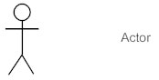

**Relationships**   
Illustrate relationships between an actor and a use case with a simple line. For relationships among use cases, use arrows labeled either "uses" or "extends." A "uses" relationship indicates that one use case is needed by another in order toperforma task. An "extends"relationship indicates alternative options under a certain use case.

<<include>>

<<extends>>

## 3.1 FUNCTIONS OF THE SYSTEM:-

## 1)Use-case Diagram of PMS:-

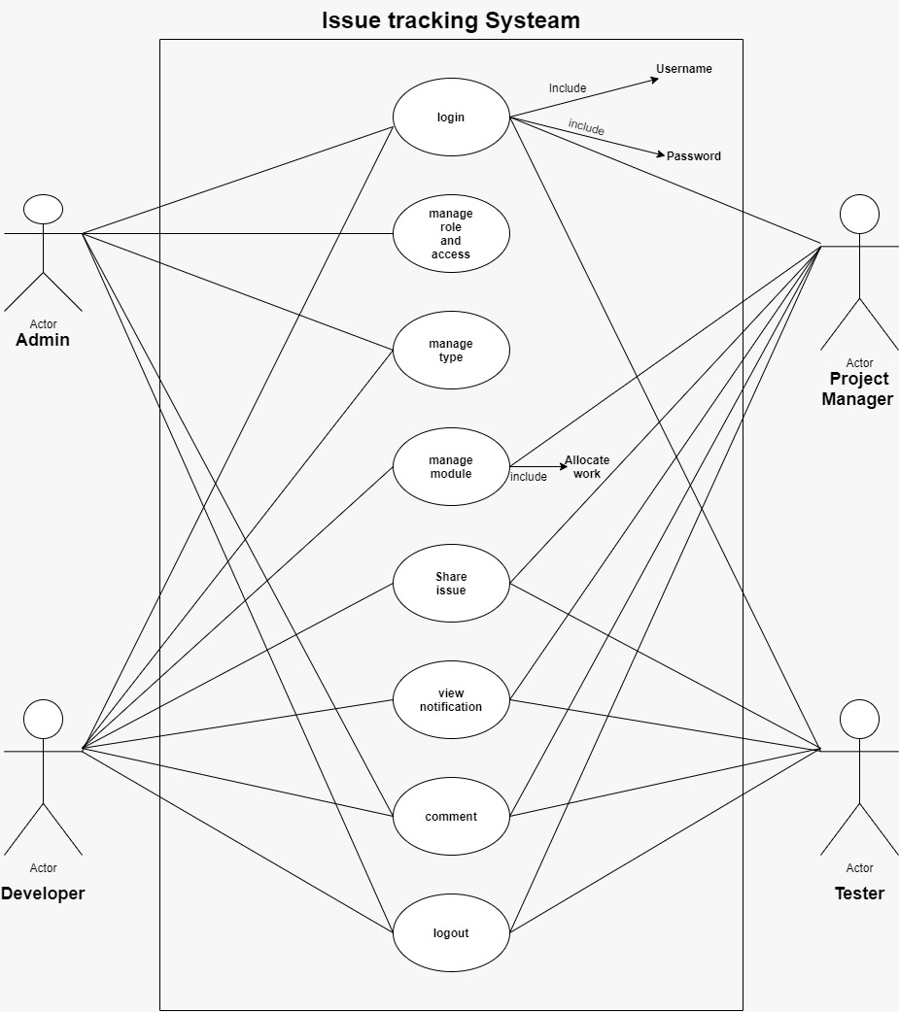

## 2)Class Diagram of PMS:-

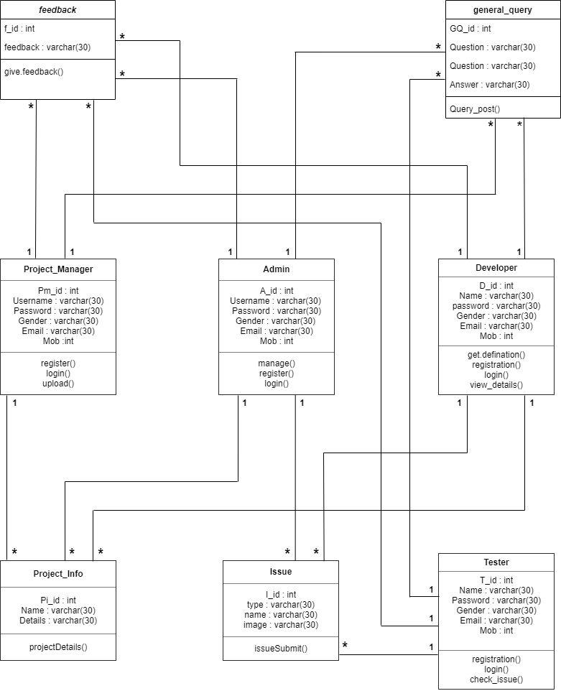

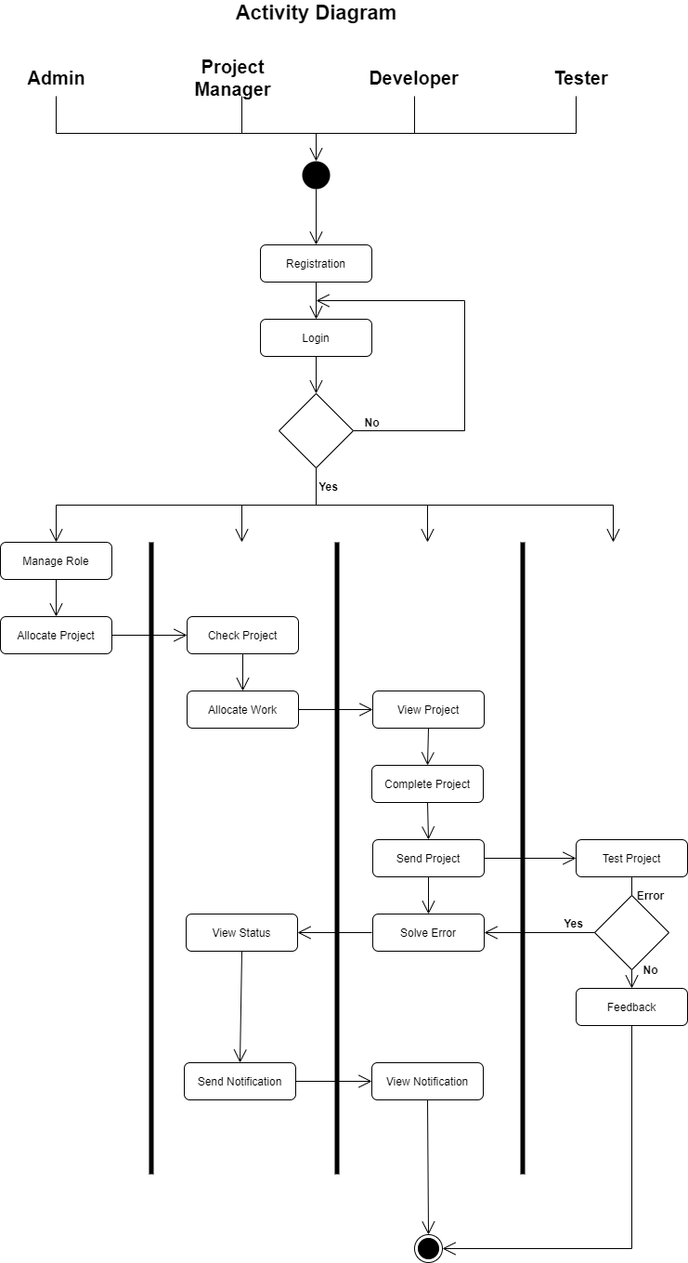

**Data Dictionary**

**Registration Table**

|  |  |  |  |  |  |
| --- | --- | --- | --- | --- | --- |
| Sr No | Field Name | Datatype | Size | Constraint | Description |
| 1 | R_id | Integer | 3 | Primary Key | This is unique field for Registration Table |
| 2 | Usertype | Varchar | 15 |  |  |
| 3 | Username | Varchar | 30 |  |  |
| 4 | Password | Varchar | 30 |  |  |
| 5 | Gender | Varchar | 30 |  |  |
| 6 | Email | Varchar | 30 |  |  |
| 7 | Mob | Integer | 10 |  |  |

**Issue Table**

|  |  |  |  |  |  |
| --- | --- | --- | --- | --- | --- |
| Sr No. | Field Name | Datatype | Size | Constraint | Description |
| 1 | I_id | Integer | 3 | Primary Key | This is unique field for IssueTable. |
| 2 | R_id | Integer | 3 | Foreign Key | This is reference field for Registration Table |
| 3 | Issue_type | Varchar | 30 |  |  |
| 4 | Issue_Name | Varchar | 30 |  |  |
| 5 | Issue_image | Varchar | 30 |  |  |

**Project_Info Table**

|  |  |  |  |  |  |
| --- | --- | --- | --- | --- | --- |
| Sr No. | Field Name | Datatype | Size | Constraint | Description |
| 1 | Pi_id | Integer | 3 | Primary Key | This is unique field for Project_InfoTable. |
| 2 | R_id | Integer | 3 | Foreign Key | This is reference field for Registration Table |
| 3 | Name | Varchar | 100 |  |  |
| 4 | Details | Varchar | 300 |  |  |

**General Query Table**

|  |  |  |  |  |  |
| --- | --- | --- | --- | --- | --- |
| Sr No. | Field Name | Datatype | Size | Constraint | Description |
| 1 | Gq_id | Integer | 3 | Primary Key | This is unique field for General_QueryTable. |
| 2 | R_id | Integer | 3 | Foreign Key | This is reference field for Registration Table |
| 3 | Question | Varchar | 300 |  |  |
| 4 | Answer | Varchar | 300 |  |  |

**Feedback Table**

|  |  |  |  |  |  |
| --- | --- | --- | --- | --- | --- |
| Sr No. | Field Name | Datatype | Size | Constraint | Description |
| 1 | F_id | Integer | 3 | Primary Key | This is unique field for FeedbackTable. |
| 2 | R_id | Integer | 3 | Foreign Key | This is reference field for Registration Table |
| 3 | Feedback | Varchar | 30 |  |  |

**7. Conclusion**

Thus we conclude that we enjoyed very much working on the project **“PROJECT MANAGEMENT SYSTEM”** our internal **guide Prof. Himani** helped us a lot in improving the quality of our project.

This is just the stepping stones for project development there is new paths to be discovered and there are new goals that are to be archived.

**8. Bibliography**

**Books**

* + - Python books
    - Django Framework

**Websites**

* + - www.google.com
    - https://stackoverflow.com/