
User Guide, Privacy & Operations Handbook
Practical workflows, document handling, citations, exports, backups and troubleshooting

Document | DocuLens project reference
Edition | 1.0 — generated from supplied project archive
Repository | https://github.com/Devputta/DocuLens
Scope | Documented implementation and practical operating guidance

Important: This handbook describes the supplied source archive and its documentation. It does not claim that every feature has been independently audited or that the hosted deployment is currently healthy.

How to use this guide
This handbook is for people using DocuLens to read, search, compare and extract information from documents. It describes the intended workflow and the limits to keep in mind.
- Use sample or non-sensitive documents when learning the interface.
- Keep original source files unchanged; treat extracted results as working copies.
- Verify important claims against the original page or passage.
- This guide describes the supplied project; UI labels may evolve between releases.

What DocuLens is for
DocuLens is a local-first document intelligence workbench for PDF, DOCX and TXT. It aims to help users find evidence and compare documents while keeping the main workspace in the browser.
- Read documents and inspect extracted text.
- Search for exact phrases or important terms.
- Ask questions and inspect citations to source passages.
- Extract and edit tables, inspect figures, compare revisions and export results.
- Back up local workspace data when needed.

Privacy-first operating model
Most document processing and storage occur locally in the browser. Remote AI is optional and changes what information leaves the device.
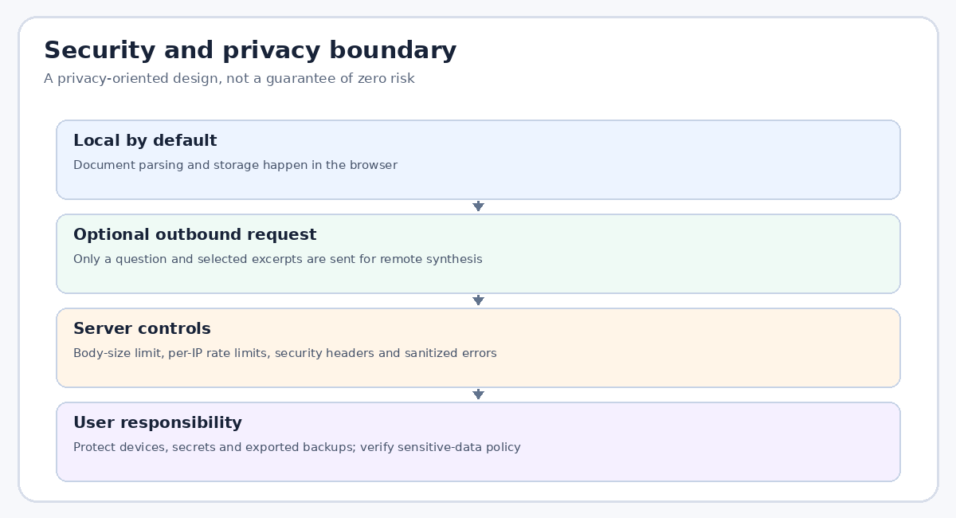
Privacy boundary overview.
- The complete PDF is not designed to be uploaded to the AI proxy.
- A remote inquiry can send the question and selected excerpts to Gemini.
- Without remote AI, a deterministic local inquiry path is designed to work where supported.
- Browser-local data is not automatically synchronized to another device.
- Use your organization's data policy to decide whether remote inquiry is allowed.

Before you begin
Use a modern browser with enough memory for the documents you plan to process. For a first run, choose a small text-based PDF to validate the workflow.
- Keep the original document available for comparison.
- Check available device storage and browser permissions.
- If deploying your own instance, ensure the production build and server are both working.
- For scanned documents, expect OCR to take longer than text-based extraction.
- Do not use the app as the only copy of important documents.

Supported document types
The project documents three main input formats. Each format has a different extraction profile and limitations.
Format | Best for | What to check
PDF | Reports, papers and manuals | Text layer, page count, scan quality
DOCX | Word documents | Headings and tables after conversion
TXT | Plain text notes and reports | Encoding, paragraph breaks and headings

Importing a document
Choose a file through the app's document-import workflow. Wait for parsing and extraction to complete before starting search or inquiry.
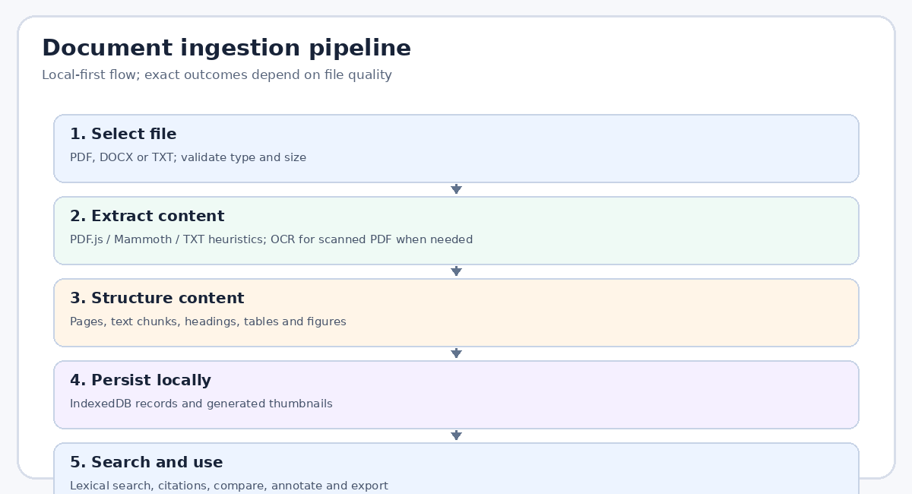
Document ingestion stages.
- Prefer a clean, readable file name.
- Stay within the documented PDF limit of 25 MB and 500 pages.
- If a file fails, verify that it opens in a normal reader and is not encrypted or corrupted.
- Avoid repeatedly importing duplicates unless you need separate working copies.
- After import, check the page count and document status.

Understanding PDF extraction
Text-based PDFs usually produce better search and citation results than scanned pages. A PDF may mix selectable text, scanned images and diagrams.
- Check whether text can be selected in a normal PDF reader.
- Scanned pages may need OCR; verify names, numbers and punctuation.
- Complex columns and footnotes can be extracted in an unexpected order.
- Use page navigation to confirm an important passage in the original layout.
- OCR text is a convenience layer, not an authoritative replacement for the page image.

Understanding DOCX extraction
DOCX content is converted locally through Mammoth. The extracted text is useful for reading and search, but the original Word layout may not be reproduced exactly.
- Check headings and paragraph order.
- Inspect tables for merged cells or multi-level headers.
- Verify footnotes, captions and text boxes against the original file.
- Keep the original DOCX when formatting or exact page layout matters.
- Do not assume extracted pagination matches Word pagination.

Understanding TXT and virtual pages
TXT files are divided using paragraph breaks and heading heuristics. The reader may display virtual or reflowed pagination.
- Blank lines can define paragraph boundaries.
- ALL-CAPS and numbered headings may be recognized heuristically.
- Virtual page labels do not correspond to pages in a printed source.
- For stable citations, preserve the original text file and section structure.
- If paragraph breaks are missing, clean the text before import where practical.

Scanned documents and OCR
OCR converts pixels into searchable text. Results depend on scan quality, orientation, contrast, language and typography.
- Use clear scans with adequate resolution.
- Rotate pages upright before import if possible.
- Review numeric values, legal names, dates and citations manually.
- The bundled language model is English; multilingual OCR needs separate configuration.
- If OCR text is absent, check that the local language asset is available.

Workspace and document library
The local workspace organizes imported documents and related extracted information. The browser's IndexedDB stores workspace data for the same origin/profile.
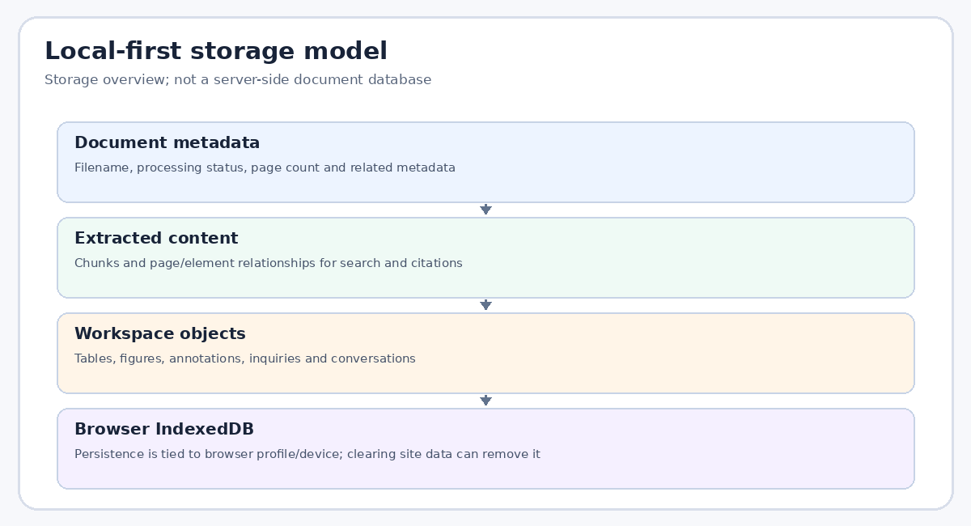
Local storage overview.
- Use clear file names so documents can be distinguished.
- Reload the app to verify persistence after import.
- Avoid clearing site data unless you have a backup.
- Browser profiles and devices do not share local storage automatically.
- If the browser reports storage pressure, export a backup and remove unneeded items carefully.

Reading and navigating
Use the reader to move through a document and inspect the context around a passage. Search or inquiry results are more trustworthy when the surrounding text is reviewed.
- Confirm the document name before following a citation.
- Read the paragraph before and after the quoted evidence.
- Check page numbers in the original PDF when exact pagination matters.
- For virtual TXT pages, use headings and paragraph context instead of print-page assumptions.
- Return to the original file for final verification.

Search effectively
Lexical search ranks text by term and phrase overlap. It is useful for locating terminology, names, section titles and repeated wording.
- Start with a distinctive exact phrase when you know the wording.
- Try synonyms or alternate terminology if results are sparse.
- Use a section heading as a query when looking for a specific topic.
- Open results and inspect context instead of trusting the rank alone.
- A low rank does not prove that a passage is irrelevant.

Find and highlight
The reader includes a find/highlight workflow with occurrence counts and automatic navigation as described by the project documentation.
- Use a short distinctive phrase first.
- Check occurrence count to understand whether a term is common.
- Navigate among highlighted occurrences and inspect the surrounding text.
- If the phrase is not found, try a shorter stem or alternative spelling.
- Text extraction errors can prevent a visually present word from being searchable.

Asking a document question
Use inquiry when you need a concise answer grounded in the documents already imported. Keep questions specific enough to retrieve evidence.
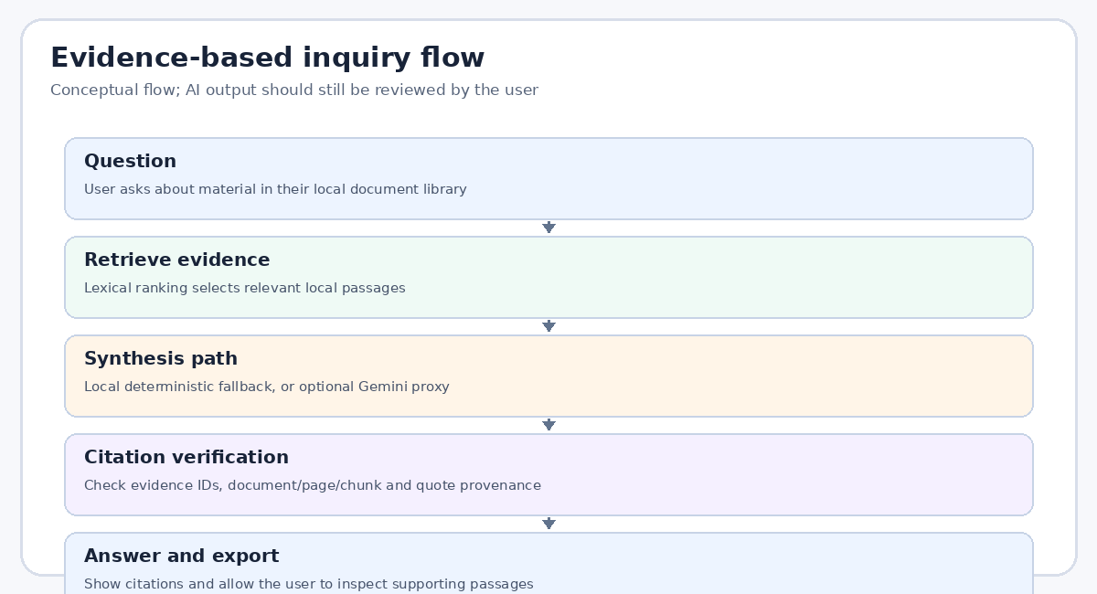
Inquiry workflow.
- Ask one focused question at a time.
- Name the document or topic when several files overlap.
- Ask for the source or page when the answer must be auditable.
- Open every citation used for a consequential decision.
- If the answer is incomplete, reformulate the question or search directly.

Reading citations responsibly
Citations connect an answer to extracted evidence, but citation presence alone is not proof that the claim is correct or complete.
- Follow each evidence token to the source passage.
- Check that the quote supports the specific statement made.
- Watch for missing context, exceptions, tables or footnotes.
- Treat OCR errors as possible source-text errors.
- For legal, medical, financial or compliance decisions, independently review the original document.

Offline and remote inquiry modes
When remote AI is unavailable or not configured, the project is designed to use deterministic local synthesis. Remote synthesis may provide a different style of answer but introduces a data-transfer boundary.
Mode | Data path | User consideration
Local fallback | Browser-local retrieval and synthesis | May be less fluent or less comprehensive
Remote Gemini | Question and selected excerpts sent to proxy/provider | Check sensitivity and provider policy
Unavailable server | Local path where supported | Some remote-only capabilities may be unavailable

Notes and annotations
Annotations help preserve the user's interpretation and follow-up work alongside source material. Treat them as part of the workspace data.
- Write notes that distinguish your own interpretation from source quotations.
- Include a source page or section when recording a conclusion.
- Avoid placing passwords or secrets in notes.
- Back up notes with the workspace when the feature is available.
- Review annotations after comparing document revisions.

Working with tables
Table extraction reconstructs rows and columns from document structure or coordinates. The result is a draft representation that may need correction.
- Check the header row and column order.
- Review numbers, negative signs, decimal points and dates.
- Watch for merged cells, footnotes and wrapped text.
- Edit cells or rows before export where supported.
- Compare important totals with the source document.

Exporting tables to CSV
CSV is a portable text format for spreadsheets and data tools. The project documents RFC-4180-compatible export and defenses against formula injection.
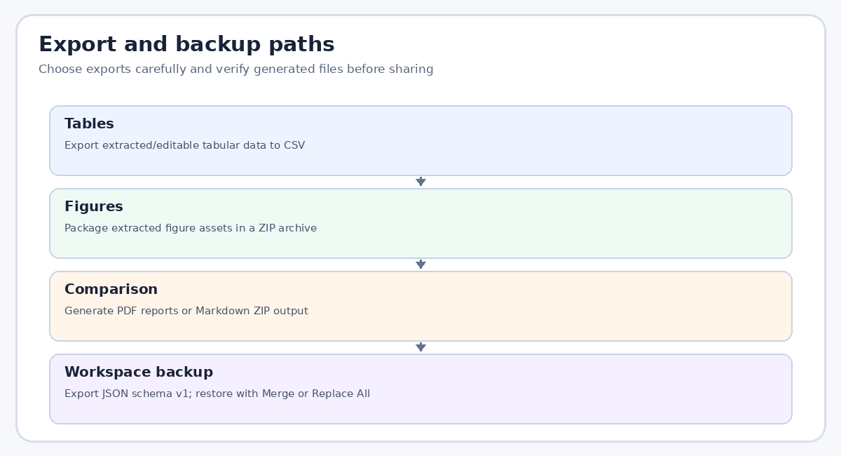
Export options overview.
- Open the exported CSV in a trusted spreadsheet or text editor.
- Confirm commas, quotes and newlines are represented correctly.
- Review cells beginning with formula-triggering characters before sharing.
- Check date and numeric formatting after spreadsheet import.
- Do not assume CSV preserves formatting, merged cells or formulas from the source.

Working with figures
Figures may be extracted from embedded raster images, vector drawings or page scans. OCR can make some diagram text searchable.
- Open figures at a readable size.
- Check legends, axis labels and footnotes in the source page.
- OCR text order may not match the diagram's visual layout.
- Do not infer a chart's values from extracted text alone.
- Use the original figure for presentation or publication.

Comparing documents
Use comparison to find similarities and differences, then verify each finding in the source documents. Choose the comparison mode that matches your question.
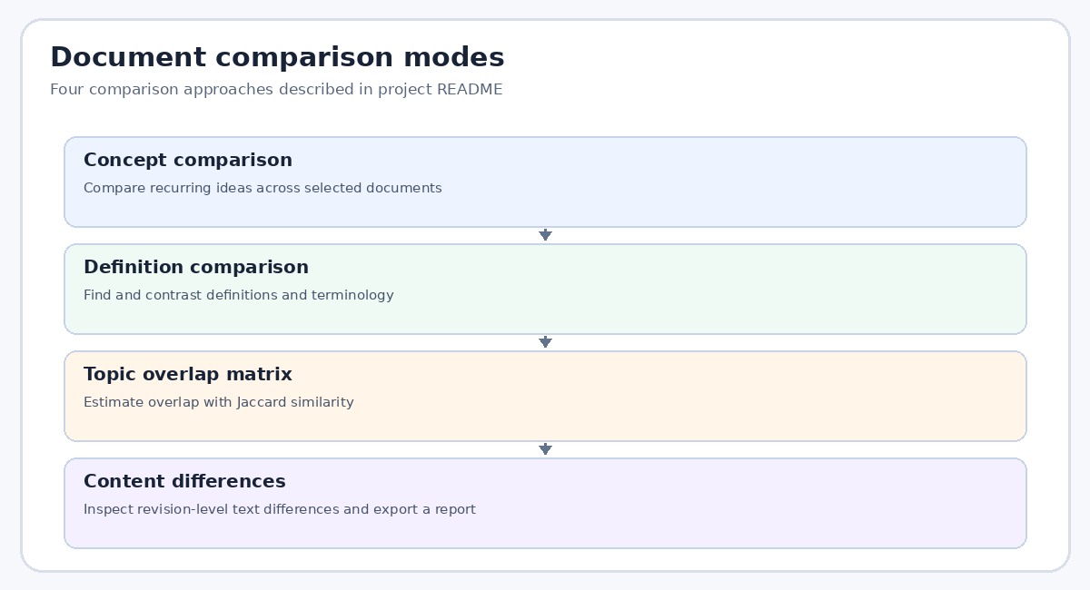
Comparison modes.
Mode | Useful question | Best practice
Concept | Which themes recur? | Inspect representative passages
Definition | How is a term defined? | Compare context and qualifiers
Topic overlap | Which topics overlap? | Treat similarity as a lexical indicator
Revision diff | What text changed? | Check extraction and formatting artifacts

Concept and definition comparison
Concept comparison looks for recurring ideas; definition comparison looks at how a term is described. These outputs are aids for review, not final interpretation.
- Choose a relevant set of documents rather than the entire library.
- Check whether the same term has different meanings by domain.
- Read the source paragraphs for qualifications and exceptions.
- Record disagreements instead of forcing a single definition.
- Export or note the source locations for later review.

Topic overlap and revision differences
A Jaccard overlap score estimates shared terms relative to the union of terms. Revision diff shows textual changes between versions.
- A high overlap score does not mean the documents agree.
- A low score may result from synonyms or different writing styles.
- A text diff may show changes caused by extraction order or OCR.
- Review surrounding context before deciding whether a change is meaningful.
- Keep the original versions for auditability.

Exporting comparison reports
The project describes PDF comparison reports and Markdown ZIP archives. Check the generated report before distribution.
- Verify document names and comparison settings.
- Open embedded figures to confirm readability.
- Check page breaks and citation/source labels.
- Avoid sharing reports containing confidential excerpts with unauthorized recipients.
- Retain a copy of the input versions for reproducibility.

Backup your workspace
The project describes a single-file JSON backup with schema version 1. A backup can contain document text, extracted elements, notes and inquiry history.
- Create a backup before browser resets, device migration or risky updates.
- Store it somewhere secure and accessible only to authorized people.
- Use a descriptive date-based filename.
- Do not commit backup files to a public repository.
- Test the restore workflow with a safe sample before relying on it.

Restore: Merge versus Replace All
Restore behavior offers conflict handling. The exact choice should reflect whether the existing local workspace must be preserved.
Option | Intent | Caution
Merge | Combine backup records with current workspace under conflict rules | Check duplicate/conflicting records
Replace All | Replace current workspace data with backup data | May overwrite current local data

Install as a PWA and work offline
DocuLens is described as an installable PWA with service-worker caching. Offline availability depends on successful initial caching and browser support.
- Open the site online at least once before testing offline use.
- Use the browser's install option when available.
- Test offline mode with a non-sensitive sample document.
- If a new version is released, reload to receive updated assets.
- Some remote AI features require network access even when the document workspace is local.

Troubleshooting common problems
Use a step-by-step approach: note the exact symptom, check the browser console or server logs, and change one cause at a time.
Symptom | Likely check
Blank page / 404 | Verify dist/index.html exists and server static path is correct
Import fails | File type, size, corruption or encryption
No OCR text | Language asset path, scan quality and browser console
No search results | Try alternate terms and check extraction
Remote AI disabled | Server-side API key and deployment configuration
429 response | Wait for rate-limit window to reset

