Week 1 – Problem 1

Graph –

M2 and K12 has been set in such a manner so that the oscillation of y1 is less.

System run for 100 seconds -

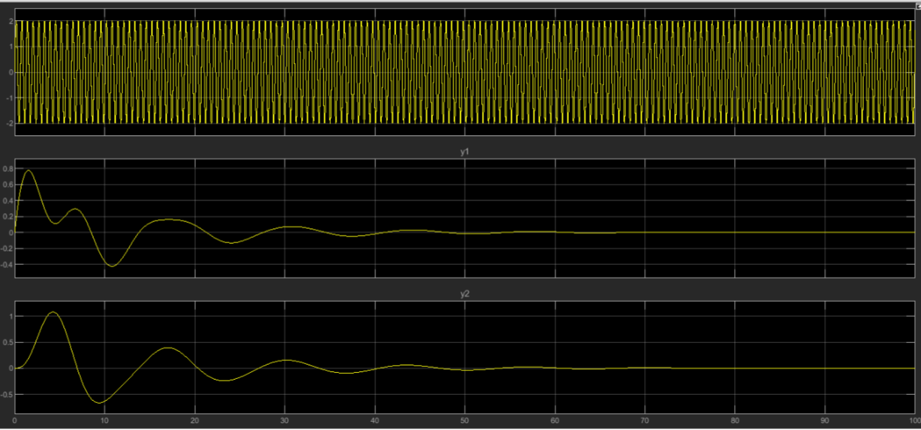

For 10 seconds –

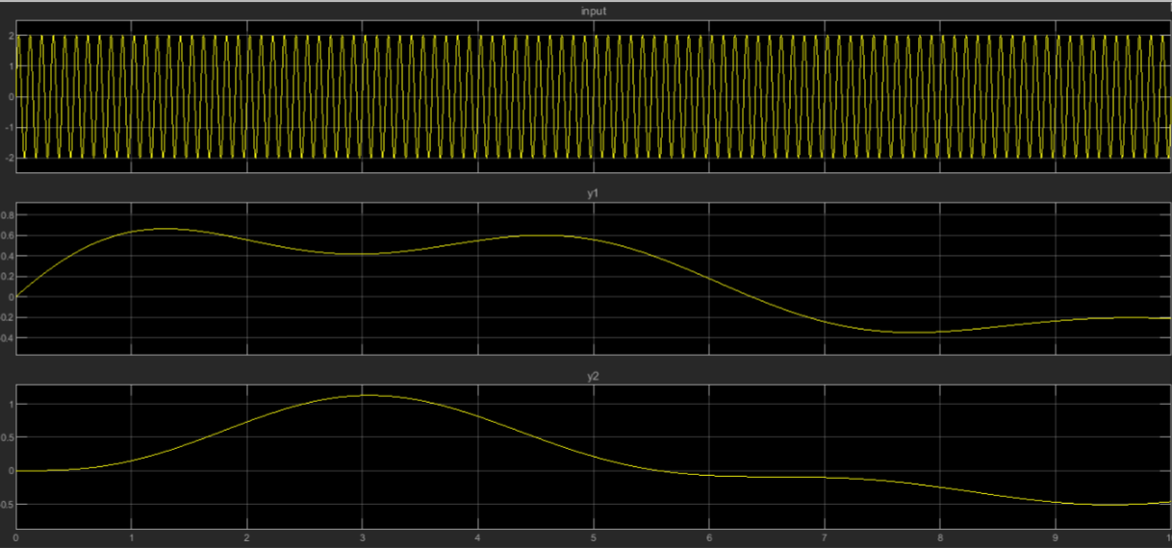

References –

Nagoorkani Book – Chapter 1 – Mathematical model of control system