Week 1 – Problem 10

Graph –

The values of Forward Bias and Reverse Bias voltage and current:

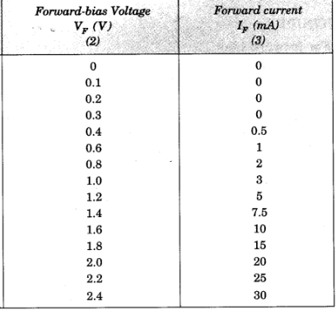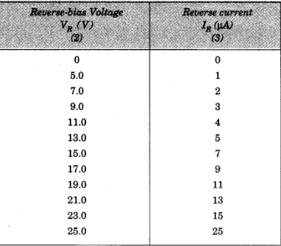

X- axis : Voltage

Y-axis : Current

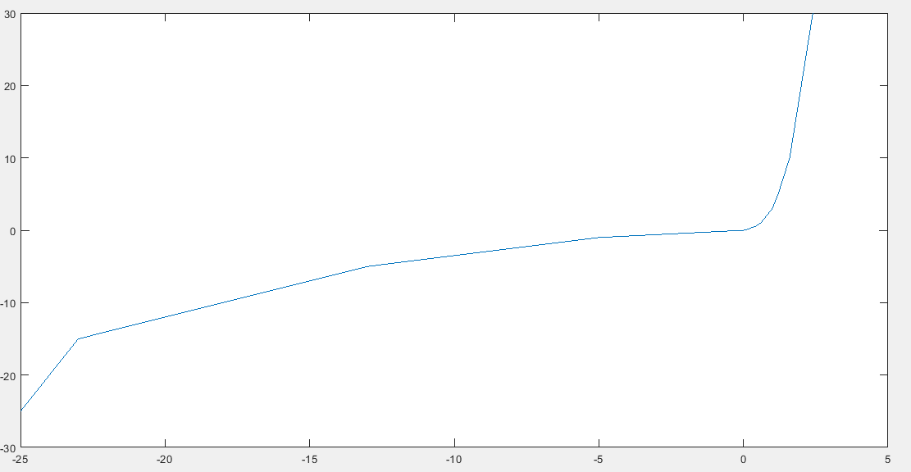

References –

LookUp Table – Articulate video

<https://www.youtube.com/watch?v=HmfwKoFHrO4&feature=emb_logo>

Collected Data of Forward Bias and Reverse Bias from –

<https://www.learncbse.in/to-draw-the-i-v-characteristic-curve-of-a-p-n-junction-in-forward-bias-and-reverse-bias/>