Week 1 – Problem 2

Graph –

The input signal is given a noise by writing a code in Matlab script to show the bumpy road.

The input signal is noise and displacement of M1(vehicle) and M2(tyre) are y1 and y2 is shown :

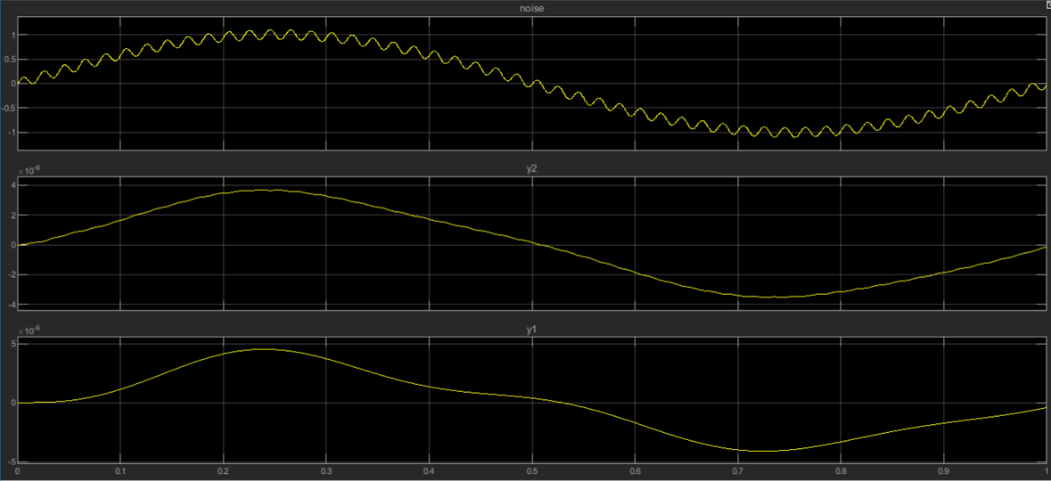

References :

Robust control of an active suspension-

<https://in.mathworks.com/help/robust/gs/active-suspension-control-design.html>

Suspension matlab modelling -

<https://ctms.engin.umich.edu/CTMS/index.php?example=Suspension&section=SystemModeling>

<https://www.longdom.org/open-access/analysis-of-automotive-passive-suspension-system-with-matlab-program-generation-0976-4860-4-115-119.pdf>

Research papers referred :

The papers has been uploaded in git.