Week 1 – Problem 3

Graph –

The sampling time is set at 1/5000 since the frequency is given as 5000 Hz.

1. Frequency – 100Hz

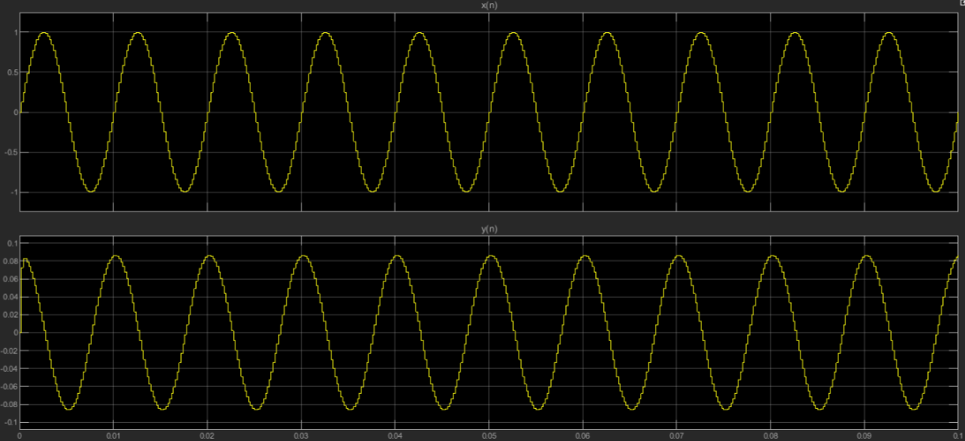

1. Frequency – 300Hz

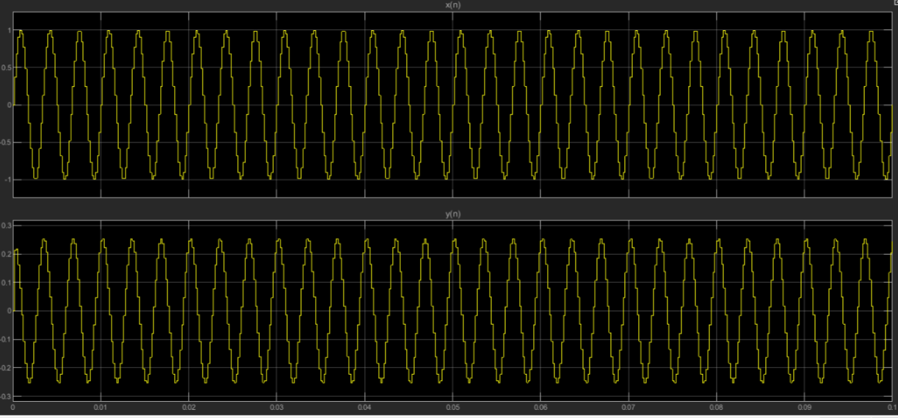

1. Frequency – 500Hz

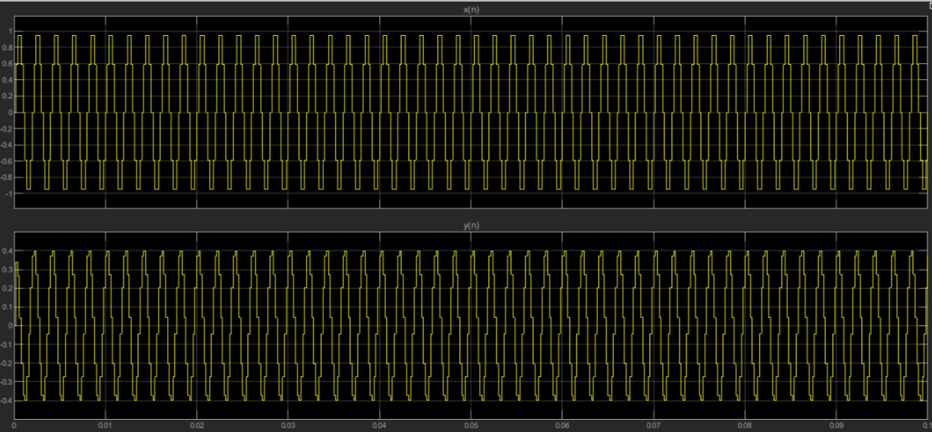

1. Frequency – 760Hz

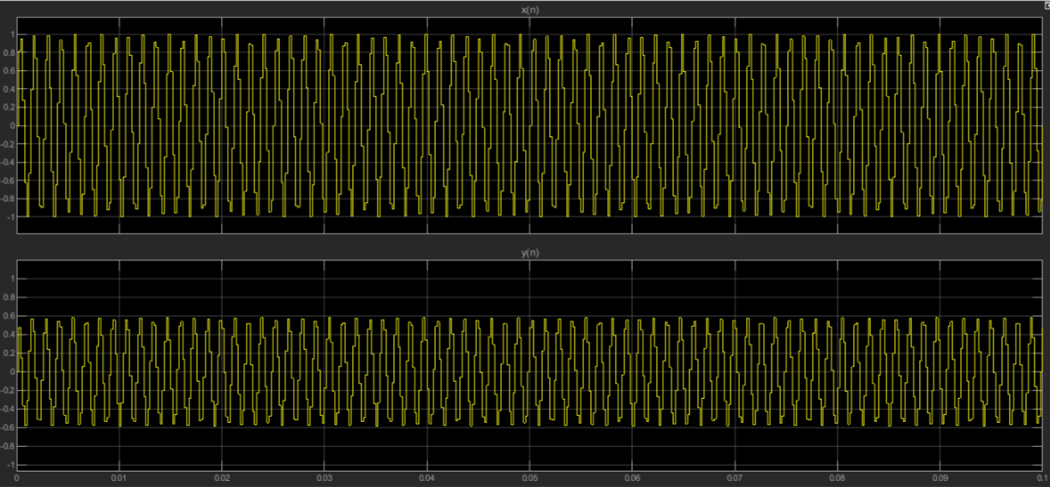

1. Frequency – 1000Hz

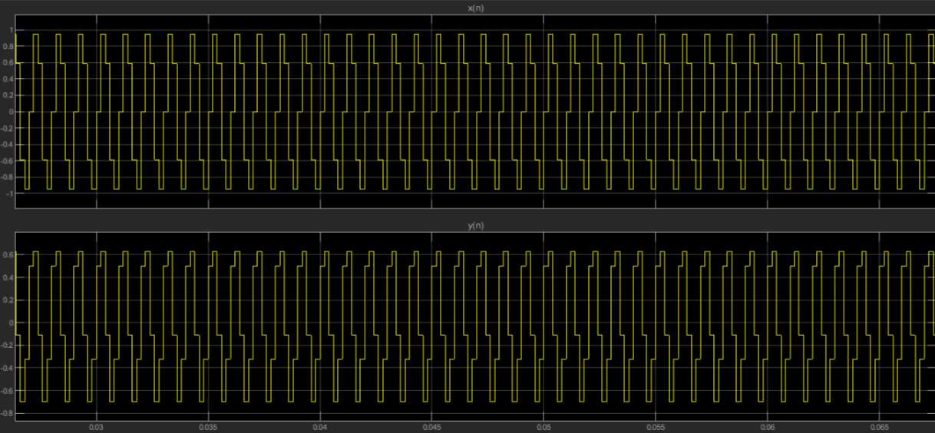

References :

Ramesh Babu – Discrete Transform Signal Processing