Week 1 – Problem 4

Graph –

The high pass filter has been drawn and the response of the filter is shown at y(n) :

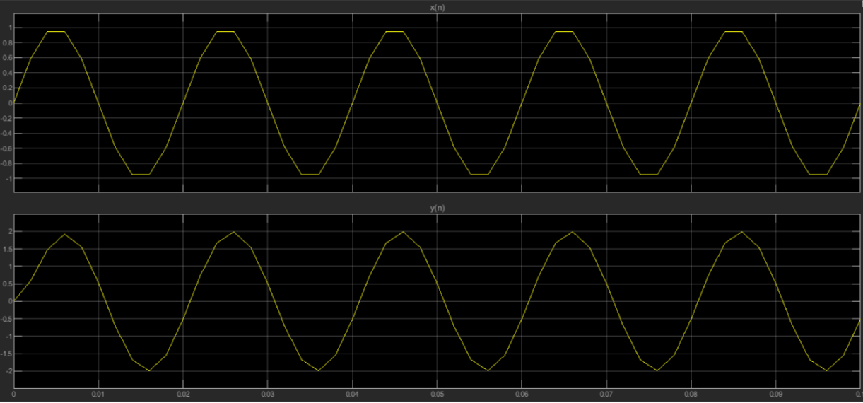

References :

Ramesh Babu – Discrete Time Signal Processing