Week 1 – Problem 5

Graphs has been recorded for 5 different input with 5 different initial condition

1. Repeating sequence stairs – Input ( Initial condition of Integrator is 0).

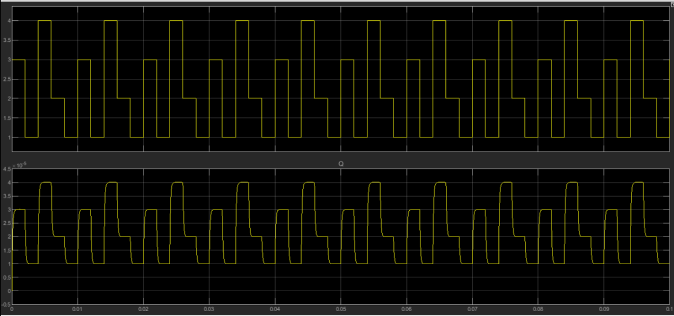

1. Sine wave – Input ( Initial condition of Integrator is 1).

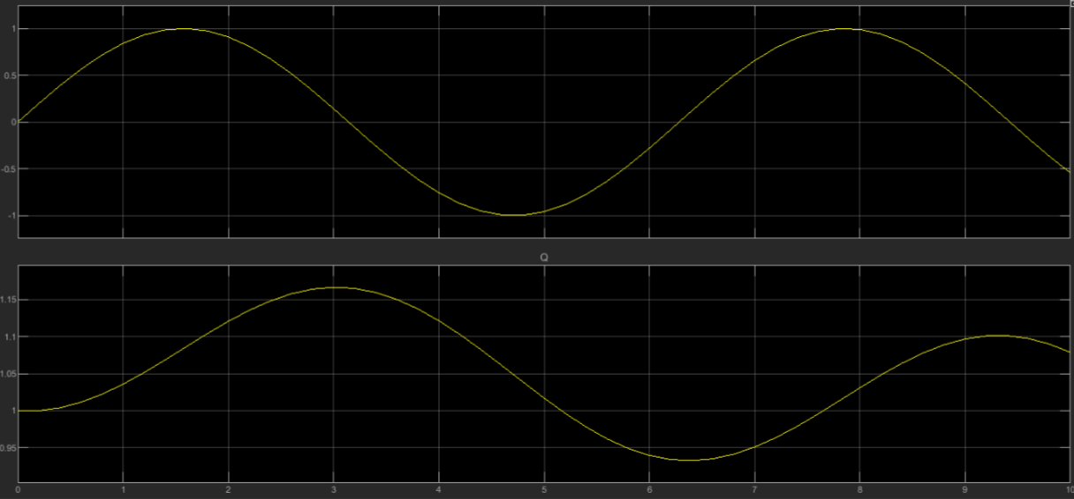

1. Step signal – Input ( Initial condition of Integrator is 2).

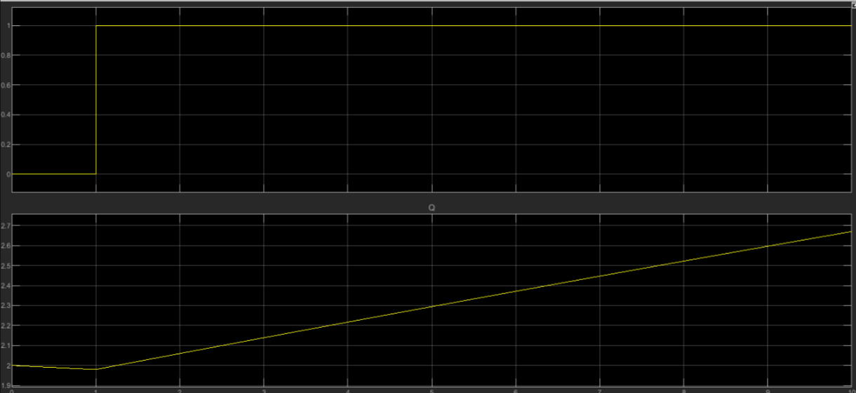

1. Ramp signal – Input ( Initial condition of Integrator is 3).

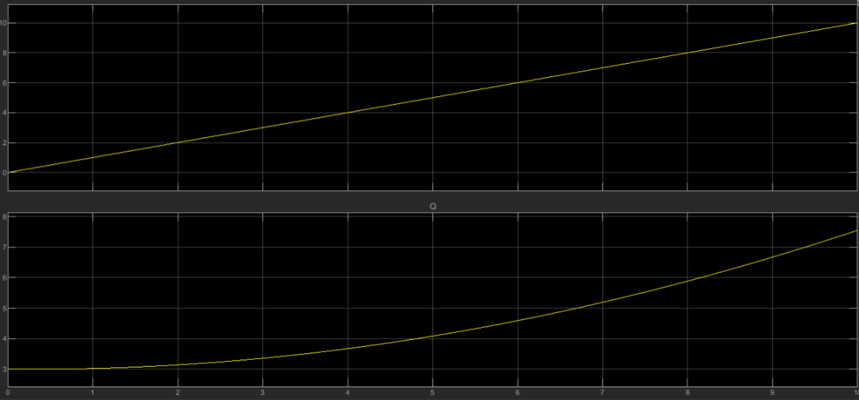

1. Pulse signal – Input ( Initial condition of Integrator is 4).

