Week 1 – Problem 5

Graph –

1. When the input is repeating sequence and the initial condition of integrator is 0.

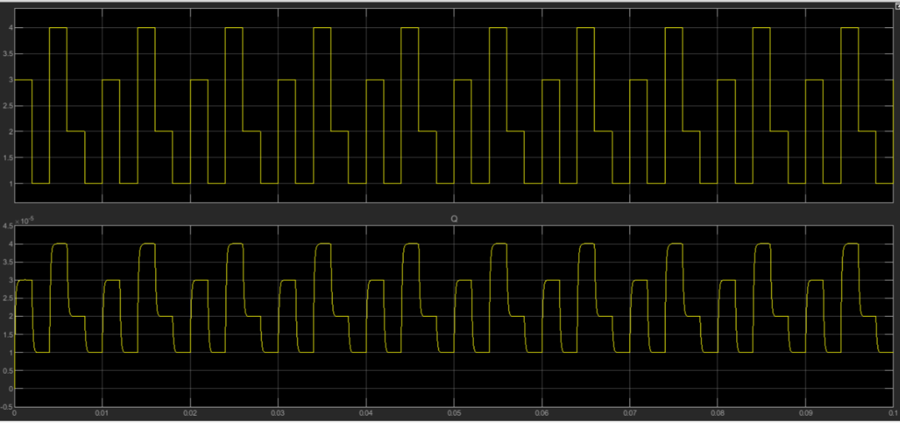

1. When the input is sine wave and the initial condition of integrator is 1.

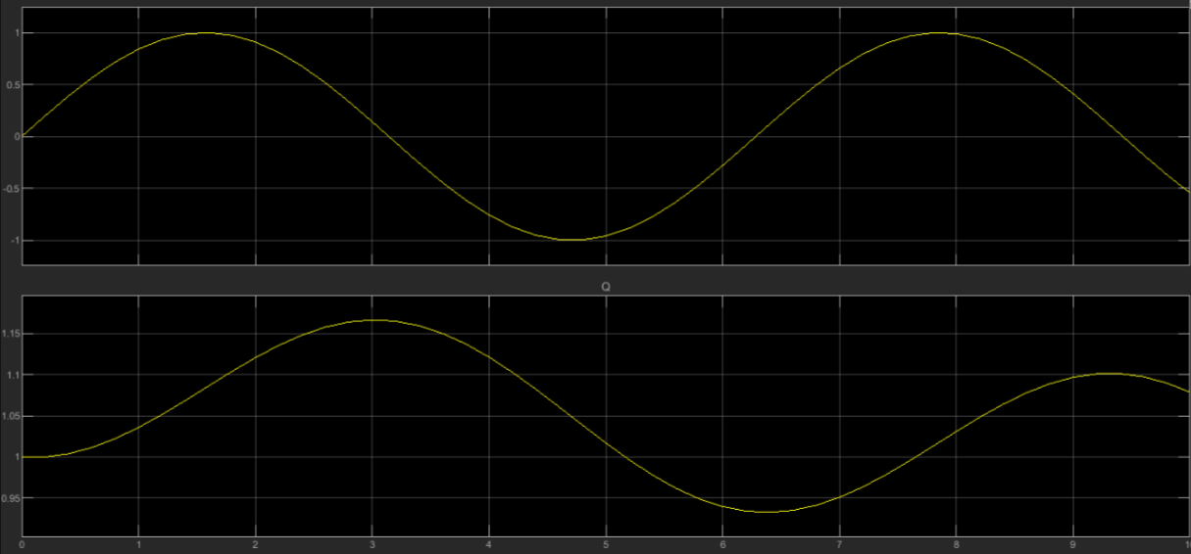

1. When the input is step signal and the initial condition of integrator is 2.

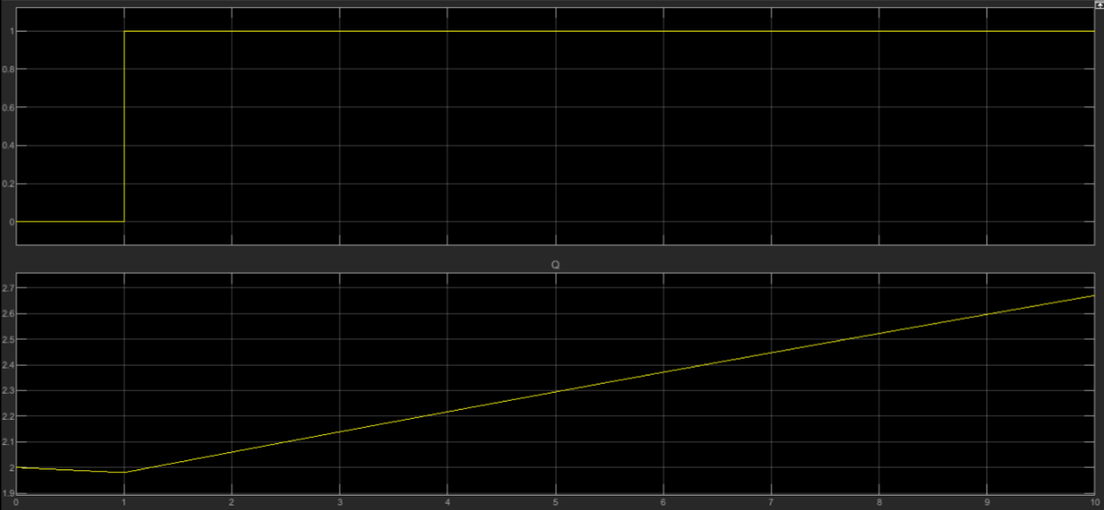

1. When the input is ramp signal and the initial condition of integrator is 3.

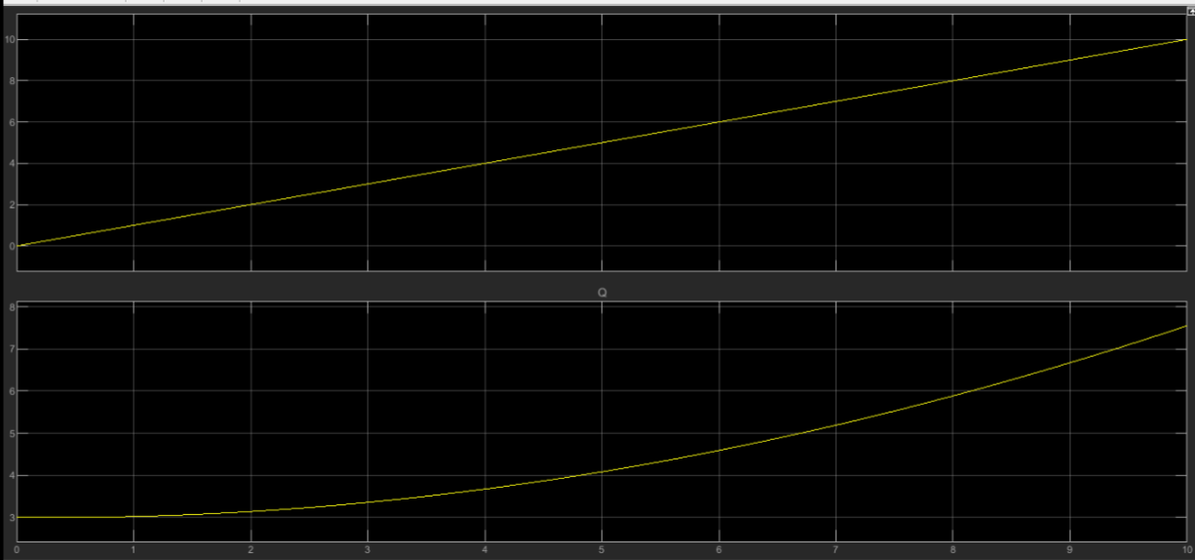

1. When the input pulse signal and the initial condition of integrator is 4.

