Week 1 – Problem 6

Graph –

1. When the Input is Pulse -

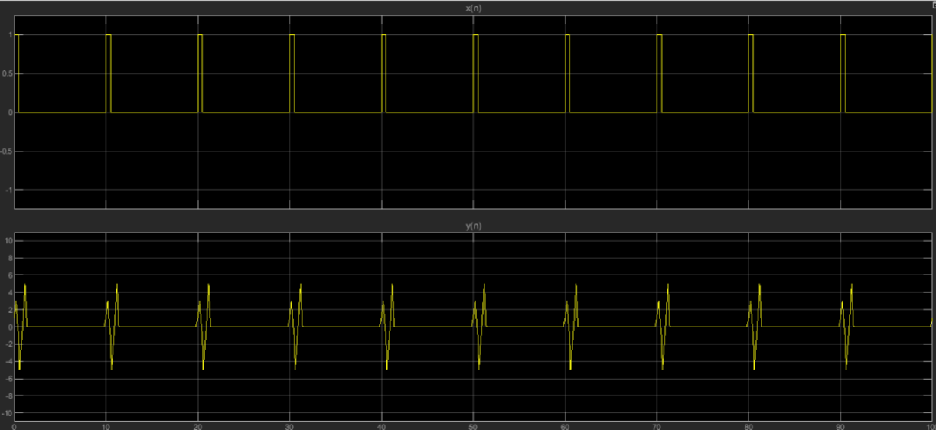

1. When the input is sine wave –

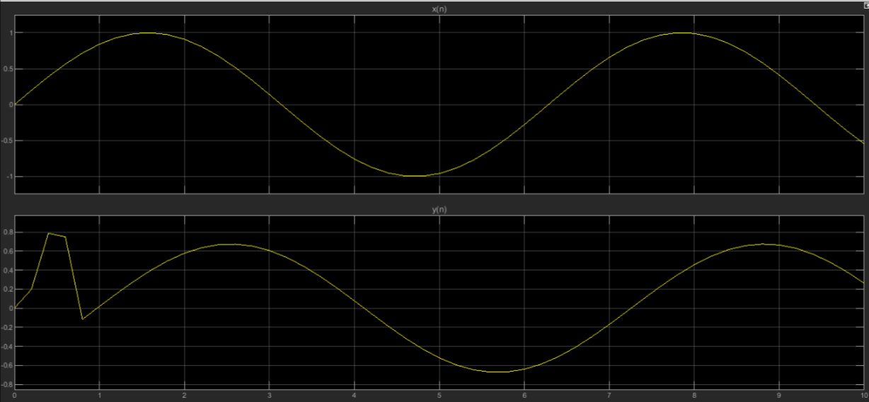

References –

Matlab Documentation of Direct Form Filter

Ramesh Babu – Discrete Transform Signal Processing