Week 1 – Problem 7

Graph –

1. When the Input is Pulse -

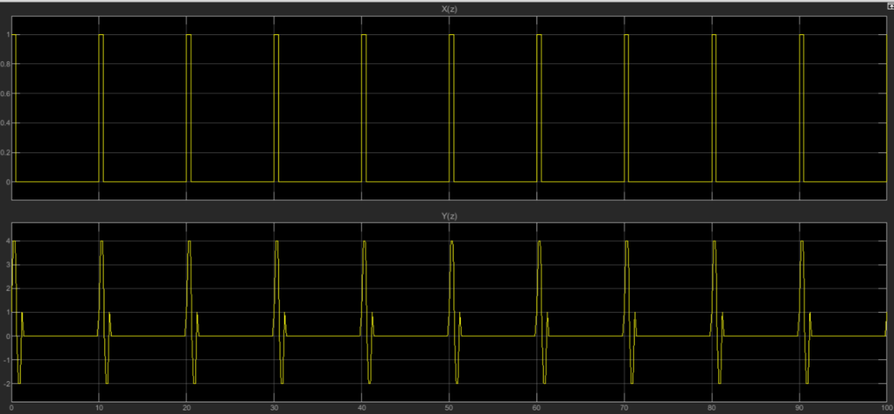

1. When the input is sine wave –

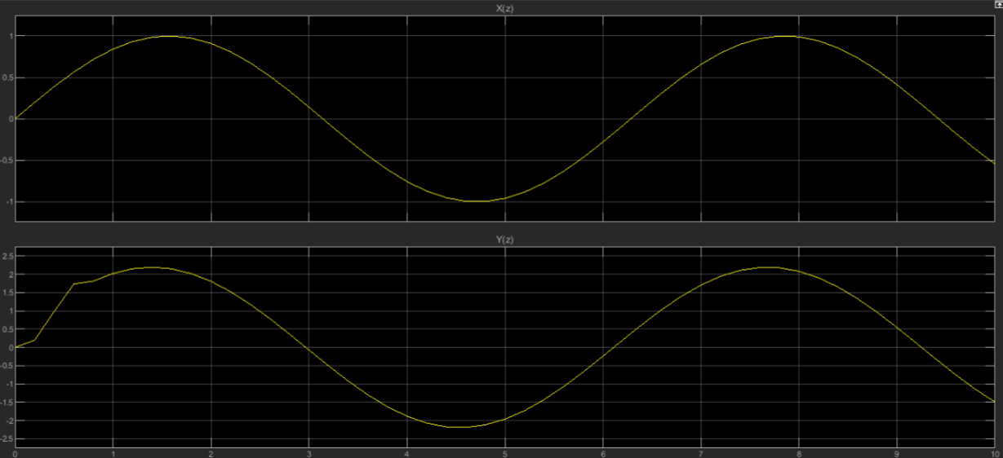

References –

Youtube link - <https://www.youtube.com/watch?v=oYYHJrwGPrc>

Matlab Documentation of Cascade form

Ramesh Babu – Discrete Transform Signal Processing