Week 1 – Problem 9

2 models of BLDC has been designed.

1st model –

Input is Load.

Motor has been set to 40,000 rpm.

**Graph** –

Rotor speed:

Conditions given :

0 to 1 sec – Running condition ( +40,000 rpm in graph)

1 to 2 sec – Reverse Brake (-40,000 rpm in graph)

After 2 sec – Brake (settled to 0 – motor stopped running)

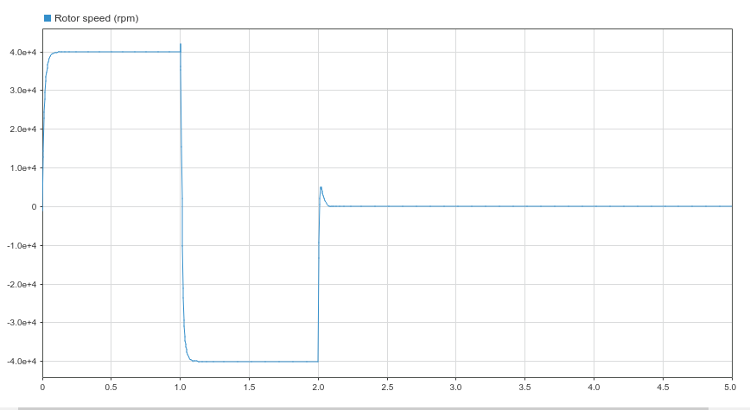

Effeciency –

Conditions given :

0 to 1 sec – Running condition ( +40,000 rpm in graph)

1 to 2 sec – Reverse Brake (-40,000 rpm in graph)

After 2 sec – Brake (settled to 0 – motor stopped running)

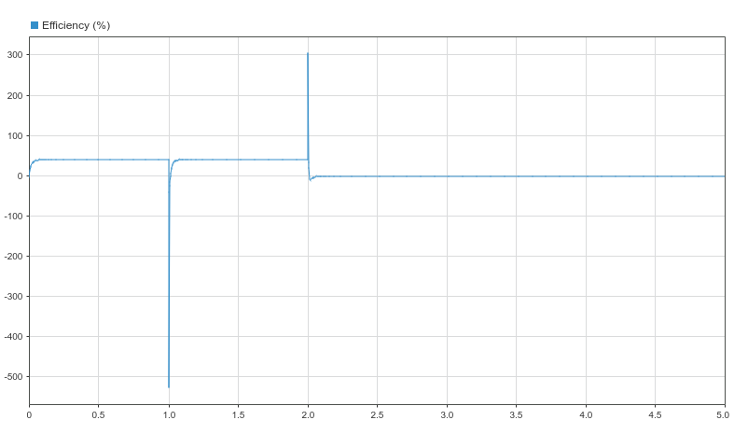

2nd model –

Input – Speed (3000 rpm)

Graph –

Rotor Speed :

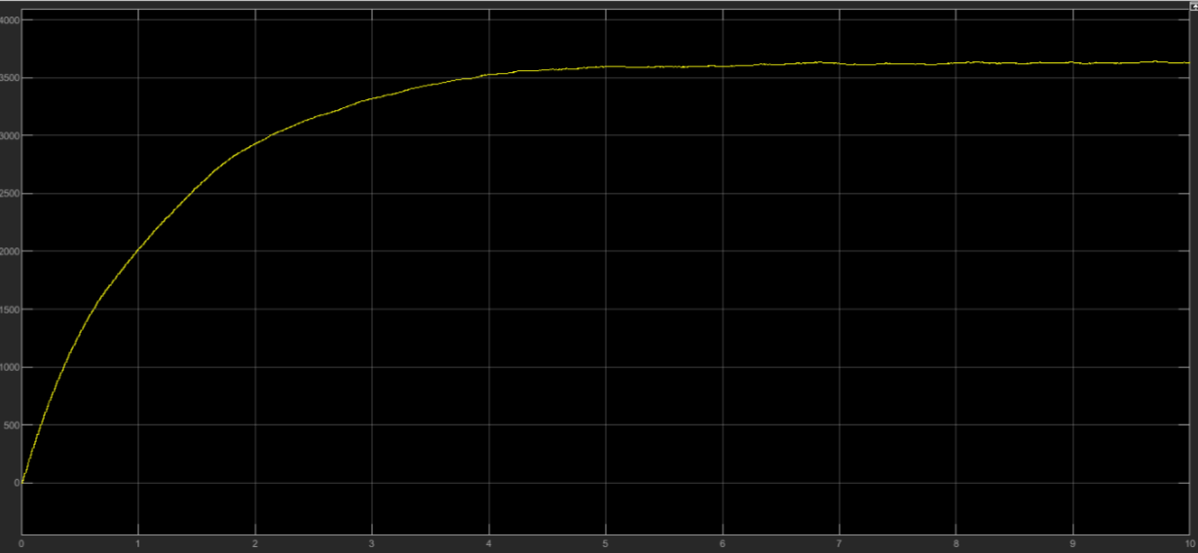

References :

MATLAB Documentation

* <https://in.mathworks.com/help/physmod/sps/ug/brushless-dc-motor.html>

Papers referred –

<file:///C:/Users/hp/Downloads/SpeedControlofBLDCMotorusingPWMTechnique.pdf>

<https://www.irjet.net/archives/V2/i8/IRJET-V2I834.pdf>

<http://webfiles.portal.chalmers.se/et/MSc/BaldurssonStefanMSc.pdf>

youtube link –

<https://www.youtube.com/watch?v=KurVsueM4fg&t=600s>