Week 3 _ Problem 1

References :

1. Modelling a Vending Machine using Mealy Semantics - <https://in.mathworks.com/help/stateflow/ug/model-a-vending-machine-using-mealy-semantics.html>
2. Mealy and Moore Semantics – <https://in.mathworks.com/help/stateflow/ug/overview-of-mealy-and-moore-machines.html#brdsz2u>
3. Mealy and Moore State machine YouTube video - <https://www.youtube.com/watch?v=0_OZKWdCixw>

Graph –

1. When the input is uniform random number :

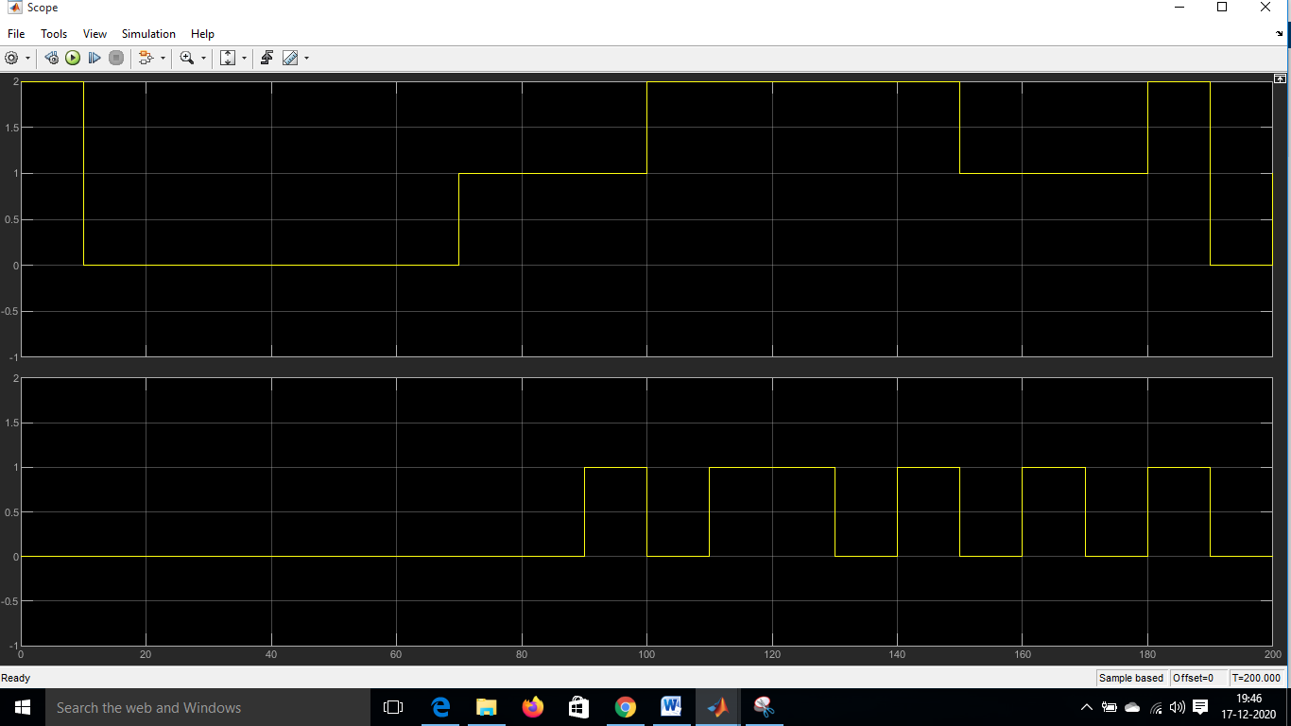

1. When the input is signal builder:

