**Creating a Pizza ordering Chatbot using Watson Conversation Slots feature**

When the reader has completed this Code Pattern, they will understand how to:

* Create a chatbot dialog with Watson Conversation
* Use the power of Conversation Slots to more efficiently populate data fields
* Use Conversation Slots to handle various inputs within one Node

## The Flow:

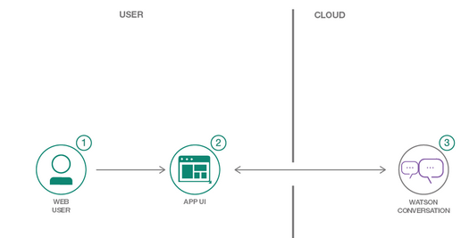

1. User sends messages to the application (running locally or on IBM Cloud).
2. The application sends the user message to IBM Watson Conversation service, and displays the ongoing chat in a web page.
3. Watson Conversation uses the Slots feature to fill out the required fields for a pizza order, and sends requests for additional information back to the running application.

**Task1: Initial Challenge:**

Change the existing dialog flow to make use of slots to reduce the number of nodes required to implement logic in your Watson Conversation Dialog and should look as below 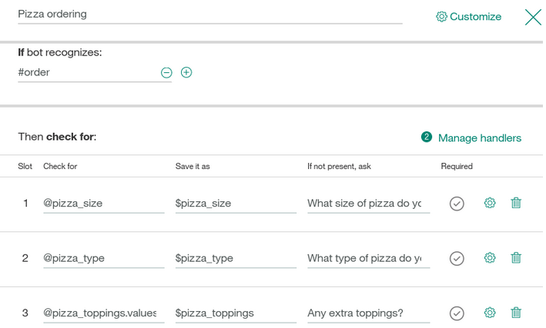

**Task2: More exploration and learning visit**-

<https://github.com/IBM/watson-conversation-slots-intro>

Instructions for creating the chatbot:

1. Login to IBM Cloud using the following link:

<http://console.bluemix.net/>

After you login you will reach a dashboard

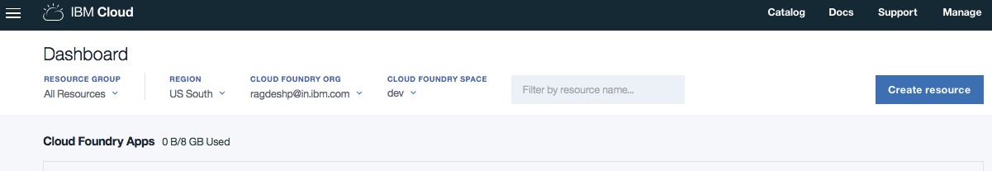

You will observe the Cloud Foundry Apps and Cloud Foundry Services

1. Click on the ‘Catalog’ from top right hand corner

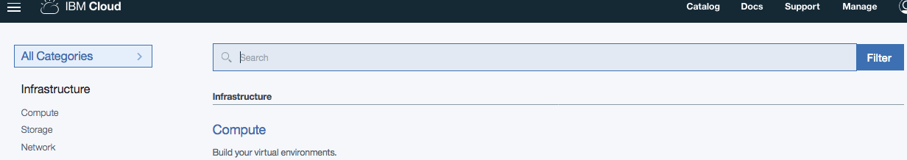

1. Search ‘Conversation’ in the search catalog

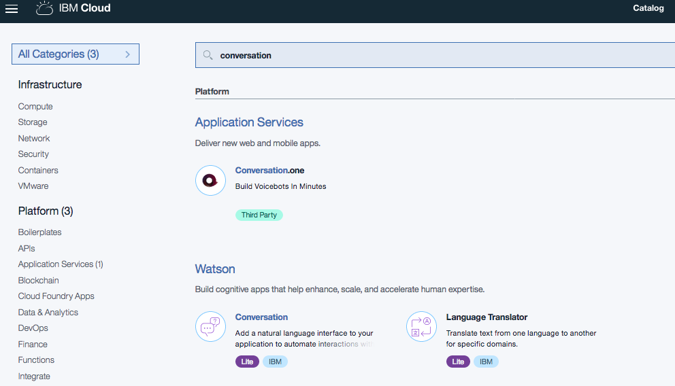

1. Click on the ‘Conversation’ service from Watson catalog.

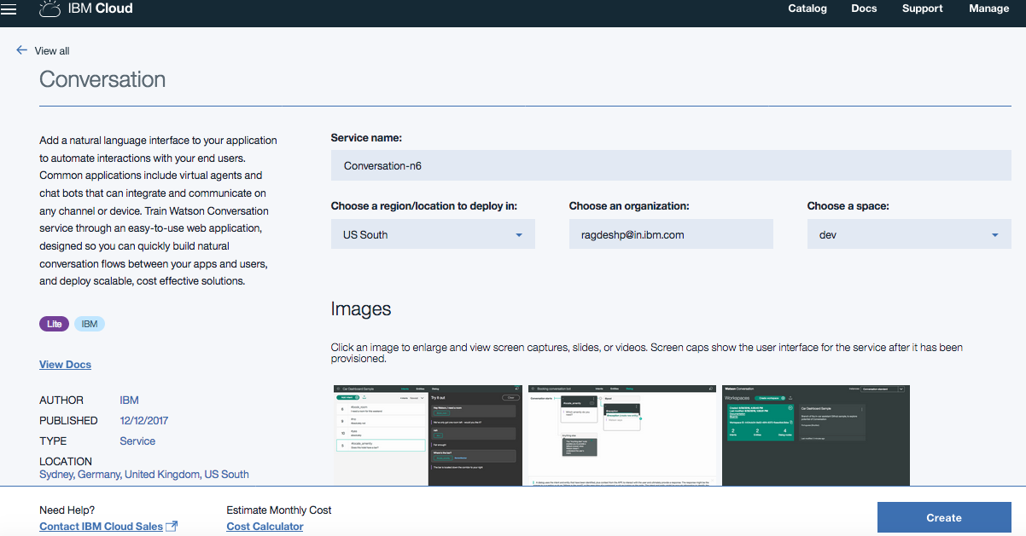

Now enter the Service name appropriately.

1. You reach the Conversation service dashboard

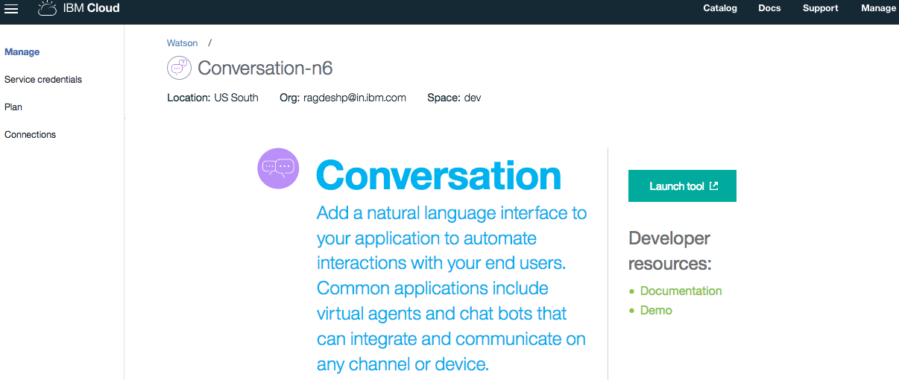

1. Click on the ‘Launch tool’ link and you would see the below page

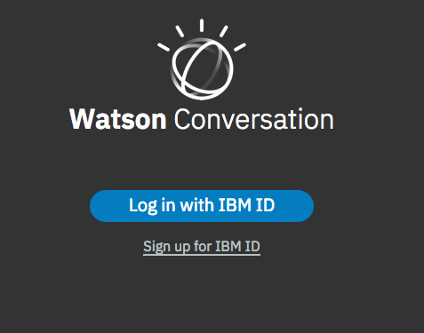

1. Now sign in with IBM ID and you would see the workspace dashboard

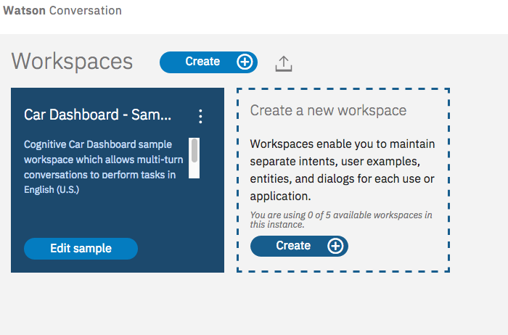

1. Import the workspace by click the below icon:



1. Import a workspace json by choosing the file

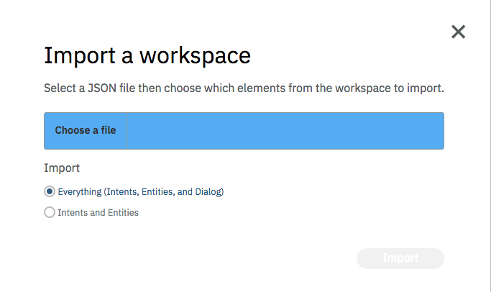

1. Choose the workspace file – PizzaBotWithoutSlotFinal.json from the repository <https://github.com/IBMDevConnect/IBMCodeDay-2018/tree/master/SlotChatBot_MiniLab> , You would see the following ‘Build’ area to view the ‘Intents’, ‘Entities’ and ‘Dialog’ and perform the following the steps below
2. Enter ‘Order a pizza’
3. Enter the size of the pizza
4. Enter the type of the pizza
5. Enter – Do you require the extra toppings?
6. Enter the toppings
7. Last you would see the total order being placed.
8. Please note the Dialog flow construction in the workspace dashboard. This requires lot of nodes and lot of dialog flows for each scenario. This is an overhead when we have too many variables.
9. Then import the workspace - watson-pizzeria_final.json into the workspace. You would see the following ‘Build’ area to view the ‘Intents’, ‘Entities’ and ‘Dialog’

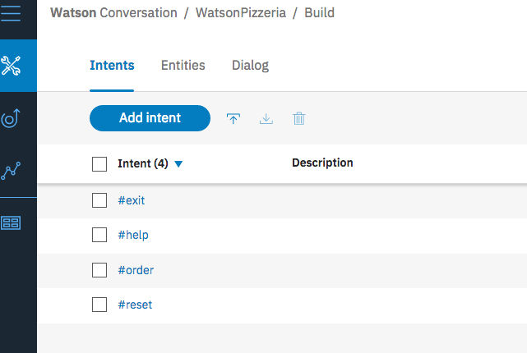

1. Click on the ‘Dialog’ tab and you would see the below:

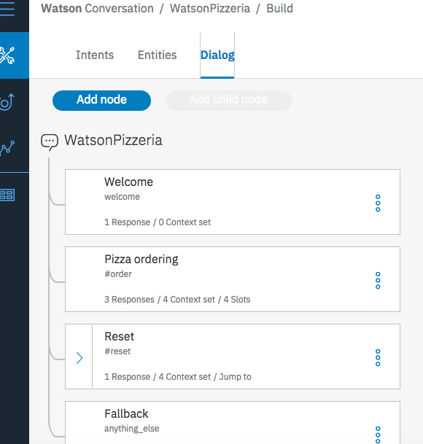

1. Click on the right top corner icon  to open the ‘Try it Out’ Pane as below:

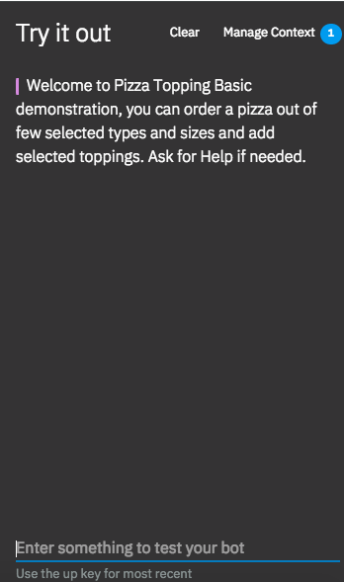

1. Enter ‘order a pizza’ as input
2. Enter the size of pizza – ‘medium’
3. Enter the type – ‘Vegetarian’
4. Enter Extra Toppings
5. Last you will see the full order being made.

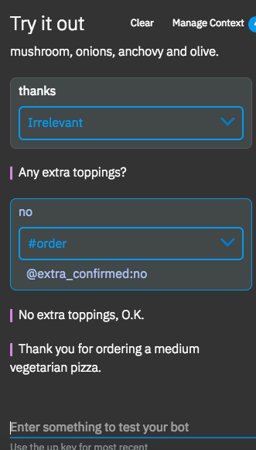

During the above execution – please observe the nodes which are getting executed, all the executing stands at a single node which is the slot node.

Lesson learnt: Slots help in reducing the multiple nodes into a single node.