NIIT UNIVERSITY

SMART SEARCH ENGINE

TESTING

**SEARCH QUERY**:

**Positive Scenario**

**Inputs**: Any query.

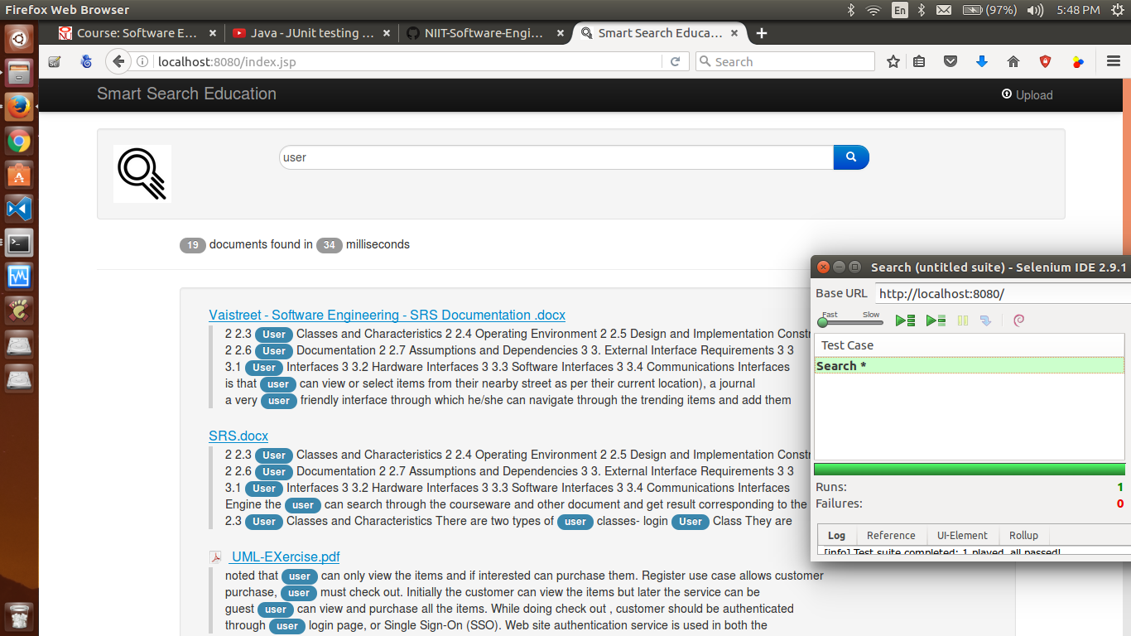

**Desired Outputs**: Results Displayed.

**Actual Output**: Results Displayed

**Negative Scenario**: Content not available in database - No results found will be displayed.

TEST CASE STATE: Succesful

**DOWNLOAD** :

**Positive Scenario: File download pop up.**

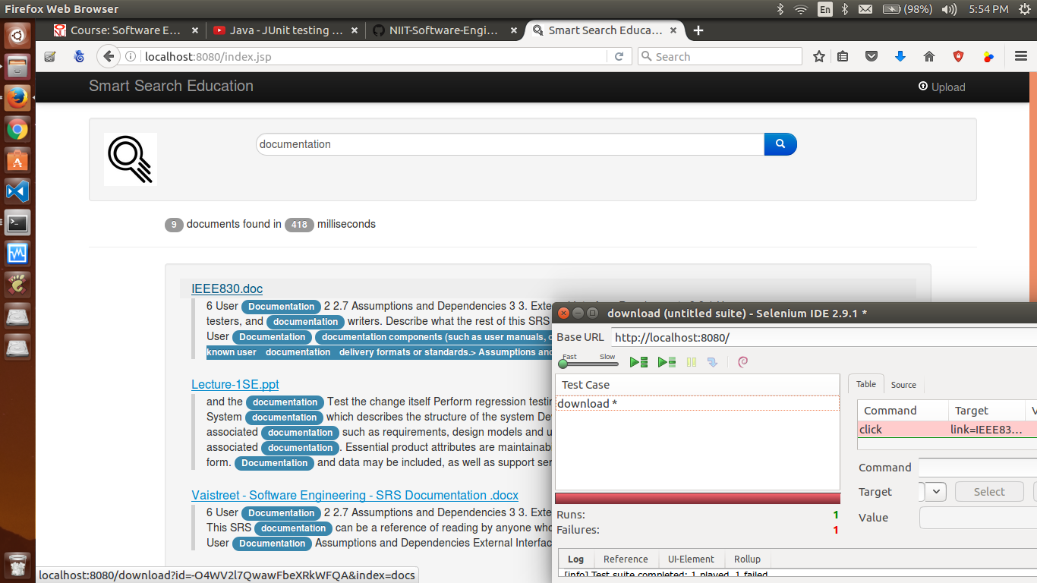

**Desired Outputs**: download pop-up.

**Actual Output**: download pop-up

TEST CASE STATE: Failure - can not understand the reason because everything is working fine

**UPLOAD:**

**Positive Scenario: FILE upload**

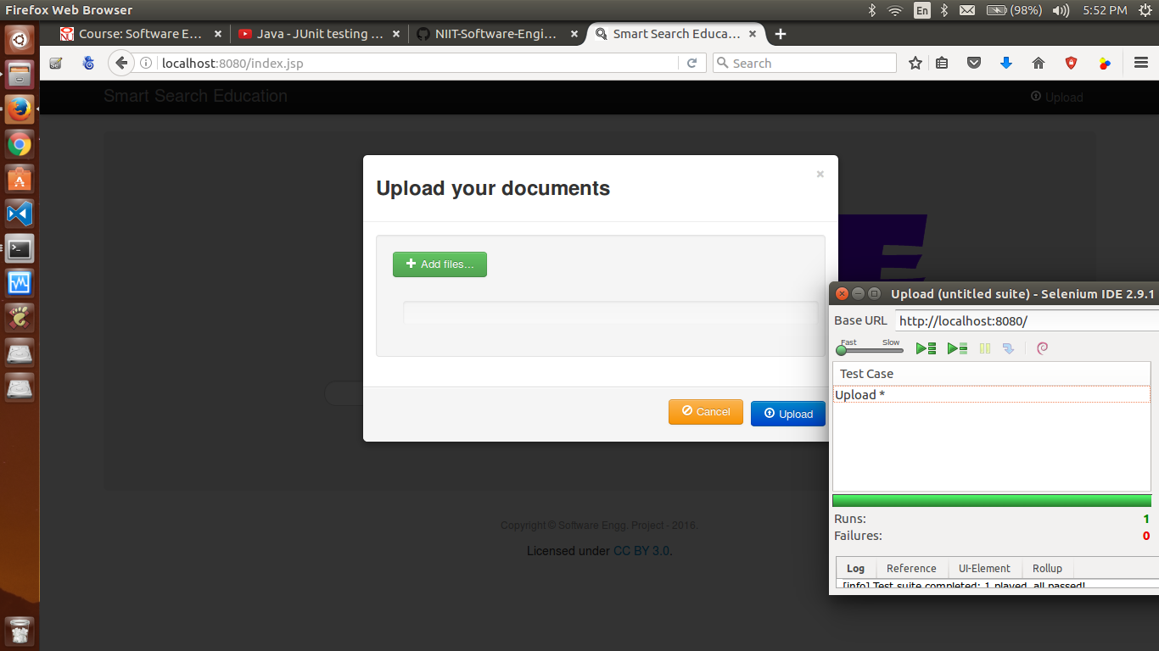

**Desired Outputs**: File upload

**Actual Output:** File upload

**Negative Scenario**: API Fails if non indexable content is uploaded eg. Image, Video

Desired Output: Index Error

TEST CASE STATE: Successful