Monit Paper Sales Agency/Monit Paper Associates

1. What We Discussed — Meeting Summary
Over two detailed discussions with Mr. Monit Jain, we mapped the complete paper trading workflow of Monit Paper Sales Agency & Monit Paper Associates. Here's a summary of the key topics covered and the pain points identified.

1.1 Business Overview
Monit Paper Agency has been in paper and paperboard trading for 30+ years, operating from multiple locations in Indore. The business is an authorized distributor for 10-12 major paper mills including ITC Limited, NR Agarwal, Gayatri Shakti, Emami, Balkrishna, and JK Paper.
- Two firms — Agency (ITC business) & Associates (NR and others) — same customers, separate billing.
- Two sales models — Direct Indenting (mill-to-customer) & Stock-and-Sell (godown stock + sheeter cutting).
- 3+ salesmen, procurement team, accountants, godown staff — all coordinating via WhatsApp, Excel, and phone calls.

1.2 Topics Covered in Discussion
S. No. | Topic | What Was Discussed
1 | Order Lifecycle | How inquiries come in (direct + mill-run driven), how orders are confirmed, and the 'full & final' confirmation process.
2 | Procurement Process | Placing orders with 10-12 mills, tracking delivery dates, multi-point truck pickups (Vapi example), and the Excel/Word manual workflow.
3 | Stock Management | 5 stock statuses (Available, Reel-to-Sheet, Booked, Ordered, In Transit), 'Material in Transit' policy, and the stock sharing lesson.
4 | Salesman Conflicts | Real incident: one salesman sold reel-cut material already allocated to another customer. Customer sentiment destroyed.
5 | Bill Interception | Unique workflow: intercepting mill trucks mid-route to swap mill invoices with Monit's customer invoices.
6 | Credit & Payment | Mills demand 100% advance; customers get unsecured credit. Need automated credit checks before confirming orders.
7 | Reporting Pain | Owner manually filters Excel daily for follow-up reports, MIS, and stock data. Wants 100% automation.
8 | Customer-Facing App | AI chatbot that acts as a salesperson — checks availability, suggests alternatives, handles orders. But NEVER shows stock quantities.
9 | Planning Engine | Existing carton dimension optimizer — customer gives box L×W×H, system recommends optimal sheet size. 'Game changer' for customer acquisition.
10 | Diplomatic Responses | When credit is the issue, system must NOT say 'your payment is due.' Instead: 'Let me check if this stock is available.'
11 | Stock Visibility Lesson | Previously shared daily stock with quantities — competitors/mills reverse-engineered turnover. Stopped. Never share quantities again.
12 | Growth Vision | Reduce people-dependency, increase system-dependency. 'The system should be the expert, not the person.'

2. Current Problems — What You're Facing
Based on our discussions, we identified 12 core problems that are impacting daily operations, customer relationships, revenue, and the ability to scale. Each problem below references exactly what was discussed in our meetings.
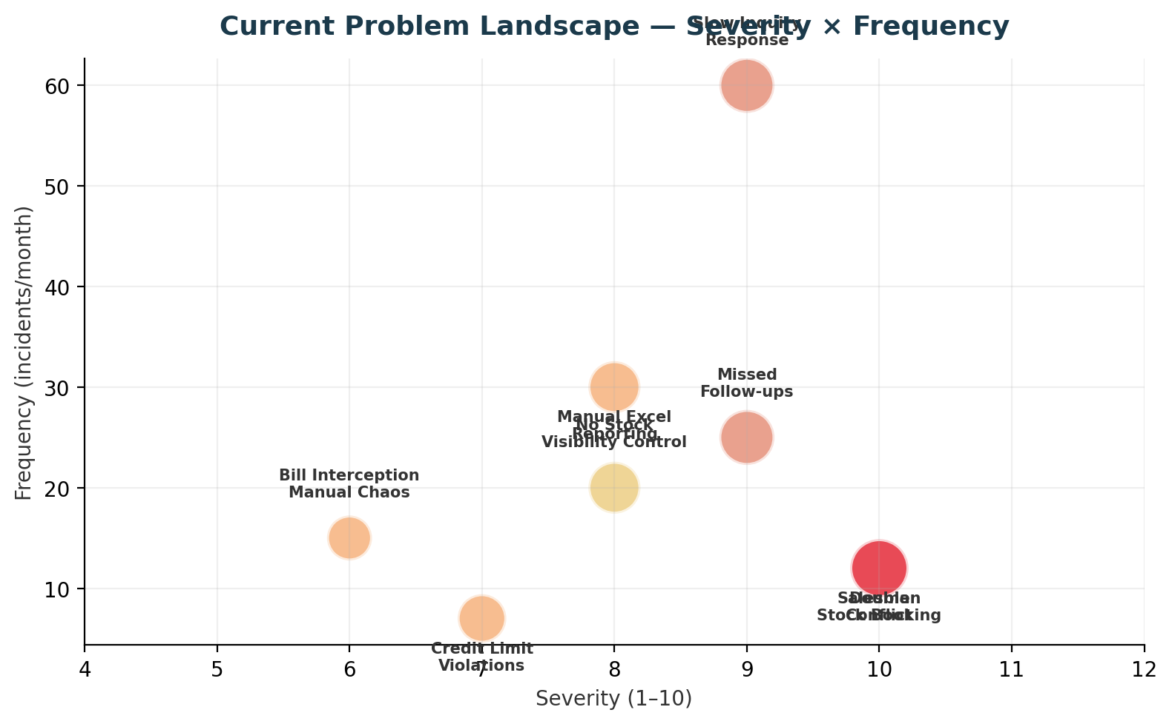

Problem 1: Double Stock Booking by Multiple Salesmen
Impact:
- Customer sentiment permanently damaged — 'pehle paisa bhi liya, sab kiya, ab deliver nahi kar rahe.'
- Salesman credibility lost. Internal conflicts between sales team members.
- Emergency workarounds needed — sometimes returning money, sometimes making settings.
Root Cause:
- No real-time stock locking. All salesmen see the same Google Sheet / stock list with no reservation mechanism.

Problem 2: Entire Procurement Done on Excel & Word
Impact:
- No automated follow-ups — delivery dates slip and no one notices until the customer asks.
- No consolidated view of pending orders across 10-12 mills.
- Manual PO creation wastes hours daily. Error-prone — wrong quantities, wrong specs.
- Cannot track mill performance (who delivers on time, who doesn't).

Problem 3: Manual MIS & Reporting — Owner's Daily Pain
Impact:
- 2+ hours daily spent by the owner on manual Excel filtering — time that should go to strategic decisions.
- Reports are always stale — by the time they're compiled, the data has changed.
- Follow-ups fall through cracks. Customers not contacted for weeks — orders lost to competitors.
- No visibility into salesman performance, inquiry conversion, or market trends.

Problem 4: Slow Inquiry Response — Customers Go Elsewhere
Impact:
- Average response time: 30-120 minutes. In paper trading, speed wins the order.
- Competitors like Hansal have apps — customers are demanding 'why don't you also focus on this kind of app.'
- After-hours inquiries completely lost — no one available to respond at night or early morning.
- Team behind inquiry is stressed: 'within 5 minutes or 2 minutes, inquiry has to be closed.'

Problem 5: Stock Visibility — Too Much or Too Little
Impact:
- Sharing quantities exposed business turnover to competitors and mills — MIS reverse-engineered.
- But completely hiding stock means customers can't plan — they need to know IF something is available.
- Current system is all-or-nothing: either share the Excel (risky) or don't share at all (lose business).

Problem 6: No Systematic Credit Check Before Orders
Impact:
- Orders processed for customers who already have heavy outstanding — increasing credit risk.
- No automated check: salesman may not know customer's payment status at the time of order.
- When owner catches it later, order is already committed — awkward to reverse.
- Can't refuse directly without damaging relationship — 'tum mere limit set karoge?'

Problem 7: No Market Intelligence — Who's Inquiring But Not Buying?
Impact:
- No tracking of inquiries that don't convert — lost revenue that could be recovered.
- Can't identify which customers are 'window shopping' vs. seriously buying.
- Can't detect competitor threats: a regular customer's order drop might mean they found another supplier.
- No search pattern data — don't know what the market is demanding.

Problem 8: People Dependency — Can't Scale Without Experts
Impact:
- Business knowledge lives in people's heads, not in a system. If someone leaves, knowledge goes with them.
- New hires need months to become effective — they don't know which customer needs which quality.
- Can't scale operations: more volume = more people = more coordination problems.
- Owner is the bottleneck for every decision because only he has the complete picture.

Problem 9: Material in Transit — Invisible Stock
Impact:
- 4-5 days of stock invisible to the system — can't sell what you can't see.
- Customers told 'out of stock' when material is actually on its way.
- Manual tracking of what's in transit vs. what's arrived — error-prone, often forgotten.

Problem 10: Bill Interception — Manual & Risky
Impact:
- Entirely dependent on field person physically finding the truck — no digital coordination.
- If interception is missed, customer receives mill's invoice — exposing buying price.
- No system to track which trucks need interception today, who is assigned, and confirmation.

Problem 11: No Customer-Facing Digital Presence
Impact:
- Competitors have apps — Monit doesn't. Perception gap.
- But simple 'stock listing' apps don't work for Monit's model — need intelligent suggestions, not just a catalog.
- Customer self-service = faster decisions. Without it, every inquiry needs a phone call.

Problem 12: Tally is Isolated — No System Talks to It
Impact:
- Double data entry — same information entered in Excel AND Tally.
- Payment status in Tally not visible to sales team — they don't know customer's outstanding when taking orders.
- Invoices generated in Tally but not linked to the order workflow — no end-to-end traceability.

3. How Automation Solves Each Problem
Every problem identified above has a specific, targeted solution in the proposed system. Below is the problem-to-solution mapping with the exact feature that addresses it.
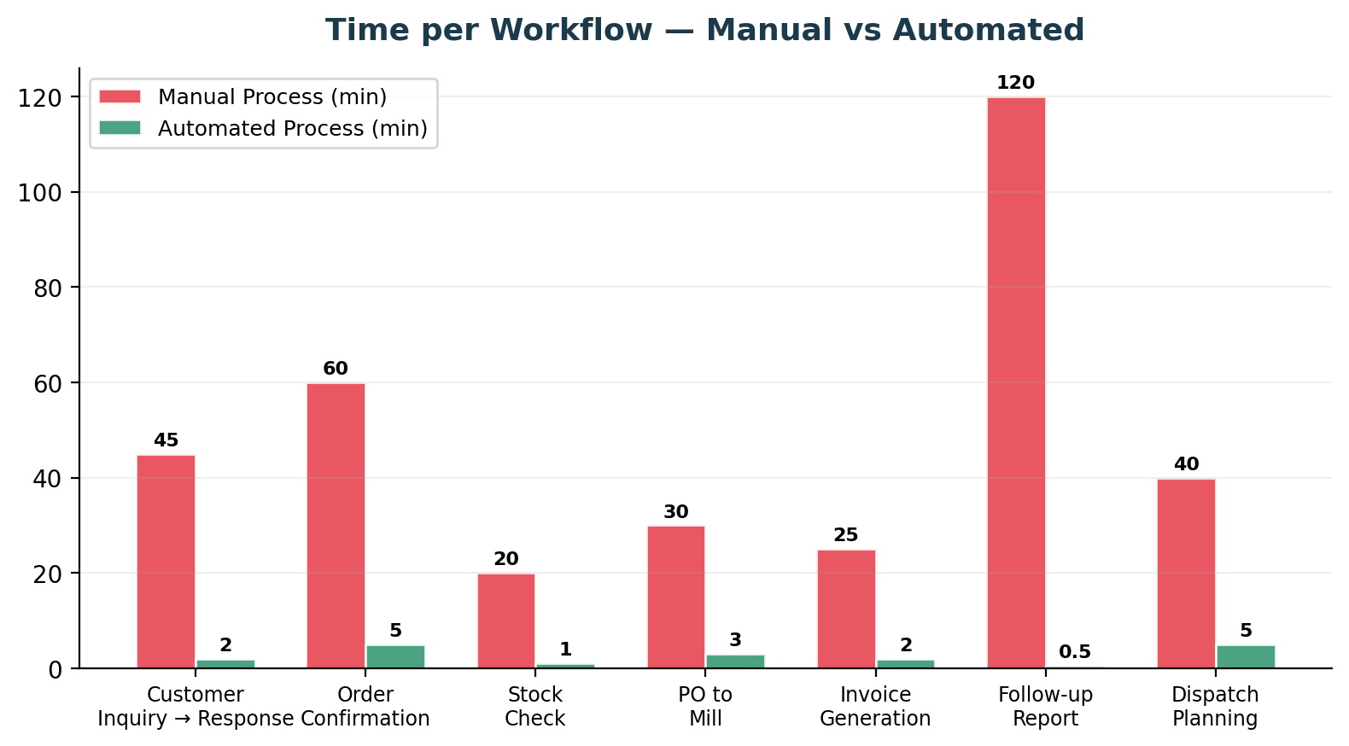

Problem | Solution | How It Works | Result
Problem 1  Double Stock Booking | REAL-TIME STOCK LOCKING | When any salesman starts an order, system instantly soft-locks that stock. Other salesmen see it as 'Booked for [Customer] by [Salesman].' Lock auto-expires if order isn't confirmed within 2 hours. Only the owner can override. No more 'uska maal tha, maine bech diya.' | 100% eliminated
Problem 2  Excel/Word Procurement | DIGITAL PURCHASE ORDER MODULE | One-click PO generation with auto-formatted PDF. Track every mill order with status flow: Order → Confirmed → In Run → Ready → Dispatched → Received. Automated follow-up reminders. Club loading suggestions for same-region mills. No more Word documents. | 100% digitized
Problem 3  Manual MIS/Reports | AUTO-GENERATED REPORTS & DASHBOARDS | Mill-wise follow-up reports generated automatically — 'which customers haven't been contacted for this mill.' Real-time dashboards for stock, sales, pending orders. Daily MIS scheduled and delivered — zero manual Excel work. | 2+ hrs/day saved
Problem 4  Slow Inquiry Response | AI CHATBOT + INSTANT AVAILABILITY | Customer asks on app/WhatsApp → chatbot checks stock in 1 second → shows available/partial/timeline. AI suggests alternatives proactively. Works 24/7. Response time: 30-120 min → under 5 min. 'Buying pattern depends on response speed.' | 95% faster
Problem 5  Stock Visibility Dilemma | SMART VISIBILITY: AVAILABLE/NOT — NEVER QUANTITY | Customer sees only: Available (green), Partially Available (yellow), Available in X Days (blue), Not Available (red). NEVER the quantity. Internally, quantities are fully tracked. Owner can hide specific stock. Turnover data is never exposed. | Data protected
Problem 6  No Credit Check | AUTOMATED RULE-BASED APPROVAL ENGINE | Every order passes through invisible credit check: credit limit, overdue status, customer tier. Auto-approve for clean customers. Escalate to owner with one-click Approve/Hold/Reject for others. Diplomatic responses: 'Let me check availability' (not 'your payment is due'). | 100% automated
Problem 7  No Market Intelligence | SEARCH & INQUIRY ANALYTICS | Every app search, every chatbot conversation, every 'searched but didn't order' is tracked. Reports show: what's being demanded, who's inquiring but not buying, which customers' volumes are dropping. 'Zaroorat toh thi kyunki inquiry hai — maal kahin aur se aa raha hai.' | Full visibility
Problem 8  People Dependency | SYSTEM-GUIDED OPERATIONS | Customer-product mapping in system (not in people's heads). AI suggests what to offer based on customer profile. New hire just follows system prompts. 'System expert hota hai bhaiya' — the system knows which customer needs which quality, when, and from which mill. | 60% less dependency
Problem 9  Invisible Transit Stock | IN-TRANSIT TRACKING FROM DAY 1 | The day mill dispatches, system creates 'In Transit' stock entry. Visible to salesmen as 'Available in X days.' On godown arrival, staff confirms via packing slip → converts to Available stock. Never miss a sale because 'maal hai hi nahi' when it's actually on the truck. | 4-5 days recovered
Problem 10  Manual Bill Interception | DIGITAL INTERCEPTION WORKFLOW | System assigns field person, shows which trucks need interception today, generates customer invoices automatically (from Tally sync). Field person confirms interception in-app. Alerts if an interception is missed before truck reaches customer gate. | Zero missed swaps
Problem 11  No Digital Presence | CUSTOMER APP + AI CHATBOT + PLANNING ENGINE | Not just a stock catalog (like Hansal) — an intelligent sales assistant. Carton dimension optimizer ('game changer'), proactive alternatives across multiple mills, stock lot deals, reel-cut options. '6 printers in Indore already asked for this.' First-mover advantage. | Competitive moat
Problem 12  Isolated Tally | TWO-WAY TALLY BRIDGE | New system syncs with Tally in near-real-time. Push: invoices, DN/CN generated in system → auto-created in Tally. Pull: payment receipts, outstanding balances, aging → drives credit checks and approval engine. No double entry. Single source of truth. | Zero double entry

4. Before vs After — The Complete Picture
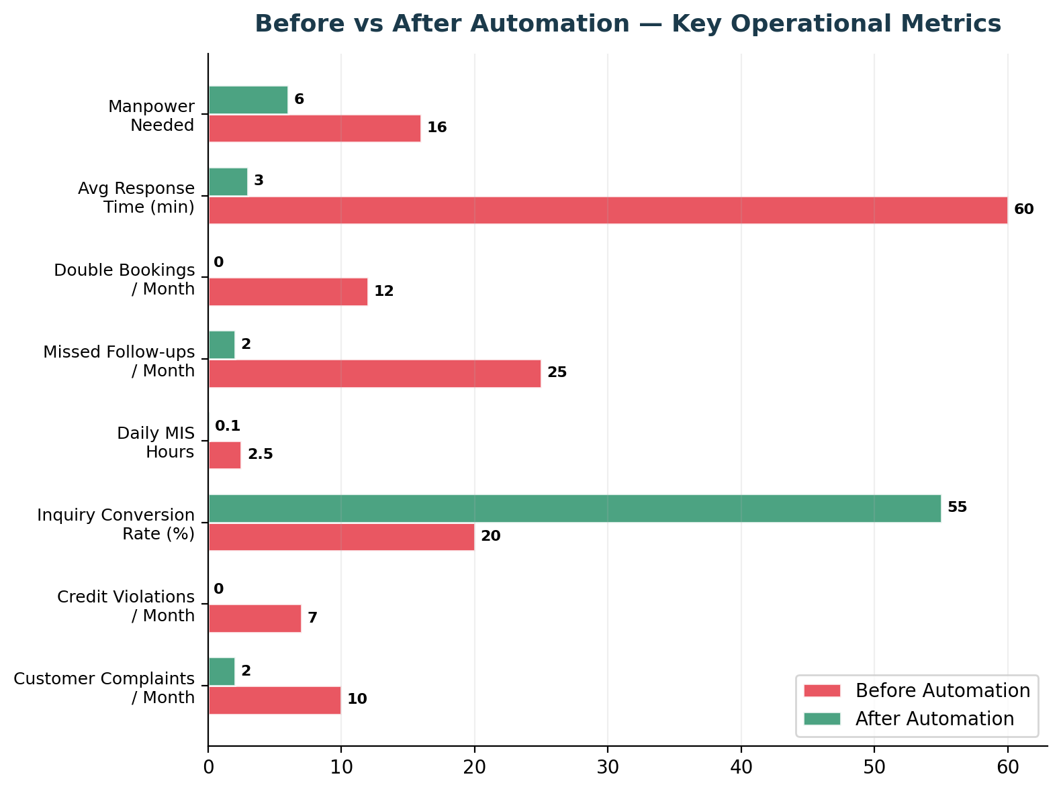

Time | What Happens
9:30 AM | Open Tally, Excel, Google Sheet, WhatsApp — 4 different systems to start the day.
10:00 AM | Check WhatsApp for overnight inquiries. Miss some. Start calling back customers — some already bought elsewhere.
10:30 AM | Salesman A takes an order. Doesn't inform Salesman B. Same stock at risk.
11:00 AM | Manually create PO in Word. Format it. Convert to PDF. Email to mill. 30 min per PO.
12:00 PM | Customer calls: 'When will my material arrive?' — no one knows. Start calling the mill, transporter.
1:00 PM | Owner starts manual Excel filtering for follow-up reports. Which customers haven't ordered this month?
3:00 PM | Material arrives at godown. Staff writes on paper. Accountant will enter in Tally tomorrow.
4:00 PM | Billing for dispatch — manually check stock in Google Sheet, create invoice in Tally, print.
5:00 PM | Owner still filtering Excel for MIS. Day ends with incomplete picture.
7:00 PM | Customer sends late inquiry on WhatsApp. No one responds. Inquiry lost.
Time | What Happens
9:30 AM | Dashboard shows: overnight inquiries (auto-captured by chatbot), pending approvals, today's dispatches, overdue follow-ups.
10:00 AM | 3 orders already taken by AI chatbot overnight. Owner reviews and approves in 2 taps.
10:30 AM | Salesman A creates order — stock auto-locked. Salesman B sees 'Booked for XYZ.' Offers alternatives.
11:00 AM | PO generated in 1 click. Auto-emailed to mill. Added to tracking system with TAT-based reminders.
12:00 PM | Customer checks order status on app — 'In Transit, arriving tomorrow.' No phone call needed.
1:00 PM | Owner checks auto-generated report: 'Mill-wise follow-up needed for 5 customers.' Done in 1 minute.
3:00 PM | Godown staff scans packing slip. System auto-converts 'In Transit' to 'Available.' Weight reconciled.
4:00 PM | Dispatch planned by system. Invoice auto-generated. Bill interception assigned to field person with route.
5:00 PM | Owner reviews dashboard: today's sales, pending orders, credit exposure. Complete picture in 30 seconds.
11:00 PM | Customer checks availability on app at night. Chatbot responds: 'Available! Want to order?' Inquiry captured.
Area | Before | After | Improvement | What It Means
Manpower | 16 people across functions | 5-6 people (same output) | ~60% reduction | Hire 'minimum wale' — system guides them.
Response Time | 30-120 minutes | 1-5 minutes (AI instant) | 95% faster | No more 'tab tak kahi aur se le lunga.'
Double Bookings | 10-15 / month | Zero | 100% eliminated | Real-time stock locking. Peace of mind.
Daily MIS | 2+ hours manual | Auto-generated, instant | 100% automated | No more Excel filtering — ever.
Inquiry Conversion | ~20% | ~55% | 2.75× better | AI suggests, cross-sells, follows up.
Customer Reach | 9:30 AM - 7 PM | 24/7 via app + chatbot | 3× window | Night inquiries captured, not lost.
Credit Violations | 7 / month | Zero (system-enforced) | 100% prevented | Diplomatic refusals, no ego clashes.
Follow-up Misses | 25 / month | 2 / month (edge cases) | 92% reduction | Auto-generated, per-mill, per-customer.
Data Entry | Double (Excel + Tally) | Single (auto-sync) | 50% less work | Tally bridge eliminates duplication.
Competitive Edge | No app, no digital | AI + Planning Engine | First mover | '6 printers already asking for this.'
Process | Manual (Current) | Automated (Future) | Automation Method
Daily Stock Update | Staff updates Google Sheet manually every morning | Real-time database updates as material moves (in, out, reserved). No daily compilation. | Database transactions
Stock Check for Order | Salesman calls godown or checks Google Sheet (may be outdated) | Salesman/customer checks system → instant query → shows Available/Booked/In Transit/Ordered | Real-time database query
Stock Reservation | No mechanism. Same stock shown to all salesmen. Conflicts happen. | Salesman A creates order → stock soft-locked with timestamp. Salesman B sees 'Booked for XYZ.' Lock expires after 2 hours. | Database locking with expiry
Material in Transit | Entered in Tally when it arrives at godown (3-5 days delay) | Entered the day mill dispatches. Visible as 'In Transit' with arrival date. On arrival, converts to Available. | Status-based workflow
Reel-to-Sheet Cutting | Manually track which reel was cut, how many sheets produced, waste generated | Sheeter job form: input reel, target size, quantity. System tracks: reel consumed, sheets added, waste recorded. | Inventory transaction with reel/sheet linkage
Stock Aging | Owner occasionally asks 'kaunsa maal purana hai?' No systematic tracking. | Auto-generated weekly report: items in stock >30, >60, >90 days. Slow-moving identification. | Scheduled report query
Stock Visibility Control | All-or-nothing: share Excel (exposes quantities) or don't share (lose business) | Customer/external sees only: Available/Partial/X Days/Not Available. NEVER quantities. Owner can hide strategic stock. | Access control + filtered API
Process | Manual (Current) | Automated (Future) | Automation Method
Inquiry Capture | Customer calls/WhatsApps → someone writes it down or remembers | Customer uses app/chatbot OR salesman enters inquiry form. All inquiries logged with timestamp, source, details. | Structured data entry + event logging
Availability Check | Salesman checks Google Sheet, calls godown, asks other salesmen | System queries database → returns availability status in <1 second. AI suggests alternatives if not available. | Real-time database query + AI logic
Quotation | Salesman manually calculates price, sends WhatsApp message | System fetches customer rate card (if locked) or shows mill cost + margin. Generate quotation PDF. | Rate card lookup + template
Order Confirmation | Salesman sends 'full & final' confirmation via WhatsApp manually | System generates Sales Order, sends formatted confirmation to customer (app/WhatsApp/email). Customer can acknowledge. | SO creation + notification API
Credit Check | Not done systematically. Sometimes caught after order is taken. | BEFORE confirming order, system checks: credit limit, outstanding (from Tally), overdue days. Auto-approve or escalate to owner. | Rule engine + Tally API query
Order Approval | Owner manually reviews orders, calls salesman to discuss | Orders needing approval appear on owner's dashboard/mobile with one-click: Approve/Hold/Reject. Summary shows credit, overdue, stock. | Approval workflow + push notifications
Fulfillment Planning | Manually decide: godown stock or mill order? Which firm to bill from? | System auto-determines: stock available → allocate godown stock. Not available → create purchase requisition. Auto-select firm based on mill. | Business logic + database update
Customer Communication | Manual WhatsApp/SMS for every update (order confirmed, dispatched, delivered) | Automated notifications at each stage. Customer checks status on app anytime. | Event-triggered notifications + app UI
Customer Action | Manual (Current) | Automated (AI Chatbot) | Underlying Technology
Check Availability | Customer calls: 'Do you have 23x36 FBB 300 GSM?' → Salesman checks → calls back in 30 min | Customer asks chatbot (app/WhatsApp) → chatbot queries database → responds in 2 seconds: 'Available!' or 'Not available, but I have 23.5x36 available' | AI NLP + database API query
Suggest Alternatives | Salesman knows customer's needs, suggests manually: 'Try 210 GSM instead' | Chatbot knows customer profile, suggests: 'This exact size isn't available, but 210 GSM will work for your machine, and it's ₹5/kg cheaper.' | AI + customer profile data + business rules
Carton Optimization | Customer doesn't even know what paper size they need. Salesman does mental calculation or calls back later. | Customer inputs box L×W×H + type → chatbot calls Planning Engine API → responds: 'You need 18x23, 12 ups, 2% waste. Available in stock.' | AI + Planning Engine API integration
Handle Credit Issues | Customer orders, later salesman checks credit, finds overdue, has to awkwardly refuse: 'Uhh, let me check with boss' | Customer orders → chatbot checks credit invisibly. If overdue: 'Let me check if this stock is booked. Our team will contact you shortly.' Owner gets alert. | AI + rule engine + diplomatic response templates
Place Order | Customer confirms verbally/WhatsApp → salesman manually creates order in Excel/system | Customer confirms order on app → chatbot creates order in database → sends to owner for approval (if needed) or auto-processes | AI conversation flow + database insert + approval routing
Night/Holiday Inquiries | Lost completely. No one to respond. | Chatbot responds 24/7. Inquiry captured, logged. Human team follows up next day. | Always-on AI service
Track Order | Customer calls: 'Where is my material?' → Salesman checks manually, calls back | Customer asks chatbot or checks app: 'Your order is in transit, arriving tomorrow 2 PM' | AI + database query + status tracking
Report | Manual (Current) | Automated (Future) | How It Works
Mill-wise Follow-up | Owner manually filters Excel: 'ITC ke liye kitne customers jinse follow-up nahi hua?' Takes 20 min. | Daily auto-generated report emailed at 6 AM: 'ITC — 5 customers not contacted in 15+ days: [list with last order date]' | Scheduled SQL query → email with PDF/Excel
Stock Position | Open Google Sheet, manually check each item. Outdated by the time you look. | Real-time dashboard: stock by location, type, status. Filter by mill, GSM, size. Drill down to details. | Live database query + web dashboard
Sales Performance | Manually compile: how much each salesman sold this month? From Tally + memory. | Auto report: per salesman — orders booked, revenue, inquiries handled, conversion rate. Compare to last month. | Database aggregation query + scheduled report
Pending Orders | Manually go through Excel: which orders are pending with which mill? Delivery dates? | Dashboard shows: all open POs by mill, expected dates, overdue flags (red). One-click drill down. | Database query + status filter
Customer Aging | Ask accountant to manually filter Tally outstanding report by age. | Auto report: outstanding by customer, age-bucketed (current, 30d, 60d, 90d, 120+). Sorted by risk. | Tally API pull + aging calculation + scheduled report
Inquiry Conversion | No tracking. Don't know how many inquiries converted to orders. | Auto report: X inquiries received → Y quoted → Z converted to orders. Conversion rate: Z/X%. Reasons for drop-off. | Event analytics + funnel analysis
Market Intelligence | No idea what customers are searching for, what's trending. | Auto report: most-searched paper types, sizes, GSMs. Unmet demand (searches with no match). Customers inquiring but not buying. | App search log analytics
Process | Manual (Current) | Automated (Future) | Automation Method
Load Planning | Manually decide which orders to combine in one truck, call transporter | System suggests optimal load: orders ready, same route/region. One-click load plan generation (PDF for godown). | Algorithm + template generation
Bill Interception Assignment | Owner/manager manually tells field person: 'Today truck XYZ needs interception at ABC location' | System auto-assigns field person, provides route, shows pending interceptions on mobile app. GPS-based. | Geolocation + task assignment workflow
Customer Invoice Generation | Accountant manually creates invoice in Tally (for the bill swap) | System auto-generates invoice when dispatch is confirmed. Synced to Tally. Printable for field person. | Tally API + invoice template
Interception Confirmation | Field person calls/WhatsApps: 'Done. Bill swapped.' | Field person taps 'Interception Complete' in app (with GPS location). System marks truck as 'Bills Swapped.' | Mobile app + database update + GPS log
Delivery Tracking | Customer calls: 'Where is my truck?' Salesman calls transporter, calls back customer. | Customer checks app: 'Dispatched Feb 10, arriving Feb 12.' Automated SMS/WhatsApp when dispatched and delivered. | Status tracking + notification API
E-Way Bill Generation | Manually enter invoice details on GST portal, generate E-Way Bill, print. | System auto-generates E-Way Bill via API when dispatch confirmed. PDF stored, emailed to transporter. | E-Way Bill API integration
Process | Manual (Current) | Automated (Future) | Automation Method
Payment Receipt | Accountant enters payment in Tally. Sales team doesn't know until they ask. | Tally payment entry auto-synced to system every 5 min. Sales team sees updated outstanding on customer profile instantly. | Tally API pull + database sync
Credit Check Before Order | Not done, or manually checked by calling accountant | System auto-checks before order approval: outstanding balance, credit limit, utilization %, overdue days. Escalates if threshold breached. | Rule engine + Tally data
Collection Follow-up | Owner/salesman remembers (or forgets) to call customers for payment | Auto-generated daily list per salesman: 'Your customers with overdue payments: [list with days overdue, amount].' Push notification. | Scheduled query + notification
PDC Tracking | Manually note on paper or Excel: cheque #, date, bank, amount | PDC register in system: upcoming cheques, deposited, cleared, bounced. Alerts 2 days before cheque date. | Database + scheduled alerts
Credit Utilization Alert | No alert. Owner finds out when customer already has heavy outstanding. | Auto-alert when customer's credit utilization >90%: 'Customer X has used ₹4.5L / ₹5L credit (90%). New order pending approval.' | Real-time calculation + threshold alert
We're providing a complete software solution in two phases:
Phase | What You Get | Timeline
Phase 1 | Web-based system for your internal team to manage everything — orders, stock, purchase, billing, reports | Months 1-5
Phase 2 | WhatsApp Chatbot for customers — checks stock, takes orders, answers questions 24/7 | Months 5-8

Phase 1 fixes your internal problems. Phase 2 gives you competitive advantage over other traders.

5. Key Changes — What Improves
Area | Today | With System
Stock Management | Google Sheet updated manually, often outdated | Real-time updates, always current, zero double bookings
Credit Checks | Done manually or forgotten | Automatic check before every order
Reports | Owner spends 2 hours daily on Excel | Auto-generated reports emailed every morning
Customer Inquiries | 30-120 minutes to respond, lost after hours | Instant response 24/7 via WhatsApp Chatbot
Purchase Orders | Created manually in Word (20 min each) | Auto-generated in 1 second
Tally Integration | Double data entry, frequent mismatches | Single entry, automatic sync every 5 minutes

6. Phase 1: Web System — Key Features

For Owner
• Dashboard: Today's sales, pending approvals, alerts
• One-click order approvals with customer credit info
• Automated daily/weekly reports
• Business analytics and performance tracking

For Sales Team
• Instant stock availability check
• Create orders with automatic credit validation
• Customer history and follow-up reminders
• Track orders and delivery status

For Purchase Team
• Auto-generate purchase orders
• Track pending orders and deliveries
• Automatic alerts for low stock

For Accountant
• Generate invoices and sync with Tally
• Customer aging reports
• Payment tracking and alerts

7. Phase 2: WhatsApp Chatbot
AI-powered assistant that works 24/7 through WhatsApp — no app installation needed.
Customer Asks | Chatbot Response
'Do you have 23x36 FBB 300 GSM?' | Instant check + response in 3 seconds with availability or alternatives
'What paper for 12x8x6 box?' | Calculates exact sheet size, wastage using Planning Engine
'I want to order 5000 sheets' | Creates order, checks credit, confirms or escalates to you
'Where is my order?' | Shows current status, expected delivery, truck details
Inquiry at 11 PM | Responds immediately, logs inquiry, you follow up next morning

Key Benefits:
• Works 24/7 — captures after-hours inquiries (30% more business)
• Instant responses — customers don't wait or go elsewhere
• Intelligent suggestions — suggests alternatives if exact product unavailable
• Planning Engine integration — instant carton calculations
• Handles credit issues diplomatically — never embarrasses customer
• No app needed — works on WhatsApp everyone already has

8. How It Works — Simple Example

Customer Stock Inquiry via WhatsApp
Step | What Happens
1 | Customer sends WhatsApp: 'Do you have 23x36 FBB 300 GSM?'
2 | Chatbot checks your live inventory
3 | If available: 'Yes, 5000 sheets in stock!' | If not: Suggests alternatives
4 | Customer can immediately place order or ask more questions
5 | System logs inquiry for your analytics

Time: 3 seconds vs 30-60 minutes manual response

9. Summary — Expected Results
Metric | Current | With System
Response time to customer | 30-120 minutes | < 3 seconds
After-hours inquiries | Lost | 100% captured
Double bookings | ~12 per month | Zero
Daily report time (owner) | 2 hours | 5 minutes
Manual work | 14 hours/day | 2.5 hours/day
Team size needed | 16 people | 5-6 people

Bottom Line:
Handle 2-3× more business with same team. Respond faster than any competitor. Complete visibility and control over operations.

— End of Document —
CONFIDENTIAL — Monit Paper Sales Agency / Monit Paper Associates

