SOFTWARE REQUIREMENTS SPECIFICATION
Integrated Paper Trading Management System

Monit Paper Sales Agency
Monit Paper Associates

Document Version | 1.0
Date | February 9, 2026
Prepared For | Monit Paper Sales Agency / Monit Paper Associates, Indore, MP
Primary Contact | Mr. Monit Jain — +91 81200 44474
Status | Draft — Pending Client Approval

CONFIDENTIAL

Table of Contents
1. Introduction
2. Overall Description
3. User Roles & Permissions
4. System Architecture Overview
5. Module 1 — Procurement & Purchase Management
6. Module 2 — Inventory & Stock Management
7. Module 3 — Sales & Order Management
8. Module 4 — Customer-Facing App & AI Chatbot
9. Module 5 — Planning Engine Integration
10. Module 6 — Dispatch & Logistics Management
11. Module 7 — Billing, Invoicing & Tally Integration
12. Module 8 — Payment & Credit Management
13. Module 9 — Quality, Claims & Returns Management
14. Module 10 — Reporting, Analytics & Market Intelligence
15. Module 11 — CRM & Customer Relationship Management
16. Module 12 — Configuration & Master Data
17. Non-Functional Requirements
18. Business Rules Engine
19. Integration Requirements
20. Growth After Automation — Impact Analysis
21. Phased Rollout Plan
22. Appendices

1. Introduction

1.1 Purpose
This Software Requirements Specification (SRS) defines the functional and non-functional requirements for an Integrated Paper Trading Management System to be developed for Monit Paper Sales Agency and Monit Paper Associates. The system aims to digitize and automate the end-to-end paper trading operations — from procurement and inventory management to sales, dispatch, customer engagement, and reporting.

1.2 Scope
- Procurement from 10–12 authorized paper mills with TAT tracking and delivery management.
- Inventory management across multiple godowns and locations in Indore with real-time stock reservation.
- Sales order lifecycle — inquiry, quotation, order confirmation, fulfillment, and invoicing.
- Customer-facing AI chatbot/app for availability checks, carton planning, and order placement.
- Planning engine integration for carton dimension optimization and paper size recommendation.
- Dispatch and logistics including multi-point pickup, truck load planning, and bill interception.
- Tally ERP integration for accounting, billing, and payment synchronization.
- Reporting and analytics for business intelligence, follow-up tracking, and market insights.
- Credit and payment management with rule-based multi-level approval workflows.

1.3 Business Context
Monit Paper Agency is a 30+ year old paper and paperboard trading business based in Indore, Madhya Pradesh. The agency operates as an authorized distributor for major Indian paper mills (ITC Limited, NR Agarwal, Gayatri Shakti, Emami Paper Mills, Balkrishna Paper Mills, JK Paper, and others) and serves the packaging, digital printing, and food-grade packaging industries.
Two Firms:
- Monit Paper Sales Agency — handles ITC Limited (PSPD) business.
- Monit Paper Associates — handles NR Agarwal and other mill business.
Both firms share the same customer base. The internal decision of which firm fulfills an order is made by the sales/management team based on the supplying mill.
Business Models:
- Direct Indenting — customer orders, Monit places order with mill, material goes directly or via godown.
- Stock-and-Sell — Monit maintains stock; two sub-models:
- Bundles — pre-packed sheets from mills.
- Reel Cutting (Sheeter) — Monit has 2 sheeters to convert reels into custom sheet sizes.
Key Problem Statement:
Currently, procurement is managed entirely in Excel and Word documents. Stock tracking uses Google Sheets. Billing runs on Tally. There is no integrated system. The business owner spends significant time manually filtering Excel data for follow-ups and reporting. Multiple salesmen accessing the same stock pool leads to double-booking conflicts. The goal is to reduce people-dependency and increase system-dependency — "the system should be the expert, not the person."

1.4 Definitions & Acronyms
Term | Definition
GSM | Grams per Square Meter — paper thickness/weight measurement
FBB | Folding Box Board
SBS | Solid Bleached Sulfate board
Duplex Board | Multi-layered paperboard (Grey Back / White Back variants)
Kraft | Strong brown paper used for packaging
Deckle | Width of the paper machine / reel width
Reel | Roll of paper as produced by the mill
Sheeter | Machine that cuts reels into flat sheets
TAT | Turn Around Time — time from order to material readiness
PO / SO | Purchase Order / Sales Order
DN / CN | Debit Note / Credit Note
PDC | Post-Dated Cheque
Stock Lot | Non-prime / excess material sold at discounted rates by mills
Indent | Direct order placed with mill on behalf of customer
E-Way Bill | Electronic waybill required under GST for goods movement
PSPD | Paperboards and Specialty Papers Division (of ITC)
Mill Run | A production batch/cycle at the paper mill

2. Overall Description

2.1 Product Perspective
The system is a new, standalone web and mobile application that integrates with:
- Tally ERP (existing) — for accounting, billing, and payment data.
- Planning Engine (existing Sheeter App) — for carton optimization and paper size recommendation.
- WhatsApp Business API — for customer notifications and chatbot interaction.
- Email systems — for mill communication and order confirmations.
- Mill portals (ITC, etc.) — for order status tracking (future scope).

2.2 User Classes
User Class | Who | Description | Access Level
Owner / Director | Monit, Papa | Final approval authority, full dashboard, all reports | Full Access
Sales Team | 3+ salesmen | Inquiry mgmt, quotations, customer interaction, orders | Sales Module
Purchase Team | Procurement staff | Mill orders, delivery tracking, procurement planning | Procurement Module
Accountant | Accounting staff | Tally entries, billing, stock entries, payments | Billing & Accounts
Godown Staff | Warehouse workers | Stock receiving, packing slip verification | Inventory Module
Sheeter Operator | Machine operators | Reel-to-sheet cutting jobs, trim waste | Sheeter Module
Customer | External (via App) | Availability check, inquiry, order, tracking | Customer App
AI Agent | System automated | Auto availability, rule checks, notifications | Automated

2.3 Operating Environment
- Web Application — Admin panel, dashboards, all internal operations (responsive web).
- Mobile App — Customer-facing with AI chatbot (Android priority, iOS later).
- WhatsApp Integration — Chatbot for customers who prefer WhatsApp.
- Backend — Cloud-hosted, API-driven architecture.
- Database — Relational database (PostgreSQL) with Redis cache for real-time operations.

2.4 Key Constraints
- Tally remains the primary accounting system; the new system must sync with it, not replace it.
- Customer-facing app must NEVER expose stock quantities — only availability status.
- Multiple salesmen accessing the same stock pool — real-time conflict resolution is critical.
- Mill portals have varying transparency levels (ITC is stage-wise; others may be minimal).
- System must handle both firms (Agency + Associates) with unified customer view but separate billing.

3. User Roles & Permissions

3.1 Role-Permission Matrix
Module | Owner | Sales | Purchase | Accountant | Godown | Customer
Dashboard (Full) | RW | R | R | R | — | —
Customer Master | RW | R | R | R | — | —
Mill/Supplier Master | RW | R | RW | R | — | —
Inquiry Management | RW | RW | R | — | — | RW (own)
Sales Orders | RW | RW | R | R | — | R (own)
Order Approval | RW | — | — | — | — | —
Purchase Orders | RW | R | RW | R | — | —
Inventory | RW | R | RW | RW | RW | —
Dispatch Planning | RW | R | RW | R | RW | —
Billing & Invoicing | RW | R | R | RW | — | —
Payment & Credit | RW | R | — | RW | — | —
Reports | RW | R(own) | R(own) | R(own) | — | —
Configuration | RW | — | — | — | — | —
R = Read, RW = Read/Write, — = No Access

3.2 Multi-Level Approval Configuration
- Level 1 — System Auto-Approval: All rules pass (credit OK, stock available, customer qualified).
- Level 2 — Sales Person Review: For flagged cases (partial stock, minor rule violations).
- Level 3 — Owner/Director Approval: Cases exceeding limits, large orders, or escalated cases.

4. System Architecture Overview

4.1 Architecture Layers
Layer | Components
Client Layer | Web App (Admin), Mobile App (Customer), WhatsApp Chatbot, Email Notifications
API Gateway | Centralized request routing, authentication, rate limiting
Application Layer | Purchase, Inventory, Sales, Dispatch, Billing, Payment, CRM, AI/Chatbot, Rules Engine, Reporting, Notification services
Integration Layer | Tally Bridge (Sync API), Planning Engine API, WhatsApp Business API, E-Way Bill API, E-Invoice API
Data Layer | PostgreSQL (Primary DB), Redis (Cache/Real-time), S3/Blob (Documents & Images)

4.2 Key Architectural Decisions
- Real-time stock locking — When a salesperson initiates an order, stock is soft-locked to prevent conflicts.
- Event-driven notifications — All state changes trigger notifications to relevant stakeholders.
- Configurable rule engine — Business rules stored as data, not code. Owner adjusts without developers.
- Tally as accounting truth — New system handles workflow; Tally remains the ledger. Two-way sync.
- AI chatbot as controlled gateway — Never directly commits stock. Auto-processes within rules or escalates.

5. Module 1 — Procurement & Purchase Management

5.1 Overview
This module handles the complete lifecycle of purchasing paper/board from mills — from identifying the need (customer orders or stock replenishment) through order placement, delivery tracking, and material receipt with weight reconciliation.

5.2 Mill/Supplier Master
ID | Requirement | Priority
PR-001 | Maintain master list of all 10-12 supplier mills with contact, products, payment terms | High
PR-002 | Mill product catalog: paper types, GSM range, deckle widths, sizes, MOQs | High
PR-003 | Configurable TAT per mill-product combination | High
PR-004 | Multi-level TAT: mill default, category, specific paper, special-run | High
PR-005 | Mill-wise pricing: base rates, dealer margins, volume discounts, active schemes | High
PR-006 | Track mill incentive programs — quarterly targets, rebates, early payment discounts | Medium

5.3 Purchase Order Lifecycle
ID | Requirement | Priority
PR-010 | Purchase need from: (a) Customer SO requiring material, (b) Stock replenishment | High
PR-011 | PO form: mill, paper type, GSM, size, quantity, delivery date, customer ref, instructions | High
PR-012 | Auto-suggest optimal mill based on TAT, pricing, truck load optimization | Medium
PR-013 | Club loading suggestion for same-region mills (e.g., 4 NR units in Vapi) | High
PR-014 | Generate standardized PO PDF (replace Word → PDF manual process) | High
PR-015 | Email PO directly to mill from system | High
PR-016 | Pending Order List — all open POs not yet fully received | High
PR-017 | Track: order date, expected delivery, current status, follow-up history | High

5.4 Mill Order Tracking
Order status flow (configurable per mill):
Order Placed → Order Confirmed by Mill → Included in Run → Roll/Reel Ready → Sheet Cut (if applicable) → Packed → Ready for Dispatch → Dispatched → In Transit → Received at Godown
ID | Requirement | Priority
PR-020 | Support stage-wise status updates reflecting mill's own tracking (ITC model) | High
PR-021 | Manual status entry + future API/email parsing for automated updates | High
PR-022 | Automated follow-up reminders when delivery dates approaching or overdue | High
PR-023 | Delivery date change log — old/new dates with reason for every revision | Medium

5.5 Material Receipt & Reconciliation
ID | Requirement | Priority
PR-030 | Create 'Material in Transit' inventory entry on dispatch day (not arrival) | High
PR-031 | Record dispatch details: truck/lorry #, driver, bill copy ref, consignment weight | High
PR-032 | Godown receipt: actual weight, packing slip verification, visible damage/shortage | High
PR-033 | Weight reconciliation: mill weight vs actual. Flag if discrepancy > tolerance (0.5%) | High
PR-034 | Convert 'In Transit' to godown stock upon receipt, recording specific location | High
PR-035 | Full traceability: receipt linked to original PO | Medium

6. Module 2 — Inventory & Stock Management

6.1 Five Stock Statuses
Status | Description | Available for Sale?
Available (AVL) | Physical stock in godown, unallocated | Yes — Immediate
Reel-to-Sheet (RTS) | Available as reel, needs sheeter cutting | Yes — With cutting lead time
Booked (BKD) | Allocated to specific customer/job; can be freed if urgent | Conditional — Needs approval
Ordered (ORD) | PO placed with mill, not yet dispatched | Yes — With TAT lead time
In Transit (TRN) | Dispatched from mill, on the way | Yes — With transit time

6.2 Multi-Location Management
ID | Requirement | Priority
IN-001 | Track stock across all locations: Sanwer Road, Rajwada, Kailash Park, future sites | High
IN-002 | Each entry: location, paper type, mill, GSM, size, quantity, status, lot/batch ref | High
IN-003 | Inter-location stock transfers with full audit trail | Medium
IN-004 | Consolidated view (all locations) and location-wise view | High

6.3 Real-Time Stock Reservation (Salesman Conflict Prevention)
CRITICAL: This solves the exact problem described in the MOM — where one salesman sold material already cut for another customer's order, leading to customer sentiment damage.
ID | Requirement | Priority
IN-010 | Soft-lock (reserve) stock immediately when salesperson initiates order | Critical
IN-011 | Configurable lock expiry (e.g., 2 hours) — auto-release if order not confirmed | High
IN-012 | Second salesperson sees 'Booked for [Customer]' with alternatives offered | Critical
IN-013 | Only Owner can override and reallocate booked stock | High
IN-014 | All booking/unbooking actions logged with timestamps for audit | High

6.4 Reel & Sheeter Management
ID | Requirement | Priority
IN-020 | Separate reel inventory with deckle width, diameter/weight, mill lot number | High
IN-021 | Sheeter job orders: input reel specs, target sheet size, quantity, expected output | High
IN-022 | On completion: deduct reel, add sheets, record trim waste | High
IN-023 | Track trim waste as sellable byproduct (type, quantity, value) | Medium
IN-024 | Optimization suggestions: when reel-cut can fulfill a sheet order with minimal waste | Medium

6.5 Stock Visibility Rules
CRITICAL BUSINESS RULE:
ID | Requirement | Priority
IN-040 | Customer-facing system NEVER displays stock quantities. Only: Available / Partially / X days / Not Available. | Critical
IN-041 | Even internal sharing excludes quantities — prevents turnover reverse-engineering | Critical
IN-042 | Owner can manually hide specific stock (strategic reservation) | High

7. Module 3 — Sales & Order Management

7.1 Two Sales Channels
Channel 1 — Proactive (Mill-Run Driven):
- Mill sends daily run report → Monit matches to customer database → shares on WhatsApp groups → inquiries come in.
Channel 2 — Reactive (Customer-Initiated):
- Customer sends inquiry via WhatsApp/phone/app/chatbot → sales team or AI checks availability → quotation → order.

7.2 Inquiry Management
ID | Requirement | Priority
SL-001 | Capture every inquiry: customer, paper type, GSM, size, quantity, urgency, source channel | High
SL-002 | Auto-assign to mapped salesperson (or round-robin if unmapped) | High
SL-003 | Auto-check stock availability and display result to salesperson | High
SL-004 | Track inquiry-to-order conversion rate and non-conversion reasons | High
SL-005 | SLA-based escalation: 5 min for app, 30 min for phone/WhatsApp | High
SL-006 | Mill-run broadcast responses auto-create linked inquiries | Medium

7.3 Quotation & Pricing
ID | Requirement | Priority
SL-010 | Customer-wise rate cards: negotiated rates per paper type, GSM, mill brand | High
SL-011 | Auto-populate pricing for rate-locked customers | High
SL-012 | Manual rate with system showing: mill cost, standard margin, suggested price | High
SL-013 | Price approval if rate below configurable minimum margin | Medium
SL-014 | Mill price change alerts → flag affected customer rate cards for review | Medium
SL-015 | Separate stock lot pricing with margin tracking | High

7.4 Sales Order & Approval
ID | Requirement | Priority
SL-020 | Generate SO: customer, paper spec, quantity, rate, firm (Agency/Associates), delivery date | High
SL-021 | 'Full and final' confirmation sent to customer with change window | High
SL-022 | Customer acknowledgment tracking (app/chatbot/manual) | High
SL-023 | Determine fulfillment source: godown stock / in-transit / reel-cut / new mill order | High
SL-024 | Auto-trigger purchase requisition if mill order needed | High
SL-025 | Auto-select billing firm based on supplying mill | High

7.5 Order Approval Workflow
The approval engine is the heart of the sales module:
ID | Requirement | Priority
SL-030 | Every order passes approval check: stock, credit, overdue, qualification, custom rules | Critical
SL-031 | Auto-Approved: ALL rules pass → order proceeds to fulfillment automatically | High
SL-032 | Escalated: Rule fails → summary to approver: customer, stock, credit, failed rule(s) | Critical
SL-033 | Approver gets: Approve / Approve with Conditions / Hold / Reject (one-touch) | High
SL-034 | Rejection NEVER communicated as 'rejected' — diplomatic stock-related response only | Critical
SL-035 | Two-step approval for high-risk: credit utilization < 5% remaining | Medium
SL-036 | Situational override: 'Mill Pressure Mode' temporarily relaxes limits (time-bound, logged) | High

8. Module 4 — Customer-Facing App & AI Chatbot
This is the "game changer" module — a customer-facing interface (mobile app + WhatsApp chatbot) that acts as an AI-powered salesperson. It handles availability checks, suggests alternatives, collects inquiries, and routes orders through the approval system. Crucially, it must behave diplomatically and never expose internal business decisions to the customer.

8.1 Availability Search
ID | Requirement | Priority
CA-001 | Search by paper type, GSM, sheet size, mill brand | High
CA-002 | Results show ONLY: Available (green), Partial (yellow), X days (blue), Not Available (red) | Critical
CA-003 | Available in X days = mill TAT + transit time | High
CA-004 | Alternative suggestions: nearby GSM, sizes, different mills, reel-cut options | High
CA-005 | Log every search for market intelligence (what, when, who, result, follow-up action) | High

8.2 Carton Dimension Optimizer
ID | Requirement | Priority
CA-010 | Input: box L×W×H + box type (reverse tuck-in, lock bottom, etc. — 20-40 types) | High
CA-011 | With machine size on profile → Planning Engine calculates machine-specific optimal size | High
CA-012 | Without machine size → calculate based on standard stock sizes | High
CA-013 | Output: sheet size, ups, wastage %, stock availability for that size | High
CA-014 | Multiple plans ranked: least wastage, cheapest, fastest availability | High
CA-015 | Die match alert: 'Compatible die exists — saves ₹X on die cost' | Medium

8.3 AI Chatbot — Conversational Sales
The chatbot must behave like a knowledgeable salesperson, not just a search tool:
ID | Requirement | Priority
CA-020 | Conversational: understand context, suggest alternatives proactively | High
CA-021 | Example: '23x36 not in stock, but 23.5x36 available. NR has exact. ITC fresh run in 4 days.' | High
CA-022 | Machine-aware: 'Your machine takes 25x36. But 18x23 gives 12 ups/2% waste vs 6 ups/8%' | High
CA-023 | Reel-cut suggestion: 'Not in sheets but can cut from reel. Ready by [time].' | Medium
CA-024 | Stock lot proactive: 'Also have 210 GSM stock lot — can bill as 200 GSM at ₹5/kg discount' | Medium

8.4 Hidden Rule Engine — Diplomatic Decision Flow
The chatbot transparently serves the customer while invisibly enforcing business rules. The customer never sees the internal decision-making.
Internal Situation | Customer-Facing Response
Stock available, all rules pass | "Available! Would you like to order?"
Stock available, credit issue (soft) | "Let me check if this is already booked… one moment." → Internal alert to owner
Stock available, credit issue (hard) | "Let me connect you with our sales team for this one."
Stock not available | "Not available currently. Here are alternatives: [list]"
Partially available | "Partially available now. Rest in [X] days."
Customer blocked | "I'll have the team reach out to you shortly."
Owner approves (from escalation) | "Great news — it's available! Shall I proceed?"
Owner rejects (from escalation) | "This batch is committed. Sales team will contact you with options."

9. Module 5 — Planning Engine Integration
An existing Planning Engine (Sheeter App) is already in production with clients like Vijay Shri Printers. It calculates optimal sheet sizes from carton dimensions, considering machine sizes, die inventory, and wastage optimization. Integration is via REST API — planning only, not costing.
ID | Requirement | Priority
PE-001 | Integrate via API — planning only (not costing, which is printer-specific) | High
PE-002 | Customer dimension input → API call → display optimized sheet recommendations | High
PE-003 | Cross-reference results with current stock availability | High
PE-004 | Factor in customer's machine size if on profile | High
PE-005 | Store planning history for recommendation improvement | Medium
PE-006 | 'What if' mode — modify parameters and see instant plan changes | Medium

10. Module 6 — Dispatch & Logistics Management

10.1 Dispatch Planning
ID | Requirement | Priority
DL-001 | Group ready material by customer, destination, urgency for optimal truck loads | High
DL-002 | Inbound: multi-point pickup (one truck, multiple mills in same region) | High
DL-003 | Outbound: multi-drop delivery planning (one truck, multiple customers) | High
DL-004 | Flag truck-load readiness vs. need for combining with other orders | High
DL-005 | Urgency-based dispatch: urgent items go even if truck isn't full | High
DL-006 | Generate loading plan document for mill/godown | High

10.2 Bill Interception Workflow
Monit's unique workflow: mill sends goods with mill's invoice. Monit's field person intercepts the truck en route, swaps the mill invoice with Monit's own customer invoice before delivery.
ID | Requirement | Priority
DL-010 | Record mill invoice details upon dispatch: invoice #, lorry #, driver, quantities | High
DL-011 | Auto-generate Monit's customer invoice (via Tally) for the interception | High
DL-012 | Assign field person for interception: which truck, where, printable invoices | High
DL-013 | Field person confirms interception: mill invoice collected, Monit invoice given | Medium
DL-014 | Mandatory interception for direct delivery (mill → customer) shipments | High

10.3 Transportation & Compliance
ID | Requirement | Priority
DL-020 | Transporter master: name, vehicles, rate/ton-km, service areas | Medium
DL-021 | Track freight costs per dispatch (inbound, outbound, direct delivery) | Medium
DL-022 | Freight allocation to specific SOs for profit calculation | Medium
DL-023 | E-Way Bill generation / portal integration for GST compliance | High

11. Module 7 — Billing, Invoicing & Tally Integration

11.1 Invoice Generation
ID | Requirement | Priority
BL-001 | Generate Sales Invoices from confirmed SOs and dispatched quantities | High
BL-002 | Correct firm selection: Agency (ITC) / Associates (NR/others) — configurable mapping | High
BL-003 | Advance billing support: invoice before physical delivery when confirmed | High
BL-004 | Include: GSTIN, HSN codes, GST rates, paper-specific details (type, GSM, size, qty) | High
BL-005 | Debit Notes / Credit Notes for rate adjustments, returns, quality claims, shortages | High

11.2 Tally Synchronization
CRITICAL INTEGRATION — Tally remains the accounting backbone.
ID | Requirement | Priority
BL-010 | Two-way sync: Push invoices/DN/CN to Tally; Pull payments/balances from Tally | Critical
BL-011 | Near-real-time sync (< 5 min) or configurable batch sync | High
BL-012 | Pull purchase bill data from Tally to update procurement records | High
BL-013 | Continuous payment status sync — drives approval workflow and AI chatbot | Critical
BL-014 | Handle firm bifurcation: Agency and Associates → separate Tally company files | High

11.3 GST & Tax Compliance
ID | Requirement | Priority
BL-020 | E-Invoice generation (mandatory above threshold turnover) | High
BL-021 | E-Way Bill generation for every dispatch above threshold | High
BL-022 | GSTR reconciliation — match purchase register with GSTR-2A/2B | Medium
BL-023 | TCS (Tax Collected at Source) on sales above ₹50 lakh/customer/year | Medium

12. Module 8 — Payment & Credit Management
Paper trading operates on a unique financial model: mills require 100% advance payment, but dealers extend unsecured credit to customers. Managing this credit exposure is critical.
ID | Requirement | Priority
PM-001 | Configurable credit limit per customer (set by owner) | High
PM-002 | Real-time credit utilization: limit - outstanding - pending invoices - pipeline orders | Critical
PM-003 | Credit health indicators on every interaction: limit, utilized, available, overdue | High
PM-004 | Temporary credit limit adjustments (increase/decrease) with date range and reason | High
PM-005 | Auto-categorize: Prompt, Slow (15-30d late), Risky (30+d late), Defaulter | Medium
PM-010 | Pull payment receipts from Tally — show all payments against invoices | High
PM-011 | PDC tracking: cheque #, date, amount, bank, status (received/deposited/cleared/bounced) | Medium
PM-012 | Automated payment reminders to sales team (not directly to customers) | High
PM-013 | Aging analysis per customer: current, 30d, 60d, 90d, 120+ days | High
PM-020 | Daily collection follow-up list per salesperson | High
PM-021 | Collection activity logging: called, visited, promised date, partial payment | Medium

13. Module 9 — Quality, Claims & Returns Management
ID | Requirement | Priority
QC-001 | Complaint registration: customer, invoice, paper details, complaint type, photos | High
QC-002 | Categorize: mill defect, sheeter defect, transit damage, customer handling | High
QC-003 | Generate claim document for mill with details, evidence, requested resolution | High
QC-004 | Claim lifecycle: raised → submitted → acknowledged → investigated → resolved | Medium
QC-005 | Customer returns: quantity, reason, condition, resolution (replacement/CN/restock) | High
QC-006 | Quality metrics per mill: complaint rate, claim acceptance rate, resolution time | Medium
QC-007 | Auto-generate weight shortage claims when discrepancy exceeds tolerance | High

14. Module 10 — Reporting, Analytics & Market Intelligence
Owner's primary demand: "I want auto-generated reports so I don't have to manually filter Excel." This module provides comprehensive automated reporting and market intelligence from system data.

14.1 Sales Reports
ID | Report | Frequency
RP-001 | Sales Summary — by firm, mill, product, customer with period comparison | Daily/Weekly/Monthly
RP-002 | Salesperson Performance — orders, revenue, inquiries, conversion rate | Weekly/Monthly
RP-003 | Customer-Wise Sales — revenue, product mix, order size, frequency | Monthly
RP-004 | Mill-Wise Sales — product sales volume, margin analysis per mill | Monthly
RP-005 | Product-Wise Sales — best-selling types, GSMs, sizes; trend analysis | Monthly

14.2 Procurement & Inventory Reports
ID | Report | Frequency
RP-010 | Pending Orders — open POs with status, dates, overdue flags | Daily
RP-011 | Mill Performance Scorecard — TAT adherence, weight accuracy, quality rating | Monthly
RP-020 | Stock Position — by location, type, GSM, size with status breakdown | Real-time/Daily
RP-021 | Stock Aging — items >30, >60, >90 days; slow-moving identification | Weekly
RP-022 | Stock Turnover — days of inventory on hand per category | Monthly
RP-023 | Sheeter Output — reel consumption, sheets produced, waste % | Daily/Weekly

14.3 Financial & Follow-Up Reports
ID | Report | Frequency
RP-030 | Receivables Aging — outstanding by customer, age-bucketed | Daily
RP-031 | Collection Report — payments received vs dues | Daily/Weekly
RP-032 | Margin Analysis — per-transaction, per-customer, per-mill | Monthly
RP-040 | Mill-Wise Customer Follow-Up — who hasn't been contacted, what they buy, last order | Daily
RP-041 | Inquiry Response Time — by channel and salesperson | Weekly
RP-042 | Lost Inquiry Analysis — non-conversion reasons, patterns, competitor indicators | Monthly

14.4 Market Intelligence (from App/Chatbot Data)
ID | Intelligence | Priority
RP-050 | App search patterns: most-searched paper types, GSMs, sizes → demand signals | High
RP-051 | Unmet demand: searches for products not in stock → stocking opportunity | High
RP-052 | Inquiry-to-order drop-off analysis: searched → available → didn't order. Why? | High
RP-053 | Competitor indicators: regular customer volume drop, search-but-don't-buy patterns | Medium
RP-054 | Demand forecasting: predict 2-4 week demand by product category | Medium

15. Module 11 — CRM & Customer Relationship Management
ID | Requirement | Priority
CR-001 | Customer master: company, GST, contacts, addresses, communication preferences | High
CR-002 | Primary salesperson assignment — all notifications go to mapped salesperson first | High
CR-003 | Customer tiering: Platinum, Gold, Silver, Bronze with tier-based SLAs | Medium
CR-004 | 360° interaction timeline: calls, visits, inquiries, orders, complaints | High
CR-005 | Auto follow-up: 'Customer X hasn't ordered in Y days (usually orders every Z days)' | High
CR-006 | Sales visit planning with nearby customer suggestions | Low
CR-007 | Sample tracking: what sent, when, follow-up date, outcome (ordered/rejected/pending) | Medium
CR-008 | Product preference map: per customer — types, GSMs, sizes, mills they regularly buy | High

16. Module 12 — Configuration & Master Data

16.1 Master Data
ID | Master | Key Fields
MD-001 | Paper Type Master | Type, sub-type, HSN code, GST rate
MD-002 | GSM Master | Available GSMs per paper type
MD-003 | Size Master | Standard sheet sizes, reel deckle widths
MD-004 | Mill Master | Name, location, products, TAT, payment terms
MD-005 | Customer Master | See CRM module (CR-001)
MD-006 | Transporter Master | Name, vehicles, rates, service areas
MD-007 | Location/Godown Master | Address, capacity, type
MD-008 | Box Type Master | 20-40 carton types for planning engine
MD-009 | Die Master | Existing dies — dimensions, customer, usage count
MD-010 | Firm Master | Agency & Associates: GST, bank accounts, Tally mapping

16.2 Configurable Settings
ID | Setting
CF-001 | Credit limit defaults by customer tier
CF-002 | Approval escalation thresholds (credit utilization %)
CF-003 | Stock lock timeout duration (e.g., 2 hours)
CF-004 | Inquiry response SLA per channel
CF-005 | Weight tolerance % for reconciliation
CF-006 | Mill-to-Firm billing mapping
CF-007 | Minimum margin rules per product category
CF-008 | TAT settings per mill/product/category
CF-009 | Customer qualification flags for auto-processing
CF-010 | Stock visibility rules (show/hide/restrict)
CF-011 | Notification message templates (WhatsApp, email, app)
CF-012 | Chatbot escalation trigger rules

17. Non-Functional Requirements

17.1 Performance
ID | Requirement
NF-001 | Stock availability check: < 2 seconds
NF-002 | AI chatbot response: < 5 seconds
NF-003 | Dashboard / reports loading: < 3 seconds
NF-004 | Support: 50 concurrent internal users + 500 customer app users
NF-005 | Tally sync: < 5 minutes of transaction

17.2 Availability, Security & Scalability
ID | Requirement
NF-010 | 99.5% uptime during business hours (Mon–Sat 9:30AM–7PM IST)
NF-011 | Daily data backup with 30-day retention
NF-012 | Graceful degradation if Tally sync is down
NF-020 | Authenticated access with OTP for sensitive actions
NF-021 | Role-based access control (RBAC)
NF-022 | HTTPS/TLS encryption for all API communication
NF-023 | Customer financial data never visible to customers
NF-024 | Audit logs for all sensitive operations
NF-030 | Scale from ~100 to 500+ active customers over 3 years
NF-031 | Mills, products, locations addable via config — no code changes
NF-040 | Hindi + English support for internal UI; Hinglish for chatbot
NF-041 | Simple customer app: max 3 taps to check availability
NF-050 | Data migration: existing Excel, Google Sheets, Tally historical data

18. Business Rules Engine
The owner explicitly wants business rules to be configurable, not hardcoded: "The system should be the expert, not the person." Rules drive automated decisions across all modules.

18.1 Credit & Payment Rules
Rule ID | Condition | Action
BR-001 | Credit utilization > 100% | Block order, escalate to Owner
BR-002 | Credit utilization > 90% | Flag for owner review, two-step approval
BR-003 | Overdue > 30 days | Warn salesperson, require owner approval
BR-004 | Overdue > 60 days | Auto-flag as 'Watch'; chatbot says 'let me check'
BR-005 | Customer 'Blocked' | No orders; chatbot says 'connect with team'

18.2 Stock & Availability Rules
Rule ID | Condition | Action
BR-010 | Stock available + rules pass | Show 'Available' immediately
BR-011 | Stock available + rules fail (soft) | 'Checking availability…' → internal escalation
BR-012 | Stock available + rules fail (hard) | 'Connecting with team' → escalation
BR-013 | Stock not available | 'Not Available' with alternatives
BR-014 | Partial stock | 'Partially Available' with timeline

18.3 Situational Overrides
Rule ID | Description | Priority
BR-040 | 'Mill Pressure Mode' — temporarily relax credit limits by configurable % for set duration | High
BR-041 | All overrides logged with reason; auto-revert after expiry | High
BR-042 | Ad-hoc customer-specific rules: e.g., 'Allow 150% credit for 7 days for customer X' | Medium

19. Integration Requirements
# | System | Direction | Data Exchanged | Priority
1 | Tally ERP | Bi-directional | Invoices, payments, ledger, purchase bills, DN/CN | Critical
2 | Planning Engine | Outbound | Box dimensions → optimal sheet sizes/plans | High
3 | WhatsApp Biz API | Bi-directional | Customer messages, chatbot, notifications | High
4 | E-Way Bill Portal | Outbound | Invoice details → E-Way Bill generation | High
5 | E-Invoice Portal | Outbound | Invoice details → IRN generation | High
6 | Email (SMTP) | Outbound | POs to mills, confirmations, alerts | Medium
7 | SMS Gateway | Outbound | OTP, critical alerts | Low
8 | ITC Portal (Future) | Inbound | Order status, dispatch details | Future

20. Growth After Automation — Impact Analysis
This section presents the projected operational and business impact of implementing the Integrated Paper Trading Management System. The analysis compares current manual operations with the automated system across six key dimensions.

20.1 Executive Impact Summary
Metric | Before Automation | After Automation | Impact
Manpower Optimization | 16 people across functions | 5–6 people (same or more output) | ~60% reduction
Inquiry Response Time | 30–120 minutes (manual) | 1–5 minutes (automated) | ~95% faster
Double Stock Booking | 10–15 incidents/month | 0 incidents (system-locked) | 100% eliminated
Daily MIS / Reports | 2+ hours manual Excel work | Instant auto-generated | 100% automated
Inquiry-to-Order Conversion | ~20% conversion rate | ~55% (faster response, AI suggestions) | 2.75× improvement
Customer Reach (24/7) | Business hours only | 24/7 via app & chatbot | 3× availability window
Revenue Growth (2-Year) | Baseline | +75% projected (compounding) | Significant growth
Payment Overdue Incidents | Frequent (manual checks) | Rare (system auto-blocks) | ~90% reduction

20.2 Manpower Optimization
The most immediate impact is the reduction in people-dependency. The system automates repetitive tasks (stock updates, report generation, follow-up tracking), allowing the business to handle 2–3× volume with the same or fewer people. New hires don't need to be 'experts' — the system guides them.
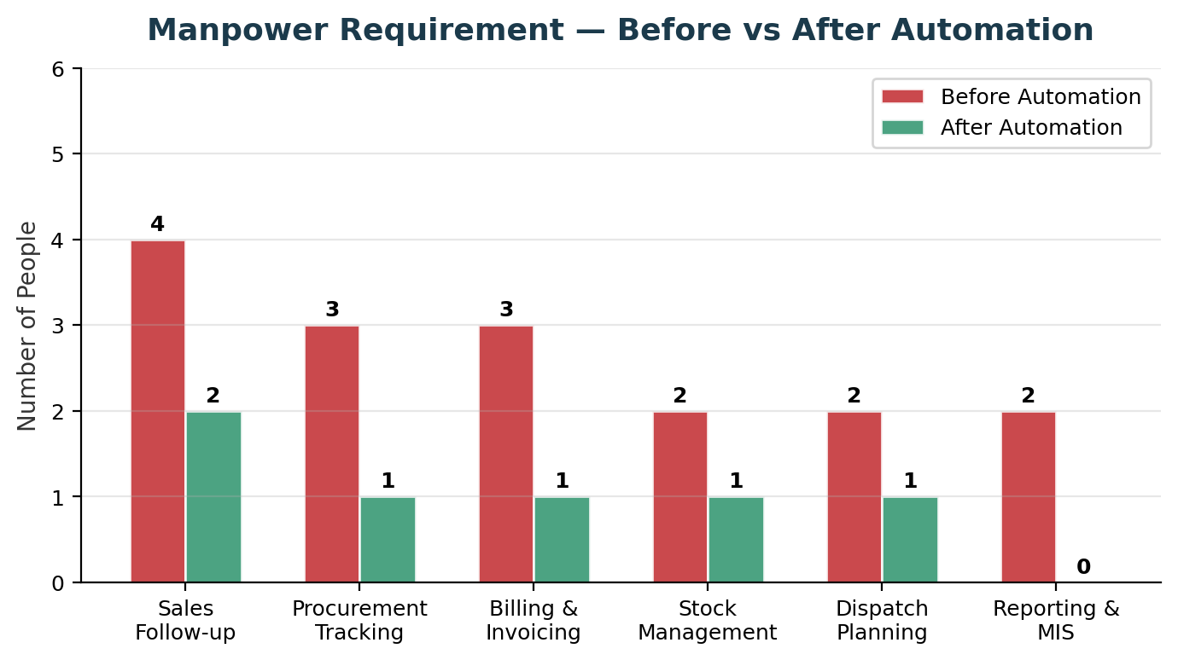
Function | Before (Manual) | After (Automated)
Sales Follow-up | 4 people doing manual Excel filtering, phone calls, WhatsApp coordination | 2 people: system auto-generates follow-up lists, AI chatbot handles routine inquiries
Procurement Tracking | 3 people tracking orders via Excel, Word POs, email follow-ups | 1 person: system tracks all POs, auto-alerts on delays, generates PO PDFs
Billing & Invoicing | 3 people: manual Word/Tally entry, bill interception coordination | 1 person: auto-generated invoices synced with Tally, digital interception workflow
Stock Management | 2 people: daily Google Sheet updates, manual stock checks | 1 person: real-time system updates, automated transit tracking
Dispatch Planning | 2 people: manual truck load planning, phone coordination | 1 person: system suggests optimal loads, digital loading plans
Reporting & MIS | 2 people: daily Excel report compilation, manual filtering | 0 people: fully automated, scheduled, real-time dashboards

20.3 Response Time Improvement
Speed of response is the #1 factor in converting inquiries to orders. Currently, customers wait 30–120 minutes for availability confirmation. With automation, this drops to under 5 minutes — often instant via the AI chatbot. This directly prevents customers from sourcing elsewhere.
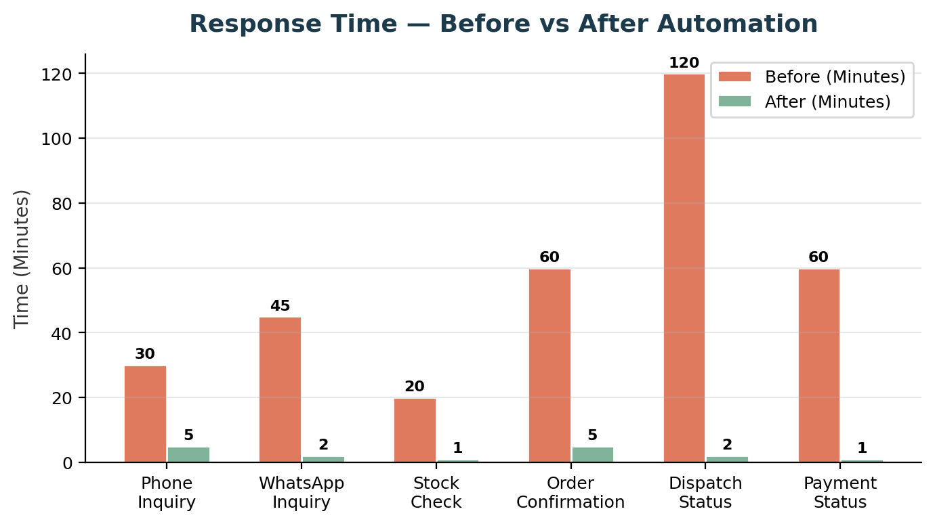

20.4 Operational Error Elimination
The most painful current issue: one salesman sells stock already allocated to another customer's order. This damages customer relationships permanently. The real-time stock reservation system eliminates this entirely. Other errors — wrong firm billing, missed follow-ups, credit limit violations — are similarly addressed by system-enforced rules.
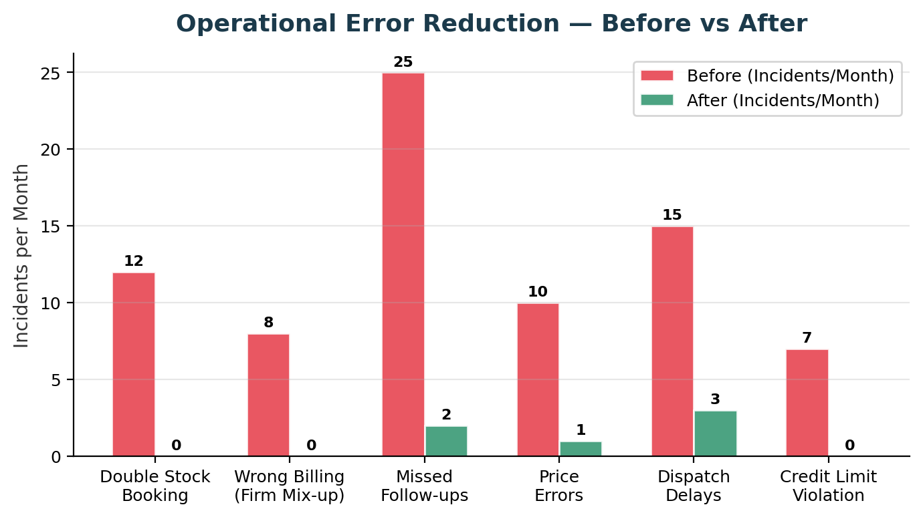

20.5 Inquiry-to-Delivery Conversion Improvement
Currently, out of every 100 inquiries, only ~20 convert to confirmed orders — primarily due to slow response times, inability to suggest alternatives, and lack of systematic follow-up. The AI chatbot with instant availability, proactive suggestions, and the planning engine can more than double this conversion rate.
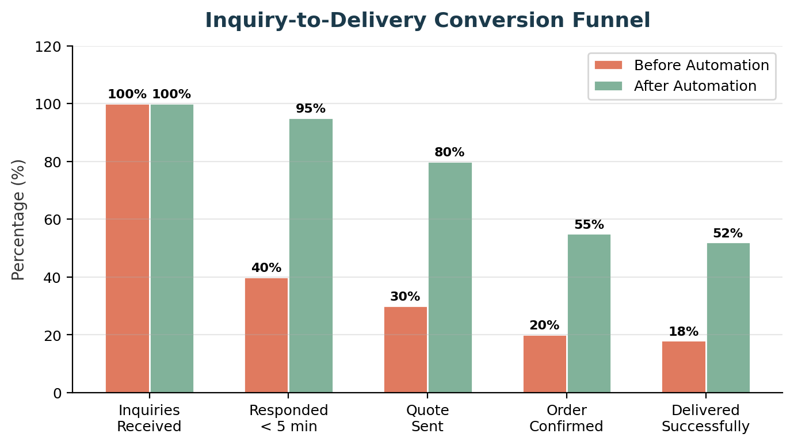

20.6 Daily Operational Time Savings
Current daily operations consume ~14 person-hours on repetitive tasks that can be automated. After implementation, this drops to ~2.5 person-hours — freeing the team to focus on relationship building, new customer acquisition, and strategic decisions.
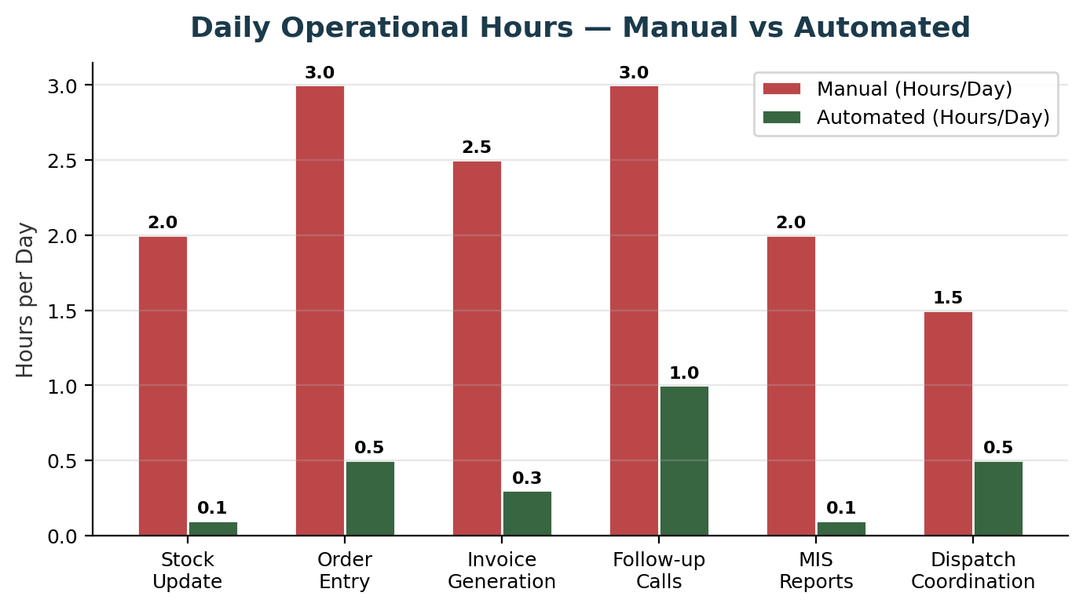

20.7 Projected Revenue Growth
The compound effect of faster response, higher conversion, 24/7 availability, intelligent cross-selling (AI suggesting alternatives, stock lots, reel-cuts), and reduced operational friction is projected to drive significant revenue growth. Conservative estimate: 75% growth over 2 years from the same customer base, with additional upside from new customers attracted by the app/chatbot.
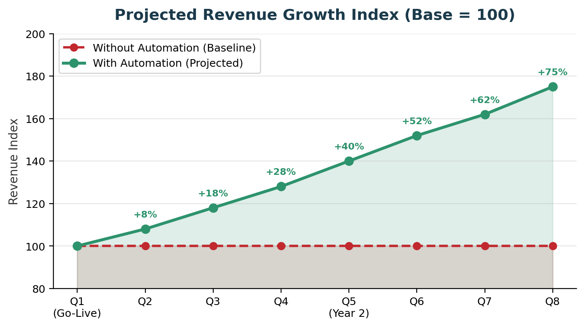

20.8 Key Growth Drivers After Automation
Growth Driver | How It Works | Impact
Zero Double Bookings | Real-time stock locking eliminates the #1 customer sentiment destroyer. Every salesman sees live, accurate stock — including what's booked, in transit, and available. | Customer retention, trust
24/7 Customer Access | Customers can check availability, get AI suggestions, and place inquiries anytime — not just during 9:30AM–7PM. Night-time and early-morning inquiries are captured automatically. | +30% inquiry volume
AI Cross-Selling | Chatbot proactively suggests alternatives: different GSM, different mill, reel-cut option, stock lot deals. Converts 'not available' into 'here's what we can do.' | +15% order value
Planning Engine Advantage | No competitor offers carton-dimension-to-paper-size optimization. This is a unique differentiator that locks in customers (especially Vijay Shri-type printers). | Competitive moat
Market Intelligence | Every app search, every inquiry, every 'search but didn't order' — feeds into demand analytics. Know what the market wants before competitors do. | Strategic advantage
Reduced Dependency on Experts | New staff don't need years of product knowledge — the system guides decisions. Scale the team without quality loss. | Scalability
Mill Relationship Optimization | System tracks TAT adherence, quality, and fill rates per mill. Data-driven decisions on which mills to prioritize. | Better procurement terms
Payment Discipline | Automated credit checks prevent overexposure. Collection follow-ups are systematic, not forgotten. | Cash flow improvement

21. Phased Rollout Plan

Phase 1 — Foundation & Procurement (Months 1–3)
Focus: Replace Excel/Word-based procurement with a structured system.
Deliverable | Description
Master Data Setup | Mill, product, customer, location masters
Purchase Order Module | Order form, PO generation (PDF), email to mill
Pending Order Tracking | Status tracking, delivery dates, follow-up alerts
Material Receipt | Transit tracking, godown receipt, weight reconciliation
Basic Inventory | Multi-location stock with 5 statuses
Tally Bridge (Phase 1) | Pull payment/outstanding data from Tally
Dashboards | Procurement dashboard, pending orders, stock position

Phase 2 — Sales & Internal Ops (Months 3–5)
Focus: Digitize sales workflow, stock reservation, approval engine.
Deliverable | Description
Inquiry Management | Capture, assignment, tracking
Sales Order Workflow | SO creation, confirmation, fulfillment tracking
Stock Reservation | Real-time soft-locking (salesman conflict fix)
Approval Workflow | Rule-based with multi-level escalation
Dispatch Planning | Load planning, bill interception, delivery tracking
Tally Bridge (Phase 2) | Push invoices, pull updated payments
Sales Reports | Performance, follow-up, conversion reports

Phase 3 — Customer App & AI Chatbot (Months 5–8)
Focus: Launch the 'game changer' customer-facing experience.
Deliverable | Description
Mobile App | Registration, search, availability, order, tracking
AI Chatbot (App) | Conversational availability, alternatives, inquiry/order flow
WhatsApp Chatbot | Same capabilities via WhatsApp Business API
Planning Engine | Carton dimensions → optimal sheet size recommendation
Hidden Rule Engine | Silent credit checks with diplomatic responses
Market Intelligence | Search analytics, demand tracking

Phase 4 — Advanced Features (Months 8–12)
Focus: Refine, optimize, and add advanced capabilities.
Deliverable | Description
Credit Management | Full lifecycle, PDC, collection follow-up
Quality & Claims | Complaint registration, mill claims, returns
Advanced Reporting | Forecasting, mill scorecards, margin analysis
CRM Enhancements | Visit planning, sample tracking, journey analytics
AI Improvements | Learning from data, better recommendations
GST Compliance | E-Invoice, E-Way Bill automation, GSTR reconciliation

22. Appendices

Appendix A — Mill Portfolio
Mill | Products | Billing Firm | Typical TAT
ITC Limited (PSPD) | FBB, SBS, Coated, Packaging Board | Monit Paper Sales Agency | 3–7 days
NR Agarwal Industries | Duplex Board (GB/WB), Kraft | Monit Paper Associates | 4–10 days
Gayatri Shakti Paper | Duplex Board, Kraft | Associates | 5–12 days
Emami Paper Mills | Writing/Printing, Packaging | Associates | 7–15 days
Balkrishna Paper Mills | Duplex Board | Associates | 5–10 days
JK Paper Ltd | FBB, Writing/Printing | Agency / Associates | 5–15 days
Others (6-7 mills) | Various | As configured | Variable

Appendix B — Product Catalog Structure
Paper Type | Sub-Types | GSM Range | Common Sizes
Duplex Board | Grey Back (GBD), White Back (WBD) | 200–450 GSM | 23x36, 25x36, 28x36
FBB | Standard, Premium | 210–400 GSM | 23x36, 25x36, 22x28
SBS | Standard | 200–350 GSM | Various
Kraft Paper | Brown, White | 80–300 GSM | Reel and sheet
Coated Paper | C1S, C2S | 80–300 GSM | Various

Appendix C — Additional Paper Trading Activities
The following 25 activities are standard in the paper trading industry. All have been incorporated into the relevant modules of this SRS:
# | Activity | Covered In
1 | Weight Reconciliation (mill vs actual) | Procurement (PR-033)
2 | Quality Claims & Returns | Quality Module (Section 13)
3 | Sample Management | CRM (CR-007)
4 | Debit Note / Credit Note Management | Billing (BL-005)
5 | Mill Commission & Incentive Tracking | Procurement (PR-006)
6 | Freight & Transport Cost Management | Dispatch (DL-020–022)
7 | GST / E-Way Bill / E-Invoice Compliance | Billing (BL-020–023)
8 | Payment Collection & PDC Management | Payment (Module 12)
9 | Customer Segmentation & Tiering | CRM (CR-003)
10 | Price List & Margin Management | Sales (SL-010–015)
11 | Sheeter Trim/Waste Management | Inventory (IN-020–024)
12 | Multi-Location Godown Management | Inventory (IN-001–004)
13 | Transit & Stock Insurance Claims | Quality (QC-002)
14 | Seasonal Demand Forecasting | Reporting (RP-054)
15 | Competitor Price Intelligence | Reporting (RP-053)
16 | Sales Team Visit/Activity Tracking | CRM (CR-006)
17 | Mill Scheme Pass-through | Procurement (PR-006)
18 | Stock Lot / Seconds Management | Inventory (IN-030–032)
19 | Reel Inventory & Conversion Tracking | Inventory (IN-020–024)
20 | Customer Machine Profile Management | Customer App (CA-050–052)
21 | Die Library Management | Config (MD-009)
22 | Inter-Godown Stock Transfers | Inventory (IN-003)
23 | Mill Run Broadcast & Proactive Sales | Sales (SL-006)
24 | Advance Payment to Mills (100% advance model) | Payment (PM-014)
25 | Unsecured Credit Risk Management | Payment (PM-001–005)

— End of Document —
This document is subject to review and approval by the Monit Paper Agency management team.
Requirements may be refined during the detailed design phase.
CONFIDENTIAL — Monit Paper Sales Agency / Monit Paper Associates

