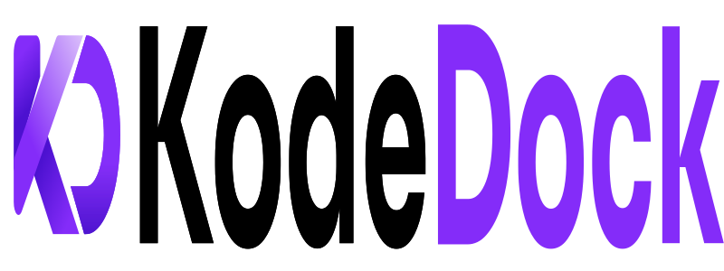
EXECUTIVE MASTER SPECIFICATION
& BUSINESS WHITEPAPER
The Next-Generation Digital Code Marketplace & Trust-Engineered Software Escrow Platform
Author & Founder: | KodeDock Core Engineering Team
Target Evaluation: | Academic Committee / Startup Investors / Enterprise Partners
Architecture Status: | Production-Grade Distributed Microservices
Release Version: | Version 1.0.0 (September 2026)

1. Executive Summary & The 30-Second Elevator Pitch
KodeDock is an automated, trust-engineered digital code marketplace and escrow platform built specifically for software developers, tech founders, and digital agencies. It solves the massive multi-billion-dollar trust deficit in buying and selling software source code by eliminating raw, dangerous .zip downloads and replacing them with guaranteed 7-Day Escrow Protection and automated GitHub Private Repository Duplication.
📌 CORE STRATEGIC VALUE PROPOSITION
For Indian & Global Developers: KodeDock provides a verified mechanism to transform dormant private repositories into scalable digital software assets generating recurring royalty income in INR and USD.
For Tech Founders & Buyers: It eliminates the risk of purchasing broken, fake, or malicious templates through an automated 7-day inspection window and direct git integration.

2. Market Opportunity & Macro Economic Impact
The Indian Developer Economy & The Freelancer Trap
India possesses over 5.2 million active software developers—the second-largest developer ecosystem in the world, projected to become #1 globally by 2027. However, the vast majority of Indian tech talent remains trapped in the linear 'hourly service treadmill' (Upwork, Fiverr, domestic freelancing) where income is strictly bounded by billable hours.
Every single day, freelance developers write high-quality authentication systems, Razorpay payment flows, SaaS dashboards, and Flutter applications. Once the client project completes, that intellectual property sits dormant in private folders. KodeDock creates an economic pipeline for developers to monetize their existing codebases as production-ready boilerplates.
Competitive Positioning Benchmark
Platform Feature | Legacy Marketplaces (Envato) | Generic Platforms (Gumroad) | ⚓ KodeDock (Our Platform)
Code Fulfillment | Manual .zip download | Generic download link | Automated Private GitHub Duplication
Trust Guarantee | No escrow / Rigid refunds | No escrow / Chargeback risk | Automated 7-Day Trust Escrow
Indian Payments | High PayPal fees, bad forex | Stripe-only (Fails on Indian cards) | Native UPI, Netbanking & Razorpay
Tax Compliance | US withholding tax forms | Complex VAT/Sales tax | Automated 1% TDS (Sec 194-O) & GST
Code Security | Slow manual review (weeks) | Zero code inspection | Automated Gitleaks & Malware Scan
Live Previews | Static images / Slow demos | Static images | In-Browser WebContainer Sandbox

3. Technical System Architecture & Microservices Topology
KodeDock is engineered using an independent, high-throughput microservices architecture. Each backend service is self-contained with its own execution environment, communicating across a shared bridge network (`kodedock-network`) and Redis Pub/Sub event bus.
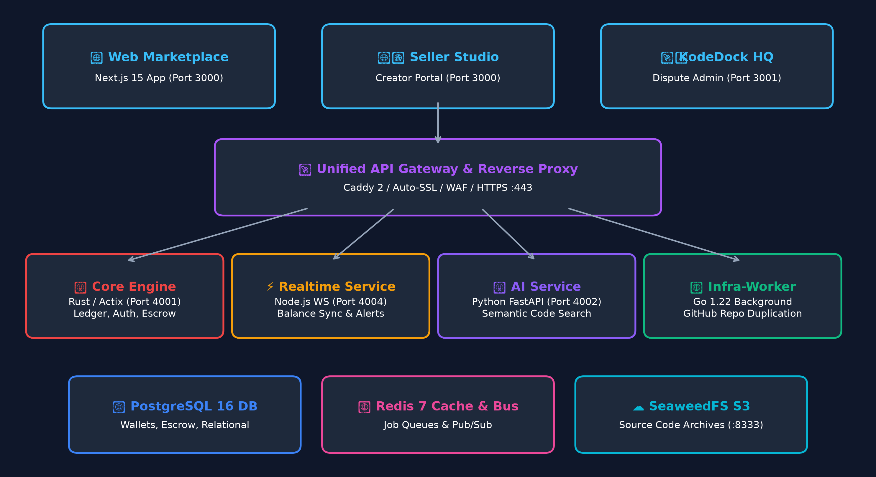
Figure 1: High-Level Microservices & Infrastructure Topology
Deep-Dive Breakdown of Microservices
🦀 1. Core Engine (Rust / Actix-Web / SQLx): Handles user authentication, double-entry financial ledgers in integer paise, Argon2id password hashing, AES-256-GCM encrypted OAuth token management, and Razorpay HMAC-SHA256 signature validation. Rust guarantees sub-millisecond execution with zero memory overhead.
🐹 2. Infra-Worker (Go 1.22): An asynchronous background engine listening to Redis BLPop queues. It performs automated sandboxed git cloning, commit history truncation, private GitHub repo creation via REST API, and PDF invoice generation.
⚡ 3. Realtime Service (Node.js / WebSockets): Manages bidirectional WebSocket connections for instant live wallet balance updates, order alerts, and multi-tab client synchronizations.
🧠 4. AI & Semantic Search Engine (Python / FastAPI): Vector embedding pipeline matching natural language buyer queries (e.g., 'Next.js SaaS kit with Stripe') against codebase metadata using cosine similarity and PostgreSQL hybrid search.
☁️ 5. Object Storage (SeaweedFS S3): High-performance S3-compatible storage compiled directly from Go source, providing pre-signed download URLs for large code archives.
4. The Financial Trust Engine: 7-Day Escrow & Double-Entry Ledger
Financial transactions in KodeDock adhere to strict double-entry bookkeeping rules. To eliminate precision loss and rounding errors, all amounts are stored as integer paise (1 INR = 100 paise).
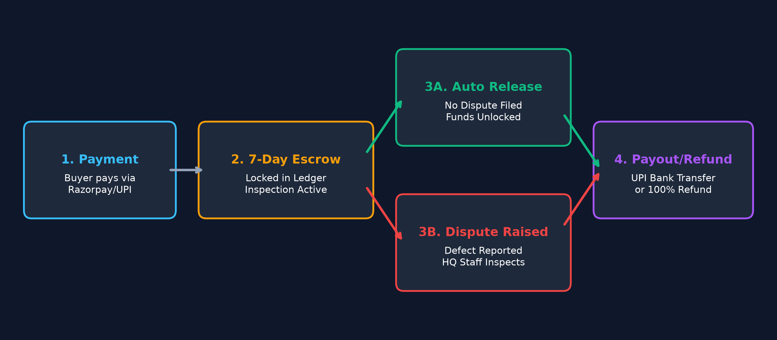
Figure 2: 7-Day Escrow State Machine & Dispute Lifecycle
Mathematical Escrow Model & State Transitions
When a buyer purchases a ₹4,999 template, the funds transition through an automated lifecycle:
• 1. Payment Verification: Razorpay webhook validates payment signature via HMAC-SHA256. Order is created.
• 2. Escrow Lock: ₹4,999 (499,900 paise) is credited to the seller's wallet under locked_in_escrow status.
• 3. 7-Day Inspection Window: The buyer has 7 days to run and verify the codebase. If defective, they file a dispute.
• 4. Automated Release: If no dispute is logged within 168 hours (7 days), the background Cron Scheduler automatically moves the balance from locked_in_escrow to available_balance.
• 5. Payout Execution: Seller requests a payout via UPI or NEFT. The system calculates and deducts 1% Section 194-O TDS and platform fees before triggering the bank transfer.
5. Automated Code Delivery & GitHub Pipeline
Unlike legacy platforms that force buyers to download raw .zip files (which frequently result in environment mismatches and pirated re-uploads), KodeDock implements an automated Git Provisioning Pipeline:
Step 1: 1. Ephemeral Sandbox Initialization: The Go worker initializes an isolated temporary filesystem directory.
Step 2: 2. Vendor Clone: The worker shallow-clones the seller's master repository (`git clone --depth=1`).
Step 3: 3. Commit History Stripping: Internal development commit messages and sensitive branches are wiped (`rm -rf .git && git init`).
Step 4: 4. Target Repository Creation: The worker interacts with the GitHub REST API (`POST https://api.github.com/user/repos`) using the buyer's encrypted OAuth token to create a fresh private repository.
Step 5: 5. Clean Push: The codebase is pushed directly to the buyer's GitHub account (`git push origin main`), granting instant personal access.
6. Security, Anti-Fraud & Cryptographic Protocols
🔒 1. AES-256-GCM Token Encryption: Seller and buyer GitHub OAuth tokens are encrypted at rest in PostgreSQL using AES-256-GCM with authenticated key derivation.
🔒 2. HttpOnly SameSite=Strict Cookies: JWT authentication tokens are never exposed to browser localStorage, immunizing the frontend against Cross-Site Scripting (XSS) token theft.
🔒 3. TOCTOU-Safe Wallet Transactions: Balance deductions utilize PostgreSQL row-level locks (`SELECT balance FROM wallets WHERE user_id = $1 FOR UPDATE`) within ACID transactions, preventing double-spending race conditions.
🔒 4. Automated Secret & Malware Scanner: Uploaded code is scanned against 100+ secret signatures (OpenAI keys, AWS credentials, private RSA certs) and known CVEs before being published.
🔒 5. Abstract Syntax Tree (AST) Plagiarism Check: Analyzes code structure against public open-source repositories to stop unauthorized resale of unmodified open-source software.
7. Legal, Taxation & Regulatory Compliance (Indian & Global)
Operating a compliant marketplace in India requires adherence to strict legal and taxation standards:
Compliance Mandate | Regulatory Section | Platform Implementation in KodeDock
1% E-Commerce TDS | Section 194-O Income Tax Act | Automatically deducts 1% TDS on gross sales upon escrow release; issues Form 16A quarterly.
B2B GST Invoicing | CGST & SGST Rules | Validates buyer GSTIN in real-time; generates GST-compliant invoices for business tax credit.
Seller KYC Verification | PMLA & RBI Guidelines | Penny-drop ₹1 bank account verification + PAN card name matching prior to payout activation.
Platform Fee GST | 18% GST on Services | 18% GST is levied and remitted strictly on KodeDock's 10% platform commission fee.

8. Business Model, Monetization & Unit Economics
Monetization Streams
• 1. Marketplace Transaction Take-Rate: 10% to 15% platform commission on all code sales.
• 2. Sandbox In-Browser Demo Hosting: ₹499/month for pro creators to provide WebContainer live previews.
• 3. Verified Developer Studio Pass: ₹999/month for verified badges, priority search ranking, and instant 24h escrow.
• 4. Multi-Seat Enterprise Licenses: 2.5x price multiplier for agency licenses allowing unlimited client deployments.
Unit Economics (Example on ₹5,000 Average Order Value)
Gross Merchandise Value (GMV): ₹5,000.00
Platform Take Rate (12%): ₹600.00
Server & Storage Infrastructure Cost: -₹12.00 (Rust & SeaweedFS efficiency)
Payment Gateway Processing Fee (2%): -₹100.00
------------------------------------------------
Net Contribution Margin: ₹488.00 (~81.3% Gross Profit Margin)
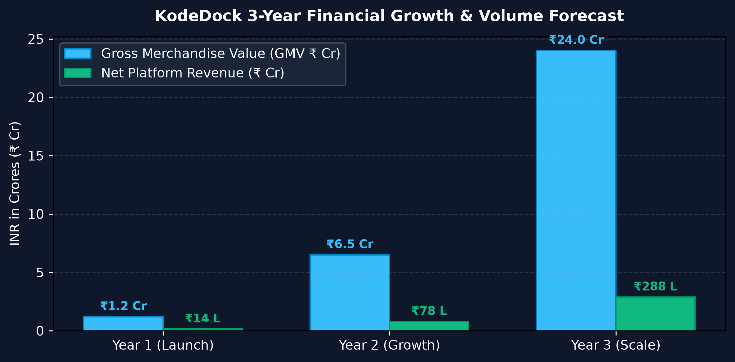
Figure 3: 3-Year GMV and Platform Net Revenue Projections
9. Strategic 4-Phase Roadmap & Milestones
🚩 • Phase 1 (Q1): Core Execution & Reality — Implement Go worker real Git push, multi-tab WebSocket support, and AI hybrid search.
🚩 • Phase 2 (Q2): Security, Escrow & Tax — Deploy 7-day escrow cron engine, 1% TDS deduction, and Gitleaks security scanner.
🚩 • Phase 3 (Q3): Developer Experience & Sandboxing — Deploy Unified Caddy Gateway, WebContainer live preview, and developer webhooks.
🚩 • Phase 4 (Q4): Global Scale & Affiliates — Launch YouTuber affiliate program, Software licensing SDK, and Stripe USD global payments.
10. Conclusion & Founder's Vision
KodeDock bridges the fundamental gap between software creators and software buyers. By engineering trust into the protocol—combining the memory-safe speed of Rust, the asynchronous power of Go, and a mathematical 7-day escrow ledger—KodeDock creates a transformative economic ecosystem that unlocks the true value of software intellectual property for millions of developers worldwide.

