1 nov 2026

Project name - resume copilot

Goal - To be best only and only in resume screening process
Subgoals - to be more economical that current ai resume parser

What we’re
1. A resume screening engine that helps companies providing them with service to evaluate candidates resumes.

Functional components -

Non functional components -

Where will be placed in current screening cycle
We aim to provide service to company with their hiring process.
Now here are 2 ways we can go -
- We could either be an whole independent application where company could upload their job description and matching company’s identity candidates apply for their role via out portal
- We could provide a sandbox which will have execution engine and storage capacity

Broad architecture design -

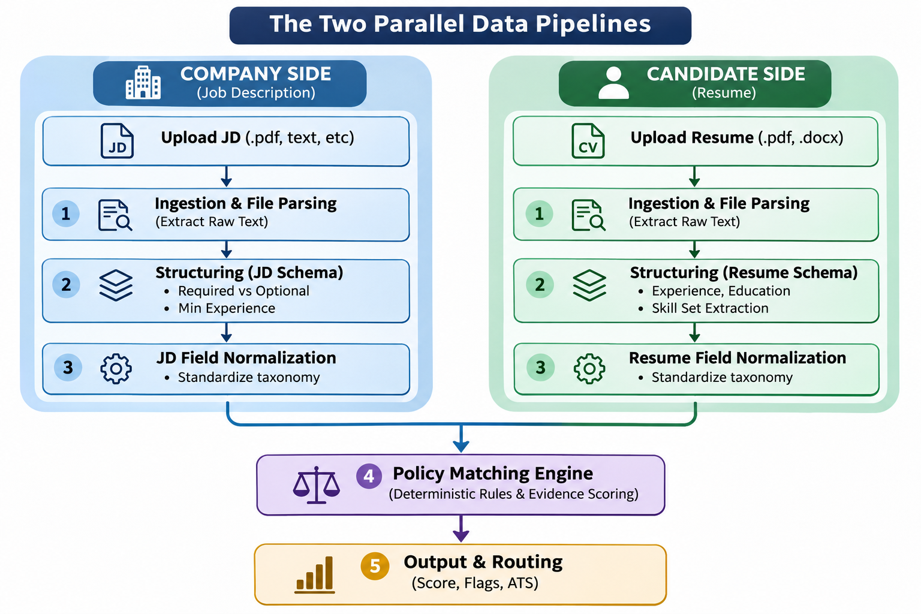

1st stage Upload - covers only file submission and storage

Boundary: This list covers only file submission and storage. Problems occurring after successful upload, such as OCR failure, layout detection, reading-order errors and text extraction inaccuracies, should be documented under a separate Document Parsing and Ingestion category.

1. Company's end (Job Description / Requirements Upload)
ID | Problem | Explanation
C-U1 | Unsupported file format | Company uploads a file format not supported by the platform.
C-U2 | Corrupted document | Uploaded job description is damaged or unreadable.
C-U3 | Password-protected document | Uploaded document requires a password.
C-U4 | Incorrect document uploaded | Recruiter accidentally uploads an unrelated or incorrect job description.
C-U5 | Outdated document uploaded | Recruiter uploads an older version of the job description.
C-U6 | Duplicate document upload | Same job description is uploaded multiple times.
C-U7 | Multiple documents uploaded incorrectly | Multiple job descriptions are uploaded where the system expects one, or vice versa.
C-U8 | Empty document | Uploaded job description contains no content.

2. Candidate's end (Resume Upload)
ID | Problem | Explanation
A-U1 | Unsupported file format | Candidate uploads a resume in an unsupported format.
A-U2 | Corrupted resume | Uploaded resume is damaged or unreadable.
A-U3 | Password-protected resume | Resume requires a password to access.
A-U4 | Incorrect resume uploaded | Candidate accidentally uploads the wrong file.
A-U5 | Outdated resume uploaded | Candidate uploads an older resume instead of the updated version.
A-U6 | Duplicate resume upload | Candidate submits the same resume multiple times.
A-U7 | Multiple resumes uploaded incorrectly | Candidate uploads multiple resume versions when only one is expected.
A-U8 | Empty resume | Uploaded file contains no resume content.
A-U9 | Resume file size exceeds limit | Resume exceeds the platform's maximum permitted file size.

3. Common problems (Company + Candidate)
ID | Problem | Explanation
U1 | File size restriction | Uploaded file exceeds the maximum allowed size.
U2 | Upload interruption | Network disconnection interrupts the upload process.
U3 | Incomplete upload | File is only partially uploaded.
U4 | Incorrect file extension | File extension does not match the actual file format.
U5 | MIME-type mismatch | Declared content type does not match the actual file type.
U6 | Upload timeout | Upload takes too long and the request expires.
U7 | Server-side upload failure | Backend or upload service fails to receive or process the upload request.
U8 | Storage failure | Insufficient storage or storage-service failure prevents saving the file.
U9 | Permission failure | User does not have the required upload or storage permissions.
U10 | Malicious file upload | Uploaded document contains malware or malicious embedded content.
U11 | Unsupported encoding | File uses an encoding that the upload system cannot handle or preserve.

1. Problem hierarchy
Parent problem | Subproblems
File format compatibility | Unsupported file format, incorrect file extension, MIME-type mismatch, unsupported encoding
File integrity and accessibility | Corrupted file, password-protected file, empty document
Upload reliability | Upload interruption, incomplete upload, upload timeout
Upload infrastructure failure | Server-side failure, storage failure, permission failure
File size limitations | File exceeds maximum upload size
Duplicate submission | Duplicate document upload
Incorrect document submission | Wrong document uploaded, outdated document uploaded
Multiple document handling | Multiple documents uploaded incorrectly
Upload security | Malicious file upload

2. Company vs Candidate classification
These parent problems can occur at both ends, but some have different manifestations.
Parent problem | Company | Candidate | Common
File format compatibility | ✓ | ✓ | ✓
File integrity and accessibility | ✓ | ✓ | ✓
Upload reliability |  |  | ✓
Upload infrastructure failure |  |  | ✓
File size limitations |  |  | ✓
Duplicate submission | ✓ | ✓
Incorrect document submission | ✓ | ✓
Multiple document handling | ✓ | ✓
Upload security |  |  | ✓

Solution design for stage 1 -

File format compatibility -
- Problems covered:
- Unsupported file formats.
- Incorrect file extensions.
- MIME-type mismatch.
- Unsupported encoding.
3.Proposed solution: Multi-layer File Validation and Format Normalization.Instead of trusting the file extension or MIME type provided by the client, validate the actual uploaded file.
Required mechanisms:
Mechanism | Responsibility
Extension allowlist | Restrict accepted extensions, e.g. PDF, DOCX, TXT.
MIME validation | Check declared content type against the actual file.
Magic-byte detection | Identify the actual file format using its binary signature.
Encoding detection | Identify unsupported or incorrectly encoded text files.
Format normalization | Convert supported input formats into a consistent internal representation where necessary.
Failure handling:
- Unsupported format → Reject and explain accepted formats.
- Extension/MIME mismatch → Reject or flag for validation.
- Invalid file signature → Reject.
- Encoding issue → Attempt supported decoding; otherwise request another upload.
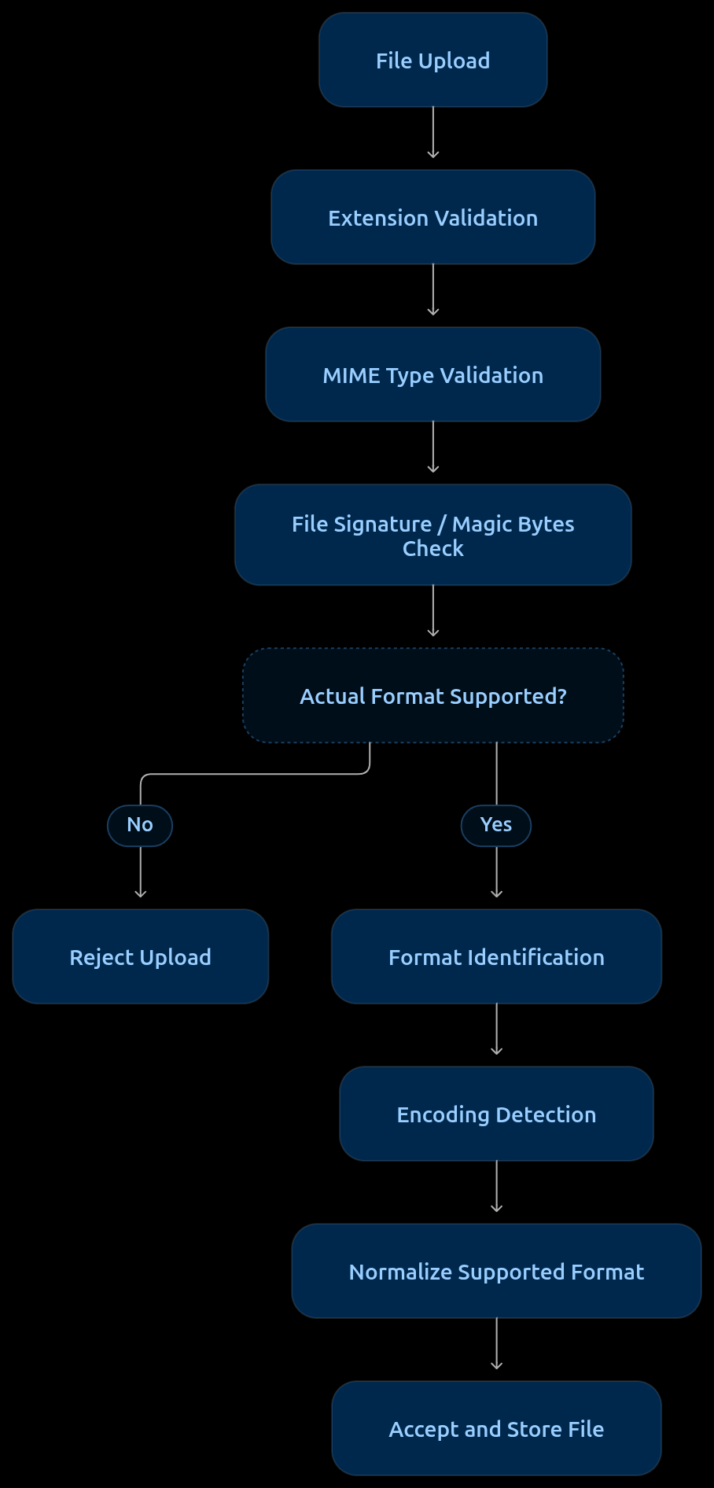

Important architectural decision: Never trust client-provided file metadata as proof of file type.

File Integrity and Accessibility
Problems covered:
- Corrupted or damaged documents.
- Password-protected documents.
- Empty documents.

Proposed solution: File Integrity Validation Layer
Introduce a validation layer immediately after file-format verification. Its responsibility is to ensure that the uploaded file is accessible, structurally valid and contains data before it enters the processing pipeline.
Proposed workflow
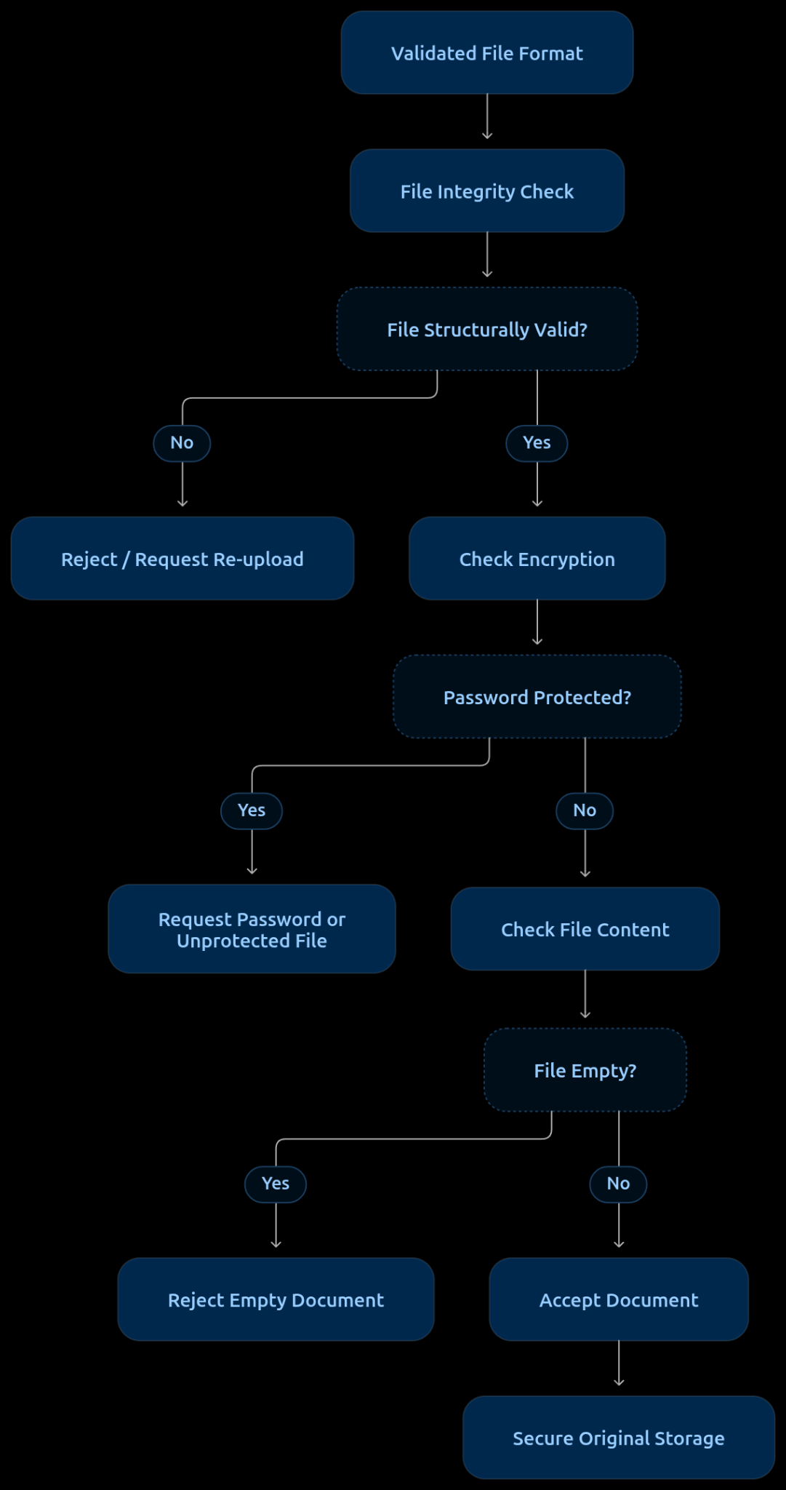

Required mechanisms
Mechanism | Responsibility
Structural integrity validation | Verify that the document can be opened and its internal structure is valid.
Encryption detection | Identify password-protected or encrypted documents.
Content existence validation | Check whether the document contains actual content rather than being empty.
Page/content validation | Identify documents containing blank pages or no usable content.
File checksum | Generate a hash to identify file corruption or unexpected changes during storage and transfer.

Failure handling
Failure | System response
Corrupted document | Reject and request re-upload.
Password-protected document | Request password or an unprotected copy.
Empty document | Reject and notify the uploader.
Partially damaged document | Reject or flag for manual inspection rather than silently accepting it.

Important architectural decisions
- Never silently accept a document that fails integrity validation.
- Preserve the original uploaded file for traceability.
- Do not confuse a structurally valid document with a successfully parsed document. Parsing is a separate stage.
- Password handling should avoid storing passwords in plaintext or exposing them in logs.
Expected outcome: Only structurally valid, accessible and non-empty documents proceed to the next stage.

Upload Reliability
Problems covered:
- Upload interruption.
- Incomplete file upload.
- Upload timeout.

Proposed solution: Resumable and Fault-Tolerant Upload Mechanism
Introduce a reliable upload mechanism that can recover from network interruptions, detect incomplete transfers and prevent partially uploaded files from being accepted.
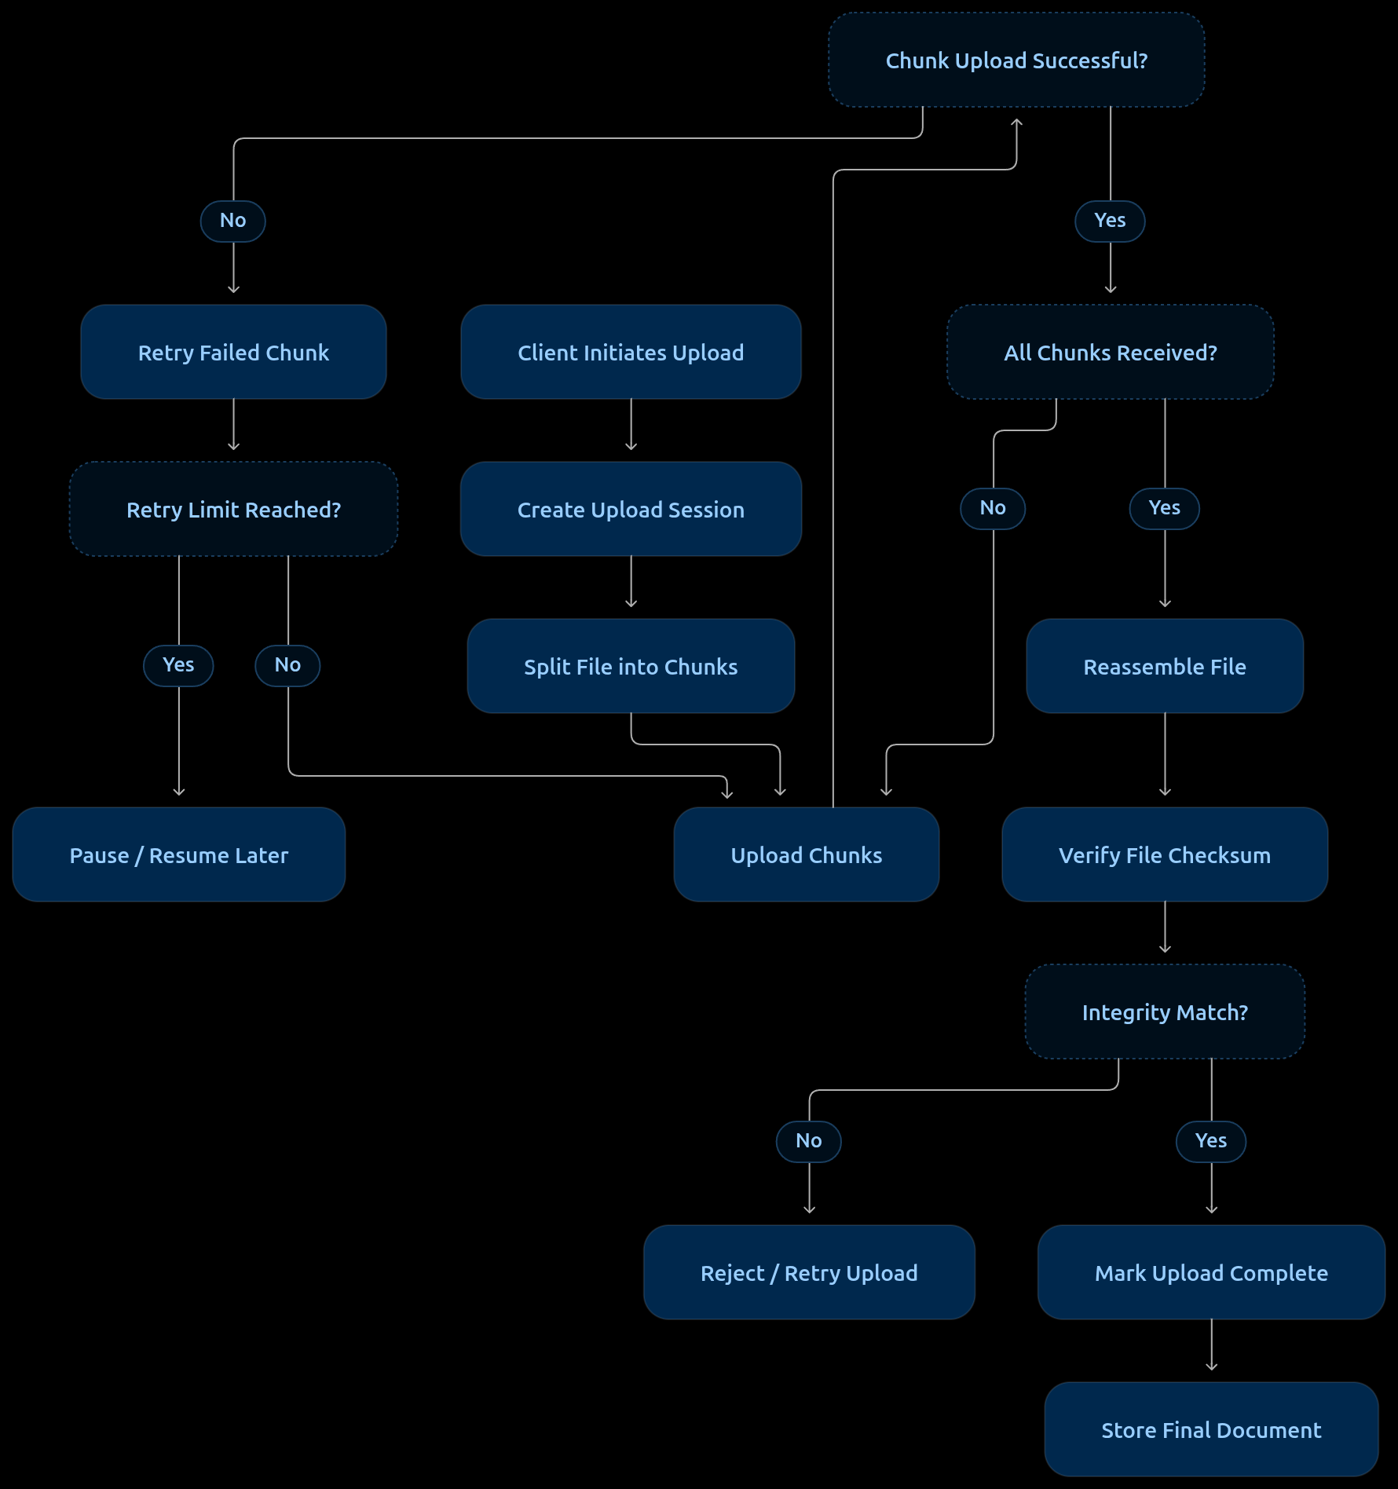

Required mechanisms
Mechanism | Responsibility
Chunk-based uploading | Divide large files into smaller pieces for reliable transfer.
Upload session management | Maintain upload state and uniquely identify each upload.
Retry mechanism | Automatically retry failed chunk transfers.
Resumable uploads | Continue interrupted uploads without restarting from zero.
Timeout management | Apply configurable timeouts to upload requests.
Checksum verification | Verify that the reconstructed file matches the original.
Upload state tracking | Track pending, uploading, paused, failed and completed states.

Failure handling
Failure | System response
Network interruption | Pause upload and preserve completed chunks.
Chunk upload failure | Retry the failed chunk.
Repeated failures | Pause upload and allow manual resumption.
Upload timeout | Retry or resume based on the upload state.
Missing chunks | Prevent file reconstruction until all chunks arrive.
Checksum mismatch | Reject the reconstructed file and initiate recovery.
Abandoned upload | Expire the session and clean up temporary chunks after a retention period.

Important architectural decisions
- Use unique upload session IDs to prevent chunks from different uploads mixing.
- Make chunk uploads idempotent to avoid duplicate chunks during retries.
- Never expose partially uploaded files to the screening pipeline.
- Maintain upload state on the server, not exclusively in the browser.
- Use temporary storage and atomic finalization after successful verification.
Expected outcome: Uploads become recoverable, verifiable and resistant to temporary network or server communication failures.

Upload Infrastructure Failure
Problems covered:
- Server-side upload failure.
- Storage failure.
- Upload permission failure.

Proposed solution: Fault-Tolerant Upload Infrastructure
Introduce a reliable upload infrastructure that handles server failures, storage availability and access authorization independently.
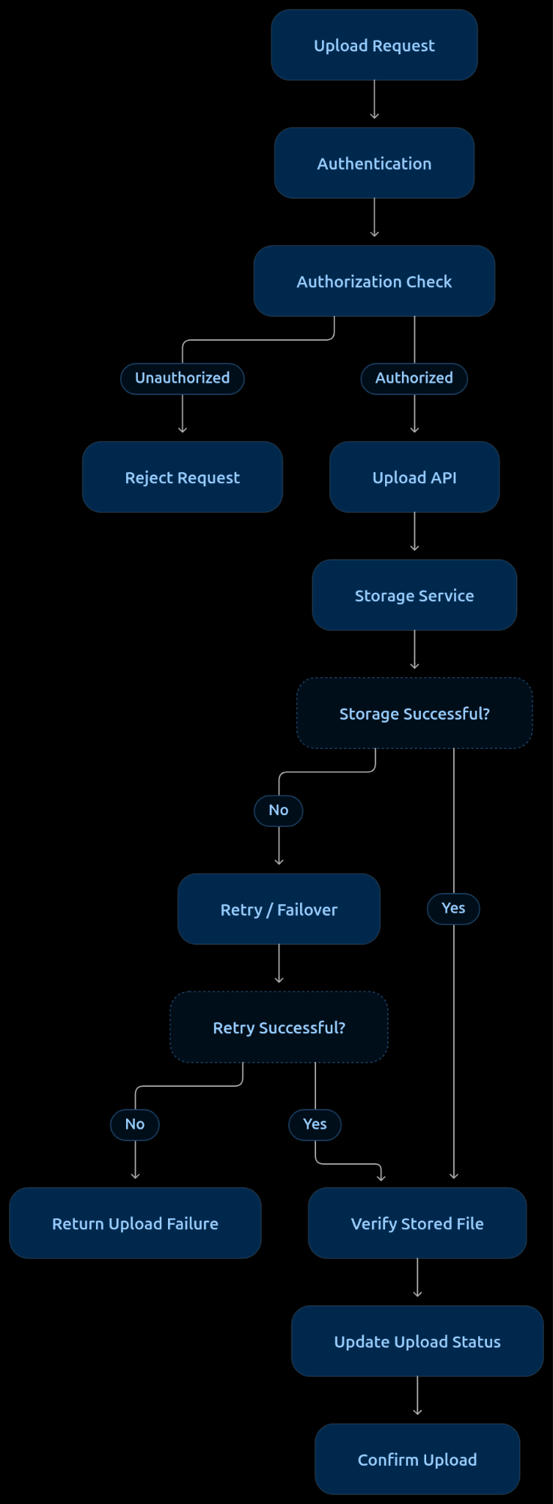

Required mechanisms
Mechanism | Responsibility
Authentication | Verify the identity of the uploader.
Role-based access control (RBAC) | Ensure the user can upload the relevant document type.
Storage abstraction | Decouple application logic from the underlying storage provider.
Retry mechanism | Retry transient storage and server failures.
Health checks | Monitor upload services and storage availability.
Failover mechanism | Route uploads to an available storage instance or service when supported.
Storage verification | Confirm that the uploaded file was successfully persisted.
Transactional status management | Prevent the application from marking unsuccessful uploads as completed.

3. Failure handling
Failure | System response
Upload API unavailable | Retry through an available service instance.
Storage service unavailable | Retry with backoff or use configured failover storage.
Insufficient storage capacity | Reject the upload and raise an infrastructure alert.
Permission denied | Return an authorization error.
Authentication failure | Reject the request.
Storage write failure | Keep upload status unsuccessful and retry where appropriate.
Database status update failure | Reconcile storage and upload records before marking completion.

4. Important architectural decisions
- Keep authentication and authorization separate.
- Avoid tightly coupling the application to a particular storage provider.
- Use temporary storage until the upload is verified.
- Maintain consistent upload status between the application database and storage.
- Use exponential backoff for transient failures.
- Monitor storage capacity and service health.
Expected outcome: Upload infrastructure becomes more reliable, recoverable and secure, even when individual application or storage components fail.

Initial File Validation
Problems covered:
- File size restrictions.
- Unsupported file formats.
- Incorrect file extensions.
- MIME-type mismatches.

Proposed solution: Pre-upload Validation Gateway
Before transferring the actual file, perform client-side validation for immediate feedback and server-side validation for security and correctness.
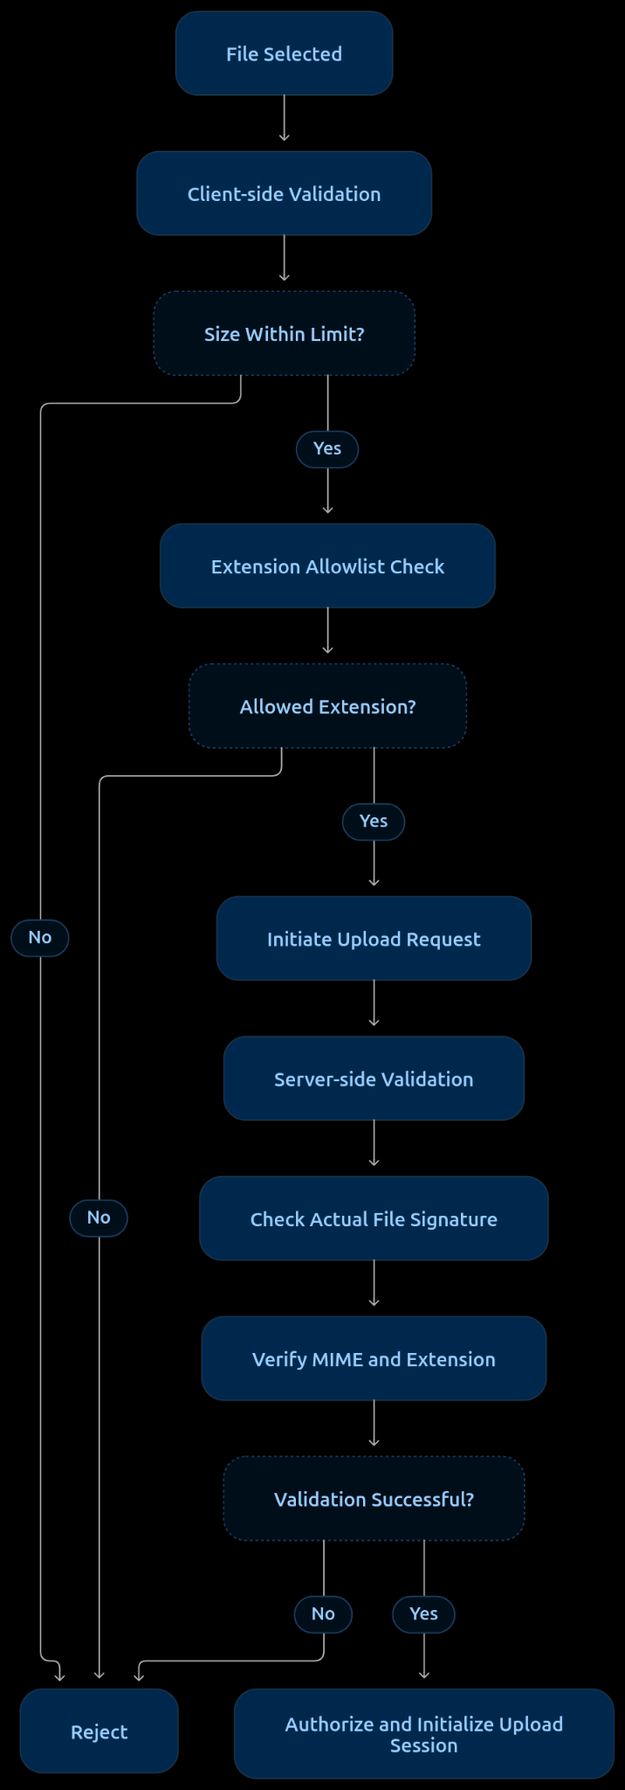
Important design decision: Client-side checks improve user experience but cannot be trusted as security controls. All critical validations must be repeated server-side.

Duplicate and Version Management
Problems covered:
- Duplicate document uploads.
- Outdated document uploads.
- Multiple versions of the same document.
- Accidental re-upload of previously submitted documents.

Proposed solution: Document Deduplication and Version Control System
Introduce a document management mechanism that identifies duplicate files, maintains document versions and ensures that the screening pipeline uses the correct version.
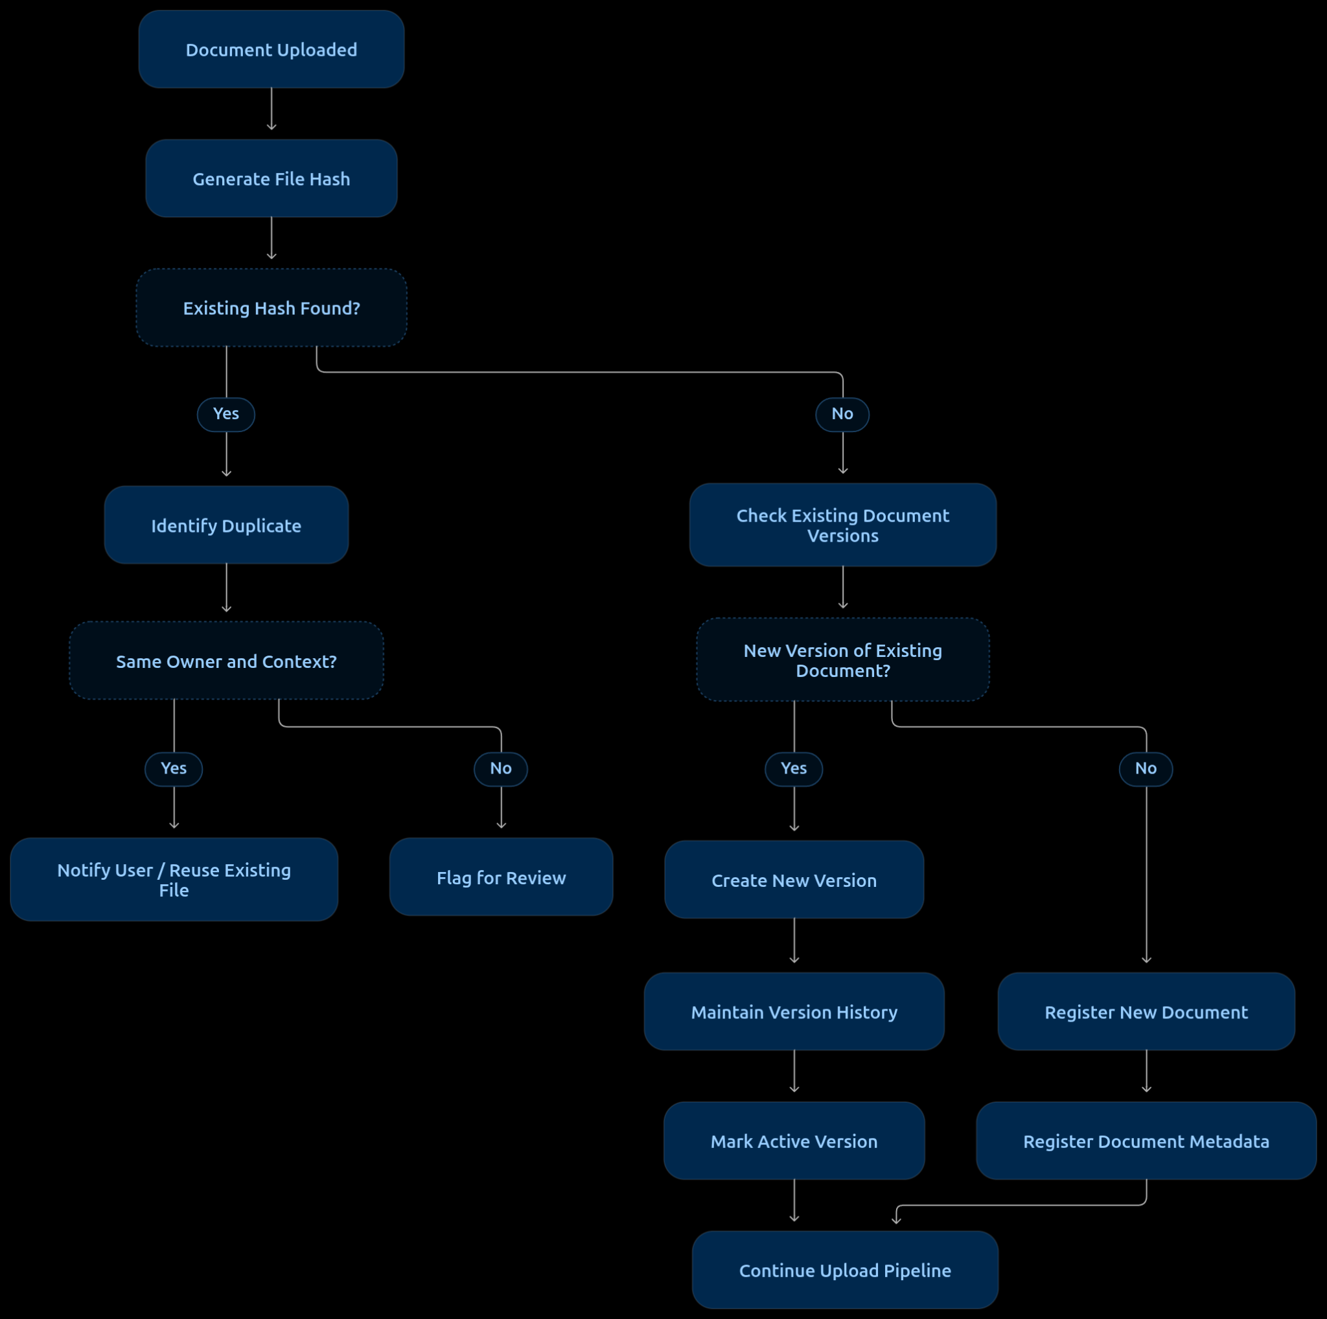

Required mechanisms
Mechanism | Responsibility
Cryptographic hashing (SHA-256) | Identify byte-identical documents.
Duplicate detection | Identify repeated uploads within the same candidate or job context.
Document versioning | Maintain previous and updated document versions.
Metadata tracking | Store uploader, upload timestamp, document type and associated job/candidate ID.
Active version management | Identify which document version should be used for screening.
Version history | Preserve previous versions for auditing and traceability.

3. Failure handling
Scenario | System response
Identical file uploaded again | Notify user and offer reuse of existing document.
Same file uploaded under another candidate | Flag for ownership verification.
Updated resume uploaded | Create a new version and retain the previous one.
Older version uploaded accidentally | Notify user if a newer version is already registered.
Concurrent version uploads | Apply version locking or conflict detection.

4. Important architectural decisions
- Do not rely exclusively on file hashes to identify outdated or semantically identical documents. Hashes detect byte-level identity, not content similarity.
- Maintain version history instead of overwriting previous documents.
- Keep candidate identity and job association separate from file identity.
- Every screening evaluation should reference the exact document version used.
- Do not automatically assume that the latest uploaded file is always the correct version; make the active version explicit.
Expected outcome: Prevent duplicate processing, maintain document history and ensure that screening evaluations use the intended document version.

Multiple Document Handling
Problems covered:
- Multiple documents uploaded when only one is expected.
- Multiple resumes or versions submitted together.
- Supporting documents uploaded separately from the primary resume.
- Incorrect association of uploaded documents with candidates or job openings.

Proposed solution: Multi-Document Management and Association Layer
Introduce a document management layer that identifies, classifies and associates uploaded files with their respective candidate, job application and document category.
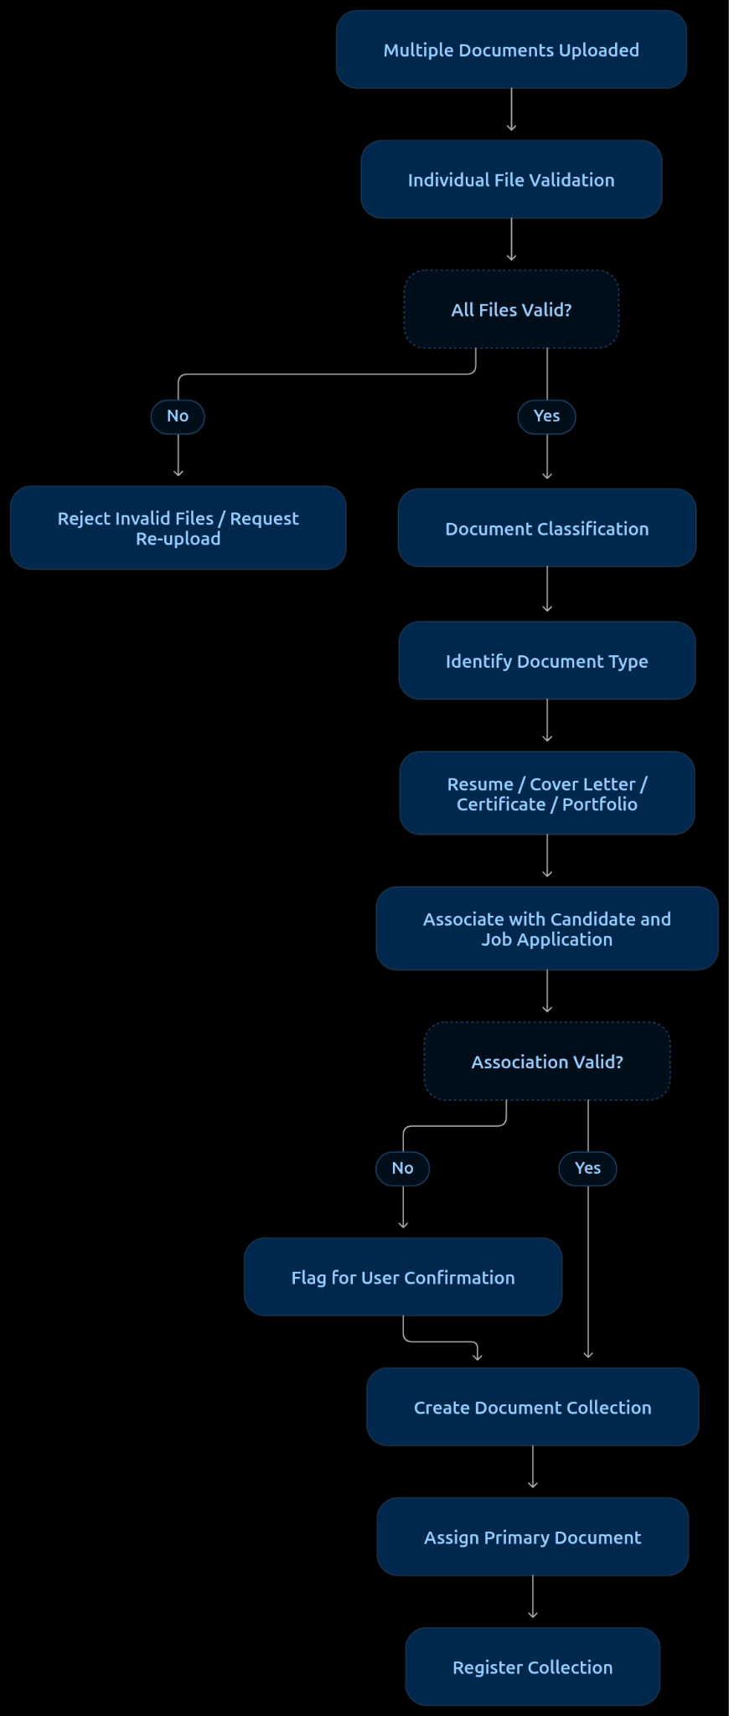

Required mechanisms
Mechanism | Responsibility
Multi-file upload support | Accept multiple documents within one submission.
Individual file validation | Validate each file independently.
Document classification | Identify resumes, cover letters, certificates and supporting documents.
Document association | Link documents to the correct candidate and job application.
Primary document identification | Identify which resume should serve as the primary screening document.
Collection management | Maintain all uploaded documents under one application record.
Duplicate detection | Avoid registering the same document multiple times.

Failure handling
Scenario | System response
One file is invalid | Reject that file without necessarily rejecting other valid files.
Multiple resumes uploaded | Ask the candidate to select the primary resume.
Supporting document uploaded without a resume | Request the primary resume if required.
Document type cannot be identified | Ask the uploader to specify its category.
Document associated with the wrong application | Flag for confirmation and prevent processing under the incorrect application.
Duplicate supporting documents | Notify the uploader or reuse the existing document.

Important architectural decisions
- Treat each uploaded file as an independent document entity.
- Maintain a parent application record connecting all related documents.
- Never automatically treat every uploaded document as a separate resume.
- Keep the primary resume distinguishable from supporting evidence.
- Preserve individual document metadata, ownership and version history.
- Allow partial success when one file fails but others upload successfully.
Expected outcome: Multiple documents can be uploaded, organized and associated with the correct candidate and job application without creating confusion during subsequent screening.

Upload Security
Problems covered:
- Malicious file uploads.
- Malware embedded in documents.
- Dangerous embedded scripts or active content.
- Unauthorized access to uploaded documents.
- Exploitation of document-processing components through crafted files.

Proposed solution: Secure File Upload and Malware Inspection Layer
Introduce a security inspection layer that examines uploaded files before they are accepted into permanent storage or passed to document-processing components.
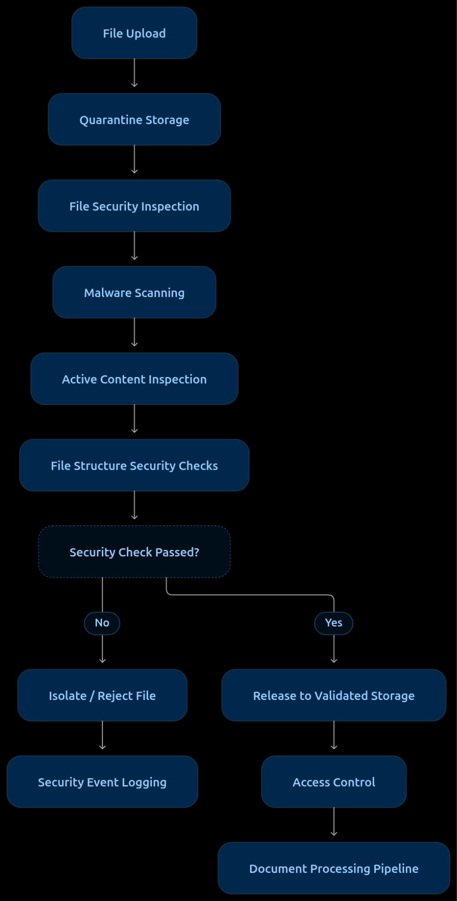

Required mechanisms
Mechanism | Responsibility
Quarantine storage | Temporarily isolate uploaded documents before approval.
Antivirus scanning | Detect known malware and malicious file signatures.
Content Disarm and Reconstruction (CDR) | Remove potentially dangerous active content from supported document formats when appropriate.
Active content detection | Identify embedded scripts, macros and potentially dangerous elements.
File structure inspection | Detect malformed or suspicious document structures.
Sandboxed inspection | Process potentially dangerous documents in an isolated environment.
Access control | Restrict document access to authorized users and services.
Security event logging | Record suspicious uploads and inspection outcomes.

Failure handling
Scenario | System response
Malware detected | Reject and quarantine the document.
Suspicious embedded scripts | Block or sanitize the document according to security policy.
Security scanner unavailable | Keep the file quarantined; do not release it for processing.
Malformed document structure | Reject or send for isolated inspection.
Unauthorized document access | Deny access and record the security event.
CDR processing failure | Retain the original in quarantine and prevent unsafe release.

Important architectural decisions
- Never process an uploaded document directly from an untrusted upload location.
- Keep original files immutable and separate from sanitized derivatives.
- Apply least-privilege access to document storage.
- Do not assume PDF or DOCX files are safe simply because they are common formats.
- Treat malware scanning and prompt-injection detection as separate security controls. Prompt injection is a content-level threat that needs additional handling during document ingestion.
- Fail closed: if security inspection cannot establish that a file is safe, do not release it.
Expected outcome: Uploaded documents are inspected, isolated and securely released before entering the screening pipeline.

Incorrect Document Submission and Ownership Association
Problems covered:
- Wrong resume uploaded under a candidate's application.
- Job description associated with the wrong job opening.
- Resume associated with the wrong candidate.
- Documents submitted under an incorrect application.
- Unauthorized document replacement or modification.

Proposed solution: Document Ownership and Association Validation Layer
Introduce a validation mechanism that verifies the relationship between the uploaded document, uploader, candidate identity and job application before the document is registered for screening.
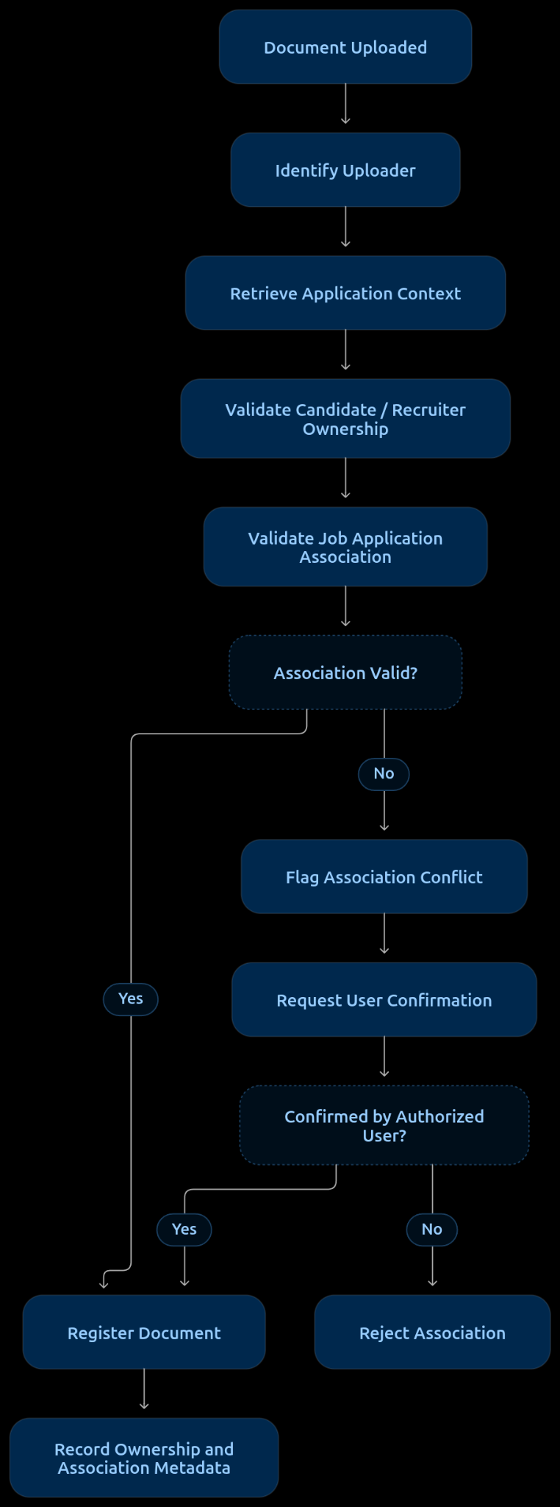

Required mechanisms
Mechanism | Responsibility
User identity verification | Identify the authenticated uploader.
Application ID mapping | Associate documents with the correct job application.
Ownership validation | Verify that the uploader has authority over the relevant candidate or job record.
Role-based access control | Restrict document submission and replacement permissions.
Association validation | Ensure documents are linked to the intended candidate and job opening.
Document ownership metadata | Maintain uploader ID, owner ID, application ID and upload timestamp.
Audit logging | Record document association, replacement and ownership changes.

3. Failure handling
Scenario | System response
Resume uploaded under the wrong candidate | Flag and prevent registration under the incorrect candidate.
JD uploaded under the wrong job opening | Request correction from the authorized recruiter.
Unauthorized document replacement | Reject the operation and record the security event.
Application ID mismatch | Reject the association.
Ownership cannot be verified | Hold the document until verification.

4. Important architectural decisions
- Never use filenames as proof of candidate or job ownership.
- Maintain application-level document associations rather than relying on user-provided metadata.
- Separate uploader identity from document ownership.
- Restrict document replacement to authorized users.
- Maintain an audit trail for every ownership or association change.
Expected outcome: Every uploaded document is associated with the correct candidate or job opening, reducing cross-candidate contamination and incorrect screening.
Abuse and resource exhaustion
Problems covered:
- Excessive upload requests.
- Automated upload spam.
- Denial-of-service attempts.
- ZIP/decompression bombs.
- Resource exhaustion through unusually complex or oversized files.
Proposed solution:
- Rate limiting per user, IP and tenant.
- Upload quotas.
- Maximum file and decompressed-content limits.
- Request throttling.
- Resource limits for scanning and processing.
- Temporary storage quotas.

SOLUTION TO UPLOAD

Resume Upload: A Simple Build Plan in Three Tiers
Build the upload step in three layers: Core first, then Hardening, then Optimizations. This page explains each layer in plain language and compares them side by side. The full technical version is the doc titled Unified Upload Architecture for Resume Screening (Stage 1). This page is the simplified, tiered view of it.

1. What the upload step does
When a recruiter uploads a job description or a candidate uploads a resume, the system must answer five questions before the file moves on:
- Who is sending it, and are they allowed to?
- Is it the right kind of file and the right size?
- Is it safe?
- Is it usable, meaning not broken, locked or empty?
- Is it the right file for the right job or person?
Think of a front desk checking a package before it enters a building. The quick checks come first, the careful ones come last, and nothing goes inside until every check passes. The person also gets a clear answer within a few seconds, whether the file is accepted or not.

2. The three tiers
Tier | In one sentence | When to build it
Core | The minimum that makes upload work and keeps it safe | Build first
Hardening | Extra protection and reliability for real-world use | After Core is live
Optimizations | Speed and cost improvements | Only when measurements show a need
Rule of thumb: do not start Hardening or Optimizations until Core works. Hardening and Optimizations only make sense once there is something real to protect and measure.

3. The flow at a glance
flowchart TD
A[1 Who is uploading and are they allowed] --> B[2 Basic rules: size, type, one file per slot]
B --> C[3 Upload to a locked quarantine area]
C --> D[4 Check the real file type]
D --> E[5 Antivirus scan]
E --> F[6 Check the file is usable and has no macros]
F --> G[7 Duplicates and versions]
G --> H[8 Save and tell the parsing step]
A -- fail --> X[Stop with a clear reason]
B -- fail --> X
C -- fail --> X
D -- fail --> X
E -- fail --> X
F -- fail --> X
The quick checks run first, so most bad files are stopped in under a second. Every upload ends with exactly one answer: Ready, Rejected, Blocked, Failed or Duplicate.

4. Tier 1: Core (build first)
The starting rules. These are proposed values to adjust later: PDF, DOCX or TXT only. At most 5 MB and 10 pages. One active file per slot (one resume per application, one job description per job). No password-protected files. No macros or active content.
# | Step | In plain words | Problems it solves
1 | Sign-in and permission | Only the right person can upload to the right job or application | U9, C-U4, A-U4
2 | Basic rules | Refuse files that are too big, have the wrong extension, or are a second file for an already filled slot | C-U1, A-U1, U1, A-U9, C-U7, A-U7
3 | Quarantine upload | Send the file straight to a locked holding area. If the connection drops, send the whole file again. Throw away unfinished uploads | U2, U3, U6
4 | Real file type check | Look inside the file instead of trusting its name. The name, the declared type and the real type must agree. Text files must be UTF-8 | U4, U5, U11
5 | Usable file check | Reject files that are password-protected, broken, empty, too long, or that blow up in size when opened (zip bombs). This runs in a locked-down worker with time and memory limits | C-U2, A-U2, C-U3, A-U3, C-U8, A-U8
6 | Macro and active content check | Reject files with macros, embedded programs or auto-running scripts. Normal web links are fine | U10
7 | Antivirus scan | Use a ready-made antivirus engine rather than building one | U10
8 | Duplicate check | If the same file is already uploaded, say so and reuse it | C-U6, A-U6
9 | Replace and versions | Uploading again is an explicit Replace. The old version is kept and the new one becomes the active version once it passes | C-U5, A-U5
10 | Save and hand off | Move the file to safe permanent storage and tell the parsing step. Never report success unless the file is really saved. Retry storage faults up to 3 times | U7, U8
11 | Basic safety net | A simple limit on uploads per user per hour, and a log of who uploaded what | Abuse, audit
Possible results. Every upload ends in exactly one of these:
Result | Meaning | What the person sees
Ready | Passed every check | Ready
Rejected | A fixable problem: wrong type, too big, locked, broken, empty | The reason and what to fix
Blocked | Virus, macro or active content, or a suspicious file | A generic not-accepted message
Failed | A system problem after 3 retries | Please try again
Duplicate | The same file is already there | The existing file
Core on its own already covers every problem on your list at a basic level. What it leaves thin is heavy abuse and deep reliability, which is what Hardening adds.

5. Tier 2: Hardening (add once the core is live)
# | Addition | What it does | Why it matters | Add it when
H1 | Stronger abuse protection | Limits per IP address and per customer, a daily upload quota, a cooldown after repeated rejected uploads, and a cap on how much quarantine space one user can hold | Stops spam and floods that Core's simple limit will not | You see repeated or automated uploads, or before public launch
H2 | Blocked-file vault and security alerts | Keep blocked files in a locked area for 30 days. Alert the team when blocked uploads spike or the scanner is down | Lets you investigate attacks | Before opening to the public
H3 | Clean-up and consistency checks | A scheduled job compares stored files with the database and flags mismatches. Alerts on stuck jobs | Prevents ghost uploads and wasted storage | After the first weeks of real traffic
H4 | Backup storage and failover | Switch to a second storage location if the first one fails | Keeps uploads working during outages | When customers depend on uptime
H5 | Privacy and retention automation | Delete files automatically by rule, record consent, delete on request, use a separate encryption key per customer | Compliance and customer trust | Before onboarding customers with strict requirements
H6 | Same-file, different-person signal | Note when an identical resume file appears under two candidates. No manual review needed | Useful for fraud checks later | When recruiters ask for it
H7 | Clear message for every reason | Specific, friendly text for each rejection reason | Fewer confused users and support tickets | After you see the most common rejections
H8 | Rejection-rate review | Track rejections by reason. If one strict rule rejects more than about 2 percent of legitimate files, reconsider that rule | Keeps strict rules fair | As soon as you have real traffic
H9 | Safe-parsing rule | The parsing step opens files only in locked-down workers | The upload step does not clean files, so the next step must be careful | Before parsing goes live

6. Tier 3: Optimizations (add when measurements justify them)
Do not add these on a guess. First measure the time each step takes and how many uploads are repeats. The time savings below are estimates, not measurements.
# | Optimization | What it does | Estimated saving | Add it when
O1 | Hash-first shortcut | The browser computes the file's fingerprint first. If the system already knows it, no upload is needed | About 2 s down to 0.2 s for repeats | Repeat uploads are a noticeable share of traffic
O2 | Result memory | Remember the antivirus result for a file already checked in the same customer account | Skips the scan, about 0.1 to 0.6 s | The same files appear often and scan time matters
O3 | Warm workers | Keep the antivirus engine and workers running and ready | Avoids occasional 1 to 30 s start-up delays | The slowest uploads are much slower than typical ones
O4 | Single-pass checking | One worker downloads the file once and runs the checks together | About 0.2 to 0.6 s | Waiting between steps is a visible part of total time
O5 | Live status updates | The server pushes status to the screen instead of the screen asking repeatedly | Up to 1 to 2 s of perceived delay | Users notice a lag between finishing and seeing the result
O6 | Text-file fast path | Skip the heavy structure check for plain text files | About 0.2 to 0.5 s for TXT | Many uploads are TXT
O7 | Nearby upload locations | Upload endpoints close to your users | About 20 to 40 percent of transfer time | Most users are far from the storage region
O8 | Browser pre-checks | Check size and type in the browser before uploading | Avoids wasted uploads | Many rejections are simple mistakes. This one is cheap and can be built early
O9 | Scale up before peaks | Add capacity before known job closing dates | Avoids queues at deadlines | Deadline spikes cause slowdowns
O10 | Parallel scanning (keep in reserve) | Run the antivirus and structure checks at the same time | About 0.2 to 0.6 s | Only if the time target is still missed after the others. The trade-off is that the file is opened before the scan finishes

7. Comparison 1: the three tiers side by side
 | Core | Hardening | Optimizations
Goal | Works and is safe | Survives real-world use, abuse and audits | Faster and cheaper
When | Build first | After Core is live | When measurements show a need
Number of items | 11 steps | 9 additions | 10 options
What you get | Every upload gets a safe, clear, final answer | Protection from spam, outages and compliance problems | Lower time and compute use
If you skip it | The system is unsafe or unusable | It works, but is risky to open to the public or to large customers | It works, only slower
Problems on your list | All covered at a basic level | Abuse and failure cases handled in depth | None new
Typical time for one resume (estimate) | About 2.5 s | About 2.5 s. The extra protection adds almost no delay | About 1.8 s
Effort | Largest | Medium | Small per item
How you decide | Always | A checklist before public launch | Measurements such as slowest-upload time and repeat-upload share
Who is involved | Developers | Developers, plus security and legal for privacy | Developers, plus whoever watches the metrics

8. Comparison 2: what each stage looks like in each tier
Stage | Core | Hardening | Optimizations
1. Who is uploading | Sign-in and permission check | Separate data and encryption keys per customer | None
2. Is the upload allowed | Basic rules: size, type, one file per slot | Stronger limits per IP and customer, cooldowns | Browser pre-checks, hash-first shortcut
3. Getting the file in | Quarantine upload, whole-file retry, discard unfinished uploads | Clean-up job, backup storage | Nearby upload locations
4. Is it the right kind of file | Real type check, UTF-8 for text | Rejection-rate review | Text-file fast path
5. Is it safe | Antivirus and macro check | Blocked-file vault, security alerts | Result memory, parallel scanning (reserve)
6. Is it usable | Reject locked, broken, empty, too long and zip-bomb files | Clear message for each reason | Single-pass checking, warm workers
7. Duplicates and versions | Fingerprint duplicate check, Replace creates a new version | Same-file, different-person signal | Hash-first shortcut
8. Hand-off to parsing | Save, then notify the parsing step | Safe-parsing rule, alerts on stuck jobs | Live status updates
9. When something fails | Retry 3 times, then a clear failure | Consistency checks and alerts | None
10. Privacy and storage | Delete rejected files at once, basic activity log | Automatic deletion, consent, delete on request | None
11. Watching the system | Basic log | Dashboards, alerts, rejection-rate review | Timing per step, scaling before peaks

9. Comparison 3: which tier solves which problem
Problem group | Examples from your list | Core | Hardening
Wrong or unsupported file type | C-U1, A-U1, U4, U5, U11 | Solved | None needed
Broken, locked or empty file | C-U2, C-U3, C-U8, A-U2, A-U3, A-U8 | Solved | Clearer messages
File too big | U1, A-U9 | Solved | Daily quotas
Interrupted or incomplete upload | U2, U3, U6 | Solved by resending the whole file | Clean-up job
Server or storage failure | U7, U8 | Solved by 3 retries | Backup storage, consistency checks
Permission problems | U9 | Solved | Per-customer isolation
Malware | U10 | Solved by antivirus and macro rejection | Vault and alerts
Wrong or outdated document | C-U4, C-U5, A-U4, A-U5 | Solved by permission check and Replace | None needed
Duplicate upload | C-U6, A-U6 | Solved | Same-file, different-person signal
Several files at once | C-U7, A-U7 | Solved by one file per slot | None needed
Spam and floods (added) | Not on your original list | Basic limit | Full protection

10. How long it takes (estimates)
These are engineering estimates for a typical 150 to 500 KB resume on a normal connection, not measurements. Measure real timings in a pilot.
Situation | Typical time to a final answer
Rejected before upload (too big, wrong extension, not allowed) | 0.1 to 0.3 s
Repeat of a file already uploaded, with the hash-first shortcut (O1) | 0.2 to 0.5 s
Rejected at the real-file-type check | 0.7 to 1.5 s
Blocked by antivirus | 1.1 to 2.5 s
Ready, with Core only | About 1.2 to 3.7 s, typically 2.5 s
Ready, with Optimizations | About 1 to 2.6 s, typically 1.8 s
Uploading the file over the network is the largest single part of this time, and it depends on the person's connection. A 5 MB file on a slow 2 Mbps link needs about 20 seconds just to transfer.

11. Left out of the first version on purpose
Left out | Why | Where it goes
Chunked, resumable upload | With a 5 MB limit, resending the whole file is simpler and cheaper | Revisit if the size limit is raised
Cleaning (sanitizing) files | Extra work for every file. Files with macros are rejected instead | Revisit only if too many legitimate files are rejected
Opening suspicious files in a test sandbox | Heavy computing cost per file | Revisit if your threat model requires it
Password-protected files | Handling passwords adds risk | A later extension
Cover letters, certificates and other extra documents | More rules and more ways to go wrong | A later version
Email and bulk ZIP intake | More attack surface | Later, as separate entry points
Wrong-document and hidden-instruction checks | They need the text inside the file | The parsing stage
Manual review queue | It creates work for people | Not planned
Re-scanning stored files | Recurring computing cost | Revisit if old files are reused after a long time

12. Plain-language glossary
- Quarantine: a locked holding area. Nothing in it is used until it passes every check.
- Antivirus scan: a program that looks for known malicious code in a file.
- Macro or active content: small programs hidden inside a document that can run automatically.
- Hash (fingerprint): a short code calculated from a file's contents. Identical files always give the same code.
- Real file type check: the first few bytes of a file reveal what it truly is, whatever its name says.
- Zip bomb: a small file that expands into something enormous when opened, to exhaust the system.
- Version: one saved copy of a document. A Replace adds a new version and keeps the old one.
- Rate limit: a cap on how many requests one user can make in a period of time.
- Audit log: a permanent record of who did what and when.
- Parsing: the next stage, which reads the text out of the file.
- Worker: a separate program that does one job, such as checking a file, away from the main application.

13. Next steps
- Build Core in the order of the table in Section 4.
- Run a small pilot and record the time per step and the rejection reasons.
- Work through the Hardening checklist before opening to the public.
- Add Optimizations only when a measurement says they are needed.
- Then move on to Stage 2, document parsing, using the hand-off from step 10 of Core.

