Sales Dashboard Report

**Data source:** Sales Data edited.xlsx | Sheet: Sales Data  
**Period covered:** 2013-01-01 to 2014-12-31

# Executive Summary (KPIs)

|  |  |  |  |
| --- | --- | --- | --- |
| Total Revenue | 10,226,625 | Total Units Sold | 33,874 |
| Number of Orders | 10,000 | Average Order Value | 1,022.66 |
| Weighted Avg. Price | 301.90 | Unique Products | 11 |
| Sales Reps | 72 | Cities Covered | 23 |
| Report Generated On | 2025-08-24 02:18 | Currency / Units | As per data |

## Monthly Revenue Trend

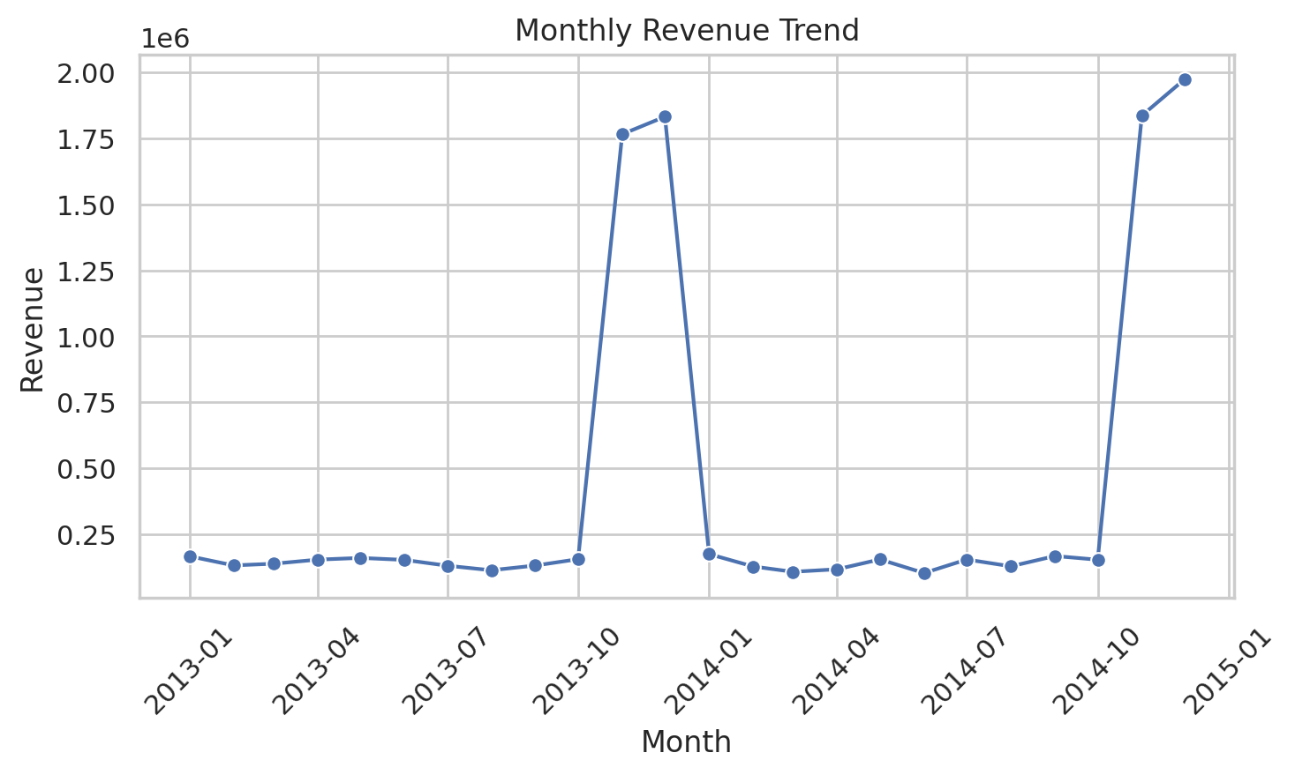

## Revenue by Region

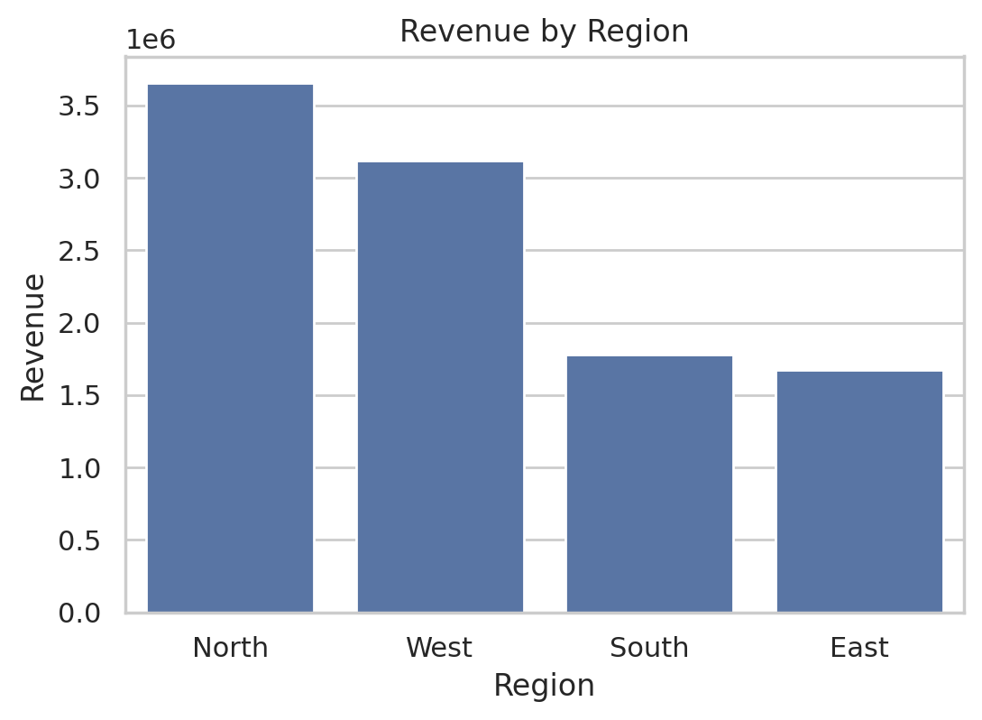

## Top Products by Revenue

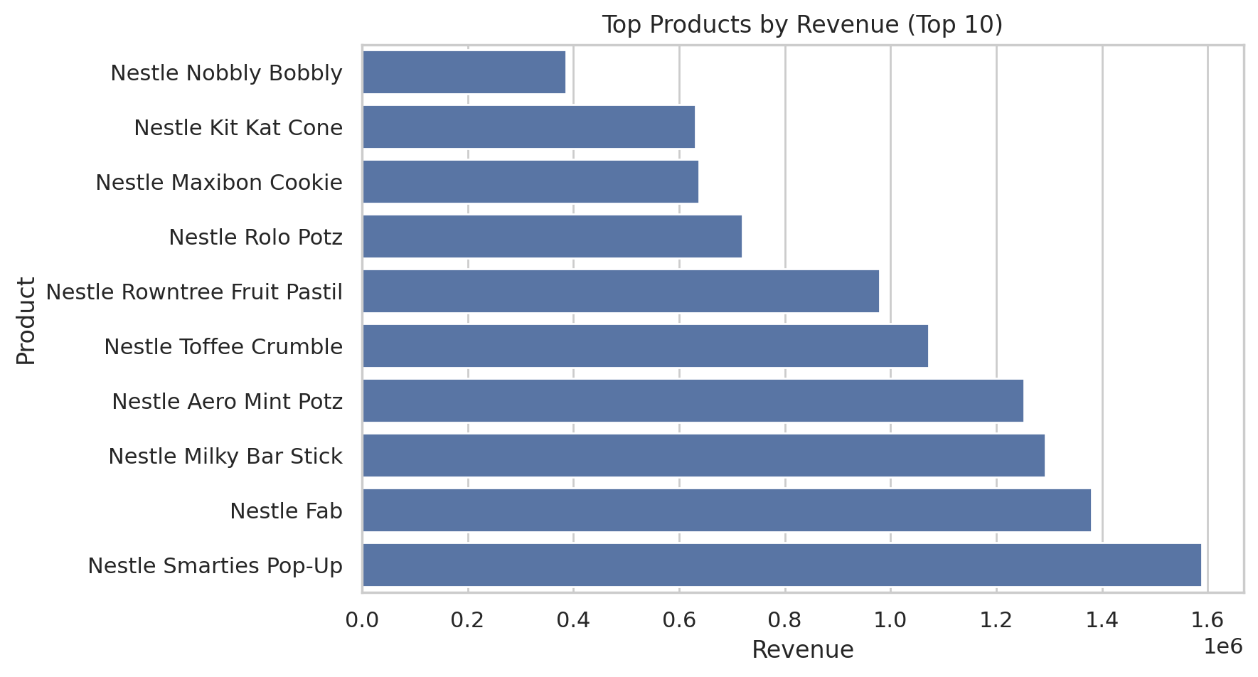

## Top Sales Reps by Revenue

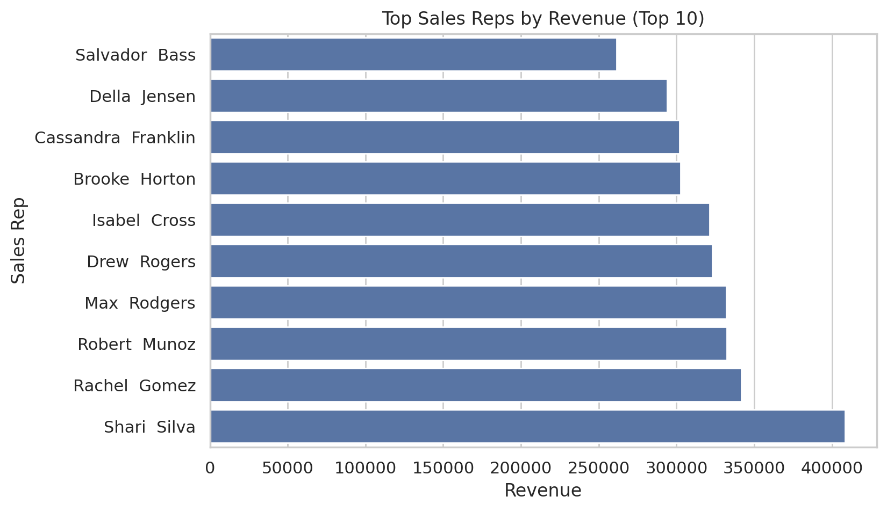

## Revenue by Day of Week

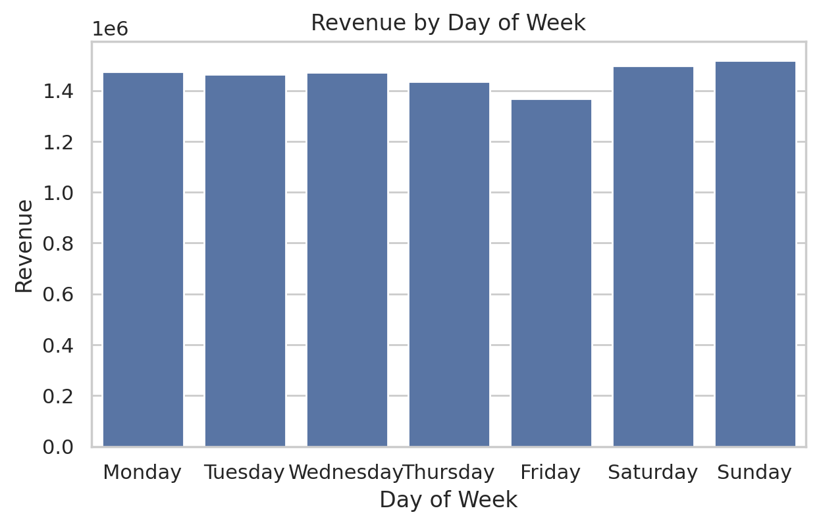

## Top Cities by Revenue

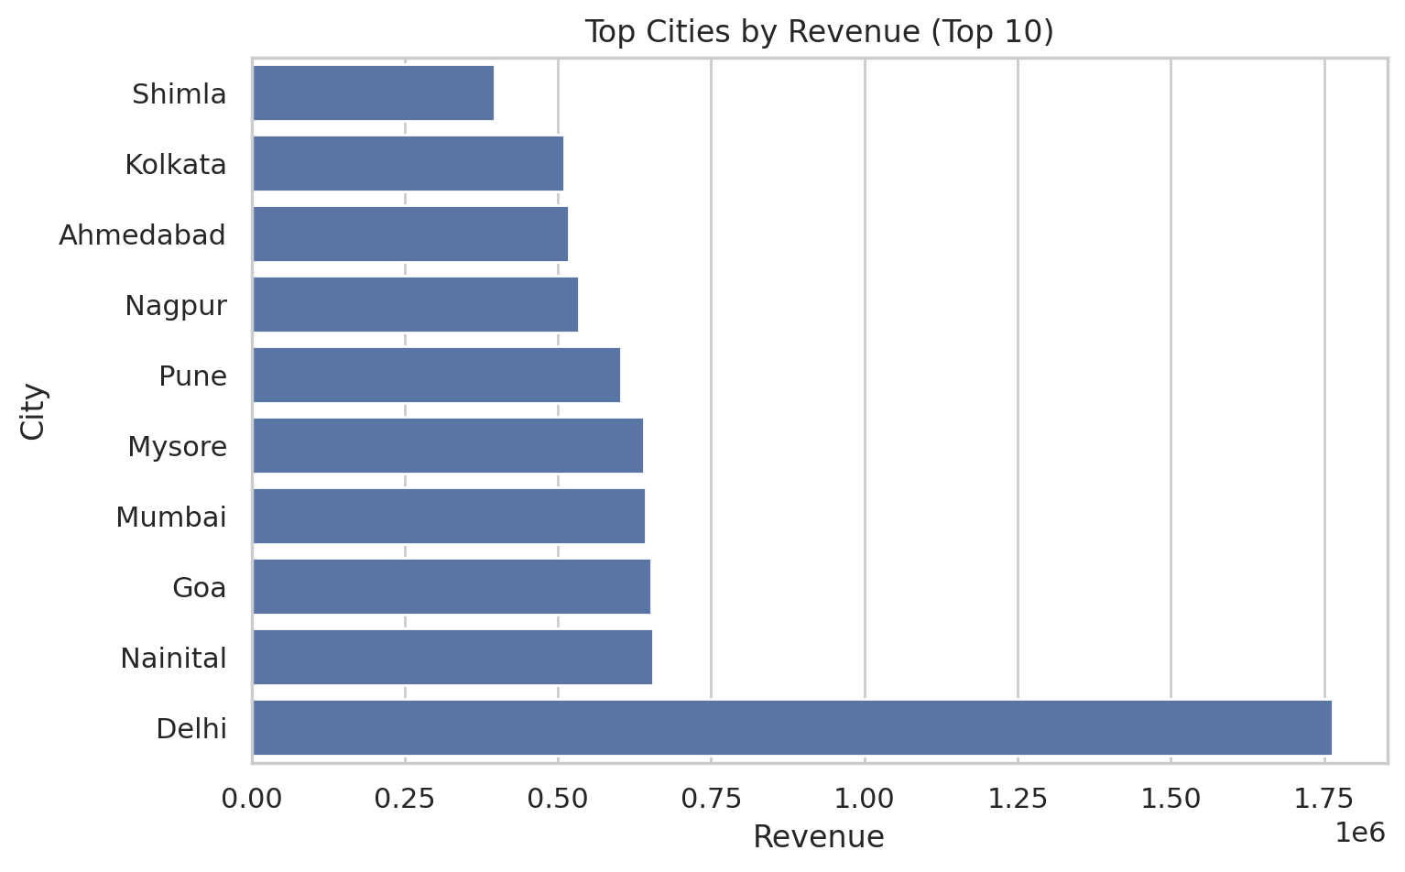

## Top 10 Products (Revenue & Units)

|  |  |  |
| --- | --- | --- |
| Product | Units | Total Sales |
| Nestle Smarties Pop-Up | 5267 | 1588831 |
| Nestle Fab | 4375 | 1379740 |
| Nestle Milky Bar Stick | 4153 | 1293337 |
| Nestle Aero Mint Potz | 4262 | 1252203 |
| Nestle Toffee Crumble | 3586 | 1072377 |
| Nestle Rowntree Fruit Pastil | 3258 | 979502 |
| Nestle Rolo Potz | 2498 | 719702 |
| Nestle Maxibon Cookie | 2152 | 638340 |
| Nestle Kit Kat Cone | 2101 | 631179 |
| Nestle Nobbly Bobbly | 1253 | 386345 |

## Top 10 Sales Reps (Revenue)

|  |  |
| --- | --- |
| SalesRep | Total Sales |
| Shari Silva | 408287 |
| Rachel Gomez | 341627 |
| Robert Munoz | 332530 |
| Max Rodgers | 331986 |
| Drew Rogers | 322985 |
| Isabel Cross | 321156 |
| Brooke Horton | 302753 |
| Cassandra Franklin | 302080 |
| Della Jensen | 293968 |
| Salvador Bass | 261456 |

## Top 10 Cities (Revenue)

|  |  |
| --- | --- |
| City | Total Sales |
| Delhi | 1764426 |
| Nainital | 655124 |
| Goa | 652865 |
| Mumbai | 643215 |
| Mysore | 639673 |
| Pune | 602513 |
| Nagpur | 534082 |
| Ahmedabad | 517965 |
| Kolkata | 510157 |
| Shimla | 396905 |

## Revenue by Region

|  |  |
| --- | --- |
| Region | Total Sales |
| North | 3655726 |
| West | 3118347 |
| South | 1780729 |
| East | 1671823 |