**COMPUTER VISION PRACTICAL DOCUMENTATION**

**Name : DEVU VIJAYAN**

**Place : NSTI W TRIVANDRUM**

**AIM:** Loading Image Formats Tutorial

**LIST OF HARDWARE/SOFTWARE USED:**

➢   Windows OS

➢   VS Code

**PROCEDURE:**

Step 1: Open VS code

Step 2: Create a new Python file

Step 3: Type the code to execute the program.

Step 4: Save and run the code

**CODE:**

#Import libraries

import cv2

import matplotlib.pyplot as plt

# Load an image using OpenCV

image_path = "hd1.jpg"

image_cv2 = cv2.imread(image_path)

# Convert the image from BGR to RGB

image_cv2_rgb = cv2.cvtColor(image_cv2, cv2.COLOR_BGR2RGB)

# Display the image

plt.imshow(image_cv2)

plt.title('Image loaded with OpenCV')

plt.show()

from PIL import Image

# Load an image using PIL

image_pil = Image.open(image_path)

# Display the image

plt.imshow(image_pil)

plt.title('Image loaded with PIL')

plt.show()

import imageio

# Load an image using imageio

image_imageio = imageio.imread(image_path)

# Display the image

plt.imshow(image_imageio)

plt.title('Image loaded with imageio')

plt.show()

# PNG image path

image_path_png = "hd2.png"

image_path_jpg = "img1.jpg"

# OpenCV

image_cv2_png = cv2.imread(image_path_png)

image_cv2_png_rgb = cv2.cvtColor(image_cv2_png, cv2.COLOR_BGR2RGB)

plt.imshow(image_cv2_png_rgb)

plt.title('PNG loaded with OpenCV')

plt.show()

# PIL

image_pil_png = Image.open(image_path_png)

plt.imshow(image_cv2_png_rgb)

plt.title('PNG loaded with OpenCV')

plt.show()

# imageio

image_imageio_png = imageio.imread(image_path_png)

plt.imshow(image_cv2_png_rgb)

plt.title('PNG loaded with OpenCV')

plt.show()

**OUTPUT:** 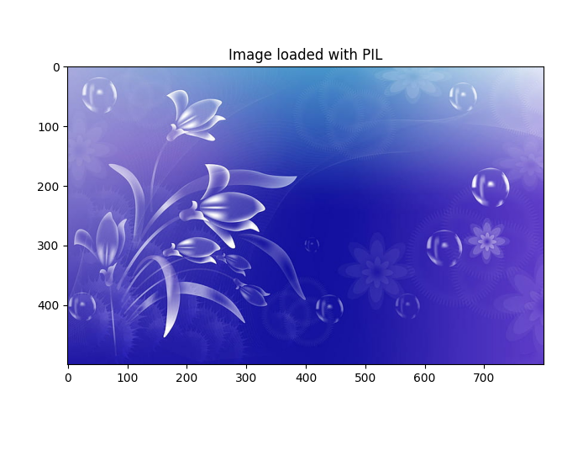

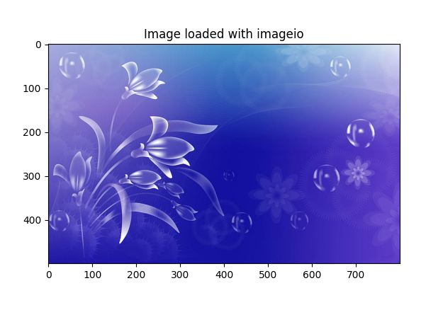

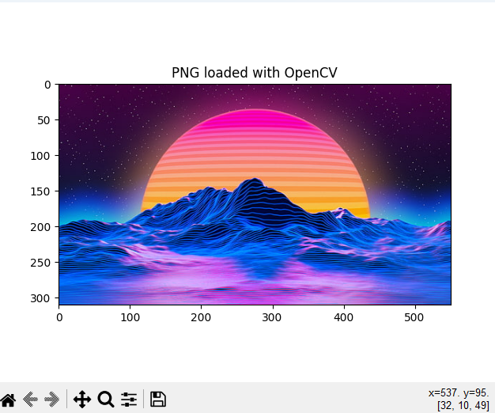

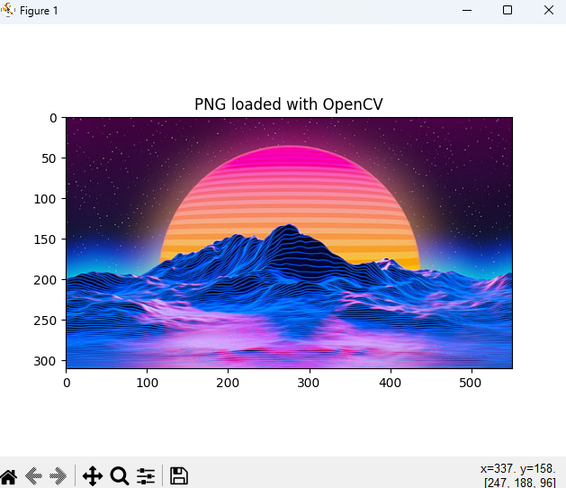

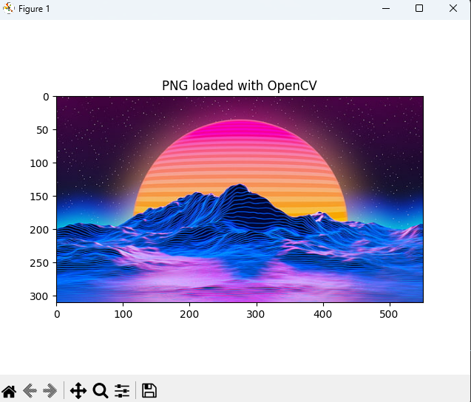

**Result:**

This program executed successfully.

Question 2. Image Resizing, Cropping, and Rotation

**LIST OF HARDWARE/SOFTWARE USED:**

➢   Windows OS

➢   VS Code

**PROCEDURE:**

Step 1: Open VS code

Step 2: Create a new Python file

Step 3: Type the code to execute the program.

Step 4: Save and run the code

**CODE:**

# Load the necessary library

import cv2

import matplotlib.pyplot as plt

# Load an image

image = cv2.imread('img.jpg')

# Convert the image from BGR (OpenCV format) to RGB (Matplotlib format)

image_rgb = cv2.cvtColor(image, cv2.COLOR_BGR2RGB)

# Resize image to 256x256 pixels

resized_image = cv2.resize(image_rgb, (125, 128))

# Display the original and resized images

plt.figure(figsize=(10, 5))

plt.subplot(1, 2, 1)

plt.title('Original Image')

plt.imshow(image_rgb)

plt.axis('off')

plt.subplot(1, 2, 2)

plt.title('Resized Image (125x128)')

plt.imshow(resized_image)

plt.axis('off')

plt.show()

# Save or display the resized image

# cv2.imwrite('resized_image.jpg', resized_image)

# Crop image to a region (x, y, width, height)

cropped_image = image_rgb[50:130, 50:200]

# Display the original and resized images

plt.figure(figsize=(10, 5))

plt.subplot(1, 2, 1)

plt.title('Original Image')

plt.imshow(image_rgb)

plt.axis('off')

plt.subplot(1, 2, 2)

plt.title('cropped_image')

plt.imshow(cropped_image)

plt.axis('off')

plt.show()

# Rotate image by 45 degrees

(h, w) = image_rgb.shape[:2]

center = (w // 2, h // 2)

M = cv2.getRotationMatrix2D(center, 45, 1.0)

rotated_image = cv2.warpAffine(image_rgb, M, (w, h))

# Display the original and resized images

plt.figure(figsize=(10, 5))

plt.subplot(1, 2, 1)

plt.title('Original Image')

plt.imshow(image_rgb)

plt.axis('off')

plt.subplot(1, 2, 2)

plt.title('rotated_image')

plt.imshow(rotated_image)

plt.axis('off')

plt.show()

**OUTPUT**:

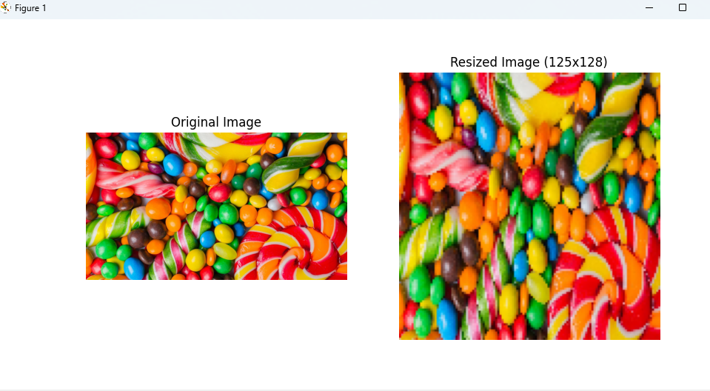

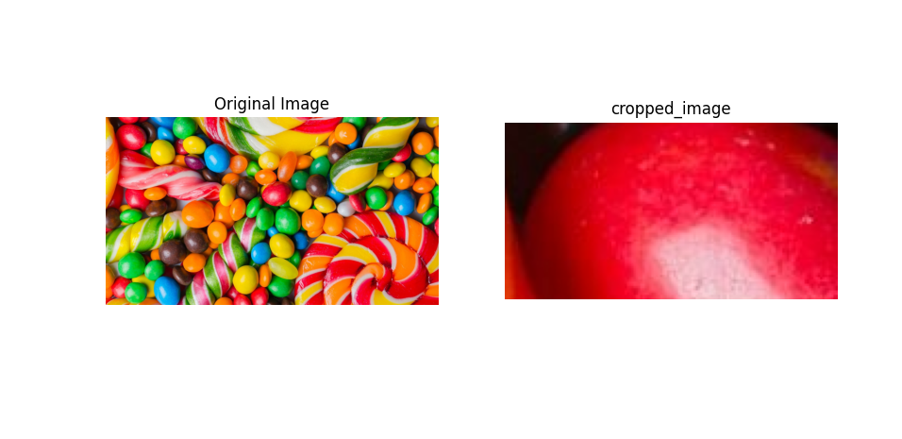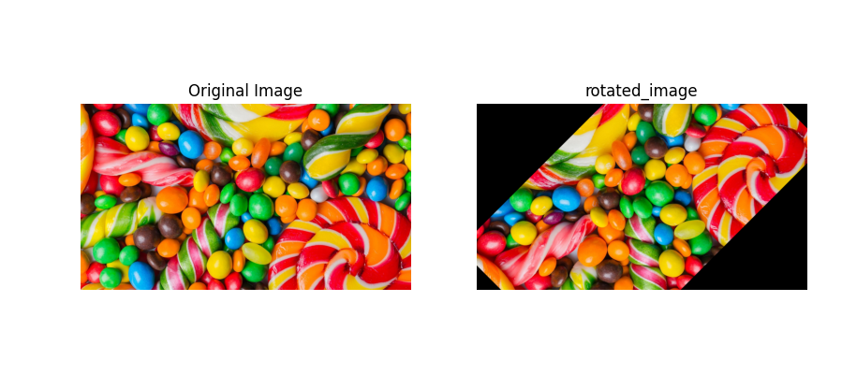

**Result:**

This program executed successfully.

Question 3. Image Denoising

**LIST OF HARDWARE/SOFTWARE USED:**

➢   Windows OS

➢   VS Code

**PROCEDURE:**

Step 1: Open VS code

Step 2: Create a new Python file

Step 3: Type the code to execute the program.

Step 4: Save and run the code

**CODE:**

# import necessary libraries

import cv2

import matplotlib.pyplot as plt

# Load an image

image = cv2.imread('hd2.png')

# Convert the image from BGR (OpenCV format) to RGB (Matplotlib format)

image_rgb = cv2.cvtColor(image, cv2.COLOR_BGR2RGB)

# Apply Gaussian blur to denoise

denoised_image = cv2.GaussianBlur(image_rgb, (11, 11), 0)

# Display the original and resized images

plt.figure(figsize=(10, 5))

plt.subplot(1, 2, 1)

plt.title('Original Image')

plt.imshow(image_rgb)

plt.axis('off')

plt.subplot(1, 2, 2)

plt.title('denoised_image')

plt.imshow(denoised_image)

plt.axis('off')

plt.show()

# Convert to grayscale

gray_image = cv2.cvtColor(image_rgb, cv2.COLOR_BGR2GRAY)

# Apply histogram equalization

equalized_image = cv2.equalizeHist(gray_image)

# Display the original and resized images

plt.figure(figsize=(10, 5))

plt.subplot(1, 2, 1)

plt.title('Gray Image')

plt.imshow(gray_image, cmap="gray")

plt.axis('off')

plt.subplot(1, 2, 2)

plt.title('equalized_image')

plt.imshow(equalized_image, cmap="gray")

plt.axis('off')

plt.show()

**OUTPUT:-**

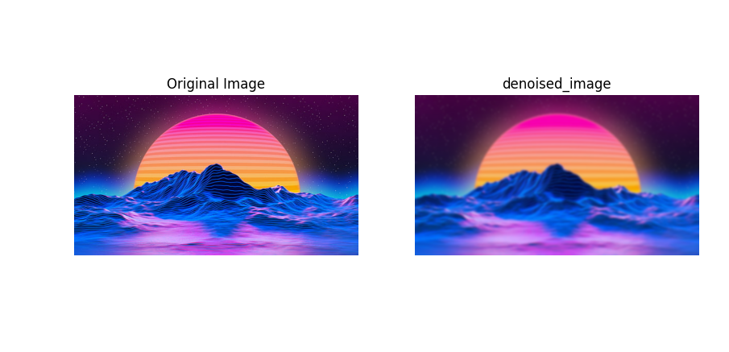

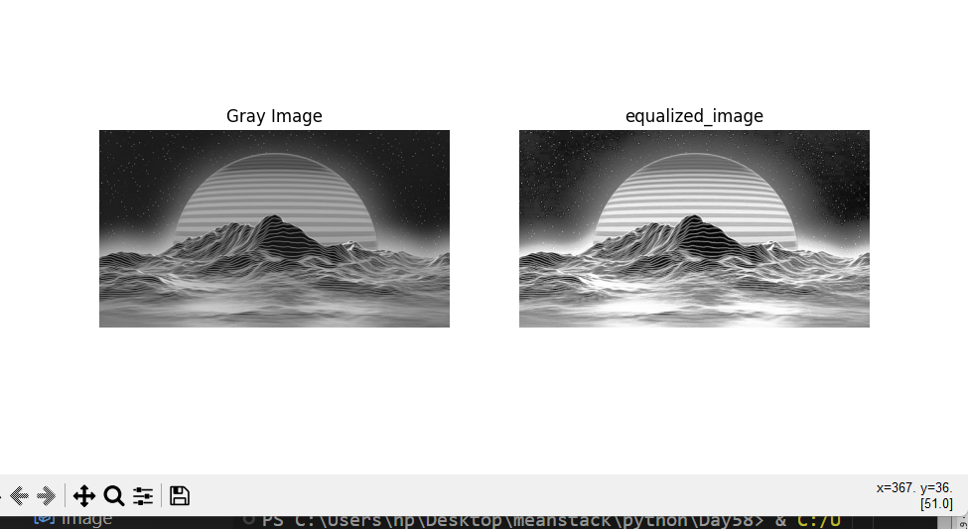

**Result:**

This program executed successfully.