AutismVision-detection using image

**Project Report**

# 

SUBMITTED TO

SCHOOL OF COMPUTER SCIENCE ENGINEERING AND TECHNOLOGY, BENNETT UNIVERSITY

GREATER NOIDA, 201310, UTTAR PRADESH, INDIA

# Submitted By :-

SIDDHARTH BANSAL (E22CSEU0591)

ARINDAM RAWAT (E22CSEU0599)

DEV VISHNU SRIVASTAV (E22CSEU0574)

HITANSHU SINGH (E22CSEU0600)

# DECLARATION

I/We hereby declare that the work which is being presented in the report entitled “Sound-Scape”, is an authentic record of my/our own work carried out during the period from JAN, 2023 to April, 2023 at the School of Computer Science and Engineering and Technology, Bennett University Greater Noida.

The matters and the results presented in this report have not been submitted by me/us for the award of any other degree elsewhere.

Signature of Candidate

Dev Vishnu Srivastav

(E22CSEU0574)

Siddharth Bansal

(E22CSEU0591)

Hitanshu Singh

(E22CSEU0600)

Arindam Rawat

(E22CSEU0599)

# ACKNOWLEDGEMENT

I would like to take this opportunity to express my deepest gratitude to our mentor, Dr. Hardeo Thakur, for his invaluable guidance, unwavering support, and invaluable assistance throughout the development of Soundscape. Dr. Hardeo’s expertise and insightful solutions have been instrumental in overcoming various challenges encountered during the project, significantly contributing to its successful completion.

I am also grateful to our esteemed Vice Chancellor, Dean of the SCSET , Head of the Department of DTI, and all faculty members for their encouragement and support throughout this journey. Their expertise and encouragement have been invaluable in shaping the direction of the project and ensuring its successful execution.

Signature of Candidate

Dev Vishnu Srivastav

(E22CSEU0574)

Siddharth Bansal

(E22CSEU0591)

Hitanshu Singh

(E22CSEU0600)

Arindam Rawat

(E22CSEU0599)

# Tables Of Content

**Abstract 5**

**Introduction & Motivation 5**

Introduction 5

Motivation 5

**Problem Definition & Objectives 6**

Problem definition 6

Objectives 6

**Literature Review and Dataset Description 6**

Literature Review 6

Dataset Description- 10

**Diagrams related project 12**

**Background 12**

**Methodology 15**

**Software and Hardware Requirements: 16**

Software Requirements 16

Google Collab 16

Hardware Requirements 16

**Implementation 17**

**Results 20**

**Result (Taking real dataset) 24**

**Comparison 25**

**Contribution 25**

**Answer to C2 questions 26**

**Conclusion 26**

**References 27**

## 1.

## Abstract

Autism Spectrum Disorder (ASD) is a neuro-disorder in which a child or a person has a lifelong effect on interaction and communication with others. It is diagnosed at any stage in life It is called “behavioral disease” . The ASD problem starts with childhood and continues to keep going on into adolescence and adulthood . We have used Convolutional Neural Network (CNN ) for predicting and analysis of ASD problems in a child, adolescents, and adults. Dataset is consist of Autistic and Non-Autistic face images of children. We are using two models of CNN (Convolutional Neural Network) methods for prediction which are VGG16 and VGG19. It is giving accuracy of almost 84.333 % and 84.0% respectively .

## 2. Introduction & Motivation

1. Introduction

Autism spectrum disorder (ASD) is a neurodevelopmental disorder with onset in early childhood that is associated with a wide range of symptoms and ability levels. Although no cure exists for **autism** spectrum disorder, and there is no one-size-fits-all treatment. The only treatment is to maximize your child's ability to function by reducing **autism** spectrum disorder symptoms and supporting development and learning. In this project we are going to detect autism disease by analysing images to make such a model which will help two determine ASD and help people gain confidence in their recovery rate.

1. Motivation

* While surfing on the web, one day one of us came across an advertisement of a child suffering from ASD which took attention to look into the term.
* On detailed research we analysed The Centers for Disease Control's Autism and Developmental Disabilities Monitoring (ADDM) Network reports that in 2014, approximately 1 in 59 children in the United States (1 in 37 boys, and 1 in 151 girls), has been identified with an autism spectrum disorder (ASD).
* The biggest challenge we see coming is to detect the ASD with high accuracy for our testing dataset so as to ensure to get the best output from our project.
* Thus, we decided to work on the project and propose NGOs to lead it further, maybe our little contribution can create a little effect.

## 3. Problem Definition & Objectives

1. Problem definition

Topic -Image-based Autism detection using eye movements and fixation time We have a dataset of facial images of autistic and non-autistic children. We have to predict autism from facial image.

1. Objectives

Our aim is to develop a binary classifier for discriminating the two classes of facial image . We have to train the classifier that can predict the class of participants into autistic (1) and non-autistic (0) using CNN classifiers of machine learning using various models of CNN and comparing their results.

## 4. Literature Review and Dataset Description

1. Literature Review

|  |  |  |  |  |  |  |  |
| --- | --- | --- | --- | --- | --- | --- | --- |
| S  No. | Paper  Title | Name of the  Conference/j ournal (Year) | Purpose | Methodolo gy | Dataset | Results | Future Scope |
| 1. | Visualizat ion of  Eye-Track ing Patterns in Autism Spectrum Disorder: Method and Dataset  [[1]](https://ieeexplore.ieee.org/document/9082703) | [Thirteenth](https://ieeexplore.ieee.org/xpl/conhome/8843511/proceeding)  [International Conference](https://ieeexplore.ieee.org/xpl/conhome/8843511/proceeding)  [on](https://ieeexplore.ieee.org/xpl/conhome/8843511/proceeding) [Digital](https://ieeexplore.ieee.org/xpl/conhome/8843511/proceeding)  [Information](https://ieeexplore.ieee.org/xpl/conhome/8843511/proceeding)  [Management](https://ieeexplore.ieee.org/xpl/conhome/8843511/proceeding)  [(ICDIM)](https://ieeexplore.ieee.org/xpl/conhome/8843511/proceeding)  Date of  Conference:  24-26 Sept. 2018  Conference Location:  Berlin,  Germany,  Germany | Aim of this paper is to visualize the eye-tracking  patterns of ASD-diagnos ed individuals with  particular  focus on children at early stages of development. | This paper use the  methodolo gy of  transformi ng the dynamics  of eye  motion  into a  visual  representat ion, and  hence diagnosisrelated tasks  could be  approache  d using  image-bas ed techniques  . | It uses 59  participants( children) for an eye  tracking experiment.  Then the  psychologist labelled  participants  into two  categories  as: i)  ASD-Diagn osed, or ii) Non-ASD. | The promising prediction accuracy achieved by a simple  logistic regression model  evidently demonstrated the validity and  applicability of our  methodology  . | In future, the dataset can allow for developing  further useful applications or discovering interesting  insights  using Machine Learning or data mining techniques. |

|  |  |  |  |  |  |  |  |  |
| --- | --- | --- | --- | --- | --- | --- | --- | --- |
| 2. | Learning Clusters  in Autism Spectrum Disorder: Image-Ba sed Clustering of Eye-Track ing Scanpaths with Deep Autoenco der [[2]](https://ieeexplore.ieee.org/document/8856904) | 41st Annual  International Conference  of the IEEE  Engineering in Medicine and Biology  Society  (EMBC).  Date of  conference 23-27 July 2019  Conference Location:  Berlin,  Germany,  Germany | Aim of this  conference  was to apply  unsupervised machine learning to  discover  clusters in  Autism  Spectrum Disorder (ASD). | The  clustering  model was  trained using compresse d  representat ions  learned by a deep  autoencod er.  The key idea is to  learn  clusters  based on the visual representat ion of  eye-tracki ng scanpaths. | It uses the dataset of images of retina for clustering. Eye-tracking scanpaths  could be grouped into coherent clusters | Its results  provided a set of  implications  to be considered. First, the clustering experiments empirically  confirmed that eye-tracking scanpaths  could be grouped into coherent clusters, which  largely resembled the original grouping of samples (i.e. ASD or nonASD). | The dataset can allow  developing further applications discovering interesting insights image  clustering eye-tracking. | for  useful or  using  based of |
| 3. | Predict  Autism  Spectrum  Disorder Using  Machine Learning and Eye-Track ing  Scanpaths  [[3]](https://www.researchgate.net/publication/331784416_Learning_to_Predict_Autism_Spectrum_Disorder_based_on_the_Visual_Patterns_of_Eye-tracking_Scanpaths) | 12th  International Conference  on Health  Informatics  Date of  Conference-  February 2019  Conference  Location -  Prague, Czech  republic | This paper  describes the visualization  of eye tracking with the focusing on Autism  Spectrum Disorder. | It uses the techniques of image  based diagnosis | This dataset includes visualization s of  eye-tracking scanpaths  with a  particular focus  Autism  Spectrum Disorder m(ASD). | Results evidently demonstrated that such  visual representatio ns could  simplify the prediction problem, and attained a  high accuracy as well | We can use simple neural network models and a relatively limited dataset). | |

|  |  |  |  |  |  |  |  |
| --- | --- | --- | --- | --- | --- | --- | --- |
| 4. | Early detection for autism spectrum disorder  in young  children  [[4]](https://doi.org/10.1093/pch/pxz119) | Article :  Paediatrics  & Child  Health,  Volume 24,  Canada,  Issue 7,  November  2019, Pages 424–432  Published  Date - 24  Oct 2019 | This paper  statement provides clear,  comprehensiv  e, evidence-infor med recommendatio ns and tools to help  community  paediatricians  and other primary care providers . | This paper describes the result on canadian children. It provides the general informatio n of ASD. | The dataset has the figure of  canadian child and the suggestion  for ASD  detection.it describes the sign of ASD , it will be very helpful  to diagnose it. | This paper gave an overview of data with the help of  canadian children and described the information of research in a beautiful manner. | In future, this dataset can be used for data analysing of  future model  It can be used as a dataset in the coming days. |
| 5. | Evaluatin  g the EEG and Eye Movemen ts for  Autism  Spectrum  Disorder . [[5]](https://ieeexplore.ieee.org/document/8622501) | 2018 IEEE  International Conference  on Big Data  (Big Data)  Date of  Conference:  10-13 Dec.  2018  Conference location:Seat tle, WA,  USA | This paper presents an analysis and comparison between EEG,  Eye and  combined data. | They have compared four  models,tw  o models  were created for each model with only  EEG and  combined  data by  using PCA and without using  PCA, Like  SVM with PCA and  without PCA. . | The dataset has the figure of  canadian child and the suggestion  for ASD  detection.it describes the sign of ASD , it will be very helpful  to diagnose it. | This paper gave an overview of data with the help of  canadian children and described the information of research in a beautiful manner. | In future, this dataset can be used for data analysing of  future model  It can be used as a dataset in the coming days. |
| 6. | Automati c  Detection of Autism Spectrum Disorder by Tracking the Disorder Co-morbi  dities [[6]](https://ieeexplore.ieee.org/document/8877080) | 2019 9th  Annual  Information  Technology, Electromech anical Engineering and  Microelectro nics  Conference  (IEMECON) Date of  Conference:  13-15 March | This main aim of this paper provides insights into the mechanism underlying risk  perception in ASD. | In this paper we use the SVM  classifier  as it's  more robust and accurate in compariso n to other classifiers.  The SSD  was  calculated | The data  were collected , using Biopac MP150  system, from three  electrodes  placed on  the midline(Fz,P z,and Cz)  electrodes placed according to | The overall accuracy has a value of  99% for  automatic detection of ASD. | ERP is a very good technique  for neuropsychiatric  research and holds great  promise for the future work. |

|  |  |  |  |  |  |  |  |
| --- | --- | --- | --- | --- | --- | --- | --- |
|  |  | 2019 Conference Location:  Jaipur, India |  | by computing the difference between the median risky and medium  neutral response. | 10-20 international systems. |  |  |
| 7. | A Review of Early  Detection of Autism  Based on Eye-Track ing and  Sensing Technolo  gy  [[7]](https://ieeexplore.ieee.org/abstract/document/9112493) | 2020  International Conference on Inventive  Computation  Technologies (ICICT)  Date of  Conference:  26-28 Feb.  2020 Conference Location:  Coimbatore,  India | The main aim of this paper is to detect and monitor ASD in the early stage of life using  eye-tracking  and sensing technologies. | The eye  tracking technique allows psychologi sts to  diagnose  ASD by  monitorin  g eye  movement for a short time and  analyze  the eye fixation of ASD. | The data  was  collected  from 65  participants,  34 with  ASD  children  and 31 TD children.  The average age was 8 years old. They collected the data by Tobi X2 eye tracking. | The result showed the children in the training group  significantly increased the percentage of engagements to faces  relative to objects after training. And also showed the ASD  children  have less fixation on the face. | In the future,  Studies collected the eye fixation and eye-tracking maps while watching the  visual dynamic stimuli or static stimuli. |
| 8. | Predicting  Autism Diagnosis using Image with Fixations and  Synthetic  Saccade  Patterns  [[8]](https://ieeexplore.ieee.org/document/8795004) | 2019 IEEE  International Conference on  Multimedia  & Expo  Workshops  (ICMEW)  Date of  Conference:  8-12 July  2019 Conference Location:  Shanghai,  China | This paper  describes the  predictions of  ASD  diagnosis  using gaze data. | In this  paper, we propose two machine learning methods, synthetic saccade approach and image based approach, to automatica  lly classify  ASD  given the scanpath data from | The data  provided contains 300 images.  There are  6050 sample from TD and ASD  subjects. We split them  into training and  validation dataset (80% vs 20%). | In this paper an impressive  results of  92%  accuracy on 20  high-functioning ASD and 19  typically developed adults, which may not be  directly applicable to gaze patterns from children. | In the future One  of the goals of  the challenge is to propose ML models to classify ASD and typically developed (TD) viewers using gaze data. |
|  |  |  |  | children  on free  viewing of natural images |  |  |  |

1. Dataset Description-

Characteristics of dataset

This dataset includes visualizations of facial images with a particular focus Autism

Spectrum Disorder (ASD).

Dataset link: https://drive.google.com/drive/u/1/home

We will be using this (https://drive.google.com/drive/u/1/home) as our dataset. This dataset includes visualizations of facial image with a particular focus on Autism Spectrum Disorder (ASD). This dataset is also publicly available and has been used to give successful experimental results in context to ASD. In the dataset 1 is representation for Autisitic and 0 is representation for Non_Autisitic. The data is provided in the consolidated directory. This directory has the two sub directories of Autistic and Non_Autistic. It represents the consolidation of the files from the train, test and valid directories into a single set. The training set is labeled as a train. All categories consist of two sub directories, Autistic and Non_Autistic.

The dataset descriptions is as follows:-

* Train: Train dataset images used to prepare our model, to train it.
* Test: Test dataset images used to test our model and then we measure performance of our model.
* Valid: Valid dataset used to provide an unbiased evaluation of a model fit on the training dataset while tuning model hyperparameters.

**Activities of children during which images were clicked:**

○ Repeat words,phrases from television or movies

○ Repetitive activities with objectives like pencils ,toys figures ○ Repetitive body , arm,hand of fingers movement.

○ During sharing of interests , achievements or emotions.

○ During eye contact to communicate.

○ Unusual reactions with smells , sounds ,taste.

○ During playing with peers.

○ There are also many more activities during which those dataset images are clicked.

Dataset described above is in the public domain, and can be easily downloaded. We have done some modifications for sorting the dataset, and the final one we have uploaded and worked from <https://drive.google.com/drive/u/1/home>

### 5. Diagrams related project

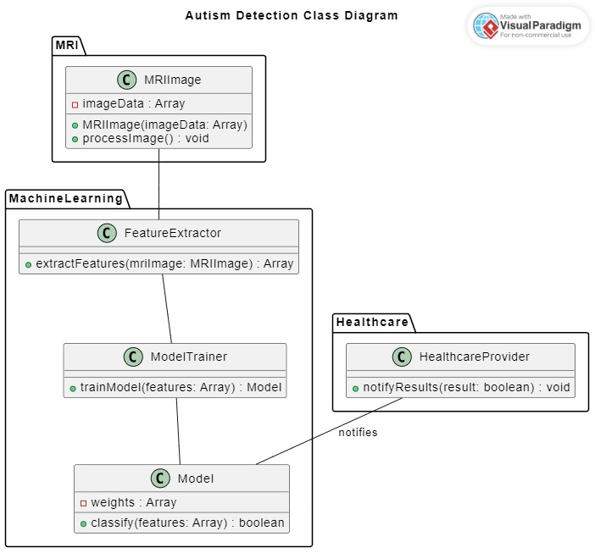 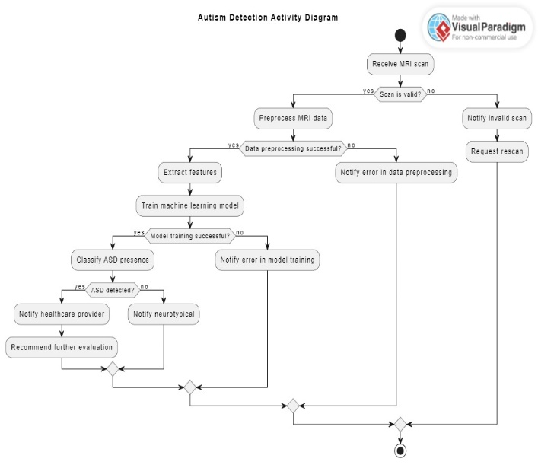

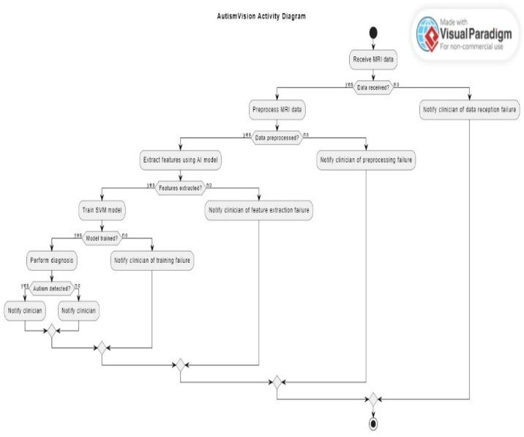 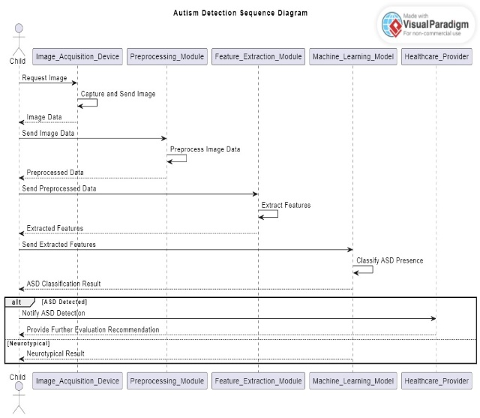

Communication map

|  |  |  |
| --- | --- | --- |
| Meeting Type | Frequency/Schedule | Who Attends |
| Project Update | Weekly | Project team and mentor |
| Feature Discussion Meetings | As needed | Project team |
| User Feedback Sessions | Monthly Project team | Project team |
| Planning Meetings | Bi-weekly | Project team and mentor |
| Review and Demo Sessions | End of each development cycle | Project team |

### 6. Background

*a. CNN (Convolutional Neural Network)*

Unlike regular Neural Networks, in the layers of CNN, the neurons are arranged in 3 dimensions: width, height, depth. The neurons in a layer will only be connected to a small region of the layer (window size) before it, instead of all of the neurons in a fully-connected manner.

Moreover, the final output layer would have dimensions (number of classes), because by the end of the CNN architecture we will reduce the full image into a single vector of class scores.



The components of a CNN are as detailed below:

* 1. Convolution Layer : In convolution layer we take a small window size (typically of length 3*3) that extends to the depth of the input matrix. During every iteration we slid the window by stride size,, and computed the dot product of filter entries and input values at a given position. That is, the network will learn filters that activate when they see some type of visual feature such as an edge of some orientation or a blotch of some color.
  2. 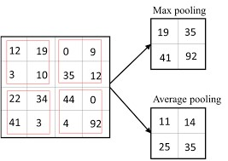Pooling Layer : We use a pooling layer to decrease

the size of the activation matrix and ultimately reduce the learnable parameters.

There are two type of pooling :

* + 1. Max Pooling
    2. Average Pooling

1. Fully Connected Layer :

In convolution layers neurons are connected only to a local region, while in a fully connected region, we connect all the inputs to neurons.

1. Final Output Layer :

After getting values from the fully connected layer, we connect them to the final layer of neurons (having count equal to total number of classes), that will predict the probability of each image to be in different classes.

**Model of CNN which we are using in this project are :**

1. ***VGG16:***

VGG16 is a convolution neural net (CNN ) architecture which we would be using. It is considered to be one of the excellent vision model architectures till date. Most unique thing about VGG16 is that instead of having a large number of

hyper-parameter they focused on having Convolution layers of 3x3 filter with a stride 1 and always used same padding and maxpool layer of 2x2 filter of stride2 It follows this arrangement of convolution and max pool layers consistently throughout the whole architecture. In the end it has 2 FC(fully Connected layers) followed by a softmax for output. The 16 in VGG16 refers to it having 16 layers that have weights.

This network is a pretty large network and it has about 138 million (approx) parameters.

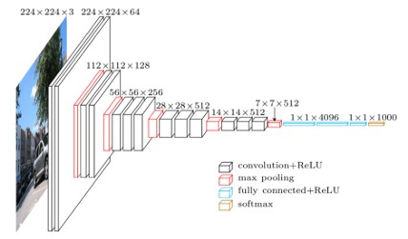

1. ***VGG19:***

VGG19 is a variant of the VGG model which in short consists of 19 layers (16 convolution layers, 3 Fully connected layers, 5 MaxPool layers and 1 SoftMax layer).

The VGG19 network uses only five types of layers. All convolution layers use 3 × 3 kernels and all the max pool layers use 2 × 2 kernels. 19 counts only the convolution and fully connected layers. Due to the presence of fully connected layers, VGG-19 is not fully convolutional and therefore, will only be able to accept 224 × 224 × 3 inputs without retraining.

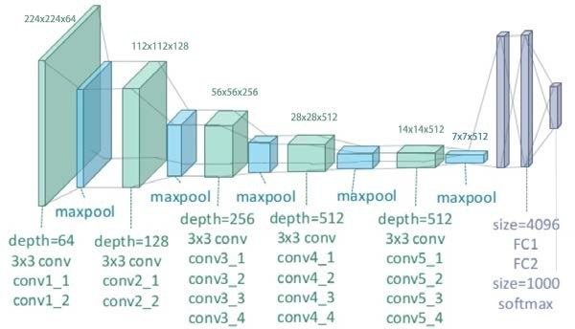

## 7. Methodology

* Load Train dataset: First, we will start by training our dataset. Our dataset contains the file with file names as “Non_Autistic.135.jpg , Autistic.391.jpg”, where the word is splitted by ‘.’, initial word describes the kind (whether the person is autistic or not and next word describes the image no.).
* Load Test dataset: Our dataset contains the file with file names as “Non_Autistic.135.jpg

, Autistic.391.jpg”

* We will be using Multi layer neural networks as deep neural networks.
* Since the dataset consists of images ,Convolutional neural networks will be used.
* Preparing Model: Then, we will prepare the model following the steps given below:

We will define hyperparameters

Then Flatten the output layer to 1 dimension

Further we will add a fully connected layer with 512 hidden units and ReLU activation

Next a dropout rate of 0.5 will be added

Lastly a final sigmoid layer for classification will be added

* Preprocessing of Data: We will be preprocessing the data and extracting data from images in the form of matrix.
* Preparing the training dataset:

Training Generator: Here we will be preparing and generating the train data.

Validation Generator: We will be creating a validation generator to filter out the data to ensure the quality of performance by using the validate data.

**validation_data**: Data on which to evaluate the loss and any model metrics at the end of each epoch. The model will not be trained on this data.

* Model Fitting: Now we will train the data for a fixed number of epochs and batch size.
* Preparing the testing dataset: We will create a testing generator for generating the test dataset using the previously loaded test images.
* Prediction: Now, we will be predicting the result for the test dataset and using the model evaluated earlier.

Output will be as follows :

Image name as :- actual_name(image name{0 or 1}) , eg. autistic.127.jpg(1) , here

0/1 is prediction.

* Our predictions will next go to submission_13010030.csv.

|  |  |  |
| --- | --- | --- |
| ● This file contains the predicted result, and further we will calculate its accuracy , | | |
| precision etc.  **8. Software and Hardware Requirements:** | |  |
| A. Software Requirements   * Google Collab   Languages   * Python 3 * Matlab   Tools:   * Keras * Tensorflow * PIL   Libraries :   * Numpy * Pandas |  | * Optimizer * Layers * Seaborn * Os * VGG16 * VGG19 * Model |
| B. Hardware Requirements   * Laptop * 8 GB RAM, GPU * System with fast processor and a graphics card. | |

* Matplotlib
* SKlearn

## 9. Implementation

* Train dataset: We have classified the dataset as category (0,1) as (Non Austistic ,

Austistic) respectively.

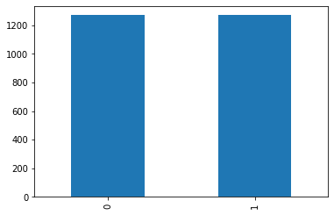 filename category

* 1. Non_Autistic.135.jpg 0
  2. Non_Autistic.1211.jpg 0
  3. Non_Autistic.261.jpg 0
  4. Autistic.999.jpg 1
  5. Non_Autistic.1227.jpg 0

2539 Autistic.303.jpg 1

* Test dataset: Here we will load the test dataset which will consist of only filename.

Filename

* + 1. Autistic.135.jpg
    2. Autistic.27.jpg
    3. Autistic.14.jpg
    4. Autistic.88.jpg
    5. Autistic.17.jpg
* Sample Image: Now, we will load the sample image as given below:

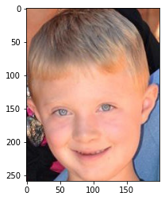

* Model was prepared with hyperparameters as epochs = 20 and batch_size = 12.

Model was compiled with :

model.compile(loss='binary_crossentropy',

optimizer=optimizers.SGD(lr=1e-3, momentum=0.9), metrics=['accuracy'])

Now Model is prepared with output as:

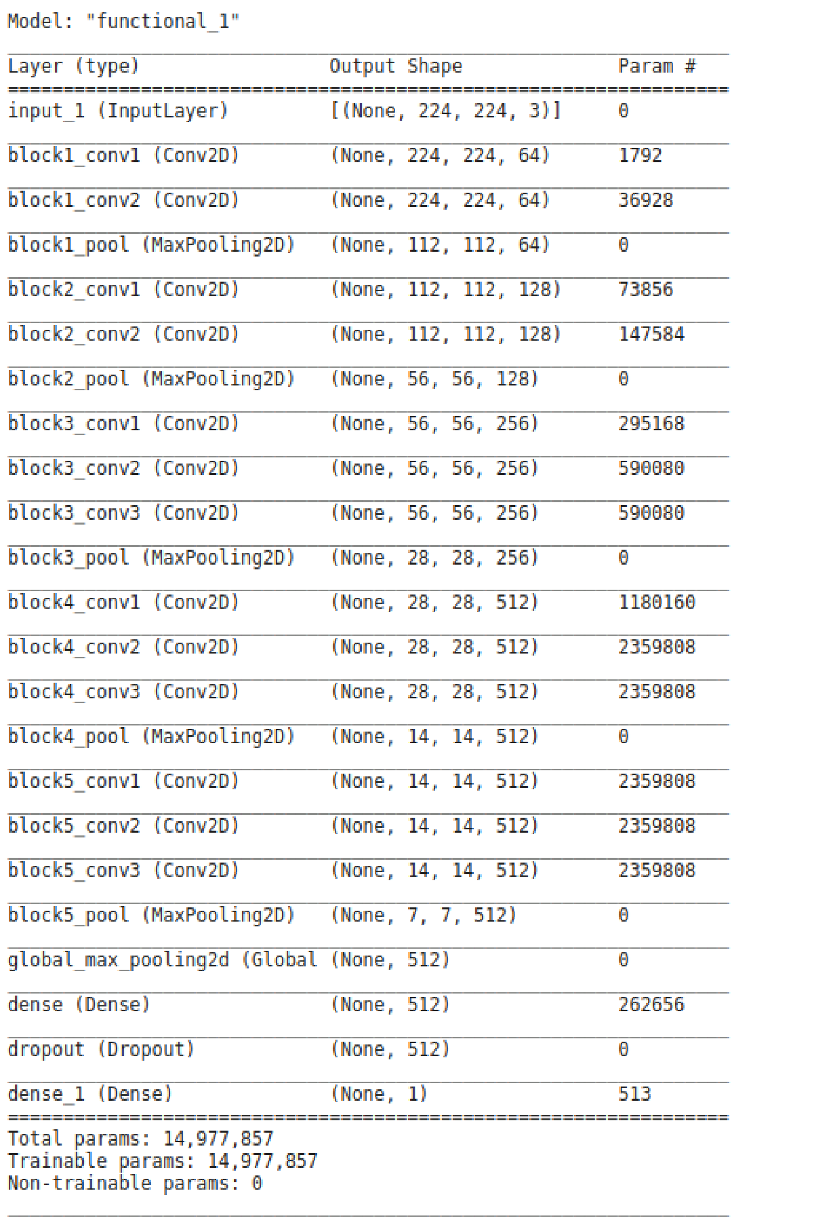

* Next data was trained and preprocessed with using parameters as :

rotation_range=15, rescale=1./255, shear_range=0.2, zoom_range=0.2, horizontal_flip=True, fill_mode='nearest', width_shift_range=0.1, height_shift_range=0.1

* Now data will validated and stored in “validation_datagen”
* Model fitting was carried out , and for each epoch accuracy and loss was calculated.

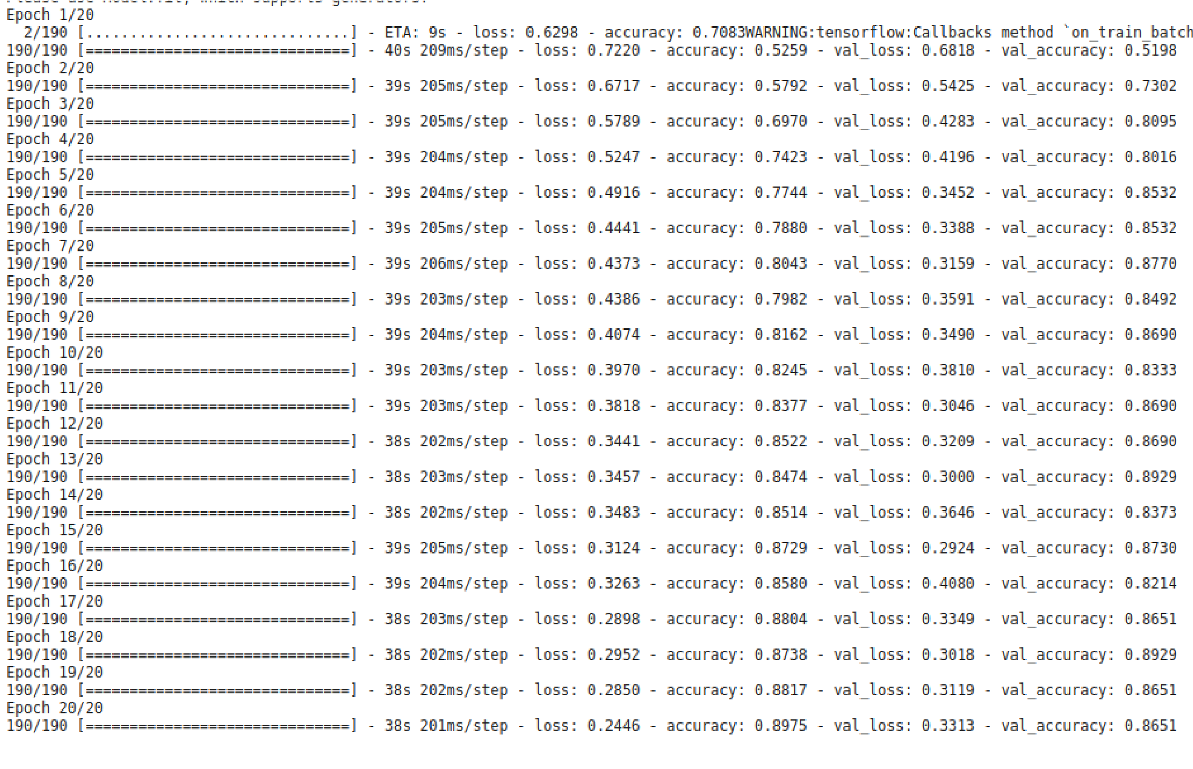

* Loss and accuracy for model will be : accuracy = 0.865079 ; loss = 0.331409 ● Next prediction was made with a threshold as 0.5 .

( Refer image5.jpeg).

This image contains 9 images with actual and predicted results as filename. ● Our predictions will next go to submission_13010030.csv, which will be as follows:

**id label**

|  |  |
| --- | --- |
| Autistic | 1 |
| Autistic | 1 |
| Autistic | 1 |
| Autistic | 1 |
| Autistic | 1 |
| Autistic | 1 |

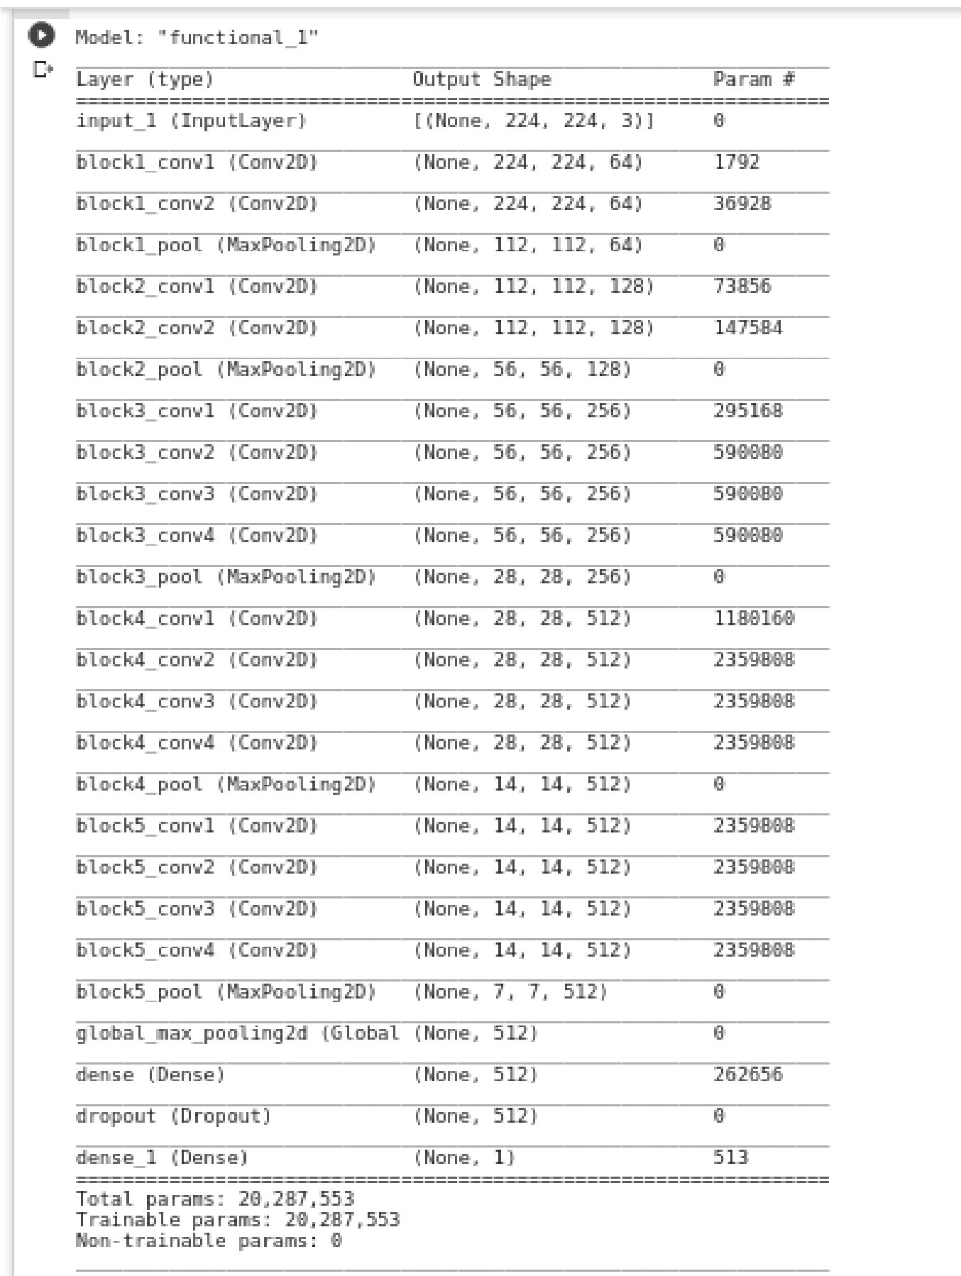For **VGG19,**

model was as follows :

## 10. Results

* Graph for Actual Test Data: 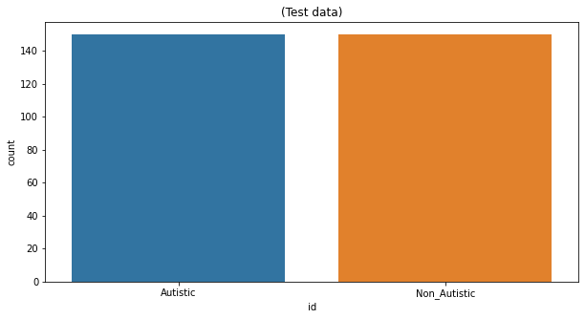

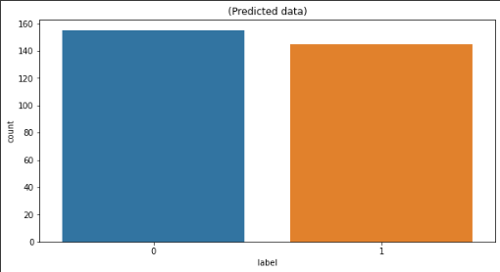For VGG16:

* Graph for Predicted Data :
* Number of images which were classified as :
  1. Predicted Autistic : 149

○ Predicted Non Autistic : 151

○ Actual Autistic : 150 ○ Actual Non Autistic : 150

* Percentage of images classified as :
  1. Actual Non Autistic percentage in total test data: 50.0 %

○ Predicted Non Autistic percentage in total test data:

50.33333333333333 %

○ Actual Autistic percentage in total test data: 50.0 %

○ Predicted Autistic percentage in total test data:

49.666666666666664 %

* Confusion matrix was used for predicting accuracy & other results:

■ True positive : 126

■ True Negative : 127

■ false Positive : 24

■ false Negative : 23

* 1. Accuracy is: 84.33333333333334 %

○ Precision is: 84.0 %

○ Sensitivity is: 84.56375838926175 %

○ Specificity is: 84.10596026490066 %

For VGG19:

* Graph for Predicted Data :
* 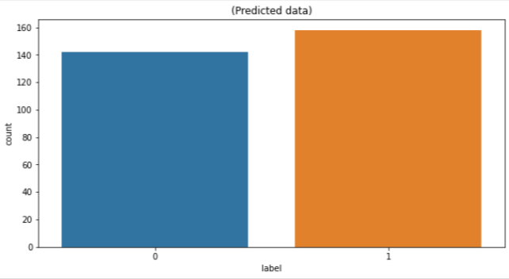
* The number of images which were classified as :

○ predicted Autistic : 158

○ predicted Non Autistic : 142

○ Actual Autistic : 150 ○ Actual Non Autistic : 150

* Percentage of images classified as :

○ Actual Non Autistic percentage in total test data: 50.0 %

○ Predicted Non Autistic percentage in total test data:

47.333333333333336 %

○ Actual Autistic percentage in total test data: 50.0 %

○ Predicted Autistic percentage in total test data:

52.666666666666664 %

* Confusion matrix was used for predicting accuracy & other results:

■ True positive : 130

■ True Negative : 122

■ false Positive : 20

■ false Negative : 28

○ Accuracy is: Accuracy is: 84.0 %

○ Precision is: 86.66666666666667 %

○ Sensitivity is: 82.27848101265823 %

○ Specificity is: 85.91549295774648 %

## 11. Result (Taking real dataset)

Here we took the images for the prediction and result calculation from a real dataset that is from the Internet and our own family members. THese images are in the “test2” folder in the Dataset folder.

Dataset :

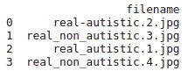

Results :

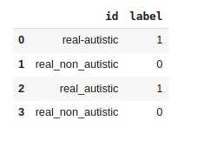

Dataset Link :

https://drive.google.com/drive/u/1/home

## 12. Comparison

Base paper has a dataset of 59 participants labelled as ASD-Diagnosed and Non-ASD.

In this base paper , a key idea in the methodology is to construct a visual representation of eye motion. They have transformed the eye-tracking records into visual patterns.It appears that the ASD- diagnosed participant had a tendency of looking at the bottom of the screen ,where the eye-tracking device was placed . The data transformation process was fully implemented using python. The visualizations were produced by the Matplotlib library .

We have a dataset of 1470 autistic facial images and 1470 non-autistic facial images . Out of those we are using 1269 images comprising both autistic and non-autistic for training purposes. We have used 149 images for testing the model. We have used VGG16 and VGG19 models of CNN (Convolutional Neural Network) methodology to train the model and test the model .Accuracy of this model is approx 84.33% and 84% respectively and precision is about 84.6% and 86.3% .

## 13. Contribution

We have used base code from ref no. 9 for training and fitting the model. Later we improved the accuracy from 77% to 84.3%, precision, specificity and sensitivity. By making significant changes like epoch number, batch size and various other factors, we have also improved training and testing as compared to base code.

Also, we have calculated various factors to judge the results in a better way such as calculating the true positive, true negative, false positive and false negative followed by the representation of the confusion matrix, calculating the accuracy, precision, sensitivity and specificity of the prediction result in the submission.csv.

We have also implemented the VGG19 model of CNN and compared the results of both the models.

## 14. Answer to C2 questions

* Number of parameters:

○ Input layer: Zero as input layer has nothing to learn . It just provides the input image’s shape so there are no learnable parameters here

○ CONV layer : Number ((m * n * d)+1)* k), added 1 because of the bias term for each filter.

■ m: height of filter

■ n: width of filter

■ d: no of filter in prev layer

■ k: no of filter in present layer

■ So, for example , for conv layer 1 in block 1:

* m=3 n=3 d=3 k=64
* Hence, no of params = ((3*3*3)+1)*64 = 1792

○ Max pooling layer : Zero because there are no parameters we could learn in the pooling layer. This layer is just used to reduce the image dimension size.

○ Fully connected layer : (( c * p)+1*c) , here 1*c is added as a bias term.

■ c : current layer neurons

■ p : previous layer neurons

## 15. Conclusion

In this project, we proposed a CNN (Convolutional Neural Network) architecture to identify and classify ASD patients. Our proposed CNN architecture is able to obtain higher classification performance with fewer parameters, which will reduce the training time. Therefore, our proposed model is less complex and faster as compared to other similar models.

**The result shows that the accuracy of our model using test data by the VGG16 model is 84.33% and the VGG19 model is 84%** meaning that it outperformed the best accuracy obtained on this dataset so far and **we get better accuracy in the VGG16 model.** But **precision in the VGG16 model is 84% whereas in the VGG19 model is 86.6%**, here **VGG19**

**outperforms the VGG16 results in terms of precision.** Our model **Sensitivity and specificity is approximately 84.56 and 84.10% for the VGG16 model and, 82.27 % and 85.915% for the VGG19 model**, so we can say that our project determines actual positive cases and negative cases (in case of Autistic and Non_Autistic predicate true) very efficiently.

## 16. References

[1.] Romuald Carette, Mahmoud Elbattah, Gilles Dequen, Jean-Luc Guérin, Federica Cilia,

“Visualization of Eye-Tracking Patterns in Autism Spectrum Disorder: Method and Dataset”, 2018

Thirteenth International Conference on Digital Information Management (ICDIM)

[Visualization of Eye-Tracking Patterns in Autism Spectrum](https://ieeexplore.ieee.org/abstract/document/8846967) [Disorder: Method and Dataset](https://ieeexplore.ieee.org/abstract/document/8846967)

[2]M. Elbattah, R. Carette, G. Dequen, J. -L. Guérin and F. Cilia, "Learning Clusters in Autism Spectrum Disorder: Image-Based Clustering of Eye-Tracking Scanpaths with Deep Autoencoder," 2019 41st Annual International Conference of the IEEE Engineering in Medicine and Biology Society (EMBC).

[Learning Clusters in Autism Spectrum Disorder: Image-Based](https://ieeexplore.ieee.org/document/8856904) [Clustering of Eye-Tracking Scanpaths with Deep Autoencoder](https://ieeexplore.ieee.org/document/8856904)

[3.] Romuald Carette, Mahmoud Elbattah, Federica Cilia, Gilles Dequen, ”Predicting Autism Spectrum

Disorder Using Machine Learning and Eye-Tracking”, 12th International Conference on Health

Informatics At: Prague, Czech Republic

[Learning to Predict Autism Spectrum Disorder based](https://www.researchgate.net/publication/331784416_Learning_to_Predict_Autism_Spectrum_Disorder_based_on_the_Visual_Patterns_of_Eye-tracking_Scanpaths) [on the Visual Patterns of Eye-tracking Scanpaths](https://www.researchgate.net/publication/331784416_Learning_to_Predict_Autism_Spectrum_Disorder_based_on_the_Visual_Patterns_of_Eye-tracking_Scanpaths)

[4] Lonnie Zwaigenbaum, Jessica A Brian, Angie Ip, Early detection for autism spectrum disorder in young children, Paediatrics & Child Health, Volume 24, Issue 7, November 2019, Pages 424–432, [Early detection for autism spectrum disorder in young](https://doi.org/10.1093/pch/pxz119) [children](https://doi.org/10.1093/pch/pxz119)

[5.] Sashi Thapaliya, Sampath Jayarathna, Mark Jaime, ”Evaluating the EEG and Eye Movements for

Autism Spectrum Disorder” , 2018 IEEE International Conference on Big Data (Big Data)

[Evaluating the EEG and Eye Movements for Autism Spectrum](https://ieeexplore.ieee.org/document/8622501) [Disorder - IEEE Conference Publication](https://ieeexplore.ieee.org/document/8622501)

[6.] Tanu and D. Kakkar, "Automatic Detection of Autism Spectrum Disorder by Tracing the Disorder

Co-morbidities," 2019 9th Annual Information Technology, Electromechanical Engineering and

Microelectronics Conference (IEMECON)

[Automatic Detection of Autism Spectrum Disorder by](https://ieeexplore.ieee.org/document/8877080) [Tracing the Disorder Co-morbidities](https://ieeexplore.ieee.org/document/8877080)

[7.] Zeyad Abdulhameed Taha Ahmed, Mukti E. Jadhav, “A Review of Early Detection of Autism Based on Eye-Tracking and Sensing Technology” , 2020 International Conference on Inventive Computation Technologies (ICICT)

[A Review of Early Detection of Autism Based on Eye-Tracking](https://ieeexplore.ieee.org/abstract/document/9112493) [and Sensing Technology](https://ieeexplore.ieee.org/abstract/document/9112493)

[8.] Chongruo Wu, Sidrah Liaqat, Sen-ching Cheung, Chen-Nee Chuah, Sally Ozonoff, “Predicting

Autism Diagnosis using Image with Fixations and Synthetic Saccade Patterns”, 2019 IEEE International

Conference on Multimedia & Expo Workshops (ICMEW)

[Predicting Autism Diagnosis using Image with Fixations](https://ieeexplore.ieee.org/document/8795004) [and Synthetic Saccade Patterns](https://ieeexplore.ieee.org/document/8795004)

[9]. Cihan Senol, Student at Gaziosmanpasa University, Kielce, Świętokrzyskie, Poland <https://www.kaggle.com/cihan063/autism-cnn-vgg16>