**Meeting - October 13th**

During my research, I discovered two things. One, people don’t appear to want to give unless they receive swag in return. And two, we’d be most successful convincing people to give if we can change their mindset to “You were going to purchase this item but do you really need it? And if no, why not spend the money and give the entire purchase amount to someone without an expectation of return but we will still give you points so that you can then donate even more to charity.”

I searched online for donation processes and the model I frequently saw was similar to these from [this NBC article](https://www.nbcnews.com/better/lifestyle/14-charitable-gifts-give-back-those-need-ncna823386). In a nutshell, if you are going to purchase anything, you should buy it from “x” company because they will donate a like item or a percentage of sales to a needy group. (Sidenote, I [personally shop at this company](https://us.whogivesacrap.org/) and admitted I do feel good about myself because I need toilet paper, there is no plastic involved and I’m helping people. It’s a trifecta win.)

But I did find [Fill it Forward](https://www.fillitforward.com/) that doesn’t expect users to purchase anything and instead just wants people to fill their water bottles, scan a code, and then funds are directed to charities. The money to those charities comes from product sales of Fill it Forward bottles and corporate sponsorships. This is a good example of our proposal because Fill it Forward is incentivizing water consumption, which humans will constantly do because we need water to survive.

Then I stumbled across the [Trees not Tees](https://www.treesnottees.com/) website. It is trying to convince race organizers to add to the race entry form “I don’t need another T-shirt - please plant a tree for me instead”. Then a tree will be planted for the runner and then an email certificate will be sent to the participant of their tree with geolocation. This is an example of a motivated consumer opting out of something they probably don’t need but they still receive something in return. [(Here is another swag example.)](https://www.runnersworld.com/gear/a20850230/ask-the-gear-guy-race-day-swag-thats-outside-the-ordinary/)

The above examples show models that span from “buy this and we’ll donate that” to “do what you normally do and we’ll donate” to “actively opt-out and we will do this in your name”. All of these actions have one thing in common, people were choosing to perform an action. We need to figure out how to consolidate these actions into one cohesive operation that allows consumers to opt-out but also allows consumers to verify that their sacrifices aren’t just going into the coffers of large corporations. How do we create a framework that allows a person to accumulate points, and see the value of their impact without feeling like they aren’t making a difference? Where do we find that accountability? (Also, completely unrelated, we need some definitions for our consumer actions.)

**Devin - JouleBug**

This app is all based around the aspect of friendly competition and fostering a sense of community around being sustainable. There are different sections of the app that focus on different areas of sustainability such as, water, energy, & waste. Under each one of these sections, there are listed activities that contribute to reducing your carbon footprint. After you complete a certain action you “buzz” it and add it to your daily log of activities. After each buzz, the app gives you information on how much you’ve benefited the earth and how much money you are potentially saving by performing that action. For example, one of the actions is to unplug electronic items when they are not in use or to turn off your power strip. The app lets you know that this would be the equivalent of planting one tree or charging your laptop 598 times, all over the course of a year. Another aspect of this app is the social aspect. JouleBug allows you to add friends with whom you can compete and share your various sustainability achievements. There is also a challenge page where you can challenge your friends (and vice-versa) with different ways to stay eco-friendly. The app logs your practices and allows you to obtain different rewards/statuses on the app. Instead of there being some type of monetary reward given for completing certain things, the apps just reminds you of the money that you’re saving by doing things like turning off the lights or stopping your running water. There is also an advanced section for those people who want to take it to the next level.

**Neha**

Paperkarma:

PaperKarma helps users opt-out from thousands of verified mailers by just scanning the mails, selecting your address and then unsubscribing from the mailer list.

Sustainability @BU:

I found this app very much similar to JouleBug as it has the same functionality to buzz whenever you do a sustainable task.

I think some of the definitions for our consumer actions could be to divide them as per the basic standards like:

1) Use alternative transport

2) Save energy

3) Save water

4) Reuse/reduce waste

5) Save paper

6) Save plastic

Regarding making people feel that their actions are worthy and valued, we can do a similar thing as suggested by Devin. We can show our users how much money they have saved for themselves by performing a minor change in their actions, that should be more than sufficient to drive their sustainable instincts.

Above this, we can make our users sign up for sustainable challenges where they can see their rank among other potential users and compete with them to keep a streak alive.

We can relate corresponding CO2 emission rates by giving users a relative carbon cost of any sustainable action they carry out and the amount of CO2 emission saved would be added as a score to their profiles (called as eco score). The amount corresponding to the eco score can then be donated to the organizations we have tied up with as per the willingness of our users.

Regarding the funding issue, big organizations do need to show the government their annual donation history, so we can tie up with individuals/orgs to collect funds.

**Kurt**

[Buengo](https://www.buengo.com/): Buengo is an “alternative way to raise money for charity” by selling items that you no longer want. It may be a little thin on the “sustainability” side of things, but a large part of waste is paying it forward with items you no longer want to second-hand sources that are not completely useless yet.

Buengo seems to be a more structured gofundme type page that incorporates a marketplace. You sell your things and have the proceeds go to certain “fundraisers” that are generally tied into one of their many charitable partners. They also have a “newsfeed” social media-type aspect to the app that allows you to “Find out about all the good things happening in the world and add your own stories to create a community for good!”

I agree with Kyra’s assertion that we need to consolidate “actions” and believe that Neha’s definitions are a good start. I think we also need to think about(as far as user profiles go) how we’re going to make this app functional from the business side. Do we allow businesses to customize these actions, i.e. Starbucks being able to choose a “opt out of paper cup” action to their specific business? Or are we only going to focus on the consumer side? Just something to think about.

[Ecosia](https://www.ecosia.org/?c=en) - Ecosia has a similar purpose to trees not tees. It’s a search engine that simply uses the profits from your searches to plant trees across the globe. A more granular/singular purpose.

[Tap](https://plasticsmartcities.org/products/tap) - Tap is another interesting concept. This app attempts to map public and private refill stations (with branded partnerships) across cities in order to cut down on plastic pollution. I think a good idea would be to harness existing app networks like this one and be almost the “through line” so to speak, the “currency” that takes the calculations from apps like Joulebug and Tap and converts them to our own point/reward system for donations. I’m still unclear on where that money is “coming from” actually which is why I think it might be smart for us to consider both the “business” as well as the “consumer as user profiles.

[Donegood](https://donegood.co/) - Donegood might be a good model to focus on as you can actually sort and find businesses from sustainable attributes such as “eco-friendly” or “cruelty-free”. So maybe we also define “sustainable attributes” and allow users to specify what KIND of good they want to do as well as what charity they want to donate to. Just a thought.

Here’s a good article from [Harvard Business Review](https://hbr.org/2019/07/the-elusive-green-consumer) on “The Elusive Green Consumer”, might give us some demographic ideas for user profiles.

Nielsen also did a [Global Survey of Corporate Social Responsibility and Sustainability](https://www.nielsen.com/us/en/insights/article/2015/green-generation-millennials-say-sustainability-is-a-shopping-priority/) which gives us some good insight on user motivations(See image below).

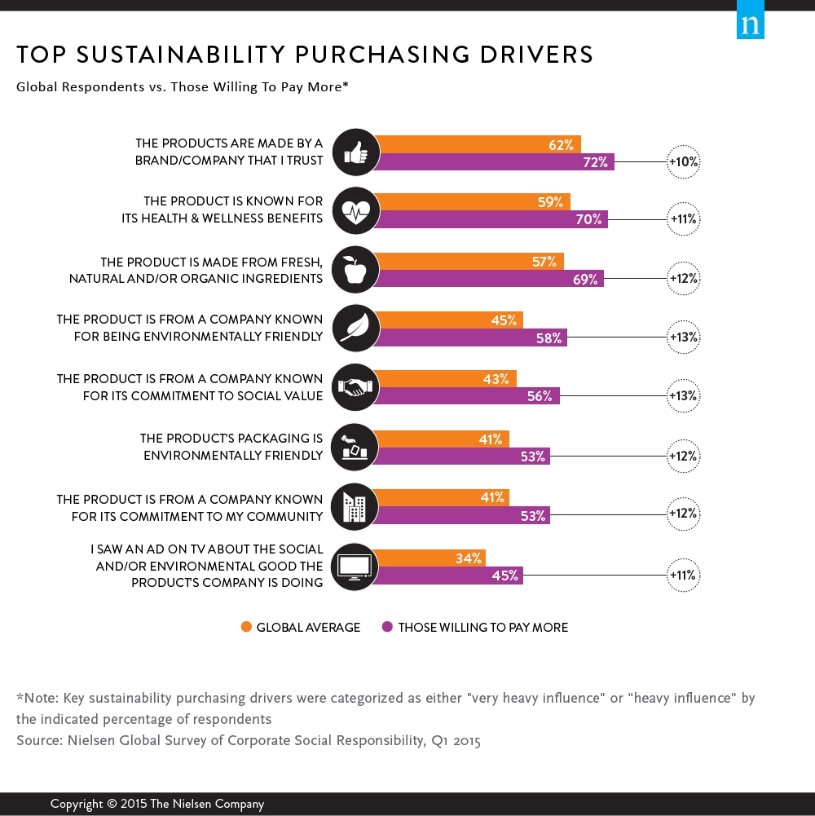

**Amar**

**GiveTide**

I choose this app as it gives us a perspective on how some of the charitable apps function and what they have to offer.

* This app allows users the opportunity to round up purchases and donate that amount to a charity of their choice.
* Pick any number of the thousands of nonprofits supported by GiveTide. If an organization doesn't have a profile yet, you can request it with a single tap!
* Each Purchase is rounded up to the nearest dollar and the change donated.
* Enable Auto-Donate to automatically donate your spare change at the end of every week.
* No more digging through email receipts. Your entire donation history in one place.

**Meeting - October 22: Next Meeting October 29th, all materials due before then**

In our last meeting we discussed the need to come up with:

1. User Profiles
2. Consumer Action Definitions
3. What features we do/don’t like from our research
4. What we’d like to consider for future implementation within the application that is beyond the scope of this class
5. Specific application features
6. Deliverables for the project

**User Profiles**

|  |  |  |
| --- | --- | --- |
| **Highly Motivated Environmentalist** | **Motivations** | **Specific Goals** |
|  | * Wants to stop climate change * Have the smallest carbon footprint or negative impact on the environment * Help other countries that are negatively impacted by America’s waste management policies | * Educate others about how easy it can be to be environmentally friendly * Discover new ways to be sustainable and donate * Determine the best organizations to donate app funds to that will further climate change goals |
| **Gafa Taulimaina** is a girl who moved from Idaho to Pennsylvania for a job as a librarian. She interacts with different people from various social levels and feels that her position as a community center is a platform to encourage climate activism and awareness. | “People don’t understand that if everyone does one small thing, it adds up to a big difference and I want to show how if we work together as a community, we can do good for our city, state, country and eventually the world.”  “Climate activism shouldn’t be between the haves and have nots. It should be accessible and available to everyone. ”  “If McDonald’s can get kids to know their jingle as a toddler, I think I should be able to give kids an environmentally friendly foundation that can be the bedrock of the rest of their lives.” | |

|  |  |  |
| --- | --- | --- |
| **Slightly Motivated Environmentalist** | **Motivations** | **Specific Goals** |
|  | * Wants to limit his contributions towards climate change * Reduce his carbon footprint * Make sure that people around him and people in the future have a healthy Earth to live on | * Make sure that he recycles the things in his house that he is able to * Find new ways to contribute to sustainability in his community * Get a few of his friends to attend a cleanup for the Bay |
| **William Smith** a man currently living in Baltimore Maryland. He lives just outside the city and has recently gotten into becoming more sustainable. He wants to reduce his carbon footprint and help the environment stay clean | “I have recently signed up for a few applications that will help me keep track of my carbon footprint”  “I am planning to attend a few beach cleanups in the new future with a few of my friends”  “Hopefully I can get a few more of my friends and family interested in reducing their carbon footprints as well” | |

|  |  |  |
| --- | --- | --- |
| **Not Interested Environmentalist** | **Motivations** | **Specific Goals** |
|  | * Ignorance and misplaced values, not believing that humans have an effect on global environmental changes * It doesn’t hit close enough to home as he sees beautiful pine trees out from his window and thinks that the environment is still in good hands * He focuses on immediate problems that need to be fixed right away instead of thinking about the long term negative impacts of people on the environment | * Use the latest technologies making personal life easier and better, ignoring its negative impact on the current environment and future generations * Has a thought process that the natural resources are available and are supposed to be utilized and a single person not using won't make a lot of difference to the environmental issues * Short term luxuries and living a high notch life |
| **Jay Cooper** is a man currently living in Bay Area, California. Living closer to Silicon Valley, he is more inclined towards using the latest technologies in the form of cars, smartphones and smart homes. He thinks he is worthy of and deserves a whole lot of luxury items and believes that technological inventions are supposed to make our lives luxurious and comfortable even at the cost of future environmental risks. | “I believe that people can fulfil inner psychological needs with external material objects even if they are not needed and that they can buy their way to true happiness and that’s what matters above everything”  “Sometime in the future, science will cure all diseases, solve world hunger, eliminate pollution etc. A single person can make no difference, so there's no harm in enjoying the modern lifestyles we are a part of ” | |

|  |  |  |
| --- | --- | --- |
| **Moderately Motivated Environmentalist** | **Motivations** | **Specific Goals** |
|  | * Wants to help prevent global warming * Looking to teach his kids the importance of sustainability * Make sure his family is living in a healthy environment | * Make sure he prevents laziness from getting in the way of sustainable practices * Wants to properly educate his kids on different ways of being sustainable * Teach his kids about which items are trash and what are recyclable |
| **John Page** is a married man with kids currently living in Washington DC. He has been practicing sustainability for the past of years but to a certain extent. He knows how important sustainability is but sometimes just gets lazy. He also wants his kids to practice sustainable acts starting in their childhood. | “I want to set a consistent example of sustainability practices for my kids”  “I want to be 100% committed to sustainability and hopefully I can stop being lazy at times ”  “Sustainability is important and your kids should be educated from the beginning” | |

**Consumer Action Definitions**

We have several actions that need defining. They are:

1. *Green penny* - currency that is accumulated by a user during purchase oriented actions5
2. *Eco-score* - currency that is accumulated/awarded for individual actions (unplugging laptops, etc)
3. *Scan to Save* - for-profit organizations that provide QR codes to consumers so they can award points and consumers can hold companies accountable.
4. *SusDonate* - the act of taking the application generated currency and transitioning to another part of the application that allows them to donate to a charitable organization
5. *Give to Live* - charity organizations/estate planners that have opted into the application for receipt of funds
6. *Optimized money* - converting app currency into tangible dollars

**Features we like/don’t like/future implementation**

Please cull the list above and put in the appropriate column what we like about the above suggestions. Each person, analyze the research of the person who submitted after you, so we can get a fresh perspective on the information. For example, I will analyze Devin’s.

|  |  |  |  |
| --- | --- | --- | --- |
|  | FEATURES WE LIKE | FEATURES WE DON’T LIKE | FUTURE IMPLEMENTATION |
| KYRA (Joulebug) | The competitive nature of the app with challenges; virtual community to connect with friends;encourages ways to integrate sustainability in daily lives; changes behavior; | Logging could be tedious; Isn’t a monetization factor to pay forward the savings | I think we should have tips or informative nuggets that pop up when a person does something. |
| DEVIN (Paperkarma/Sustainability @BU) | I like that you don’t have to go through an unsubscribe from each mailing list, it is useful that the app does this for you because many users could either forget or just not feel like it at all | I don’t like how there is a limitation that only focuses on paper, I know that paper is a major issues but I felt like the app could just encompass multiple things |  |
| AMAR (Fill Forward/Trees Not Trees) | I like the incentivizing water consumption idea because humans drink water regardless. I really like the trees not trees example where they are trying to convince race organizers to plant trees instead of giving out t-shirts. | I don’t like how there is a limitation on only t-shirt. There are so many other items used and given in an organized race. |  |
| NEHA  (Buengo/Ecosia/Donegood) | Buengo: I like that the fundraisers are already tied to the app along with other charitable partners.  The news feed is a great idea to let people know how others are contributing towards achieving sustainability.  Donegood: I feel adding self explanatory sustainable attributes is a good way of making our app easy to use and understand. Just dividing the general sustainable actions beforehand would make it easier for users to log their efforts without spending more time on the app. | Ecosia: I don’t know if we are planning on doing sustainable actions on behalf of our users or we can just narrow it down to monetary donations. | We can tie up with orgs other than charitable companies selling sustainable goods/products/food items and allow users to make an environmentally friendly personal purchase from the app itself in case they wish to utilise their savings for personal benefits. |
| KURT  (GiveTide) | Linking to bank account to donate.  Rounding up dollar amount purchases is an interesting aspect.  Auto-donate setting can be activated on purchases. Pre-set your exact cause to give to.  Sponsored by particular philanthropy group. | Covers the charity portion of our app, but does not necessarily tie into sustainability at all. | Maybe treat “Green penny” currency much the same way that GiveTide treats rounding up, at least the one-click, instantaneous aspect of it. The easier we make the donation feature, the more likely people are to buy-in. |

**Deliverables for the project**

According to the syllabus we need to describe what the service is, what information is needed, how information is collected, processed, analyzed and stored, and the expected utilities/impacts of the service. We should have a unifying vision for the service, how the service is embedded in the environment that it is used and the features and functions of the service. Everything should be in GitHub and we have a video presentation that shouldn’t be longer than 15 minutes.

I’m creating a table here that will list these deliverables and document what we think is the best way to represent those items. I encourage everyone to add their thoughts as we go along.

|  |  |  |
| --- | --- | --- |
| REQUIREMENT | DELIVERABLE | Assigned To |
| What the service is | Slides (pull from proposal) | Kyra |
| What information is needed | A prior mapping of the amount of carbon emission saved for each sustainable activity undertaken. |  |
| How is information collected, processed, analyzed and stored | Data Flow Diagrams, Entity Relationship Diagrams | Kurt |
| Expected utilities/impacts of the service. | How do we want to display this deliverable? | Devin, Amar |
| How the service is embedded in the environment that it is used (data and currency)/unifying vision | How do we want to display this deliverable? | Neha |
| Features, functions and names of the service (current and present) | Wireframe | Amar, Neha, Kyra |
| Presentation | Video | Kyra |

**October 29 - Meeting**

Neha, Devin and Amar - Create the personas

To do list:

1. Create list of data for application
2. Determine currency rates/action points for the data/calculate the two types of in-app currency -tie points to how much you save in carbon emissions

**Data**

1. **Energy**
   1. Natural Gas
   2. Coal
   3. Distillate
   4. Petroleum
   5. Residual Fuel Oil
   6. Geothermal
   7. Solar
2. **Emissions**
   1. Co2 emissions
   2. Greenhouse gas
   3. Hydroflourocarbons
   4. Methane
   5. Nitrogen Trifluride
   6. Nitrus Oxide
   7. Perfluorocarbons
   8. Sulfur hexaflouride
3. **Ecological Footprint**
   1. Cropland
   2. Grazing
   3. Forest
   4. Carbon
   5. Fish
   6. Urban
4. **Freshwater**
5. **Sustainability**
   1. Safe drinking water
   2. Sanitation
   3. Electricity access
   4. Renewable energy consumption
   5. Air pollution
   6. Protected Areas
6. **Energy 2.0**
   1. Rural access to electricity
   2. Access to clean fuels
   3. Renewable energy consumption
   4. Renewable electricity output

**Currency information**

I did some light digging into monetizing sustainability and it appears that this isn’t currently something most people do because there are many factors to consider such as region, item, age, etc. I was thinking that maybe we just create our own point system that we then translate into dollars. For example, turning off your laptop is 1 point, using a reusable cup is 3 points and hanging up your clothes to dry is 10 points, and 100 points equals $10.00. In that way, we can incentivize people to participate. We basically want to show them how their actions add up to savings and they can then take those savings and pay them forward to charities.

**November 1 - Questions from Kyra**

We need to take all of our information and coalesce it into digestible information. We need to narrow down:

1. The data we want to focus on and how to display it
2. Our currency model and how to roll it out/put it into our application
3. List of features we want included in our application
4. List of features we’d like to include in future releases of our application
5. Incorporating Personas/identities into our application (Or is that just knowledge for us?)

I’ve added an extra column to the table from “Deliverables for the project” and we should discuss who wants to sign up for what.

**November 2 Meeting**

**Group Project Progress:**

Kurt will get a rough draft of the diagrams done over the weekend and share them with everyone else so that we can all add ideas and finalize. We will then move forward with the wireframe based on the diagrams.

Neha will figure out what our data calculations look like and we'll decide on what data visualizations we want to include.

**November 12 Meeting**

Kyra is going to take DFDs and suzz them up for inclusion in the slides and also start creating the slides and inputting data. Kurt created the DFDs in Lucidchart and shared them with the entire group and is now going to move forward with the ERD. We expect to have more progress by Thursday but would like to transition to assignment #4 for our next meeting on Tuesday.

**November 15 - Slide Brainstorming**

What does everyone think about this broad framework for the slides?

1. **INTRODUCTION - Introduce our application and ourselves**
2. **INTRODUCTION - Broadly describe what our application will do**
3. **THE CHALLENGE - Explain the problem - climate change (Devin, can you get some facts on these so we can flesh out these slides?)**
4. **OUR AUDIENCE - Explain who our intended audience is (personas)**
5. THE DATA - Explain the data will be collecting (Neha)
6. **OUR SOLUTION - Explain how the data will flow through our application (DFD,** ERD)
7. OUR SOLUTION - Show how we’d like our application to look (wireframe)
8. THE APPLICATION - Explain features of our application
9. CONCLUSION

**November 19**

Everyone is going to create a wireframe mockup that shows how we think the application should look. Devin is going to research some information about climate change to give to Kyra to add to the slides. Kyra will work on the slides and Kurt and Kyra have a meeting to talk about the ERD.

After the ERD is finished, Kyra will jazz it up to add to the slides. We anticipate that creating the wireframe will help us solidify what features of the application we want to include.

**4 interesting facts:**

(water)

<https://www.guarana-technologies.com/app-development/environment-apps/#:~:text=Luckily%2C%20mobile%20apps%20are%20able,and%20to%20fight%20global%20warming.&text=These%20apps%20contain%20functions%20like,to%20becoming%20more%20eco%2Dfriendly>.

“Dropcountr connects people and their water utilities on the mobile devices they use every day. Dropcountr is available and convenient to customers of participating utilities on any device or desktop computer. On average, users save about 9% in monthly water use – give Dropcountr a try today to save water, time and money.”

(home/electricity)

<https://www.electricchoice.com/blog/green-apps-track-energy-usage/>

“Both are easy to install and will send details about energy usage to a mobile device via the Neurio app. Alternatively, users can also check this information on a computer. The app helps users to monitor their energy consumption, compare their homes to others, and will also forecast the total cost of a monthly bill. On average users have seen an average of 15% reduction in their monthly electricity bill”

(recycling)

<https://ecowarriorprincess.net/2018/07/7-free-mobile-apps-to-help-you-recycle/>

This recycling app helps residents of the United States recycle over 350 materials at thousands of locations across the country.

(car)

<https://www.motherjones.com/environment/2020/02/our-addiction-to-ride-sharing-apps-is-hurting-the-environment/>

while ride-sharing trips in electric cars/bike riding can actually reduce emissions by up to 68 percent per trip.

**December 11**

Had a quick meeting so Kyra could continue to work on the slides. Devin, Amar and Kurt agreed to create a document that gives a definition of the files in the project so they are easily organized for the uninitiated. Neha passed her Tableau project to Kyra for her to integrate into the slides. (Orange signifies that this notes has been addressed)

I’ve gone through the slides and think the bulk of them are there. What we are missing are:

1. How the information is collected, processed, analyzed and stored. I believe this should go somewhere around slides 9 -10
2. How the service is embedded in the environment where it is used. Would that be the application slides 23- 29?
3. **Features and functions of the service. I’m thinking Tableau and the renderings satisfy that note?**