Project informations
Block: Robot HW
Person responsible for this block:
eng. Bazan Michal

Table of contents
Project informations 1
Change sheet 3
Glossary 4
Analysis of the technical state of art, review of the knowledge analysis 5
Requirements regarding the project 7
Inertial Measurement Unit (IMU) 7
Distance Sensors 7
WiFi Interface 7
DC Motors with Encoders 7
DC Motor Drivers 7
Power Management System 8
Requirements regarding components 9
Main component analysis 10
Design 12
Block diagram 12
Description table 13
Electronics design 14
MCU 14
Power 15
Distance sensors 16
Motors 17
MPU9255 18
Encoders 19
Level shifters 20
Requirements veryfication 21
HWE1 Review 21
HWE2 Review 22
References 23
Base components 23
Schematic 23
Additional components 23

Change sheet

Date | Description
02/21/2024 | Basic info, glossary, requiremets, requirement analysis and design.
03/04/2024 | Peripherial needs summary.
03/05/2024 | Schematic description regarding REV 0.1, updated glossary.
03/05/2024 | Edit figures (REV 0.1 → 0.2).
03/06/2024 | Edit figures, add section regarding debouncing encoders (REV 0.2 → 0.3), updated glossary.
03/08/2024 | Edif figures, add section regarding level shifting (REV 0.3 → 0.4), remove debouncing section. Add pullups to encoders, (REV 0.4 → REV 0.5), add new component to reference section.
03/11/2024 | Edit figures due to small change in power section (REV 1.0 → 1.1).
04/03/2024 | Update references, add design review and test description.

Glossary

MCU – Master Control Unit
IMU – Inertial Measurement Unit
Debouncing – removing unwanted input noise.

Analysis of the technical state of art, review of the knowledge analysis

Creating a riding robot with sensors involves integrating various technologies and components to achieve stable locomotion and effective sensing capabilities. Here's an analysis of the technical state of the art and a review of knowledge related to this endeavor:
- Hardware Components:
  - Actuators: Utilizing advanced actuators like brushless DC motors or servo motors can provide precise control over movement.
  - Sensors: Incorporating a variety of sensors such as gyroscopes, accelerometers, encoders, and proximity sensors enables the robot to gather data about its surroundings and maintain balance.
  - Microcontrollers: Advanced microcontrollers like Arduino or Raspberry Pi offer the computational power needed for sensor data processing and motor control.
  - Power Supply: Efficient power management systems, such as lithium-ion batteries or fuel cells, are crucial for prolonged operation.
- Locomotion Mechanisms:
  - Wheeled: Wheeled locomotion is common due to its simplicity and stability. Differential drive or omnidirectional wheels can provide maneuverability.
  - Legged: Legged locomotion offers advantages in traversing uneven terrain but requires more complex control algorithms and mechanisms.
  - Hybrid: Some designs combine wheels with legs or tracks to balance stability and versatility.
- Control Systems:
  - PID Control: Proportional-Integral-Derivative control loops are commonly used for maintaining balance and controlling movement based on sensor feedback.
  - Machine Learning: Advanced control strategies involving machine learning techniques like reinforcement learning or neural networks can optimize control in dynamic environments.

- Sensor Integration and Fusion:
  - Sensor Fusion: Combining data from multiple sensors enhances the robot's perception accuracy and reliability.
  - Environment Mapping: Techniques like Simultaneous Localization and Mapping (SLAM) enable the robot to create maps of its surroundings for navigation.
  - Obstacle Detection: Sensors like LiDAR, ultrasonic sensors, or cameras aid in detecting obstacles and planning collision-free paths.
- Safety and Redundancy:
  - Fault Tolerance: Implementing redundancy in critical components and fail-safe mechanisms ensures the robot can handle unforeseen situations.
  - Emergency Stop: Incorporating emergency stop mechanisms based on sensor inputs or manual intervention prevents accidents and damage to the robot or its surroundings.
- Wireless Communication:
  - Remote Control: Providing wireless control interfaces allows operators to monitor the robot's status and intervene if necessary.
  - Data Transmission: Wireless communication protocols facilitate real-time data transmission between the robot and external devices for telemetry and control purposes.
- Human-Machine Interaction:
  - User Interface: Designing intuitive user interfaces for controlling and monitoring the robot simplifies operation for end-users.
  - Feedback Mechanisms: Incorporating feedback mechanisms like haptic feedback or visual indicators enhances user experience and situational awareness.

Requirements regarding the project

In this chapter, we will look into the hardware requirements and implementation details for our project. The project aims to incorporate various components including Inertial Measurement Unit (IMU), distance sensors, WiFi interface, DC motors with encoders, DC motor drivers, and a power management system. Each of these components plays a crucial role in the functionality and performance of the system.

Inertial Measurement Unit (IMU)
The IMU serves as a vital sensor in our project, providing information about the device's orientation, acceleration, and angular velocity. The IMU typically consists of accelerometers, gyroscopes, and magnetometers integrated into a single unit. These sensors enable the device to detect changes in motion, orientation, and magnetic fields. The IMU's data will be utilized for tasks such as motion tracking, gesture recognition, and stabilization.

Distance Sensors
Distance sensors are essential for detecting obstacles and measuring distances within the environment. They utilize various techniques such as ultrasonic, infrared, or laser-based technologies to determine the distance between the sensor and nearby objects. This information is crucial for navigation and obstacle avoidance tasks. The integration of distance sensors enhances the safety and autonomy of the device.

WiFi Interface
The inclusion of a WiFi interface enables wireless communication between the device and external systems such as smartphones, computers, or cloud services. It facilitates data exchange, remote control, and firmware updates over a local network or the internet. The WiFi interface allows for seamless integration with other smart devices and enables remote monitoring and management capabilities.

DC Motors with Encoders
DC motors with encoders provide precise control over the motor's rotation and speed. Encoders generate feedback signals that indicate the motor's position and velocity, allowing for closed-loop control and accurate motion control algorithms. These motors are commonly used in robotics applications for tasks such as propulsion, manipulation, and stabilization. The integration of DC motors with encoders enhances the device's mobility and agility.

DC Motor Drivers
DC motor drivers are electronic circuits that control the speed and direction of DC motors. They regulate the voltage and current supplied to the motors based on input commands from the microcontroller or sensor feedback signals. Motor drivers ensure efficient and reliable operation of the motors while protecting them from overcurrent, overvoltage, and thermal issues. Proper selection and configuration of motor drivers are crucial for achieving optimal performance and longevity of the motors.

Power Management System
The power management system is responsible for managing the device's power supply, distribution, and consumption. It includes components such as batteries, voltage regulators, and power monitoring circuits. The power management system ensures efficient utilization of energy resources, prolongs the device's battery life, and prevents unexpected shutdowns or damage due to power fluctuations. It plays a critical role in the overall reliability and endurance of the device.

Type of Verification: D - Design Review, A - Analysis, T - Test, N/A - not applicable
ID | OBJ_TEXT | Veryfication  method
HWE_1_010 | Hardware should use IMU and distance sensors in front and rear part of the robot. | D
HWE_1_020 | Hardware should include WiFi interface for comm purposes. | D
HWE_1_030 | Hardware should be equipped with DC motors. | D
HWE_1_040 | Hardware should use encoders. | D
HWE_1_050 | Hardware should use proper DC motor drivers. | D
HWE_1_060 | Hardware should introduce simple power management system. | D T

Requirements regarding components

In developing the hardware for the robot, specific components are required to meet the functional and operational needs outlined in the project specifications. The following requirements detail the necessary components for the hardware implementation:

Type of Verification: D - Design Review, A - Analysis, T - Test, N/A - not applicable

ID | OBJ_TEXT | Veryfication method
HWE_2_010 | All communication interfaces should support 3V3 logic. | D
HWE_2_020 | MCU should be equipped with WiFi interface. | D
HWE_2_030 | Power management system should provide power supply to logic part of the system | D T
HWE_2_040 | Power management system should provide power supply to DC motors. | D T
HWE_2_050 | IMU sensor should at least introduce the possibiliy of 6DOF measurement. | D
HWE_2_060 | Distance sensors should introduce at least range of 2m. | D T
HWE_2_070 | Distance sensors and IMU should provide comm interface to MCU. | D

Main component analysis

Component | Req_ID | Price | Parameters
ESP-WROOM-32E  [1] | HWE_2_020  HWE_1_020 | 59.90 | 5V supply  WiFi 802.11BGN HT40  Bluetooth module  38 GPIOs including:  - 3 x UART,  - 3 x SPI,  - 2 x I2C,  - ADC and DAC,  - PWM Outputs,  - SD card interface.
ESP8266  [2] | HWE_2_020  HWE_1_020 | 29.00 | 5V supply,  WiFi support,  10 GPIOs including:  - UART,  - I2C,  - PWM Outputs.
SJ01 120:1 6V 160RPM + encoder  [3] | HWE_1_030  HWE_1_040 | 37.90 | Supply: 4.5V – 7.5V  Current: 170mA  Engine gear: 120:1  Rotation speed: 160RPM
SJ02 120:1 6V 160RPM + encoder  [4] | HWE_1_030  HWE_1_040 | 39.50 | Supply: 3.0V – 7.5V  Current: 170mA  Engine gear: 120:1  Rotation speed: 160RPM
IMU 10DoF - MPU9255  [5] | HWE_1_010  HWE_2_050  HWE_2_070 | 185.00 | Supply: 3.3V – 5.5V  Comm: I2C  DoF: 10
LSM6DS3TR-C 6-DoF  [6] | HWE_1_010  HWE_2_050  HWE_2_070 | 61.90 | Supply: 3V/5V  Comm: I2C/SPI  DoF: 6
HC-SR04  [7] | HWE_1_010  HWE_2_060  HWE_2_070 | 8.90 | Supply: 5V  Comm: GPIO (requires logic lever converter)  Range: 2cm - 200cm
HY-SRF05  [8] | HWE_1_010  HWE_2_060  HWE_2_070 | 11.90 | Supply: 5V  Comm: GPIO (requires logic lever converter)  Range: 2cm - 400cm
WB291111  [9] | HWE_1_050 | 19.90 | Logic supply: 5V  Load supply: 5V – 46V  Imax: 2A  Channels: 2
18650 Li-ion Samsung INR18650-25R  [10] | HWE_1_060 | 21.90 | Supply: 3.7V  Imax: 20A  Capacity: 2500mAh
18650 Li-Ion INR18650-F1HR | HWE_1_060 | 22.90 | Supply: 3.6V  Imax: 20A  Capacity: 2600mAh

Port | Ext. Device | Count
I2C | IMU | 1
GPIO Int | Encoder | 4
GPIO Input | Distance meter | 4
GPIO Output | Distance meter | 4
GPIO Output | Motor Driver | 4
PWM Output | Motor Driver | 2

I2C | GPIO INT | GPIO INPUT | GPIO OUTPUT | PWM OUTPUT
1 | 4 | 4 | 8 | 2
Table 1: Required peripherials summary

Design

Block diagram
This chapter provides a comprehensive block diagram illustrating the architecture and components of the robot. The block diagram serves as a visual aid to understand the interconnection and functionalities of various modules within the robot system. Each block represents a distinct subsystem or component essential for the overall functionality of the robot.

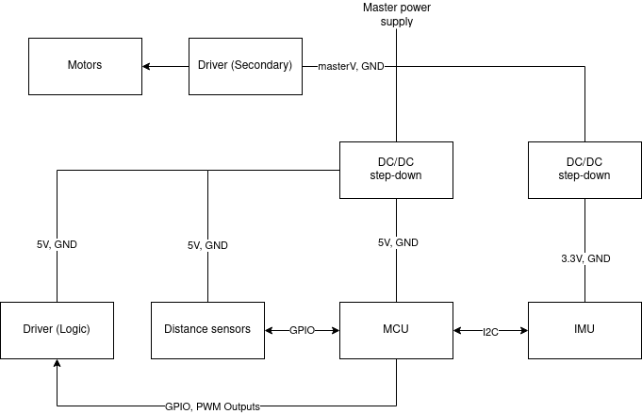Figure 1: Hardware block diagram

Description table

Block | Description
Master power supply | Two 18650s connected in series supplying HW with 7.4V.
Motors | DC motors making it possible for the robot to move.
Driver (Secondary) | Supply of the DC motors, it is supplied with master power supply.
DC/DC step-down | Conversion of master power supply to required levels.
Distance sensors | Front and rear distance sensors.
MCU | Master control unit – ESP32 module.
Driver (Logic) | Control of the behavior of the motors.
IMU | 10DoF sensor.

Electronics design

To be compliant with requirements listed above, hardware design has been divided into six main sections.

MCU
This section contains the MCU and leads for sensors, the motor controller, the communication interface for the IMU, and jumpers to select the MCU's 3.3V or 5V power supply.

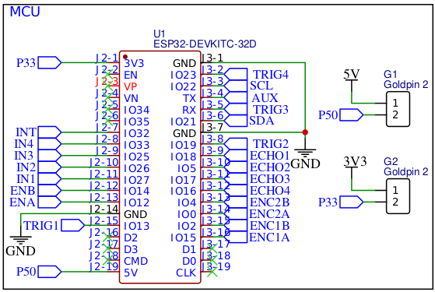Figure 2: MCU section

Power

The section consists of two linear stabilizers that allow voltage stabilization at 3.3V and 5V levels. Due to the low power loss with the operating conditions of the components, it was decided not to implement step-down converter circuits.

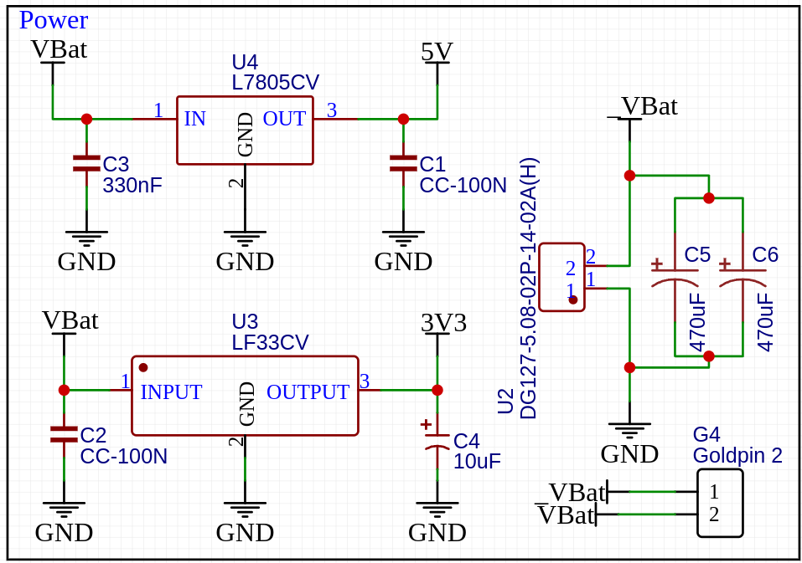Figure 3: Power section

Distance sensors

This section consists of four goldpin mounting slots for connecting distance sensors.

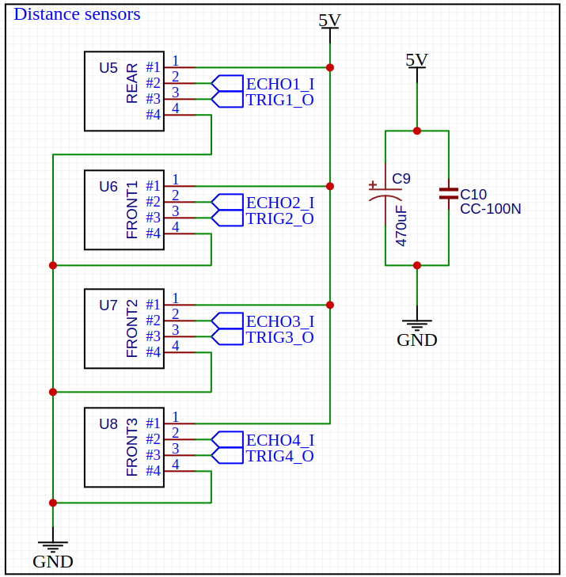Figure 4: Distance sensors section

Motors

The section consists of goldpin type leads that output control signals to the motor controllers and provide power to the logic.

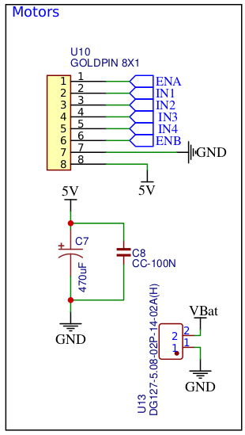Figure 5: Motors section

MPU9255

The section contains leads for communicating with the MPU9255 IMU and a jumper to "hardware enable" the use of interrupts.

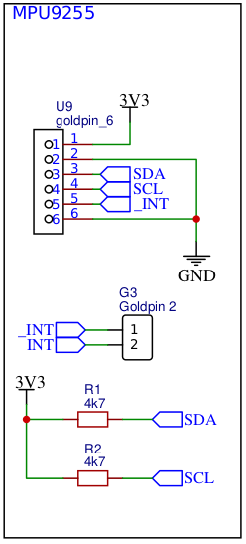Figure 6: MPU9255 section

Encoders

The section contains leads for connecting encoders to determine odometry.

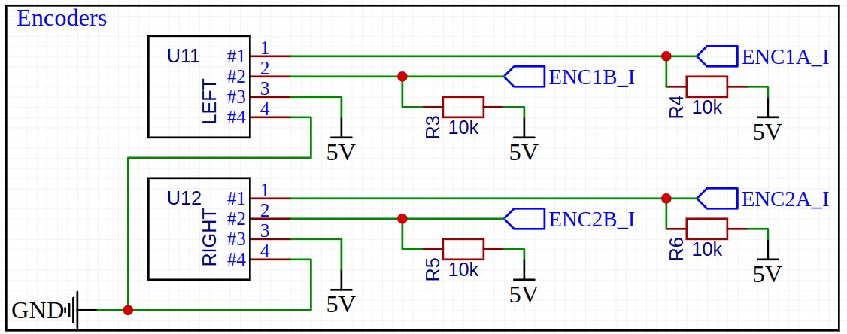Figure 7: Encoders section

Level shifters

Though esp32 are 5V tolerant, it is better to use logic shifters not to damage MCU.

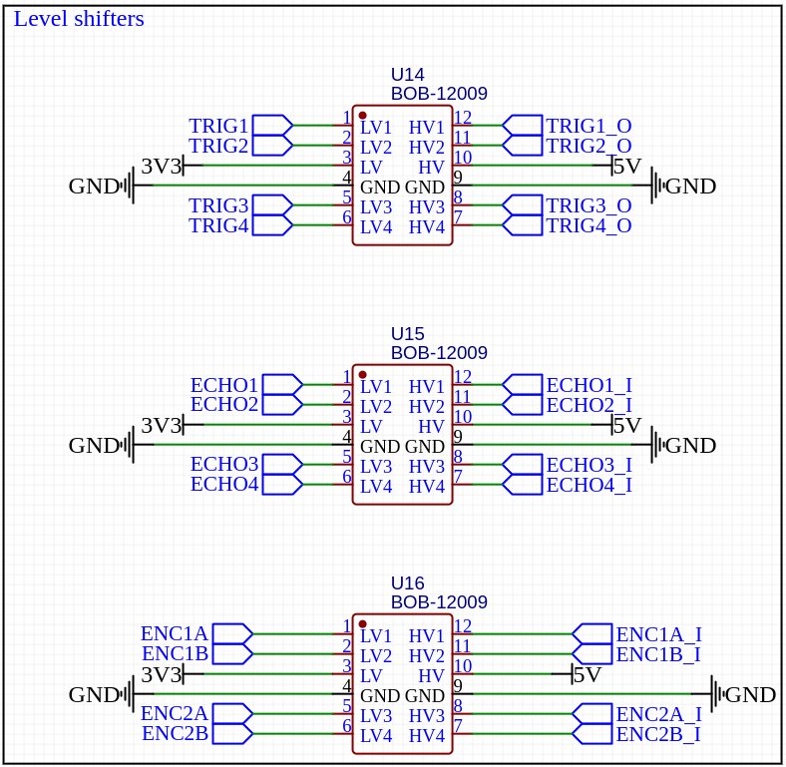Figure 8: Level shifters

Requirements veryfication

HWE1 Review

ID | PARENT_ID | OBJ_TEXT | REQ_VERYFICATION | Result
HWE_4_010 | HWE_1_010 | Hardware should use IMU and distance sensors in front and rear part of the robot. | Hardware introduces IMU and distance sensors. | Passed
HWE_4_020 | HWE_1_020 | Hardware should include WiFi interface for comm purposes. | Used MCU introduces WiFi on-board module. | Passed
HWE_4_030 | HWE_1_030 | Hardware should be equipped with DC motors. | Hardware uses DC motors with encoders attached to it. | Passed
HWE_4_040 | HWE_1_040 | Hardware should use encoders. | Hardware uses DC motors with encoders attached to it. | Passed
HWE_4_050 | HWE_1_050 | Hardware should use proper DC motor drivers. | Hardware uses suitable DC motor driver. | Passed
HWE_4_060 | HWE_1_060 | Hardware should introduce simple power management system. | After applying master supply (VBAT), circuit should not be supplied unless MAIN_SUP jumper is short. | Passed
HWE_4_070 | HWE_1_060 | Hardware should introduce simple power management system. | After shorting MAIN_SUP jumper, MCU should not be supplied unless 3V3_SUP or 5V_SUP jumper is short. | Passed
HWE_4_080 | HWE_1_060 | Hardware should introduce simple power management system. | None of the tracks should be shorted with GND. | Passed

HWE2 Review

ID | PARENT_ID | OBJ_TEXT | REQ_VERYFICATION | Result
HWE_3_010 | HWE_2_010 | All communication interfaces should support 3V3 logic. | All interfaces support 3V3 logic. Logic shifters have been introduced to the design to satisfy this requirement. | Passed
HWE_3_020 | HWE_2_020 | MCU should be equipped with WiFi interface. | Used MCU introduces WiFi on-board module. | Passed
HWE_3_030 | HWE_2_030 | Power management system should provide power supply to logic part of the system | Logic is supplied with power after shorting MAIN_SUP jumper. | Passed
HWE_3_040 | HWE_2_030 | Power management system should provide power supply to logic part of the system | After shorting 3V3_SUP or 5V_SUP jumper, MCU is supplied with corresponding voltage. | Passed
HWE_3_050 | HWE_2_040 | Power management system should provide power supply to DC motors. | DC motors are supplied with master supply after shorting MAIN_SUP jumper. | Passed
HWE_3_060 | HWE_2_050 | IMU sensor should at least introduce the possibiliy of 6DOF measurement. | Used IMU introduces 10DOF measurement. | Passed
HWE_3_070 | HWE_2_060 | Distance sensors should introduce at least range of 2m. | Distance sensors introduce range of 2m. | Passed
HWE_3_080 | HWE_2_070 | Distance sensors and IMU should provide comm interface to MCU. | Distance sensors provide GPIO interface for MCU. | Passed
HWE_3_090 | HWE_2_070 | Distance sensors and IMU should provide comm interface to MCU. | IMU provides I2C interface for MCU. | Passed

References

Base components
[1]. https://botland.com.pl/moduly-wifi-i-bt-esp32/8306-esp32-devkitc-32e-v4-wifi-bt-42-platforma-z-modulem-esp-wroom-32e-5904422336394.html
[2]. https://botland.com.pl/moduly-wifi-esp8266/8241-modul-wifi-esp8266-nodemcu-v3-5904422300630.html
[3]. https://botland.com.pl/silniki-dc-z-przekladnia-i-enkoderami/6287-silnik-z-przekladnia-sj01-120-1-6v-160rpm-enkoder-6959420910205.html
[4]. https://botland.com.pl/silniki-dc-z-przekladnia-i-enkoderami/6288-silnik-katowy-z-przekladnia-sj02-1201-6v-160rpm-enkoder-6959420910199.html
[5]. https://botland.com.pl/czujniki-9dof-imu/8298-imu-10dof-mpu9255-bmp280-3-osiowy-akcelerometr-zyroskop-i-magnetometr-oraz-barometr-waveshare-12476-5904422375805.html
[6]. https://botland.com.pl/akcelerometry/21828-lsm6ds3tr-c-6-dof-imu-3-osiowy-akcelerometr-i-zyroskop-adafruit-4503.html
[7]. https://botland.com.pl/ultradzwiekowe-czujniki-odleglosci/1420-ultradzwiekowy-czujnik-odleglosci-hc-sr04-2-200cm-justpi-5903351241366.html
[8]. https://botland.com.pl/czujniki-odleglosci/14329-ultradzwiekowy-czujnik-odleglosci-2-400cm-hy-srf05-5903351241588.html
[9]. https://botland.com.pl/sterowniki-silnikow-moduly/8227-dwukanalowy-sterownik-silnikow-l298n-modul-wb291111-iduino-st1112-5903351241236.html
[10]. https://botland.com.pl/akumulatory-li-ion/23832-ogniwo-18650-li-ion-samsung-inr18650-25r-2500mah-20a.html
[11]. https://botland.com.pl/akumulatory-li-ion/22841-ogniwo-18650-li-ion-inr18650-f1hr-2600mah.html

Schematic
https://github.com/DevxMike/master_degree/blob/master/robot/HW/Schematic_Robot_schematic_2024-03-05.pdf

Additional components
[12]. https://www.tme.eu/pl/details/l7805cv/stabilizatory-napiecia-nieregulowane/stmicroelectronics/
[13]. https://www.tme.eu/Document/7ef951ff8781134d4e0fc54509f46fc7/lfxx.pdf
[14]. https://www.tme.eu/pl/details/cct-330n_50v/kondensatory-mlcc-tht/sr-passives/ct40805y334m500f3r/
[15]. https://www.tme.eu/pl/details/ecea1hka100b/kondensatory-elektrolityczne-tht/panasonic/
[16]. https://botland.com.pl/kola-z-oponami/7420-dfrobot-kolo-80x17mm-6959420911066.html
[17]. https://botland.com.pl/konwertery-napiec/2259-konwerter-poziomow-logicznych-dwukierunkowy-4-kanalowy-sparkfun-bob-12009-5903351248716.html
[18]. https://botland.com.pl/ladowarki-do-akumulatorow-li-ion/13824-ladowarka-do-akumulatorow-18650-xtar-mc2-plus-6952918340744.html
[19]. https://botland.com.pl/koszyki-na-baterie/5240-koszyk-na-2-akumulatory-typu-18650-polaczenie-szeregowe-5904422374341.html

