2.

10, 20

10

20

4

10

20

4, 8

10

15, 20

4, 8

10, 20

30

15

4, 8

15

30

20

4

1

8

10

20

5

30

1, 2

8

10

4

20

4

10

8, 9

1, 2

30

15

15

30

10

4, 8

20

6

9

1, 2

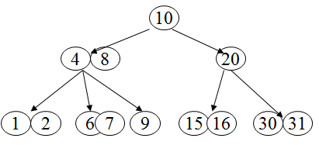3.

Delete 7

30, 31

15, 16

20

4, 8

10

9

1, 2

6

Delete 16

30, 31

15

20

4, 8

10

9

1, 2

6

Delete 6

30, 31

15

20

2, 8

10

9

1

4

Delete 20

31

15

30

4, 8

10

9

1, 2

6, 7