

A

MINI PROJECT ON

**Billing System**

Submitted By

Bhor Ajay

Kantode Pratik

Mhaske Priyanka

Jadhav Devyani

**Certificate**

This is to certify that the report of the project entitled Is a bona fide work of

Bhor Ajay

Kantode Pratik

Mhaske Priyanka

Jadhav Devyani

Submitted to the

University Of Mumbai

In partial fulfilment of the requirement for the award to the degree of

Second year Of Engineering In Computer Science

Under the guidance of

MissYogeshwari hardas miss. Harshada sonkamble (Project Guide) (Head Of Department)

**ACKNOWLEDGEMENT**

Primarily we would thank God for being able to complete this Project with success. We would like to express our special thanks of gratitude to our App Development teacher **Miss.yogeshwari Hardas** for their able guidance and support in completion of our project.

At last we are thankful to all other teaching and non teaching staffs for there support. We are thankful to our Friends who helped us in the process of creation of the webpage. We would like to give a gratitude to our Parents for their love and support.

Bhor Ajay

Kantode Pratik

Mhaske Priyanka

Jadhav Devyani

**SE Computer**

**INDEX**



|  |  |  |
| --- | --- | --- |
| **Sr.No.** | **Name of Chapter** | **Page No.** |
| **Chapter 1** | **Synopsis**  1.1 Project Title    1.2 Project Option  1.3 Internal Guide    1.4 Problem Statement | 1 |
| Chapter 2 | ABSTRACT | 2 |
| Chapter 3 | Introduction | 3 |
| Chapter 4 | HARDWARE & SOFTWARE REQUIREMENT | 4 |
| Chapter 5 | Billing system | 14 |
| Chapter 6 | Types Of Billing Systems | 15 |
| Chapter 7 | Codeing | 17 |
| Chapter 8 | Conclusion | 28 |
| Chapter 9 | References | 29 |

**CHAPTER 1**

# ABSTRACT

Simple Billing System is based on the concept of creating the complete bill of a shop’s purchase. It includes an admin login system. The admin can quickly handle and also check out all the deals. This mini task has limited features, however, the vital one.

Speaking about the features of the Simple Billing system, the individual can produce a total expense of a thing by going into the variety of items, name, amount, and also price per thing. Besides this, the system generates a total quantity with VAT and also requests the amount paid as well as shows the complete return amount to the individual. The last function includes a listing of all transactions with purchase id.

**CHAPTER 2**

# INTRODUCTION

This project is developed to manage the bill submission process in big organization. Using this system user can submit their bill online and check the status of their bill. In this system employee can submit their bill to their manager online. After submitting the bill concerned manager gets the notification. Manager review the bill and approve the bill or disapprove. Employee can check the status of the bill any time after login the system.

Employee can submit bill of various amount. An email will be sent to the concerned people to let them know about the status of the bill. The main propose of this bill management system project is developing a system that automate the bill submission and bill approval task. In big organization bill submission is very tiresome work and maintaining the record of bill is very difficult and time consuming. In present system, user have to work manually to maintain bill records and it is very difficult to know the status of the submitted bill.

In present manual system, submitting the bills to their corresponding managers is a time consuming process and we have to maintain records manually. Some times in manual process, there is a possibility to get errors. To overcome all these problem we have developed this bill management system.

# CHAPTER 3

**HARDWARE & SOFTWARE REQUIREMENT**

**•Hardware Requirement:**

1. i3 Processor Based Computer or higher

1. Memory: 1 GB RAM

1. Hard Drive: 50 GB

1. Internet Connection

•**Software Requirement:**

Windows 7

Microsoft Word

Internet

# CHAPTER 5

## Billing System

A billing system is a combination of software and hardware that receives call detail and service usage information, groups this information for specific accounts or customers, produces invoices, creates reports for management, and records (posts) payments made to customer accounts.

This figure shows standard processes used in a billing system. In this diagram, the customer calls customer care or a sales department and works with an activation agent to establish a new account. The agent (customer care) enters the customer's service preferences into the system, checks for credit worthiness, and provides the customer with a phone number so that the customer may make and receive calls through the telephone network. This diagram shows the billing system is divided into two parts; a front end (near real time processing) and a back end (periodic bill processing). The front end gathers call information as connections made through the network (such as switches) and uses these events create call detail records (CDRs) of the customer's communication activities. Each CDR includes the identification of the customer and other relevant information that are passed onto the billing system. The billing system also receives CDRs from other carriers (such as a long distance service provider). The billing system then guides the billing records to the correct account and rates the call using the rate tables. These updated billing records are placed in a billing pool. The back end of the billing system periodically combines records from the bill pool to create a single invoice that is sent to the customer. The customer then sends the payment to the telecom service provider. The payments are posted (recorded) in the billing system. History files are then updated for the use of customer service representatives (CSRs) and auditing managers.

**CHAPTER 6**

# Types Of Billing Systems

A system is a set of procedures or protocols that work together as an interconnecting network. There are [three basic types of systems:](https://en.wikipedia.org/wiki/Medical_billing) closed, open, and isolated.

# Closed

A closed system is a system that doesn’t allow transfers. In terms of medical billing systems, it means that this system focuses on one singular practice. The biggest example of a closed system is using EMRs, or electronic medical records in your practice. EMRs are basically the digital versions of old-school paper charts. While this is still used in modern practices today, it is combined with other types of records. EMRs, are as the system implies, closed. They don’t allow for collaboration with other doctors and healthcare facilities (i.e. labs, urgent cares, etc.).

# Open

An open system is a system that allows for transfers across healthcare professionals, practices, facilities, etc. An example of using an open medical billing system is using EHRs, or electronic health record. Sometimes people in the medical interchange EMR and EHR, but in reality, EHRs are a highly collaborative record-keeping style, which enables everyone to be privy to the patient’s healthcare.

Having an open system means the medical billing software (AdvacedMD, AllMeds, GE Centricity, McKesson, etc.) needs to be able to communicate and collaborate efficiently. Not all software allows for an open system because they want to keep it closed and have sole access to patient records. Also, some practitioners and healthcare facilities argue that because of HIPAA it’s important to be careful with open systems to protect the patient’s privacy.

# Isolated

An isolated system is one that is completely removed from healthcare facilities, physicians, and practices. PHRs, or personal health records, are used in isolated medical billings systems. The patients hold all their healthcare records and they’re designed and managed by them. These records are separate and shouldn’t replace EMRs or EHRs; it is simply to help the patient manage their health information.

Since PHRs can’t legally replace official healthcare records, isolated medical billing systems aren’t commonly used. Sometimes, if the patient uses appropriate software, their PHR can be used to fill out the medical practices’ official records. Again, this requires open communication between the software to ensure that everything gets transferred correctly.

Each system has its pros and cons in terms of medical billing systems. While the records aren’t the only aspect in the types of medical billing systems, it does play a major role in determining [the type of system](https://accelerated-mb.com/value-based-payment-systems/) you want in your practice. Once you’ve determined the system and the record-keeping you want, then you can move forward on either choosing software or keeping the one you currently have. Medical billing systems will help you determine the extent of outsourcing medical billing and [coding.](https://accelerated-mb.com/medicalbilling-coding-collections/medical-coding-bradenton/)

# CHAPTER 7

**Codeing:**

import java.util.ArrayList;

import java.util.List;

import java.util.Scanner;

import java.text.SimpleDateFormat;

import java.util.Date;

import java.util.Calendar;

class Product

    {

        // properties

        private String id;

        private String pname;

        private int qty;

        private double price;

        private double totalPrice;

        // constructor

        Product(String id, String pname, int qty, double price, double totalPrice)

        {

            this.id=id;

            this.pname = pname;

            this.qty = qty;

            this.price = price;

            this.totalPrice = totalPrice;

        }

            // getter methods

            public String getId()

                {

                    return id;

                }

                public String getPname()

                {

                    return pname;

                }

                public int getQty()

                {

                    return qty;

                }

                public double getPrice()

                {

                    return price;

                }

                public double getTotalPrice()

                {

                    return totalPrice;

                }

                //displayFormat

                public static void displayFormat()

                {

                   System.out.format("-----------------------------------------------------------------------------------------------------------------------------------");

                    System.out.print("\nProduct ID \t\tName\t\tQuantity\t\tRate \t\t\t\tTotal Price\n");

                    System.out.format("-----------------------------------------------------------------------------------------------------------------------------------\n");                   }

                // display

                public void display()

                {

                    System.out.format("   %-9s             %-9s      %5d               %9.2f                       %14.2f\n" ,id, pname, qty, price, totalPrice);

       }

    }

public class ShoppingBill

    {

        public static void main(String args[])

            {

                // variables

                String id = null;

                String productName = null;

                int quantity = 0;

                double price = 0.0;

                double totalPrice = 0.0;

                double overAllPrice = 0.0;

                double cgst, sgst, subtotal=0.0, discount=0.0;

                char choice = '\0';

                System.out.println("\t\t\t\t--------------------Invoice-----------------");

                System.out.println("\t\t\t\t\t "+"  "+"Metro Mart Grocery Shop");

                System.out.println("\t\t\t\t\t3/98 Mecrobertganj New Mumbai");

                System.out.println("\t\t\t\t\t"  +"    " +"Opposite Metro Walk");

                System.out.println("GSTIN: 03AWBPP8756K592"+"\t\t\t\t\t\t\tContact: (+91) 9988776655");

 //format of date and time

SimpleDateFormat formatter = new SimpleDateFormat("dd/MM/yyyy HH:mm:ss");

                Date date = new Date();

                Calendar calendar = Calendar.getInstance();

                String[] days = new String[] { "Sunday", "Monday", "Tuesday", "Wednesday", "Thursday", "Friday", "Saturday" };

 //prints current date and time

System.out.println("Date: "+formatter.format(date)+"  "+days[calendar.get(Calendar.DAY_OF_WEEK) - 1]+"\t\t\t\t\t\t (+91) 9998887770");

 Scanner scan = new Scanner(System.in);

 System.out.print("Enter Customer Name: ");

String customername=scan.nextLine();                   //create Scanner class object

//creating an ArrayList to store the product

    List<Product> product = new ArrayList<Product>();

 do

                    {

 // read input values

 System.out.println("Enter the product details: ");

  System.out.print("Product ID: ");

   id = scan.nextLine();

   System.out.print("Product Name: ");

    productName = scan.nextLine();

   System.out.print("Quantity: ");

   quantity = scan.nextInt();

   System.out.print("Price (per unit): ");

  price = scan.nextDouble();

   //calculate total price for a particular product

   totalPrice = price * quantity;

                        //calculates overall price

                        overAllPrice = overAllPrice + totalPrice;

                        //creates Product class object and add it to the List

                        product.add( new Product(id, productName, quantity, price, totalPrice) );

                        // ask for continue shopping?

                        System.out.print("Want to add more items? (y or n): ");

                        //reads a character Y or N

                        choice = scan.next().charAt(0);

                        //read remaining characters, don't store (no use)

                        scan.nextLine();

                    }

                while (choice == 'y' || choice == 'Y');

                //display all product with its properties

                Product.displayFormat();

                for (Product p : product)

                {

                    p.display();

                }

                //price calculation

                System.out.println("\n\t\t\t\t\t\t\t\t\t\tTotal Amount (Rs.) " +overAllPrice);

                //calculating discount

                discount = overAllPrice*2/100;

                System.out.println("\n\t\t\t\t\t\t\t\t\t\t    Discount (Rs.) " +discount);

                //total amount after discount

                subtotal = overAllPrice-discount;

                System.out.println("\n\t\t\t\t\t\t\t\t\t\t          Subtotal "+subtotal);

               //calculating tax                  sgst=overAllPrice*12/100;

               System.out.println("\n\t\t\t\t\t\t\t\t\t\t          SGST (%) "+sgst);

                cgst=overAllPrice*12/100;

                System.out.println("\n\t\t\t\t\t\t\t\t\t\t          CGST (%) "+cgst);

                //calculating amount to be paid by buyer

 System.out.println("\n\t\t\t\t\t\t\t\t\t\t     Invoice Total " +(subtotal+cgst+sgst));

   System.out.println("\t\t\t\t----------------Thank You for Shopping!!-----------------");

  System.out.println("\t\t\t\t                     Visit Again");

  // close Scanner

      scan.close();

  }

    }

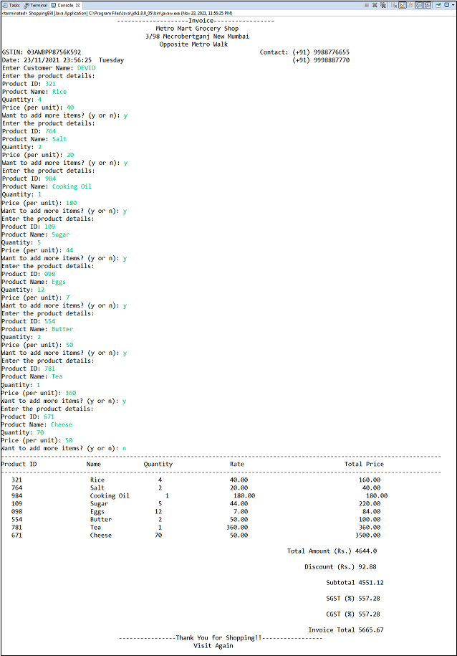

**CHAPTER 8**

# CONCLUSION

Working on the Self-Serve team this co-op term taught me a lot about how complicated it is to collect money from customers. There is definitely more to learn and understand, but now I can confidently describe the topics I talked about in this post. Billing was quite a different world than I imagined but I am very glad that I embarked on this journey! Hopefully, you understand a little more about how a billing system works now too