COMP.8157 — Advanced Database Topics, 2026S
University of Windsor, School of Computer Science
Instructor: Dr. Andreas S. Maniatis

D.4.2 Design Document
Performance Evaluation of Vector Indexing Techniques for AI Search Systems
Group 4

1. Introduction & Context
Vector indexes are the part of an AI search system that decides how fast and how accurately a query gets answered, and teams building these systems usually have to pick between Flat, IVF, and HNSW with only loose intuition or a vendor's own benchmark to go on. Those benchmarks rarely hold the corpus, embedding model, and hardware fixed across the methods being compared, so a measured difference could just as easily be an artefact of the test setup as a real property of the index. This design describes how the team's framework avoids that trap: every experimental variable except the index structure itself is fixed, so whatever difference shows up in latency, recall, memory, or build time can be attributed to the index.
What follows implements the fourteen functional requirements and the non-functional requirements laid out in the companion D.4.1 document, and reflects the system as it stands for the D.4 submission — in particular, the HNSW index and the parameter-tuning sweep, which were still marked in progress at the D.3.1 midterm checkpoint, are now built, tested, and described below alongside the Flat and IVF work that was already complete at that point.

2. Goals & Non-Goals
The goal is a workload-consistent, reproducible comparison of the three index families, reported on four axes — query latency (mean, p50, p95), recall@K against an exact ground truth, memory footprint, and build time — across both a fixed-size real-data benchmark and a scalability sweep from 1,000 to 100,000 vectors. A secondary goal, carried over from the original proposal, is extensibility: the layered pipeline should let someone add another index type, such as Product Quantization or DiskANN, by implementing one shared interface rather than touching the ingestion, embedding, query, evaluation, or persistence code.
Success is defined numerically rather than by impression. The targets below are the ones the acceptance criteria in D.4.1 test against, and the right-hand column records where the system actually landed at the time of this submission.
Objective | Measurable target | Outcome
Approximate accuracy | recall@10 ≥ 0.95 for both IVF and HNSW on the 20,000-headline corpus at the deployed defaults (AC-3) | Met — IVF 0.9625, HNSW 0.9950
Exact-search baseline | Flat reports recall@10 = 1.000 in every run, since it is its own ground truth (AC-2) | Met in all four recorded runs
Speed-up over exact search | Both approximate methods answer faster than Flat at 20,000 vectors | Met — IVF 1.6×, HNSW 4.0× on mean latency
Scale | The full 1,000–100,000 sweep completes for all three methods on one CPU machine within 4 GB of RAM (AC-4) | Met — peak a little above 1 GB
Reproducibility | The same config and seed produce byte-identical embeddings on re-run (AC-6) | Met
Configurability | No source-code edit is required to change any index parameter (AC-7) | Met — every parameter lives in YAML
Several things were deliberately left out of scope. Distributed or multi-node index sharding was never part of the plan; the course scope has been single-machine since the full proposal. The same goes for GPU acceleration — every index in this project runs on FAISS's CPU implementations. There is no hosted, always-on query-serving API, since the deliverable is a benchmarking tool that a user runs on demand, not a production search service. There is no server-hosted database engine either. Results are written as CSV tables and PNG charts to the local filesystem and, since the design review, appended to an embedded SQLite database that lives in the repository as a single file — the distinction that matters is between persisting results, which the framework does, and depending on a database server, which it deliberately does not.

3. System Architecture

3.1 Logical Architecture
The system keeps the layered architecture proposed at the full-proposal stage — the five pipeline stages of the original design, joined since the design review by reporting and persistence — with each layer implemented as its own module behind a narrow interface. That separation is not just a tidy diagram — it is the reason the team was able to report granular, honest progress at the midterm checkpoint ("Flat and IVF complete, HNSW in progress") without the finished layers depending on anything still unfinished.
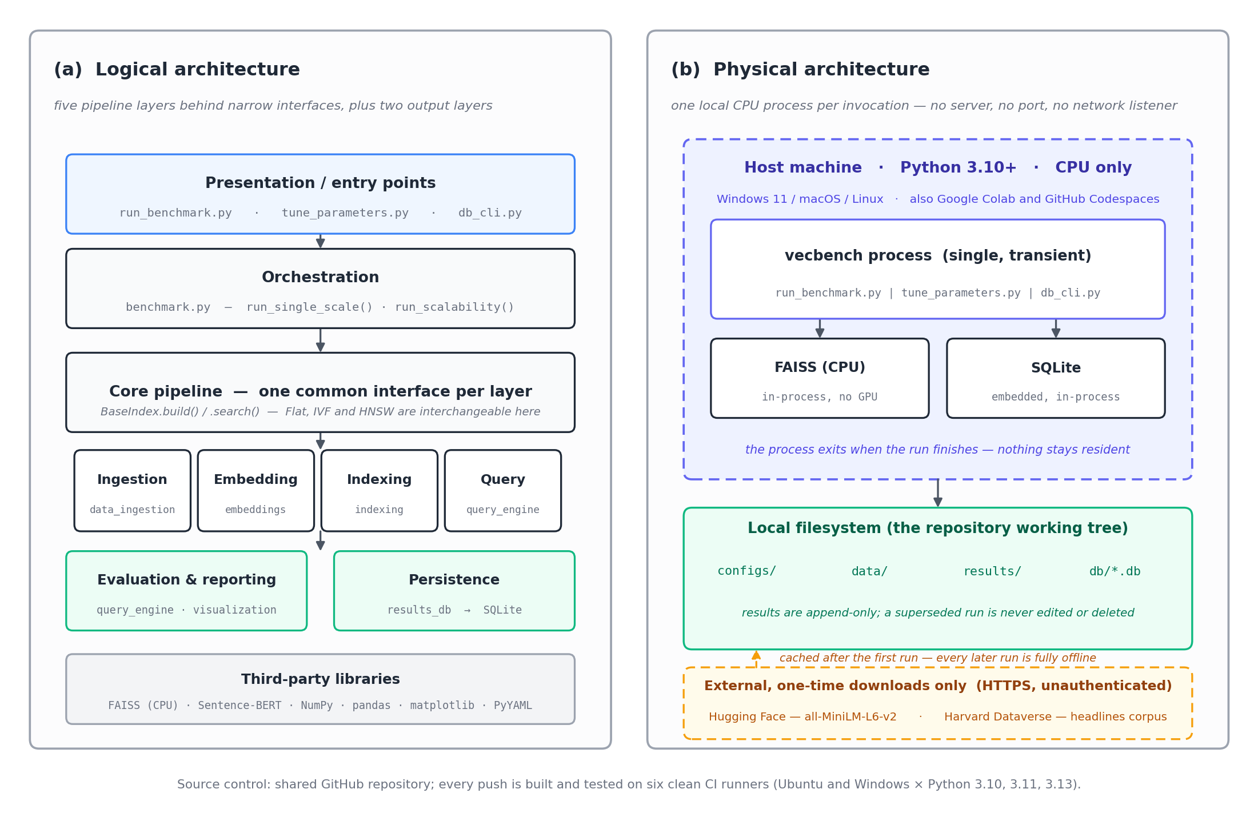
Figure 1 — System architecture: (a) the logical layering, and (b) what actually runs on a machine.
data_ingestion.py loads raw text, cleans and normalises it, segments it into semantic units, and holds out a query subset; a separate synthetic path generates base and query vectors directly for the large scalability runs, bypassing text entirely. embeddings.py turns text into deterministic 384-dimensional Sentence-BERT vectors using all-MiniLM-L6-v2, or produces clustered synthetic vectors for the scalability experiments. indexing.py builds Flat, IVF, and HNSW indexes from the same embedded vectors behind one BaseIndex interface exposing build() and search(). query_engine.py runs the held-out queries against an index, discarding a warm-up set before timing, and computes recall@K, latency percentiles, memory, and build time. visualization.py takes the resulting metrics and turns them into CSV tables and comparison / scalability charts.
results_db.py closes the loop: it opens (and, on first use, creates) the SQLite results database, records the run and its full configuration before any work starts, writes one measurement row per method per dataset size, appends the run's execution log, and marks the run completed or failed when it ends. db_cli.py is the read side of the same store, and is the only component that exists purely for the person using the framework rather than for the pipeline itself. benchmark.py ties the pipeline layers together through two entry points, run_single_scale() and run_scalability(), called from the run_benchmark.py CLI. tune_parameters.py sits alongside it as a separate entry point: it embeds the corpus once, then re-queries an already-built IVF or HNSW index across a sweep of nprobe or efSearch values, since both are query-time-only settings and re-building the index at every step would just waste time.

3.2 Physical Architecture
Everything runs as a single local Python 3.13 process — there is no client-server split and nothing stays running between experiments; the tool is invoked once per run from the command line. Indexing and search both use FAISS's CPU build, so there is no GPU dependency anywhere in the pipeline. Input corpora and configuration files live under data/ and configs/; every run's output — CSV tables and PNG charts — is written to results/, and its rows are appended to db/vecbench_results.db. SQLite is embedded rather than hosted, so that database is a file inside the working tree with no server process, no port, and no credentials: the physical deployment does not gain a tier by having gained a database. The one external dependency is the Sentence-BERT model itself, which is pulled from Hugging Face on first use and cached locally afterward, so every subsequent run is offline and deterministic. Source control runs through the team's shared GitHub repository, with each member pushing only the modules they own, which is documented with commit-history evidence in the midterm report.

3.3 Data Flow
Figure 2 traces one invocation end to end. The distinction it is drawing is between three kinds of edge that are easy to conflate on a plain block diagram: the solid edges are data moving down the pipeline, the blue dashed edges are configuration reaching into every stage, and the amber edges are the execution log, which every stage writes and which ends up in the same database file as the measurements it describes.
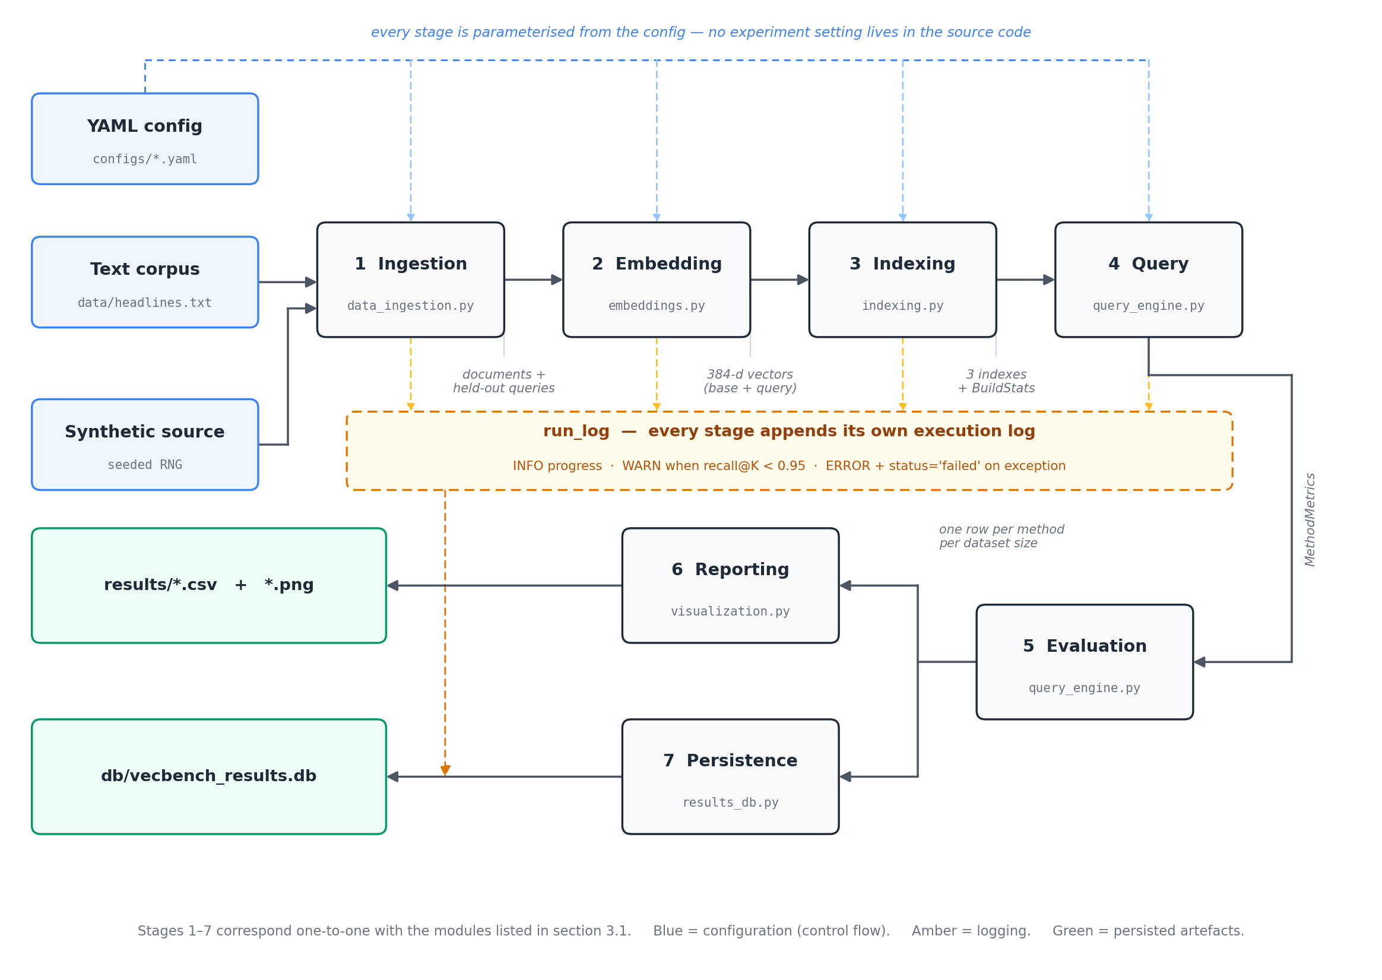
Figure 2 — Data flow from configuration and corpus through to results, charts, and database rows.
The property worth noticing is that nothing flows backwards. A stage reads the config and the output of the stage before it, and writes forward; no stage reaches back into an earlier one. That is what allows the whole pipeline to be re-run from a config file and produce the same numbers, and it is also why a single index type can be swapped in at stage 3 without any other stage being aware of it.

4. Data Model
The data model has two halves that mirror each other. In memory, four small dataclasses carry data between layers; on disk, a four-table SQLite schema records what those dataclasses held. MethodMetrics is the hinge between them — every row of every results CSV, every point on every chart, and every row of the measurement table is one MethodMetrics record.

4.1 In-memory structures
Structure | Fields | Where it comes from
Corpus | documents, queries, base_vectors, query_vectors | data_ingestion.load_corpus() — either the cleaned text corpus and its held-out queries, or raw vectors when using the synthetic source.
BuildStats | build_time_s, memory_bytes, n_vectors | BaseIndex.build() — construction cost and serialized-size memory proxy, recorded the same way for all three index types.
QueryResult | indices, latencies_ms | query_engine.run_queries() — per-query retrieved IDs and timing, after warm-up queries are thrown away.
MethodMetrics | method, label, n_vectors, k, build_time_s, memory_mb, latency mean/p50/p95, qps, recall_at_k | query_engine.evaluate() — one row per method per dataset size; this is what actually ends up in every results CSV and chart.

4.2 Persistent schema
A CSV is a snapshot of one run, and that was enough while there was only one experiment. Once the team began sweeping dataset sizes and tuning parameters, the questions stopped being "what did this run report" and became "how does HNSW recall at 100k compare with the run we did last week, on the same machine, at the same efSearch" — which, across a directory of CSV files, means re-reading files by hand. Four tables answer it with a WHERE clause instead. The CSVs are kept as the per-run artefact; the database is what makes runs comparable.
Table | One row per | Integrity rules that do real work
run | invocation of run_benchmark.py or tune_parameters.py | status and experiment are CHECK-constrained to their allowed values; the full config is stored verbatim alongside the hostname, CPU count, and Python and FAISS versions, so two rows can be checked for comparability instead of assumed to be comparable.
measurement | (run, method, dataset size) | recall_at_k CHECKed into [0,1]; method restricted to Flat, IVF, HNSW; n_vectors, k, build time and memory constrained non-negative; UNIQUE (run_id, method, n_vectors) so one run cannot silently record a method twice at the same scale.
tuning_point | parameter setting tried in a sweep | knob restricted to nprobe or efSearch and method to the two approximate families; UNIQUE (run_id, method, knob, value). Kept separate from measurement because a tuning point re-queries an index built once, so it has no build time or memory of its own.
run_log | log line emitted during a run | level restricted to DEBUG, INFO, WARN, ERROR; indexed on (run_id, level), because filtering a run's log by severity is the most common troubleshooting query.
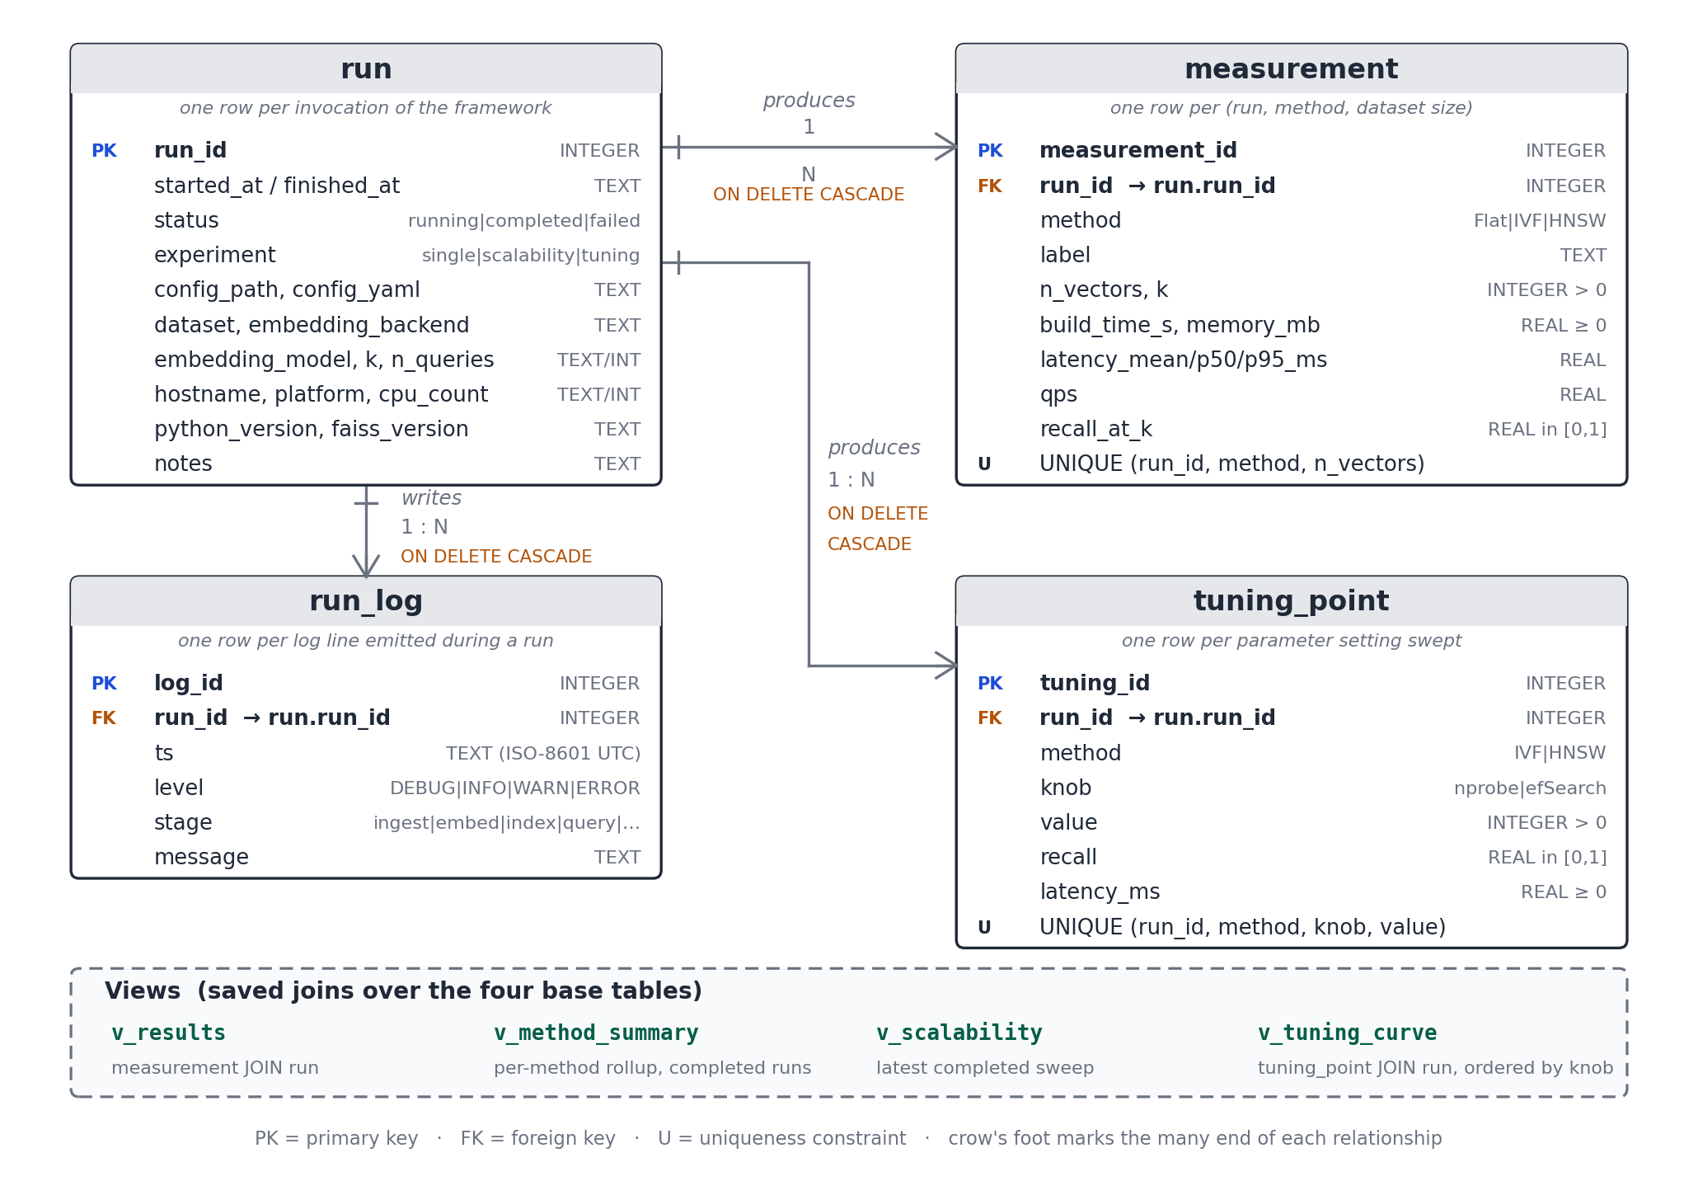
Figure 3 — Entity-relationship diagram of the results database (SQLite, db/schema.sql).
Every relationship is one-to-many from run, and every one of them cascades on delete, so removing a mis-configured run takes its measurements, tuning points, and log lines with it and cannot leave orphaned rows behind. Four views sit on top — v_results pre-joins each measurement to its run context, v_method_summary rolls the three methods up across every completed run, v_scalability returns the most recent completed sweep, and v_tuning_curve orders a sweep by knob value — so the questions the team actually asks do not require re-writing the same join each time.
The constraints are not decoration. Recall is a fraction by definition, so a value outside [0,1] is not an unusual result but a broken evaluator, and the schema is the cheapest place to catch that: it fails at write time, next to the code that produced it, rather than surfacing later as an odd-looking point on a chart.

5. Component Design

5.1 A common interface for all three indexes
Every index implements the same two methods, and that is what lets the query engine and evaluator treat Flat, IVF, and HNSW identically further down the pipeline:
class BaseIndex:
def build(self, vectors) -> BuildStats: ...
def search(self, queries, k) -> (distances, indices): ...

5.2 Flat — the ground truth
FlatIndex wraps faiss.IndexFlatIP, doing exhaustive exact search over inner product on L2-normalised vectors, which is equivalent to cosine similarity. There is no training step, recall is always 1.000 by definition, and its top-K result is what every other method gets scored against.

5.3 IVF — and the small-N problem it ran into
IVFIndex wraps faiss.IndexIVFFlat: vectors are partitioned into nlist clusters by k-means, and a query only searches the nprobe nearest clusters. FAISS wants roughly 39 training points per cluster, and at small dataset sizes the originally requested nlist could exceed what k-means could actually train on — this was the issue flagged in the midterm report's risk register. It is resolved by clamping nlist to the dataset size before training:
nlist = max(1, min(requested_nlist, n_vectors // 39 if n_vectors >= 39 else 1))
which keeps IVF valid and warning-free across the whole 1K–100K range without changing its behaviour at larger scales, where the requested nlist is well below this ceiling anyway.

5.4 HNSW — the piece finished since the midterm checkpoint
HNSWIndex wraps faiss.IndexHNSWFlat, a multi-layer proximity graph. M sets the number of bi-directional links per node, trading graph memory for connectivity; ef_construction controls how wide the search is while the graph is being built, which affects final graph quality; ef_search controls how wide the search is at query time, which is the actual speed/recall knob a user tunes. The defaults used here are M=32, ef_construction=80, ef_search=64. This module, along with tune_parameters.py, is what moved from "in progress" to "done" between the D.3.1 report and this submission.

5.5 Query engine and evaluation
run_queries() fires a handful of warm-up queries and throws the results away before it starts timing, so one-off costs like lazy memory allocation don't leak into the measured latency. recall_at_k() compares each method's top-K IDs against Flat's top-K, query by query, and averages the result. evaluate() then bundles the build stats and query results together into one MethodMetrics row per method.

5.6 Orchestration
run_single_scale() builds the Flat ground truth once, then builds, queries, and evaluates every configured method at a single dataset size. run_scalability() just calls run_single_scale() repeatedly across a list of sizes and stacks the results, which is what feeds the scalability charts. tune_parameters.py works a bit differently: since nprobe and efSearch are both query-time settings, the corpus is embedded once and the already-built index is re-queried at each setting in the sweep, rather than rebuilding the index every time — a small design choice, but it's the difference between a tuning sweep that finishes in minutes and one that doesn't.

5.7 Persistence and logging
The database is opened and the run row written before any indexing begins, not after the results are in. That ordering is deliberate: a run that crashes half way through has still recorded what it was trying to do and how far it got, which is exactly the run whose evidence is worth having. The orchestrator wraps the whole pipeline, so an exception writes an ERROR line and sets the run's status to 'failed' before it is re-raised — the traceback still reaches the terminal, but it is no longer the only record that the run happened.
with ResultsDB(path) as db:
run_id = db.start_run(experiment, config_path, config) # before any work
try:
for m in run_single_scale(cfg): db.add_measurement(run_id, m)
db.finish_run(run_id, status='completed')
except Exception as exc:
db.log(run_id, 'ERROR', stage, f'{type(exc).__name__}: {exc}')
db.finish_run(run_id, status='failed')
raise
Logging goes to the same file as the results rather than to a separate log on disk, which is the one design decision in this component that took an argument to settle. The case for it is that a failure and the partial results it produced are then always in one place and joined by the same run_id, so "what did run 2 measure, and what went wrong while it measured it" is one query rather than two files and a timestamp comparison.

6. Interface Design

6.1 Command line
Entry point | Arguments | What it does
run_benchmark.py | --config (required), --mode {single, scalability}, --outdir | Runs one comparison or a full scalability sweep; writes a CSV and PNG charts to results/.
tune_parameters.py | --config (required), --outdir | Runs the IVF/HNSW parameter sweep; writes a CSV and PNG charts to results/tuning/.
db_cli.py | subcommand (init, runs, show, results, tuning, logs, summary, export, sql), plus --db | Reads the results database: lists and filters runs and measurements, prints a run's log, exports to CSV, and accepts read-only SQL.

6.2 Configuration files
Every experiment is fully described by a YAML file under configs/: data source, embedding backend, per-method index parameters (nlist and nprobe for IVF; M, ef_construction, and ef_search for HNSW), the value of k, the warm-up count, and — for scalability runs — the list of dataset sizes to sweep. Nothing about an experiment lives in the source code, which is the whole point of FR-8 and is also what makes the exact configuration behind any reported result something that can just be checked into GitHub next to the code that produced it.

6.3 Output
Every run produces a CSV table (one MethodMetrics row per method and scale), a set of PNG charts under results/, and a set of rows in the results database. The CSV and charts are what a downstream engineer reads to decide which index to run in their own system; the database is what they query when they want to compare that decision against the last one.

6.4 Screen layout
The framework has no graphical interface, so the equivalent of a wireframe is the layout of what the terminal prints. Two screens matter. The first is the progress-and-summary screen a benchmark run produces, which is deliberately ordered so the per-method lines stream as the work happens and the comparison table lands at the end; the second is the tabular output shared by every db_cli.py query, which is column-aligned with a rule under the header and a row count underneath, so that it can be read directly or piped somewhere else without reformatting.
$ python run_benchmark.py --config configs/text_sbert.yaml
[ingest] 20000 documents, 200 held-out queries
[embed] sbert / all-MiniLM-L6-v2 -> (20000, 384)
Flat latency=1.8181 ms recall@10=1.000 mem=29.3 MB build=0.011s
IVF(nlist=100,nprobe=32) latency=1.1684 ms recall@10=0.963 mem=29.6 MB build=0.223s
HNSW(M=32,efS=64) latency=0.4509 ms recall@10=0.995 mem=34.5 MB build=2.729s
============================ RESULTS ============================
method label n_vectors latency_mean_ms recall_at_k
Flat Flat 20000 1.81811 1.000
IVF IVF(nlist=100,nprobe=32) 20000 1.16839 0.963
HNSW HNSW(M=32,efS=64) 20000 0.45091 0.995
Table : results/sbert/single_results.csv
Stored as run 4 in db/vecbench_results.db

$ python db_cli.py results --min-recall 0.95 --max-latency 1.0 --sort latency
run_id method label n_vectors latency_mean_ms recall_at_k
------ ------ ------------------- --------- --------------- -----------
4 HNSW HNSW(M=32,efS=64) 20000 0.45091 0.995
(1 row)

7. Constraints & Security
The framework is CPU-only by design, so the 100,000-vector scalability runs are bounded by single-machine RAM and single-threaded FAISS search — an accepted limitation given the single-machine scope agreed at the proposal stage, not an oversight. SQLite carries its own constraint, which is that it takes a single writer at a time: two benchmarks writing to the same database file concurrently will make one of them fail with a lock error. Since a benchmark run is measuring latency and would be distorted by a second run competing for the same CPU anyway, running them one at a time is the correct behaviour rather than a workaround, and the --db flag exists for the case where separate result sets really are wanted. The only network dependency is the one-time Sentence-BERT model download from Hugging Face; after that first run, everything is offline and fully deterministic. The ABC News Headlines corpus is public, CC0-licensed news text, so there's no personal or sensitive data anywhere in the pipeline, and no data-protection controls beyond ordinary academic-integrity handling are needed.
Because this is a local command-line tool with no listening service, no authentication layer, and no secrets to manage, the usual server-side security concerns — auth bypass, exposed credentials, network exposure — do not apply here. The database does not change that: SQLite is embedded, so it has no user accounts to compromise and no port to reach it on, and its file inherits the permissions of the working tree it sits in. Two smaller concerns are real and are handled. Every write the framework performs is a parameterised query, so a corpus path or a free-text note cannot be read as SQL; and the sql subcommand of db_cli.py refuses anything that is not a read, because a recorded measurement is evidence and evidence should not be editable from a convenience tool. The one constraint the team does treat as non-negotiable is reproducibility: since the project's central claim only holds if identical runs actually produce identical results, every source of randomness in the pipeline is seeded, and that is enforced as a hard requirement rather than left as a nice-to-have.

8. Design Rationale
FAISS was the obvious choice for the indexing layer because it is the one widely-used library implementing Flat, IVF, and HNSW under a consistent API — using three separate libraries would have reintroduced exactly the cross-library inconsistency (different metric conventions, different memory accounting) the project is trying to eliminate. Sentence-BERT's all-MiniLM-L6-v2 was picked for its compact 384-dimensional output, which embeds tens of thousands of headlines quickly enough on CPU to fit the course timeline while still producing embeddings that cluster news headlines in a semantically sensible way.
Declarative YAML configuration over hard-coded parameters was a direct response to FR-8 and to the reproducibility requirement — the config used to produce any given result can sit in version control right next to the code, rather than requiring someone to remember which line was edited for which run. SQLite was chosen for persistence over both a server database and a directory of files. Against PostgreSQL or MySQL: a benchmarking tool whose whole appeal is that a grader can clone it and run it should not require a server to be installed, configured, and running first, and nothing in the workload needs concurrency, replication, or network access. Against simply keeping the CSVs: files give no constraints, no joins, and no cheap way to ask a question that spans runs. SQLite is the option that gives a real relational schema — foreign keys, CHECK constraints, views — at the cost of one file in the repository and no installation at all, and it ships inside the Python standard library, so it adds nothing to requirements.txt. The four dataclasses (Corpus, BuildStats, QueryResult, MethodMetrics) exist so the query engine, evaluator, persistence, and visualization layers all share one stable, typed schema no matter which of the three index types produced the data; that's also what will make it possible to bolt on a fourth index type later without touching evaluation or visualization code at all. And per-query timing, rather than timing a whole batch at once, was chosen specifically so the framework could report p50/p95 tail latency instead of just a mean that could quietly hide bad tail behaviour — which matters a great deal more in a production search system than the average case does.

