**Assignment2**

Name:Dew

ID:18406040245

1. Tutorial 1

Breast Cancer Data Exploration: 1

CIFAR - 10 Data Exploration 2

Visualizing the Breast Cancer data 3

Visualizing the CIFAR - 10 data 5

2. Homework 8

# Tutorial

**The code is running in jupyter**

## Breast Cancer Data Exploration:

from sklearn.datasets import load_breast_cancer

breast = load_breast_cancer()

breast_data = breast.data

breast_data.shape

breast_labels = breast.target

breast_labels.shape

import numpy as np

labels = np.reshape(breast_labels,(569,1))

final_breast_data = np.concatenate([breast_data,labels],axis=1)

final_breast_data.shape

import pandas as pd

breast_dataset = pd.DataFrame(final_breast_data)

features = breast.feature_names

Features

features_labels = np.append(features,'label')

breast_dataset.columns = features_labels

breast_dataset.head()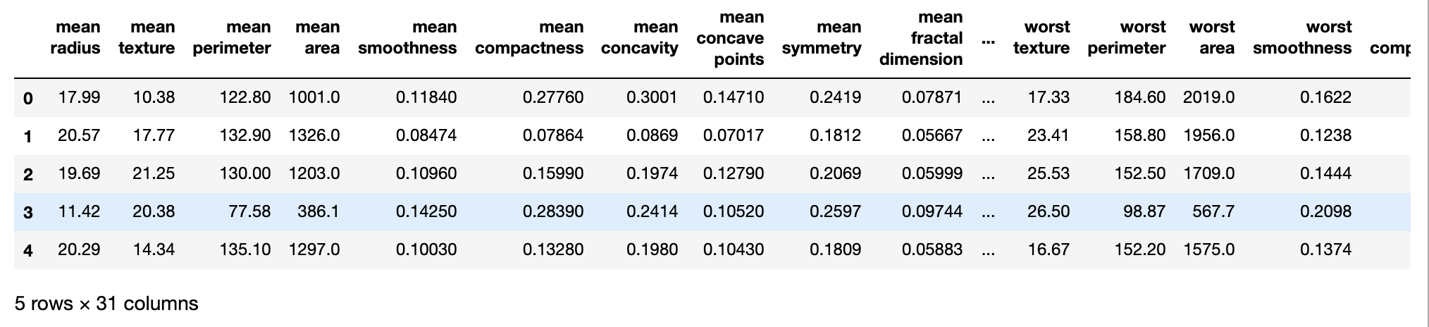

breast_dataset['label'].replace(0, 'Benign',inplace=True)

breast_dataset['label'].replace(1, 'Malignant',inplace=True)

breast_dataset.tail()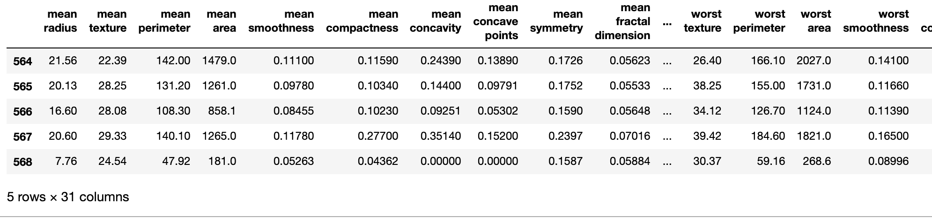

## CIFAR - 10 Data Exploration

conda install Keras

conda install TensorFlow

from keras.datasets import cifar10

(x_train, y_train), (x_test, y_test) = cifar10.load_data()

print('Traning data shape:', x_train.shape)

print('Testing data shape:', x_test.shape)

y_train.shape,y_test.shape

# Find the unique numbers from the train labels

classes = np.unique(y_train)

nClasses = len(classes)

print('Total number of outputs : ', nClasses)

print('Output classes : ', classes)

import matplotlib.pyplot as plt

%matplotlib inline

label_dict = {

0: 'airplane',

1: 'automobile',

2: 'bird',

3: 'cat',

4: 'deer',

5: 'dog',

6: 'frog',

7: 'horse',

8: 'ship',

9: 'truck',

}

plt.figure(figsize=[5,5])

# Display the first image in training data

plt.subplot(121)

curr_img = np.reshape(x_train[0], (32,32,3))

plt.imshow(curr_img)

print(plt.title("(Label: " + str(label_dict[y_train[0][0]]) + ")"))

# Display the first image in testing data

plt.subplot(122)

curr_img = np.reshape(x_test[0],(32,32,3))

plt.imshow(curr_img)

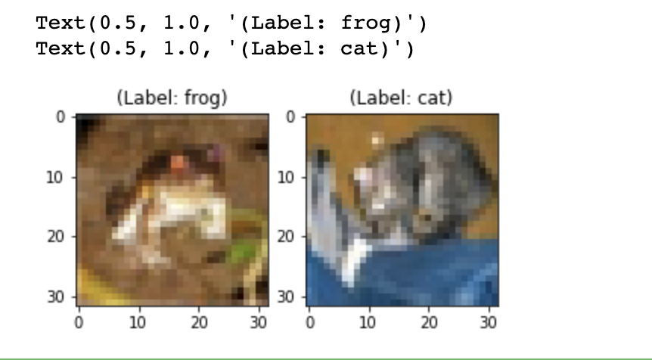print(plt.title("(Label: " + str(label_dict[y_test[0][0]]) + ")"))

## Visualizing the Breast Cancer data

from sklearn.preprocessing import StandardScaler

x = breast_dataset.loc[:, features].values

x = StandardScaler().fit_transform(x) # normalizing the features

x.shape

np.mean(x),np.std(x)

feat_cols = ['feature'+str(i) for i in range(x.shape[1])]

normalised_breast = pd.DataFrame(x,columns=feat_cols)

normalised_breast.tail()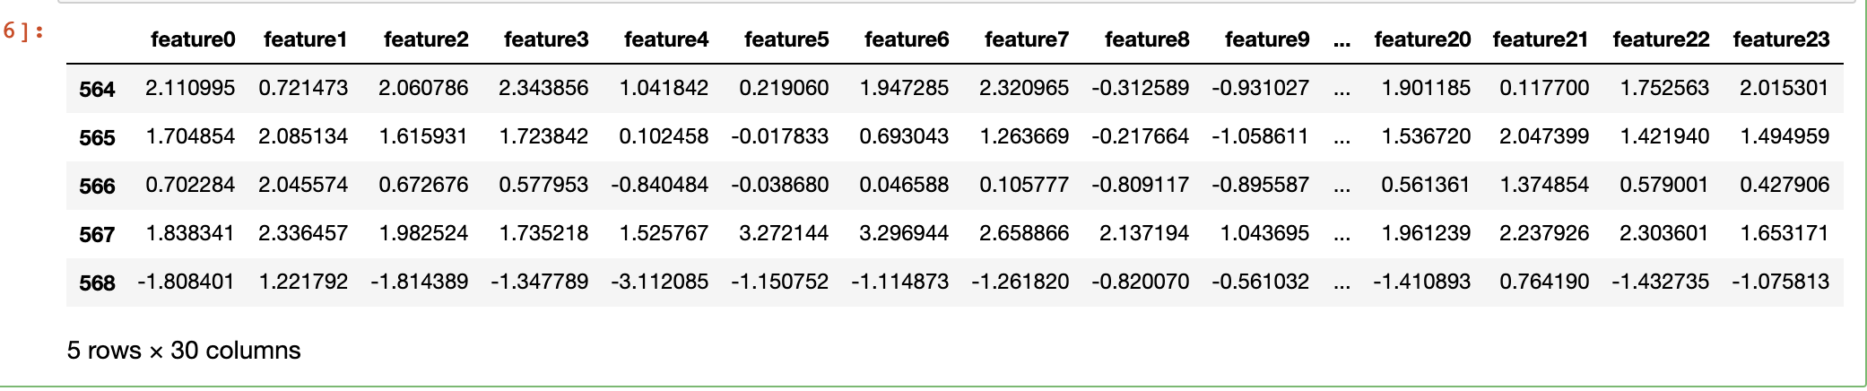

from sklearn.decomposition import PCA

pca_breast = PCA(n_components=2)

principalComponents_breast = pca_breast.fit_transform(x)

principal_breast_Df = pd.DataFrame(data = principalComponents_breast

, columns = ['principal component 1', 'principal component 2'])

principal_breast_Df.tail()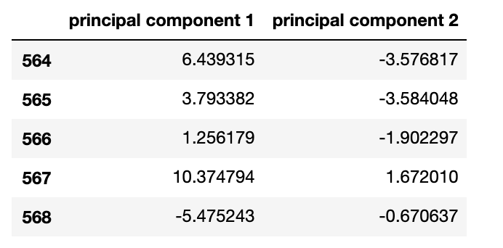

print('Explained variation per principal component: {}'.format(pca_breast.explained_variance_ratio_))

plt.figure()

plt.figure(figsize=(10,10))

plt.xticks(fontsize=12)

plt.yticks(fontsize=14)

plt.xlabel('Principal Component - 1',fontsize=20)

plt.ylabel('Principal Component - 2',fontsize=20)

plt.title("Principal Component Analysis of Breast Cancer Dataset",fontsize=20)

targets = ['Benign', 'Malignant']

colors = ['r', 'g']

for target, color in zip(targets,colors):

indicesToKeep = breast_dataset['label'] == target

plt.scatter(principal_breast_Df.loc[indicesToKeep, 'principal component 1']

, principal_breast_Df.loc[indicesToKeep, 'principal component 2'], c = color, s = 50)

plt.legend(targets,prop={'size': 15})

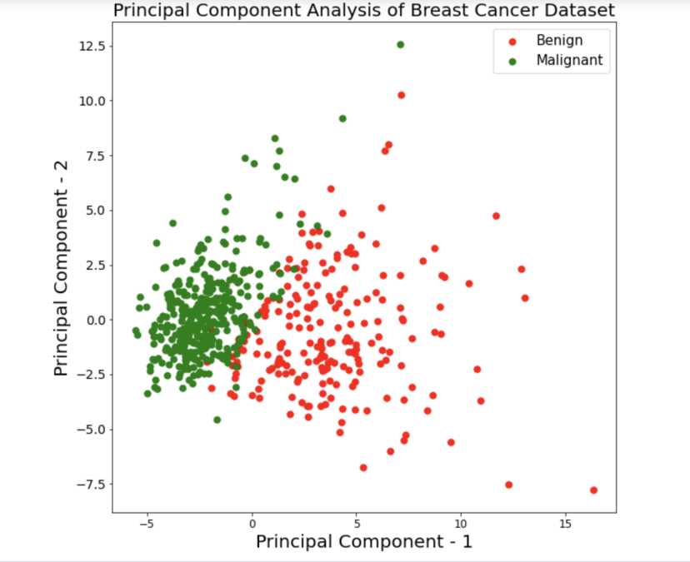

## Visualizing the CIFAR - 10 data

np.min(x_train),np.max(x_train)

x_train = x_train/255.0

np.min(x_train),np.max(x_train)

x_train.shape

x_train_flat = x_train.reshape(-1,3072)

feat_cols = ['pixel'+str(i) for i in range(x_train_flat.shape[1])]

df_cifar = pd.DataFrame(x_train_flat,columns=feat_cols)

df_cifar['label'] = y_train

print('Size of the dataframe: {}'.format(df_cifar.shape))

df_cifar.head()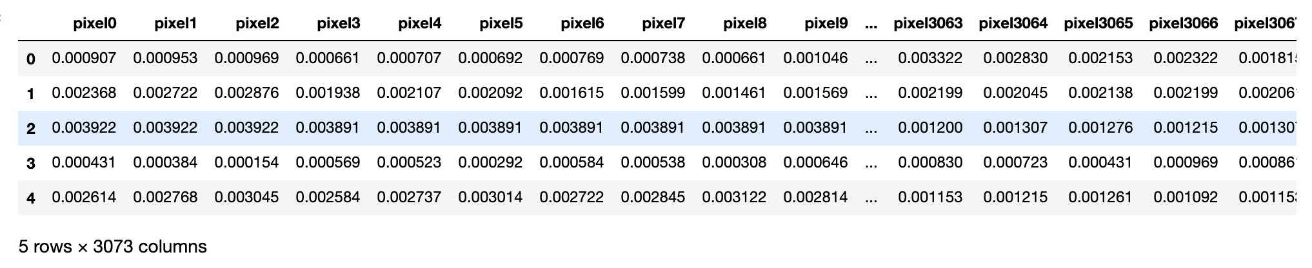

pca_cifar = PCA(n_components=2)

principalComponents_cifar = pca_cifar.fit_transform(df_cifar.iloc[:,:-1])

principal_cifar_Df = pd.DataFrame(data = principalComponents_cifar

, columns = ['principal component 1', 'principal component 2'])

principal_cifar_Df['y'] = y_train

principal_cifar_Df.head()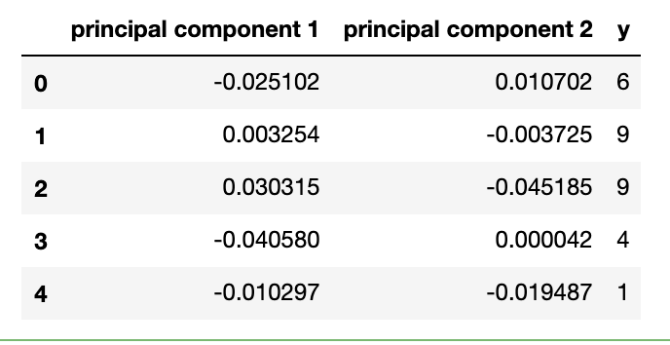

print('Explained variation per principal component: {}'.format(pca_cifar.explained_variance_ratio_))

import seaborn as sns

plt.figure(figsize=(16,10))

sns.scatterplot(

x="principal component 1", y="principal component 2",

hue="y",

palette=sns.color_palette("hls", 10),

data=principal_cifar_Df,

legend="full",

alpha=0.3

)

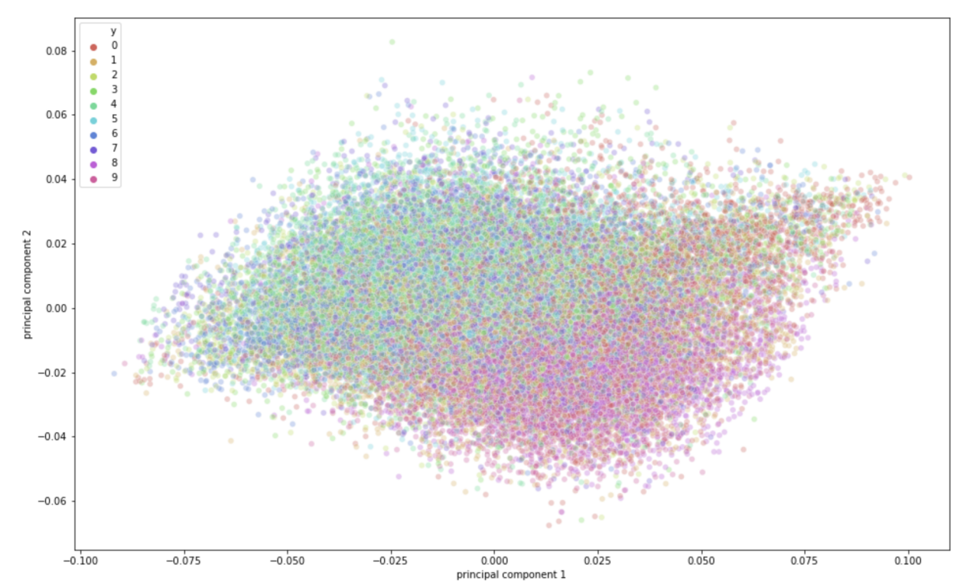

Speed Up Deep Learning Training using PCA with CIFAR - 10 Dataset

x_test = x_test/255.0

x_test = x_test.reshape(-1,32,32,3)

x_test_flat = x_test.reshape(-1,3072)

pca = PCA(0.9)

pca.fit(x_train_flat)

pca.n_components_

train_img_pca = pca.transform(x_train_flat)

test_img_pca = pca.transform(x_test_flat)

from keras.models import Sequential

from keras.layers import Dense

from keras.utils import np_utils

from keras.optimizers import RMSprop

y_train = np_utils.to_categorical(y_train)

y_test = np_utils.to_categorical(y_test)

batch_size = 128

num_classes = 10

epochs = 20

model = Sequential()

model.add(Dense(1024, activation='relu', input_shape=(99,)))

model.add(Dense(1024, activation='relu'))

model.add(Dense(512, activation='relu'))

model.add(Dense(256, activation='relu'))

model.add(Dense(num_classes, activation='softmax'))

model.summary()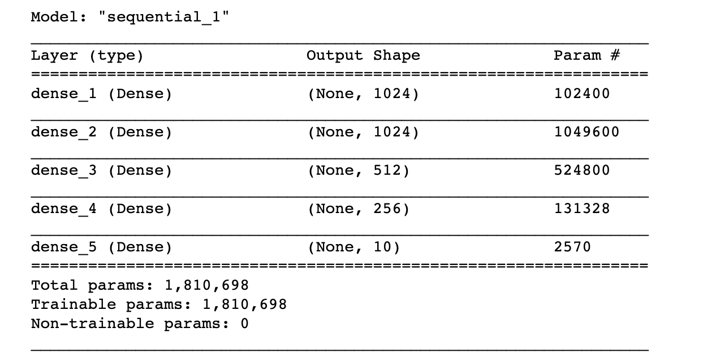

model.compile(loss='categorical_crossentropy',

optimizer=RMSprop(),

metrics=['accuracy'])

history = model.fit(train_img_pca, y_train,batch_size=batch_size,epochs=epochs,verbose=1,

validation_data=(test_img_pca, y_test))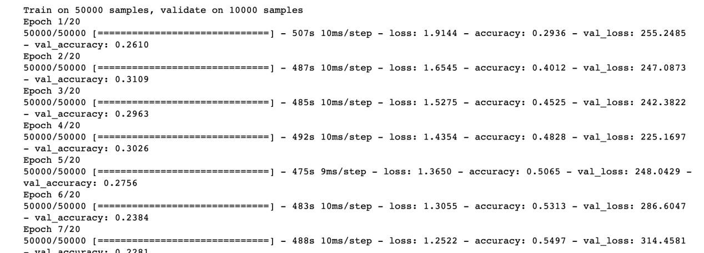

# Homework

import matplotlib.pyplot as plt

import pandas as pd

import seaborn as sns

import numpy as np

from sklearn.preprocessing import StandardScaler

from sklearn.decomposition import PCA

df = pd.read_csv("/Users/dew/Desktop/iris.csv")

df.head()

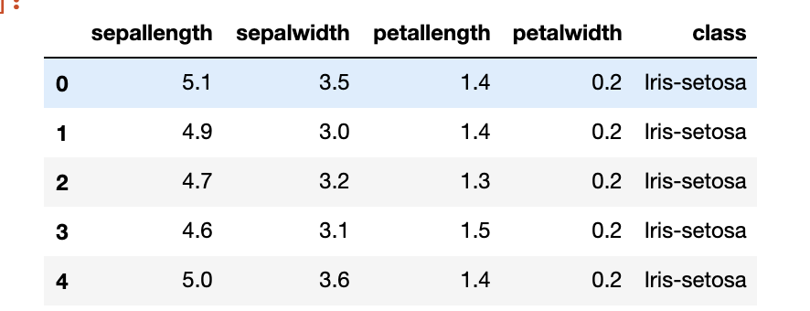

df1 = df.loc[:,df.columns[0:4]]

scaler = StandardScaler()

scaler.fit(df1)

scaled_df = scaler.transform(df1)

pca = PCA(n_components = 4)

pca.fit(scaled_df)

x_pca = pca.transform(scaled_df)

percent_variance=pca.explained_variance_ratio_

plt.bar(x = range(1,5),height=percent_variance,tick_label=["PC" + str(i) for i in range(1,5)])

plt.ylabel('Percentate of Variance Explained')

plt.xlabel('Principal Component')

plt.title('PCA Scree Plot')

plt.savefig("PCA scree Plot.jpg")

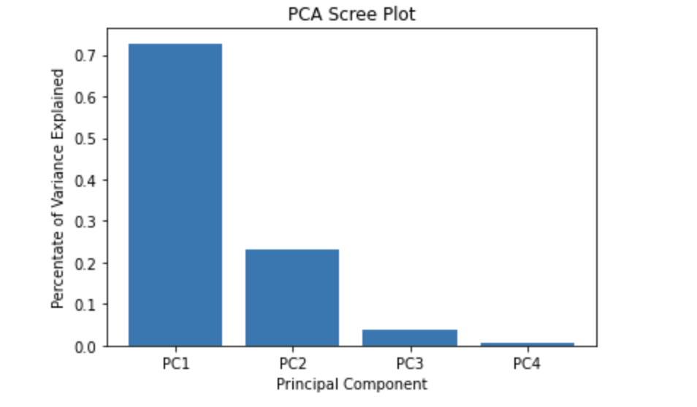

df2 = pd.DataFrame(data=x_pca,columns=["PC"+str(i) for i in range(1,5)])

df['target']=df.loc[:,df.columns[4]]

df3 = pd.concat([df2,df['target']],axis=1)

plt.figure(figsize=(9,6))

sns.scatterplot(x="PC1",y="PC2",hue='target',data=df3)

plt.xlabel("PC1")

plt.ylabel("PC2")

plt.title("PC1 VS PC2")

plt.savefig("PC1 and PC2.jpg")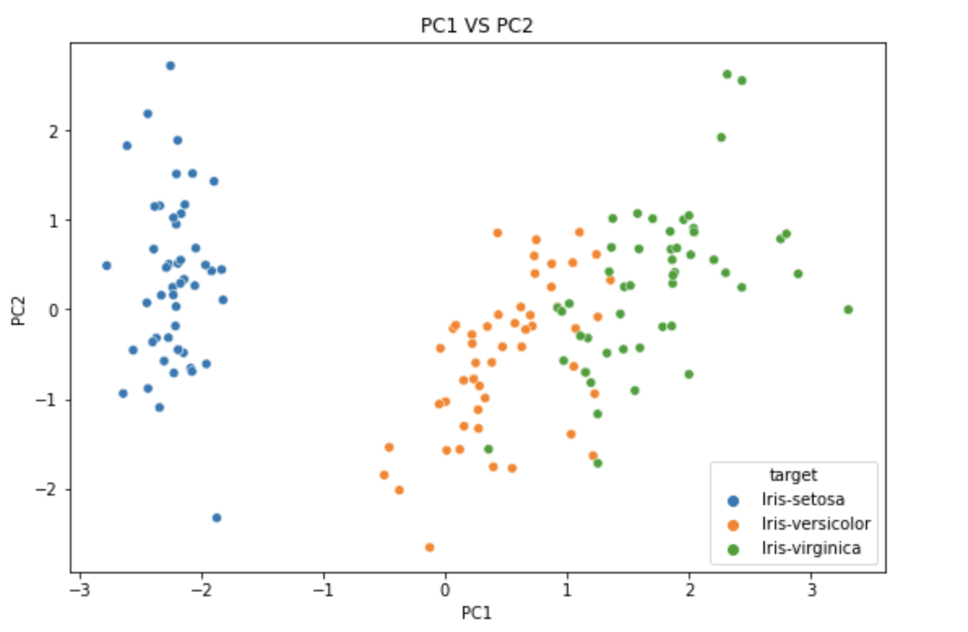

from matplotlib import patches

from scipy.spatial import ConvexHull

def encircle(x,y, ax=None, **kw):

if not ax: ax=plt.gca()

p = np.c_[x,y]

hull = ConvexHull(p)

poly = plt.Polygon(p[hull.vertices,:], **kw)

ax.add_patch(poly)

df3_1 = df3.loc[df3.target == df3.target.unique()[0],:]

df3_2 = df3.loc[df3.target == df3.target.unique()[1],:]

df3_3 = df3.loc[df3.target == df3.target.unique()[2],:]

plt.figure(figsize=(9,6))

sns.scatterplot(x="PC1",y="PC2",hue='target',data=df3)

encircle(df3_1.PC1,df3_1.PC2,alpha=0.1)

encircle(df3_2.PC1,df3_2.PC2,fc = "gold", alpha=0.1)

encircle(df3_3.PC1,df3_3.PC2,ec = "firebrick",fc = "gold", alpha=0.1)

plt.savefig("3.jpg")