**Assignment3**

Name:Dew

ID:18406040245

# Ensemble learning notebook

## (1)Bagging

%matplotlib inline

import itertools

import numpy as np

import seaborn as sns

import matplotlib.pyplot as plt

import matplotlib.gridspec as gridspec

from sklearn import datasets

from sklearn.tree import DecisionTreeClassifier

from sklearn.neighbors import KNeighborsClassifier

from sklearn.linear_model import LogisticRegression

from sklearn.ensemble import RandomForestClassifier

from sklearn.ensemble import BaggingClassifier

from sklearn.model_selection import cross_val_score, train_test_split

from mlxtend.plotting import plot_learning_curves

from mlxtend.plotting import plot_decision_regions

np.random.seed(0)

label = ['Decision Tree', 'K-NN', 'Bagging Tree', 'Bagging K-NN']

clf_list = [clf1, clf2, bagging1, bagging2]

fig = plt.figure(figsize=(10, 8))

gs = gridspec.GridSpec(2, 2)

grid = itertools.product([0,1],repeat=2)

for clf, label, grd in zip(clf_list, label, grid):

scores = cross_val_score(clf, X, y, cv=3, scoring='accuracy')

print "Accuracy: %.2f (+/- %.2f) [%s]" %(scores.mean(), scores.std(), label)

clf.fit(X, y)

ax = plt.subplot(gs[grd[0], grd[1]])

fig = plot_decision_regions(X=X, y=y, clf=clf, legend=2)

plt.title(label)

plt.show()

# 截屏2020-12-26 下午8.04.38

#plot learning curves

X_train, X_test, y_train, y_test = train_test_split(X, y, test_size=0.3, random_state=42)

plt.figure()

plot_learning_curves(X_train, y_train, X_test, y_test, bagging1, print_model=False, style='ggplot')

plt.show()

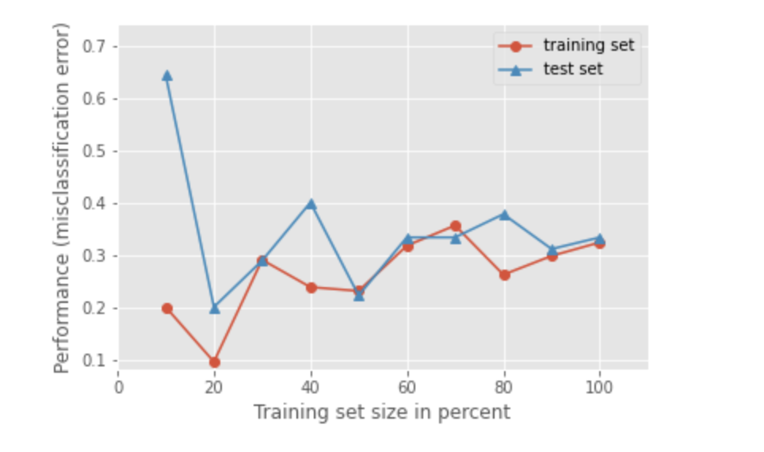

#Ensemble Size

num_est = np.linspace(1,100,20).astype(int)

bg_clf_cv_mean = []

bg_clf_cv_std = []

for n_est in num_est:

bg_clf = BaggingClassifier(base_estimator=clf1, n_estimators=n_est, max_samples=0.8, max_features=0.8)

scores = cross_val_score(bg_clf, X, y, cv=3, scoring='accuracy')

bg_clf_cv_mean.append(scores.mean())

bg_clf_cv_std.append(scores.std())

plt.figure()

(_, caps, _) = plt.errorbar(num_est, bg_clf_cv_mean, yerr=bg_clf_cv_std, c='blue', fmt='-o', capsize=5)

for cap in caps:

cap.set_markeredgewidth(1)

plt.ylabel('Accuracy'); plt.xlabel('Ensemble Size'); plt.title('Bagging Tree Ensemble');

plt.show()

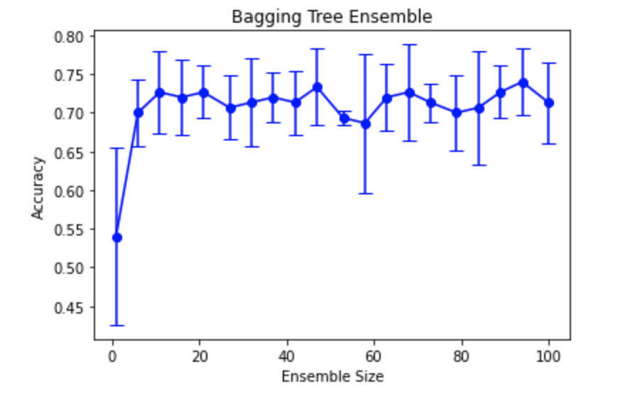

## Boosting

import itertools

import numpy as np

import seaborn as sns

import matplotlib.pyplot as plt

import matplotlib.gridspec as gridspec

from sklearn import datasets

from sklearn.tree import DecisionTreeClassifier

from sklearn.neighbors import KNeighborsClassifier

from sklearn.linear_model import LogisticRegression

from sklearn.ensemble import AdaBoostClassifier

from sklearn.model_selection import cross_val_score, train_test_split

from mlxtend.plotting import plot_learning_curves

from mlxtend.plotting import plot_decision_regions

iris = datasets.load_iris()

X, y = iris.data[:, 0:2], iris.target

#XOR dataset

#X = np.random.randn(200, 2)

#y = np.array(map(int,np.logical_xor(X[:, 0] > 0, X[:, 1] > 0)))

clf = DecisionTreeClassifier(criterion='entropy', max_depth=1)

num_est = [1, 2, 3, 10]

label = ['AdaBoost (n_est=1)', 'AdaBoost (n_est=2)', 'AdaBoost (n_est=3)', 'AdaBoost (n_est=10)']

fig = plt.figure(figsize=(10, 8))

gs = gridspec.GridSpec(2, 2)

grid = itertools.product([0,1],repeat=2)

for n_est, label, grd in zip(num_est, label, grid):

boosting = AdaBoostClassifier(base_estimator=clf, n_estimators=n_est)

boosting.fit(X, y)

ax = plt.subplot(gs[grd[0], grd[1]])

fig = plot_decision_regions(X=X, y=y, clf=boosting, legend=2)

plt.title(label)

plt.show()

## 截屏2020-12-26 下午8.10.09

#plot learning curves

X_train, X_test, y_train, y_test = train_test_split(X, y, test_size=0.3, random_state=0)

boosting = AdaBoostClassifier(base_estimator=clf, n_estimators=10)

plt.figure()

plot_learning_curves(X_train, y_train, X_test, y_test, boosting, print_model=False, style='ggplot')

plt.show()

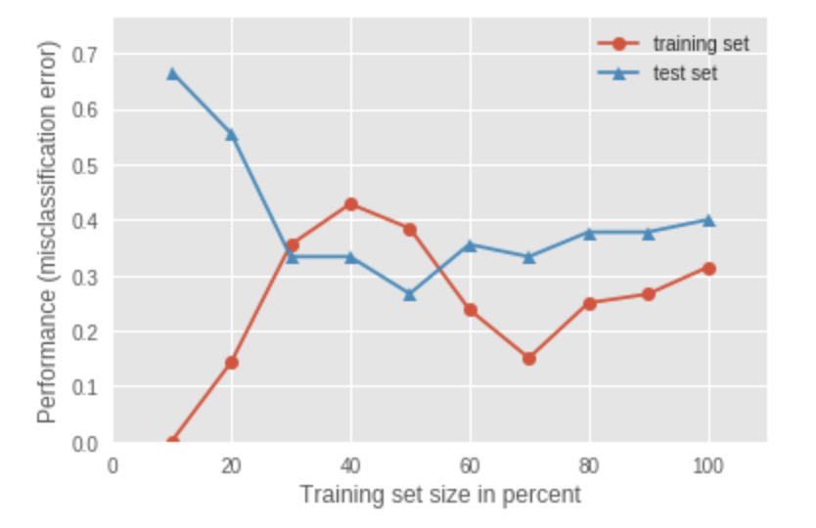

#Ensemble Size

num_est = np.linspace(1,100,20).astype(int)

bg_clf_cv_mean = []

bg_clf_cv_std = []

for n_est in num_est:

ada_clf = AdaBoostClassifier(base_estimator=clf, n_estimators=n_est)

scores = cross_val_score(ada_clf, X, y, cv=3, scoring='accuracy')

bg_clf_cv_mean.append(scores.mean())

bg_clf_cv_std.append(scores.std())

plt.figure()

(_, caps, _) = plt.errorbar(num_est, bg_clf_cv_mean, yerr=bg_clf_cv_std, c='blue', fmt='-o', capsize=5)

for cap in caps:

cap.set_markeredgewidth(1)

plt.ylabel('Accuracy'); plt.xlabel('Ensemble Size'); plt.title('AdaBoost Ensemble');

plt.show()

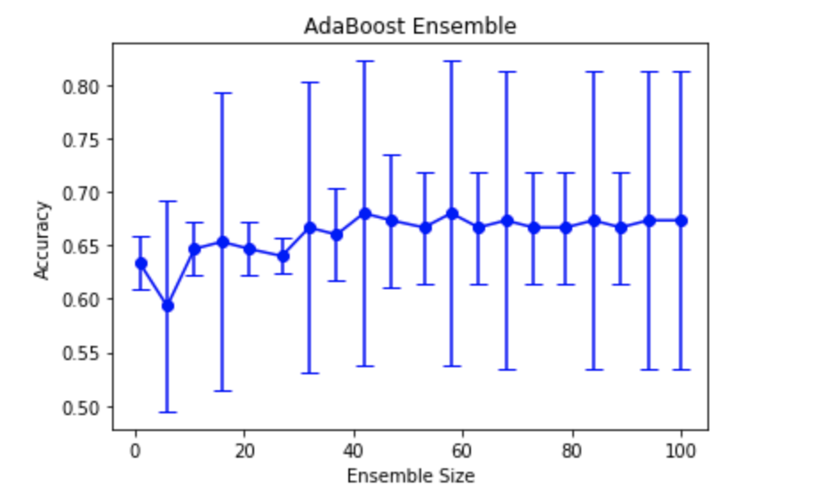

## Stacking

import itertools

import numpy as np

import seaborn as sns

import matplotlib.pyplot as plt

import matplotlib.gridspec as gridspec

from sklearn import datasets

from sklearn.linear_model import LogisticRegression

from sklearn.neighbors import KNeighborsClassifier

from sklearn.naive_bayes import GaussianNB

from sklearn.ensemble import RandomForestClassifier

from mlxtend.classifier import StackingClassifier

from sklearn.model_selection import cross_val_score, train_test_split

from mlxtend.plotting import plot_learning_curves

from mlxtend.plotting import plot_decision_regions

iris = datasets.load_iris()

X, y = iris.data[:, 1:3], iris.target

clf1 = KNeighborsClassifier(n_neighbors=1)

clf2 = RandomForestClassifier(random_state=1)

clf3 = GaussianNB()

lr = LogisticRegression()

sclf = StackingClassifier(classifiers=[clf1, clf2, clf3],

meta_classifier=lr)

label = ['KNN', 'Random Forest', 'Naive Bayes', 'Stacking Classifier']

clf_list = [clf1, clf2, clf3, sclf]

fig = plt.figure(figsize=(10,8))

gs = gridspec.GridSpec(2, 2)

grid = itertools.product([0,1],repeat=2)

clf_cv_mean = []

clf_cv_std = []

for clf, label, grd in zip(clf_list, label, grid):

scores = cross_val_score(clf, X, y, cv=3, scoring='accuracy')

print ("Accuracy: %.2f (+/- %.2f) [%s]" %(scores.mean(), scores.std(), label))

clf_cv_mean.append(scores.mean())

clf_cv_std.append(scores.std())

clf.fit(X, y)

ax = plt.subplot(gs[grd[0], grd[1]])

fig = plot_decision_regions(X=X, y=y, clf=clf)

plt.title(label)

plt.show()

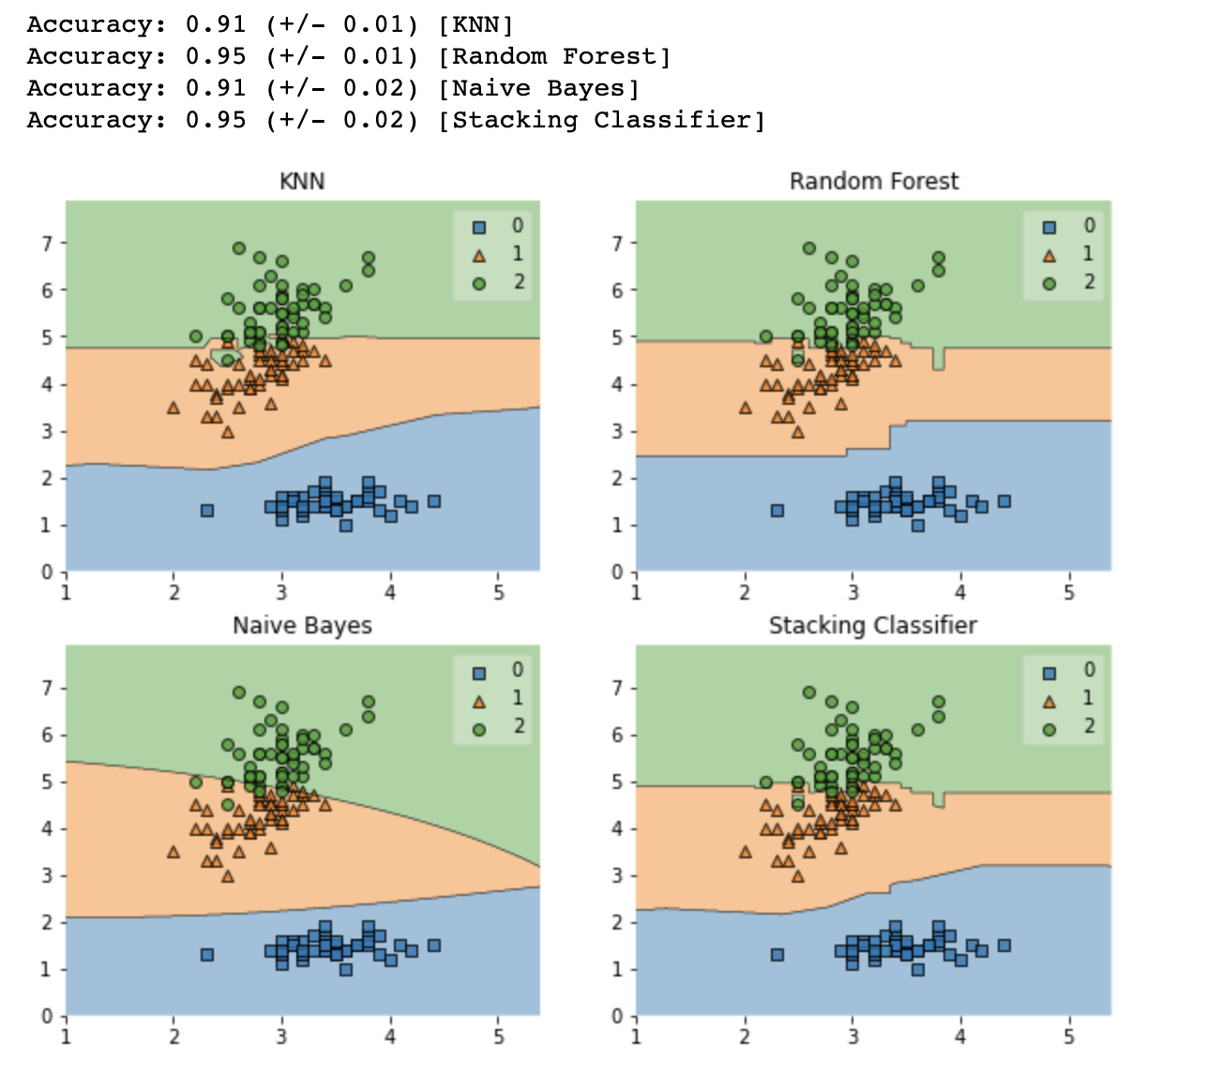

plt.figure()

(_, caps, _) = plt.errorbar(range(4), clf_cv_mean, yerr=clf_cv_std, c='blue', fmt='-o', capsize=5)

for cap in caps:

cap.set_markeredgewidth(1)

plt.xticks(range(4), ['KNN', 'RF', 'NB', 'Stacking'])

plt.ylabel('Accuracy'); plt.xlabel('Classifier'); plt.title('Stacking Ensemble');

plt.show()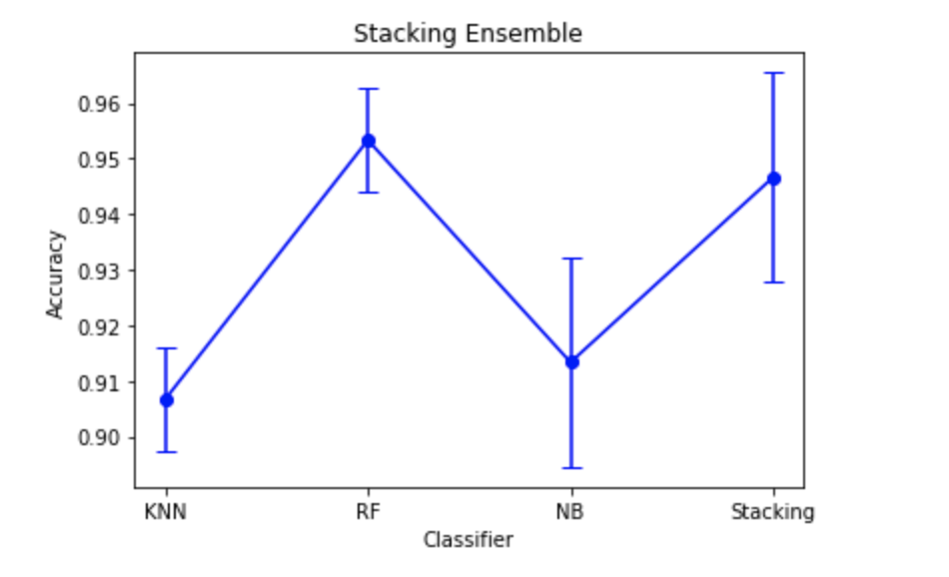

#plot learning curves

X_train, X_test, y_train, y_test = train_test_split(X, y, test_size=0.3, random_state=42)

plt.figure()

plot_learning_curves(X_train, y_train, X_test, y_test, sclf, print_model=False, style='ggplot')

plt.show()

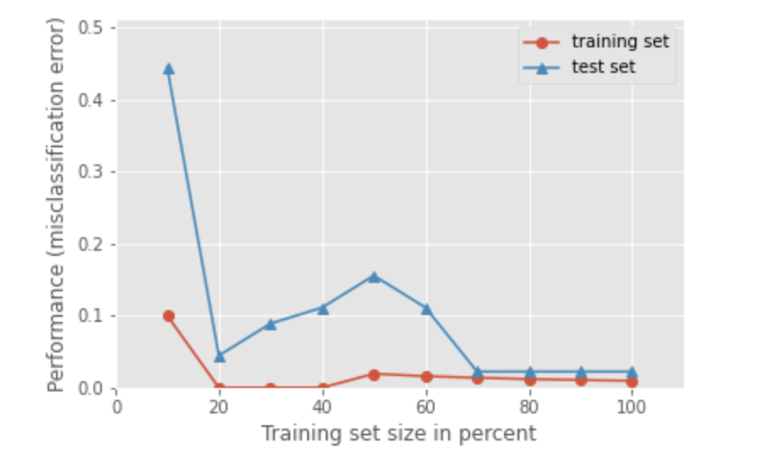

# Work on the glass.arff using RandomForest and AdaBoost algorithms in Weka.

## （1）RandomForest

First, open the data file

## 截屏2020-12-26 下午8.33.02

Then,choose RandomForest classifier in classify.

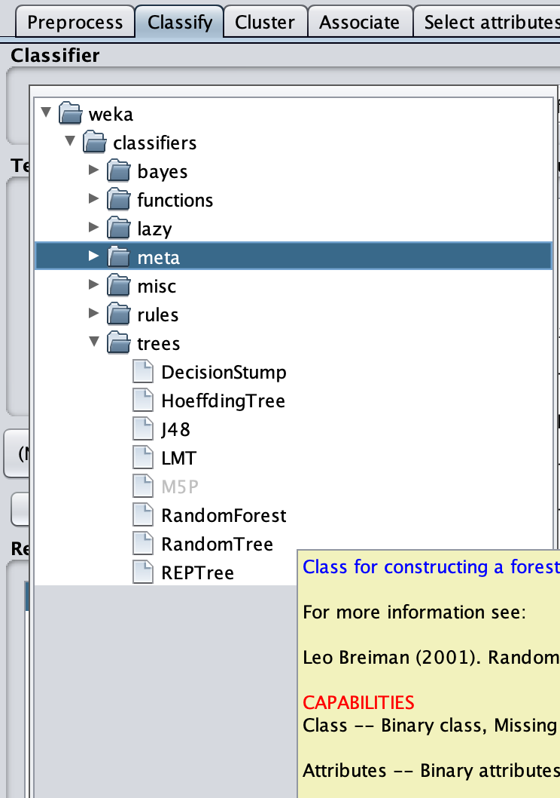

Click start

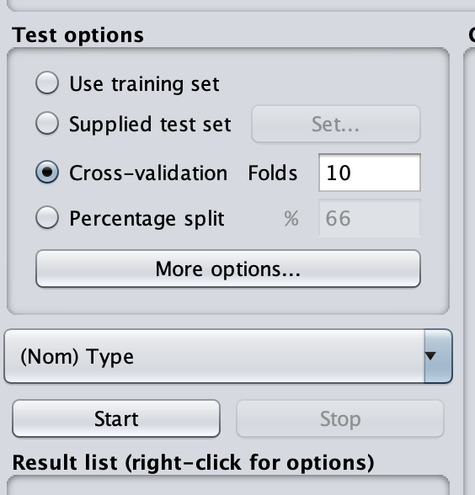

At last,we get the result.

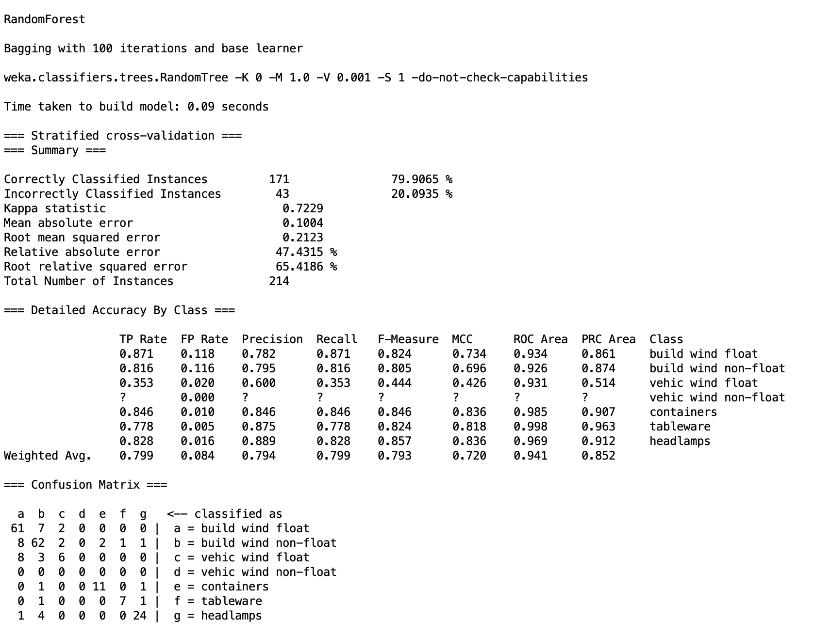

## AdaBoost

The specific step is same as RandomForest,but we should choose AdaBoostM1 classifier in classify.

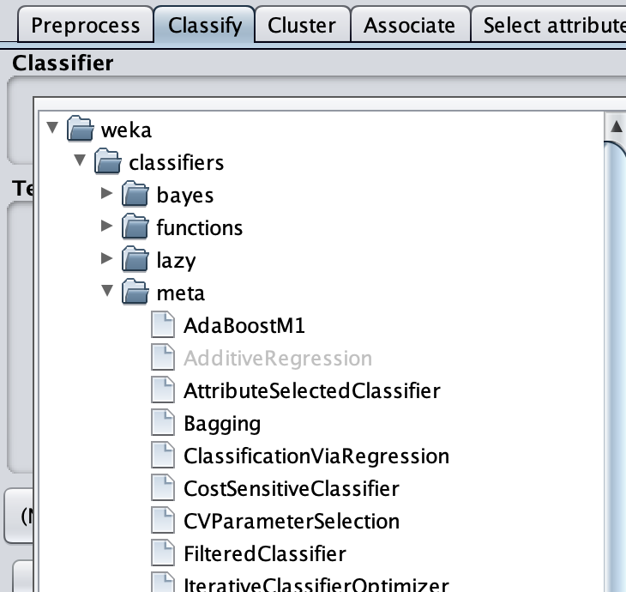

At last, we get result.

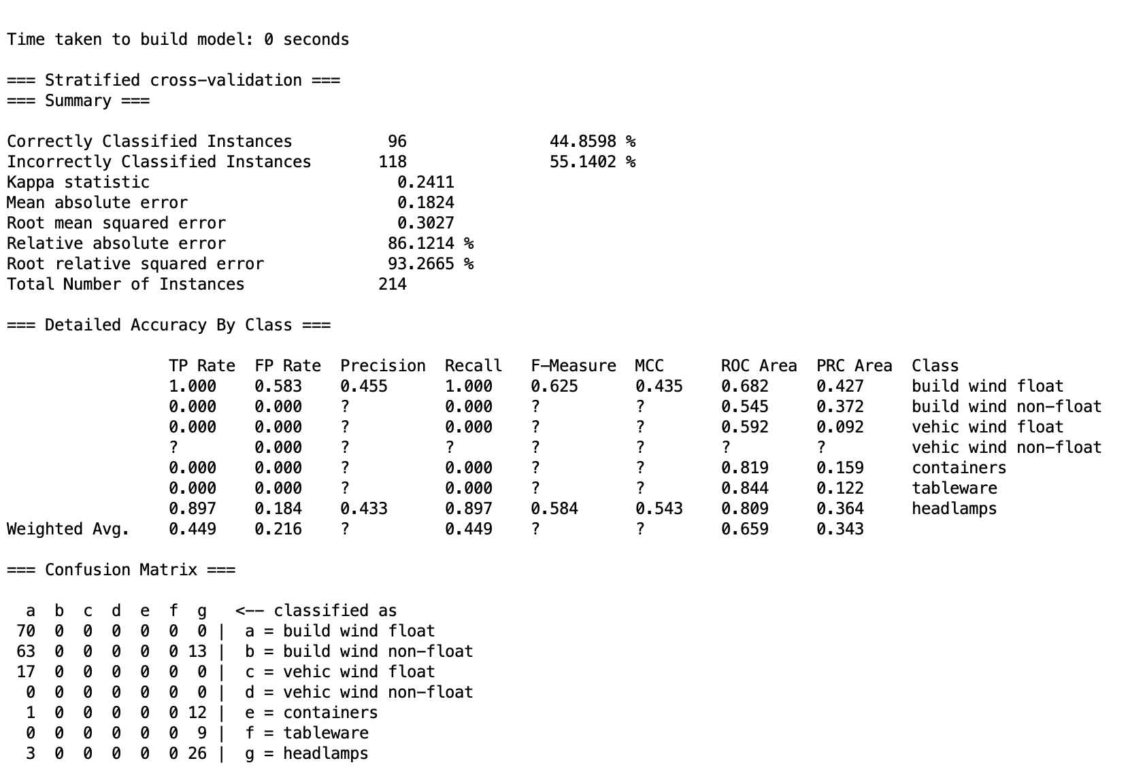

# Compare your accuracy of results with that of J48 (Decision Tree) algorithm

For J48 (Decision Tree) algorithm:

# 截屏2020-12-26 下午9.18.12

Click start,we get result.

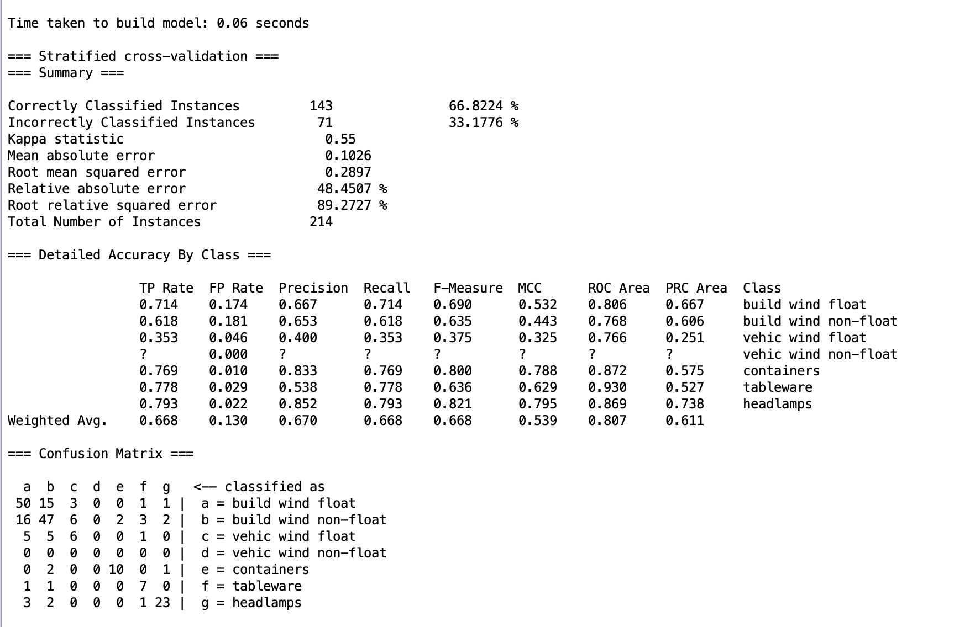

|  |  |  |  |  |  |  |
| --- | --- | --- | --- | --- | --- | --- |
| **algorithm** | **Correctly Classified rate** | **Kappa statistic** | **Mean absolute error** | **Root mean squared error** | **Relative absolute error** | **Root relative squared error** |
| **RandomForest** | 79.9065 % | 0.7229 | 0.1004 | 0.2123 | 47.4315 % | 65.4186 % |
| **Adaboost** | 44.8598 % | 0.2411 | 0.1824 | 0.3027 | 86.1214 % | 93.2665 % |
| **J48** | 66.8224 % | 0.55 | 0.1026 | 0.2897 | 48.4507 % | 89.2727 % |

In conclusion,The accuracy rank of these algorithm here is

**RandomForest>J48>Adaboost**