FULL STACK DEVELOPMENT WORKSHOP SERIES
Assignment 01 - Static Front-End Skeleton
SyncBoard Client Project Report - Huddle
Group | 97
Project | SyncBoard Client - Huddle collaborative task board
Submission | Assignment 01 front-end skeleton report
Repository | https://github.com/Dew3120/huddle
Assignment Tag | assignment-01-static-front-end-skeleton

Table of Contents
Introduction 3
Project Scope 3
Functional Requirements Coverage 4
Technical Requirements Coverage 4
Team and Contribution Chart 5
Commit Evidence Summary 5
GitHub Repository and Tag 6
How to Run 6
Screenshots of the Front End 7
Figure 1: Board Dashboard 7
Figure 2: Create Task Page 8
Figure 3: Task Detail Modal 8
Figure 4: Edit Task Form 9
Figure 5: Search and Filter State 10
Figure 6: No Matching Tasks State 11
Figure 7: 404 Not Found Page 11
Current Limitations and Next Milestone 12
Conclusion 12

Introduction
Huddle is the front-end skeleton for the SyncBoard client project. It is designed as a collaborative task board for small teams to create, assign, track, move, edit, delete, search, and filter work items. The Assignment 01 submission focuses on the client-side React experience using mock data, clear component structure, routing, shared state, and a user interface that can later connect to a real backend API.
The project is built with Vite and React. Backend features such as authentication, database persistence, JWT handling, real HTTP task storage, deployment, and real-time sync are intentionally outside this first milestone because they belong to later workshop sessions. The current application keeps data access isolated through a front-end API module so future server integration can happen without rewriting the visible interface.

Project Scope
The submitted scope covers the static and interactive front-end skeleton required for Assignment 01. The app contains a board page, new-task page, task-detail route, validated edit flow, filter/search controls, mock loading behavior, no-results handling, and a polished responsive layout. The latest UI also includes sticky navigation, independent column scrolling, dark/light theme support, glowing cards and buttons, colored status and assignee pills, and a task-detail modal shown over a blurred board background.

Functional Requirements Coverage
Requirement | How Huddle covers it | Status
Board view | Three task columns render mock data with visible per-column counts and clear task cards. | Completed
Create a task | A controlled form adds new tasks and validates required fields, minimum title length, and past due dates. | Completed
Move and delete | Task cards support move-left, move-right, and delete actions. Deletion asks for confirmation. | Completed
Task detail route | The /tasks/:id route opens the selected task in a modal with edit support and deep-link behavior. | Completed
Filter and search | Users can search by task title and filter by assignee, status, and overdue state. Filter state is kept in the URL query string. | Completed
Four UI states | Loading, error/retry, empty/no-results, and success states are represented in the interface. | Completed

Technical Requirements Coverage
Requirement | How Huddle covers it | Status
Agreed folder structure | The project uses api, components, pages, hooks, context, utils, and data folders with one component or helper module per file. | Completed
API module | Task loading is isolated in src/api/tasks.js. Components import the API helper instead of calling fetch directly. | Completed
Routing with catch-all | React Router provides /, /tasks/new, /tasks/:id, and a catch-all 404 page. Navigation uses React Router Link components. | Completed
Shared state | Task state is shared through Context and managed deliberately with useReducer actions. | Completed
README | README explains the scope, stack, setup commands, project structure, routes, screenshots, limitations, and team contributions. | Completed
Evidence of teamwork | Merged feature branches and pull requests show the frontend foundation, shared Button work, and search/filter work. | Completed

Team and Contribution Chart
The chart records each member's role for Group 97 and keeps the Student ID column ready for the final ID values before upload.
Student ID | Name | Role | Contribution Summary
 | T D Gnanasena | Team lead and front-end integration | Led the Assignment 01 scope alignment, rebuilt the client as a Vite React app, implemented the board foundation, routing, shared Context/useReducer state, add/move/delete/edit flows, validation, UI states, README updates, and final interface polish.
 | J Charles | Shared UI component contributor | Created and cleaned up the reusable Button component and button module styling so task cards, forms, filters, and modal actions use a consistent shared control pattern.
 | K V Dilnath | Search and filter contributor | Implemented the task search and filtering support, including the filter utility, filter controls, assignee/status/overdue filtering, URL query state, result counts, and no-results behavior.
 | R S Boklagama | Documentation and design support | Supported final report preparation by gathering resources and screenshot evidence, and helped review layout direction and color palette choices during the final presentation polish.

Commit Evidence Summary
The commit evidence below uses the visible repository history and writes each short hash with its actual commit title. This avoids unclear hash-only references in the final report.
Member | Commit Names / Evidence
T D Gnanasena | 79c33d0 - Align repository with Assignment 01 frontend scope; c4198ad - Set up React frontend with Vite; a8c1cbc - Build static task board with reusable components; c0f0b75 - Add interactive task board controls; 4c64f2a - Add task loading and feedback states; 8f956cd - Add routed frontend architecture and shared task state; e178aad - Add task form validation; fef42cf - Add validated task editing; dfcaf47 - Update README for Assignment 01 frontend; 15824dc - Polish Assignment 01 frontend UI.
J Charles | 154d5fa - Add reusable button component; 5e1b1ac - Clean shared button formatting.
K V Dilnath | e2adf31 - feat: add task search and filters; a59f2d9 - Clean task filter formatting.
R S Boklagama | Final report, resource gathering, screenshot evidence, layout review, and color palette support are recorded as documentation/design contribution evidence.

GitHub Repository and Tag
Repository link: https://github.com/Dew3120/huddle
Assignment tag link: https://github.com/Dew3120/huddle/tree/assignment-01-static-front-end-skeleton
The assignment tag assignment-01-static-front-end-skeleton is used for the final Assignment 01 front-end submission version. The tag should be updated after the final report and screenshots commit so the tagged GitHub version contains the same material submitted in this report.

How to Run
Requirements: Node.js and npm installed on the machine.
git clone https://github.com/Dew3120/huddle.git
cd huddle
git checkout assignment-01-static-front-end-skeleton
npm install
npm run dev

After running npm run dev, open the local Vite URL shown in the terminal. It is usually http://localhost:5173/. If that port is busy, Vite will print another local port such as http://localhost:5174/.
To verify the production build:
npm run build

Screenshots of the Front End
The screenshots below are captured from the running Vite application and show the main pages and interaction states required for the Assignment 01 front-end skeleton.

Figure 1: Board Dashboard
Route / state: /
The board dashboard is the main Huddle workspace. It shows the project name, sticky navigation, dark/light theme control, progress summary, inline task creation form, search and filter controls, and the three required workflow columns: To Do, In Progress, and Done. Each column shows a count, task cards are grouped by status, and the card controls allow users to move work across the board or delete it after confirmation. The colored column accents, glowing card frames, status pills, assignee labels, and independent column scrolling make the page readable while still matching the polished dark interface requested for the final front-end skeleton.
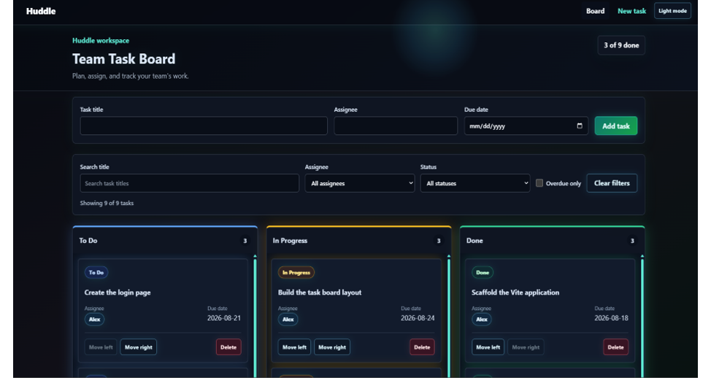
Figure 1: Main board page with task columns, controls, filters, counts, and styled task cards.

Figure 2: Create Task Page
Route / state: /tasks/new
The Create a new task page demonstrates that task creation is available as its own route as well as through the board workflow. The form is controlled by React state and includes fields for task title, assignee, and due date. New tasks are created in the To Do column, which matches the workflow expectation for incoming work. The page also keeps the same navigation and theme controls as the board, showing that routing does not break the shared application shell.
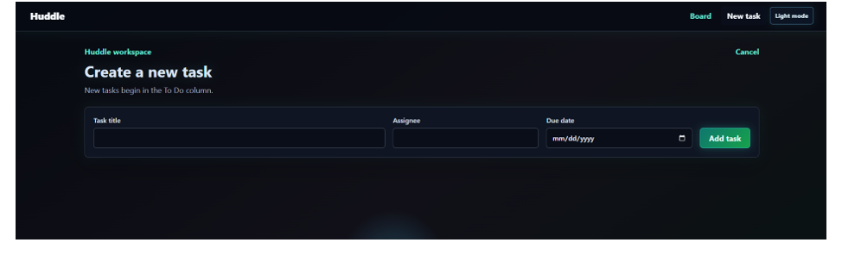
Figure 2: Dedicated new-task route with controlled input fields and add-task action.

Figure 3: Task Detail Modal
Route / state: /tasks/task-001
The task detail screenshot shows the selected task opened as a modal over the board instead of replacing the whole dashboard with a separate plain page. The background remains visible but blurred, while the modal stays clear and focused. This proves the task-detail route supports deep linking while preserving board context. The modal displays the task title, assignee, status, and due date, and provides an Edit task action for moving into the update flow.
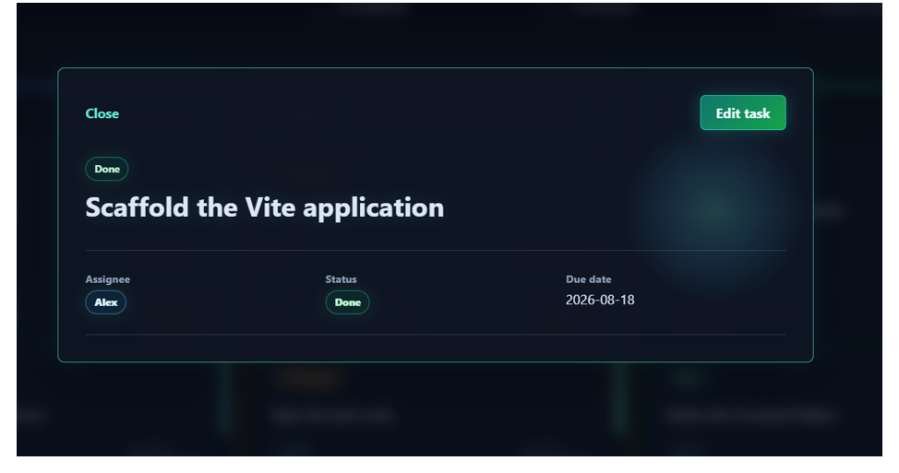
Figure 3: Task detail route shown as a clear modal over a blurred board background.

Figure 4: Edit Task Form
Route / state: /tasks/task-001 after pressing Edit task
The edit screenshot shows the validated update form inside the task modal. Users can change the task title, assignee, and due date, then either save changes or cancel. This demonstrates the shared task state design: edits are handled through the same Context and reducer system used by the board, so updated values can be reflected across the interface without direct mutation. Keeping the edit form inside the modal also makes the workflow efficient because the user does not lose the board context.
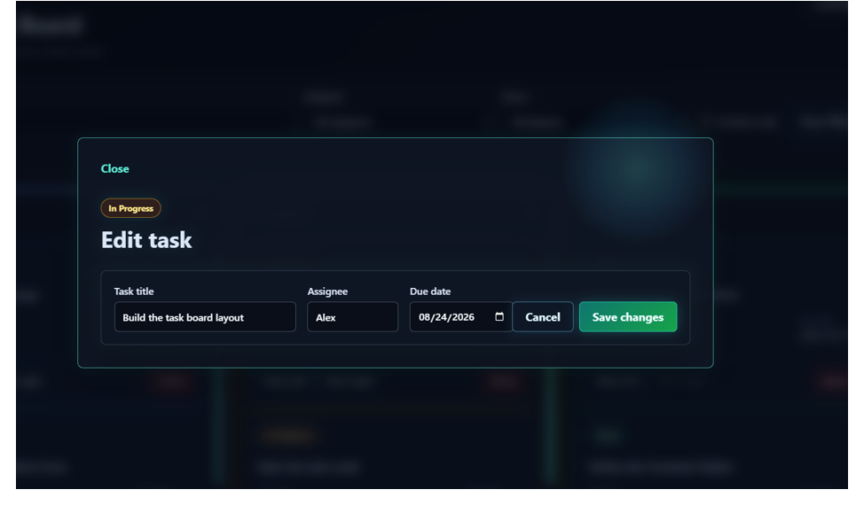
Figure 4: Validated edit form for updating task title, assignee, and due date.

Figure 5: Search and Filter State
Route / state: / with search/filter controls applied
This screenshot proves that Huddle can narrow the board based on user input. The search field filters tasks by title, while the assignee, status, and overdue controls support more focused task views. The interface updates the visible task count and task columns to match the selected filter state. This behavior is useful for a team board because users can quickly find a task by title or focus on work assigned to a person, a workflow status, or an overdue deadline.
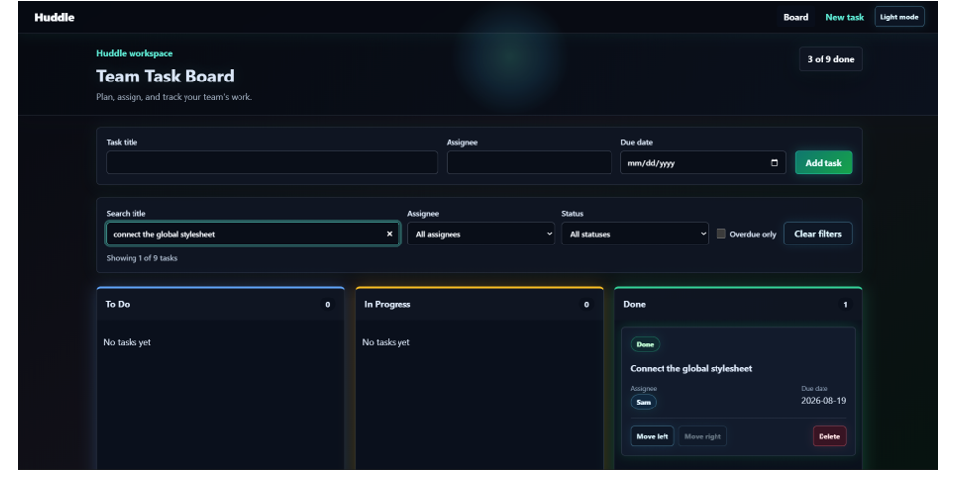
Figure 5: Filtered board view showing search input, filtered count, and matching task card.

Figure 6: No Matching Tasks State
Route / state: / with a search query that has no matches
The no-results screenshot is part of the four required UI states. When a search query does not match any task, Huddle does not show a broken or empty board without explanation. Instead, it displays a clear no matching tasks message and offers a Clear filters action. This confirms that the app handles empty filtered data gracefully and gives the user an obvious recovery path.
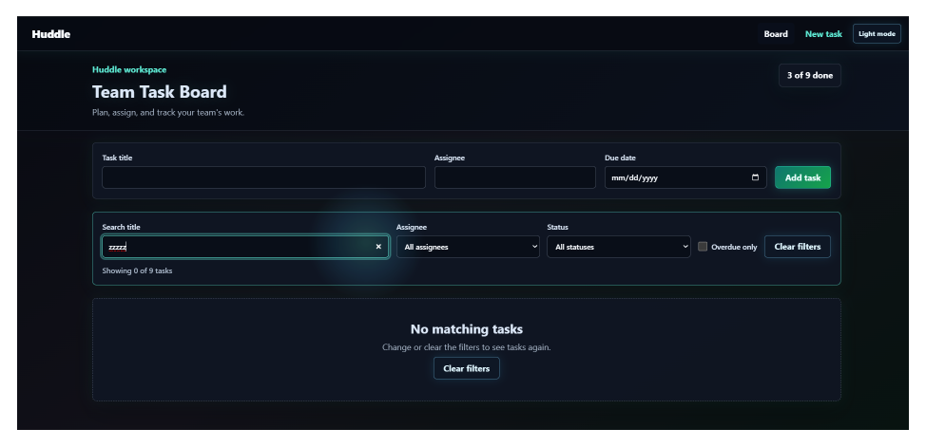
Figure 6: No-results state with a clear message and recovery action.

Figure 7: 404 Not Found Page
Route / state: /wrong-page
The 404 page confirms the catch-all route required in the technical checklist. If a user visits an unknown URL, Huddle shows a friendly not-found page rather than crashing or leaving a blank screen. The Return to board link gives a direct route back to the main workflow, which keeps navigation predictable and completes the routed front-end architecture.
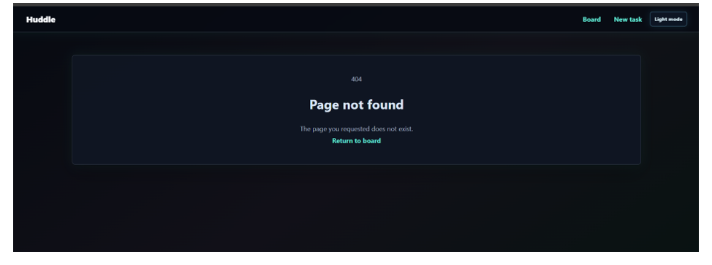
Figure 7: Catch-all 404 route with return-to-board navigation.

Current Limitations and Next Milestone
The current app uses mock task data and front-end state only, so changes reset when the app reloads. Authentication, logout, backend REST APIs, JWT, database persistence, WebSockets, CI, Docker, and deployment are intentionally not part of Assignment 01. Those features are planned for later milestones, beginning with the Express and Node API work in Assignment 02.

Conclusion
The Assignment 01 submission provides a complete front-end skeleton for the SyncBoard client. It demonstrates component-based React development, routing, state management, mock API separation, validation, search/filter behavior, UI states, team Git workflow, and a polished Huddle interface ready for future backend integration.

