BUFLEA PROXY SERVER

Document No. | Revision 1
Owner: | udfjj39546284@gmail.com
Revision: | 2.0
Date: | Sept 30, 2014

Version History

Revision | Date | Author | Description of Change
0.1 | 02/06/2014 | udfjj39546284@gmail.com | Documented created

Table of Contents
1 Executive Summary 4
1.1 Functional Block Diagram 4

Summary

Buflea came from my Cat Name. Buflea proxy server was designed for streaming, delivering high troughput to long steady connections. You might notice a small toughput decrease in small chunks cblocks that pokes hundreds of connections grabbing several kbytes.

The server can be tuned up to match the needs. Following items can be configured.

- number of standalone threads
- number of inflation threads for high pick traffic
(these gets created to satisfy high volume, and goes away after)
- number of connections per thread
- buffers sizes per socket for request, and response, user & kernel
- acredited list of allowable IP's
- admins,
- subscribers
- black list
- alowed hosts
- personal mode (compilation flag)
- configurable proxy chain, transparent proxy
- integration with web server
- remote management access
- metrics
- logs per each IP
- Many levels of logging (Informatiom, Warning, Error, Trace, Debug and Headers)
- transparent SSL, to hosts configured remotely.
- Simulatneous different Proxy protocols
  - SOCKS 5
  - SOCKS 4
  - HTTP
  - TRANSPARENT
  - REDIRECT

Block Diagram

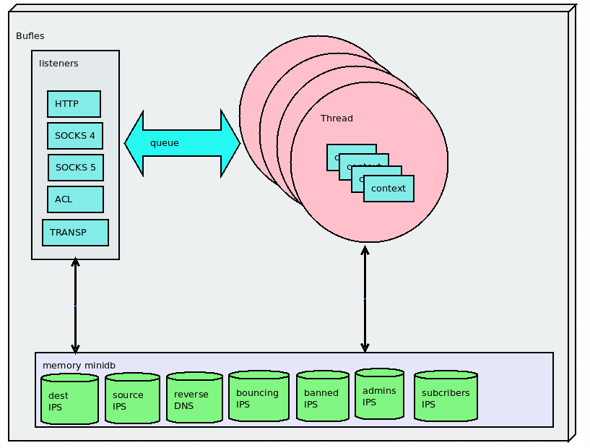

Logic Diagram

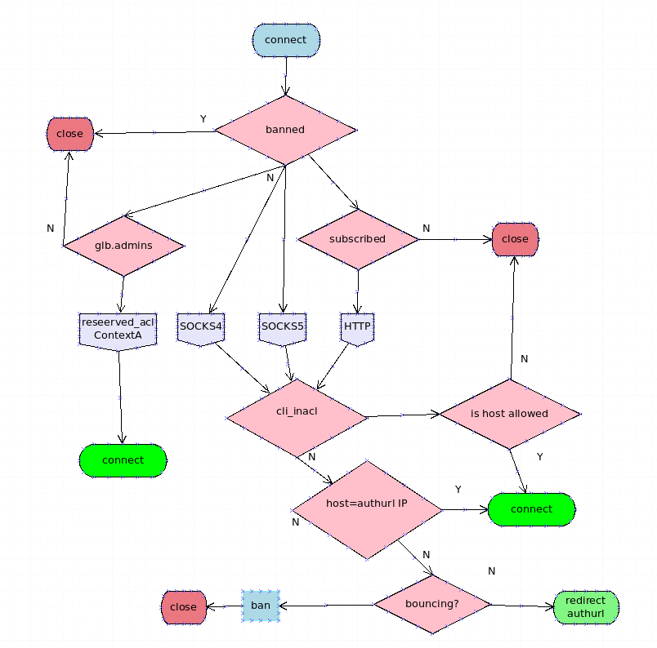

Sequence Diagram

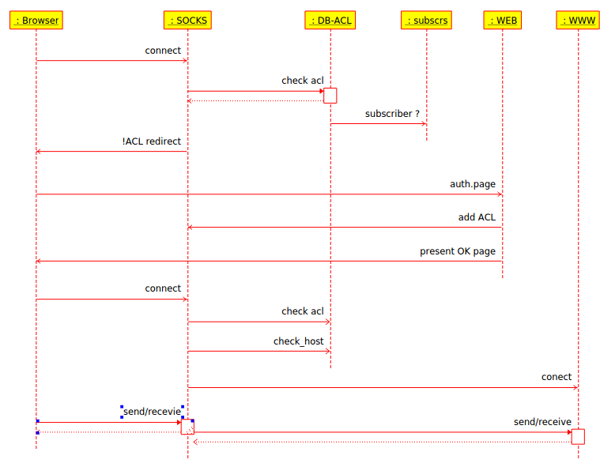

Class Diagram

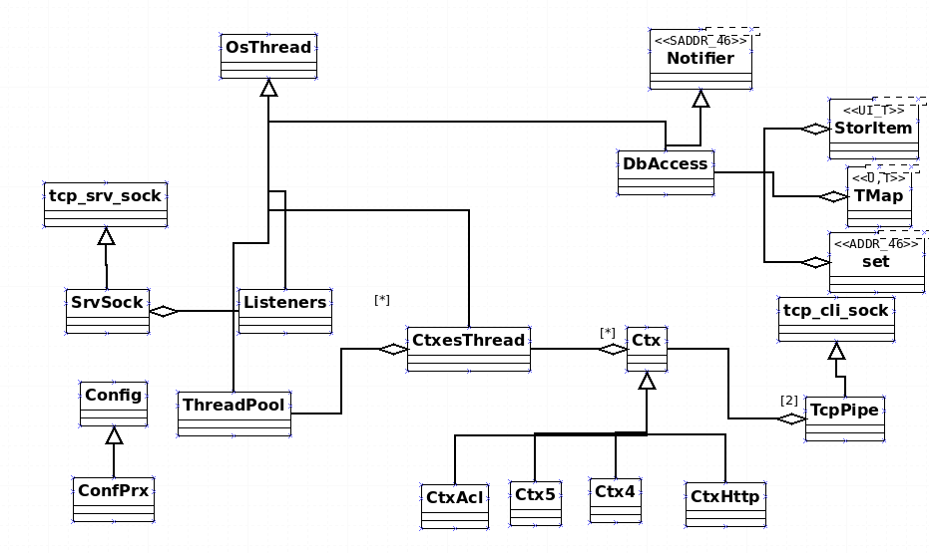

Configuration file details at coinscode.com

