| **HTML Page** | **Likely Tables Used** | **Notes** |
| --- | --- | --- |
| elevatorerror.html | logs, telemetry_device, user_devices | If logging errors or statuses from devices |
| login.html | users_login | User authentication |
| logs.html | logs, users, telemetry_device | Displays logs with user and device context |
| register_super.html | supervisors, users_login | Supervisor registration and login details |
| register.html | users, users_login, supervisors | User registration under supervisors |
| specific_userdevice.html | users, user_devices, telemetry_device | Shows device(s) for a specific user |
| super_device_overview.html | supervisors, users, user_devices | Overview of all devices managed by a supervisor |
| supervisors.html | supervisors, users, user_devices | List or profile of supervisors |
| support.html | (Possibly no direct DB) | Likely static or support contact info |
| totaldevicestats.html | telemetry_device, user_devices, users | Aggregated stats across all devices |
| user_device_overview.html | users, user_devices, telemetry_device | All users and their associated devices |
| users.html | users, supervisors,user_devices,elemetry_device | Display list of users and their supervisors |

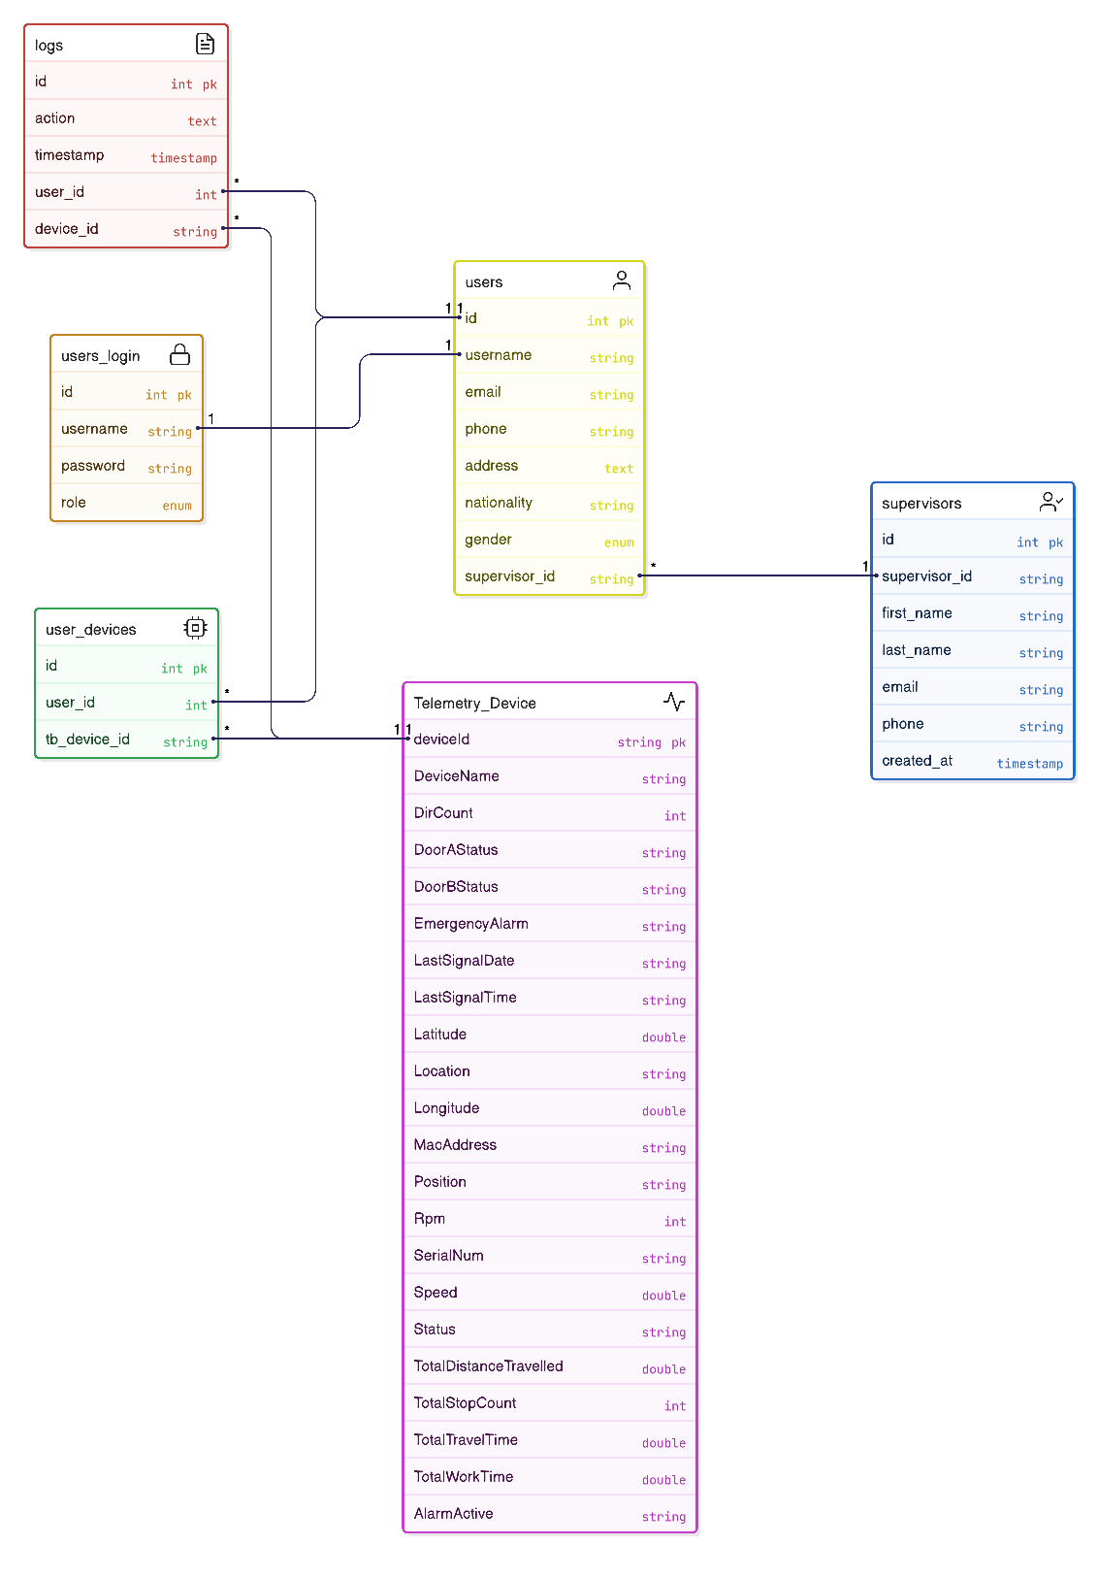\

|  |  |
| --- | --- |
| **Module** | **Purpose** |
| Login | Authorization module(User login and role-based access) |
| Register | User creation module (with optional device and supervisor assignment) |
| Users | Manage user list; map users to devices and supervisors |
| Supervisors | Configuration of Supervisor List |
| Logs (Tentatively) | Displaying logs(parameters not defined) |
| Supervisor Register | Supervisor Creation module (Assigning credentials to them) |
| User Devices | Displaying devices of a particular User |
| Machine Data Elevator | Sync and display real-time data from ThingsBoard (e.g., DirCount, status) |
| Alarms / Elevator Errors | Displaying alarms /errors |
| Control Data (Tentatively) | Displaying control data parameters |
| Supervisor Devices | Display all devices and users under that particular supervisor |
| Support Center | Contact or Support Interface |
|  |  |

### **3. Routing Flow (Frontend-Backend Navigation)**

1. **User visits /**

→ Redirected to login.html

1. **Login (login.html)**

→ On success, user is redirected based on role (user, supervisor, admin)→ User: user_device_overview.html?username=...→ Supervisor: super_device_overview.html?supervisor_id=...→ Admin: users.html or dashboard

1. **User Registration (register.html)**

→ Fetches available devices and supervisors→ On submit, calls /api/register

1. **User Device Overview (user_device_overview.html)**

→ Fetches devices for the user→ Links to specific_userdevice.html?deviceId=...&username=...

1. **Specific Device (specific_userdevice.html)**

→ Fetches device details and telemetry→ Can trigger telemetry sync

1. **Supervisors (supervisors.html)**

→ Lists supervisors and their summary

1. **Supervisor Device Overview (super_device_overview.html)**

→ Shows all users/devices for a supervisor

1. **Total Device Stats (totaldevicestats.html)**

→ Aggregates stats for all devices/users

### **2. API to HTML Page Mapping**

| **HTML Page** | **APIs Used** | **Purpose/Usage** |
| --- | --- | --- |
| login.html | POST /api/login | Authenticates user and redirects based on role |
| register.html | GET /api/unassigned-devices, POST /api/register, GET /api/supervisors | Shows available devices, supervisors, and registers new user |
| register_super.html | POST /api/register-supervisor | Registers a new supervisor |
| users.html | GET /api/users, POST /api/assign-supervisor, POST /api/assign-device | Lists users, assigns supervisors/devices |
| user_device_overview.html | GET /api/user-devices/:username, GET /api/user-devices-details/:username | Shows all devices for a user, with details |
| specific_userdevice.html | GET /api/user-devices-details/:username, POST /api/device/:tb_device_id/sync-telemetry | Shows details and telemetry for a specific device |
| supervisors.html | GET /api/supervisors, GET /api/supervisors-summary | Lists supervisors and their summary info |
| super_device_overview.html | GET /api/supervisor-users-devices/:supervisor_id | Shows all users and devices managed by a supervisor |
| totaldevicestats.html | GET /api/users, GET /api/user-devices-details/:username, GET /api/unassigned-devices | Aggregates stats across all devices/users |
| logs.html | (Likely) GET /api/user-devices/:username, GET /api/users, GET /api/user-devices-details | Displays logs with user/device context |
| elevatorerror.html | (Likely) GET /api/user-devices/:username, GET /api/user-devices-details/:username | Shows device errors/statuses |
| support.html | (No direct API, possibly static or mailto link) | Static support info |

### **1. API Endpoint Functionality**

| **Method** | **Path** | **Purpose/Functionality** | **Input (req)** | **Output (res)** |
| --- | --- | --- | --- | --- |
| POST | /api/login | User authentication | { username, password } | { success, role, username } |
| POST | /api/register | Register a new user | user info, device, supervisor | { success } |
| GET | /api/users | Get all users (with supervisor info) | - | [users] |
| POST | /api/assign-supervisor | Assign a supervisor to a user | { username, supervisor_id } | { success } |
| XPOST | /api/assign-device | Assign a device to a user | { username, tb_device_id } | { success } |
| GET | /api/user-devices/:username | Get all devices for a specific user | :username | [devices] |
| GET | /api/unassigned-devices | Get all devices not assigned to any user | - | [devices] |
| POST | /api/register-supervisor | Register a new supervisor | supervisor info | { success } |
| GET | /api/supervisors | Get all supervisors | - | [supervisors] |
| GET | /api/supervisors-summary | Get summary of supervisors (users/devices count) | - | [summary] |
| GET | /api/supervisor-users-devices/:supervisor_id | Get all users and devices for a supervisor | :supervisor_id | [users+devices] |
| POST | /api/device/:tb_device_id/sync-telemetry | Sync telemetry for a device from ThingsBoard | :tb_device_id | telemetry data |
| POST | /api/sync-thingsboard-devices | Sync all devices from ThingsBoard | - | { success, count } |
| GET | /api/user-devices-details/:username | Get detailed device info for a user | :username | [device details] |