CONTENTS OF SYNOPSIS
SL N0 TOPIC PAGE NO
- TITLE OF THE PROJECT
- INTRODUCTION & OBJECTIVES
- DFD’S
- MODULER DESCRIPTION
- DATA STRUCTURE(TABLES)
- PROCESS LOGIC
- TOOLS PALTEFORM USED
- REQUIREMENT SPECIFICATION
- SECURITY MECHANISM
- CONCLUSION
- FUTURE SCOPE & ENHANCEMENT

TITLE OF THE PROJECT
Shaadishopping.COM

INTRODUCTION
AND OBJECTIVES
OF THE PROJECT

INTRODUCTION
The shaadishopping.com Web site is the application that provides customers with online shopping. Through a Web browser, a customer can browse the catalog, place items to purchase into a virtual shopping cart, create and sign in to a user account, and purchase the shopping cart contents by placing an order with a credit card.

Overview of shaadishopping.com
The Application is a working demonstration of how to use bluePrints principles in a real application design. This document is an online guide to the design and the implementation of the application Enterprise Applications with web technology.
Each release of the application maintains consistent design features such as separating logic and presentation, using web component for control and web pages for presentation, using business components, and so on. High-level design features, this document goes deeper into the implementation details of the current application release.
This document is provided as an online-only resource so that it may be continually extended and updated. This document begins with a description of the separate applications that the sample application comprises, describes the modular structure of the shaadishopping.com application, and provides an in-depth description of several pieces of the modules.
Quality function deployment (QFD) is a quality management technique that translates the needs of the employee into technical requirements for software

DFD’S
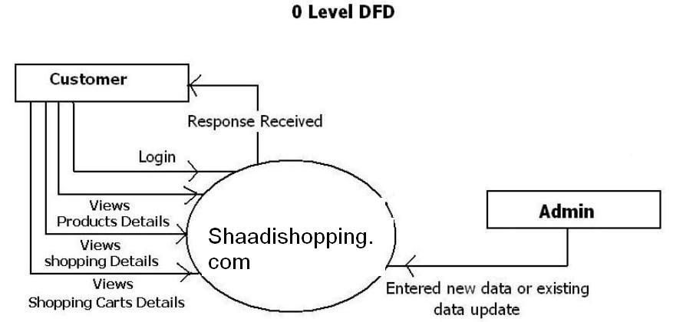

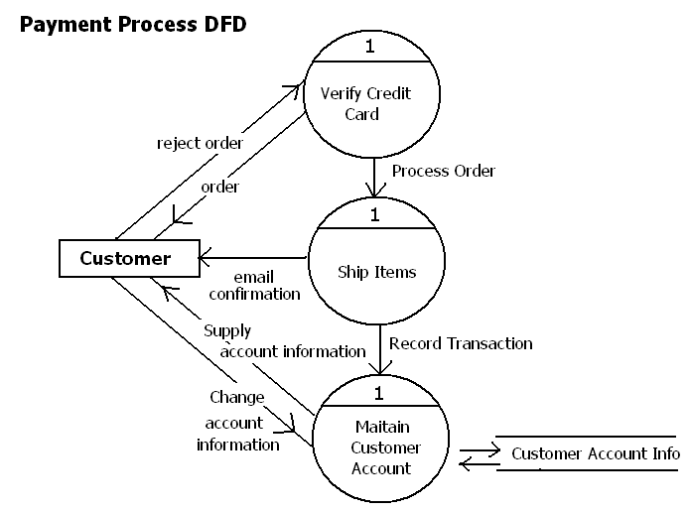

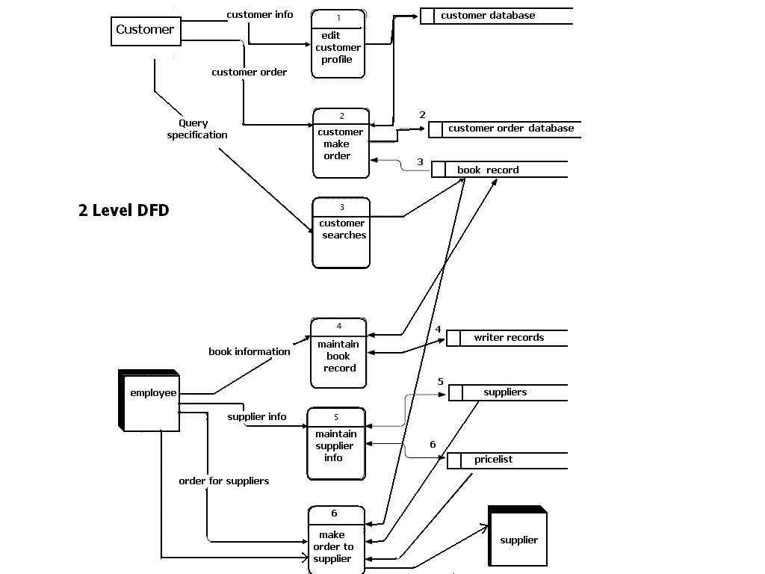

MODULAR DESIGN

- Each Shaadishopping.com module has different requirements from the others. This section describes the requirements, design, and implementation of each module.
- Control module—the control module dispatches requests to business logic, controls screen flow, coordinates component interactions, and activates user signon and registration. The control module is implemented by the WAF and application-specific WAF extensions.
- Shopping cart module—the shopping cart tracks the items a user has selected for purchase
- Signon module—the signon module requires a user to sign on before accessing certain screens, and manages the sign on process
- Messaging module—the messaging module asynchronously transmits purchase orders from the pet store to the OPC
- Catalog module—the catalog module provides a page-based view of the catalog based on user search criteria
- Customer module—the customer module represents customer information: addresses, credit cards, contact information, and so on

Control Module Requirements
The control module forms the framework underlying the application, so it naturally has the most high-level requirements. Extensibility and maintainability are prime considerations in this module. The control module must be extensible because all real-world enterprise applications change constantly. Because the control module plays a role in virtually every interaction, its code must be well-structured to avoid complexity-related maintenance problems. The requirements of the control module are:
- The module must handle all HTTP requests for the application. This module controls a Web application, and interacts with a user who sends HTTP service requests. The control module is responsible for classifying and dispatching each of these requests to the other modules.
- HTTP responses may be of any content type. Web application developers do not want to be limited to just textual content types. The control module must also be able to produce binary responses.
- Business logic must be easily extensible. Enterprise applications are always changing and growing as business rules and conditions change. A developer familiar with the control module should be able easily to add new functionality with minimal impact on existing functions.
- New views must be easy to add. Most business logic changes imply new user views, so developers must be able to create new views easily.
- Module must provide application-wide control of look and feel. Manually editing hundreds or dozens of user views is not a practical way to manage application look and feel. The control module must provide a way for application screen layout and style to be controlled globally.
- Application must be maintainable even as it grows. The control module must be structured so that new functions added over time do not result in a thicket of unmaintainable “spaghetti” code. It should be possible to easily understand the control of even an application with several hundred business classes.
- Application-wide functionality must be easy to add. New application requirements occasionally apply to every operation or view in an application. The control module must be structured so that such requirements can be easily met.
Design Pattern:
This software based on concept of the Model View Controller (MVC) design pattern.
View renders the data from the Model in response to the request made to the model by controlled events made by user interaction.
Model View Controller is a design approach to separate the application object model from GUI, originally invented around 80s. Then later on it has become a widely accepted common design pattern. The main objective behind this pattern is to decouple the view of the data (presentation layer) from the actual data processing so that the same model can be used for various views. This is achieved by using three different types of objects that interact with each other in loosely coupled manner with their discreet set of tasks.
These three objects are known as Model, View and Controller.
VIEW:
View is the graphical data presentation (outputting) irrespective of the real data processing. View is the responsible for look and feel, some custom formatting, sorting etc. View is completely isolated from actual complex data operations. For example, Online product catalog view is completely separated from database connection, query, tables etc. It simply gets final row-data from the model and puts some cosmetics and formatting before displaying it in browser. View provides interface to interact with the system. The beauty of MVC approach is that it supports any kind of view, which is challenging in today’s distributed and multi-platform environment.
A MVC model can have multiple views, which are controlled by controller. View interface can be of WEB-FORMS, HTML, XML/XSLT, XTML, and WML or can be Windows forms etc.
MODEL:
Model is responsible for actual data processing, like database connection, querying database, implementing business rules etc. It feeds data to the view without worrying about the actual formatting and look and feel. Data provided by Model is display-neutral so it can be interfaced with as many views without code redundancy; this eases your code maintenance and reduces bugs and allows code -reuse at good extent. Model responds to the request made by controllers and notifies the registered views to update their display with new data.
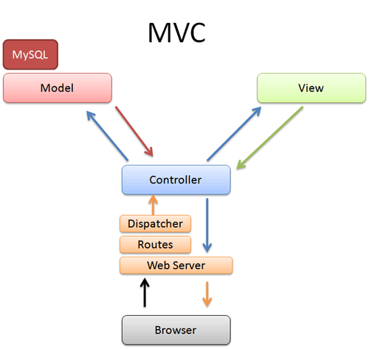

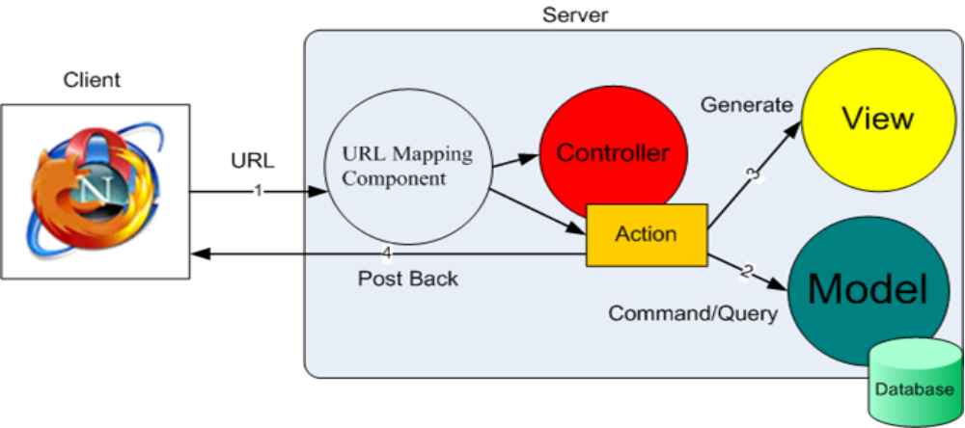

Benefits:
Following are the few of the benefits of MVC design pattern.
- Since MVC handles the multiple views using the same enterprise model it is easier to maintain, test and upgrade the multiple system.
- It will be easier to add new clients just by adding their views and controllers.
- Since the Model is completely decoupled from view it allows lot of flexibilities to design and implement the model considering reusability and modularity. This model also can be extended for further distributed application.
- It is possible to have development process in parallel for model, view and controller.

PROJECT Scheduling

Gantt chart is a project scheduling technique. Progress can be represented easily in Gantt chart, by coloring each milestone when completed. The project will start in the month of February and end will end after 4 months at the end May

February March April

TOOLS/PLATFORM USED:

Front End Active Server Pages (ASP.Net)

- User friendly
- GUI
- Separation of work (designing & coding)
- Written once run anywhere
Middle-Tier
- Asp.Net APIs

Back End Sql-Server

- Security
- Performance
- Scalability
- Reliability
- Support RDMS concepts

TESTING METHODS

- Structured testing tools had been used for testing the programs.

- Small programs are developed to test the individual modules.

- Each module is tested by the development of appropriate functionality.

- Groups of people were assigned to test the software functionality.

- The same group is responsible to test the reliability of software by using various inputs and techniques, on various parts and functionalities.

- The group had done Alpha testing.

- Software is distributed to doctors and scientist to Beta-test the entire software.

Table Structures

Table Structure
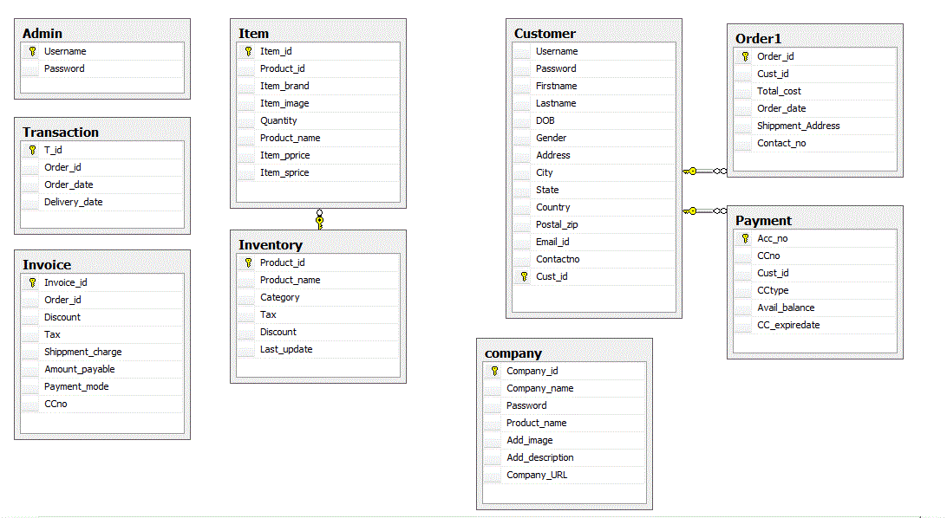
HARDWARE & SOFTWARE REQUIREMENTS

SYSTEM REQUIREMENTS
Hardware Specification:-
It is recommended that the minimum configuration for clients is as appended below:-
Suggested Configuration of Windows clients:-
Microprocessor : - Pentium-IV & Above
Ram : - 512 MB of RAM
Hard Disk : - 2.5 gigabytes (GB) on installation drive, which
:- includes 500 MB on system drive.
CD ROM Drive : - 52 X CD ROM Drive

Software Specifications:-

Operating System : Windows 2000XP/Windows 2000 NT
RDBMS : Sql Server 2005
Front End : Microsoft Visual Studio.NET 2008

SECURITY MECHANISM

In the software security there are two levels of security. The 1st level of security, which is provided by the FRONT END and 2nd level of security provided by the database which is being used.
FRONT END SECURITY:-
This security level is developed or designed by the s/w developer or designer. S/he provides her/his s/w the security for the system, by considering many factors regarding to the particular s/w.
In this software following are used to provide security.
LOGIN CHECKING:
There are two login’s are provided in this software one for employees and one for applicants. In order to avail the services of software employees have to provide a valid id and password and only after entering correct id and password employee will get entry otherwise they will be blocked from accessing any services of this site. Similarly a login check is provided for user applying for job. In order to enter recruitment zone user have to enter id and password which they got after registration , in this way security have been provided for both employee section and applicant section. There is also provision to change the password in case password is known by other.
BACK END SECURITY:-
In this particular software our back end used is SQL server 2000. So all the inbuilt security aspects provided by the SQL server 2000 database is used as it is. It will provide the strong feature of security so that it will be difficult to change, modify any personal or university data. Information is vital to success, but when damaged or in the wrong hands, it can threaten success. SQL server 2000 provides extensive security features to safe guard your information from both unauthorized viewing and intentional or inadvertent damage. This security is provided by granting or revoking privileges on a person- by- person and privilege-by-privilege basis. There are six ways by which security regarding to the database can be provided. They are as follows-
CREATE USER
DELETE USER
MODIFY USER

Goals that are successfully achieved-
There were many problems in existing system like to purchase items from shops. It was time taking and wastes of time. It will make life easy to purchase FMCG as well as to purchaseOther goods efficiently by placing order using internet.
- It will make human life easy to purchase items without taking the time.
- To get better information about products
- To see samples of newly launched products easily
- Efficiently use of plastic money(credit cards)
- To provide a better solution of marketing and purchasing anywhere and anytime
- SOFTWARE INTERFACE

- - FRONT END
- We use rich set of validation controls provided by ASP.NET and where we not achieved this through validation control we implemented JavaScript for all the Client side validations. We usually use lot of client side validation not server side. The form is not submitted until user fills in correct data. It is extremely useful to restrict mistakes by user.

- - BACK END

- We have used SQLSERVER as the Back end.SqlServer provides efficient/effective solution for major database tech.
- - Large database and space management.
- - Many concurrent database users.
- - High transaction processing requirement
- - High Availability
- - Industry accepted standards
- - Manageable security
- - Portability
Demerits of Existing Systems
In the current working system the user faces so many problems. Some of them are given below:-
- Limited customers.
- The use of man power in the existing system is so high because maintaining the details about all the products, stock, transaction and much other process.
- Quick reports on the current status will be very time consuming and the chances of error will be high.
- Need a lot of paper work (registers).
- Need mush skilled persons to take care all the activities.
- Calculation mistake are another problem for the system and have drawback of accuracy of result obtained.

CODING METHODS

- Event driven programming language ASP.Net had been used for coding the modules and programs.

- Structured English and pseudo-codes are used to closely refine the mechanisms using the facility of defined objects.

- Various stubs had been used to facilitate incremental coding followed by testing.

- The basic philosophy followed at this stage:” code one line followed by rigorous testing”.

- Integrated development environment of .Net had been used for the development of various modules in integrated manner.

- Incremental compilation had been used to compile and test on which work was in progress.

Stepwise refinement technique had been used to code the modules

CODE-BEHIND LOGIC

The main problem with ASP Classic pages is that an *.asp page does not yield modularized code. Both HTML and Script are present in a single page. But Microsoft's ASP.NET implementation contains a new-fangled method to break up business logic code from presentation code. Each ASPX created in Visual Studio has an equivalent class written in a .NET compliant language such as C#. This class consists of event handlers, initialization code and other supporting code for the user interface in the ASPX file. The C# file that hold this class is called the code-behind file and affords the ASPX file's programmatic implementation.

WHAT IS .NET?
.NET is set of common services which can be used from a number of languages and have the following specialties:
- These services are executed in the form of intermediate code that is independent of the underlying architecture.
- They operate in the runtime (Common Language Runtime), which manages resources and monitors applications execution.

The .NET frameworks are a multi-language environment for building, deploying, and running web services and applications. The Microsoft .NET platform provides .NET infrastructure and tools to build and operate a new generation of services.
FRONT END AND BACK END SECURITY

FRONT END SECURITY

This security level is developed or designed by the s/w developer or designer. S/he provides her/his s/w the security for the system, by considering many factors regarding to the particular s/w.
In this software following are used to provide security.

LOGIN CHECKING

There are two login’s are provided in this software one for user and another for admin. In order to avail the services of user have to provide a valid id and password and only after entering correct id and password user will get entry otherwise they will be blocked from accessing any services of this site. Similarly a login check is provided for admin that check credentials for admin which can do any admin job. In this way, security has been provided for both user section and admin section. There is also provision to change the password in case password is known by other. Password recover section provides users to recover their password whenever they have forgotten their password

CONCLUSION

This project has been
ADVANTAGES: -
- All the procedure in this project is automatic accept the entry of data from
The user.
- The project gives the user-friendly environment, which gives the way of working in more efficient manner.

LIMITATIONS: -
- This project does not cancel the order once placed, due to using third party tool (Web Services).
- System date for the project is like as backbone for the human, i.e. proposed system is depends on system date so it must be correct.

Shaadishopping.com
This software can be easily upgraded in the future. And also include many more features for existing system.
    - It is connected with the internet for easily retrieved data about different types of products,newly launched products can be easily added into the site using database.
    - All the information can be easily accessed the Customer like their details, order status, stock,
    - Transaction. It can be modify and the others details can be easily provided to customer.
    - Report on the different basis will be easily created on the demand.

