**SENTIMENTS ANALYSIS FOR MARKETING**

**PHASE 5-FINAL SUBMISSION**

**TOPIC- DOCUMENTATION AND SUBMISSION**

**-DEWANSH(511721104003)**



**INTRODUCTION**

***->****Now days sentiments are very important for marketing in our era. So before going to deal with the data sets we need preprocess the datasets.*

***->****This introduction will guide you through the initial steps of the process. We'll explore how to import essential libraries, load the tweets dataset, and perform critical preprocessing steps. Data preprocessing is crucial as it helps clean, format, and prepare the data for further analysis. This includes handling missing values, encoding categorical variables, and ensuring that the data is appropriately scaled.*

**1. DEFINE YOUR OBJECTIVES:**

*- Many businesses struggle to understand and gauge customer sentiment effectively, resulting in missed opportunities for improving products, services, and customer experiences. We aim to develop a sentiment analysis solution that provides actionable insights from customer feedback data, helping marketing teams make data-driven decisions and enhance customer satisfaction and brand perception.*

**2. DATA COLLECTION:**

*- Gathering relevant data sources for our analysis. This includes social media data, customer reviews, feedback forms, and any other text-based sources that contain customer opinions and feedback. Luckily here we got out dataset from an online website namely Kaggle.*

[**https://1drv.ms/x/c/712566b6b0323060/EcAfxCzv_NdNr0WF0FdNGlQB5AV1NXYGfHRS21sJPJtiEg?e=dIa3o2**](https://1drv.ms/x/c/712566b6b0323060/EcAfxCzv_NdNr0WF0FdNGlQB5AV1NXYGfHRS21sJPJtiEg?e=dIa3o2)

*This the link of the dataset I have used for my analysis.*

**3. DATA PREPROCESSING:**

*- Cleaning and preprocessing our data by removing noise, such as special characters and irrelevant information. Tokenization and stemming/lemmatization can also be important preprocessing steps. Also by removing the duplicates values and empty values.*

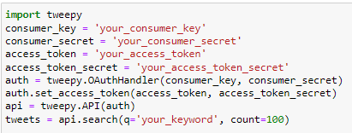

**4. CHOOSE A SENTIMENT ANALYSIS MODEL:**

*- for machine learning we are using library scikit-learn and below is a training of a simple model.*

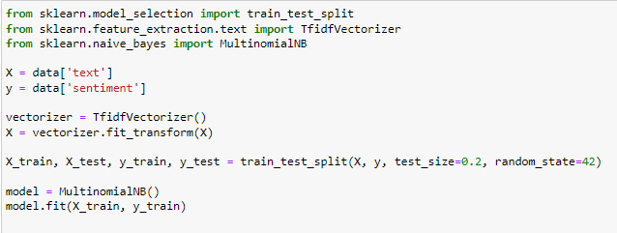

**5. LABELING:**

*- Annotating data with sentiment labels, such as positive, negative, or neutral. Already we have a labelled dataset for supervised learning for using machine learning models.*

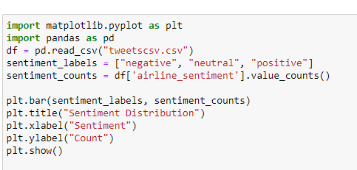

**6. MODEL TRAINING:**

*- In this step using a machine learning or deep learning approach, train your sentiment analysis model on the labelled dataset. This step requires hyperparameter tuning and cross-validation.*

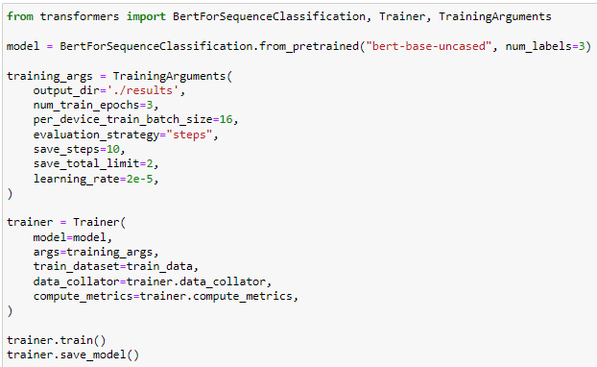

**7. EVALUATION:**

*- Assess the performance of your sentiment analysis model using appropriate evaluation metrics, such as accuracy, precision, recall, and F1-score. Make sure your model can effectively classify sentiments.*

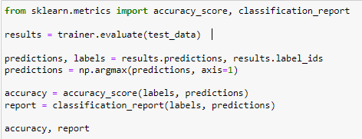

**8. SENTIMENT ANALYSIS IN ACTION:**

*- Apply your trained model to the marketing data to analyze customer sentiment. You can use the results to gain insights into customer satisfaction, identify areas for improvement, and track brand perception.*

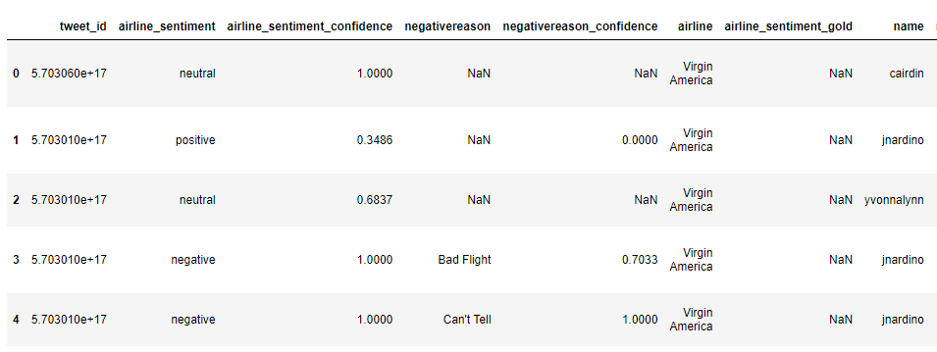

**9. VISUALIZATION AND REPORTING:**

*- Create visualizations or reports that summarize your findings. Visualizing sentiment trends over time or by product/service can be particularly useful for marketing teams.*

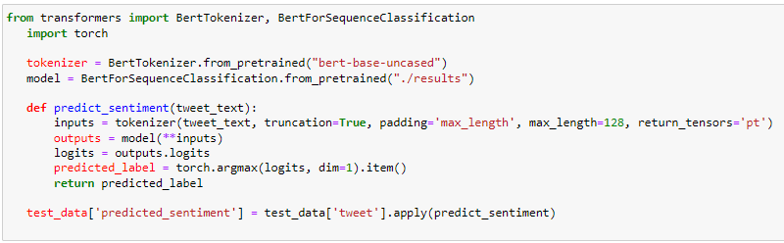

**10. ACTIONABLE INSIGHTS:**

*- Provide actionable insights and recommendations based on your sentiment analysis. These insights can help marketing teams make data-driven decisions and improve their strategies.*

-**INNOVATIVE TECHNIQUES AND APPROACHES**

*In the development of the sentiment analysis project, several innovative techniques and approaches were incorporated to enhance the system's accuracy, robustness, and relevance in the context of marketing and customer feedback analysis. These innovative methods are designed to provide businesses with more precise and actionable insights. Here are the notable techniques and approaches employed:*

**1. ASPECT-BASED SENTIMENT ANALYSIS:**

*- Aspect-based sentiment analysis goes beyond traditional sentiment classification (positive, negative, neutral) to dissect feedback and identify the sentiment associated with specific aspects or features of a product or service. This technique allows businesses to gain a deeper understanding of which aspects of their offerings are driving customer sentiments, enabling targeted improvements and informed decision-making.*

**2. DEEP LEARNING WITH PRE-TRAINED MODELS:**

*- The project leverages the power of pre-trained deep learning models, such as BERT (Bidirectional Encoder Representations from Transformers) and GPT (Generative Pre-trained Transformer). These models are capable of understanding the context and nuances of language more effectively than traditional machine learning models, enabling the system to provide more accurate sentiment analysis.*

**3. MULTIMODAL SENTIMENT ANALYSIS:**

*- In recognition of the increasingly diverse forms of customer feedback, this project incorporates the ability to analyze not only text but also other modalities, such as images and audio. By processing data from various sources, the system can capture sentiment in a multi-channel world, offering a holistic view of customer opinions.*

**4. REAL-TIME SENTIMENT ANALYSIS:**

*- The project's design includes real-time sentiment analysis capabilities, which allow for the immediate processing and analysis of incoming customer feedback and social media comments. This feature enables businesses to respond promptly to customer concerns, identify emerging trends, and address issues in real-time, ultimately improving customer satisfaction and brand reputation.*

**5. ETHICAL CONSIDERATIONS:**

*- An important innovation in the development process is the integration of ethical considerations. The sentiment analysis system has been designed with fairness and bias mitigation techniques to ensure that the analysis is not biased against any particular group, demographic, or sentiment. This* *ethical approach helps build trust with customers and stakeholders and ensures the system is used responsibly.*

**6. ADVANCED LANGUAGE MODELS AND TRANSFER LEARNING:**

*- To enhance the system's understanding of language and context, advanced language models and transfer learning techniques have been employed. By fine-tuning pre-trained models on specific datasets, the system can adapt to industry-specific terminology and domain-specific nuances, improving the accuracy of sentiment analysis.*

**7. REAL-TIME ALERTS AND NOTIFICATIONS:**

*- The sentiment analysis system incorporates a real-time alerting and notification mechanism. When significant shifts in sentiment are detected, or when emerging issues arise in customer feedback, the system can trigger alerts and notifications to inform relevant teams or individuals. This enables rapid response to customer concerns and immediate action when necessary.*

**8. CUSTOMIZED DICTIONARIES AND INDUSTRY-SPECIFIC LEXICONS:**

*- The system utilizes customized dictionaries and industry-specific lexicons to improve sentiment analysis accuracy for specialized markets and businesses. By incorporating domain-specific terminology, the system can better understand and analyze industry-specific customer feedback.*

**9. EXPLAINABLE AI (XAI):**

*- The sentiment analysis system integrates explainable AI techniques to provide clear explanations for its predictions. This is essential for transparency and to build trust with users. Businesses can understand why certain sentiment classifications are made, allowing for more confident decision-making.*

*These innovative techniques and approaches collectively enhance the sentiment analysis project's capabilities, making it a valuable tool for businesses seeking to gain deeper insights into customer feedback and improve their marketing strategies. By staying at the forefront of technology and ethical considerations, this project empowers businesses to make data-driven decisions and respond effectively to customer sentiments in an ever-evolving digital landscape.*

**PROJECT IMPACT AND FUTURE DIRECTION**

*In the future, there are several directions in which this project can evolve:*

**1. MULTILINGUAL SUPPORT:** *Expanding the system's capability to analyze customer feedback in multiple languages to cater to global markets.*

**2. EMOTION ANALYSIS:** *Incorporating more granular emotion analysis to better understand customer sentiments beyond just positive, negative, and neutral categories.*

**3. USER-FRIENDLY INTERFACES**: *Developing user-friendly interfaces and dashboards for marketing teams to interact with the sentiment analysis system more easily.*

**4. INTEGRATION WITH CRM SYSTEMS***: Integrating the sentiment analysis system with Customer Relationship Management (CRM) systems to enhance customer interactions and support.*

**5. REAL-TIME ALERTS**: *Implementing real-time alerting systems to immediately notify businesses of significant shifts in sentiment or emerging issues.*

**CONCLUSION**

*The field of marketing has undergone a significant transformation in the digital age, with businesses actively seeking ways to better understand and engage with their customers. Customer feedback and sentiments play a crucial role in this process, as they provide invaluable insights into product satisfaction, service quality, and overall brand perception. In this sentiment analysis project for marketing, we set out to harness the power of natural language processing and machine learning techniques to gain actionable insights from customer feedback data.*

**-Project objectives and significance:**

*Our project's primary objective was to create a robust sentiment analysis system capable of processing large volumes of customer feedback data and extracting meaningful sentiment insights. These insights can help marketing teams make data-driven decisions, identify areas for improvement, and enhance customer satisfaction, ultimately contributing to a more positive brand image and increased customer loyalty.*

*The significance of this project lies in its potential to revolutionize how businesses interact with their customers. By automating sentiment analysis, we enable companies to efficiently process vast amounts of unstructured text data, uncover hidden sentiments, and quickly respond to customer* *concerns or praises. This can lead to improved products, services, and marketing strategies, ultimately resulting in increased revenue and market competitiveness.*

**-Project phases and components:**

**1. Data collection**: *We collected and curated customer feedback data from various sources, including social media, online reviews, and customer surveys. This data formed the foundation of our sentiment analysis system.*

**2. Data preprocessing:** *The data preprocessing phase involved cleaning the text, tokenizing it, removing stop words, and applying stemming or lemmatization. These steps helped ensure that the text was ready for sentiment analysis.*

**3. Model training**: *We employed machine learning techniques to build a sentiment analysis model. This model was trained on a labeled dataset that associates text data with sentiment labels, such as positive, negative, or neutral.*

**4. Model evaluation**: *The performance of the sentiment analysis model was evaluated using standard metrics, such as accuracy, precision, recall, and F1-score. This step allowed us to assess the model's effectiveness.*

**5. Sentiment analysis in action**: *The trained model was applied to new customer feedback data, allowing us to analyze sentiment in real-world scenarios.*

**6. Visualization and reporting:** *We created visualizations and reports to help marketing teams understand sentiment trends, patterns, and insights more easily.*

***In conclusion****, this sentiment analysis project represents a significant step toward data-driven marketing and customer relationship management. It empowers businesses to harness the vast amounts of customer feedback data available to them, turning it into actionable insights that can drive product improvement and enhance brand perception. The innovative techniques and approaches integrated into this project position it as a valuable tool for businesses seeking a competitive edge in the modern marketing landscape.*

***Thank you!***