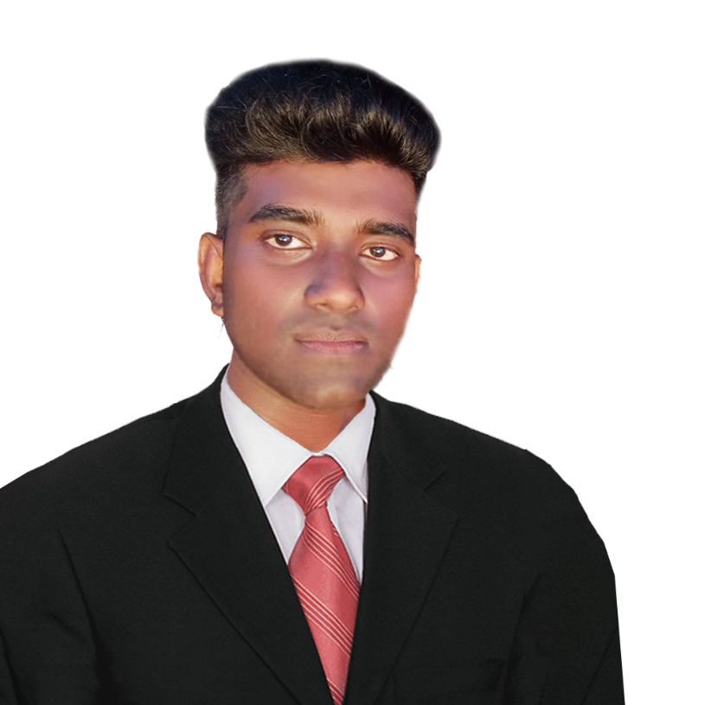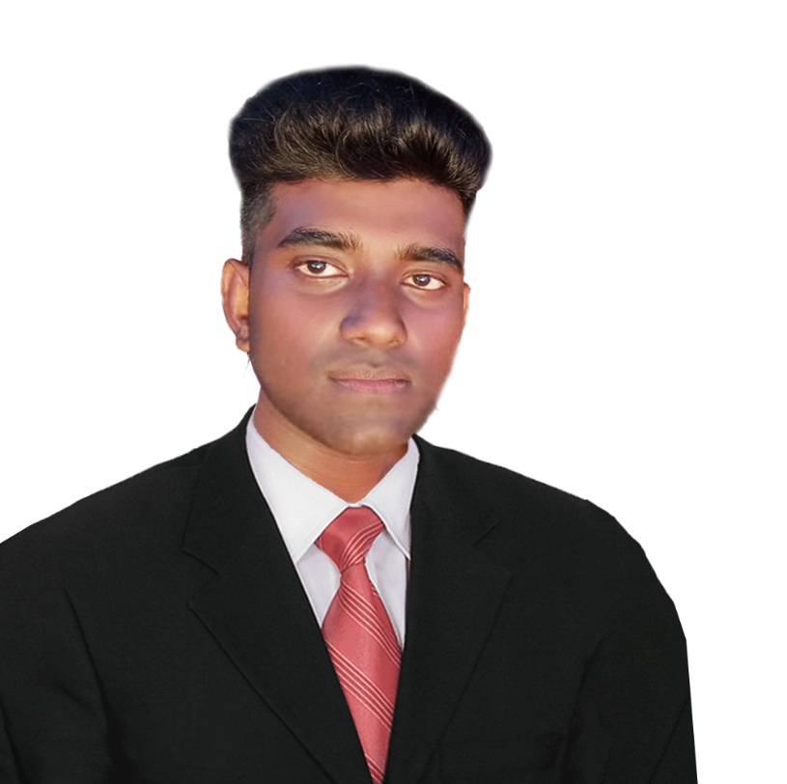



2024-07-07

LANGUAGE

I do hereby certify that the above information’s are true and accurate to the best of my knowledge and belief.

……………………………

Signature

…………………………

Date

I have all kinds of computer experience and more than one year work experience in computer department of Aluthgama Local council.(“*Pradeshiya Sabhawa*”)

**Local council - Aluthgama**

**20 22**

**20 21**

WORK EXPIRIANCE

EDUCATION



PROFILE

**SAEGIS Campus - Nugegoda**

**VTC - Kandewiharaya**

Studying for my 4-year IT degree at Saegis Campus

I have successfully completed the NVQ Level 4 IT course

Aluthgama, Sri Lanka

077 919 7196

**20 23**

D. D. LAKSHAN

**DEWAPURAGE DHANUSHKA LAKSHAN**



PHOTOSHOP



ILLUSTRATOR



CORDING

A driven and analytical computer science student with a keen eye for detail and a knack for problem-solving. I am eager to apply my technical skills and creativity to innovate in software development.

SKILLS

TAMIL



ENGLISH



SINHALA



<dhanushkalakshaan196@gmail.com>

CONTACT