Course | Digital Signal Processing Lab | Experiment No. | 08
Name | Dewashish Lambore | PRN | ____________
Language | Python 3.10 | Date | ____ / ____ / 2026
Discrete Fourier Transform and its Inverse
The seasonal breathing of the planet in the Mauna Loa CO₂ record
Abstract: The monthly Mauna Loa CO₂ record (the Keeling Curve) was trimmed to 67 whole years (N = 804), detrended, and transformed with a DFT implemented from its definition, as a matrix product and by the FFT; the three agreed to 1e-13, the IDFT recovered the signal to 1e-12 ppm, and Parseval's theorem held to 1e-16. The spectrum consists of two clean lines at exactly 1 and 2 cycles per year (amplitudes 2.84 and 0.81 ppm) above a noise floor of about 0.016 ppm. An IDFT of these two lines alone rebuilt the seasonal cycle, which peaks in May and bottoms out in Oct (6.2 ppm peak to trough) and explains 88 % of the detrended variance; removing it reproduced NOAA's official deseasonalized series to 0.165 ppm. Cutting the record by 5 months caused leakage that lowered the annual line by 23 %, which a Hann window and zero padding largely corrected. The seasonal swing grew from 5.8 to 6.6 ppm over six decades.
Keywords: DFT, IDFT, FFT, spectral leakage, windowing, zero padding, Parseval, frequency-domain filtering, Keeling Curve, CO₂, Python

1. Aim and Objectives
Aim: to compute the DFT and IDFT of a real-world signal, verify their properties, and use them to analyse and filter the signal in the frequency domain, in Python.
- Implement the DFT and IDFT from the definition and as a matrix, and compare them with the FFT in accuracy and speed.
- Read frequencies, amplitudes and phases from the spectrum and understand leakage, windowing and zero padding.
- Use the IDFT to synthesise the seasonal cycle and to remove it, and validate the result against NOAA's own product.

2. Real-World Application
Atmospheric CO₂ has been measured continuously on Mauna Loa, Hawaii, since 1958. The record rises every year because of fossil-fuel burning, but it also 'breathes': each northern spring and summer, forests and crops take up CO₂, and each autumn and winter decaying vegetation releases it. Climate scientists separate this seasonal cycle from the long-term rise in exactly the way done here, and the DFT is the natural tool because the cycle is a sum of sinusoids at 1, 2, ... cycles per year. The DFT and IDFT also sit at the heart of many everyday technologies (Table 1).
Table 1. Where the DFT and IDFT are used
Technology | What the DFT / IDFT does
Climate science (this experiment) | separates seasonal cycles from trends; seasonal adjustment of indices
4G / 5G / Wi-Fi (OFDM) | the transmitter is an IDFT and the receiver a DFT, one per symbol
MRI scanners | the image is the 2-D IDFT of the measured k-space data
Audio and music apps | spectrum analysers, pitch detection, MP3 / AAC compression
Power-quality meters | measure harmonics of the 50 Hz mains (IEC 61000-4-7)

3. Theory
The discrete Fourier transform of an $N$-point sequence $x[n]$ and its inverse are
$X[k]=\sum_{n=0}^{N−1}{}x[n] e^{−j2πkn/N}, x[n]=\frac{1}{N}\sum_{k=0}^{N−1}{}X[k] e^{j2πkn/N}$ (1)
for $k,n=0,…,N−1$. Collecting the twiddle factors $W_{N}^{kn}=e^{−j2πkn/N}$ in an $N×N$ matrix gives the matrix form, whose inverse is its scaled conjugate:
$X=Wx, W^{−1}=\frac{1}{N}W^{*}$ (2)
Bin $k$ corresponds to frequency $f_{k}=kf_{s}/N$, so the resolution is ${f_{s}}/N$. For a real signal a sinusoid $Acos(2πk_{0}n/N+ϕ)$ appears in bins $k_{0}$ and $N−k_{0}$, from which its amplitude and phase are read:
$f_{k}=\frac{kf_{s}}{N}, A=\frac{2|X[k_{0}]|}{N}, ϕ=∠X[k_{0}]$ (3)
Two properties are checked numerically: energy is preserved (Parseval) and the spectrum of a real signal is conjugate-symmetric, so only bins 0 to N/2 carry information:
$\sum_{n=0}^{N−1}{}{|x[n]|}^{2}=\frac{1}{N}\sum_{k=0}^{N−1}{}{|X[k]|}^{2}, X[N−k]=X^{*}[k]$ (4)
Leakage. The DFT implicitly repeats the N samples periodically. If a sinusoid does not complete a whole number of cycles in N samples, the repetition has a jump and the line spreads into neighbouring bins. A tapering window such as the Hann window reduces the spread, and zero padding to $PN$ points samples the same spectrum more finely without adding resolution:
$w[n]=\frac{1}{2}−\frac{1}{2}cos\frac{2πn}{N}, X_{pad}[k]=\sum_{n=0}^{N−1}{}x[n] w[n] e^{−j2πkn/(PN)}$ (5)
Note. Direct evaluation of Eq. 1 needs N² complex multiplications; the fast Fourier transform (FFT) computes exactly the same numbers in about N log₂ N by reusing partial sums. It is fastest when N has only small prime factors.

4. Dataset Description
The Mauna Loa monthly mean CO₂ record is published by the NOAA Global Monitoring Laboratory (in cooperation with Scripps Institution of Oceanography, which began it under C. D. Keeling). Values are dry-air mole fractions in parts per million (ppm). The CSV is 38 kB, freely downloadable and cached. It runs from 1958-03 to 2026-09 (823 months); NOAA also supplies a deseasonalized column, used here only as an independent check. For the DFT the record is trimmed to 1959-01 to 2025-12: N = 804 months = 67 whole years, so that 1 cycle per year falls exactly on bin k = 67.
Table 2. Dataset attributes
Property | Value | Property | Value
Provider | NOAA GML / Scripps | Station | Mauna Loa Observatory, Hawaii (3,397 m)
Full record | 1958-03 to 2026-09 | DFT record | 1959-01 to 2025-12, N = 804
Range | 312.42 to 432.34 ppm | Sampling | fs = 12 per year (monthly)
Resolution fs/N | 0.0149 cycles/year | Nyquist frequency | 6 cycles per year
Columns used | year, month, average, deseasonalized | Months without day count | 195 (early record)

Table 3. Last six samples of the DFT record
Year | Month | Decimal year | CO₂ (ppm) | NOAA deseasonalized | Trend | Detrended r[n]
2025 | 7 | 2025.5417 | 427.87 | 427.49 | 426.73 | +1.14
2025 | 8 | 2025.6250 | 425.48 | 427.41 | 426.95 | -1.47
2025 | 9 | 2025.7083 | 424.37 | 427.85 | 427.18 | -2.81
2025 | 10 | 2025.7917 | 424.87 | 428.12 | 427.40 | -2.53
2025 | 11 | 2025.8750 | 426.46 | 428.40 | 427.62 | -1.16
2025 | 12 | 2025.9583 | 427.49 | 428.22 | 427.85 | -0.36

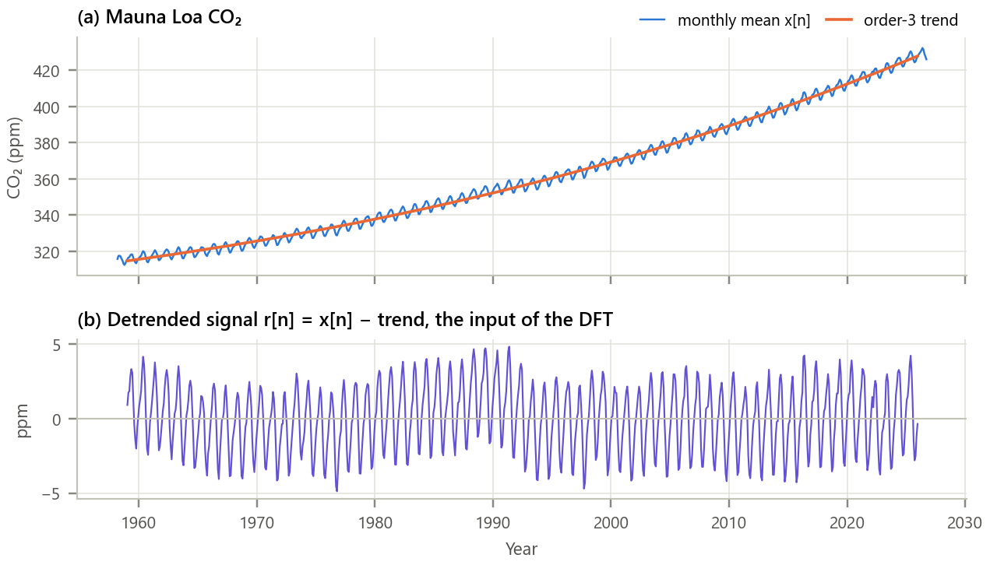
Figure 1. The input signal. (a) Monthly CO₂ with the order-3 polynomial trend; (b) the detrended signal.
Inference. CO₂ rose from about 316 to 426 ppm, and the rise is accelerating (the slope of the trend grew from 0.96 ppm/yr around 1960 to 2.57 ppm/yr around 2020). After the trend is removed, what remains is a strikingly regular oscillation of about ±3 ppm every year: a periodic signal for which the DFT is the natural description.

5. Methodology and Implementation
The trend is removed by least squares, the DFT of r[n] is computed, the bins at 1 and 2 cycles per year (k = 67 and 134, with their mirrors) are kept and all others set to zero, and the IDFT of what remains is the seasonal model. Leakage is studied by deleting 5 months, and the DFT matrix is timed against the FFT for several N.
Table 4. Software modules
Module | Responsibility
config.py | URL, sampling rate, trend order, harmonics, leakage and timing settings
data_loader.py | Download once, cache, trim to whole years
dft.py | DFT by definition, DFT matrix, IDFT, amplitude/phase, bin masking, Hann window, checks
analysis.py | Spectrum, leakage, seasonal synthesis, decades, growth rate, timing
plots.py / gui.py | Report figures / interactive spectrum analyser and DFT calculator
test_dft.py | 10 unit tests (inverse, Parseval, symmetry, linearity, shift, leakage): all pass

Core of dft.py
1 def dft_direct(x): # X[k] = sum x[n] e^{-j 2 pi k n / N}
2 N = len(x)
3 return np.array([sum(x[n] * np.exp(-2j * np.pi * k * n / N) for n in range(N))
4 for k in range(N)])
5
6 def dft_matrix(N): # W[k, n] = e^{-j 2 pi k n / N}
7 k = np.arange(N)
8 return np.exp(-2j * np.pi * np.outer(k, k) / N)
9
10 def idft(X): # x = (1/N) W* X
11 return np.conj(dft_matrix(len(X))) @ X / len(X)
12
13 def keep_bins(X, bins): # ideal filter: keep +k and N-k only
14 mask = np.zeros(len(X), bool)
15 for k in bins:
16 mask[k % len(X)] = mask[-k % len(X)] = True
17 return np.where(mask, X, 0)
18

GUI. gui.py (Figure 2) lets the user change the record length month by month, the trend order, the window and the zero-padding factor, and choose which harmonics the IDFT keeps. It reports the line amplitude, whether N/12 falls on a bin, the resolution and the error against NOAA. A calculator returns the DFT of any typed sequence for checking hand calculations. Run python run_experiment.py and python gui.py.
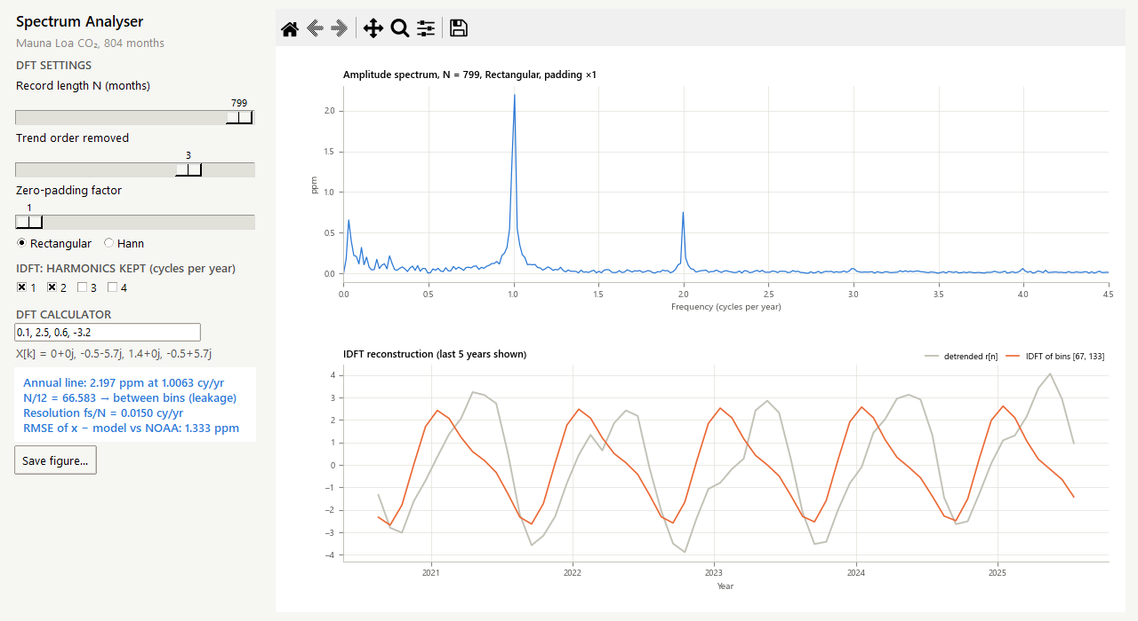
Figure 2. The spectrum analyser with N = 799 months. N/12 is not an integer: the annual line leaks, and an IDFT that keeps the nearest bins drifts out of phase.

6. Calculations
4-point DFT by hand. One sample per quarter of the seasonal model (January, April, July, October), rounded: x = [0.1, 2.5, 0.6, −3.2]. With N = 4, $W_{4}=e^{−jπ/2}=−j$, so $W_{4}^{kn}$ cycles through 1, −j, −1, j:
Table 5. DFT of four quarterly values
k | X[k] = x[0] + x[1]W⁴ᵏ + x[2]W⁴²ᵏ + x[3]W⁴³ᵏ | X[k] | |X[k]| | 2|X[k]|/N
0 | 0.1 + 2.5 + 0.6 − 3.2 | 0.00 | 0.00 | n/a (mean)
1 | 0.1 + 2.5(−j) + 0.6(−1) − 3.2(j) | -0.50 − j5.70 | 5.72 | 2.86
2 | 0.1 − 2.5 + 0.6 + 3.2 | 1.40 | 1.40 | 0.70
3 | 0.1 + 2.5(j) + 0.6(−1) − 3.2(−j) | -0.50 + j5.70 | 5.72 | mirror of k = 1

Checks. X[3] is the complex conjugate of X[1] (symmetry). Parseval: Σx² = 16.86 and (1/4)Σ|X|² = (0 + 32.74 + 1.96 + 32.74)/4 = 16.86. IDFT of x[1]: (1/4)[X[0] + X[1]·j + X[2]·(−1) + X[3]·(−j)] = (1/4)(0 + 5.7 − 0.5j − 1.4 + 5.7 + 0.5j) = 2.5. Real record: |X[67]| = 1142.8, so A = 2|X|/N = 2.843 ppm with phase φ = -1.665 rad. The fundamental alone peaks where 2πn/12 + φ = 0, i.e. n = 3.18 months after the start of January (mid-April); adding the 2-cycle harmonic moves the combined peak to May. These values match the program (checked by test_dft.py).

7. Results and Discussion
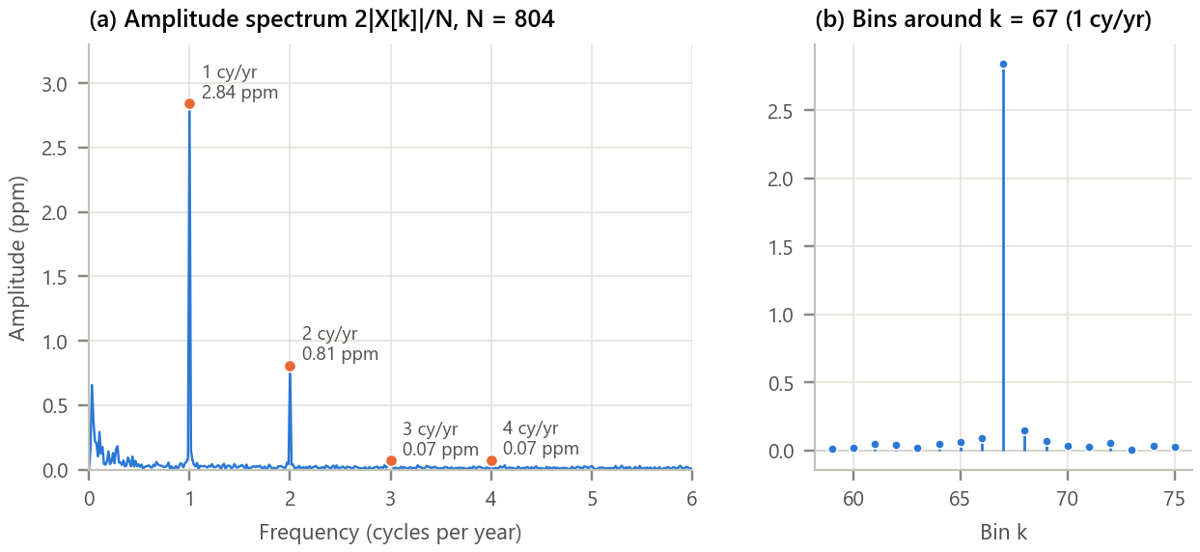
Figure 3. Amplitude spectrum of the detrended record. (a) 0 to 6 cycles per year (Nyquist); (b) individual bins around k = 67.
Inference.
- The spectrum is almost empty except for two lines exactly at 1 and 2 cycles per year: 2.843 ppm and 0.807 ppm, about 177 and 50 times the noise floor (0.016 ppm). The 3 and 4 cycle harmonics are tiny (0.068 and 0.072 ppm), so the seasonal cycle is well described by two sinusoids.
- Because N = 804 is a whole number of years, the annual line falls on a single bin: its neighbours are at noise level, i.e. there is no leakage. The small bump near 0 cycles per year is slow variation in the growth rate that a cubic trend does not capture.

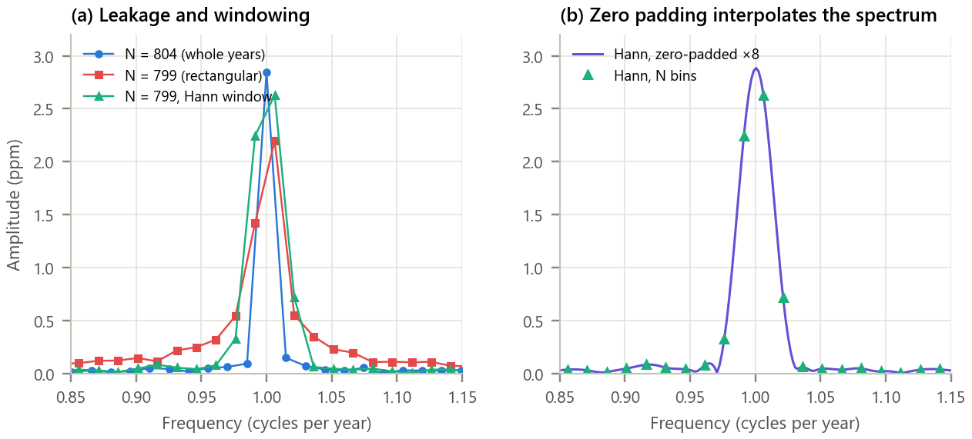
Figure 4. Leakage, windowing and zero padding. (a) N = 804 versus N = 799 with rectangular and Hann windows; (b) Hann-windowed spectrum zero-padded ×8.
Inference. With 799 months, N/12 is not an integer (the annual line sits 0.58 of a bin between bins), and the line leaks: its peak drops from 2.84 to 2.20 ppm and its energy spreads into neighbouring bins. The Hann window recovers the peak to 2.63 ppm and suppresses the far leakage, at the cost of a wider main lobe. Zero padding then shows the underlying curve: its maximum is 2.88 ppm at 1.0006 cycles per year, close to the true values. Zero padding interpolates; it does not sharpen the line.

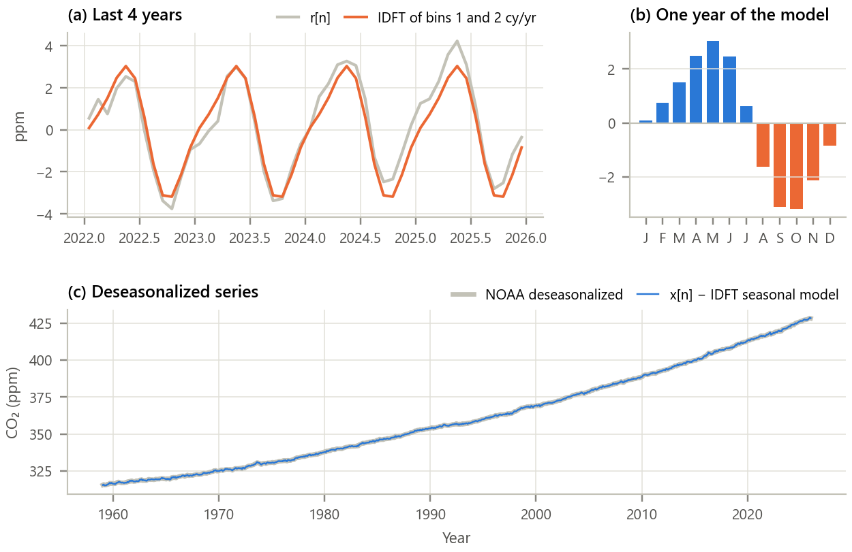
Figure 5. Synthesis and removal of the seasonal cycle with the IDFT. (a) Detrended signal and the IDFT of the two seasonal lines; (b) one year of the model; (c) deseasonalized CO₂ compared with NOAA's product (RMSE 0.165 ppm).
Inference.
- Keeping only 4 of 804 DFT coefficients reproduces the seasonal oscillation and explains 88 % of the detrended variance; what is left (std 0.76 ppm) is weather-driven noise and year-to-year growth variation.
- CO₂ is highest in May and lowest in Oct, a 6.2 ppm swing: the Northern Hemisphere biosphere draws CO₂ down through the growing season and releases it in autumn and winter.
- Subtracting the model gives a deseasonalized curve within 0.165 ppm of NOAA's official series, which is produced by a different method, so the simple DFT/IDFT filter is fit for purpose.

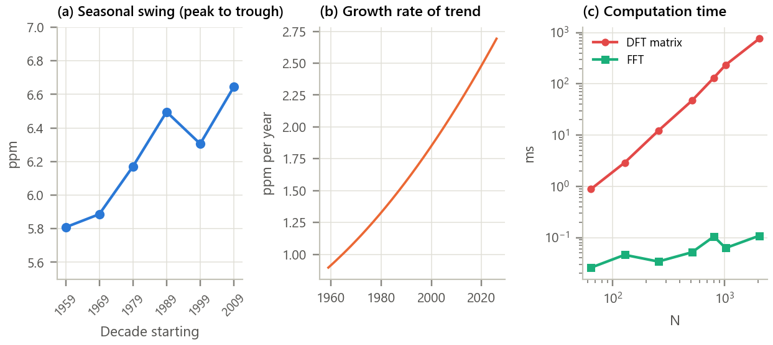
Figure 6. Long-term changes and computational cost. (a) Peak-to-trough seasonal swing per decade (IDFT of two lines); (b) growth rate of the trend; (c) time for one transform.
Inference.
- The seasonal swing grew from 5.81, 5.89, 6.17, 6.50, 6.31, 6.64 ppm decade by decade, about 14 % in total, consistent with published reports of a strengthening seasonal exchange in the north. Meanwhile the growth rate of CO₂ itself nearly tripled.
- The DFT matrix takes 120 ms for N = 804 and grows as N²; the FFT takes 0.09 ms, about 1271 times faster. The FFT is slower for N = 804 than for N = 1024 (0.06 ms) because 804 = 4·3·67 has a large prime factor.

Table 6. Summary of results
Quantity | Result
DFT matrix / definition versus FFT | 1e-13 / 4e-14
IDFT reconstruction error; Parseval; symmetry | 1e-12 ppm; 1e-16; 1e-16
Annual / semi-annual line | 2.843 / 0.807 ppm at 1.000 / 2.000 cy/yr
Seasonal maximum, minimum, swing | May, Oct, 6.22 ppm
Deseasonalized versus NOAA (RMSE) | 0.165 ppm
Leakage (N = 799): rectangular / Hann / Hann + padding | 2.20 / 2.63 / 2.88 ppm
Seasonal swing 1959-1968 / 2009-2018 | 5.81 / 6.64 ppm
FFT speed-up at N = 804 | 1271 ×

8. Conclusion
The DFT and IDFT were implemented from first principles and verified against the FFT and against their defining properties to machine precision. Applied to the Keeling Curve, the DFT reduced 67 years of monthly data to two numbers that matter, the 2.84 ppm annual and 0.81 ppm semi-annual lines, and the IDFT of those lines alone rebuilt the planet's seasonal breathing (maximum in May, minimum in Oct) well enough to reproduce NOAA's deseasonalized record within 0.17 ppm. The experiment also exposed the practical side of the transform: choose N to contain whole periods or use a window to control leakage, remember that zero padding interpolates but does not resolve, and use the FFT, ideally with a highly composite N, because the direct sum quickly becomes too slow.

9. Learning Outcomes
- Compute the DFT and IDFT by definition, as a matrix product and with the FFT.
- Convert bins to frequencies and read amplitudes and phases of sinusoidal components.
- Explain and control spectral leakage with record length, windowing and zero padding.
- Filter in the frequency domain by editing DFT coefficients and inverting with the IDFT.

10. References
[1] A. V. Oppenheim and R. W. Schafer, Discrete-Time Signal Processing, 3rd ed. Pearson, 2010, ch. 8 and 9.
[2] F. J. Harris, “On the use of windows for harmonic analysis with the discrete Fourier transform,” Proc. IEEE, vol. 66, no. 1, pp. 51-83, 1978.
[3] X. Lan, P. Tans and K. W. Thoning, “Trends in globally-averaged CO₂ determined from NOAA Global Monitoring Laboratory measurements,” NOAA GML, https://gml.noaa.gov/ccgg/trends/.
[4] C. D. Keeling, “The concentration and isotopic abundances of carbon dioxide in the atmosphere,” Tellus, vol. 12, pp. 200-203, 1960.
[5] H. D. Graven et al., “Enhanced seasonal exchange of CO₂ by northern ecosystems since 1960,” Science, vol. 341, pp. 1085-1089, 2013.

