Course | Digital Signal Processing Lab | Experiment No. | 11
Name | Dewashish Lambore | PRN | ____________
Language | Python 3.10 | Date | ____ / ____ / 2026
FIR Filter Design by Windowing
Heart rate and breathing rate from one fingertip pulse sensor
Abstract: Linear-phase FIR filters were designed by the window method, from the ideal sinc impulse response and the rectangular, Hann, Hamming, Blackman and Kaiser windows, and implemented as non-recursive difference equations. For the same specification the four classical windows gave stopband attenuations of -21, -44, -52, -75 dB, matching the textbook values, at the cost of progressively wider transition bands; Kaiser's formulas sized a 60 dB design at N = 1511 taps (59.4 dB achieved). The filters were applied to an 8-minute photoplethysmogram (PPG) from an intensive-care patient (PhysioNet BIDMC): a 251-tap band-pass filter (0.5 to 4 Hz) recovered the heart rate with a mean absolute error of 1.49 bpm against the bedside monitor, and a 501-tap low-pass filter (0.5 Hz) recovered the breathing rate within 1.33 breaths per minute of clinicians' manual annotations. The filters' constant group delay (1 s and 2 s) was removed exactly, and longer filters improved rejection but could not remove in-band motion artefacts.
Keywords: FIR filter, window method, Hamming, Blackman, Kaiser window, linear phase, group delay, difference equation, photoplethysmography, heart rate, respiration rate, Python

1. Aim and Objectives
Aim: to design FIR filters by the window method, implement them by their difference equation, plot their frequency response, and use them to extract physiological information from a real signal, in Python.
- Derive windowed-sinc low-pass and band-pass filters and compare five windows by ripple, attenuation and transition width; size a filter with Kaiser's formulas.
- Implement the filters as y[n] = Σ bₖ x[n − k], verify linear phase and constant group delay.
- Extract heart rate and breathing rate from a PPG and validate them against hospital reference data.

2. Real-World Application
A photoplethysmogram (PPG) is measured by shining light into the skin and recording how much is absorbed as blood volume changes with each heartbeat. The same sensor is in hospital pulse oximeters, smartwatches and fitness bands. Its raw signal mixes three things at different frequencies: the cardiac pulse (about 1 to 3 Hz), a slow modulation by breathing (about 0.1 to 0.5 Hz), and noise from motion and electronics at higher frequencies. Separating them is a filtering problem, and FIR filters are preferred because their linear phase does not distort the pulse shape or shift beats relative to each other, which matters for heart-rate variability and clinical waveform analysis. Table 1 lists other uses of window-designed FIR filters.
Table 1. Where window-designed FIR filters are used
Field | Filter | Why FIR / linear phase
Wearables, pulse oximeters (this experiment) | band-pass and low-pass on PPG | keeps pulse shape and beat timing
ECG and EEG instruments | band-pass 0.5 to 40 Hz, notch | no phase distortion of clinical waveforms
Audio crossovers, equalisers | low-pass / high-pass pairs | phase-coherent summation of loudspeakers
Digital communications | pulse shaping, matched filters | symmetric taps avoid inter-symbol distortion
Seismology | band-pass of seismograms | arrival times of waves are preserved

3. Theory
An ideal low-pass filter with cut-off $f_{c}$ has an infinitely long sinc impulse response. The window method delays it by $M/2$ (with $M=N−1$) to make it causal and multiplies it by a finite window $w[n]$ of $N$ samples:
$h[n]=h_{d}[n] w[n], h_{d}[n]=2\frac{f_{c}}{f_{s}} sinc(2\frac{f_{c}}{f_{s}}(n−\frac{M}{2})), 0≤n≤M$ (1)
A band-pass is the difference of two ideal low-passes, $h_{d}=h_{d,f_{2}}−h_{d,f_{1}}$. The four classical windows are raised cosines; Kaiser's window uses the modified Bessel function $I_{0}$ and a shape parameter $β$:
$w_{Hamming}[n]=0.54−0.46cos\frac{2πn}{M}, w_{Kaiser}[n]=\frac{I_{0}(β\sqrt{1−(2n/M−1)^{2}})}{I_{0}(β)}$ (2)
Multiplying by the window convolves the ideal response with the window's spectrum: the main lobe sets the transition width and the sidelobes set the stopband attenuation (Table 2). For a required attenuation A dB and transition width Δω (rad/sample), Kaiser's formulas give the design directly:
$β=0.1102 (A−8.7) (A>50), N≈\frac{A−8}{2.285 Δω}+1$ (3)
Table 2. Window properties (Oppenheim and Schafer, Table 7.2) and measured attenuation
Window | Peak sidelobe | Filter stopband | Transition width Δf | Measured here (N = 251)
Rectangular | -13 dB | -21 dB | ≈ 2·fs/M | -21.3 dB
Hann | -31 dB | -44 dB | ≈ 4·fs/M | -44.0 dB
Hamming | -41 dB | -53 dB | ≈ 4·fs/M | -52.4 dB
Blackman | -57 dB | -74 dB | ≈ 6·fs/M | -75.4 dB

The filter is realised by the non-recursive difference equation; because the coefficients are symmetric, $h[n]=h[M−n]$, the phase is linear and every frequency is delayed by the same group delay:
$y[n]=\sum_{k=0}^{M}{}h[k] x[n−k], H(e^{jω})=A(ω) e^{−jωM/2}, τ=\frac{M}{2}\text{ samples}$ (4)
Note. A constant delay is harmless: it can be removed exactly by shifting the output M/2 samples earlier, which is done in this experiment. An IIR filter of similar selectivity (Experiment 12) needs far fewer coefficients but has a frequency-dependent delay that distorts waveform shape.

4. Dataset Description
The BIDMC PPG and Respiration Dataset (Pimentel et al., PhysioNet, ODC Attribution licence) contains 53 eight-minute recordings from adult patients at the Beth Israel Deaconess Medical Center, extracted from the MIMIC-II waveform database. Each record has the PPG, impedance respiration and ECG at 125 Hz, the bedside monitor's numeric values once per second, and every breath annotated manually by two trained annotators. Record bidmc01 (88-year-old male, medical ICU) was used: the binary WFDB file is read directly with its header gains, about 596 kB in total.
Table 3. Dataset attributes
Property | Value | Property | Value
Source | PhysioNet BIDMC 1.0.0 | Record | bidmc01, 5 signals
Sampling rate | 125 Hz | Length | 60,001 samples (8.0 min)
Signal used | PLETH (PPG), unit NU | Gain / baseline | 138229 / -63710
Reference heart rate | monitor PULSE, mean 91.0 bpm | Reference breathing | 170 annotated breaths
Monitor RESP | mean 21.4 per min | Missing PULSE values | 13 of 481 s

Table 4. Dataset preview with the unit conversion
n | Time (s) | Raw int16 | PPG = (raw − baseline)/gain | Monitor PULSE at that second
12,500 | 100.000 | 7769 | 0.51710 | 91
12,501 | 100.008 | 7769 | 0.51710 | 91
12,502 | 100.016 | 7769 | 0.51710 | 91
12,503 | 100.024 | 7769 | 0.51710 | 91
12,504 | 100.032 | 7769 | 0.51710 | 91
12,505 | 100.040 | 7904 | 0.51808 | 91

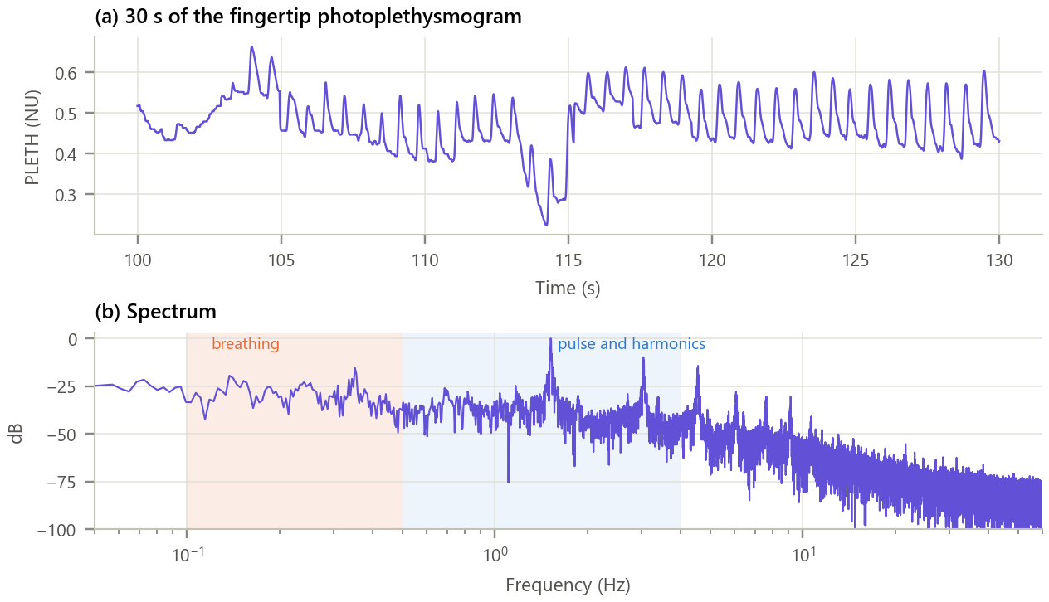
Figure 1. The input photoplethysmogram. (a) 30 s of the signal; (b) its spectrum with the breathing and pulse bands shaded.
Inference. Individual pulses are clearly visible, riding on a slow wave that follows breathing, and a large dip at about 113 s is a motion artefact. The spectrum shows the cardiac fundamental at 1.52 Hz (91 bpm) with harmonics at 3.0 and 4.5 Hz, broad energy below 0.5 Hz from breathing, and a noise floor above 10 Hz. The pulse and breathing bands do not overlap, so linear filters can separate them, provided their transition bands are narrow enough.

5. Methodology and Implementation
The band-pass filter for the pulse uses 251 taps (Hamming), the low-pass for breathing 501 taps (Hamming). The output is advanced by M/2 to remove the delay; beats and breaths are found as peaks at least 0.33 s and 1.5 s apart; rates are averaged in 16 s and 60 s windows and compared with the references.
Table 5. Software modules
Module | Responsibility
config.py | Record, file URLs, band edges, tap counts, windows, rate-estimation settings
data_loader.py | Download once, parse the WFDB header, read format-16 samples, load references
fir.py | Windows, ideal responses, windowed designs, Kaiser formulas, difference equation, H(f), delay
analysis.py | Window study, filters, delay compensation, beat and breath detection, validation, tap study
plots.py / gui.py | Report figures / interactive FIR filter designer
test_fir.py | 9 unit tests (match with SciPy firwin, symmetry, constant delay, Kaiser spec): all pass

Core of fir.py
1 def ideal_lowpass(fc, fs, N): # h_d[n] = 2fc/fs sinc(2fc/fs (n - M/2))
2 n = np.arange(N) - (N - 1) / 2
3 return 2 * fc / fs * np.sinc(2 * fc / fs * n)
4
5 def design_bandpass(f1, f2, fs, N, win="hamming"):
6 h = (ideal_lowpass(f2, fs, N) - ideal_lowpass(f1, fs, N)) * window(win, N)
7 return h / abs(np.sum(h * np.exp(-2j * np.pi * np.sqrt(f1 * f2) / fs * np.arange(N))))
8
9 def fir_filter(b, x): # y[n] = sum_k b_k x[n - k]
10 y = np.zeros(len(x))
11 for k, bk in enumerate(b):
12 y[k:] += bk * x[:len(x) - k]
13 return y
14

GUI. gui.py (Figure 2) designs a low-pass or band-pass filter with any cut-offs, any odd number of taps and any window (including Kaiser with adjustable β). It shows the impulse response with its delay, the magnitude response, the filtered PPG, and the heart or breathing rate with its error against the hospital reference; the coefficients can be saved. Run python run_experiment.py and python gui.py.
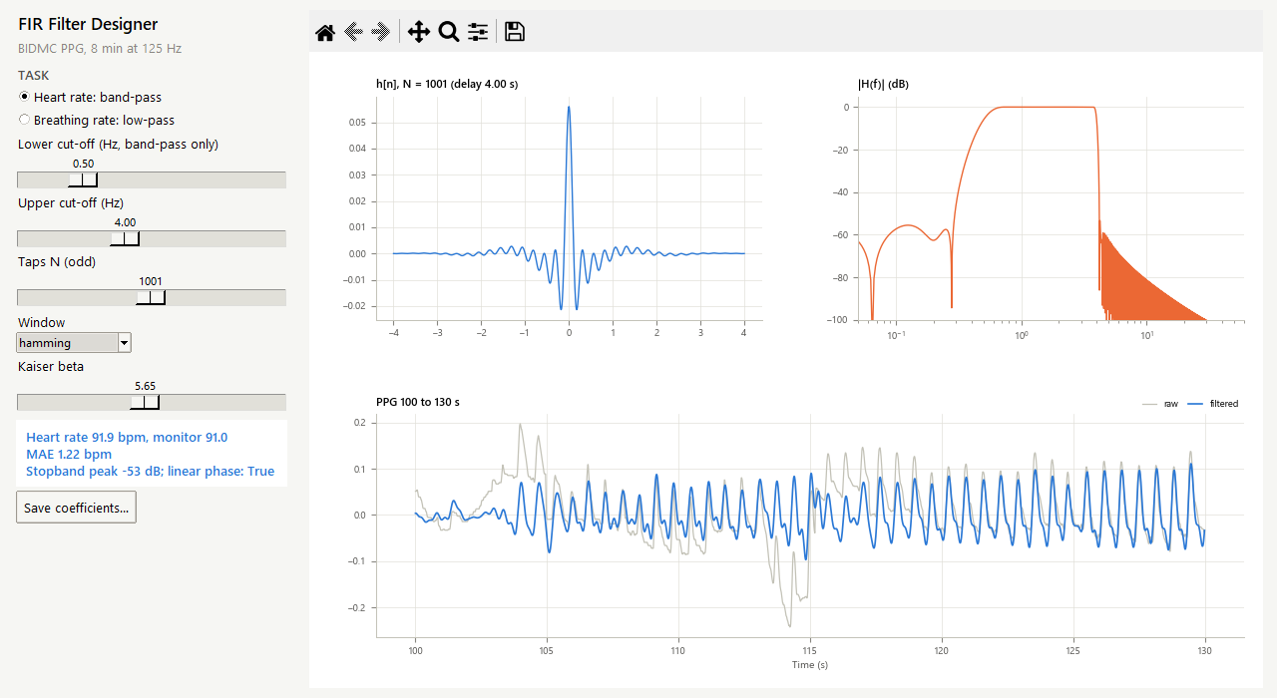
Figure 2. The FIR filter designer with a 1,001-tap Hamming band-pass filter. Stopband better than −50 dB and no baseline wander in the filtered pulse.

6. Calculations
5-tap low-pass by hand. fc = fs/4 (31.25 Hz), N = 5, M = 4, so 2fc/fs = ½ and $h_{d}[n]=\frac{1}{2}sinc(\frac{n−2}{2})$:
Table 6. Window-method design of a 5-tap filter
n | n − M/2 | h_d[n] = ½ sinc((n − 2)/2) | Hamming w[n] | h[n] = h_d w | normalised h[n]
0 | -2 | 0.0000 | 0.08 | 0.0000 | 0.0000
1 | -1 | 0.3183 | 0.54 | 0.1719 | 0.2037
2 | +0 | 0.5000 | 1.00 | 0.5000 | 0.5926
3 | +1 | 0.3183 | 0.54 | 0.1719 | 0.2037
4 | +2 | 0.0000 | 0.08 | 0.0000 | 0.0000

Sum of h[n] = 0.8438, so dividing by it gives unit DC gain; the taps are symmetric, hence linear phase with a delay of M/2 = 2 samples (16 ms). At fc the normalised filter gives |H| = 0.593 (-4.5 dB), and at fs/2 it gives 0.185. Kaiser sizing: for A = 60 dB and a transition of 0.3 Hz, Δω = 2π·0.3/125 = 0.01508 rad, β = 0.1102·(60 − 8.7) = 5.653 and N = (60 − 8)/(2.285·Δω) + 1 → 1511 taps. Delays used: (251 − 1)/2 = 125 samples = 1 s and (501 − 1)/2 = 250 samples = 2 s. The program reproduces these values (checked by test_fir.py).

7. Results and Discussion
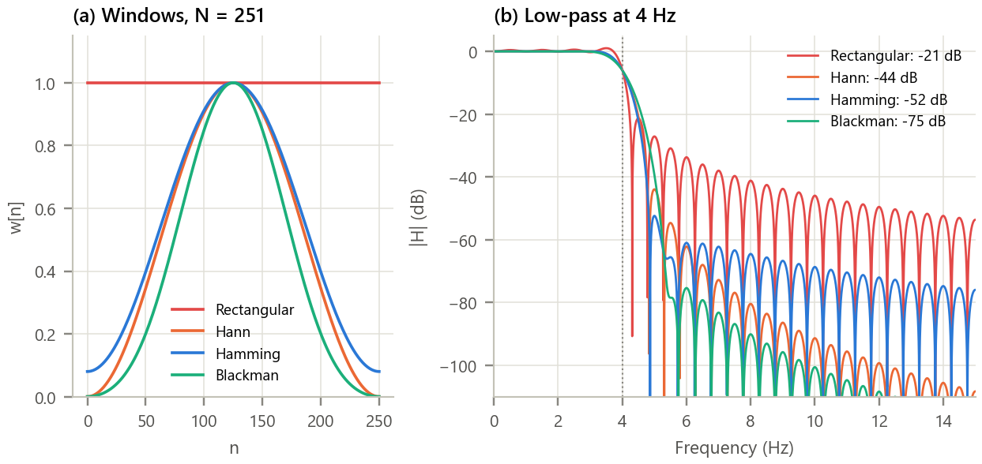
Figure 3. Effect of the window on a low-pass filter. (a) The four windows for N = 251; (b) the resulting low-pass responses at 4 Hz with their measured stopband attenuation.
Inference. Each window trades transition width for attenuation exactly as theory predicts: the rectangular window gives the sharpest edge (−3 to −40 dB in 0.40 Hz) but only -21 dB of attenuation with ripples that decay slowly; Hann reaches -44 dB, Hamming -52 dB and Blackman -75 dB, while the transition widens to 1.27 Hz. Passband ripple falls from 1.30 dB to 0.003 dB. Hamming is a good default: about 53 dB with a moderate transition.

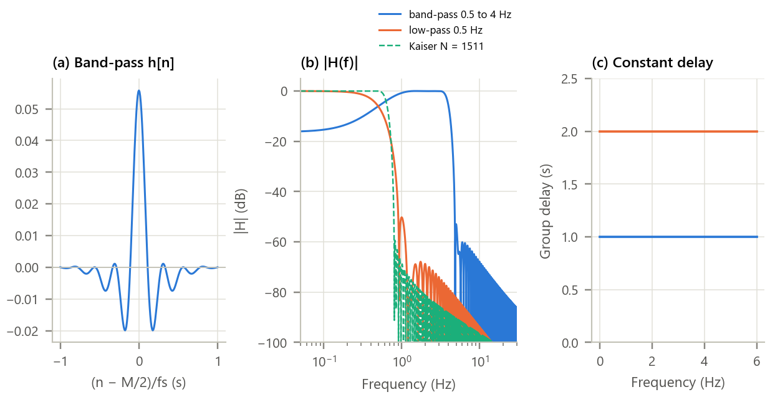
Figure 4. The designed filters. (a) Band-pass impulse response; (b) magnitude responses, including the Kaiser design; (c) group delay.
Inference. The band-pass passes the pulse with 0.01 dB at 1.5 Hz and attenuates 10 Hz noise by 68 dB, but with 251 taps its lower edge is soft: breathing at 0.25 Hz is cut by only 12 dB. The low-pass keeps 0.33 Hz breathing (-1.7 dB) and removes the 1.5 Hz pulse by 69 dB. The Kaiser design reaches 59.4 dB against its 60 dB target with N = 1511 (the formulas are approximations, so a few more taps would close the gap), and shows that a 0.3 Hz transition costs many taps at 125 Hz. Both filters are exactly symmetric (asymmetry 5e-18) and their group delay is flat at 1 s and 2 s (spread 2e-14 samples).

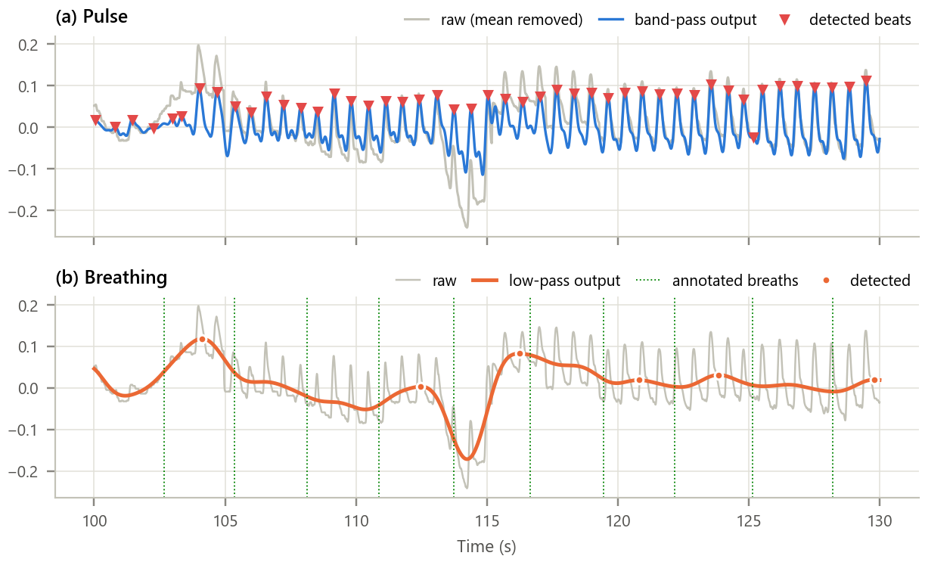
Figure 5. The filters applied to the PPG (100 to 130 s). (a) Raw signal, band-pass output and detected beats; (b) low-pass output, detected breaths and the manual breath annotations.
Inference. After delay compensation the band-pass output lines up beat for beat with the raw pulses: linear phase shifted nothing. Each pulse gives one clean peak except during the motion artefact around 113 s, where the residual slow wander causes a few missed or extra beats. The low-pass output is a smooth breathing wave whose peaks fall close to the annotators' marks, again with trouble around the artefact.

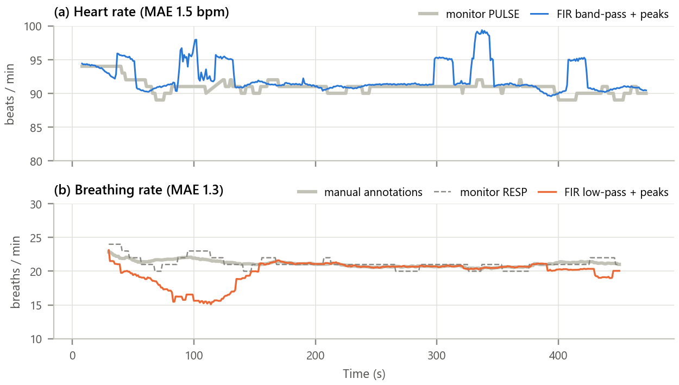
Figure 6. Rates estimated from the filtered PPG against the hospital references. (a) Heart rate (16 s windows) against the monitor; (b) breathing rate (60 s windows) against the manual annotations and the monitor's impedance-based value.
Inference.
- Heart rate: 92.2 bpm against 91.0 bpm from the monitor, mean absolute error 1.49 bpm from 725 detected beats. Short excursions to about 99 bpm coincide with motion artefacts.
- Breathing rate: 19.8 against 21.1 breaths per minute from the annotations (MAE 1.33); 87 % of annotated breaths were found within 1.5 s. The underestimate between 60 and 150 s is the artefact region, where breaths are masked.
- Lengthening the band-pass from 251 to 1001 taps improved the 0.25 Hz rejection from 12 to 58 dB and lowered the heart-rate error from 1.49 to 1.22 bpm, but the artefact spikes (99 bpm) remained: noise that lies inside the passband cannot be removed by any linear filter.

Table 7. Effect of filter length on heart-rate accuracy
Band-pass taps N | Delay (s) | Gain at 0.25 Hz (dB) | HR MAE (bpm) | Windows within ±2 bpm
251 | 1 | -11.9 | 1.49 | 79 %
501 | 2 | -22.2 | 1.22 | 85 %
751 | 3 | -40.7 | 1.22 | 85 %
1001 | 4 | -57.5 | 1.22 | 85 %

8. Conclusion
Window-designed FIR filters were built from first principles, matched SciPy's implementation exactly, and showed the predicted trade-off between transition width and stopband attenuation for each window, while Kaiser's formulas sized a filter close to a stated specification. Implemented as a symmetric difference equation, every filter had exactly linear phase and a constant delay that was removed by a simple shift, so the pulse shape and beat timing were preserved. On a real ICU recording the band-pass filter recovered the heart rate to 1.5 bpm and the low-pass filter the breathing rate to 1.3 breaths per minute of the hospital references, which is the principle behind smartwatch heart and breathing measurement. The price of FIR filters is length: sharp edges at low frequencies need hundreds or thousands of taps and seconds of delay, and no filter, however long, removes artefacts that share the signal's band.

9. Learning Outcomes
- Design low-pass and band-pass FIR filters by the window method and size them with Kaiser's formulas.
- Relate a window's main lobe and sidelobes to the filter's transition width and stopband attenuation.
- Implement an FIR filter as a difference equation, verify linear phase and compensate its group delay.
- Apply FIR filters to a physiological signal and validate the extracted rates against reference data.

10. References
[1] A. V. Oppenheim and R. W. Schafer, Discrete-Time Signal Processing, 3rd ed. Pearson, 2010, ch. 7.5 and 7.6.
[2] J. F. Kaiser, “Nonrecursive digital filter design using the I₀-sinh window function,” in Proc. IEEE Int. Symp. Circuits and Systems, 1974, pp. 20-23.
[3] M. A. F. Pimentel et al., “Toward a robust estimation of respiratory rate from pulse oximeters,” IEEE Trans. Biomed. Eng., vol. 64, no. 8, pp. 1914-1923, 2017.
[4] A. L. Goldberger et al., “PhysioBank, PhysioToolkit, and PhysioNet,” Circulation, vol. 101, no. 23, pp. e215-e220, 2000.
[5] J. Allen, “Photoplethysmography and its application in clinical physiological measurement,” Physiol. Meas., vol. 28, no. 3, pp. R1-R39, 2007.

