Course | Digital Signal Processing Lab | Experiment No. | 03
Name | Dewashish Lambore | PRN | ____________
Language | Python 3.10 | Date | ____ / ____ / 2026
Moving-Average Filter, Sampling and Reconstruction
Choosing the sampling rate of a bird-song recorder
Abstract: A real 5-second bird-song field recording (ESC-50 dataset) with a 99 % bandwidth of 6.63 kHz was treated as the analog signal and sampled at 16, 8 and 4 kHz, with no prefilter, a moving-average prefilter and a proper FIR anti-aliasing filter, then reconstructed by zero-order hold, linear and sinc interpolation. Sampling above the Nyquist rate (13.3 kHz) at 16 kHz with an FIR prefilter and sinc reconstruction reached 33.4 dB SNR, while 4 kHz folded 88 % of the song's energy into false tones. The moving average proved to be a cheap but weak anti-aliasing filter: it helped at 4 kHz (-8.6 to -3.4 dB) but hurt at 8 kHz (17.0 to 14.3 dB) because it attenuates the passband. Reconstruction quality ranked sinc > linear > hold by 12 to 27 dB.
Keywords: sampling theorem, Nyquist rate, aliasing, moving-average filter, anti-aliasing, interpolation, reconstruction, bioacoustics, Python

1. Aim and Objectives
Aim: to study the moving-average filter, the sampling of a signal, and the reconstruction of the signal from its samples, using a real audio recording in Python.
- Measure the bandwidth of a real signal and find its Nyquist rate.
- Sample it above and below the Nyquist rate and observe aliasing, with and without an anti-aliasing prefilter (moving average versus FIR).
- Reconstruct the signal by zero-order hold, linear and sinc interpolation and compare their SNR.

2. Real-World Application
Ecologists survey birds with small battery-powered acoustic recorders left in a forest for weeks. The sampling rate is the key setting: too high and the battery and memory card run out, too low and the song is destroyed by aliasing. The same trade-off appears in every digital audio system (Table 1). Before sampling, a low-pass anti-aliasing filter must remove everything above half the sampling rate; a moving average is the cheapest such filter (only additions), which is why it is common on microcontrollers. After sampling, a reconstruction filter turns the samples back into a smooth signal in the playback DAC.
Table 1. Sampling rates used in practice
System | Sampling rate | Usable band | Storage (16-bit, 1 h)
Narrowband telephone (G.711) | 8 kHz | 0.3 to 3.4 kHz | 57.6 MB
Wideband / VoIP speech (G.722) | 16 kHz | 0.05 to 7 kHz | 115.2 MB
Low-power IoT microphone | 4 kHz | up to 2 kHz | 28.8 MB
Professional audio / video | 48 kHz | up to 20 kHz | 345.6 MB
Bioacoustic field recorder | 8 to 384 kHz (selectable) | depends on species | chosen per survey

3. Theory
Sampling. Sampling a continuous signal $x_{a}(t)$ every $T_{s}=1/f_{s}$ seconds gives $x[n]=x_{a}(nT_{s})$. By the Nyquist-Shannon sampling theorem, a signal band-limited to $B$ Hz is recovered exactly if
$f_{s}>2B (\text{Nyquist rate }=2B)$ (1)
If $f_{s}$ is too low, a component at frequency $f$ above ${f_{s}}/2$ is not lost but reappears at the alias frequency
$f_{alias}=|f−kf_{s}|, k=round(f/f_{s})$ (2)
which is indistinguishable from a genuine tone, so aliasing must be prevented before sampling by a low-pass prefilter.
Moving-average filter. The $M$-point moving average and its frequency response are
$y[n]=\frac{1}{M}\sum_{k=0}^{M−1}{}x[n−k], |H(e^{jω})|=|\frac{sin(Mω/2)}{Msin(ω/2)}|$ (3)
with $ω=2πf/f_{s}$. It has unity gain at DC and nulls at $f=kf_{s}/M$, but its passband droops and its first sidelobe is only about 13 dB down, so it is a crude low-pass filter.
Reconstruction. The ideal reconstruction is the Whittaker-Shannon interpolation
$x_{r}(t)=\sum_{n=−∞}^{∞}{}x[n] sinc(\frac{t−nT_{s}}{T_{s}})$ (4)
Practical systems approximate it by the kernels in Table 2. Quality is scored by $SNR=10\log_{10}(∑r^{2}/∑(r−\hat{x})^{2})$ against the ideal band-limited signal $r$, i.e. the best any system could deliver at that sampling rate.
Table 2. Reconstruction methods
Method | Kernel between samples | Frequency behaviour | Typical use
Zero-order hold | hold the last value (staircase) | sinc-shaped droop, strong images | simple DACs
Linear | straight lines (triangle kernel) | sinc² droop, weaker images | microcontrollers, plots
Sinc (band-limited) | windowed sinc, ±32 samples | flat to fs/2, images removed | audio interpolators

Note. An analog recording cannot be stored in a computer, so the 44.1 kHz clip is first resampled to a 48 kHz grid that stands in for the analog signal; every lower rate is then an exact integer decimation (D = 3, 6, 12 for 16, 8, 4 kHz). The bird song has almost no energy near 24 kHz, so the 48 kHz grid is effectively continuous for this study.

4. Dataset Description
ESC-50 (K. J. Piczak, 2015) is a public benchmark of 2,000 five-second environmental recordings in 50 classes, collected from the Freesound field-recording archive and widely used for sound classification research. Clip 1-34495-A-14 (class 14, chirping birds) is a single 431 kB WAV file downloaded once from the project's GitHub repository and cached locally. It contains three loud bursts of song between 2.3 and 3.6 s over a quiet background, which makes both the waveform and the spectrum easy to read.
Table 3. Dataset attributes
Property | Value | Property | Value
Source | ESC-50, fold 1 | Clip / class | 1-34495-A-14 / chirping birds
Sampling rate | 44,100 Hz | Duration | 5.0 s (220,500 samples)
Format | 16-bit PCM, mono | File size | 431 kB
Peak / RMS level | 0.594 / 0.085 FS | Spectral peak | 2,102 Hz
99 % bandwidth B | 6,631 Hz | Nyquist rate 2B | 13,262 Hz
Energy above 8 / 4 / 2 kHz | 0.7 / 2.0 / 88.2 % | Licence | CC BY-NC (Freesound)

Table 4. Raw samples around the loudest point of the recording
n (44.1 kHz) | Time (s) | Sample (int16) | Normalised value
122,404 | 2.775601 | -12823 | -0.3913
122,405 | 2.775624 | -17080 | -0.5212
122,406 | 2.775646 | -19318 | -0.5895
122,407 | 2.775669 | -19478 | -0.5944
122,408 | 2.775692 | -16943 | -0.5171
122,409 | 2.775714 | -11959 | -0.3650

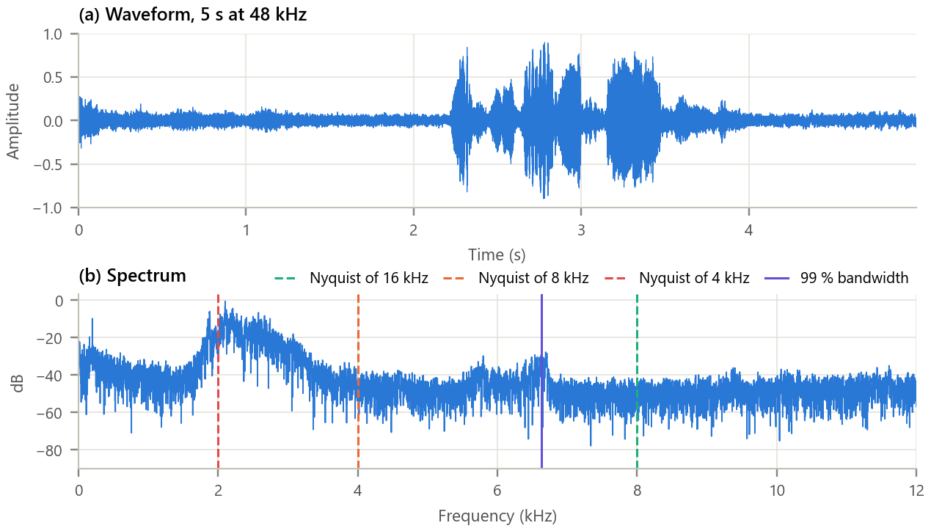
Figure 1. The recording in time and frequency. (a) Waveform; (b) spectrum with the Nyquist frequency of each test rate and the 99 % bandwidth.
Inference. The song energy sits mainly between 1.8 and 3 kHz with a peak at 2,102 Hz and harmonics reaching about 6.6 kHz. The 16 kHz rate (Nyquist 8 kHz) lies beyond the whole song; 8 kHz (Nyquist 4 kHz) cuts off the upper harmonics (2.0 % of the energy); 4 kHz (Nyquist 2 kHz) lies below the main peak and would discard or alias 88 % of the energy. The Nyquist rate of this signal is therefore about 13.3 kHz.

5. Methodology and Implementation
For each rate the reference is (1) optionally prefiltered, (2) decimated by D, (3) reconstructed on the 48 kHz grid by each method, and (4) compared with the ideal band-limited signal. The moving-average length is matched to D (M = D), and the FIR filter has 255 taps with its edge at 90% of the new Nyquist frequency.
Table 5. Software modules
Module | Responsibility
config.py | Clip URL, sampling rates, filter and reconstruction parameters
data_loader.py | Download once, cache WAV, convert to float, resample to the 48 kHz reference
sampling.py | Moving average and its response, prefilters, sampling, three reconstructions, SNR
analysis.py | Bandwidth, prefilter and reconstruction studies, storage cost
plots.py / gui.py | Report figures / interactive sampling lab with audio playback
test_sampling.py | 10 unit tests (nulls of H, alias frequency, interpolation order), all pass

Core of sampling.py
1 def moving_average(x, M): # y[n] = (1/M) sum x[n-k]
2 return np.convolve(x, np.full(M, 1.0 / M))[(M - 1) // 2:][:len(x)]
3
4 def sample(x, fs_ref, fs_new, kind="None"): # x_s[n] = x_f(n Ts)
5 D = fs_ref // fs_new
6 return prefilter(x, fs_ref, fs_new, kind)[::D]
7
8 def reconstruct(xs, D, N, method): # back to the 48 kHz grid
9 if method == "Zero-order hold":
10 return np.repeat(xs, D)[:N]
11 if method == "Linear":
12 return np.interp(np.arange(N) / D, np.arange(len(xs)), xs)
13 up = np.zeros(len(xs) * D); up[::D] = xs # Whittaker-Shannon:
14 return oaconvolve(up, sinc_kernel(D), mode="same")[:N] # sum x[n] sinc((t - nTs)/Ts)
15

GUI. gui.py (Figure 2) lets the user choose any sampling rate from 2 to 24 kHz, a prefilter (none, moving average of any length, or FIR) and a reconstruction method. It shows 5 ms of the chirp with the samples and the reconstruction, the spectrum with the Nyquist line, the SNR, the aliased energy and the storage cost, and two Play buttons let the student hear the original and the sampled version. Run python run_experiment.py and python gui.py.
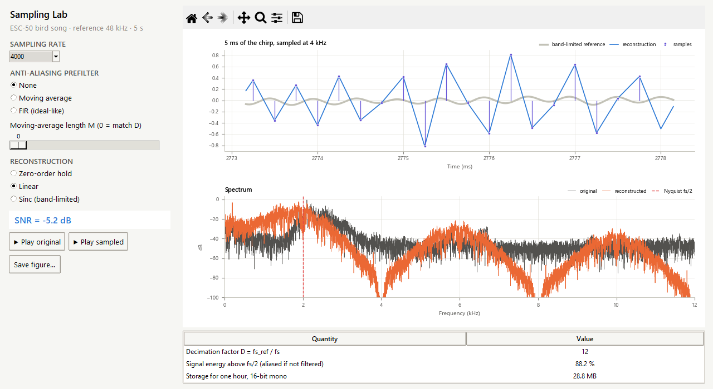
Figure 2. The sampling lab at 4 kHz with no prefilter and linear reconstruction. The reconstruction oscillates at the alias frequency while the true band-limited signal is small; the SNR is negative.

6. Calculations
Four consecutive samples of the song at 8 kHz (n = 22413 to 22416) are x[n] = {-0.3931, 0.9078, -0.4098, -0.3740}.
Table 6. Hand calculation on real samples
Quantity | Working | Result
3-point MA, y[2] | (-0.3931 + 0.9078 + -0.4098) / 3 | 0.0350
3-point MA, y[3] | (0.9078 + -0.4098 + -0.3740) / 3 | 0.0413
ZOH value at t = (n + ½)Ts | hold x[n] | 0.9078
Linear value at t = (n + ½)Ts | (0.9078 + -0.4098) / 2 | 0.2490
Alias of the song peak at fs = 4 kHz | |2102 − 1 × 4000| | 1898 Hz
MA (M = 6) gain at the 8 kHz Nyquist | sin(6ω/2)/(6 sin(ω/2)), ω = 2π·4000/48000 | 0.644 (-3.8 dB)
Storage at 8 kHz, 1 h | 8000 × 2 bytes × 3600 s | 57.6 MB

The MA gain of 0.644 at the folding frequency means that components just above 4 kHz are attenuated by less than 4 dB before they alias, which explains the weak anti-aliasing measured below. All values agree with the program output (checked by test_sampling.py).

7. Results and Discussion
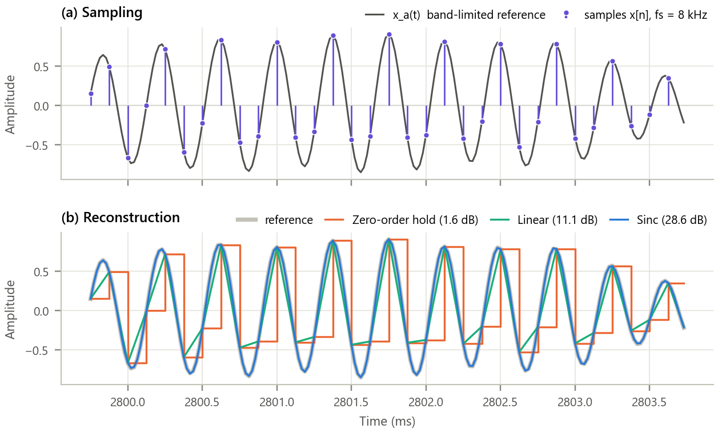
Figure 3. Sampling at 8 kHz and the three reconstructions (4 ms of one chirp). (a) Band-limited reference and its samples; (b) zero-order hold, linear and sinc reconstruction with their SNR over the whole clip.
Inference.
- At 8 kHz the 2.1 kHz chirp gets only about 3.8 samples per cycle, close to the 2-sample limit, so the way the gaps are filled matters a great deal.
- The zero-order hold staircase lags by half a sample and has large steps (1.6 dB); linear interpolation cuts the peaks (11.1 dB); the sinc interpolator follows the true curve (28.6 dB) because it is the exact inverse of band-limited sampling.

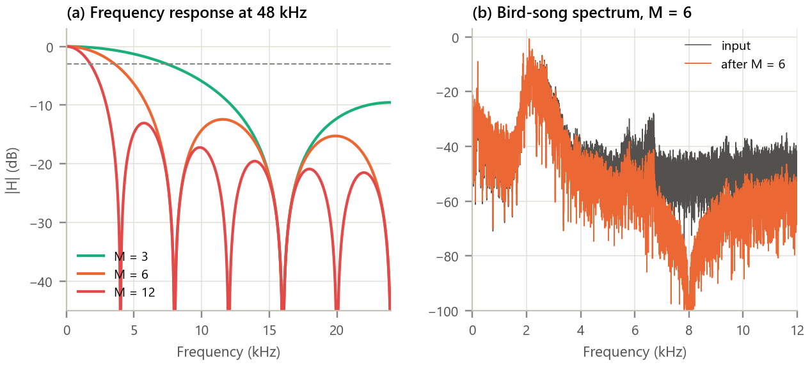
Figure 4. The moving-average filter. (a) |H| for M = 3, 6, 12 at 48 kHz; (b) spectrum of the song before and after M = 6.
Inference. Each response has nulls at multiples of 48/M kHz and a −3 dB frequency of 7.45, 3.59 and 1.78 kHz for M = 3, 6, 12, i.e. about 0.44·fs/M. The first sidelobe is only 12.4 dB down. On the song, M = 6 places a deep null at 8 kHz and leaves the 2 to 3 kHz song almost untouched, but the 9 to 12 kHz band is attenuated by only 10 to 20 dB because of the sidelobes: the moving average smooths, but it is not a sharp low-pass filter.

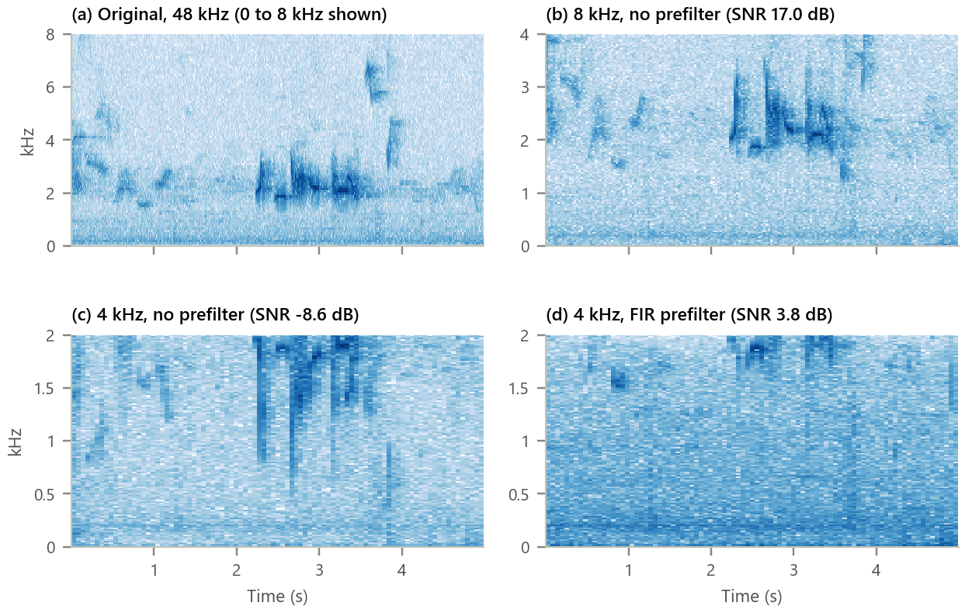
Figure 5. Aliasing seen in spectrograms. (a) Original; (b) 8 kHz without prefilter; (c) 4 kHz without prefilter; (d) 4 kHz with the FIR prefilter.
Inference. At 8 kHz the song survives with only faint folded harmonics. At 4 kHz without a prefilter the main 2 to 3 kHz song is reflected about 2 kHz: the peak at 2,102 Hz appears at 1898 Hz and strong false chirps fill the 1 to 2 kHz band where the original has none, so an analyst could mis-identify the species. With the FIR prefilter those false chirps vanish, leaving a mostly empty, honest band: the information is lost, but it is not falsified.

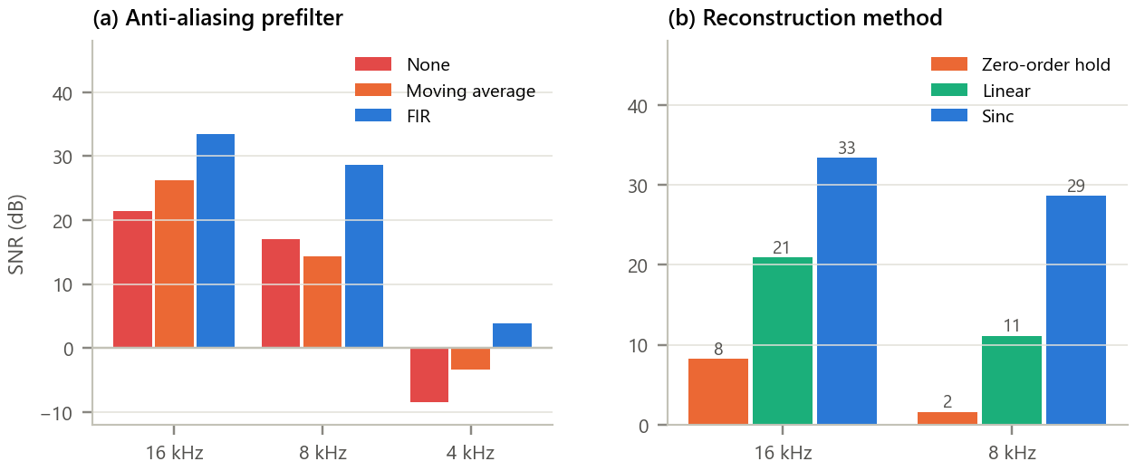
Figure 6. SNR summary. (a) Effect of the anti-aliasing prefilter (sinc reconstruction); (b) effect of the reconstruction method (FIR prefilter).
Inference. The FIR prefilter is best at every rate (33.4, 28.6 and 3.8 dB). The moving average helps at 16 kHz (+4.8 dB) and 4 kHz, but costs 2.7 dB at 8 kHz, because its passband droop removes more of the song than the little aliasing it prevents. Among reconstructions, sinc beats linear by 12.5 dB and hold by 25.2 dB at 16 kHz.

Table 7. Summary of results (SNR in dB)
Rate | Energy > fs/2 | SNR none | SNR MA | SNR FIR | Best recon. | MB / hour
16 kHz | 0.7 % | 21.4 | 26.2 | 33.4 | 33.4 dB | 115.2
8 kHz | 2.0 % | 17.0 | 14.3 | 28.6 | 28.6 dB | 57.6
4 kHz | 88.2 % | -8.6 | -3.4 | 3.8 | n/a | 28.8

8. Conclusion
The bird-song recording needs a sampling rate above about 13.3 kHz. At 16 kHz, with a good anti-aliasing filter and sinc reconstruction, it is recovered with 33.4 dB SNR at a cost of 115.2 MB per hour; 8 kHz halves the storage and still keeps the song recognisable; 4 kHz is below the song's main frequency and, without a prefilter, produces convincing but false chirps. The moving-average filter is easy to implement and has exact nulls at multiples of fs/M, but its drooping passband and high sidelobes make it a poor anti-aliasing filter, sometimes worse than none. For a field recorder the right design is therefore: choose fs above 2B for the target species, use a sharp FIR prefilter, and use band-limited (sinc) interpolation on playback.

9. Learning Outcomes
- Determine a real signal's bandwidth and Nyquist rate from its spectrum.
- Predict and recognise aliasing, and compute alias frequencies.
- Derive and interpret the frequency response of the moving-average filter and its limits as a low-pass filter.
- Compare zero-order hold, linear and sinc reconstruction quantitatively with SNR.

10. References
[1] A. V. Oppenheim and R. W. Schafer, Discrete-Time Signal Processing, 3rd ed. Pearson, 2010, ch. 4.
[2] C. E. Shannon, “Communication in the presence of noise,” Proc. IRE, vol. 37, no. 1, pp. 10-21, 1949.
[3] K. J. Piczak, “ESC: Dataset for environmental sound classification,” in Proc. ACM Multimedia, 2015, pp. 1015-1018.
[4] A. P. Hill et al., “AudioMoth: Evaluation of a smart open acoustic device for monitoring biodiversity and the environment,” Methods Ecol. Evol., vol. 9, pp. 1199-1211, 2018.
[5] ITU-T Recommendations G.711 (1988) and G.722 (2012), speech coding at 8 and 16 kHz.

