Course | Digital Signal Processing Lab | Experiment No. | 05
Name | Dewashish Lambore | PRN | ____________
Language | Python 3.10 | Date | ____ / ____ / 2026
Autocorrelation
Measuring the solar cycle from 277 years of sunspot observations
Abstract: The autocorrelation of the international monthly sunspot number (3,333 months, 1749 to 2026) was computed by the direct definition, by convolution with the folded sequence and through the power spectrum (Wiener-Khinchin); the three agreed to 4e-16. The normalised autocorrelation has its first peak at 127.8 months, i.e. a solar cycle of 10.65 years (ρ = 0.579), with repeats at 2, 3 and 4 cycles whose decreasing height (0.35, 0.25, 0.19) measures the cycle-to-cycle irregularity. The series decorrelates after 36 months, the period was stable at 10.7 to 11.0 years since 1818 but only 9.3 years in the irregular 18th century, and the cycle was still detected when buried in white noise at an SNR of -10 dB. The leftover month-to-month variation is not white noise, which the 95 % confidence band reveals.
Keywords: autocorrelation, periodicity, Wiener-Khinchin, white-noise test, sunspot number, solar cycle, space weather, Python

1. Aim and Objectives
Aim: to study the autocorrelation of a discrete-time signal, verify its properties, and use it to detect hidden periodicity and to test for randomness in a real-world signal, in Python.
- Compute autocorrelation three ways and verify symmetry, the maximum at zero lag and r[0] = energy.
- Estimate the period of the solar cycle and how it changed over 277 years.
- Test whether the residual variation is white noise, and how much noise periodicity detection tolerates.

2. Real-World Application
The Sun's activity rises and falls in a cycle of roughly 11 years, and sunspots are its oldest and most reliable measure. Solar maximum brings more flares and geomagnetic storms, which heat and expand the upper atmosphere, increase drag on low-orbit satellites, disturb GPS and HF radio, and induce currents in power grids. Satellite operators, ISRO's Aditya-L1 mission team, airlines on polar routes and grid operators therefore plan around the cycle, and the first step is to measure its period from data. Autocorrelation does exactly that: it compares a signal with delayed copies of itself, so any repetition shows up as a peak at the repetition lag even when it is hard to see in the raw data (Table 1).
Table 1. Uses of autocorrelation
Field | Signal | What the autocorrelation reveals
Space weather | monthly sunspot number | solar-cycle period, decorrelation time, predictability
Speech processing | voiced speech frame | pitch period (fundamental frequency) of the speaker
Radar and sonar | echo of a coded pulse | sharp peak at zero lag gives fine range resolution
Machine monitoring | bearing vibration | repetition rate of a defect hitting the race
Statistics, finance | residuals of a model | whether errors are white (model adequate) or correlated

3. Theory
The autocorrelation of an energy signal measures its similarity with a copy shifted by $l$ samples:
$r_{xx}[l]=\sum_{n=−∞}^{∞}{}x[n] x[n−l], l=0,±1,±2,…$ (1)
Comparing with the convolution sum shows that autocorrelation is the convolution of $x[n]$ with its folded copy (Experiment 1), and by the convolution theorem it is the inverse transform of the energy spectrum (the Wiener-Khinchin relation):
$r_{xx}[l]=x[l]*x[−l] ⟷ S_{xx}(e^{jω})={|X(e^{jω})|}^{2}$ (2)
Three properties follow directly and are verified numerically below:
$r_{xx}[−l]=r_{xx}[l], |r_{xx}[l]|≤r_{xx}[0]=E_{x}=\sum_{n}{}x^{2}[n]$ (3)
For a finite record of $N$ samples with mean $\overline{x}$, the normalised autocorrelation (autocorrelation function, ACF) is estimated by
$ρ[l]=\frac{\hat{r}[l]}{\hat{r}[0]}, \hat{r}[l]=\frac{1}{N}\sum_{n=l}^{N−1}{(x[n]−\overline{x})}(x[n−l]−\overline{x})$ (4)
Dividing by $N$ (biased) rather than $N−l$ (unbiased) gives a slightly smaller but far less noisy estimate at large lags, and is the standard choice. Two reference cases guide interpretation: a periodic signal of period $P$ has an ACF that repeats with period $P$ (a sinusoid gives $ρ[l]=cos(2πl/P)$), while white noise has $ρ[l]≈0$ for $l≠0$, with 95 % of sample values inside
$|ρ[l]|<\frac{1.96}{\sqrt{N}}$ (5)
Note. Autocorrelation is robust to noise because uncorrelated noise adds only to ρ[0]; the periodic part keeps reinforcing at its own lag. This is why a period can be read from the ACF even when the noise is larger than the signal (Section 7).

4. Dataset Description
The international sunspot number (version 2.0) is maintained by SILSO, the World Data Center for the sunspot index at the Royal Observatory of Belgium. It combines counts from about 80 observatories worldwide and has been recalibrated back to 1749, making it the longest continuous record of solar activity. The monthly mean series is a single 124 kB text file with one row per month, downloaded once and cached. The last 3 months are provisional. Sampling interval: T_s = 1 month, so 12 lags = 1 year.
Table 2. Dataset attributes
Property | Value | Property | Value
Provider | SILSO, Royal Observatory of Belgium | Series | monthly mean total sunspot number v2.0
Period | 1749-01 to 2026-09 | Samples N | 3,333 months
Mean ± std | 82.2 ± 67.6 | Range | 0 to 398.2
Largest month | 1778-05 | Months with observer count | 2,504
Columns used | year, month, decimal year, SN | Licence | CC BY-NC 4.0 (SILSO)

Table 3. Most recent six rows of the dataset
Year | Month | Decimal year | SN | Std. dev. | Observations | Definitive
2026 | 04 | 2026.286 | 79.0 | 11.2 | 1345 | yes
2026 | 05 | 2026.371 | 101.8 | 15.5 | 1319 | yes
2026 | 06 | 2026.453 | 93.3 | 15.1 | 1316 | yes
2026 | 07 | 2026.538 | 78.1 | 11.2 | 1371 | provisional
2026 | 08 | 2026.623 | 76.0 | 12.3 | 1248 | provisional
2026 | 09 | 2026.705 | 60.3 | 13.0 | 1117 | provisional

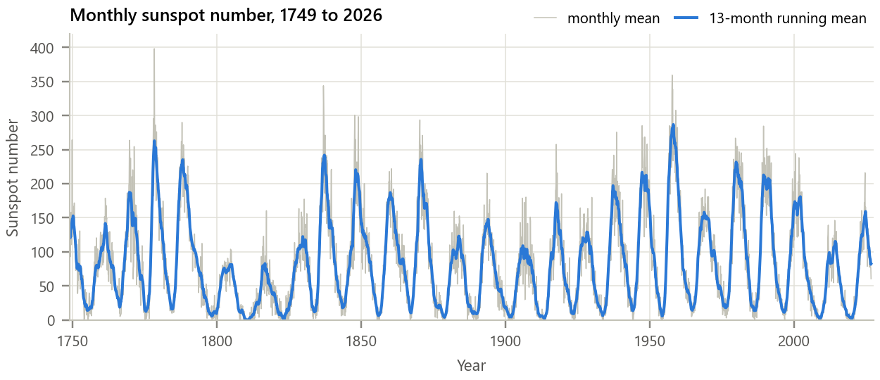
Figure 1. The monthly sunspot number and its 13-month running mean.
Inference. About 25 cycles are visible. Their heights vary widely (smoothed maxima of only about 80 in the early 1800s, the Dalton Minimum, but almost 300 in 1958), and their spacing is roughly, but not exactly, 11 years. The latest cycle (Cycle 25) peaked at a smoothed value of 159 around 2024.8. The monthly values scatter strongly around the smooth curve, so the period should be measured statistically rather than by eye.

5. Methodology and Implementation
The mean is removed, the biased ACF is computed up to 50 years of lag, and the period is taken as the largest ACF value between 60 and 200 months, refined by fitting a parabola through the peak and its neighbours. The same estimator is applied to four 70-year epochs, to the residual and the first difference, and to the record with added white noise.
Table 4. Software modules
Module | Responsibility
config.py | URL, lags, smoothing length, epochs, noise levels
data_loader.py | Download SILSO file once, cache, mark and fill missing months
autocorr.py | Three autocorrelation methods, biased / unbiased ACF, bounds, period finder
analysis.py | Main ACF, property checks, whiteness tests, epochs, noise robustness
plots.py / gui.py | Report figures / interactive periodicity detector
test_autocorr.py | 10 unit tests (properties, sinusoid ACF = cosine, white-noise bound): all pass

Core of autocorr.py
1 def autocorr_direct(x, max_lag): # r[l] = sum x[n] x[n - l]
2 return np.array([np.dot(x[l:], x[:len(x) - l]) for l in range(max_lag + 1)])
3
4 def autocorr_conv(x): # r[l] = x[l] * x[-l]
5 return np.convolve(x, x[::-1])
6
7 def autocorr_fft(x, max_lag): # Wiener-Khinchin: r = IDFT{|X|^2}
8 nfft = 1 << int(np.ceil(np.log2(2 * len(x) - 1))) # pad: no circular wrap
9 return np.fft.irfft(np.abs(np.fft.rfft(x, nfft)) ** 2, nfft)[:max_lag + 1]
10
11 def acf(x, max_lag, unbiased=False): # rho[l] = r[l] / r[0]
12 x = x - x.mean()
13 r = autocorr_fft(x, max_lag)
14 r = r / (len(x) - np.arange(max_lag + 1)) if unbiased else r / len(x)
15 return r / r[0]
16

GUI. gui.py (Figure 2) lets the user choose the raw, smoothed, residual or differenced series, any span of years, the maximum lag and the estimator, and add white noise of any strength. It shows the signal, its ACF with the 95 % band, the detected period with a significance check, and the first zero crossing. Run python run_experiment.py and python gui.py.
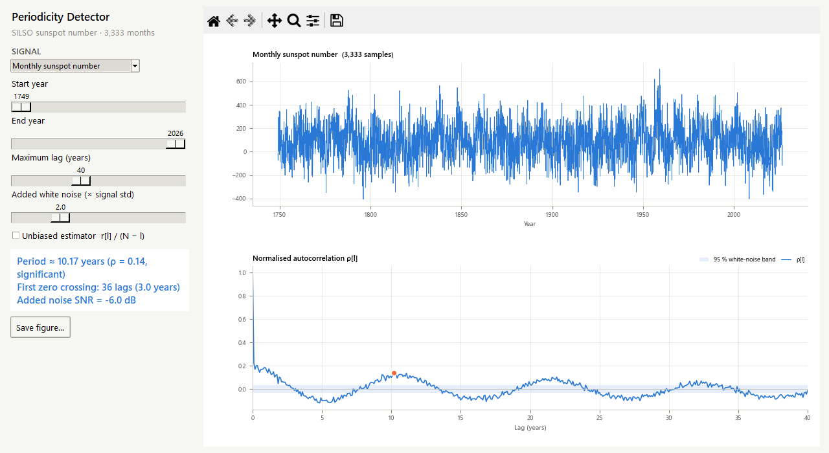
Figure 2. The periodicity detector with noise twice as strong as the signal (SNR −6 dB). The cycle is invisible in the time series but the ACF still peaks at about 10 years, above the band.

6. Calculations
Hand example. For x[n] = {2, −1, 3, 1} (n = 0 … 3), each lag multiplies the sequence with a shifted copy and adds the overlapping products:
Table 5. Autocorrelation by hand
Lag l | Overlapping products x[n]·x[n − l] | r[l] | ρ[l] = r[l]/r[0]
0 | 2·2 + (−1)(−1) + 3·3 + 1·1 | 15 | 1.000
1 | (−1)·2 + 3·(−1) + 1·3 | -2 | -0.133
2 | 3·2 + 1·(−1) | 5 | 0.333
3 | 1·2 | 2 | 0.133

By symmetry r[−1] = -2, r[−2] = 5, r[−3] = 2, so the full sequence has 2N − 1 = 7 values with its maximum r[0] = 15 = E_x at the centre. For the sunspot record: the 95 % white-noise limit is 1.96/√3333 = 0.0339; the ACF peak at lag 128 with parabolic refinement gives 127.8 months ÷ 12 = 10.65 years. Adding noise with standard deviation 3σ gives SNR = 10 log₁₀(1/3²) = -9.5 dB. The program reproduces the hand values exactly (checked by test_autocorr.py).

7. Results and Discussion
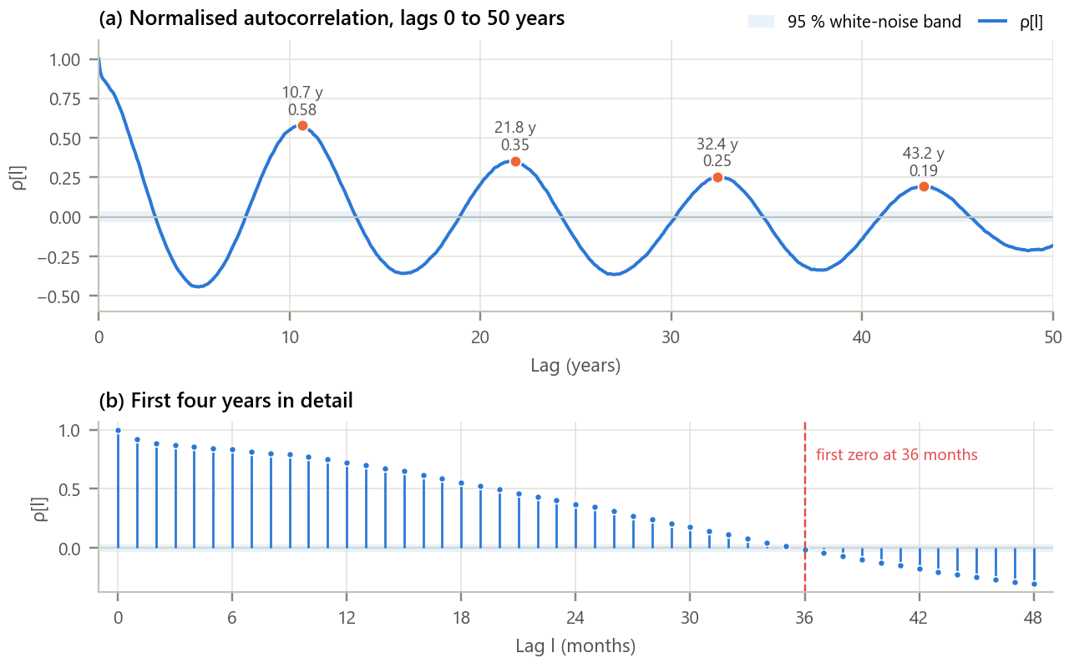
Figure 3. Normalised autocorrelation of the monthly sunspot number. (a) Lags up to 50 years with the 95 % white-noise band; (b) the first four years.
Inference.
- The ACF oscillates like a damped cosine. Its first peak is at 10.65 years (ρ = 0.579), far above the ±0.034 band, so the 11-year cycle is overwhelmingly significant. Further peaks at 21.8, 32.4, 43.2 years are integer multiples of the period.
- The peaks shrink (0.58, 0.35, 0.25, 0.19) because cycles differ in length and height, so the signal is only quasi-periodic. The deepest trough (ρ = -0.44 at 5.2 years) is half a cycle: maximum is followed by minimum.
- Neighbouring months are strongly related (ρ[1] = 0.918, ρ[12] = 0.724); the correlation falls below 0.5 after 20 months and crosses zero at 36 months, about a quarter of the cycle. Persistence forecasts are therefore useful for one to two years only.

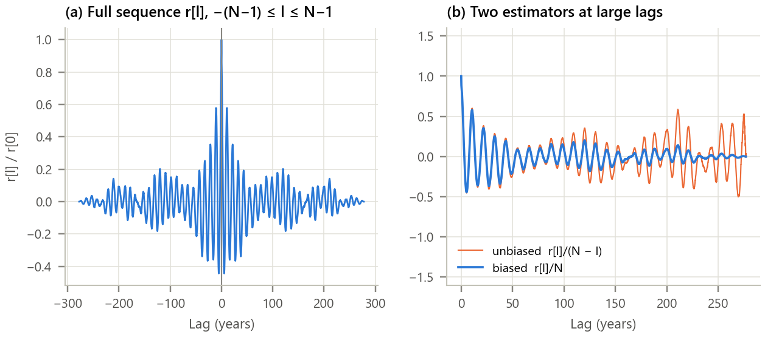
Figure 4. Properties of the autocorrelation sequence. (a) The full sequence for negative and positive lags; (b) biased versus unbiased estimates.
Inference. The full sequence is exactly even (maximum asymmetry 0e+00) and never exceeds its value at l = 0, which equals the signal energy (difference 0e+00). The direct, convolution and FFT methods agreed to 4e-16. At large lags the unbiased estimate swings wildly, because it averages only the few remaining overlapping samples, while the biased estimate tapers smoothly to zero; this is why the biased estimator is used.

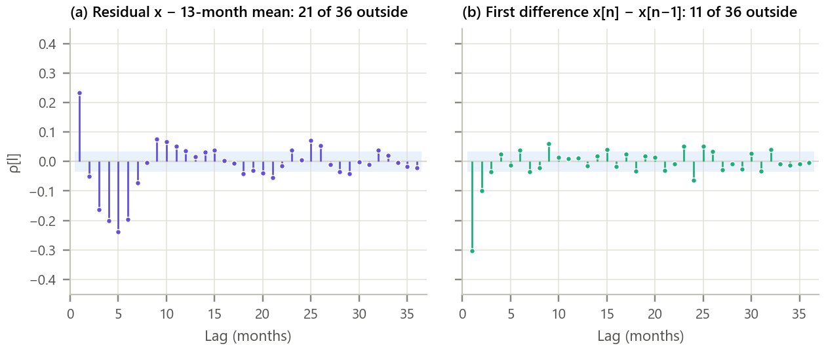
Figure 5. Testing the leftover variation for whiteness. ACF of (a) the residual after removing the 13-month mean and (b) the month-to-month difference.
Inference. Neither is white noise. The residual has 21 of 36 lags outside the 95 % band (where about 2 would be expected by chance), with a positive ρ[1] = 0.23 and a negative dip at 3 to 6 months, partly created by the 13-month smoothing itself. The difference is close to white except for ρ[1] = -0.30: a high month tends to be followed by a lower one, the signature of independent counting errors added to a slowly varying signal. The ACF therefore tells us which kind of model the noise needs.

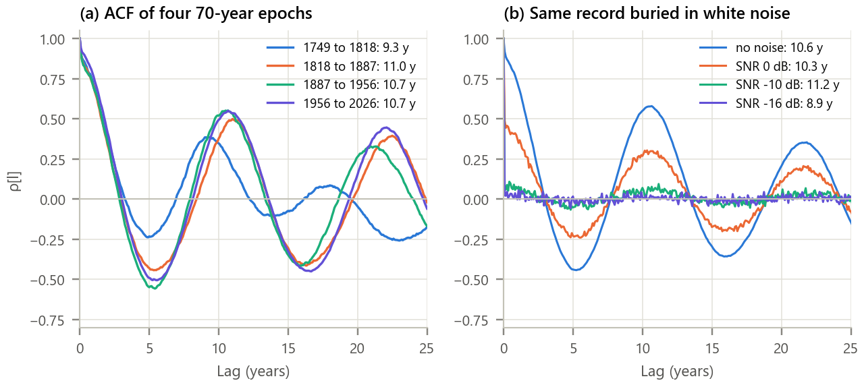
Figure 6. Stability and robustness of the period estimate. (a) ACF of four 70-year epochs; (b) the full record with added white noise.
Inference.
- Since 1818 the period is stable at 11.0, 10.7 and 10.7 years, but 1749 to 1818 gives only 9.3 years with a weak peak (ρ = 0.39): that epoch contains short cycles and the Dalton Minimum, and its early counts are the least reliable.
- With noise as strong as the signal (0 dB) the period is still 10.3 years; at -10 dB it is 11.2 years with a small but significant peak (0.094). At -16 dB the peak (0.046) sinks to the noise band (0.034) and the estimate (8.9 years) is unreliable.

Table 6. Summary of results
Quantity | Result
Solar-cycle period from the ACF | 10.65 years (ρ = 0.579)
Multiples of the period | 21.8 y, 32.4 y, 43.2 y
Decorrelation: ρ < 0.5 / first zero | 20 / 36 months
Period by epoch | 1749 to 1818: 9.3 y, 1818 to 1887: 11.0 y, 1887 to 1956: 10.7 y, 1956 to 2026: 10.7 y
Whiteness: residual / difference outside band | 21 / 11 of 36 lags
Lowest SNR with a reliable period | -10 dB
Next maximum, rough (last max + period) | about 2035

8. Conclusion
Autocorrelation extracted the solar cycle directly from the data: a period of 10.65 years, with decaying repeats that quantify how irregular the Sun is. The theoretical properties (even symmetry, maximum at zero lag equal to the energy, equivalence of the direct, convolution and spectral methods) were confirmed to machine precision. The ACF also served as a diagnostic: the cycle was stable at about 10.7 to 11 years for two centuries, the leftover month-to-month variation is not white noise, and periodicity was still recoverable at an SNR of -10 dB. Combined with the most recent maximum (2024.8), the period suggests the next maximum around 2035, a rough but useful planning horizon for satellite and grid operators; real forecasts refine it with physical models.

9. Learning Outcomes
- Compute autocorrelation by definition, by convolution with the folded signal and via the power spectrum.
- Verify and use its properties: even symmetry, maximum at zero lag, r[0] = energy.
- Detect and measure hidden periodicity, and choose between biased and unbiased estimators.
- Test a sequence for whiteness with the ±1.96/√N band and judge the noise robustness of a period estimate.

10. References
[1] J. G. Proakis and D. G. Manolakis, Digital Signal Processing, 4th ed. Pearson, 2007, ch. 2.6.
[2] A. V. Oppenheim and R. W. Schafer, Discrete-Time Signal Processing, 3rd ed. Pearson, 2010, ch. 10.
[3] SILSO World Data Center, “The International Sunspot Number,” Royal Observatory of Belgium, https://www.sidc.be/SILSO.
[4] F. Clette and L. Lefèvre, “The new sunspot number: assembling all corrections,” Solar Physics, vol. 291, pp. 2629-2651, 2016.
[5] G. E. P. Box, G. M. Jenkins and G. C. Reinsel, Time Series Analysis, 4th ed. Wiley, 2008, ch. 2.

