Course | Digital Signal Processing Lab | Experiment No. | 01
Name | Dewashish Lambore | PRN | ____________
Language | Python 3.10 | Date | ____ / ____ / 2026
Basic Operations on Discrete-Time Signals
Applied to hourly solar-irradiance and weather signals of Pune
Abstract: One week (N = 168 hourly samples) of real ERA5 reanalysis data for Pune was treated as a set of discrete-time signals, and nine elementary operations were implemented in a modular, tested Python library with an interactive GUI. Each operation solved a physical task: addition reconstructed global irradiance with zero error, subtraction flagged 11 fog-risk hours, multiplication estimated a PV yield of 5.29 kWh/kWp/day (9.9 % thermal loss), a 24-sample delay gave a persistence forecast with 74 % skill, and a 24-point moving-average convolution cut the standard deviation from 3.60 °C to 0.30 °C, exposing the multi-day trend.
Keywords: discrete-time signals, convolution, moving average, sampling, solar energy, Python

1. Aim and Objectives
Aim: to perform the basic operations on discrete-time signals (addition, subtraction, multiplication, amplitude scaling, time shifting, time reversal, time scaling and convolution ) on a real-world dataset in Python, and to interpret each result physically.
- Represent measured data as sequences $x[n]$ with an explicit index support.
- Implement every operation as a reusable, unit-tested function and expose it through a GUI.
- Verify theory numerically (energy scaling, convolution length) and relate each operation to a real engineering task.

2. Real-World Application
Rooftop-solar capacity in Maharashtra is growing quickly, and every inverter, weather station and energy-management system in such an installation works on sampled data. The operations of this experiment are the first stage of those monitoring pipelines (Table 1): pyranometer components are added, dew point is subtracted from temperature to warn of condensation on panels, irradiance is multiplied by a thermal factor to predict power, yesterday’s profile is shifted to forecast today, loggers down-sample to save bandwidth, and moving averages expose trends.
Table 1. Operations, their use here and in industry
Operation | Definition | Use in this experiment | Industrial application
Addition | $x_{1}[n]+x_{2}[n]$ | Direct + diffuse = global irradiance | Sensor fusion, station QC
Subtraction | $x_{1}[n]−x_{2}[n]$ | Temperature − dew point (fog indicator) | Noise / baseline removal
Multiplication | $x_{1}[n] x_{2}[n]$ | Irradiance × thermal factor = PV power | Power metering, windowing
Amplitude scaling | $A x[n]$ | 1 kWp → 3 kWp array | Calibration, gain control
Time shift | $x[n−k]$ | 24-h delay = persistence forecast | Latency compensation
Time reversal | $x[−n]$ | Folding, even/odd parts | Matched / zero-phase filtering
Down-sampling | $x[Dn]$ | Hourly → 3-hourly synoptic data | IoT data compression
Up-sampling | $x[n/L]$ | 3-hourly → hourly reconstruction | Sample-rate conversion
Convolution | $x[n]*h[n]$ | 24-h moving average (trend) | Smoothing, FIR filtering

3. Theory
A discrete-time signal is a sequence $x[n]$ defined only at integer $n$. Sampling a continuous signal every $T_{s}$ seconds gives $x[n]=x_{a}(nT_{s})$; here $T_{s}$ = 1 h, so $n=0$ is 00:00 IST on 1 October 2026. A finite signal is non-zero only on its support $n_{1}≤n≤n_{2}$, and its energy and average power are
$E_{x}=\sum_{n=n_{1}}^{n_{2}}{}|x[n]|^{2}, P_{x}=\frac{E_{x}}{N}$ (1)
Arithmetic operations act sample-by-sample; operations on the index $n$ change where the signal lives. Table 2 gives the effect of each on support, length and energy.
Table 2. Effect of each operation on support, length and energy
Operation | Output support | Length | Energy | Remark
$A x[n]$ | $[n_{1},n_{2}]$ | $N$ | $A^{2}E_{x}$ | amplifies (|A|>1) or attenuates
$x[n−k]$ | $[n_{1}+k, n_{2}+k]$ | $N$ | $E_{x}$ | k > 0 delay, k < 0 advance
$x[−n]$ | $[−n_{2}, −n_{1}]$ | $N$ | $E_{x}$ | mirror about n = 0
$x[Dn]$ | $[n_{1}/D, n_{2}/D]$ | ≈ $N/D$ | ≈ ${E_{x}}/D$ | keeps every D-th sample; may alias
$x[n/L]$ | $[Ln_{1}, Ln_{2}]$ | $L(N−1)+1$ | $E_{x}$ | inserts L − 1 zeros; needs interpolation
$x[n]*h[n]$ | starts at $n_{x}+n_{h}$ | $N+M−1$ | depends on h | LTI filtering (Eq. 2)

Convolution gives the output of a linear time-invariant system with impulse response $h[n]$. The causal $M$-point moving average has $h[n]=1/M$ for $0≤n≤M−1$:
$y[n]=\sum_{k=−∞}^{∞}{}x[k] h[n−k]=\frac{1}{M}\sum_{k=0}^{M−1}{}x[n−k]$ (2)
Its DC gain $∑h[n]=1$ passes constants unchanged, while any oscillation whose period divides $M$ is cancelled; with $M=24$ the daily cycle is removed. The output lags by $(M−1)/2$ samples.
Application models. Global irradiance is the sum of beam and diffuse components; PV power is irradiance multiplied by a thermal derating factor (PVWatts model, NOCT cell temperature); and a forecast is scored by RMSE and skill against the weekly mean:
$GHI[n]=DNI[n]cosθ_{z}[n]+DHI[n]$ (3)
$P[n]=\frac{G[n]}{1000}·[1+γ(T_{a}[n]+\frac{NOCT−20}{800}G[n]−25)]$ (4)
$RMSE=\sqrt{\frac{1}{N^{′}}∑{(x[n]−\hat{x}[n])}^{2}}, S=1−\frac{RMSE}{{RMSE}_{clim}}$ (5)
Note. with γ = -0.0037 /°C and NOCT = 45 °C. Signals are stored as pairs (n, x) in the code: padding with zeros and keeping n = 0 … N−1 (a common shortcut) loses samples on shifting and makes x[−n] indistinguishable from simply reversing an array.

4. Dataset Description
Hourly ERA5 / ERA5-Land reanalysis data (ECMWF, Copernicus Climate Change Service) for Pune (18.5204° N, 73.8567° E, 561 m), from 2026-10-01 to 2026-10-07 (the post-monsoon transition), downloaded from the free Open-Meteo archive API. Reanalysis blends satellite, radiosonde and ground observations with a physical model, so the record is gap-free and physically consistent. The file is only 8.7 kB (N = 168 samples × 7 signals, no missing values) and is cached locally after the first run.
Table 3. Dataset attributes and statistics (168 hourly samples)
Column | Signal | Unit | Mean | Min | Max | Role
temp_c | Air temperature | °C | 27.5 | 21.9 | 33.7 | x₁ (subtraction, shift, scaling, conv.)
dewpoint_c | Dew-point temperature | °C | 17.6 | 10.2 | 22.2 | x₂ (subtraction)
rh_pct | Relative humidity | % | 58.9 | 25.0 | 95.0 | check for DPD
ghi_wm2 | Global horizontal irradiance | W/m² | 244.6 | 0.0 | 896.0 | reference; PV input
direct_wm2 | Direct horizontal irradiance | W/m² | 176.4 | 0.0 | 718.0 | x₁ (addition)
diffuse_wm2 | Diffuse horizontal irradiance | W/m² | 68.2 | 0.0 | 266.0 | x₂ (addition)
cloud_pct | Cloud cover | % | 21.6 | 0.0 | 99.0 | context

Table 4. Dataset preview around sunrise, 1 October (irradiance in W/m²; GHI = Direct + Diffuse)
n | Time (IST) | T (°C) | Td (°C) | RH (%) | GHI | Direct | Diffuse | Cloud (%)
6 | 01-Oct 06:00 | 22.3 | 20.9 | 92 | 0 | 0 | 0 | 20
7 | 01-Oct 07:00 | 24.0 | 21.0 | 83 | 68 | 28 | 40 | 3
8 | 01-Oct 08:00 | 26.6 | 20.4 | 69 | 273 | 171 | 102 | 2
9 | 01-Oct 09:00 | 28.4 | 19.0 | 57 | 495 | 360 | 135 | 3
10 | 01-Oct 10:00 | 29.8 | 18.3 | 50 | 684 | 525 | 159 | 3
11 | 01-Oct 11:00 | 31.3 | 16.4 | 41 | 826 | 655 | 171 | 12

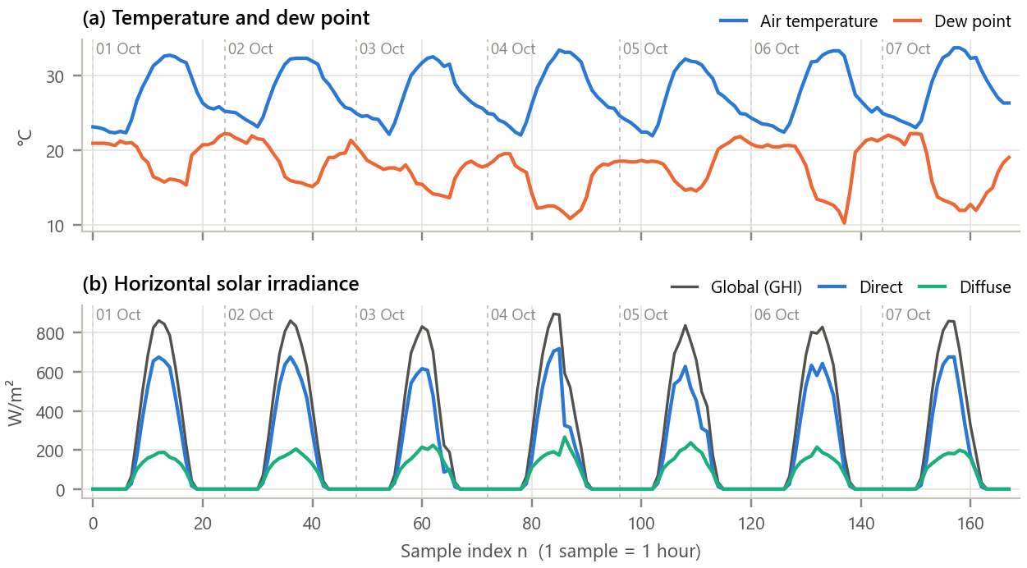
Figure 1. Raw input signals for the full week. Dashed lines mark midnight.
Inference. Every signal is dominated by a 24-sample (daily) periodicity. Temperature swings by ≈ 10.5 °C per day while dew point stays flatter; irradiance is zero for ≈ 12 h each night and peaks at 830 to 900 W/m², indicating mostly clear skies with brief afternoon cloud on 3 and 4 October. Because the signals are physically linked, arithmetic between them has real meaning.

5. Methodology and Implementation
The code is split into single-responsibility modules (Table 5). Each column is wrapped in a DTSignal(n, x) object that carries its own index vector, so a delay adds k to n and a fold negates n exactly as in Table 2. Parameters: k = 24, A = 3, D = L = 3, M = 24 (and 3), fog threshold 2 °C.
Table 5. Software modules
Module | Responsibility
config.py | All constants, paths and experiment parameters
data_loader.py | Download from Open-Meteo once, cache as CSV, clean, attach index n
signal_ops.py | DTSignal class and the nine pure operations (no I/O)
analysis.py | Physical interpretation: GHI closure, DPD, PV power, forecast skill, smoothing
plots.py / gui.py | Report figures / interactive Tkinter application
test_signal_ops.py | 20 unit tests of the identities in Table 2 (all pass)

Core of signal_ops.py
1 @dataclass
2 class DTSignal:
3 n: np.ndarray # integer sample indices
4 x: np.ndarray # sample values x[n]
5
6 def time_shift(s, k): # y[n] = x[n - k]
7 return DTSignal(s.n + k, s.x.copy())
8
9 def time_reverse(s): # y[n] = x[-n]
10 return DTSignal(-s.n[::-1], s.x[::-1].copy())
11
12 def downsample(s, D): # y[n] = x[Dn]
13 keep = s.n % D == 0
14 return DTSignal(s.n[keep] // D, s.x[keep].copy())
15
16 def convolve(s, h): # support starts at n_x + n_h, length N + M - 1
17 y = np.convolve(s.x, h.x)
18 return DTSignal(np.arange(len(y)) + s.n[0] + h.n[0], y)
19

GUI. gui.py (Figure 2) lets the user pick x₁[n] and x₂[n] from the dataset, choose any of the nine operations, and set its parameter (A, k, D, L or M) with a slider; the equation, the plots and a statistics table (N, support, mean, min, max, energy, power) update instantly. Run with python run_experiment.py (all figures and results) and python gui.py.
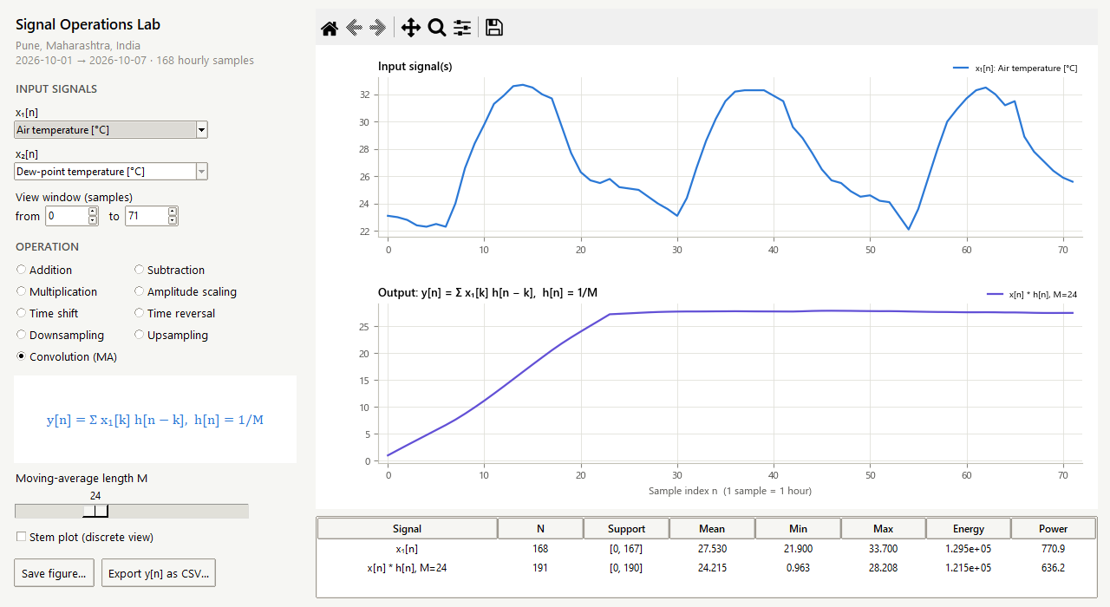
Figure 2. Interactive GUI applying a 24-point moving average. The table reports an output length of 191 = 168 + 24 − 1, as predicted by Table 2.

6. Calculations
Using the first four samples, x₁[n] = {23.1, 23.0, 22.8, 22.4} (temperature) and x₂[n] = {20.9, 20.9, 20.9, 20.8} (dew point), n = 0 … 3:
Table 6. Hand calculation on four samples
Operation | Working | Result | Support
x₁ + x₂ | 23.1+20.9 , 23.0+20.9 , 22.8+20.9 , 22.4+20.8 | 44.0, 43.9, 43.7, 43.2 | [0, 3]
x₁ − x₂ | 23.1−20.9 , 23.0−20.9 , 22.8−20.9 , 22.4−20.8 | 2.2, 2.1, 1.9, 1.6 | [0, 3]
3·x₁ | 3 × each sample | 69.3, 69.0, 68.4, 67.2 | [0, 3]
x₁[n − 2] | same values, n → n + 2 | 23.1, 23.0, 22.8, 22.4 | [2, 5]
x₁[−n] | order reversed, n → −n | 22.4, 22.8, 23.0, 23.1 | [−3, 0]
x₁[2n] | keep n = 0, 2 | 23.1, 22.8 | [0, 1]
x₁[n/2] | zero between samples | 23.1, 0, 23.0, 0, 22.8, 0, 22.4 | [0, 6]
x₁ * h, h = {⅓, ⅓, ⅓} | y[n] = (x[n] + x[n−1] + x[n−2])/3 | 7.700, 15.367, 22.967, 22.733, 15.067, 7.467 | [0, 5]

For the convolution, e.g. y[2] = (23.1 + 23.0 + 22.8)/3 = 22.9667; the output length is 4 + 3 − 1 = 6, and y[0], y[1], y[4], y[5] are partial-overlap edge values. Energy: E(x₁) = 23.1² + 23.0² + 22.8² + 22.4² = 2084.21 °C², so E(3x₁) = 9 × 2084.21 = 18757.89 °C². PV at 09:00: T_c = 28.4 + 0.03125 × 495 = 43.87 °C, f_T = 1 − 0.0037 × 18.87 = 0.9302, P = 0.495 × 0.9302 = 0.4604 kW. All values agree with the program output to four decimals (checked automatically by test_signal_ops.py).

7. Results and Discussion
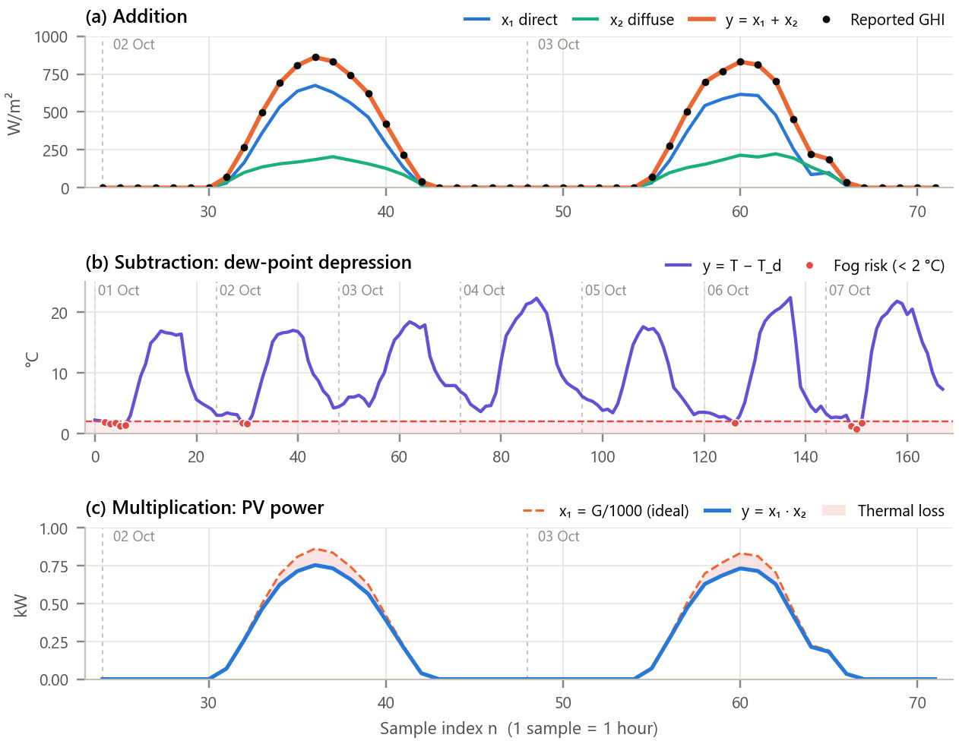
Figure 3. Arithmetic operations on real signals. (a) Direct + diffuse irradiance vs. the independently reported GHI; (b) temperature − dew point with the fog-risk band; (c) normalised irradiance × thermal factor = PV power (2 and 3 October).
Inference.
- Addition reproduces the reported GHI at every sample (maximum residual 0.0 W/m²), so the operation is exact; diffuse light supplies 27.9 % of daylight energy, typical of clear tropical skies.
- Subtraction gives a dew-point depression of 0.8 to 22.4 °C. It drops below 2 °C in 11 hours, all between 02:00 and 07:00 (when dew forms on panels), and correlates with humidity at r = -0.990, i.e. two temperatures give a humidity indicator.
- Multiplication cuts output most exactly when irradiance is highest: cells reach 61.3 °C and the factor falls to 0.866. The 1 kWp array yields 5.03 to 5.54 kWh/day, losing 9.9 % to heat.
- Amplitude scaling by A = 3 (3 kWp) keeps shape and timing; the kWh ratio is 3.00 = A while the energy ratio Σy²/Σx² is 9.00 = A², confirming Table 2.

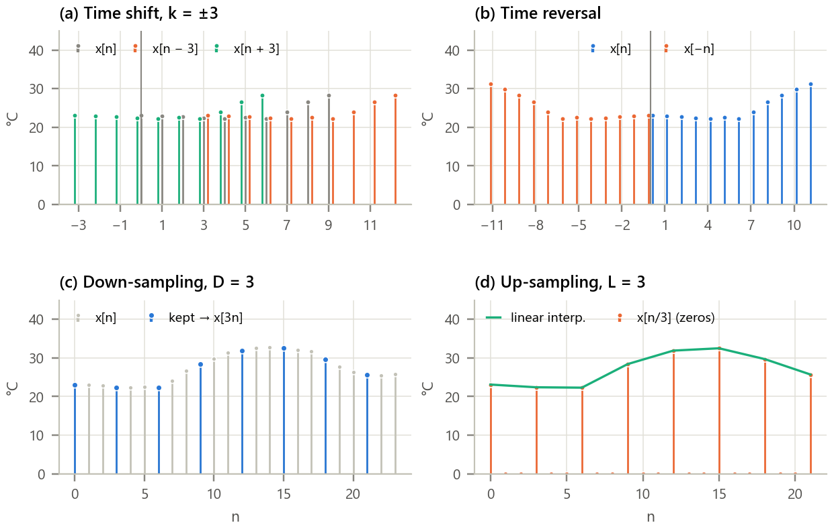
Figure 4. Operations on the independent variable n. (a) Delay and advance by 3 on ten samples; (b) folding of twelve samples; (c) down-sampling by 3; (d) zero-insertion up-sampling by 3 with linear interpolation.
Inference.
- Shifting and folding change only the position of samples: the delay moves the support to [3, 12], the advance to [−3, 6], the fold to [−11, 0]. No sample is lost because n moves with x. Splitting into even and odd parts and adding them back reproduces x[n] exactly (error 0.0).
- Down-sampling keeps 56 of 168 samples and 33.1 % of the energy (≈ 1/D). Up-sampling gives 166 = 3(56 − 1) + 1 samples, two-thirds zeros; linear interpolation restores the hourly curve with RMSE 0.42 °C, but the 3-hourly record under-reads the daily maximum by 0.20 °C on average, a sampling (aliasing) bias.

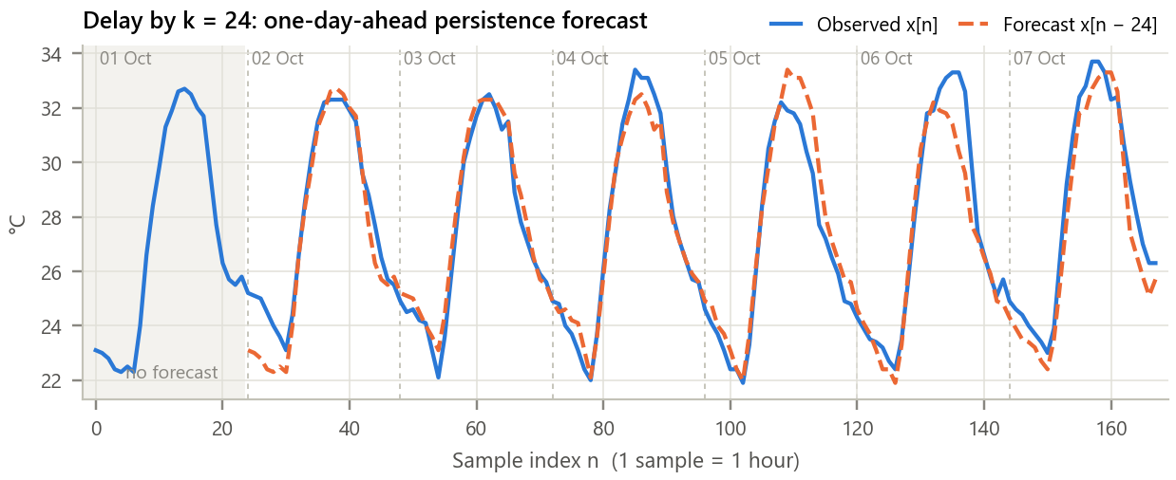
Figure 5. Time delay as a forecast. The observed temperature and the same signal delayed by one day.
Inference. A delay of k = 24 samples is the meteorologist’s persistence forecast. It achieves MAE 0.67 °C and RMSE 0.91 °C, against 3.56 °C for predicting the weekly mean, a skill of 74.4 %. Errors grow when consecutive days differ (e.g. the cooler afternoon of 5 October); any real forecast must beat this baseline.

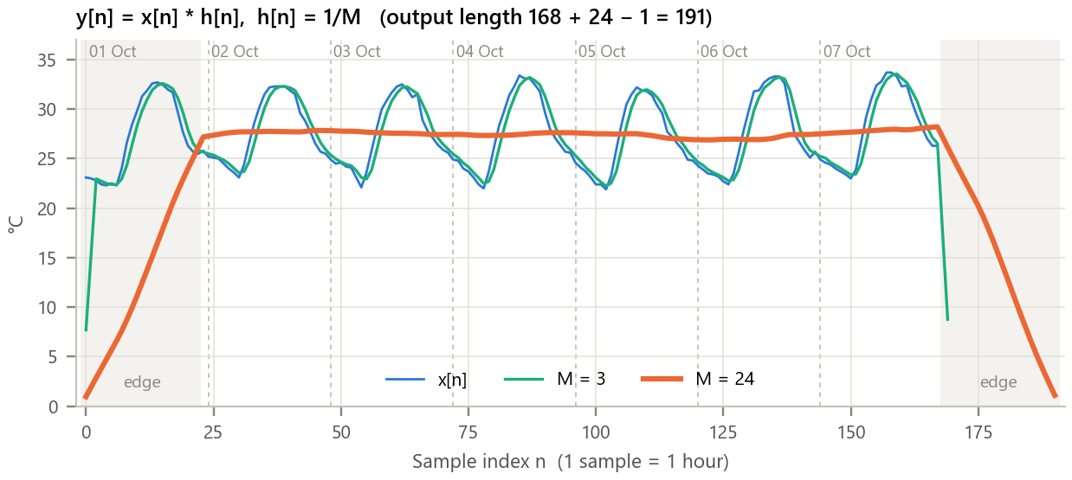
Figure 6. Convolution with moving-average kernels (M = 3 and M = 24). Shaded regions are the partial-overlap edges.
Inference. The output length is 191 = 168 + 24 − 1, as predicted. M = 3 only lightly smooths; M = 24 removes the daily cycle completely, lowering the standard deviation from 3.60 °C to 0.30 °C (92 % reduction) and revealing the daily-mean trend between 26.9 and 28.2 °C. The ramps at both ends are edge transients and the output lags by (M − 1)/2 = 11.5 h; both matter when moving averages are used for monitoring.

Table 7. Summary of results
Operation | Output support | Length | Key result
Addition | [0, 167] | 168 | GHI residual 0.0 W/m²
Subtraction | [0, 167] | 168 | 11 fog-risk hours; r = -0.990
Multiplication | [0, 167] | 168 | 5.29 kWh/kWp/day; 9.9 % loss
Amplitude scaling | [0, 167] | 168 | energy × 9.00 = A²
Time shift (k = 24) | [24, 191] | 168 | RMSE 0.91 °C; skill 74.4 %
Down-sampling (D = 3) | [0, 55] | 56 | energy 33.1 %
Up-sampling (L = 3) | [0, 165] | 166 | reconstruction RMSE 0.42 °C
Convolution (M = 24) | [0, 190] | 191 | std 3.60 → 0.30 °C

8. Conclusion
All nine basic operations were implemented and applied to real weather and solar data. Wherever theory gives an exact answer the results matched it (zero GHI residual, energy ratio A², output length N + M − 1, perfect even/odd reconstruction), and elsewhere they produced useful engineering quantities: a fog-risk window, a 9.9 % PV thermal loss, a 74 %-skilful forecast from a simple delay, and a clean trend from a moving average. Two lessons stand out: index operations are only correct if the support is tracked, and each operation has practical side-effects (sampling bias, interpolation error, edge transients and group delay) that must be accounted for in real systems.

9. Learning Outcomes
- Represent sampled data as discrete-time signals and predict the support, length and energy of the output of any basic operation.
- Implement the operations from first principles in modular, unit-tested Python with a GUI.
- Connect each operation to a real task: sensor fusion, condensation warning, PV estimation, forecasting, data compression and trend extraction.
- Recognise aliasing, interpolation error, edge effects and group delay in practical results.

10. References
[1] A. V. Oppenheim and R. W. Schafer, Discrete-Time Signal Processing, 3rd ed. Pearson, 2010.
[2] J. G. Proakis and D. G. Manolakis, Digital Signal Processing, 4th ed. Pearson, 2007.
[3] H. Hersbach et al., “The ERA5 global reanalysis,” Q. J. R. Meteorol. Soc., vol. 146, pp. 1999-2049, 2020.
[4] P. Zippenfenig, “Open-Meteo.com Weather API,” Zenodo, 2023, doi:10.5281/zenodo.7970649.
[5] A. P. Dobos, “PVWatts Version 5 Manual,” NREL Tech. Rep. NREL/TP-6A20-62641, 2014.

