Course | Digital Signal Processing Lab | Experiment No. | 12
Name | Dewashish Lambore | PRN | ____________
Language | Python 3.10 | Date | ____ / ____ / 2026
IIR Filter Design and Implementation
Removing mains hum and extracting the alpha rhythm from EEG
Abstract: Infinite-impulse-response (IIR) filters were designed by placing poles and zeros directly (a 60 Hz notch and a drift-removing high-pass) and by transforming Butterworth, Chebyshev I and elliptic analog prototypes with the pre-warped bilinear transform, and were implemented by their recursive difference equations. The bilinear designs matched SciPy to 6e-14; without pre-warping a 50 to 70 Hz band landed at 39.5 to 48.0 Hz. With only 17 coefficients the order-8 band-passes were as selective as an FIR filter of 81 taps, but their group delay varied across the band (0.14 to 0.87 s for the elliptic design), and an order-16 design written as a single difference equation became unstable through coefficient rounding while the same filter as cascaded biquads did not. Applied to 1-minute EEG recordings from PhysioNet, the notch pushed the 60 Hz line below the EEG background, and the alpha band-pass showed 15.1 times more 8 to 13 Hz power with the eyes closed than open (t = 11.0), the Berger effect.
Keywords: IIR filter, bilinear transform, pre-warping, Butterworth, Chebyshev, elliptic, notch filter, second-order sections, group delay, zero-phase filtering, EEG, alpha rhythm, Python

1. Aim and Objectives
Aim: to design IIR filters, implement them by their difference equations, plot their frequency response, and use them to process a real biomedical signal in Python.
- Design a notch and a high-pass from pole-zero positions, and band-pass filters from analog prototypes by the bilinear transform with pre-warping.
- Compare Butterworth, Chebyshev I and elliptic designs by selectivity, ripple, group delay and pole positions, and against an FIR filter of similar selectivity.
- Study stability and numerical precision (direct form versus second-order sections) and phase (causal versus zero-phase).

2. Real-World Application
Electroencephalography (EEG) records microvolt-level electrical activity of the brain from scalp electrodes. It is used to diagnose epilepsy and sleep disorders, to monitor anaesthesia depth, and in brain-computer interfaces. Every EEG amplifier contains IIR filters: a high-pass to remove slow electrode drift, a notch to remove interference from the mains supply (50 Hz in India, 60 Hz in the USA where this data was recorded), and band-passes that isolate the clinical rhythms (delta, theta, alpha, beta). IIR filters are chosen because they achieve sharp responses with very few coefficients, which suits low-power, real-time hardware. The best-known rhythm, alpha (8 to 13 Hz), grows when the eyes close, an effect first reported by Hans Berger in 1929. Table 1 lists other IIR applications.
Table 1. Where IIR filters are used
Field | IIR filter | Why IIR
EEG / ECG instruments (this experiment) | high-pass, 50/60 Hz notch, rhythm band-passes | sharp, cheap, real time
Audio equalisers and crossovers | peaking, shelving biquads | few operations per sample
Sensor anti-aliasing and smoothing | Butterworth low-pass | maximally flat passband
Radio and telecom receivers | elliptic channel filters | steepest transition for a given order
Vibration monitoring | band-pass around bearing frequencies | runs on embedded processors

3. Theory
An IIR filter feeds past outputs back, so its impulse response never ends. It is described by a recursive difference equation and a rational transfer function whose poles must lie inside the unit circle:
$y[n]=\sum_{k=0}^{M}{}b_{k} x[n−k]−\sum_{k=1}^{N}{}a_{k} y[n−k], H(z)=\frac{∑b_{k}z^{−k}}{1+∑a_{k}z^{−k}}$ (1)
Notch by pole-zero placement. Zeros on the unit circle at $±ω_{0}=2πf_{0}/f_{s}$ null the interference; poles just inside at radius $r$ restore the gain everywhere else. The closer $r$ is to 1, the narrower the notch, with bandwidth $Δω≈2(1−r)$ rad/sample:
$H_{notch}(z)=K \frac{1−2cosω_{0} z^{−1}+z^{−2}}{1−2rcosω_{0} z^{−1}+r^{2}z^{−2}}, r=1−\frac{ω_{0}}{2Q}$ (2)
Bilinear transform. Classical analog prototypes (Butterworth: maximally flat; Chebyshev I: equiripple passband; elliptic: equiripple in both bands, steepest edge) are mapped to the z-plane by
$s=2f_{s} \frac{1−z^{−1}}{1+z^{−1}} ⇒ z_{i}=\frac{2f_{s}+s_{i}}{2f_{s}−s_{i}}$ (3)
which maps the left half-plane inside the unit circle (so stability is preserved) but compresses the whole analog frequency axis onto 0 to ${f_{s}}/2$. Band edges are therefore pre-warped before the analog design:
$Ω=2f_{s}tan(\frac{πf}{f_{s}})$ (4)
Phase. Unlike a symmetric FIR filter, an IIR filter has a frequency-dependent group delay $τ(ω)=−dϕ/dω$, largest near the band edges, so it distorts waveform shape. Off-line, filtering forward and then backward cancels the phase exactly (zero phase) at the price of a squared magnitude and a non-causal filter. Numerics. High-order filters are realised as a cascade of second-order sections (biquads), because the roots of one high-degree polynomial are extremely sensitive to rounding of its coefficients.
Table 2. The three analog prototype families
Family | Passband | Stopband | Transition for a given order | Phase
Butterworth | maximally flat | monotonic | widest | most linear
Chebyshev I | equiripple (rp dB) | monotonic | narrower | less linear
Elliptic | equiripple (rp dB) | equiripple (rs dB floor) | narrowest | least linear

Note. Because poles near the unit circle give sharp resonances, IIR filters can be very selective with a handful of coefficients. The same property makes them fragile: a pole pushed outside the circle by rounding or by a design error makes the output grow without bound.

4. Dataset Description
The EEG Motor Movement/Imagery Database (Schalk et al., PhysioNet, Open Data Commons Attribution licence) holds over 1,500 one- and two-minute 64-channel EEG recordings from 109 volunteers, made with the BCI2000 system. Each subject's first two runs are 1-minute baselines: run 1 with eyes open, run 2 with eyes closed. Both runs of subject S001 were used, channel O1 (left occipital, over the visual cortex where alpha is strongest). The files are in EDF format, 2.4 MB in total, downloaded from PhysioNet's open-data mirror on AWS and parsed directly. The header records no hardware filtering, so the 60 Hz interference is still present.
Table 3. Dataset attributes
Property | Value | Property | Value
Source | PhysioNet eegmmidb 1.0.0, S001 | System | BCI2000, 64 electrodes (10-10 system)
Runs | R01 eyes open, R02 eyes closed | Channel used | O1 (occipital)
Sampling rate | 160 Hz | Length | 9,760 samples (61 s) per run
Units, resolution | uV, int16 (8092 digital = 8092 µV) | Hardware filter | HP:0Hz LP:0Hz N:0Hz
Std. dev. open / closed | 52.3 / 78.5 µV | Recording start | 12.08.09 16:15:00 (dd.mm.yy)

Table 4. Dataset preview (channel O1, t = 20 s)
n | Time (s) | O1 eyes open (µV) | O1 eyes closed (µV)
3,200 | 20.0000 | -19.0 | 54.0
3,201 | 20.0063 | -21.0 | 62.0
3,202 | 20.0125 | -38.0 | 46.0
3,203 | 20.0188 | -62.0 | 37.0
3,204 | 20.0250 | -70.0 | 39.0
3,205 | 20.0312 | -64.0 | 39.0

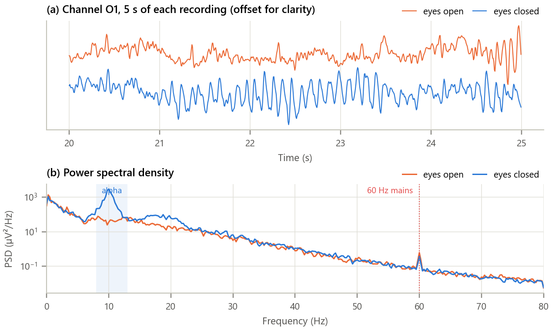
Figure 1. The raw EEG. (a) Five seconds of channel O1 in both conditions; (b) power spectral density with the alpha band and the mains frequency marked.
Inference. With the eyes closed the trace is dominated by a regular rhythm of about ten cycles per second; with the eyes open it is smaller and irregular (std 52 versus 79 µV). The spectrum makes this quantitative: a sharp peak at 10.0 Hz appears only with the eyes closed. Both recordings show a narrow line at 60 Hz, about 4.6 times the surrounding EEG background: mains interference. A falling 1/f background spans the whole range.

5. Methodology and Implementation
The processing chain is: first-order high-pass at 0.5 Hz (drift), 60 Hz notch (Q = 30), and an order-4 prototype band-pass at 8 to 13 Hz (order 8 overall) realised as second-order sections. The three prototype families are compared, alpha power is computed in 2-second epochs and the two conditions are compared with Welch's t-test.
Table 5. Software modules
Module | Responsibility
config.py | Runs, channel, band, orders, ripple, notch Q
data_loader.py | Download from the AWS mirror once, cache, parse EDF, convert to µV
iir.py | Difference equation, SOS cascade, zero-phase, notch, high-pass, pre-warp, bilinear transform
analysis.py | Family comparison, FIR equivalent, pre-warping, numerics, notch, phase, alpha study
plots.py / gui.py | Report figures / interactive IIR filter designer
test_iir.py | 8 unit tests (SciPy agreement, exact edges, stability, notch, zero phase): all pass

Core of iir.py
1 def notch(f0, Q, fs): # zeros on |z| = 1, poles at radius r
2 w0 = 2 * np.pi * f0 / fs
3 r = 1 - w0 / Q / 2
4 b = np.array([1.0, -2 * np.cos(w0), 1.0])
5 a = np.array([1.0, -2 * r * np.cos(w0), r * r])
6 return b * a.sum() / b.sum(), a, r # unit gain at DC
7
8 def bilinear_zpk(z, p, k, fs): # s = 2fs (1 - z^-1) / (1 + z^-1)
9 c = 2 * fs
10 zd, pd = (c + z) / (c - z), (c + p) / (c - p)
11 zd = np.r_[zd, -np.ones(len(p) - len(z))] # zeros at s = infinity go to z = -1
12 return zd, pd, k * np.real(np.prod(c - z) / np.prod(c - p))
13
14 def iir_filter(b, a, x): # y[n] = sum b_k x[n-k] - sum a_k y[n-k]
15 y = np.zeros(len(x))
16 for n in range(len(x)):
17 y[n] = sum(b[k] * x[n - k] for k in range(min(len(b) - 1, n) + 1)) \
18 - sum(a[k] * y[n - k] for k in range(1, min(len(a) - 1, n) + 1))
19 return y
20

GUI. gui.py (Figure 2) designs a Butterworth, Chebyshev I or elliptic band-pass of any order, edges, ripple and attenuation, optionally after the 60 Hz notch and with causal or zero-phase filtering. It shows the magnitude response, group delay, pole-zero plot and the filtered EEG for both conditions, and reports the largest pole radius, the in-band delay and the alpha-power ratio; the second-order sections can be exported. Run python run_experiment.py and python gui.py.
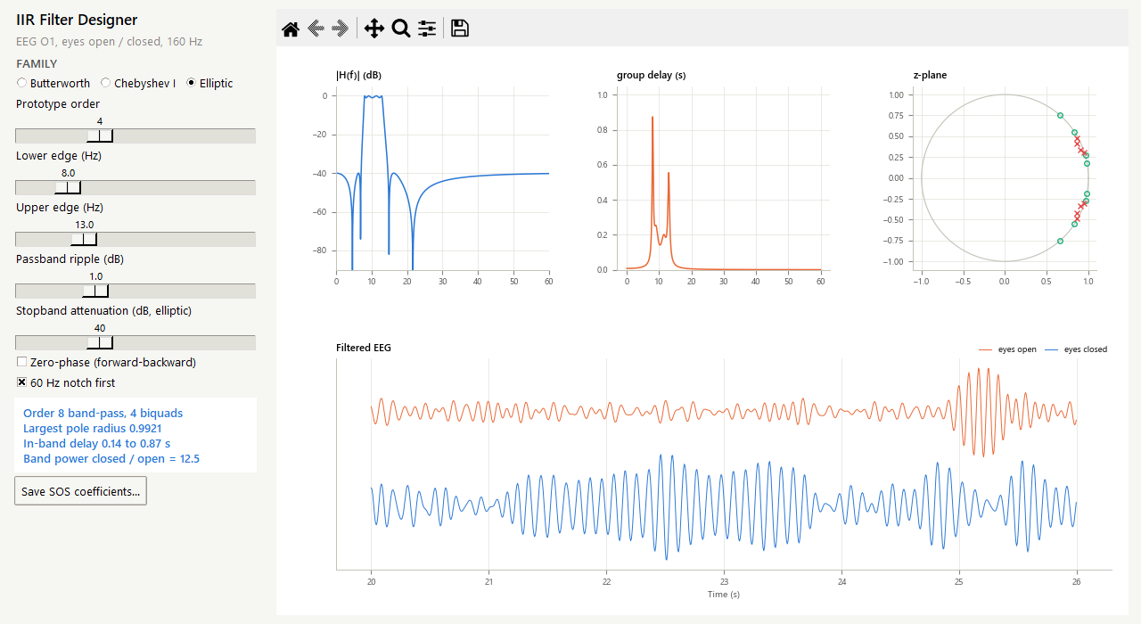
Figure 2. The IIR filter designer with the order-8 elliptic alpha band-pass. Eight poles crowd close to the unit circle near 10 Hz; the eyes-closed trace shows the alpha rhythm.

6. Calculations
60 Hz notch. ω₀ = 2π·60/160 = 3π/4 rad/sample, cos ω₀ = −0.7071.
Table 6. Hand calculations
Quantity | Working | Result
Pole radius r | 1 − ω₀/(2Q) = 1 − 2.3562/60 | 0.9607
Numerator (zeros at e^(±jω₀)) | 1 − 2cos ω₀ z⁻¹ + z⁻² | 1 + 1.4142 z⁻¹ + z⁻²
Denominator (poles) | 1 − 2r cos ω₀ z⁻¹ + r² z⁻² | 1 + 1.3587 z⁻¹ + 0.9230 z⁻²
−3 dB bandwidth | f₀/Q = 60/30 | 2.0 Hz (measured 2.03 Hz)
Time to settle to 1 % | ln 0.01 / ln r / fs | 0.72 s
High-pass pole at 0.5 Hz | p = e^(−2π·0.5/160) | 0.9806
Pre-warped alpha edges | 2fs tan(πf/fs), f = 8 and 13 Hz | 8.066 and 13.290 Hz
Bilinear map of s = −100 + j200 | (2fs + s)/(2fs − s) | 0.2421 + j0.5915 (|z| = 0.6391 < 1)

Pre-warping moves the analog edges up by only 0.8 % and 2.2 % at alpha frequencies, but by much more near the Nyquist frequency, where tan(πf/fs) grows quickly. The left-half-plane test point maps inside the unit circle, as the bilinear transform guarantees. These values agree with the program (checked by test_iir.py).

7. Results and Discussion
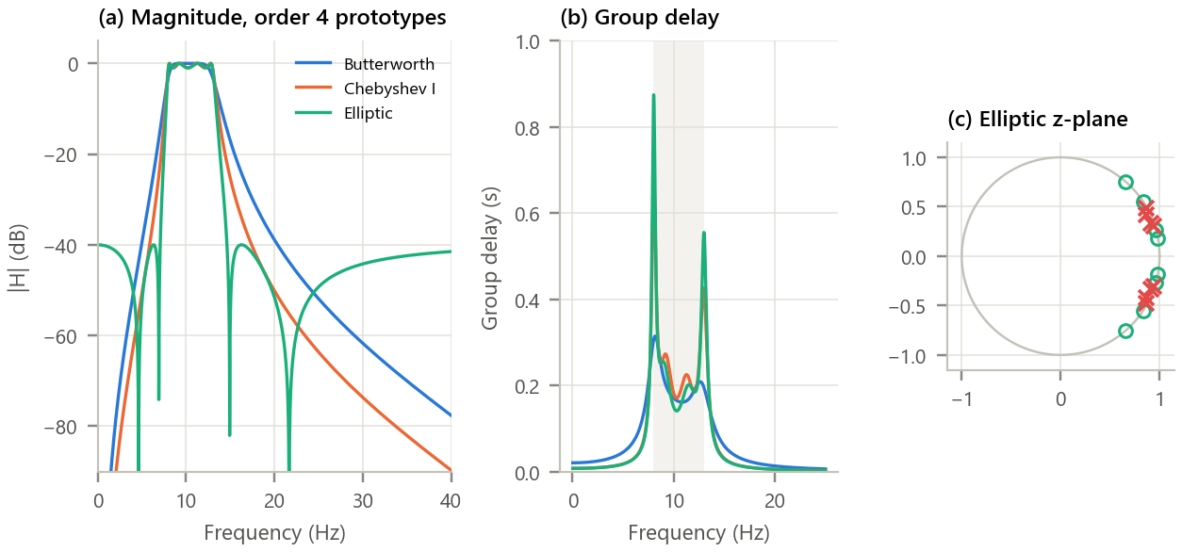
Figure 3. Three order-8 alpha band-pass designs. (a) Magnitude responses; (b) group delay (alpha band shaded); (c) poles (×) and zeros (○) of the elliptic design.
Inference.
- All three use 17 coefficients. At 5 Hz the Butterworth attenuates 40 dB, Chebyshev I 51 dB and elliptic 53 dB; Chebyshev and elliptic buy this with 1 dB passband ripple, and the elliptic's stopband stops falling at its 40 dB floor (only 40 dB at 60 Hz, against 109 dB for Butterworth).
- A Hamming-window FIR filter needs 81 taps to match the Butterworth's attenuation at 5 Hz, about 5 times more coefficients.
- The price is phase: the in-band group delay ranges from 0.16 to 0.31 s for Butterworth and 0.14 to 0.87 s for the elliptic, peaking at the band edges where the poles sit closest to the unit circle (radius 0.9921).

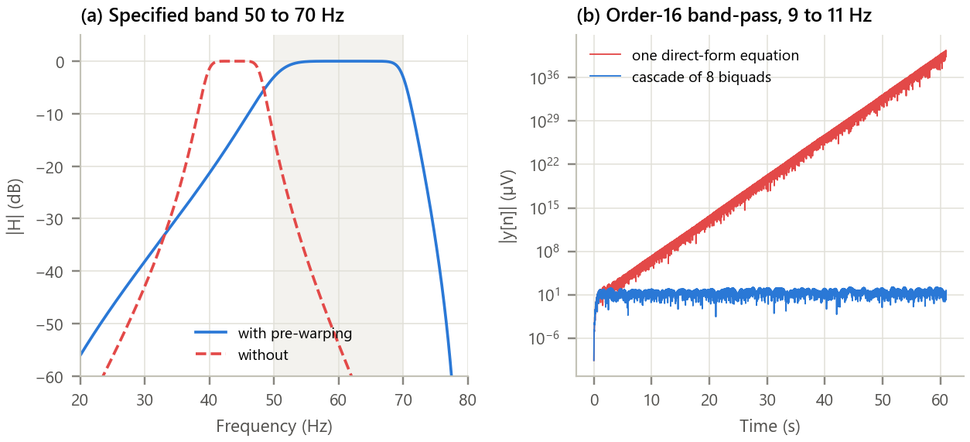
Figure 4. Pre-warping and numerical precision. (a) A Butterworth band-pass specified as 50 to 70 Hz, designed with and without pre-warping; (b) an order-16 band-pass (9 to 11 Hz) applied as one difference equation and as a cascade of biquads.
Inference.
- With pre-warping the band edges are exact (50.0 and 70.0 Hz). Without it the bilinear transform's frequency compression moves the band to 39.5 to 48.0 Hz. For the low alpha band the error is small (7.94 to 12.72 Hz), but it grows rapidly towards fs/2.
- For the order-8 filters used here the direct form agrees with the cascade to 3e-10. For the narrower order-16 design the coefficients of the single denominator polynomial, rounded to double precision, place a pole at radius 1.0233 instead of 0.9931: the filter is unstable and its output grows to about 10³⁷ µV within a minute. The same filter as eight biquads is perfectly stable, which is why SOS form is standard practice.

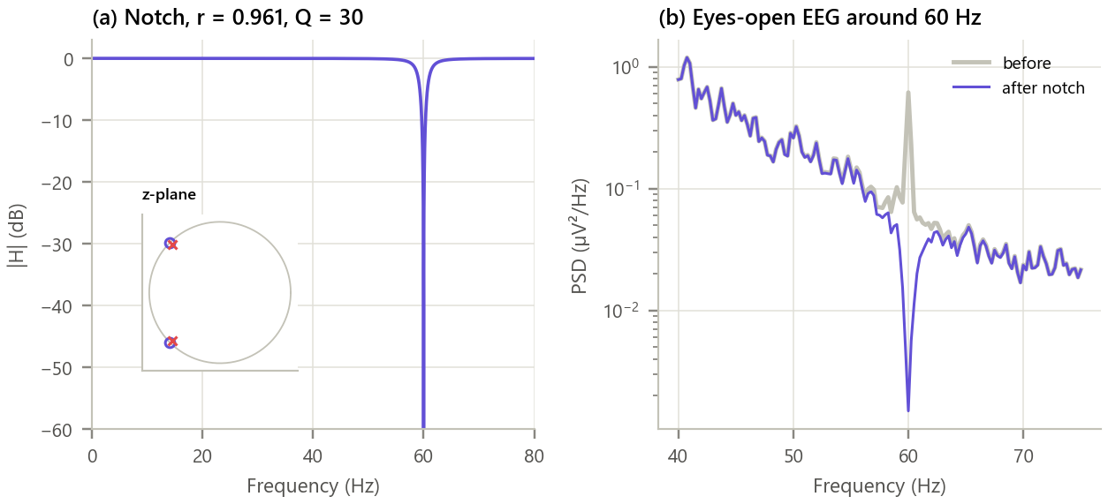
Figure 5. The 60 Hz notch filter. (a) Magnitude response with its pole-zero pair (inset); (b) eyes-open EEG spectrum before and after notching.
Inference. The notch is 290 dB deep at exactly 60 Hz, only 2.03 Hz wide at −3 dB, and leaves the alpha band untouched (gain at 10 Hz -0.0002 dB, alpha power changed by -0.0003 dB). The 60 Hz line falls from 0.617 to 0.0015 µV²/Hz, below the EEG background (about 0.14 µV²/Hz). Power in the whole 59 to 61 Hz band falls by only 10.4 dB because most of it is broadband EEG, which a notch must not remove. Its poles at radius 0.961 make the filter ring for about 0.7 s after a disturbance.

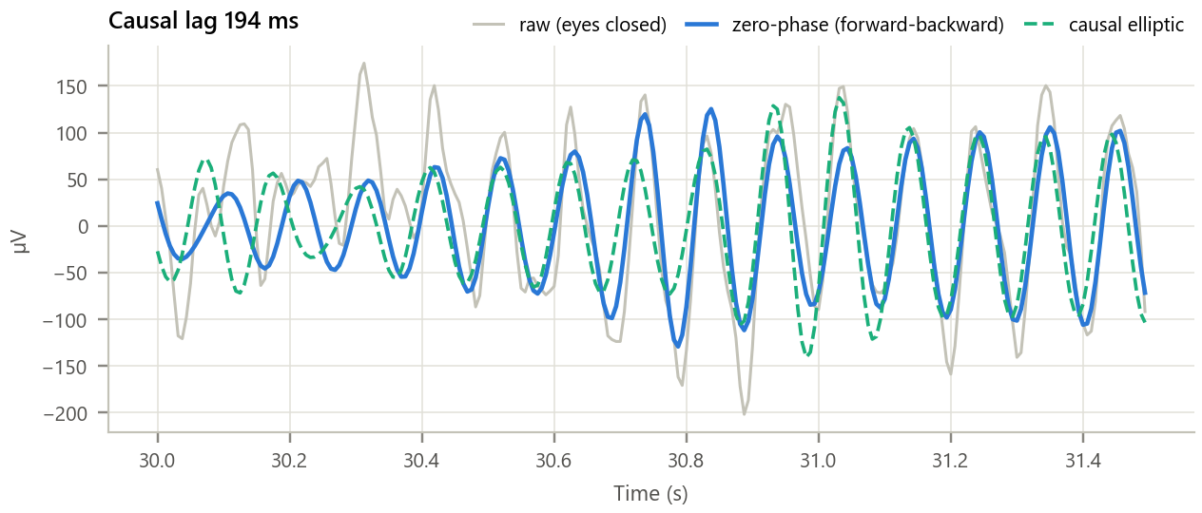
Figure 6. Causal versus zero-phase filtering of the eyes-closed EEG. 1.5 s of the raw signal with the elliptic band-pass applied causally and forward-backward.
Inference. Both outputs isolate the same 10 Hz oscillation, but the causal output is delayed by 194 ms (31 samples), about two alpha cycles, and its waveform is slightly reshaped because the delay varies with frequency. The zero-phase output lines up with the raw signal. Real-time systems (monitors, brain-computer interfaces) must accept the delay; off-line clinical analysis uses zero-phase filtering.

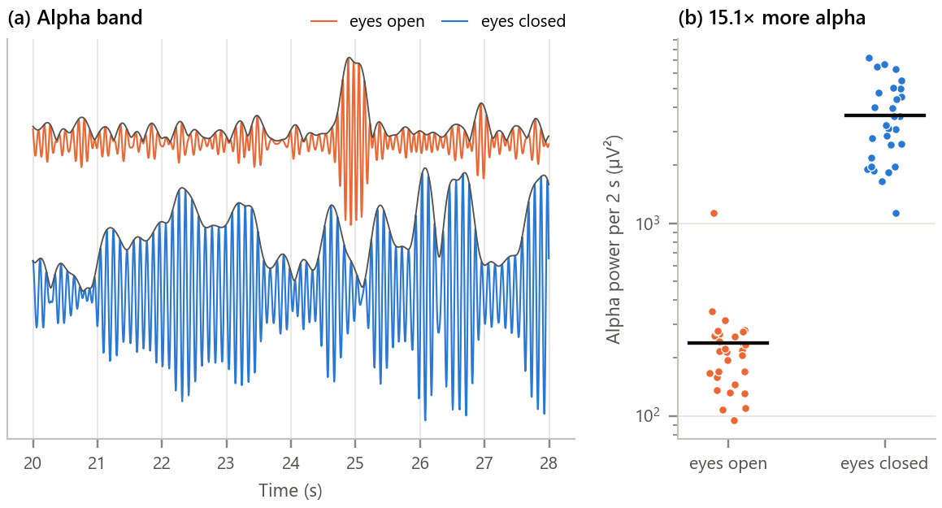
Figure 7. The Berger effect measured with the IIR filter chain. (a) Alpha-band output with its envelope in both conditions; (b) alpha power in each 2-second epoch.
Inference. With the eyes closed the alpha rhythm is continuous and large (RMS 60.2 µV); with the eyes open it appears only in brief bursts (RMS 15.5 µV). Mean alpha power is 15.1 times higher with the eyes closed, 97 % of eyes-closed epochs exceed every eyes-open epoch, and the difference is highly significant (Welch t = 11.0, p < 10⁻¹⁰). Closing the eyes removes visual input and the visual cortex falls into this idling rhythm, exactly the effect that makes alpha useful for detecting drowsiness and for eyes-closed brain-computer interfaces.

Table 7. Summary of the alpha band-pass designs (17 coefficients each; FIR equivalent 81 taps)
Quantity | Butterworth | Chebyshev I | Elliptic
−3 dB edges (Hz) | 8.01 to 13.00 | 7.90 to 13.15 | 7.93 to 13.12
Passband variation (dB) | 1.54 | 1.00 | 1.00
Attenuation at 5 / 16 Hz (dB) | 40 / 23 | 51 / 32 | 53 / 40
Attenuation at 60 Hz (dB) | 109 | 122 | 40
In-band group delay (s) | 0.16 to 0.31 | 0.17 to 0.67 | 0.14 to 0.87
Largest pole radius | 0.9709 | 0.9895 | 0.9921

8. Conclusion
IIR filters were designed in two ways: by placing poles and zeros by hand (notch, high-pass) and by transforming classical analog prototypes with the pre-warped bilinear transform, which matched SciPy exactly and preserved stability. They proved highly efficient: an order-8 band-pass with 17 coefficients replaced an FIR filter of 81 taps, and a single biquad removed mains interference. The experiment also exposed their weaknesses: non-linear phase that delays and reshapes waveforms (cured off-line by forward-backward filtering), the need to pre-warp critical frequencies, and numerical fragility that makes a cascade of second-order sections essential for high orders. Applied to real EEG, the filter chain cleaned the signal and measured a 15-fold increase in alpha power on closing the eyes, reproducing Berger's 1929 observation with a few lines of signal processing.

9. Learning Outcomes
- Design IIR filters by pole-zero placement and by the bilinear transform with pre-warping.
- Compare Butterworth, Chebyshev and elliptic responses and choose a family for a specification.
- Implement IIR filters as difference equations and as second-order sections, and judge stability from pole radii.
- Explain IIR phase distortion, apply zero-phase filtering, and use IIR filters on a real biomedical signal.

10. References
[1] A. V. Oppenheim and R. W. Schafer, Discrete-Time Signal Processing, 3rd ed. Pearson, 2010, ch. 7.1 to 7.3.
[2] J. G. Proakis and D. G. Manolakis, Digital Signal Processing, 4th ed. Pearson, 2007, ch. 10.
[3] G. Schalk et al., “BCI2000: a general-purpose brain-computer interface (BCI) system,” IEEE Trans. Biomed. Eng., vol. 51, no. 6, pp. 1034-1043, 2004.
[4] A. L. Goldberger et al., “PhysioBank, PhysioToolkit, and PhysioNet,” Circulation, vol. 101, no. 23, pp. e215-e220, 2000.
[5] H. Berger, “Über das Elektrenkephalogramm des Menschen,” Archiv für Psychiatrie und Nervenkrankheiten, vol. 87, pp. 527-570, 1929.

