Course | Digital Signal Processing Lab | Experiment No. | 09
Name | Dewashish Lambore | PRN | ____________
Language | Python 3.10 | Date | ____ / ____ / 2026
Linear Convolution using the DFT
Placing a dry voice in a real seminar room: fast convolution reverb
Abstract: A dry speech recording (L = 114,400 samples) was convolved with a room impulse response measured in a university seminar room (M = 44,100 samples, 1 s at 44.1 kHz) by multiplying their DFTs. With zero padding to N = L + M − 1 = 158,499 the result matched direct convolution to 8e-16 and the independently published reverberant file to 70.9 dB SNR, while running 3,295 times faster than direct convolution (48.0 s versus 15 ms) and needing 575 times fewer multiplications. Choosing an FFT-friendly length (160,000 instead of 158,499) made it 12 times faster again. Without enough padding the circular result was time-aliased (error 5.7e-02 for N = L). Overlap-add block processing was equally exact and trades latency for cost. The impulse response itself gave a reverberation time of 0.63 s, and dividing spectra (regularised deconvolution) removed the room again with 50 dB SNR on clean data.
Keywords: linear convolution, DFT, FFT, fast convolution, zero padding, time aliasing, overlap-add, room impulse response, reverberation, deconvolution, Python

1. Aim and Objectives
Aim: to compute the linear convolution of two real-world signals using the DFT, determine the zero padding it requires, and compare its accuracy and speed with direct convolution, in Python.
- Implement DFT-based convolution with zero padding and verify it against direct convolution and a published result.
- Show what happens when the DFT is too short (time aliasing) and implement overlap-add block convolution.
- Measure the computational saving, and use the room impulse response for acoustics (RT60) and deconvolution.

2. Real-World Application
A room is a linear time-invariant system: the sound that reaches a listener is the source signal convolved with the room's impulse response, which contains the direct sound and thousands of reflections. If that response is measured once, any dry recording can be made to sound as if it was performed in the room. This convolution reverb is used in music production, film post-production, video games and virtual reality, and acoustic consultants use it to let clients listen to a hall before it is built. Impulse responses are long (here 44,100 samples), so direct convolution is far too slow; every real product uses the DFT. The same fast convolution appears in many other systems (Table 1).
Table 1. Uses of fast (DFT-based) convolution
Application | Signal x[n] | Impulse response h[n]
Convolution reverb (this experiment) | dry voice or instrument | measured room or hall response
Headphone 3-D audio, VR | game or film sound | head-related impulse responses
Long FIR filtering | audio, sensor data | filter with hundreds of taps
Radar pulse compression | received echo | time-reversed transmitted chirp
Image blur and deblur | photograph rows | point-spread function of the lens

3. Theory
The linear convolution of x[n] (length L) with h[n] (length M) has length L + M − 1:
$y[n]=\sum_{k=0}^{M−1}{}h[k] x[n−k], 0≤n≤L+M−2$ (1)
By the convolution property of the DFT, multiplying two N-point DFTs corresponds to circular convolution of length N (Experiment 4), not linear convolution:
${IDFT}_{N}\{X[k] H[k]\}=x[n]⊛_{N}h[n]=\sum_{r}{}y[n+rN]$ (2)
The circular result is the linear one folded (time-aliased) onto N samples. The two are therefore equal if, and only if, both sequences are first zero-padded to
$N≥L+M−1 ⇒ y[n]={IDFT}_{N}\{{DFT}_{N}\{x\}·{DFT}_{N}\{h\}\}$ (3)
Cost. Direct convolution needs L·M multiplications. The DFT route needs three FFTs and one product, so it grows only as N log₂ N:
$C_{direct}=L M, C_{FFT}≈3 \frac{N}{2}\log_{2}N·2+3N$ (4)
Overlap-add splits x into blocks of B samples, convolves each block with h using an FFT of length at least B + M − 1, and adds the overlapping tails. It is exact, works for endless real-time streams, and its delay is one block. Room acoustics is read from h[n] by Schroeder's backward integration; the reverberation time RT60 is the time for the energy to fall by 60 dB:
$E(t)=\int_{t}^{∞}{}h^{2}(τ) dτ, {RT}_{60}=\frac{−60 dB}{\text{slope of }10\log_{10}E(t)}$ (5)
Note. Because convolution becomes multiplication, it can be undone by division, X = Y/H. Where |H| is tiny the division amplifies noise enormously, so in practice a regularised inverse X = Y·H*/(|H|² + ε·max|H|²) is used; ε trades residual reverberation against noise.

4. Dataset Description
All three files come from the open Communication Acoustics exercises of the Institute of Communications Engineering, University of Rostock (GitHub: spatialaudio/communication-acoustics-exercises, CC0 public domain). The dry speech is a male voice saying "Wishing you a Merry Christmas, and a Happy New Year" (Freesound #136777). The room impulse response was measured in a seminar room by clapping two wooden boards together in front of a microphone. The published wet file is the authors' own convolution of the two and serves as an independent reference. The files total about 620 kB and are cached after download.
Table 2. Dataset attributes (all mono, 16-bit PCM, fs = 44,100 Hz)
Signal | File | Samples | Duration | Peak | RMS | Size
Dry speech x[n] | xmas.wav | 114,400 | 2.594 s | 1.000 | 0.1268 | 224 kB
Room impulse response h[n] | rir_clap.wav | 44,100 | 1.000 s | 0.500 | 0.0276 | 86 kB
Published y_ref[n] | xmas_clap.wav | 158,499 | 3.594 s | 1.000 | 0.0621 | 310 kB

Table 3. Impulse-response samples around the direct sound
n | Time (ms) | h[n] (int16) | h[n] (float)
78 | 1.769 | -10565 | -0.3224
79 | 1.791 | -13852 | -0.4227
80 | 1.814 | -16379 | -0.4998
81 | 1.837 | -16179 | -0.4937
82 | 1.859 | -12796 | -0.3905
83 | 1.882 | -7017 | -0.2141

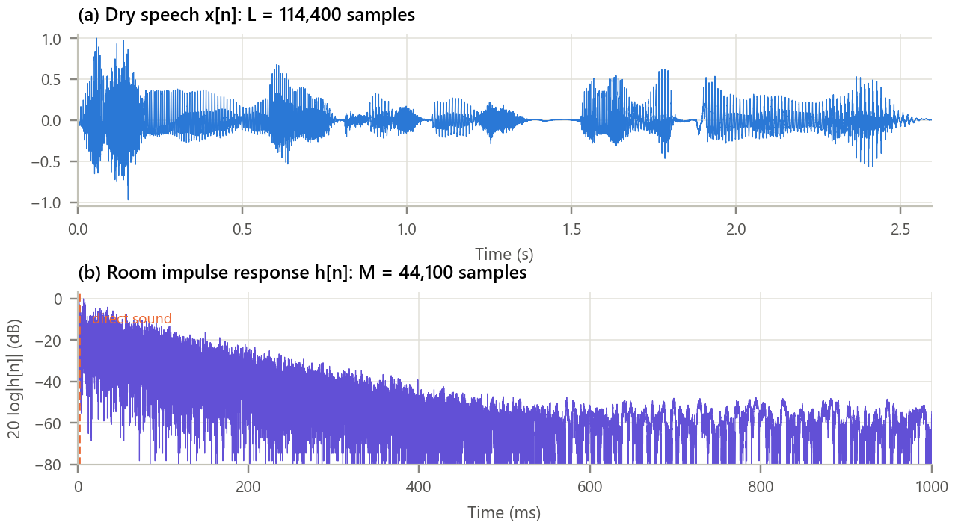
Figure 1. The two inputs of the convolution. (a) Dry speech; (b) the room impulse response on a decibel scale.
Inference. The dry speech has crisp word boundaries and silent gaps. The impulse response starts with the direct sound of the clap at 1.8 ms, followed by a dense cloud of reflections whose level falls almost linearly in decibels, the signature of an exponential energy decay. Its tail is still visible after 600 ms, so h[n] must be kept at its full length M = 44,100.

5. Methodology and Implementation
Both signals are zero-padded to N, transformed with real FFTs, multiplied bin by bin and transformed back. The result is compared with direct convolution (timed on the first 0.25 s and scaled to the full length, since its cost is proportional to L) and with the published file after a single gain factor (the file was normalised). N is then reduced to show aliasing, and overlap-add is run with block lengths of 256, 1024, 4096, 16384 samples.
Table 4. Software modules
Module | Responsibility
config.py | File URLs, block lengths, deconvolution settings
data_loader.py | Download the three WAV files once, cache, convert to float
fastconv.py | Direct and DFT convolution, fast FFT length, overlap-add, cost, RT60, deconvolution
analysis.py | Accuracy and timing, aliasing study, overlap-add study, room acoustics, deconvolution
plots.py / gui.py | Report figures / interactive convolution reverb with audio playback
test_fastconv.py | 8 unit tests (equality with direct, aliasing, overlap-add, RT60, deconvolution): all pass

Core of fastconv.py
1 def conv_dft(x, h, N=None): # y = IDFT{ DFT{x} DFT{h} }
2 N = N or len(x) + len(h) - 1 # zero padding for LINEAR convolution
3 X, H = np.fft.rfft(x, N), np.fft.rfft(h, N) # rfft pads with zeros to length N
4 return np.fft.irfft(X * H, N)
5
6 def overlap_add(x, h, B): # block convolution for long / live signals
7 N = next_fast_length(B + len(h) - 1)
8 H = np.fft.rfft(h, N)
9 y = np.zeros(len(x) + len(h) - 1)
10 for s in range(0, len(x), B):
11 seg = x[s:s + B]
12 ys = np.fft.irfft(np.fft.rfft(seg, N) * H, N)[:len(seg) + len(h) - 1]
13 y[s:s + len(ys)] += ys # add the overlapping tail
14 return y
15

GUI. gui.py (Figure 2) lets the user choose a single DFT or overlap-add, shorten the impulse response, set N as a percentage of the required padding, and set the block length. It shows the output and its difference from exact linear convolution, reports the error, the time taken and the latency, and plays the dry and processed sound so that aliasing can be heard as an echo before the first word. Run python run_experiment.py (which also writes outputs/reverberant.wav) and python gui.py.
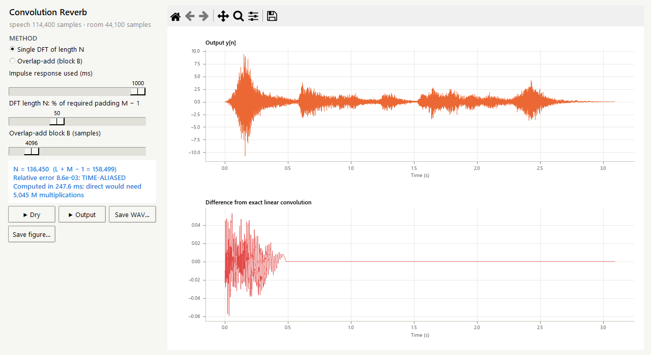
Figure 2. The convolution reverb with only half of the required zero padding. The difference panel shows the aliased tail folded onto the first half second.

6. Calculations
Small example. x = [1, 2, 3] (L = 3) and h = [1, 0.5] (M = 2), so N = L + M − 1 = 4. Padding to 4 samples and using the 4-point DFT (twiddle factor −j):
Table 5. DFT-based convolution by hand
k | X[k] of [1, 2, 3, 0] | H[k] of [1, 0.5, 0, 0] | Y[k] = X[k]·H[k]
0 | 6 | 1.5 | 9
1 | -2 − j2 | 1 − j0.5 | -3 − j1
2 | 2 | 0.5 | 1
3 | -2 + j2 | 1 + j0.5 | -3 + j1

The IDFT of Y gives y = [1, 2.5, 4, 1.5], identical to the direct sum (1·1, 2·1 + 1·0.5, 3·1 + 2·0.5, 3·0.5). With N = 3 (too short) the last value 1.5 wraps onto n = 0: y₃ = [2.5, 2.5, 4], i.e. y[0] = 1 + 1.5. For the real signals: L·M = 114,400 × 44,100 = 5.05 × 10⁹ multiplications directly, against about 8.8 × 10⁶ with FFTs of length 160,000 (a ratio of 575). N = 158,499 = 3 × 3 × 11 × 1601 contains the large prime 1601, while 160,000 = 2⁸ × 5⁴ is FFT-friendly. These values agree with the program (checked by test_fastconv.py).

7. Results and Discussion
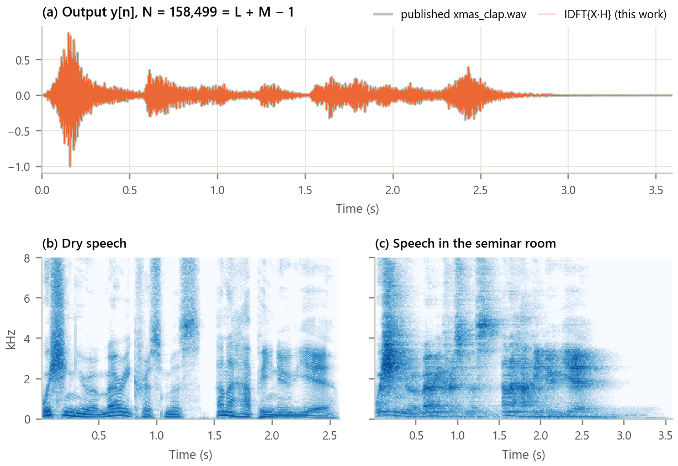
Figure 3. The convolution result. (a) Output of the DFT method overlaid on the published reverberant file; (b), (c) spectrograms of the dry and the reverberant speech.
Inference.
- The DFT result is indistinguishable from the published file: after one gain factor the relative difference is 2.8e-04 (70.9 dB), which is the 16-bit quantisation of that file. On the first 0.25 s it equals direct convolution to 8e-16, i.e. exactly up to rounding.
- The output is 1.00 s longer than the input (M − 1 samples): the room keeps ringing after the speaker stops. In the spectrogram the gaps between words fill with reverberant energy, especially below 2 kHz, which is why speech in a reverberant room sounds less clear.

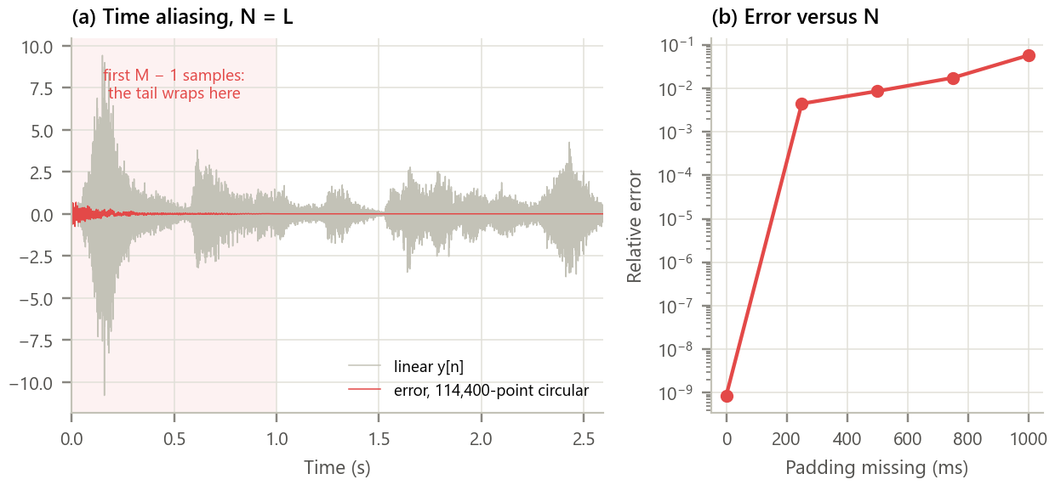
Figure 4. What happens when the DFT is too short. (a) Error of a 114,400-point (unpadded) circular result; (b) relative error against the missing padding.
Inference. Without padding (N = L) the 44,099 tail samples that do not fit wrap around and are added to the beginning: the error is confined to the first second, where it sounds like the end of the sentence echoing before the first word (relative error 5.7e-02). The error falls as N grows but remains about 4e-03 even with 250 ms missing, because the room tail is long. Only at N = L + M − 1 does it collapse to 1e-15: the padding condition is exact, not approximate.

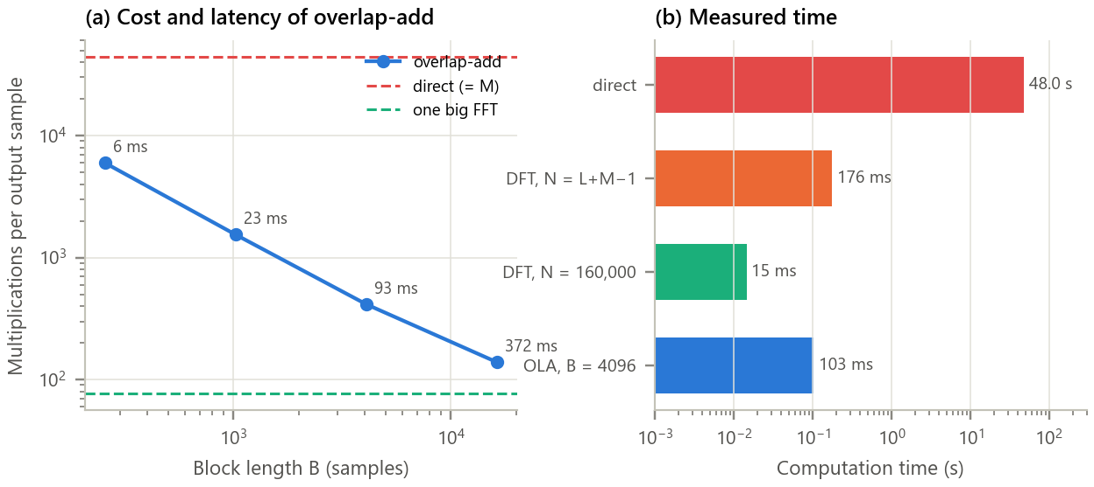
Figure 5. Overlap-add and computation time. (a) Multiplications per output sample against block length, labelled with the latency; (b) measured time of each method.
Inference.
- Every overlap-add block length reproduced the linear result exactly (error ≤ 8e-16). Short blocks give low latency (6 ms for B = 256) but cost more, because each tiny block still needs an FFT longer than M; long blocks are cheaper (138 multiplications per sample for B = 16,384) but delay the sound by 372 ms. Live audio typically uses 256 to 1,024 samples.
- Direct convolution would take about 48 s; one FFT of length 158,499 takes 176 ms, one of length 160,000 only 15 ms, and overlap-add with B = 4096 takes 103 ms.

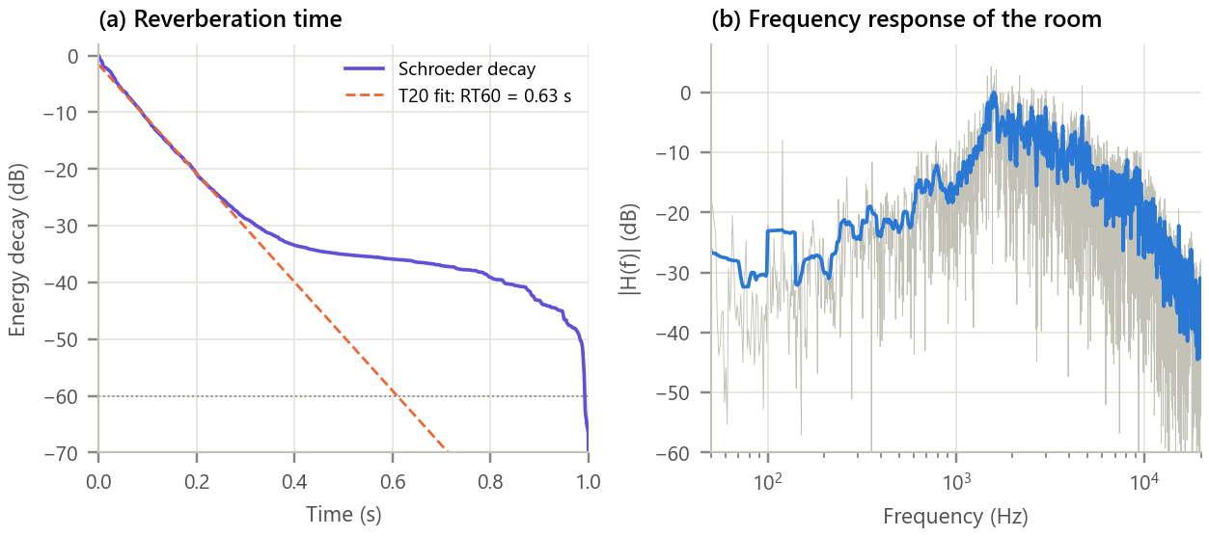
Figure 6. Room acoustics from the impulse response. (a) Schroeder energy decay curve with the T20 line fit; (b) magnitude of H(f), raw and smoothed.
Inference. The energy decays linearly in dB down to about −30 dB, giving RT60 = 0.63 s from the −5 to −25 dB range (T20) and an early decay time of 0.55 s, typical of a furnished seminar room. Below about −35 dB the curve flattens into the noise floor of the recording, which is why T30 (0.88 s) is less reliable. The direct sound carries 6.9 dB less energy than the reverberation that follows it. The frequency response is irregular and favours 1 to 3 kHz, partly because a hand clap has little low-frequency energy; a sine-sweep measurement would be flatter.

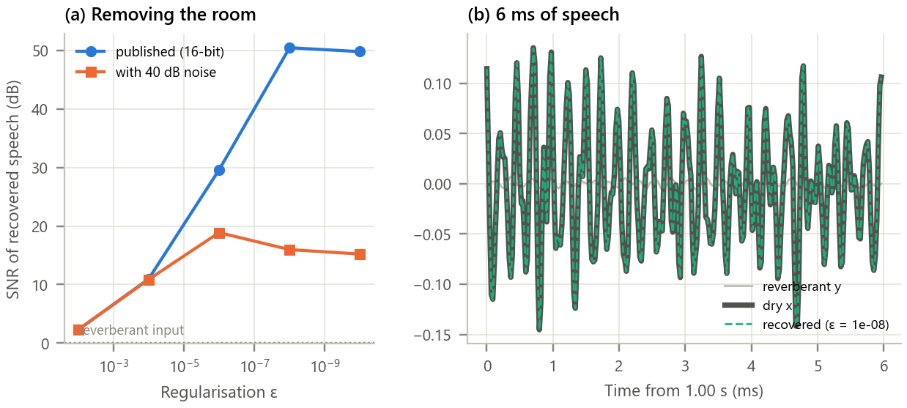
Figure 7. Removing the room again by spectral division. (a) SNR of the recovered dry speech against ε, without and with 40 dB recording noise; (b) the reverberant, dry and recovered waveforms.
Inference. The reverberant file itself has an SNR of about 0 dB against the dry speech (the reverberation is as strong as the speech). Dividing by H recovers the speech to 50.4 dB at ε = 1e-08, and the recovered waveform lies on top of the original. With realistic 40 dB noise the best result drops to 18.9 dB at a larger ε = 1e-06, and smaller ε makes it worse: dividing by the nearly-zero bins of H amplifies the noise. Deconvolution works only when h[n] is known exactly and the recording is clean.

Table 6. Summary of results
Quantity | Result
DFT method versus direct convolution | relative error 8e-16
DFT method versus published reverberant file | 70.9 dB SNR
Required DFT length L + M − 1 / FFT-friendly length | 158,499 / 160,000
Time: direct / DFT (N = L + M − 1) / DFT (fast N) / overlap-add | 48.0 s / 176 ms / 15 ms / 103 ms
Multiplications direct / FFT | 5.05 × 10⁹ / 8.8 × 10⁶
Error with N = L (no padding) | 5.7e-02
Reverberation time T20 / EDT; direct-to-reverberant ratio | 0.63 s / 0.55 s; -6.9 dB
Deconvolution SNR: clean / 40 dB noise | 50.4 dB / 18.9 dB

8. Conclusion
Linear convolution was computed exactly with the DFT once both signals were zero-padded to L + M − 1; with less padding the result was the circular convolution, whose wrapped tail is audible as an echo before the speech. On a real voice and a real room response the method reproduced a published result to 71 dB while being about 3,295 times faster than direct convolution, and choosing an FFT-friendly length mattered almost as much as using the FFT at all. Overlap-add made the same computation possible block by block, exposing the latency-versus-cost trade-off of real-time reverbs. The impulse response also described the room (RT60 ≈ 0.6 s), and the convolution theorem allowed the room to be removed again, but only as far as noise permits.

9. Learning Outcomes
- Compute linear convolution through the DFT and choose the zero-padding length N ≥ L + M − 1.
- Recognise and explain time aliasing when N is too small.
- Implement overlap-add block convolution and quantify its cost and latency.
- Compare direct and FFT-based convolution in operations and measured time, and apply fast convolution to audio.

10. References
[1] A. V. Oppenheim and R. W. Schafer, Discrete-Time Signal Processing, 3rd ed. Pearson, 2010, ch. 8.7.
[2] T. G. Stockham, “High-speed convolution and correlation,” in Proc. AFIPS Spring Joint Computer Conf., 1966, pp. 229-233.
[3] M. R. Schroeder, “New method of measuring reverberation time,” J. Acoust. Soc. Am., vol. 37, pp. 409-412, 1965.
[4] ISO 3382-2:2008, Acoustics: Measurement of room acoustic parameters, Part 2: Reverberation time in ordinary rooms.
[5] M. Geier, S. Spors et al., Communication Acoustics Exercises, University of Rostock, https://github.com/spatialaudio/communication-acoustics-exercises (CC0).

