Course | Digital Signal Processing Lab | Experiment No. | 02
Name | Dewashish Lambore | PRN | ____________
Language | Python 3.10 | Date | ____ / ____ / 2026
Testing Systems for Linearity and Time Invariance
and the time response of LTI systems, applied to Pune air-quality data around Diwali 2025
Abstract: Two weeks (N = 336 hourly samples) of real PM2.5 and NO₂ data for Pune were passed through four systems that are actually used in air-quality monitoring: the 24-hour average of the Indian standard, the exponential display filter of a low-cost sensor, the CPCB Air Quality Index, and a sensor whose gain drifts. Black-box superposition and shift tests classified every system correctly: the two filters are LTI (errors below 1e-15), the AQI is nonlinear (error 0.218) and the drifting sensor is time-varying (error 0.0198). Impulse and step responses explain the behaviour on real data: the 24-h average reached 65.1 µg/m³, exceeding the 60 µg/m³ standard for 15 hours, and lagged the hourly peak by 3 h, while the smoother's time constant matched theory (4.48 samples).
Keywords: linearity, time invariance, superposition, impulse response, step response, LTI, air quality, AQI, Python

1. Aim and Objectives
Aim: to check whether a given discrete-time system is linear and time invariant, and to obtain and interpret the time response (impulse and step response) of LTI systems, using real-world data in Python.
- Implement black-box superposition and shift tests that work for any system.
- Classify four real air-quality processing systems and confirm the expected result.
- Compute impulse and step responses, verify $y[n]=x[n]*h[n]$ for the LTI systems, and relate response time to what an operator sees during a pollution episode.

2. Real-World Application
Every air-quality number shown to the public passes through a chain of systems. India's National Ambient Air Quality Standard (NAAQS) for PM2.5 is defined on a 24-hour average; consumer sensors smooth their readings with an exponential filter so the display does not flicker; the AQI maps concentration to a 0 to 500 health scale; and cheap sensors drift as their optics get dirty. Whether each system is LTI decides what can be done with it: an LTI system is fully described by its impulse response and can be analysed, inverted or combined by convolution, while a nonlinear or time-varying system cannot. Table 1 lists the four systems tested.
Table 1. Systems under test
System | Equation | Where it is used | Expected
S1 24-h moving average | y[n] = (1/M) Σ x[n−k], k = 0 … M−1 | NAAQS 24-hour average of PM2.5 | Linear, time-invariant
S2 Exponential smoother | y[n] = α x[n] + (1−α) y[n−1] | Display filter of a low-cost sensor | Linear, time-invariant
S3 AQI sub-index | y[n] = I(x[n]), piecewise linear | CPCB National Air Quality Index | Nonlinear, time-invariant
S4 Drifting sensor | y[n] = (1 + βn) x[n] | Uncalibrated sensor whose gain drifts | Linear, time-varying

3. Theory
A discrete-time system is an operator that maps an input sequence to an output sequence, $y[n]=T\{x[n]\}$. It is linear if it obeys superposition, i.e. additivity and homogeneity together, for all inputs and all constants $a$, $b$:
$T\{a x_{1}[n]+b x_{2}[n]\}=a T\{x_{1}[n]\}+b T\{x_{2}[n]\}$ (1)
It is time-invariant if delaying the input only delays the output by the same amount:
$y[n]=T\{x[n]\} ⇒ T\{x[n−k]\}=y[n−k]\text{ for every }k$ (2)
A system that is both is LTI and is completely characterised by its impulse response $h[n]=T\{δ[n]\}$: any output is the convolution of the input with $h[n]$, and the step response is the running sum of $h[n]$:
$y[n]=\sum_{k=−∞}^{∞}{}x[k] h[n−k], s[n]=\sum_{m=−∞}^{n}{}h[m]$ (3)
For the exponential smoother the difference equation and its impulse response are
$y[n]=α x[n]+(1−α) y[n−1] ⇒ h[n]=α(1−α)^{n}u[n], τ=\frac{−1}{ln(1−α)}$ (4)
where $τ$ is the time constant: the step response reaches $1−e^{−1}=63.2$ % after about $τ$ samples. The CPCB AQI is a piecewise-linear map between concentration breakpoints $[B_{lo},B_{hi}]$ and index breakpoints $[I_{lo},I_{hi}]$:
$I=\frac{I_{hi}−I_{lo}}{B_{hi}−B_{lo}}(C−B_{lo})+I_{lo}$ (5)
Because the slope changes from one band to the next, doubling $C$ does not double $I$, so the AQI cannot be linear. Each test is scored by the relative error between its two sides, $ε=‖LHS−RHS‖/‖RHS‖$; a property is accepted when $ε$ < 1e-09, i.e. equal to floating-point precision.
Note. A system with a non-zero initial state (e.g. y[−1] = 1) fails the linearity test even if its equation is linear, because a zero input does not give a zero output. All systems here start at rest, and a unit test confirms this effect.

4. Dataset Description
Hourly surface concentrations from the CAMS global atmospheric composition reanalysis/forecast of the Copernicus Atmosphere Monitoring Service (ECMWF), served by the free Open-Meteo air-quality API for the grid cell nearest Pune (18.5204° N, 73.8567° E), from 2025-10-14 to 2025-10-27. The window brackets Diwali (20 October 2025), when Indian cities typically see a pollution episode. The file is about 15 kB (336 samples × 4 pollutants, no missing values) and is cached after the first run. Because CAMS is a model, the values reflect meteorology and emission inventories rather than a single ground sensor, which is ideal for a clean, gap-free test signal.
Table 2. Dataset attributes and statistics (336 hourly samples)
Column | Signal | Unit | Mean | Std | Min | Max | Role
pm25 | PM2.5 concentration | µg/m³ | 22.8 | 17.0 | 2.6 | 78.5 | x₁ in every test
pm10 | PM10 concentration | µg/m³ | 23.7 | 17.9 | 2.7 | 80.8 | context
no2 | Nitrogen dioxide | µg/m³ | 10.6 | 9.4 | 0.5 | 43.9 | x₂ in the superposition test
co | Carbon monoxide | µg/m³ | 353.2 | 146.8 | 162.0 | 835.0 | context

Table 3. Dataset preview around the PM2.5 peak (µg/m³)
n | Time (IST) | PM2.5 | PM10 | NO₂ | CO
138 | 19-Oct 18:00 | 71.7 | 74.7 | 24.1 | 412
139 | 19-Oct 19:00 | 74.7 | 77.3 | 35.4 | 575
140 | 19-Oct 20:00 | 77.3 | 79.9 | 43.0 | 682
141 | 19-Oct 21:00 | 78.5 | 80.8 | 43.9 | 683
142 | 19-Oct 22:00 | 76.8 | 79.2 | 41.0 | 627
143 | 19-Oct 23:00 | 71.2 | 73.6 | 36.9 | 568

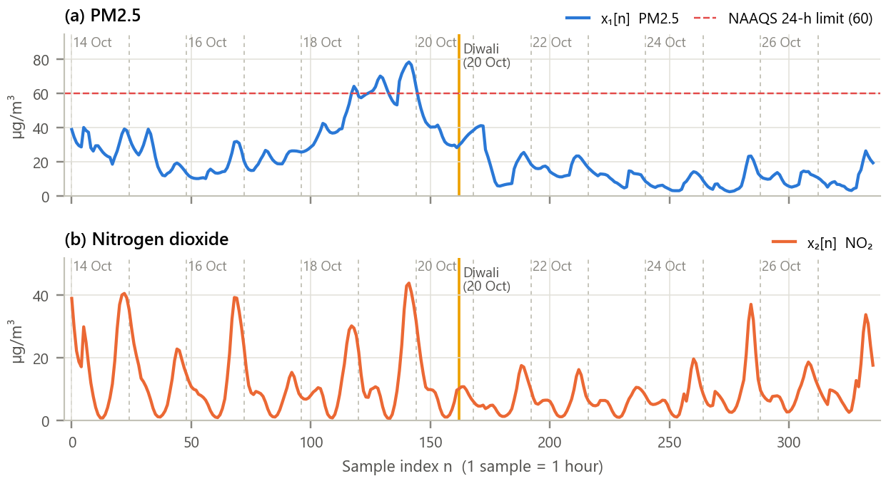
Figure 1. The two test inputs. (a) PM2.5 with the 24-h NAAQS limit; (b) NO₂. Dashed lines mark midnight.
Inference. PM2.5 rises from about 23 µg/m³ before 18 October to a peak of 78.5 µg/m³ at 21:00 on 19 October, crosses 60 µg/m³ for 20 hours, then falls to about 11 µg/m³ once the episode clears. NO₂ instead shows sharp evening traffic peaks every day. The two inputs therefore have very different shapes, which makes the superposition test demanding.

5. Methodology and Implementation
Each system is a Python callable that maps an input array to an output array from rest. The tests treat it as a black box, exactly as an engineer would test an unknown device: they only call it with inputs. Parameters: a = 1.5, b = 0.5, shift k = 12 h, M = 24, α = 0.2, β = 5 % per day.
Table 4. Software modules
Module | Responsibility
config.py | Dataset, system and test parameters, AQI breakpoints
data_loader.py | Download from Open-Meteo once, cache as CSV, clean, attach index n
systems.py | The four systems, a general difference equation, and the black-box tests
analysis.py | Test battery, impulse/step metrics, NAAQS exceedance, lag and AQI categories
plots.py / gui.py | Report figures / interactive system tester
test_systems.py | 13 unit tests, including the initial-condition effect (all pass)

Core of systems.py
1 def linearity_test(system, x1, x2, a, b):
2 lhs = system(a * x1 + b * x2) # T{a x1 + b x2}
3 rhs = a * system(x1) + b * system(x2) # a T{x1} + b T{x2}
4 return relative_error(lhs, rhs)
5
6 def time_invariance_test(system, x, k):
7 lhs = system(delay(x, k)) # T{x[n - k]}
8 rhs = delay(system(x), k) # y[n - k]
9 return relative_error(lhs, rhs)
10
11 def impulse_response(system, L):
12 d = np.zeros(L); d[0] = 1.0 # delta[n]
13 return system(d) # h[n] = T{delta[n]}
14

GUI. gui.py (Figure 2) is a system tester: choose one of the four systems or type the coefficients of any difference equation, choose a test (superposition, shift, impulse and step response, or apply to the PM2.5 data), adjust a, b, k and the system parameter, and the plots, error signal and a coloured verdict update instantly. Run python run_experiment.py for all figures and python gui.py for the tester.
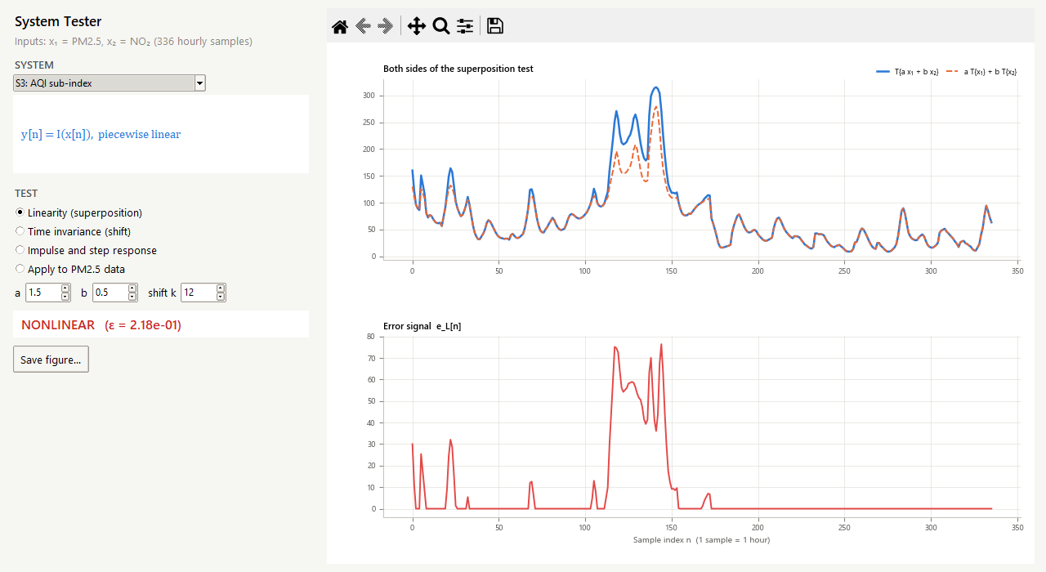
Figure 2. The interactive system tester running the superposition test on the AQI. The red verdict and the non-zero error signal show that the AQI is nonlinear.

6. Calculations
AQI superposition by hand with $x_{1}$ = 45 and $x_{2}$ = 30 µg/m³ and $a=b=1$. Using the band 30 to 60 → 50 to 100: I(45) = (50/30)(45 − 30) + 50 = 75 and I(30) = 50, so a I(x₁) + b I(x₂) = 125. But x₁ + x₂ = 75 lies in the band 60 to 90 → 100 to 200: I(75) = (100/30)(75 − 60) + 100 = 150 ≠ 125. Superposition fails. Table 5 shows that doubling the concentration does not double the index either.
Table 5. Doubling the PM2.5 concentration and the resulting AQI
C (µg/m³) | I(C) | I(2C) | 2·I(C) | Homogeneity
20 | 33.3 | 66.7 | 66.7 | holds
45 | 75.0 | 200.0 | 150.0 | fails
75 | 150.0 | 323.1 | 300.0 | fails
110 | 266.7 | 376.9 | 533.3 | fails

Drift shift test by hand with k = 1 and two samples x = {74.7, 77.3}: y[1] = (1 + β·1)·77.3 = 77.461, so y[n − 1] at n = 2 is 77.461; but T{x[n − 1]} at n = 2 = (1 + 2β)·77.3 = 77.622. The gain depends on n, so the system is time-varying. Smoother impulse response: h[0] = α = 0.2, h[1] = α(1 − α) = 0.160, h[2] = 0.128; τ = −1/ln(0.8) = 4.48 samples. All values agree with the program (checked by test_systems.py).

7. Results and Discussion
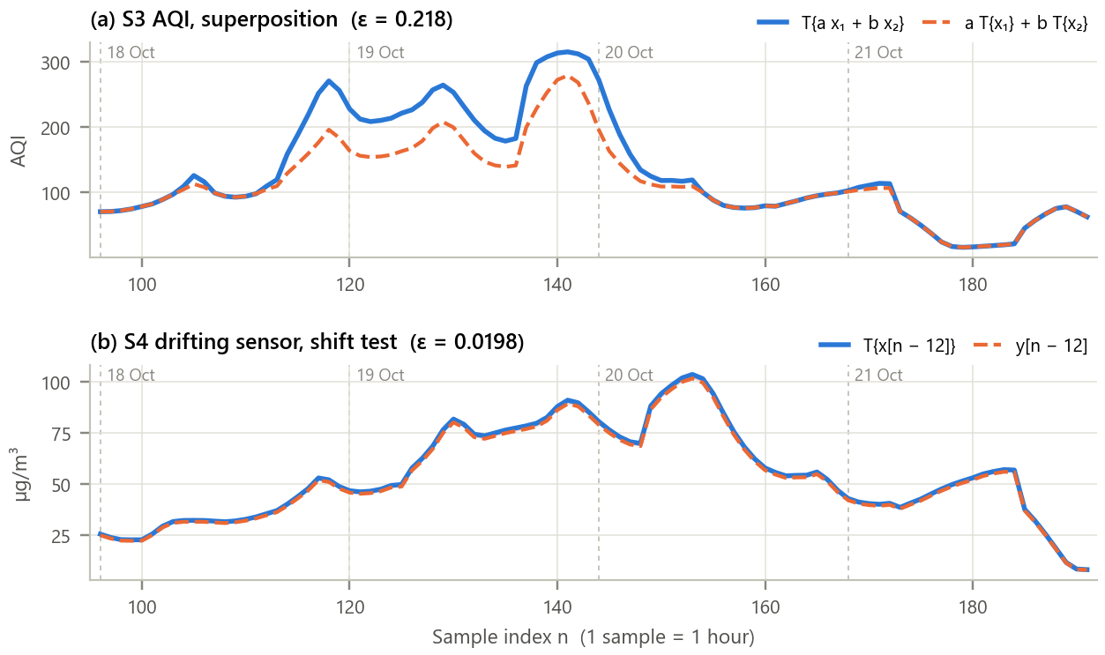
Figure 3. The two tests that fail, shown as overlays (18 to 21 October). (a) AQI: response to a x₁ + b x₂ versus the weighted sum of responses; (b) drifting sensor: response to the input delayed by k = 12 versus the delayed response.
Inference.
- AQI. The two sides agree when the combined concentration stays in one breakpoint band but separate sharply during the episode, when a x₁ + b x₂ crosses into steeper bands; the relative error is 0.218. The AQI amplifies high pollution on purpose, which is exactly what makes it nonlinear, so AQI values must never be averaged or added; the concentrations should be averaged first.
- Drift. The shaded gap grows with n because the shifted input meets a gain that is β·k = 2.50 % higher; the relative error is 0.0198. A drifting sensor cannot be described by one impulse response; it must be recalibrated.

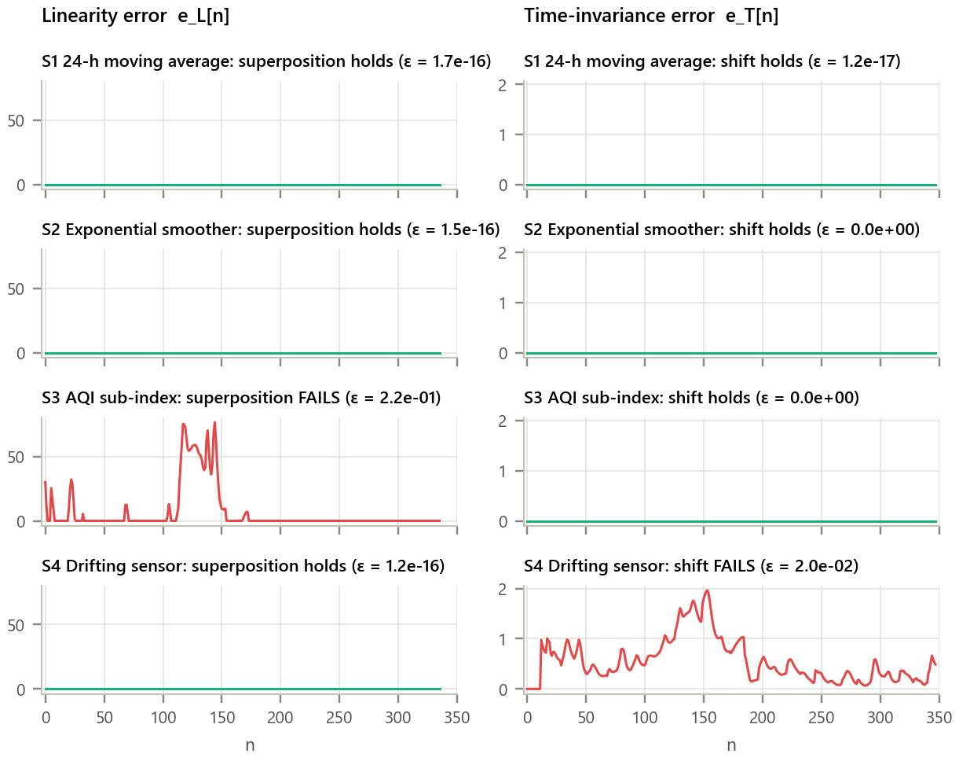
Figure 4. Error signals of both tests for all four systems. Left: e_L[n] = LHS − RHS of superposition; right: e_T[n] of the shift test. Columns share a y-scale.
Inference. The 24-h average and the exponential smoother give error signals that are zero to machine precision in both columns (ε ≈ 1e-16), so they are LTI. The AQI fails only superposition and the drifting sensor fails only the shift test, giving one example of each way a system can fail to be LTI. All four results match the expectation of Table 1.

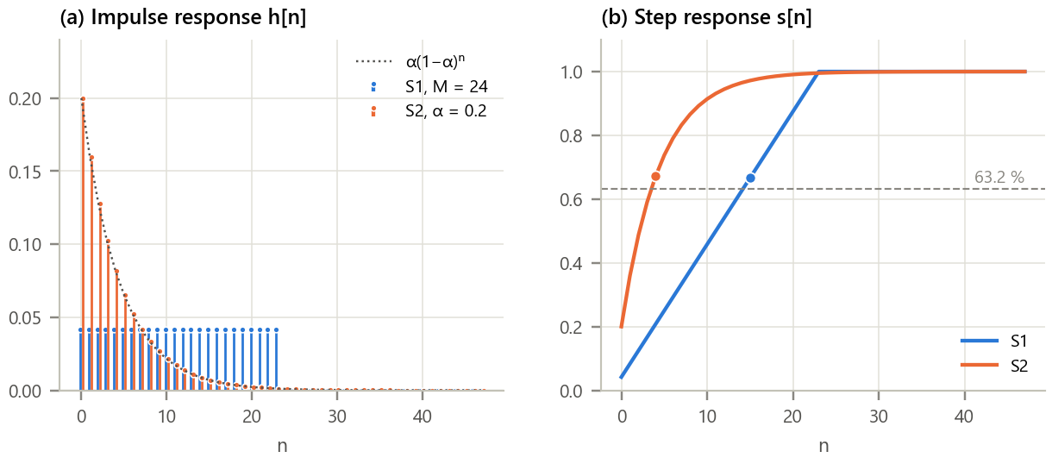
Figure 5. Time response of the two LTI systems. (a) Impulse responses with the theoretical α(1 − α)ⁿ; (b) step responses with the 63.2 % level.
Inference. The moving average has a rectangular h[n] of height 1/24 that ends after 24 samples (finite impulse response); the smoother's h[n] decays geometrically and never ends (infinite impulse response) and matches α(1 − α)ⁿ exactly. Both have DC gain Σh[n] = 1.000, so a steady concentration is reported unchanged. The step response of the average is a straight ramp reaching 63.2 % at n = 15 and 100 % only at n = 23, while the smoother reaches 63.2 % at n = 4 (τ = 4.48) and 95 % at n = 13: the smoother reacts within hours, the regulatory average within a day.

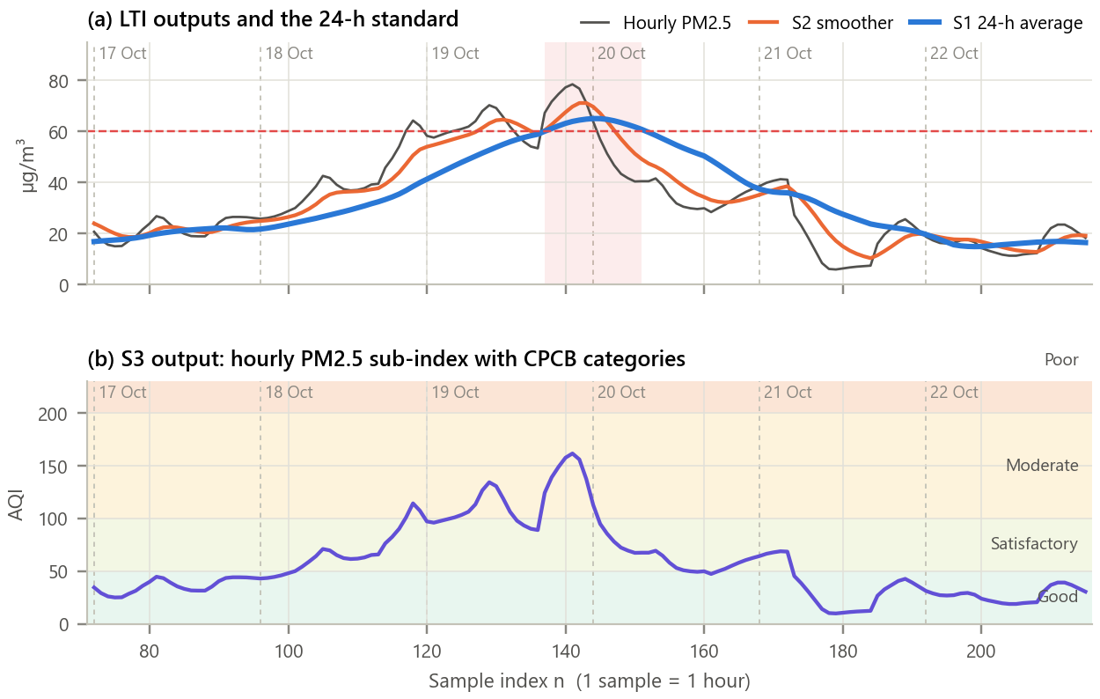
Figure 6. The systems applied to the real PM2.5 episode. (a) Hourly PM2.5, smoother and 24-h average; shading marks hours when the 24-h average exceeds the standard; (b) the AQI output with CPCB category bands.
Inference. Exactly as the step responses predict, the 24-h average peaks at 65.1 µg/m³, 3 h after the hourly peak and 17 % lower, and stays above the standard for 15 hours (19 Oct 17:00 to 20 Oct 07:00). The smoother follows more closely (peak 71.2 µg/m³, 2 h lag). For both LTI systems, x[n] * h[n] reproduces the output with error below 1e-15. The AQI peaks at 162 ("Moderate"); over the fortnight 252 hours were Good, 64 Satisfactory and 20 Moderate.

Table 6. Summary of the LTI tests
System | Linearity ε | Shift ε | Linear | Time-inv. | Verdict
S1 24-h moving average | 1.7e-16 | 1.2e-17 | yes | yes | LTI
S2 Exponential smoother | 1.5e-16 | 0.0e+00 | yes | yes | LTI
S3 AQI sub-index | 2.2e-01 | 0.0e+00 | no | yes | not LTI
S4 Drifting sensor | 1.2e-16 | 2.0e-02 | yes | no | not LTI

8. Conclusion
Black-box superposition and shift tests correctly classified four real air-quality systems: the 24-h NAAQS average and the exponential smoother are LTI, the CPCB AQI is nonlinear but time-invariant, and a drifting sensor is linear but time-varying. For the LTI systems the impulse response told the whole story: it predicted the 3-hour lag and the flattened peak of the 24-h average and the 4.5-sample time constant of the smoother, and convolution with h[n] reproduced their outputs exactly. The practical lessons are that AQI values should never be averaged (average the concentration, then convert), that regulatory averages react slowly to short episodes, and that sensor drift breaks time invariance and must be removed by calibration.

9. Learning Outcomes
- State and test linearity (superposition) and time invariance numerically for any system.
- Distinguish nonlinear and time-varying behaviour and identify their causes.
- Obtain impulse and step responses, read FIR/IIR behaviour, DC gain and time constant from them.
- Use h[n] and convolution to predict an LTI system's response to real data.

10. References
[1] A. V. Oppenheim and R. W. Schafer, Discrete-Time Signal Processing, 3rd ed. Pearson, 2010, ch. 2.
[2] J. G. Proakis and D. G. Manolakis, Digital Signal Processing, 4th ed. Pearson, 2007, ch. 2.
[3] Central Pollution Control Board, National Air Quality Index, CPCB, New Delhi, 2014.
[4] A. Inness et al., “The CAMS reanalysis of atmospheric composition,” Atmos. Chem. Phys., vol. 19, pp. 3515-3556, 2019.
[5] P. Zippenfenig, “Open-Meteo.com Weather API,” Zenodo, 2023, doi:10.5281/zenodo.7970649.

