Course | Digital Signal Processing Lab | Experiment No. | 06
Name | Dewashish Lambore | PRN | ____________
Language | Python 3.10 | Date | ____ / ____ / 2026
Cross-Correlation
Timing the tide as it travels up Chesapeake Bay
Abstract: Hourly water levels from five NOAA tide gauges spaced over 259 km of Chesapeake Bay (January 2024, 744 samples each) were cross-correlated with the gauge at the bay entrance. The cross-correlation was computed by definition, by convolution with the folded reference and through the spectrum, which agreed to 2e-16. The peak lag gave the tidal travel time to each gauge, from 4.36 h at Lewisetta to 9.95 h at Baltimore. Separating the tidal band from the wind-driven setup raised the peak correlation at Baltimore from 0.58 to 0.79. A straight-line fit of distance against delay gave a wave speed of 7.49 m/s (R² = 0.979), i.e. a mean depth of 5.7 m from c = √(gh), close to the published 6.4 m. Because the tide is periodic, the correlation has equally plausible peaks every 12.42 h; chaining short gauge-to-gauge delays resolved the ambiguity.
Keywords: cross-correlation, time-delay estimation, correlation coefficient, tides, shallow-water wave speed, Chesapeake Bay, NOAA, Python

1. Aim and Objectives
Aim: to study the cross-correlation of two discrete-time signals, verify its properties, and use it to estimate the time delay between two real-world sensors, in Python.
- Compute cross-correlation three ways and verify its symmetry and bound.
- Estimate the tidal travel time between gauges, refine it below one sample, and handle the ambiguity of a periodic signal.
- Turn the delays into a wave speed and a mean water depth, and compare with independent data.

2. Real-World Application
Whenever the same disturbance reaches two sensors at different times, the peak of their cross-correlation tells us the delay. In a bay or estuary, the tide entering from the ocean reaches inland ports hours later, so harbour masters schedule deep-draught ships by the local, delayed tide, and storm-surge warnings for upstream cities depend on knowing how fast the water travels. Chesapeake Bay is the largest estuary in the United States, with the port of Baltimore at its head, and NOAA maintains a dense, freely available network of tide gauges along it. The same technique is used in many other fields (Table 1).
Table 1. Uses of cross-correlation
Field | Two signals | Delay from the cross-correlation peak gives
Ports and coasts | tide gauges at entrance and inland | tide / storm-surge arrival time, wave speed
Water utilities | two acoustic sensors on a pipe | position of a leak between them
GPS / GNSS receivers | received signal and local code | signal travel time, hence range
Radar and sonar | transmitted and echoed pulse | distance of the target
Seismology | two seismometers | direction and speed of a seismic wave
Audio / video | two microphones or tracks | source direction, lip-sync correction

3. Theory
The cross-correlation of $y[n]$ with a reference $x[n]$ measures how similar $y$ is to $x$ delayed by $l$ samples:
$r_{yx}[l]=\sum_{n=−∞}^{∞}{}y[n] x[n−l], l=0,±1,±2,…$ (1)
If $y[n]=a x[n−D]$ + noise, then $r_{yx}[l]$ is largest at $l=D$. Like autocorrelation (Experiment 5), it is a convolution with a folded sequence and has a simple spectral form:
$r_{yx}[l]=y[l]*x[−l] ⟷ S_{yx}(e^{jω})=Y(e^{jω}) X^{*}(e^{jω})$ (2)
Unlike autocorrelation it is not even and its maximum is generally not at $l=0$; instead swapping the signals mirrors the lag axis, and the Cauchy-Schwarz inequality bounds its size:
$r_{xy}[l]=r_{yx}[−l], |r_{yx}[l]|≤\sqrt{r_{xx}[0] r_{yy}[0]}$ (3)
Dividing by this bound (after removing the means) gives the correlation coefficient $ρ_{yx}[l]∈[−1,1]$, which compares gauges of different tidal range fairly. The delay estimate is the lag of the maximum, refined between samples by fitting a parabola through the peak $ρ_{0}$ and its neighbours $ρ_{−1},ρ_{+1}$:
$\hat{D}={argmax}_{l} ρ_{yx}[l]+δ, δ=\frac{1}{2} \frac{ρ_{−1}−ρ_{+1}}{ρ_{−1}−2ρ_{0}+ρ_{+1}}$ (4)
A tide is a long, shallow-water wave whose speed depends only on depth $h$, and because it repeats every $T$ = 12.4206 h (the M2 lunar tide), the correlation repeats too:
$c=\sqrt{gh},\text{ candidate delays: }\hat{D}+mT, m=0,±1,…$ (5)
Note. A delay is only unique if it is shorter than half the signal's period. Here the full delay to Baltimore approaches one tidal period, so the true value is confirmed by chaining four short gauge-to-gauge delays, each well under 6.2 h.

4. Dataset Description
NOAA's Center for Operational Oceanographic Products and Services (CO-OPS) runs the US National Water Level Observation Network. Its free web API returns quality-controlled verified hourly heights relative to mean sea level (MSL). Five gauges from the bay entrance (Sewells Point, Norfolk) to the head (Baltimore) were requested for 2024-01, about 25 kB per gauge, merged into one cached CSV. Distances are great-circle distances from Sewells Point computed from the station coordinates; times are UTC.
Table 2. Dataset attributes (744 hourly samples per gauge, no gaps)
ID | Gauge | Lat (°N) | Lon (°E) | Distance (km) | Mean (m) | Std (m) | Range (m)
8638610 | Sewells Point | 36.943 | -76.329 | 0.0 | 0.208 | 0.303 | 1.38
8635750 | Lewisetta | 37.996 | -76.464 | 117.7 | 0.219 | 0.242 | 1.39
8577330 | Solomons Island | 38.317 | -76.452 | 153.2 | 0.199 | 0.249 | 1.52
8575512 | Annapolis | 38.984 | -76.480 | 227.3 | 0.198 | 0.272 | 1.81
8574680 | Baltimore | 39.267 | -76.578 | 259.3 | 0.164 | 0.298 | 1.97

Table 3. Dataset preview (water level in metres above MSL)
Time (UTC) | Sewells Point | Lewisetta | Solomons | Annapolis | Baltimore
11-Jan 00:00 | 0.357 | 0.172 | 0.211 | 0.381 | 0.405
11-Jan 01:00 | 0.456 | 0.167 | 0.171 | 0.306 | 0.339
11-Jan 02:00 | 0.437 | 0.192 | 0.152 | 0.226 | 0.283
11-Jan 03:00 | 0.316 | 0.264 | 0.175 | 0.173 | 0.240
11-Jan 04:00 | 0.147 | 0.319 | 0.226 | 0.140 | 0.165
11-Jan 05:00 | -0.029 | 0.324 | 0.274 | 0.139 | 0.102

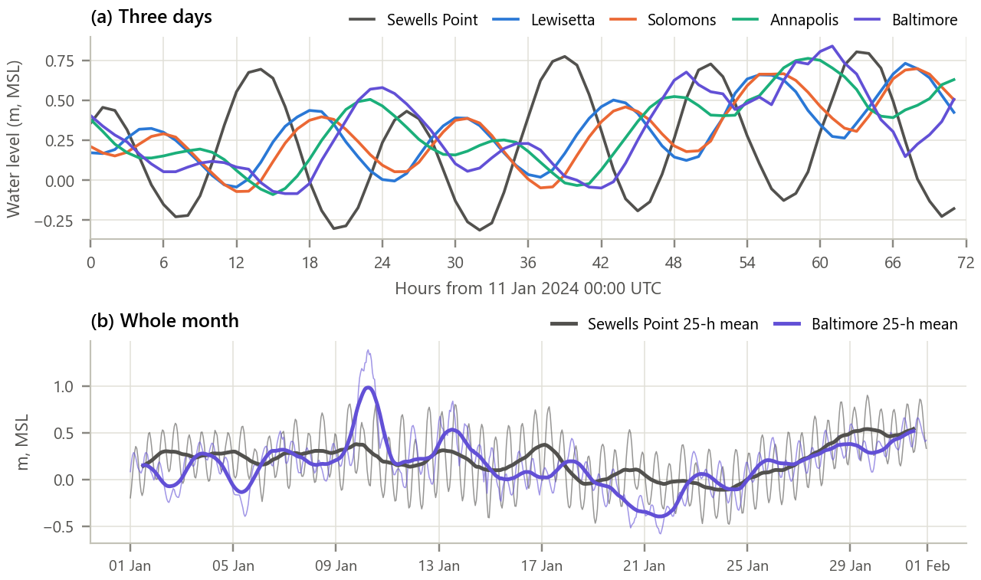
Figure 1. The five water-level records. (a) Three days from the bay mouth to the head; (b) the whole month at the two end gauges with their 25-hour running means.
Inference. In panel (a) each high water appears first at Sewells Point and then progressively later at Lewisetta, Solomons, Annapolis and Baltimore, the visual signature of a delay. Panel (b) shows that the tide (about ±0.3 to 0.4 m) rides on slow, wind-driven changes of mean level that are just as large: a storm on 9 to 10 January pushed Baltimore about 1 m above normal. These slow changes are not a travelling tide, so they will be separated from it before the delay is measured.

5. Methodology and Implementation
Each record is split into a subtidal band (25-hour moving average, the filter of Experiment 3) and a tidal band (the remainder). For each gauge y and the reference x the normalised cross-correlation is computed for lags −36 to 36 h, the peak is searched between -3 and 30 h and refined by Eq. 5, and distance is regressed on delay through the origin to obtain c.
Table 4. Software modules
Module | Responsibility
config.py | Station IDs and coordinates, period, tidal constants, lag windows
data_loader.py | Download five NOAA records once, merge, cache as one CSV
xcorr.py | Three cross-correlation methods, coefficient, peak and parabolic refinement, distances
analysis.py | Band split, delays to each gauge, chained delays, speed and depth, subtidal study
plots.py / gui.py | Report figures / interactive time-delay estimator
test_xcorr.py | 10 unit tests (symmetry, bound, delay in noise, sub-sample delay, ambiguity): all pass

Core of xcorr.py
1 def crosscorr_direct(y, x, L): # r_yx[l] = sum y[n] x[n - l]
2 N = len(x)
3 return [np.dot(y[l:], x[:N - l]) if l >= 0 else np.dot(y[:N + l], x[-l:])
4 for l in range(-L, L + 1)]
5
6 def crosscorr_fft(y, x, L): # r_yx = IDFT{ Y X* }, zero-padded
7 nfft = 1 << int(np.ceil(np.log2(2 * len(x) - 1)))
8 r = np.fft.irfft(np.fft.rfft(y, nfft) * np.conj(np.fft.rfft(x, nfft)), nfft)
9 return np.r_[r[-L:], r[:L + 1]]
10
11 def peak_lag(lags, rho): # delay with parabolic refinement
12 k = np.argmax(rho)
13 a, b, c = rho[k - 1], rho[k], rho[k + 1]
14 return lags[k] + 0.5 * (a - c) / (a - 2 * b + c)
15

GUI. gui.py (Figure 2) lets the user pick any two gauges and the band, set the lag range, and slide y manually over x: the correlation at the chosen shift is shown next to the automatic peak, the estimated delay and the implied wave speed. This makes the definition tangible, since cross-correlation is exactly 'slide, multiply, add' for every shift. Run python run_experiment.py and python gui.py.
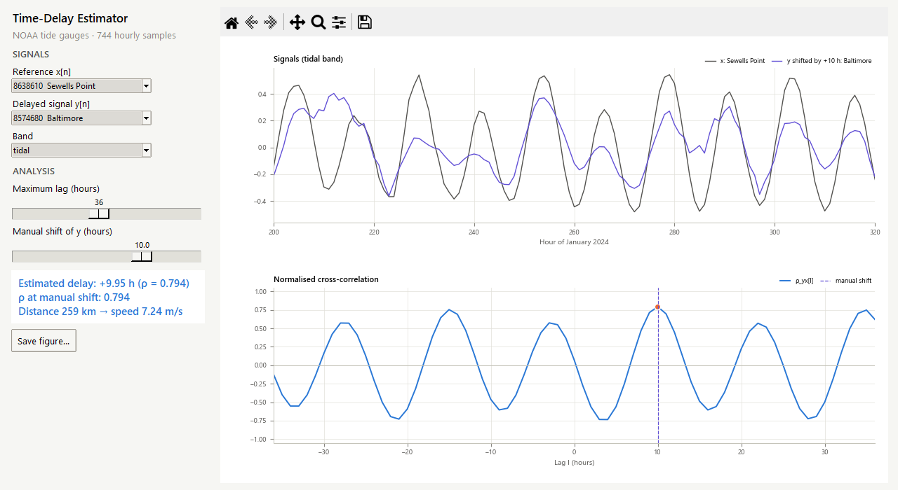
Figure 2. The time-delay estimator: Baltimore shifted by 10 h against Sewells Point. At the manual shift the correlation equals the automatic peak.

6. Calculations
Hand example. x[n] = {1, 3, 2, 0} and y[n] = {0, 1, 3, 2}, i.e. y is x delayed by one sample. For each lag, multiply y[n] with x[n − l] where both exist and add:
Table 5. Cross-correlation by hand (r = 0 for l ≤ −2)
Lag l | Products y[n]·x[n − l] | r_yx[l]
−1 | y[0]x[1] + y[1]x[2] + y[2]x[3] = 0·3 + 1·2 + 3·0 | 2
0 | 0·1 + 1·3 + 3·2 + 2·0 | 9
+1 | y[1]x[0] + y[2]x[1] + y[3]x[2] = 1·1 + 3·3 + 2·2 | 14
+2 | y[2]x[0] + y[3]x[1] = 3·1 + 2·3 | 9
+3 | y[3]x[0] = 2·1 | 2

The peak r = 14 at l = +1 recovers the one-sample delay, and equals the energy of x (1 + 9 + 4), the Cauchy-Schwarz bound. Baltimore: the tidal-band coefficient around the peak is ρ(9) = 0.7142, ρ(10) = 0.7942, ρ(11) = 0.6959, so δ = ½(0.7142 − 0.6959) / (0.7142 − 2×0.7942 + 0.6959) = -0.051 and D̂ = 9.95 h. With d = 259.3 km, c = 259.3 / 9.95 = 26.1 km/h = 7.24 m/s and h = c²/g = 5.34 m. The other candidate delay is 9.95 − 12.4206 = -2.47 h. These values match the program (checked by test_xcorr.py).

7. Results and Discussion
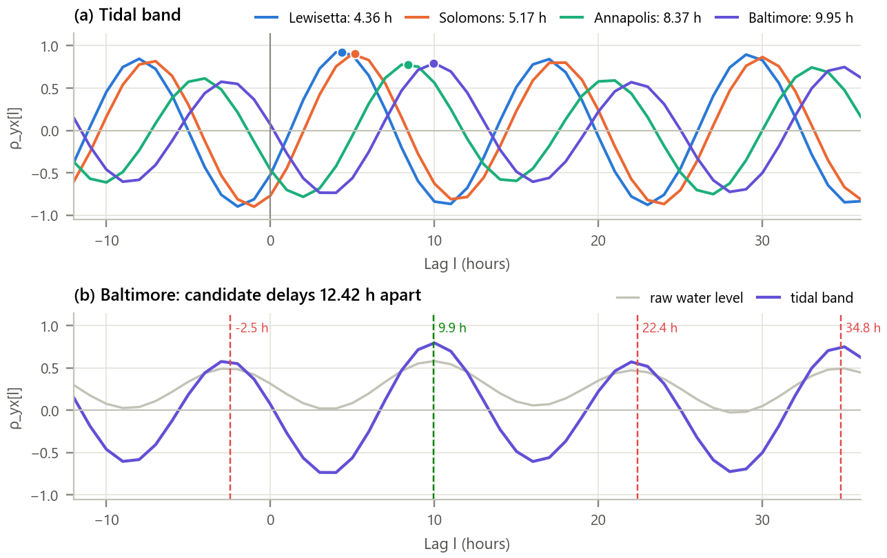
Figure 3. Normalised cross-correlation of each gauge with Sewells Point. (a) Tidal band, peaks marked; (b) Baltimore, raw versus tidal band, with candidate delays 12.42 h apart.
Inference.
- Each curve is an oscillation at the tidal period whose peak moves to larger lags with distance: Lewisetta 4.36 h (ρ = 0.92), Solomons 5.17 h (ρ = 0.90), Annapolis 8.37 h (ρ = 0.78), Baltimore 9.95 h (ρ = 0.79).
- For Baltimore the raw water level gives only ρ = 0.58, because two thirds of January's variance is wind-driven setup; the tidal band raises it to 0.79 with practically the same delay (9.94 versus 9.95 h).
- Peaks of similar height also appear at -2.47 h and 22.37 h. The correlation alone cannot say which is the true travel time.

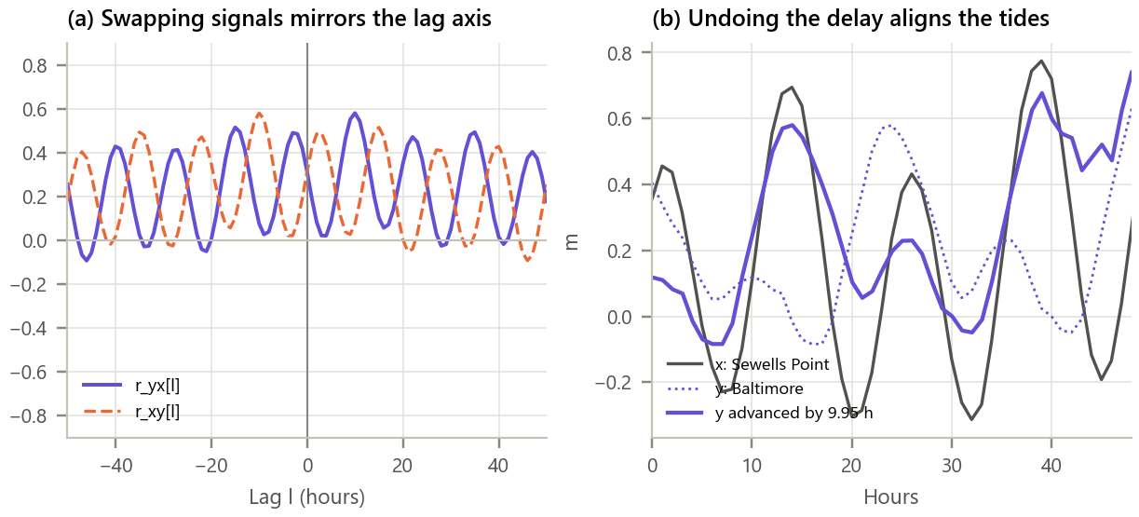
Figure 4. Properties and meaning of the delay. (a) r_yx and r_xy for Baltimore (y) and Sewells Point (x); (b) the two records before and after advancing Baltimore by the estimated delay.
Inference. Swapping the signals mirrors the lag axis exactly (error 0e+00), and the function is clearly not even (asymmetry 0.53), so the sign of the lag says which signal leads. The largest normalised value is 0.58, below the Cauchy-Schwarz bound of 1. Advancing Baltimore by 9.95 h lines its tides up with those at the entrance, although the shape is smoothed and the range differs: the wave is not only delayed but also filtered by the bay.

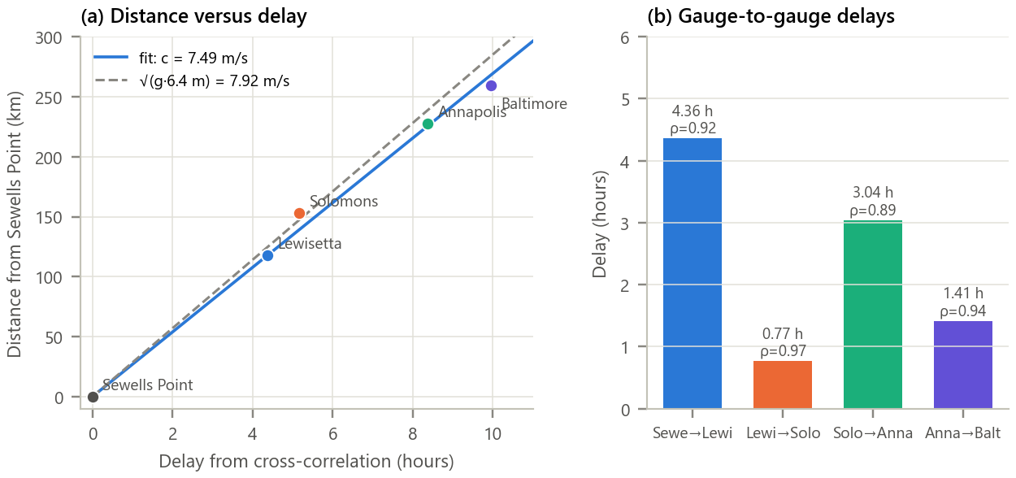
Figure 5. From delays to wave speed. (a) Distance against delay with the least-squares line and the shallow-water prediction; (b) delays between neighbouring gauges.
Inference.
- The five gauges lie close to one straight line (R² = 0.979): the tide advances at 7.49 m/s (26.9 km/h). By c = √(gh) this corresponds to a mean depth of 5.7 m, against the published 6.4 m (c = 7.92 m/s). The small shortfall is expected because straight-line distances underestimate the channel path.
- The four short steps (4.36, 0.77, 3.04, 1.41 h) are all far below half a tidal period and highly correlated (ρ ≥ 0.89), so each is unambiguous. They add up to 9.58 h, which confirms the 9.95 h candidate and rules out -2.47 h. The step speeds differ (27, 46, 24, 23 km/h) because depth varies along the bay and the straight-line distances between neighbouring gauges are only approximate.

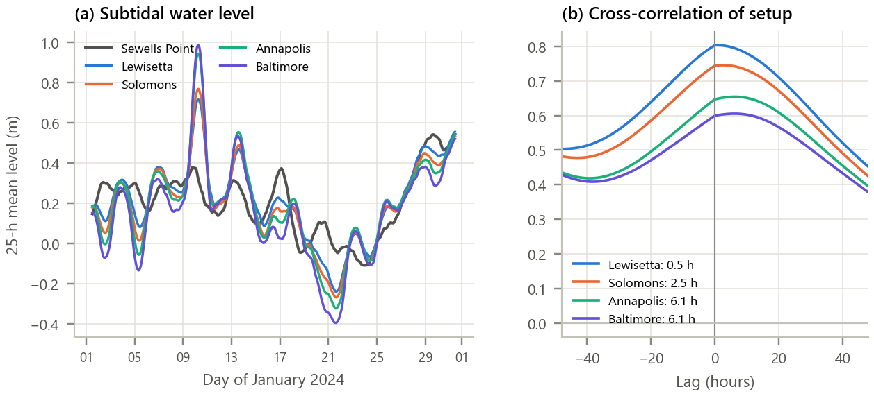
Figure 6. The wind-driven (subtidal) component. (a) 25-hour mean water level at all gauges; (b) its cross-correlation with Sewells Point.
Inference. The slow component is strongly shared along the bay (ρ = 0.80 to 0.61), but its correlation peaks are broad and its lags (0.5, 2.5, 6.1, 6.1 h) do not grow in proportion to distance as the tide's do. It is set up by wind over the whole bay at once rather than travelling as a wave, so its timing must be forecast from the weather, not from a delay. The upper bay also amplifies it: the 10 January surge was largest at Baltimore.

Table 6. Summary of delays
Gauge | Distance (km) | Delay raw (h) | ρ raw | Delay tidal (h) | ρ tidal | Chained (h)
Sewells Point | 0.0 | 0.00 | 1.00 | 0.00 | 1.00 | 0.00
Lewisetta | 117.7 | 4.33 | 0.78 | 4.36 | 0.92 | 4.36
Solomons Island | 153.2 | 5.13 | 0.72 | 5.17 | 0.90 | 5.13
Annapolis | 227.3 | 8.34 | 0.58 | 8.37 | 0.78 | 8.17
Baltimore | 259.3 | 9.94 | 0.58 | 9.95 | 0.79 | 9.58

8. Conclusion
Cross-correlation measured the travel time of the tide along Chesapeake Bay to a fraction of the one-hour sampling interval: 9.95 h over 259 km, a speed of 7.49 m/s and a mean depth of 5.7 m that agrees with the published depth to within 11 %. Its properties (mirror symmetry under swapping, the Cauchy-Schwarz bound, equivalence of the three methods) were confirmed numerically. Two practical lessons emerged. First, a clean delay needs the right band: removing the wind-driven setup raised the correlation from about 0.6 to 0.8. Second, for a periodic signal the peak is ambiguous by whole periods, and the ambiguity was resolved physically by chaining short, unambiguous delays. The same reasoning underlies leak location, GPS ranging and radar.

9. Learning Outcomes
- Compute cross-correlation by definition, by convolution with the folded reference and via the spectrum.
- Use the correlation coefficient and parabolic interpolation to estimate delays below one sample.
- Recognise and resolve the delay ambiguity of periodic signals.
- Convert delays into physical quantities (wave speed, depth) and judge them against independent data.

10. References
[1] J. G. Proakis and D. G. Manolakis, Digital Signal Processing, 4th ed. Pearson, 2007, ch. 2.6.
[2] C. H. Knapp and G. C. Carter, “The generalized correlation method for estimation of time delay,” IEEE Trans. Acoust., Speech, Signal Process., vol. 24, no. 4, pp. 320-327, 1976.
[3] NOAA CO-OPS, “Tides and Currents data API,” https://tidesandcurrents.noaa.gov.
[4] D. T. Pugh and P. L. Woodworth, Sea-Level Science, Cambridge University Press, 2014, ch. 7.
[5] Chesapeake Bay Program, “Facts and Figures,” https://www.chesapeakebay.net.

