Take-home Programming Test

# Assignment

Included in this assignment is a comma-separated value file (data.csv) that contains device information. It’s a pretty large file, so let’s first break it down by including only information that we’re interested in. Create a file parser that reads in data.csv, and only returns the information we actually are interested in.

1. Timestamp: Column 1
2. Type : Column 2
3. Gesture: Colum 5
4. Packet : Column 6

Note: Only return data that is of a valid Type (Keyboard, Mouse, Touch, Gestures).

The packets are stored in hexadecimal format with 2 characters per byte.

The packets are structured as follows.

1. The header comes first and is logged as a short.
2. The Payload will have a variable length and is an array of bytes.
3. The CRC comes last and is logged as an unsigned short.

Once the parser is functioning as we want the next step is to display the information to the user.

Here is an example UI that we would like you to base you view on. If you change Selections of the type of packet you wish to view you must update the list box to display only packets of that type. You’ll notice in the list box we show each items timestamp, type of packet and the gesture.  
  
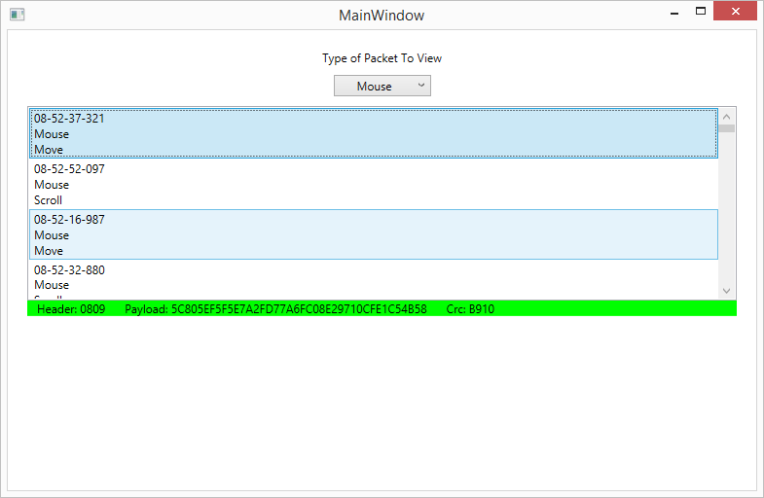

Below the list box we would like to see the packet broken into Header, Payload and CRC as shown above. Please also have different Colors for each of the different packet types. You can choose colors as you desire.

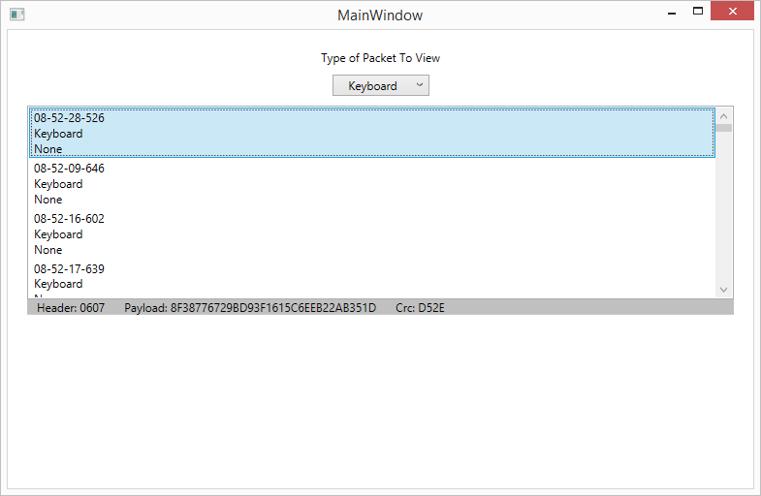

As you can see above mouse was green and keyboard is gray in this example.

1. Intuitive
   1. Easy for non-technical person to use.
   2. User should not need instructions on how to use the applications core features.
2. Modular | Reusable
   1. Make it easy for other developers to re-use your code.
3. Responsive
   1. Make sure the GUI doesn’t hang while doing intensive processing.
4. Creativity
   1. Style the application however you desire.